Word List with Images and Translations

# apple

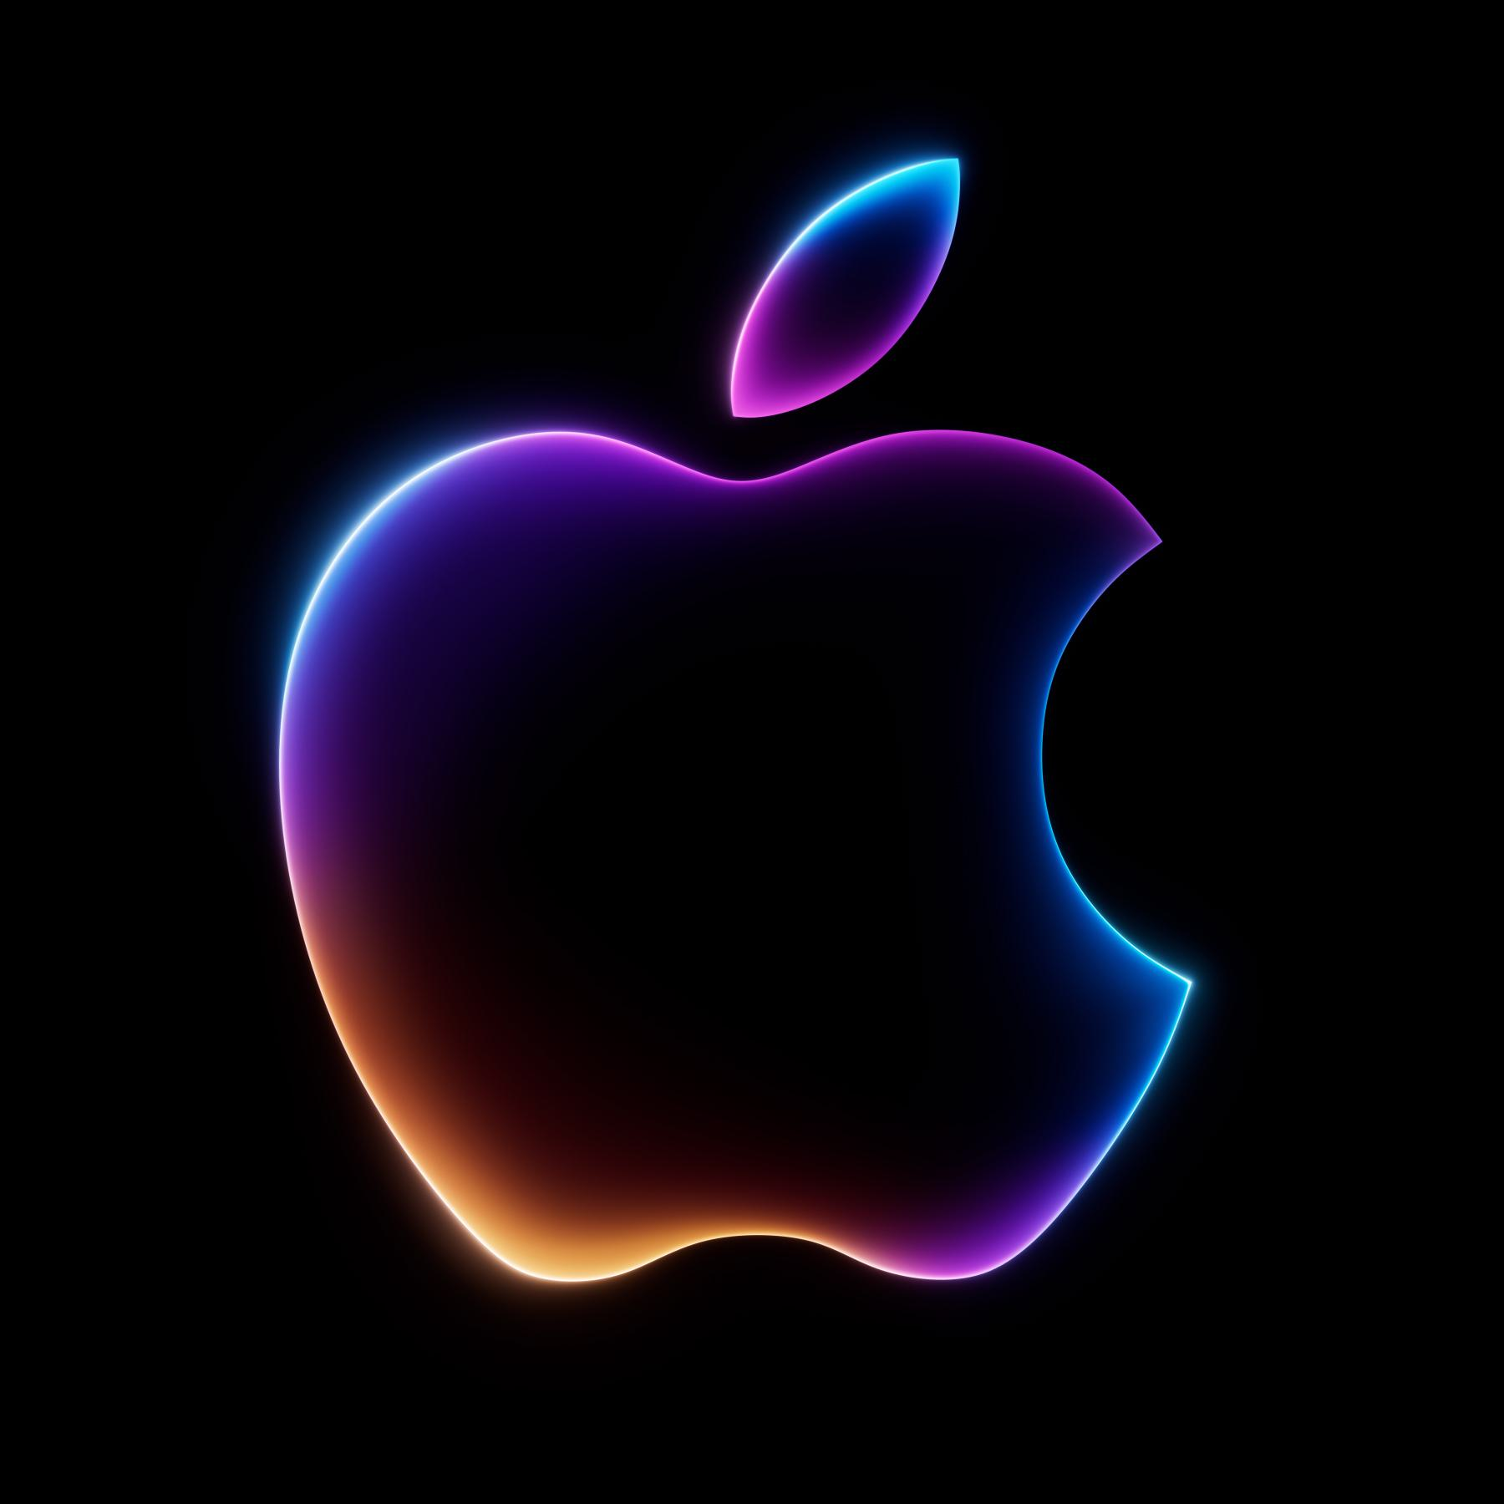

Farsi Translation: سیب

# book

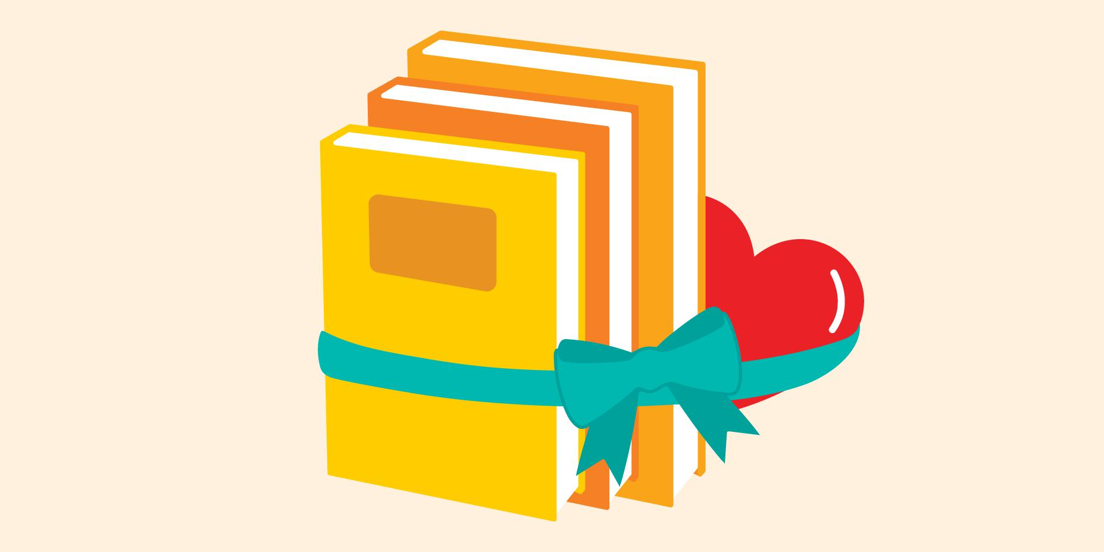

Farsi Translation: کتاب

# house

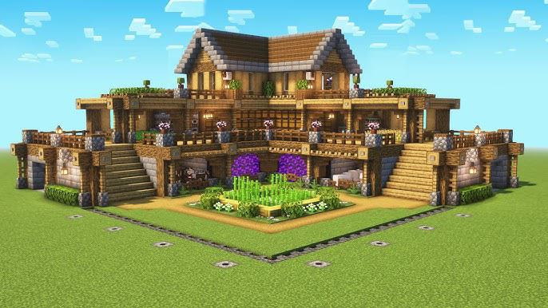

Farsi Translation: خانه