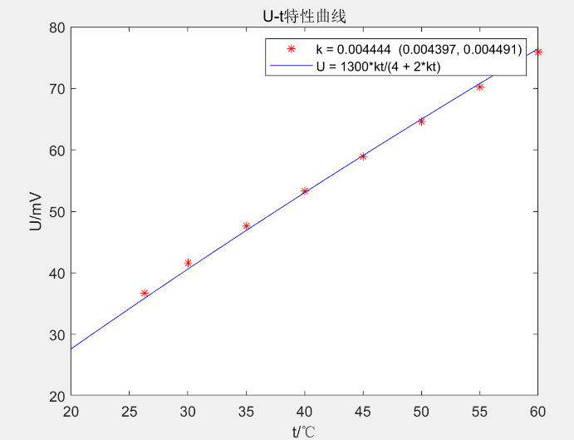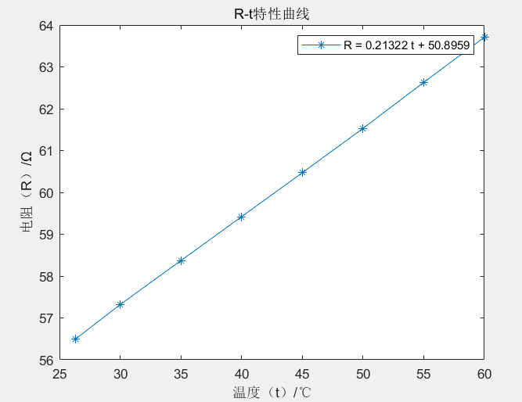

syms x

t = [26.3; 30; 35; 40; 45; 50; 55; 60]

U = [36.7; 41.6; 47.6; 53.3; 58.9; 64.6; 70.2; 75.9]

f = fittype('k\*x/(4+2\*k\*x)\*1300','independent','x','coefficients',{'k'});

cfun = fit(t,U,f)

ti = 20:.1:60;

Ui = cfun(ti);

plot(t, U, 'r\*', ti, Ui, 'b-');

title('U-t特性曲线')

xlabel('t/℃');ylabel('U/mV')