课后例句

Reading 1: Cheating Death

1. The spokesman of the company refused to ***d_________________（透露；揭露；泄露）*** more details of their latest project to the press.
2. old c________ 老东西
3. With the improvement of the people's living standard, foreign travels have become ***c_________________（(常见的事; 老生常谈; 平常的事; 平淡无奇的言语等).***
4. Just two months ago, he underwent hip ***r_________________（(替代品；替换物)*** surgery that cost $120, 000.

词性？含义？

1. It was only at the very end of the 19th century that this practice was ***a_________________（(废止；废除；取消).***
2. We have decided to ***s_________________（(暂停;中止)*** all production at the factory until safety checks can be carried out. （同样词根的词？）
3. He's an eternal ***o_________________（(乐观者；乐观主义者)***. He always expects good things to happen or things to be successful. (反义词？)
4. He attributes his l***_________________（(长寿)*** to a simple diet and a glass of wine every day.
5. For the first time it seemed possible to measure the body like a machine to test its ***l_________________（(寿命).***
6. Doctors say these new drugs can reduce pal and ***p________________（延长）*** life for two or three years.
7. Let's try and solve the mast ***i________________（目前的；当下的；紧迫的）*** problem before they get worse.
8. If the eyes are affected by the drug, you must seek ***i________________（附近的）*** medical attention.

其他含义？

1. The language of teenagers is often completely ***i________________（无法理解的）*** to the elderly.
2. A long flight of stairs made the center of the museum ***i________________（难到达的；不可及的）*** to disabled visitors. (其他含义？)
3. Caulfield claimed the company had ***d________________（区分，辨别; 区别对待; 歧视）*** against him because of his nationality. （搭配？）
4. Melania believes that dressing ***y________________（年经地：像年轻人地：具有年段人特点地）*** about keeping up with trends.
5. Cutting the bush back in the autumn will help promote ***v________________（强健的；精力旺盛的）*** growth in the spring.
6. According to a recent survey a quarter of people over 12 get no ***v________________（强度大的；积极的）*** exercise at all.
7. Tim was rude, unable to bear criticism, and more and more  ***h________________（古板的，守旧的（含贬义））*** in his views as he got older.
8. I would say the film successfully ***r________________（使重温；使再次经历）*** the joyful style of those days. (对应的原来的动词的含义？)
9. There is a trend toward more temporary employment and ***p________________ c________________（组合型职业）. p________________ 的其他含义？ 复数？*** 书的一页 什么词：
10. It is said that the new employee has broken the rule and will be punished ***a________________（相应地）. 难点***
11. Matthew has worked as a ***l________________（体力劳动者；工人）*** in factories and on construction sites since he left his hometown.
12. People setting up business on their own really need to employ an ***a________________（会计师；会计）.***
13. There has been a great deal of ***s________________（猜测；推测）*** about what will happen after the president resigns.

Big farmers are moving in, not in order to farm, but in order to ***s_____________*** with rising land prices.

1. Don't fall into the ***t________________（牢笼；困境）*** of investing all your money in one place.
2. Three teenage girls took a vow (誓言)of ***e________________（永远的；永恒的）*** friendship during the summer of 1985.
3. It is a pity that the spring flowers were already beginning to ***w________________（枯菱；千枯）.***
4. ***蝉***

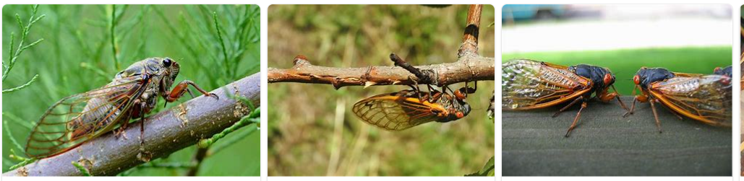

1. The business report released on Wednesday ***c________________（警告；告诚；提醒）*** investors against over-optimistic expectations. (其他含义？搭配？)
2. The actress who played the fashion designer in the movie was absolutely ***t________________（极好的；极棒的）***! （其他表示赞扬的方式？）
3. You have to be realistic - it's difficult to ***c________________（把⋯塞进（小空间）；硬塞）*** everything into a tight schedule. （其他含义？）
4. Some young mothers feel that they have got to the stage where they aren't able to ***c________________（（成功地）应付，对付）*** on their own.
5. Her father's death reminded her that she was ***m________________（不会长生不死的；终有一死的）***, and it made her very sad.
6. Some people want to achieve ***i________________（永生；长存；永恒）*** through their works.
7. He is neither a liar nor a ***f________________（幻想家；空想家；不切实际者***）, and he is careful about what he says.
8. Traveling to the Potala Palace in Tibet has been on my ***b________________ list（人生心愿清单***） for years.
9. Could you explain to us how you ***c________________ ________________（死里逃生；逃脱厄运等）*** at every stage of the journey?
10. Kathleen thinks she's o***_______ _________ ______________（不再年轻；人老珠黄）***, but she's only 32.
11. Activities o***_______ _________ （可买到的；供使用的；提供的）*** at the beach include sailing, rowing, canoeing and camping.
12. Economists agree that the economic situation is good and recovery is o***_______ _________ ________（即将到达（发生））.***
13. So you think they'll get married next year?- I think ***it's*** o***_______ _________ ________（很可能发生）.***
14. I bought the pair of boots three years ago and they are beginning to w***_______ ________（用坏；（使）磨损）. (其他含义)***
15. Dr. Rosen closed his downtown practice and s***_______ _______ ________（开业）*** in a suburban neighborhood.
16. All the three kids of the Thompsons are good musicians. The musical talent seems tor***_______ _______ _______ _______________（(某种品质、疾病、技能等）在家族中遗传，是家族特征）.***
17. During the last decade, the right wing of the party has held ***the***  w ***_______ _______（支配权；控制权）*** over the country.



1. The feedback is that more research and solid evidence are needed to r***_______ _______（（尤指通过增加另一特点而）使要加完美，西完成）*** the article.
2. Local authorities have d***_______ _______ _______（起草，拟定（名单、合同等））*** guidelines on waste treatment and disposal.