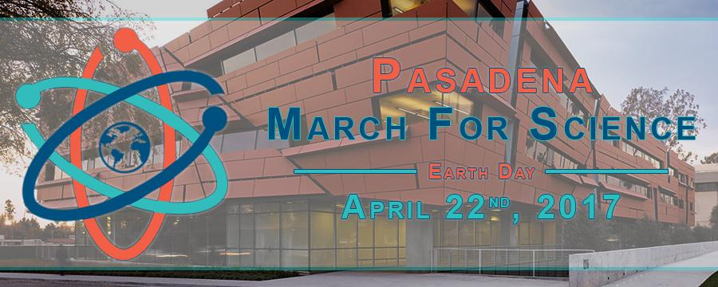

**What:** A rally and march for everyone who supports science, organized by researchers at Caltech. Confirmed speakers so far include **Caltech Professor Mary Kennedy**, **Caltech Professor Jonas Peters**, and **Pasadena Mayor Terry Tornek**, with more to come!

**Goals:** 1) Celebrate science, 2) Advocate for transparency in and the support of science, and 3) Celebrate ties between science and the community.

**When:** April 22nd, 2017 at 8:00am-11:00am

**Where:** Come to Caltech (Beckman Lawn) for the 1st rally, march by Pasadena City Hall to Memorial Park, come to Memorial Park for the 2nd rally, or participate in everything!

**Who:** Anyone who supports science

**More details at:** [www.facebook.com/MarchForSciencePasadena](http://www.facebook.com/MarchForSciencePasadena)

Questions, email: [marchforsciencepasadena@gmail.com](mailto:marchforsciencepasadena@gmail.com)

**Interested in Marching, but want to go to LA? Consider joining Caltech researchers, more info at:**

<http://www.tsf.caltech.edu/scimarch.html>