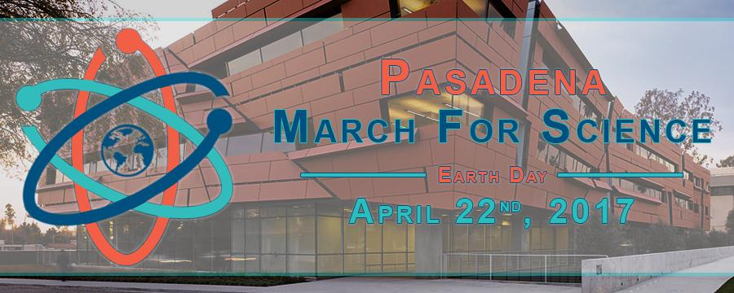

**Confirmed Speakers**

**Prof. Mary Kennedy, Caltech**

Member of the American Academy of Arts and Sciences and Vice Chair of the Caltech Officers of the Faculty

**Prof. Jonas Peters, Caltech**

Bren Professor of Chemistry and Director of the Resnick Sustainability Institute

**Mayor Terry Tornek, Pasadena**

AND MORE TO COME!



Start: **8:00 AM @ Caltech, Beckman Lawn**

End: **11:00 AM @ Memorial Park**

**More details at:** [www.facebook.com/MarchForSciencePasadena](http://www.facebook.com/MarchForSciencePasadena)

Questions, email: [marchforsciencepasadena@gmail.com](mailto:marchforsciencepasadena@gmail.com)



**Also consider joining Caltechers@LA march**

<http://www.tsf.caltech.edu/scimarch.html>