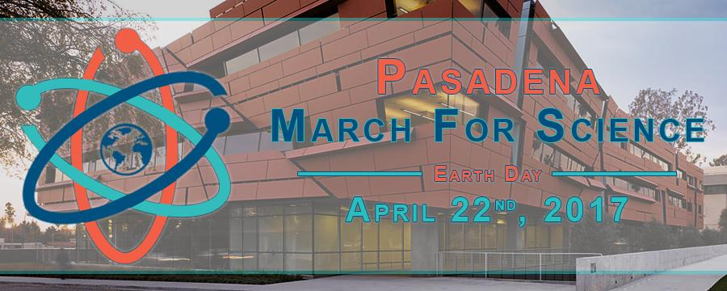

**March for Science - Pasadena**

**Confirmed Speakers:**

Congresswoman **Judy Chu**

CA State Senator **Anthony Portantino**

District 41 Assemblymember **Chris Holden**

Caltech Profs **Mary Kennedy, Jonas Peters, Michael Roukes**

Pasadena Mayor **Terry Tornek**

**Date:** 04/22/2017

**Start**: 8:00 AM @ Caltech, Beckman Lawn

**End:** 11:00 AM @ Memorial Park

**Free bagels and coffee!**

**Free t-shirts to the first 100 people!!**

**Science activities for kids and adults!!!**

**More details at:** [www.facebook.com/MarchForSciencePasadena](http://www.facebook.com/MarchForSciencePasadena)

**Questions, email:** [marchforsciencepasadena@gmail.com](mailto:marchforsciencepasadena@gmail.com)



**Also consider joining Caltechers@LA march**

<http://www.tsf.caltech.edu/scimarch.html>