**Zigbee产品设计参考手册**

版本: v1.1

编写: jason

# 目录

目录 2

修订记录 1

简介 1

前言 1

缩写 1

颜色标记说明 1

Zigbee应用规范简述 2

1.1 节点信息 2

1.2 Cluster 簇 2

1.2.1 Client/Server模式 2

1.3 简单描述符Simple descriptor 2

1.4 Endpoint 端点 2

1.5 binding 绑定 2

设备规范 3

2.1 所有设备通用簇 3

2.2 通用设备 3

2.2.1 On/Off Switch 开关 4

2.2.2 Level Control Switch 等级开关 4

2.2.3 On/Off Output 开关输出 4

2.2.4 Scene Selector 场景选择 5

2.2.5 Mains Power Outlet 电源插座 5

2.2.6 Door Lock 门锁 6

2.2.7 Simple Sensor 传感器 6

2.2.8 Smart Plug 智能插座 6

2.3照明设备 7

On/Off Light 开关灯 7

Dimmable Light 可调光灯 7

Color Dimmable Light 可调光彩色灯 8

On/Off Light Switch 灯开关 8

Dimmer Switch 调光开关 9

Color Dimmer Switch 彩色调光开关 9

Light Sensor 光传感器 9

Occupancy Sensor 10

2.4 Closures 10

Shade 窗帘 10

Shade Controller 窗帘控制器 11

Window Covering 窗户 11

Window Covering Controller 12

2.5 HVAC供热通风与空气调节设备 12

Temperature Sensor 温度传感器 12

2.6 Intruder Alarm Systems入侵报警系统设备 13

控制和指示设备IAS Control and Indicating Equipment(CIE) 13

辅助控制设备IAS Ancillary Control Equipment (ACE) 13

联防设备IAS Zone 14

报警设备IAS Warning Device (WD) 14

簇规范 14

3.1 General 通用 14

3.1.1 basic 基本 15

3.1.2 Power Configuration电源配置 16

3.1.4 Identify 识别 18

3.1.5 Group 组 19

3.1.6 Scene 场景 20

3.1.7 On/Off 开关 22

3.1.8 On/Off Switch Configuration 开关配置 23

3.1.9 Level Control 等级控制 24

3.1.10 Alarms 报警 25

3.2 测量和感应MEASUREMENT AND SENSING 26

3.2.1 Illuminance Measurement 亮度测量 26

3.2.2 Illuminance Level Sensing 亮度等级感应 27

3.2.3 Temperature Measurement 温度测试 27

3.2.6 Relative Humidity Measurement 相对湿度测量 28

3.2.8 Electrical Measurement 电量的测量 29

3.3 Lighting 照明 33

Color Control 颜色控制 33

3.4 HVAC 供热通风与空气调节 38

Fan Control 风扇控制 38

3.5 Closures 39

3.5.1 Shade Configuration 窗帘配置 39

3.5.2 DoorLock 门锁 40

3.5.3 *Window Covering 窗户遮盖 47

3.6 Security and safety 隐私与安全 48

3.6.1 IAS Zone 联防 48

3.6.3 IAS WD 报警 51

3.7 Protocol interface 51

3.8 Smart energy 智能能源 52

Metering 52

# 修订记录

**版本v1.0 - 2017.4.14**

·对常用会使用到的簇及设备进行描述。

**版本v1.1 – 2017.4.19**

·增加业务相关部分命令的参数描述，通信协议中会引用。

# 简介

该文档用于简要说明zigbee产品规范内容，用于指导产品设计人员及软件设计人员进行针对性的设计。

# 前言

## 缩写

|  |  |
| --- | --- |
| 缩写 | 全名 |
| M/O | Mandatory/ Optional 必须/可选 |
| ZCL | Zigbee cluster library |
| ZCL6/zcl6 | zigbee-cluster-library-specification6 |

## 颜色标记说明

标记灰色表示目前没有设备或与业务无关的簇或设备ID，本文档不进行详细描述.

标记红色表示是与业务会有关系的属性或命令，业务层及UI设计时需要考虑。

标记紫色表示是与业务会有关系的属性或命令，业务层及UI设计时需要考虑，实际设备较少会实现。

标记蓝色表示编者无法做出判断，需要产品设计人员自行考虑。

标记绿色表示与版本相关的信息，需有渠道可获取该信息，便于分析问题，架构师需考虑（仅存在basic簇中）。

未做标记表示与业务无关属性或命令。这部分属性ui业务层不用考虑，但服务器可存储。

注意：业务相关属性命令中可能是可选内容，说明不同厂商设备选择实现的内容也会不一样。

# Zigbee应用规范简述

## 1.1 节点信息

每个节点（或称设备）都具有的信息。厂商ID、供电方式，网络地址，mac地址、低精度电量（电池供电时）

## 1.2 Cluster 簇

Cluster是zigbee应用规范的基础，定义为相关属性与命令的集合，如‘on/off Cluster’，就含有‘on/off’属性和 ‘on、off、toggle’命令。具有开关属性的设备都会实现该Cluster。详细见 簇规范。

### 1.2.1 Client/Server模式

Cluster分Client端与server端，通常存储属性的为Server端，比如灯泡会存储开关属性。Client端通常访问server端的数据或发指令到server端，例如开关控制器发送on命令到灯。可以简单理解为接受控制的设备实现server端，输出控制命令的为client端。

## 1.3 Endpoint 端点

一个端点对应一个简单描述符，一个硬件设备上可能有多个端点，每个端点都会有一个设备ID，对应一个HA设备。比如多路开关可能包含多个On/Off Switch端点，一个门磁，就可能有门磁传感器端点和On/Off Switch端点(输出门磁状态用于直接联动)。

## 1.4 binding 绑定

zigbee规范中可以将分别实现了某个cluster的server端和client端的两个端点绑定在一起，之后两个端点可以直接通讯，比如可将on/off switch和on/off output绑定在一起，之后switch可以直接控制output。

# 设备规范

该章节描述HA规范中每中设备应实现的cluster。

## 2.1 所有设备通用簇

Server Side列表示设备需要实现列出cluster的server端功能，**Client Side**列表示设备需要实现列出cluster的client端功能，详见 簇规范 。Mandatory表示必须实现，optional表示可选实现。

所有设备公共cluster

|  |  |
| --- | --- |
| **Server Side** | **Client Side (see 7.1.4)** |
| **Mandatory** |  |
| Basic 基础 | *None* |
| Identify 识别 |  |
| **Optional** |  |
| Power Configuration | Time |
| Device Temperature Configuration | OTA Bootload |
| Alarms |  |
| Electrical Measurement |  |
| Poll Control |  |
| Partition | Partition |
| Manufacturer-specific | Manufacturer-specific |

## 2.2 通用设备

|  |  |
| --- | --- |
| **Device** | **Device ID** |
| On/Off Switch 开关 | 0x0000 |
| Level Control Switch 等级控制开关 | 0x0001 |
| On/Off Output 开关输出 | 0x0002 |
| Level Controllable Output 等级控制输出 | 0x0003 |
| Scene Selector 场景选择器 | 0x0004 |
| Configuration Tool 配置工具 | 0x0005 |
| Remote Control 远程控制设备 | 0x0006 |
| Combined Interface 联合接口（类似remote control） | 0x0007 |
| Range Extender 信号中继器 | 0x0008 |
| Mains Power Outlet 主电源插座 | 0x0009 |
| Door Lock 门锁 | 0x000A |
| Door Lock Controller 门锁控制器 | 0x000B |
| Simple Sensor 传感器 | 0x000C |
| Consumption Awareness Device 消耗计量设备 | 0x000D |
| Home Gateway 网关 | 0x0050 |
| Smart plug 智能插座 | 0x0051 |
| White Goods 大型家电 | 0x0052 |
| Meter Interface 测量接口 | 0x0053 |

### 2.2.1 On/Off Switch 开关

**On/Off Switch**

|  |  |
| --- | --- |
| **Server Side** | **Client Side (see 7.1.4)** |
| **Mandatory** | |
| *None* | On/Off (subject to binding) |
|  | Identify |
| **Optional** | |
|  | Scenes |
|  | Groups |

### 2.2.2 Level Control Switch 等级开关

**Level Control Switch Device**

|  |  |
| --- | --- |
| **Server Side** | **Client Side (see 7.1.4)** |
| **Mandatory** | |
|  | *None* |
|  | Identify |
|  | On/Off (subject to binding) |
|  | Level Control (subject to binding) |
| **Optional** | |
| On/Off Switch Configuration | Scenes |
|  | Groups |

### 2.2.3 On/Off Output 开关输出

**Clusters Supported by the On/Off Output Device**

|  |  |
| --- | --- |
| **Server Side** | **Client Side (see 7.1.4)** |
| **Mandatory** | |
| On/Off | *None* |
| Scenes |  |
| Groups |  |
| **Optional** | |
| *None* | *None* |

**Level Controllable Output**

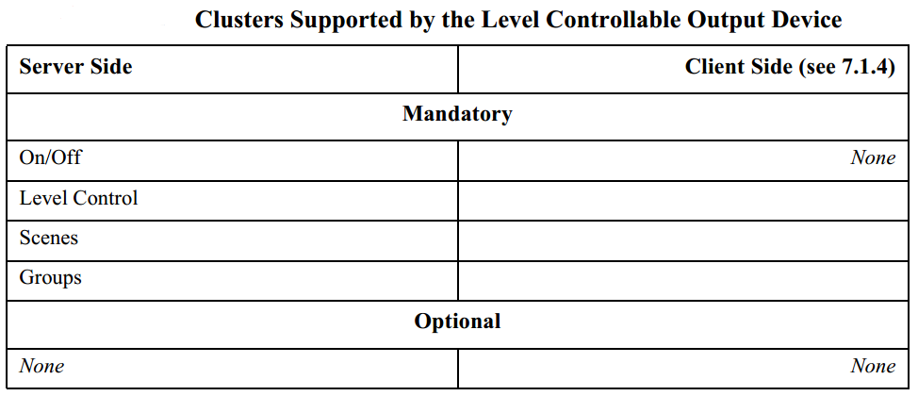

### 2.2.4 Scene Selector 场景选择

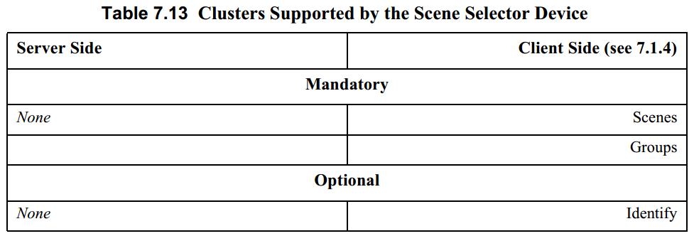

### 2.2.5 Mains Power Outlet 电源插座

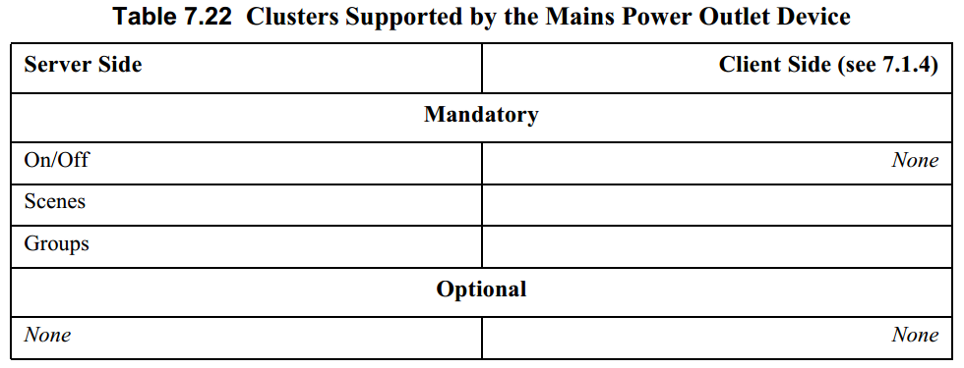

### 2.2.6 Door Lock 门锁

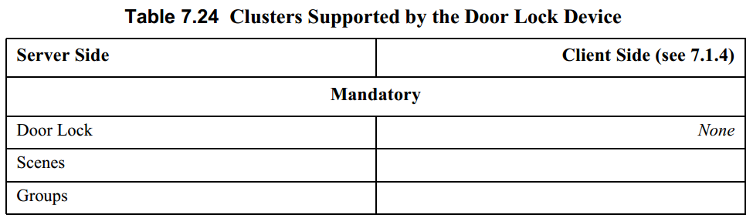

### 2.2.7 Simple Sensor 传感器

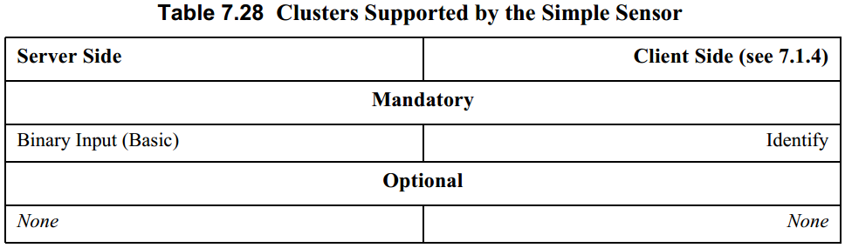

### 2.2.8 Smart Plug 智能插座

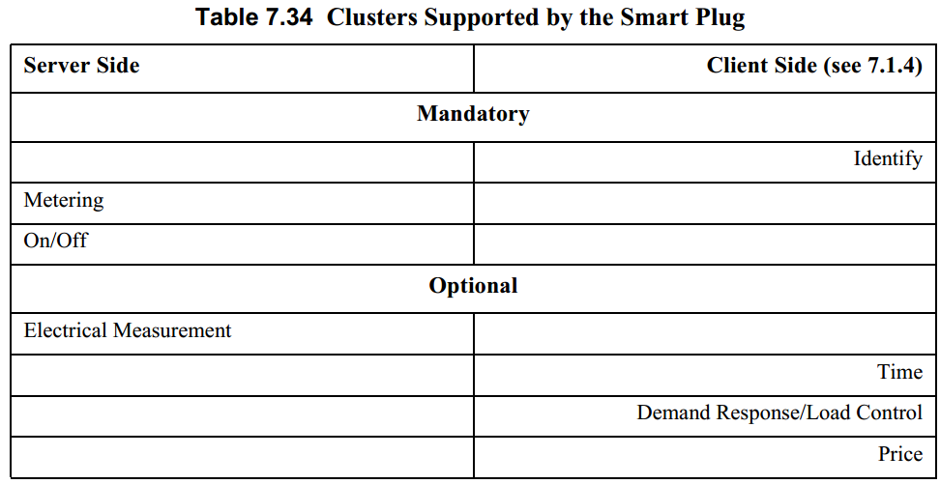

## 2.3照明设备

|  |  |
| --- | --- |
| **Device** | **Device ID** |
| On/Off Light | 0x0100 |
| Dimmable Light | 0x0101 |
| Color Dimmable Light | 0x0102 |
| On/Off Light Switch | 0x0103 |
| Dimmer Switch | 0x0104 |
| Color Dimmer Switch | 0x0105 |
| Light Sensor | 0x0106 |
| Occupancy Sensor | 0x0107 |

### On/Off Light 开关灯

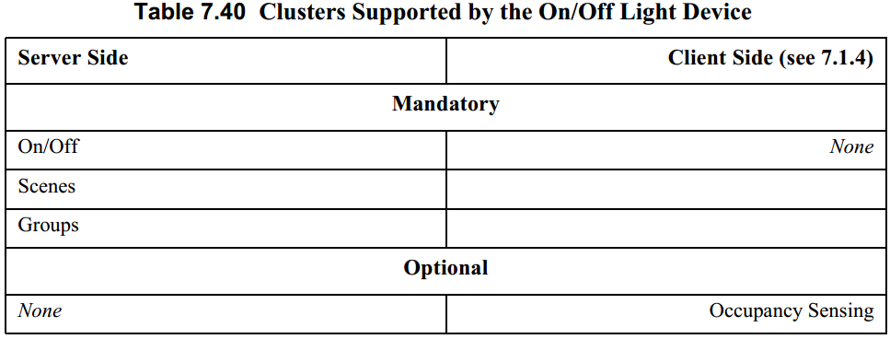

### Dimmable Light 可调光灯

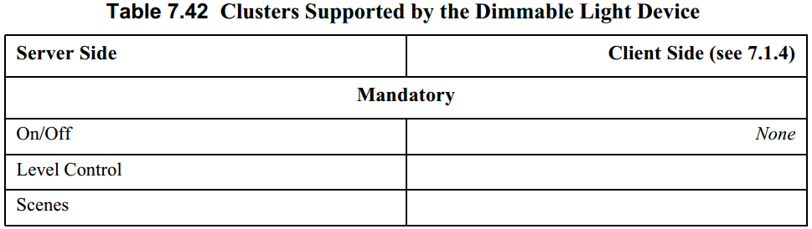

### Color Dimmable Light 可调光彩色灯

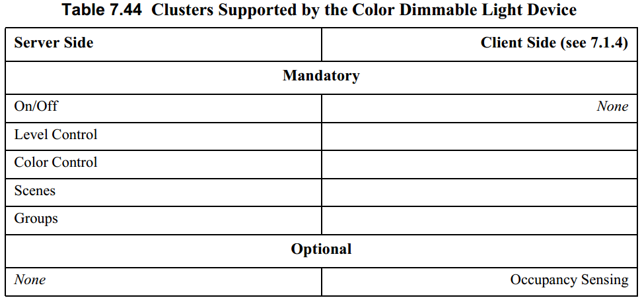

### On/Off Light Switch 灯开关

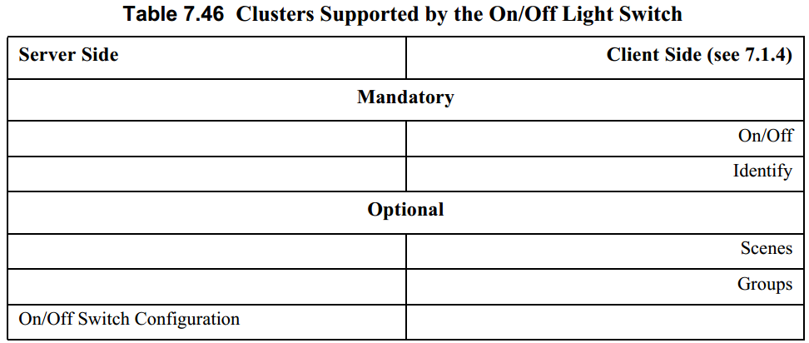

### Dimmer Switch 调光开关

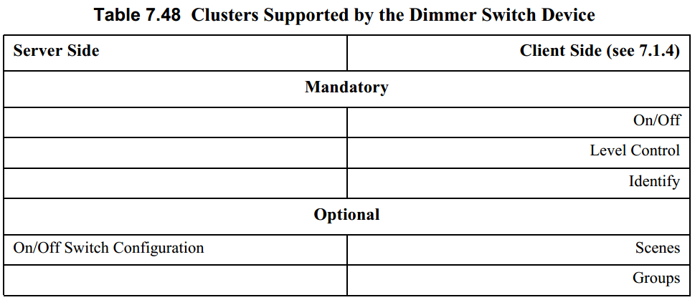

### Color Dimmer Switch 彩色调光开关

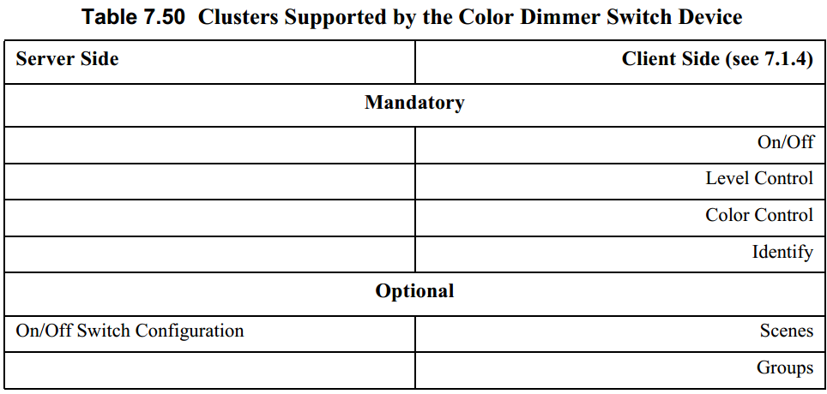

### Light Sensor 光传感器

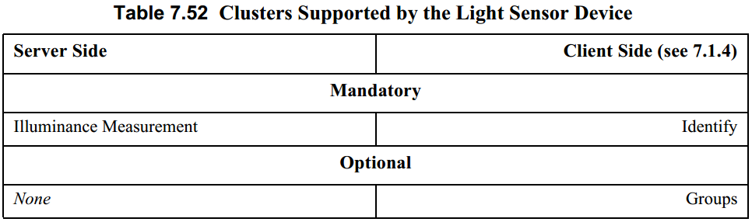

### Occupancy Sensor

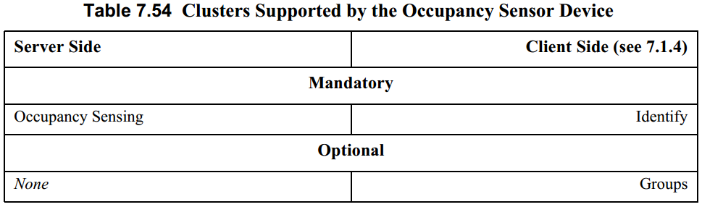

## 2.4 Closures

|  |  |
| --- | --- |
| **Device** | **Device ID** |
| Shade | 0x0200 |
| Shade Controller | 0x0201 |
| Window Covering Device | 0x0202 |
| Window Covering Controller | 0x0203 |

### Shade 窗帘

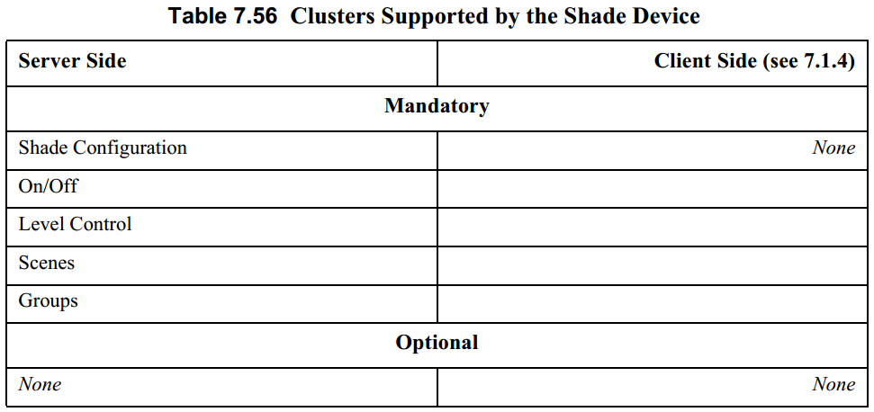

### Shade Controller 窗帘控制器

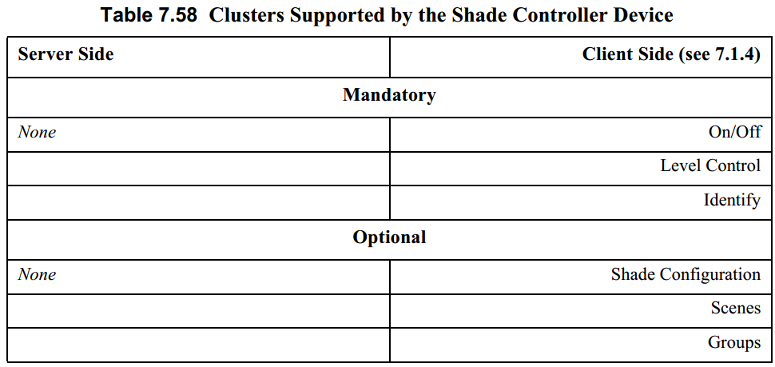

### Window Covering 窗户

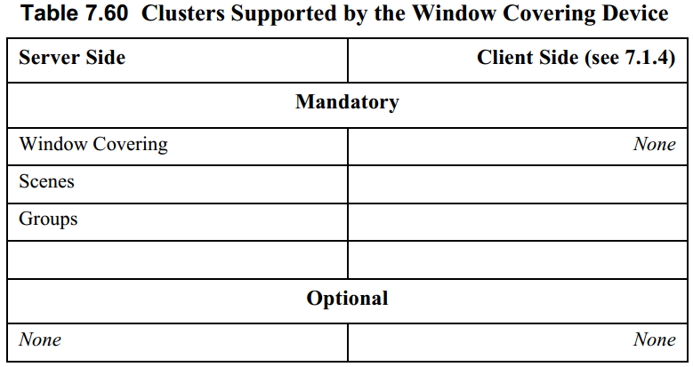

### Window Covering Controller

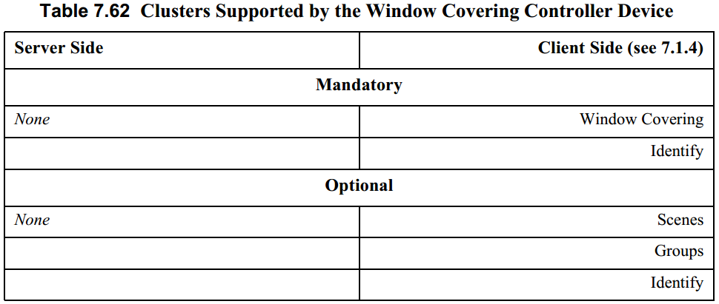

## 2.5 HVAC供热通风与空气调节设备

|  |  |
| --- | --- |
| **Device** | **Device ID** |
| Heating/Cooling Unit | 0x0300 |
| Thermostat | 0x0301 |
| Temperature Sensor | 0x0302 |
| Pump | 0x0303 |
| Pump Controller | 0x0304 |
| Pressure Sensor | 0x0305 |
| Flow Sensor | 0x0306 |
| Mini Split AC | 0x0307 |

### Temperature Sensor 温度传感器

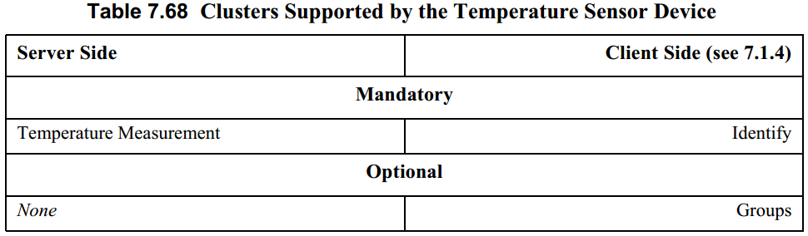

## 2.6 Intruder Alarm Systems入侵报警系统设备

|  |  |
| --- | --- |
| **Device** | **Device ID** |
| IAS Control and Indicating Equipment | 0x0400 |
| IAS Ancillary Control Equipment | 0x0401 |
| IAS Zone | 0x0402 |
| IAS Warning Device | 0x0403 |

### 控制和指示设备IAS Control and Indicating Equipment(CIE)

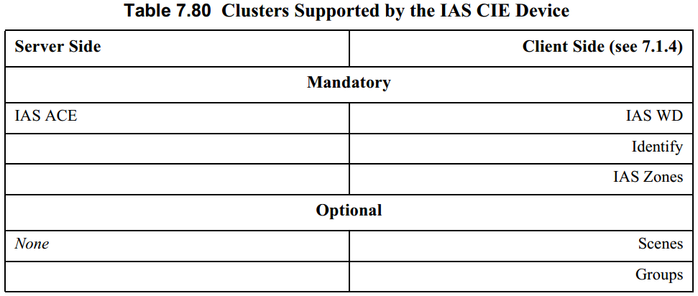

### 辅助控制设备IAS Ancillary Control Equipment (ACE)

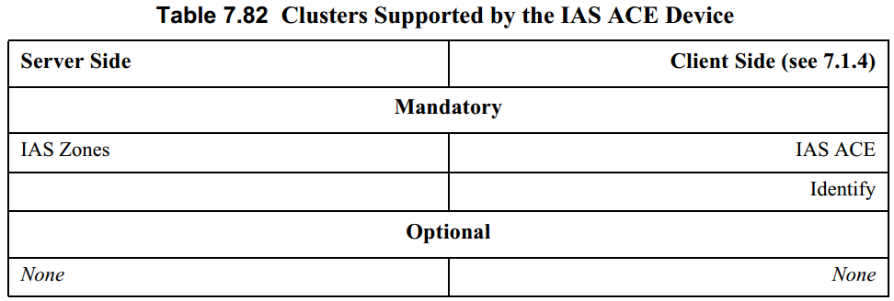

### 联防设备IAS Zone

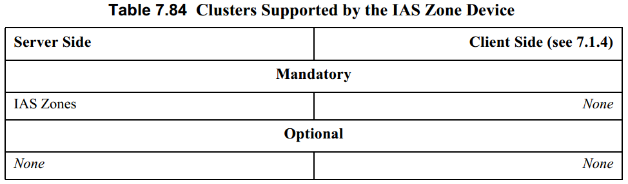

### 报警设备IAS Warning Device (WD)

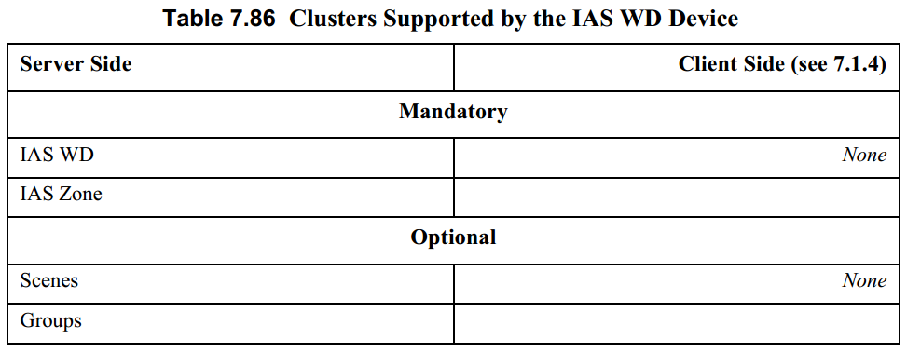

# 簇规范

簇分Server端与client端，会分别介绍。当client端无业务相关内容时不进行描述。

## 3.1 General 通用

通用簇列表

|  |  |  |  |  |  |  |  |  |
| --- | --- | --- | --- | --- | --- | --- | --- | --- |
| **ID** | | **Cluster Name** | | | **Description** | | | |
| 0x0000 | | Basic | | | Attributes for determining basic information about a device, setting user device information such as description of location, and enabling a device. | | | |
| 0x0001 | | Power Configura tion | | | Attributes for determining more detailed information about a device’s power source(s), and for configuring under/over voltage alarms. | | | |
| 0x0002 | | Device Temperature configuration | | | Attributes for determining information about a device’s internal tem perature, and for configuring under/over temperature alarms. | | | |
| 0x0003 | | Identify | | | Attributes and commands for putting a device into Identification mode(e.g., flashing a light) | | | |
| 0x0004 | | Groups | | | Attributes and commands for allocating a device to one or more of a number of groups of devices, where each group is addressable by a group address. | | | |
| 0x0005 | | Scenes | | | Attributes and commands for setting up and recalling a number of scenes for a device. Each scene corresponds to a set of stored values of specified device attributes. | | | |
| 0x0006 | | On/Off | Attributes and commands for switching devices between ‘On’ and ‘Off’ states. | | |
| 0x0007 | | On/Off Switch Configuration | Attributes and commands for configuring on/off switching devices | | |
| 0x0008 | | Level Control | Attributes and commands for controlling a characteristic of devices that can beset to a level between fully ‘On’ and fully ‘Off’. | | |
| 0x0009 | | Alarms | Attributes and commands for sending alarm notifications and configuring alarm functionality. | | | | | |
| 0x000a | | Time | Attributes and commands that provide an interface to a real-time clock. | |
| 0x000b | | RSSI Location | Attributes and commands for exchanging location information and channel parameters among devices, and (optionally) reporting data to a centralized device that collects data from devices in the network and calcu lates their positions from the set of collected data. | | | |
| 0x0b05 | | Diagnostics | Attributes and commands that provide an interface to diagnostics of the ZigBee stack | | | |
| 0x0020 | | Poll Control | Attributes and commands that provide an interface to control the polling of sleeping end device | | | |
| 0x001a | | Power Profile | Attributes and commands that provide an interface to the power profile of a device | | | |
| 0x0b01 | | Meter Identification | Attributes and commands that provide an interface to meter identification | | | |

灰色表示目前不使用或与业务无关的簇，不进行详细描述。

### 3.1.1 basic 基本

每个端点都必须实现该簇的server端。

#### Server

##### 属性：

**Attributes of the Basic Cluster**

|  |  |  |  |  |  |  |  |  |
| --- | --- | --- | --- | --- | --- | --- | --- | --- |
| **Identi fier** | **Name** | **Type Data** | | **Range** | **Access** | | **Default** | **M/O** |
| 0x0000 | *ZCLVersion ②* | uint8 | | 0x00 – 0xff | Read Only | | 0x02 | M |
| 0x0001 | *ApplicationVersion* | uint8 | | 0x00 – 0xff | Read Only | | 0x00 | O |
| 0x0002 | *StackVersion* | uint8 | | 0x00 – 0xff | Read Only | | 0x00 | O |
| 0x0003 | *HWVersion* | uint8 | | 0x00 – 0xff | Read Only | | 0x00 | O |
| 0x0004 | *ManufacturerName* | string | | 0 – 32 bytes | Read Only | | Empty string | O |
| 0x0005 | *ModelIdentifier型号* | string | | 0 – 32 bytes | Read Only | | Empty string | O |
| 0x0006 | *DateCode* | string | | 0 – 16 bytes | Read Only | | Empty string | O |
| 0x0007 | PowerSource供电类型 | | enum8 | 0x00 – 0xff | | Read Only | 0x00 | M |
| 0x0010 | *LocationDescription* | | string | 0 – 16 bytes | | Read Write | Empty string | O |
| 0x0011 | *PhysicalEnvironment* | | enum8 | 0x00 – 0xff | | Read Write | 0x00 | O |
| 0x0012 | *DeviceEnabled①* | | bool | 0x00 – 0x01 | | Read Write | 0x01 | O |
| 0x0013 | *AlarmMask* | | map8 | 000000xx | | Read Write | 0x00 | O |
| 0x0014 | *DisableLocalConfig* | | map8 | 000000xx | | Read Write | 0x00 | O |
| 0x4000 | *SWBuildID* | | string | Up to 16 bytes | | Read Only | Empty string | O |

1. *DeviceEnabled为false时，设备将不接受或发送任何除读写命令以外的应用层命令。*
2. *ZCLVersion 使用zigbee3.0的zcl版本为2，旧版本为1*

##### 命令：

**Received Command IDs for the Basic Cluster**

|  |  |  |  |
| --- | --- | --- | --- |
| **Command Identifier** | **Description** | **M/O** | **功能及参数** |
| 0x00 | Reset to Factory Defaults | O | 恢复出厂 |

### 3.1.2 Power Configuration电源配置

电源配置信息，设置信息。

#### Server

**属性**：

**Mains Information Attribute Set**

**Attributes of the Mains Information Attribute Set**

|  |  |  |  |  |  |  |
| --- | --- | --- | --- | --- | --- | --- |
| **Identifier** | **Name** | **Type** | **Range** | **Access** | **Default** | **M/O** |
| 0x0000 | *MainsVoltage电压* | uint16 | 0x0000 – 0xffff | Read Only | - | O |
| 0x0001 | *MainsFrequency频率* | uint8 | 0x00 – 0xff | Read Only | - | O |

**Mains Settings Attribute Set**  
 **Attributes of the Mains Settings Attribute Set**

|  |  |  |  |  |  |  |
| --- | --- | --- | --- | --- | --- | --- |
| **Identifier** | **Name** | **Type** | **Range** | **Access** | **Default** | **M/O** |
| 0x0010 | *MainsAlarmMask 报警设置* | map8 | 0b0000 00xx | Read Write | 0b0000 0000 | O |
| 0x0011 | *MainsVoltageMinThreshold报警阀值* | uint16 | 0x0000 – 0xffff | Read Write | 0x0000 | O |
| 0x0012 | *MainsVoltageMaxThreshold* | uint16 | 0x0000 – 0xffff | Read Write | 0xffff | O |
| 0x0013 | *MainsVoltageDwellTripPoint* | uint16 | 0x0000 – 0xffff | Read Write | 0x0000 | O |

**Battery Information Attribute Set**  
 **Attributes of the Battery Information Attribute Set**

|  |  |  |  |  |  |  |
| --- | --- | --- | --- | --- | --- | --- |
| **Identifier** | **Name** | **Type** | **Range** | **Access** | **Default** | **M/O** |
| 0x0020 | *BatteryVoltage* | uint8 | 0x00 – 0xff | Read Only | - | O |
| 0x0021 | *BatteryPercentageRemaining剩余电量0.5%精度* | uint8 | 0x00 – 0xff | Read Only Reportable | 0 | O |

**Battery Settings Attribute Set  
 Attributes of the Battery Settings Attribute Set**

|  |  |  |  |  |  |  |
| --- | --- | --- | --- | --- | --- | --- |
| **Id** | **Name** | **Type** | **Range** | **Access** | **Default** | **M/O** |
| 0x0030 | *BatteryManufacturer* | string | 0 – 16 bytes | Read Write | Empty string | O |
| 0x0031 | *BatterySize* | enum8 | 0x00 – 0xff | Read Write | 0xff | O |
| 0x0032 | *BatteryAHrRating* | uint16 | 0x0000 – 0xffff | Read Write | - | O |
| 0x0033 | *BatteryQuantity* | uint8 | 0x00 – 0xff | Read Write | - | O |
| 0x0034 | *BatteryRatedVoltage* | uint8 | 0x00 – 0xff | Read Write | - | O |
| 0x0035 | *BatteryAlarmMask 报警设置* | map8 | 0b0000 000x | Read Write | 0b0000 0000 | O |
| 0x0036 | *BatteryVoltageMinThreshold* | uint8 | 0x00 – 0xff | Read Write | 0x0000 | O |
| 0x0037 | *BatteryVoltageThreshold1* | uint8 | 0x00 – 0xff | Read*Write | 0x00 | O |
| 0x0038 | *BatteryVoltageThreshold2* | uint8 | 0x00 – 0xff | Read*Write | 0x00 | O |
| 0x0039 | *BatteryVoltageThreshold3* | uint8 | 0x00 – 0xff | Read*Write | 0x00 | O |
| 0x003a | *BatteryPercentageMinThreshold* | uint8 | 0x00 – 0xff | Read*Write | 0x00 | O |
| 0x003b | *BatteryPercentageThreshold1* | uint8 | 0x00 – 0xff | Read*Write | 0x00 | O |
| 0x003c | *BatteryPercentageThreshold2* | uint8 | 0x00 – 0xff | Read*Write | 0x00 | O |
| 0x003d | *BatteryPercentageThreshold3* | uint8 | 0x00 – 0xff | Read*Write | 0x00 | O |
| 0x003e | *BatteryAlarmState* | map32 | 0x00…x | Read | 0x000…0 | O |

### 3.1.4 Identify 识别

用于识别某个设备，可让某个设备处于识别状态（如led闪烁）便于找出特定的设备。

#### Server

##### 属性：

**Attributes of the Identify Server Cluster**

|  |  |  |  |  |  |  |
| --- | --- | --- | --- | --- | --- | --- |
| **Identifier** | **Name** | **Type** | **Range** | **Access** | **Default** | **M/O** |
| 0x0000 | *IdentifyTime 识别剩余时间* | uint16 | 0x0000 – 0xffff | Read Write | 0x0000 | M |

##### 命令：

**Received Command IDs for the Identify Cluster**

|  |  |  |  |
| --- | --- | --- | --- |
| **Command Identifier** | **Description** | **M/O** | **功能参数** |
| 0x00 | Identify | M | 让设备处于识别状态（如闪灯）  IdentifyTime=uint16  返参：无① |
| 0x01 | Identify Query | M |  |
| 0x40 | Trigger effect | O | 增强识别效果  Effect identifier=enum，详见表后 |

1. 注：返参为返回参数，无表示除命令执行结果status参数以外无其他参数。下同

###### Trigger effect

**参数：**

Effect identifier属性说明

**Values of the Effect Identifier Field of the Trigger Effect Command**

|  |  |  |
| --- | --- | --- |
| **Effect Identifier Field Value** | **Effect16** | **Notes** |
| 0x00 | Blink闪烁 | 如：灯开关一次 |
| 0x01 | Breathe 呼吸 | 如：开关15次 |
| 0x02 | Okay | 如：彩色灯亮绿色1秒，非彩色灯闪烁两次 |
| 0x0b | Channel change  通道改变 | 如：彩色灯亮橙色8秒，非彩色最高亮度持续0.5s后保持7.5s最低亮度 |
| 0xfe | Finish effect | 当前操作完成停止识别效果 |
| 0xff | Stop effect | 立即停止识别效果 |

### 3.1.5 Group 组

用于配置端点，指定到某个组或从某个组删除。或者查询组相关信息。

#### Server

属性：无

##### 命令：

**Received Command IDs for the Groups Cluster**

|  |  |  |  |
| --- | --- | --- | --- |
| **Command Identifier** | **Description** | **M/O** | **功能及参数** |
| 0x00 | Add group | M | 添加到组  Group ID=uint16，Group Name=string  返参:无 |
| 0x01 | View group | M | 查看组知否支持组名，  GroupID=uint16  返参：Status=enum，Group ID=uint16， Group Name=string |
| 0x02 | Get group membership  或取组成员关系 | M | 获取组组关系  Group count=uint8，Group list=Array of uint16  返参：Capacity=uint8, Group count=uint8 ,Group list=uint8，详见表后 |
| 0x03 | Remove group | M | 从组移除  Group ID=uint16，Group Name=string  返参: Status=enum，Group ID=uint16，Group Name=string |
| 0x04 | Remove all groups | M | 从所有组移除  参数：无 |
| 0x05 | Add group if identifying | M |  |

###### Get group membership

**返参：**

如果命令中参数count为0，那么实体应返回所有该实体所在的组id。

如果命令中参数list中含有一个以上是实体所在的组，那么实体应将这些匹配的组id返回。

如果命令中count不为0且list中没有一个是实体所在的组，那么返回列表为空。

### 3.1.6 Scene 场景

Zigbee中定义了场景的用法，可以添加删除查询场景信息，可以知道设备当前是否处于某个场景激活状态。场景需要和组配合使用，配置场景需要先将端点指定到某个组中。

#### Server

##### 属性：

**Scene Management Information Attribute Set**

|  |  |  |  |  |  |  |
| --- | --- | --- | --- | --- | --- | --- |
| **Id** | **Name** | **Type** | **Range** | **Access** | **Default** | **M/O** |
| 0x0000 | *SceneCount* | uint8 | 0x00 – 0xff (see 3.7.2.3.2 ) | Read Only | 0x00 | M |
| 0x0001 | *CurrentScene当前场景* | uint8 | 0x00 – 0xff (see 3.7.2.3.2) | Read Only | 0x00 | M |
| 0x0002 | *CurrentGroup当前组* | uint16 | 0x0000 – 0xfff7 | Read Only | 0x00 | M |
| 0x0003 | *SceneValid 当前场景是否有效* | bool | 0x00 – 0x01 | Read Only | 0x00 | M |
| 0x0004 | *NameSupport* | map8 | x0000000 | Read Only | - | M |
| 0x0005 | *LastConfiguredBy* | EUI64 | - | Read Only | - | O |

##### #命令：

**Received Command IDs for the Scenes Cluster**

|  |  |  |
| --- | --- | --- |
| **Command Identifier Field Value** | **Description** | **M/O** |
| 0x00 | Add Scene | M |
| 0x01 | View Scene | M |
| 0x02 | Remove Scene | M |
| 0x03 | Remove All Scenes | M |
| 0x04 | Store Scene 记录当前状态为场景 | M |
| 0x05 | Recall Scene恢复场景 | M |
| 0x06 | Get Scene Membership | M |
| 0x40 | Enhanced Add Scene | O |
| 0x41 | Enhanced View Scene | O |
| 0x42 | Copy Scene | O |

### 3.1.7 On/Off 开关

#### 3.1.7.1 Server

##### 3.1.7.1.1 属性：

**Attributes of the On/Off Server Cluster**

|  |  |  |  |  |  |  |
| --- | --- | --- | --- | --- | --- | --- |
| **Identifier** | **Name** | **Type** | **Range** | **Access** | **Default** | **M/O** |
| 0x0000 | *OnOff* | bool | 0x00 – 0x01 | Read Only Reportable Scene | 0x00 | M |
| 0x4000 | *GlobalSceneControl=全局场景是否有效* | bool | 0x00 – 0x01 | Read Only | 0x01 | O |
| 0x4001 | *OnTime=开持续时间 单位0.1s* | uint16 | 0x0000 – 0xffff | Read Write | 0x0000 | O |
| 0x4002 | *OffWaitTime=关闭等待时间①* | uint16 | 0x0000 – 0xffff | Read Write | 0x0000 | O |

1. 关闭时需要保证的时间，此时间内无法开启

##### 3.1.7.1.2 命令：

**Command IDs for the On/Off Cluster**

|  |  |  |  |  |
| --- | --- | --- | --- | --- |
| **Command Identifier Field Value** | **Description** | | **M/O** | **功能及参数描述** |
| 0x00 | Off | | M |  |
| 0x01 | On | | M |  |
| 0x02 | Toggle | | M |  |
| 0x40 | Off with effect | | O | 带效果关闭  Effect=enum 详见表后  返参：无 |
| 0x41 | On with recall global scene | | O | 恢复全局场景 |
| 0x42 | | On with timed off | O | 经过‘*OnTime*’属性的时间后关闭  Accept Only When On =bool, On Time=uint16, Off Wait Time=uint16 详见表后  返参：无 |

###### 3.1.7.1.2.1 Off with effect

**参数：**

Effect字段

|  |  |  |
| --- | --- | --- |
| Effect 值 | 效果 |  |
| Fade | 0.8秒内渐灭 |  |
| Dimdown | 0.8秒降低50%，剩余在12秒内渐灭 |  |
| DimupOff | 0.5增加20%亮度，后再1秒内渐灭 |  |

###### 3.1.7.1.2.2 On with timed off

Accept Only When On：表示设备处于开时该命令才有效

on time：开状态持续时间，单位0.1s

off wait Time：关状态保持时间，单位0.1s

### 3.1.8 On/Off Switch Configuration 开关配置

#### Server

属性：

**Attributes of the Switch Information Attribute Set**

|  |  |  |  |  |  |  |
| --- | --- | --- | --- | --- | --- | --- |
| Identifier | Name | Type | Range | Access | Default | M/O |
| 0x0000 | SwitchType | enum8 | 0x00 – 0x01 | Read Only | - | M |

*Values of the SwitchType Attribute*

|  |  |  |
| --- | --- | --- |
| **Attribute Value** | **Description** | **Details** |
| 0x00 | Toggle | 两个状态切换 |
| 0x01 | Momentary | 触发式开关 |
| 0x02 | Multifunction | 多功能定带开关功能 |

**Attributes of the Switch Settings Attribute Set**

|  |  |  |  |  |  |  |
| --- | --- | --- | --- | --- | --- | --- |
| **Identifier** | **Name** | **Type** | **Range** | **Access** | **Default** | **M/O** |
| 0x0010 | *SwitchActions* | enum8 | 0x00 – 0x02 | Read Write | 0x00 | M |

*Values of the SwitchActions Attribute*

|  |  |  |
| --- | --- | --- |
| **Attribute Value** | **Command Generated When Arriving at State 2 From State 1** | **Command Generated When Arriving at State 1 From State 2** |
| 0x00 | On | Off |
| 0x01 | Off | On |
| 0x02 | Toggle | Toggle |

### 3.1.9 Level Control 等级控制

#### Server

##### 属性：

**Attributes of the Level Control Server Cluster**

|  |  |  |  |  |  |  |
| --- | --- | --- | --- | --- | --- | --- |
| **Identifier** | **Name** | **Type** | **Range** | **Access** | **Default** | **M/O** |
| 0x0000 | *CurrentLevel* | uint8 | 0x00 – 0xfe | Read Only Reportable Scene | - | M |
| 0x0001 | *RemainingTime剩余过度时间* | uint16 | 0x0000 – 0xffff | Read Only | 0x0000 | O |
| 0x0010 | *OnOffTransitionTime开关过度时间* | uint16 | 0x0000 – 0xffff | Read Write | 0x0000 | O |
| 0x0011 | *OnLevel开状态等级阀值* | uint8 | 0x01 – 0xff | Read Write | 0xff | O |
| 0x0012 | *OnTransitionTime开过度时间无则使用0x0010的值* | uint16 | 0x0000 – 0xfffe | Read Write | -- | O |
| 0x0013 | *OffTransitionTime*  *关过度时间* | uint16 | 0x0000 – 0xfffe | Read Write | -- | O |
| 0x0014 | *DefaultMoveRate* | uint16 | 0x00 – 0xFE | Read Write | -- | O |

##### 命令：

**Command IDs for the Level Control Cluster**

|  |  |  |  |
| --- | --- | --- | --- |
| **Command Identi fier Field Value** | **Description** | **M/O** | **功能及参数** |
| 0x00 | Move to Level | M | 调节等级  Level=uint8(0~255), Transition time=uint16(等级过度时间 0.1s) |
| 0x01 | Move | M | 移动  Move mode=enum(Up、Down), Rate=uint8(每秒几个等级) |
| 0x02 | Step | M | 移动一步  Step mode=enum(Up、Down), Step size=uint8，Transition time=uint16 |
| 0x03 | Stop | M | 停止移动 |
| 0x04 | Move to Level (with On/Off) | M | 该类命令对于类似调光灯调亮度会影响On/Off状态，如果是音量则不会。  参数同非with On/Off版本。 |
| 0x05 | Move (with On/Off) | M |
| 0x06 | Step (with On/Off) | M |
| 0x07 | Stop | M |  |

### 3.1.10 Alarms 报警

会根据每个簇定义报警码上报警告

#### Server

##### 属性

**Attributes of the Alarm Information Attribute Set**

|  |  |  |  |  |  |  |
| --- | --- | --- | --- | --- | --- | --- |
| **Identifier** | **Name** | **Type** | **Range** | **Access** | **Default** | **M/O** |
| 0x0000 | *AlarmCount* | uint16 | 0x00 – maximum defined in profile | Read Only | 0x00 | O |

##### 命令：

**Received Command IDs for the Alarms Cluster**

|  |  |  |  |
| --- | --- | --- | --- |
| **Command Identifier Field Value** | **Description** | **M/O** |  |
| 0x00 | Reset Alarm | M | 复位报警  Alarm code= enum(具体看簇描述)，Cluster identifier=uint16 |
| 0x01 | Reset all alarms | M | 复位所有报警 |
| 0x02 | Get Alarm | O |  |
| 0x03 | Reset alarm log | O |  |

**Generated Command IDs for the Alarms Cluster**

|  |  |  |  |
| --- | --- | --- | --- |
| **Command Identifier Field Value** | **Description** | **M/O** | **功能及描述** |
| 0x00 | Alarm | M | 报警命令  Alarm code= enum(具体看簇描述)，Cluster identifier=uint16 |

## 3.2 测量和感应MEASUREMENT AND SENSING

|  |  |  |  |
| --- | --- | --- | --- |
| 0x0400 | Illuminance Measurement | Attributes and commands for configuring the measurement of illuminance, and reporting illuminance measurements | |
| 0x0401 | Illuminance Level Sensing | Attributes and commands for configuring the sensing of illuminance levels, and reporting whether illuminance is above, below, or on target | |
| 0x0402 | Temperature Measurement | | Attributes and commands for configuring the meas urement of temperature, and reporting temperature measurements |
| 0x0403 | Pressure Measurement | | Attributes and commands for configuring the meas urement of pressure, and reporting pressure measure ments |
| 0x0404 | Flow Measurement | | Attributes and commands for configuring the meas urement of flow, and reporting flow rates |
| 0x0405 | Relative Humidity Measurement | | Attributes and commands for configuring the meas urement of relative humidity, and reporting relative humidity measurements |
| 0x0406 | Occupancy Sensing | | Attributes and commands for configuring occupancy sensing, and re porting occupancy status |
| 0x0b04 | Electrical Measurement | | Attributes and commands for measuring electrical usage |

### 3.2.1 Illuminance Measurement 亮度测量

#### Server

**Illuminance Measurement Attributes**

|  |  |  |  |  |  |  |
| --- | --- | --- | --- | --- | --- | --- |
| **Id** | **Name** | **Type** | **Range** | **Acc** | **Def** | **MO** |
| 0x0000 | *MeasuredValue测量值* | uint16 | *0x0000 to 0xffff* | R | 0x0000 | M |
| 0x0001 | *MinMeasuredValue* | uint16 | 0x0001 – 0xfffd | RP | ms | M |
| 0x0002 | *MaxMeasuredValue* | uint16 | *(MinMeasuredValue + 1)* to 0xfffe | R | ms | M |
| 0x0003 | *Tolerance* | uint16 | 0x0000 – 0x0800 | R | ms | O |
| 0x0004 | *LightSensorType* | enum8 | 0x00 – 0xff | R | 0xff | O |

### 3.2.2 Illuminance Level Sensing 亮度等级感应

#### Server

属性：

**Illuminance Level Sensing Information Attribute Set**

|  |  |  |  |  |  |  |
| --- | --- | --- | --- | --- | --- | --- |
| **Id** | **Name** | **Type** | **Range** | **Access** | **Default** | **M/O** |
| 0x0000 | *LevelStatus* | enum8 | 0x00 – 0xfe | Read Only Reportable | - | M |
| 0x0001 | *LightSensorType* | enum8 | 0x00 – 0xfe | Read Only | - | O |

**Values of the *LevelStatus* Attribute**

|  |  |
| --- | --- |
| **Attribute Value** | **Description** |
| 0x00 | Illuminance on target |
| 0x01 | Illuminance below target |
| 0x02 | Illuminance above target |

**Illuminance Level Sensing Settings Attribute Set**

|  |  |  |  |  |  |  |
| --- | --- | --- | --- | --- | --- | --- |
| **Id** | **Name** | **Type** | **Range** | **Access** | **Def** | **M/O** |
| 0x0010 | *IlluminanceTargetLevel* | uint16 | 0x0000 – 0xfffe | RW | - | M |

### 3.2.3 Temperature Measurement 温度测试

#### Server

属性：

**Temperature Measurement Information Attribute Set**

|  |  |  |  |  |  |  |
| --- | --- | --- | --- | --- | --- | --- |
| **Id** | **Name** | **Type** | **Range** | **Access** | **Def** | **M/O** |
| 0x0000 | *MeasuredValue* | int16 | *MinMeasuredValue* – *MaxMeasuredValue* | RP | 0 | M |
| 0x0001 | *MinMeasuredValue* | int16 | 0x954d – 0x7ffe | R | - | M |
| 0x0002 | *MaxMeasuredValue* | int16 | 0x954e – 0x7fff | R | - | M |
| 0x0003 | *Tolerance* | uint16 | 0x0000 – 0x0800 | RP | - | O |

MeasuredValue represents the temperature in degrees Celsius as follows:

MeasuredValue = 100 x temperature in degrees Celsius.

Where -273.15°C <= temperature <= 327.67 ºC, corresponding to a MeasuredValue in the range 0x954d to

0x7fff. The maximum resolution this format allows is 0.01 ºC

### 3.2.6 Relative Humidity Measurement 相对湿度测量

#### Server

**Attributes of the Relative Humidity Measurement Information Attribute Set**

|  |  |  |  |  |  |  |
| --- | --- | --- | --- | --- | --- | --- |
| **Id** | **Name** | **Type** | **Range** | **Acc** | **Def** | **MO** |
| 0x0000 | *MeasuredValue* | uint16 | *MinMeasuredValue* – *MaxMeasuredValue* | RP | - | M |
| 0x0001 | *MinMeasuredValue* | uint16 | 0x0000 – 0x270f | R | - | M |
| 0x0002 | *MaxMeasuredValue* | uint16 | 0x0001 – 0x2710 | R | - | M |
| 0x0003 | *Tolerance* | uint16 | 0x0000 – 0x0800 | RP | - | O |

MeasuredValue represents the relative humidity in % as follows:

MeasuredValue = 100 x Relative humidity

Where 0% <= Relative humidity <= 100%, corresponding to a MeasuredValue in the range 0 to 0x2710.

The maximum resolution this format allows is 0.01%.

### 3.2.8 Electrical Measurement 电量的测量

#### Server

属性：

##### 基本属性

**Electrical Measurement Cluster Basic Information**

|  |  |  |  |  |  |  |
| --- | --- | --- | --- | --- | --- | --- |
| **Identifier** | **Name** | **Type** | **Range** | **Access** | **Default** | **M/O** |
| 0x0000 | *MeasurementType* | map32 | 0x00000000 – 0xFFFFFFFF | R | 0x00000000 | M |

***MeasurementType* Attribute**

|  |  |
| --- | --- |
| **Bit** | **Flag Name / Description** |
| 0 | Active measurement (AC)有功测量 |
| 1 | Reactive measurement (AC)无功测量 |
| 2 | Apparent measurement (AC)视在测量 |
| 3 | Phase A measurement 三相之A相测量 |
| 4 | Phase B measurement 三相之B相测量 |
| 5 | Phase C measurement三相之C相测量 |
| 6 | DC measurement 直流测量 |
| 7 | Harmonics measurement 谐波测量 |
| 8 | Power quality measurement 电源质量测量 |

##### 直流属性

**DC Measurement Attributes**

|  |  |  |  |  |  |  |
| --- | --- | --- | --- | --- | --- | --- |
| **Id** | **Name** | **Type** | **Range** | **Access** | **Default** | **M/O** |
| 0x0100 | *DCVoltage* | int16 | -32767 – 32767 | R | 0x8000 | O |
| 0x0101 | *DCVoltageMin* | int16 | -32767 – 32767 | R | 0x8000 | O |
| 0x0102 | *DCVoltageMax* | int16 | -32767 – 32767 | R | 0x8000 | O |
| 0x0103 | *DCCurrent* | int16 | -32767 – 32767 | R | 0x8000 | O |
| 0x0104 | *DCCurrentMin* | int16 | -32767 – 32767 | R | 0x8000 | O |
| 0x0105 | *DCCurrentMax* | int16 | -32767 – 32767 | R | 0x8000 | O |
| 0x0106 | *DCPower* | int16 | -32767 – 32767 | R | 0x8000 | O |
| 0x0107 | *DCPowerMin* | int16 | -32767 – 32767 | R | 0x8000 | O |
| 0x0108 | *DCPowerMax* | int16 | -32767 – 32767 | R | 0x8000 | O |

##### 无相交流电？属性

**AC (Non-phase Specific) Measurement Attributes**

|  |  |  |  |  |  |  |
| --- | --- | --- | --- | --- | --- | --- |
| **Id** | **Name** | **Type** | **Range** | **Acc** | **Default** | **M/O** |
| 0x0300 | *ACFrequency* | uint16 | 0x0000 – 0xFFFF | R | 0xFFFF | O |
| 0x0301 | *ACFrequencyMin* | uint16 | 0x0000 – 0xFFFF | R | 0xFFFF | O |
| 0x0302 | *ACFrequencyMax* | uint16 | 0x0000 – 0xFFFF | R | 0xFFFF | O |
| 0x0303 | *NeutralCurrent 中性电流？* | uint16 | 0x0000 – 0xFFFF | R | 0xFFFF | O |
| 0x0304 | *TotalActivePower* | int32 | -8,388,607–8,388,607 | R | - | O |
| 0x0305 | *TotalReactivePower* | int32 | -8,388,607–8,388,607 | R | - | O |
| 0x0306 | *TotalApparentPower* | uint32 | 0x000000–0xFFFFFF | R | - | O |
| 0x0307 | *Measured1stHarmonicCurrent* | int16 | -32768 – 32767 | R | 0x8000 | O |
| 0x0308 | *Measured3rdHarmonicCurrent* | int16 | -32768 – 32767 | R | 0x8000 | O |
| 0x0309 | *Measured5thHarmonicCurrent* | int16 | -32768 – 32767 | R | 0x8000 | O |
| 0x030A | *Measured7thHarmonicCurrent* | int16 | -32768 – 32767 | R | 0x8000 | O |
| 0x030B | *Measured9thHarmonicCurrent* | int16 | -32768 – 32767 | R | 0x8000 | O |
| 0x030C | *Measured11thHarmonicCurrent* | int16 | -32768 – 32767 | R | 0x8000 | O |
| 0x030D | *MeasuredPhase1stHarmonicCurrent* | int16 | -32768 – 32767 | R | 0x8000 | O |
| 0x030E | *MeasuredPhase3rdHarmonicCurrent* | int16 | -32768 – 32767 | R | 0x8000 | O |
| 0x030F | *MeasuredPhase5thHarmonicCurrent* | int16 | -32768 – 32767 | R | 0x8000 | O |

##### 单相交流电属性

**AC (Single Phase or Phase A) Measurement Attributes**

|  |  |  |  |  |  |  |  |
| --- | --- | --- | --- | --- | --- | --- | --- |
| **Id** | **Name** | **Type** | **Range** | **Acc** | **Default** | **M/O** | |
| 0x0500 | Reserved | int16 | -32768 – 32767 | R | 0xFFFF | O | |
| 0x0501 | *LineCurrent* | uint16 | 0x0000 – 0xFFFF | R | 0xFFFF | O | |
| 0x0502 | *ActiveCurrent 有功电流* | int16 | -32768 – 32767 | R | 0x8000 | O | |
| 0x0503 | *ReactiveCurrent* | int16 | -32768 – 32767 | R | 0x8000 | O | |
| 0x0505 | *RMSVoltage 电压* | uint16 | 0x0000 – 0xFFFF | R | 0xFFFF | | O |
| 0x0506 | *RMSVoltageMin* | uint16 | 0x0000 – 0xFFFF | R | 0xFFFF | | O |
| 0x0507 | *RMSVoltageMax* | uint16 | 0x0000 – 0xFFFF | R | 0xFFFF | | O |
| 0x0508 | *RMSCurrent 电流方均根值* | uint16 | 0x0000 – 0xFFFF | R | 0xFFFF | | O |
| 0x0509 | *RMSCurrentMin* | uint16 | 0x0000 – 0xFFFF | R | 0xFFFF | | O |
| 0x050A | *RMSCurrentMax* | uint16 | 0x0000 – 0xFFFF | R | 0xFFFF | | O |
| 0x050B | *ActivePower 有功功率* | int16 | -32768 – 32767 | R | 0x8000 | | O |
| 0x050C | *ActivePowerMin* | int16 | -32768 – 32767 | R | 0x8000 | | O |
| 0x050D | *ActivePowerMax* | int16 | -32768 – 32767 | R | 0x8000 | | O |
| 0x050E | *ReactivePower* | int16 | -32768 – 32767 | R | 0x8000 | | O |
| 0x050F | *ApparentPower* | uint16 | 0x0000 – 0xFFFF | R | 0xFFFF | | O |
| 0x0510 | *PowerFactor 功率因素* | int8 | -100 to +100 | R | 0x00 | | O |
| 0x0511 | *AverageRMSVoltageMeasurementPeriod* | uint16 | 0x0000 – 0xFFFF | RW | 0x0000 | | O |
| 0x0512 | *AverageRMSOverVoltageCounter* | uint16 | 0x0000 – 0xFFFF | RW | 0x0000 | | O |
| 0x0513 | *AverageRMSUnderVoltageCounter* | uint16 | 0x0000 – 0xFFFF | RW | 0x0000 | | O |
| 0x0514 | *RMSExtremeOverVoltagePeriod* | uint16 | 0x0000 – 0xFFFF | RW | 0x0000 | | O |
| 0x0515 | *RMSExtremeUnderVoltagePeriod* | uint16 | 0x0000 – 0xFFFF | RW | 0x0000 | | O |
| 0x0516 | *RMSVoltageSagPeriod* | uint16 | 0x0000 – 0xFFFF | RW | 0x0000 | | O |
| 0x0517 | *RMSVoltageSwellPeriod* | uint16 | 0x0000 – 0xFFFF | RW | 0x0000 | | O |

##### 直流阀值及报警

|  |  |  |  |  |  |  |
| --- | --- | --- | --- | --- | --- | --- |
| 0x0700 | *DCOverloadAlarmsMask* | map8 | 0b0000 00xx | RW | 0b0000 0000 | O |
| 0x0701 | *DCVoltageOverload* | int16 | -32768 – 32767 | R | 0xFFFF | O |
| 0x0702 | *DCCurrentOverload* | int16 | -32768 – 32767 | R | 0xFFFF | O |

**The DC Overload Alarm Mask**

|  |  |
| --- | --- |
| **Bit** | **Description** |
| Bit0 | Voltage Overload |
| Bit1 | Current Overload |

交流阀值及报警

**AC Manufacturer Threshold Alarms Attributes**

|  |  |  |  |  |  |  |  |
| --- | --- | --- | --- | --- | --- | --- | --- |
| **Id** | | **Name** | **Type** | **Range** | **Access** | **Default** | **MO** |
| 0x0800 | | *ACAlarmsMask* | map16 | 0b0000 xxxx | RW | 0b0000 0000 | O |
| 0x0801 | | *ACVoltageOverload* | int16 | -32768 – 32767 | R | 0xFFFF | O |
| 0x0802 | | *ACCurrentOverload* | int16 | -32768 – 32767 | R | 0xFFFF | O |
| 0x0803 | | *ACActivePowerOverload* | int16 | -32768 – 32767 | R | 0xFFFF | O |
| 0x0804 | | *ACReactivePowerOverload* | int16 | -32768 – 32767 | R | 0xFFFF | O |
| 0x0805 | | *AverageRMSOverVoltage* | int16 | -32768 – 32767 | R | O |  |
| 0x0806 | | *AverageRMSUnderVoltage* | int16 | -32768 – 32767 | R | O |  |
| 0x0807 | *RMSExtremeOverVoltage* | | int16 | -32768 – 32767 | RW |  | O |
| 0x0808 | *RMSExtremeUnderVoltage* | | int16 | -32768 – 32767 | RW |  | O |
| 0x0809 | *RMSVoltageSag* | | int16 | -32768 – 32767 | RW |  | O |
| 0x080A | *RMSVoltageSwell* | | int16 | -32768 – 32767 | RW |  | O |

**The *ACAlarmsMask* Attribute**

|  |  |
| --- | --- |
| **Bit** | **Description** |
| Bit0 | Voltage Overload |
| Bit1 | Current Overload |
| Bit2 | Active Power Overload |
| Bit3 | Reactive Power Overload |
| Bit4 | Average RMS Over Voltage |
| Bit5 | Average RMS Under Voltage |
| Bit6 | RMS Extreme Over Voltage |
| Bit7 | RMS Extreme Under Voltage |
| Bit8 | RMS Voltage Sag |
| Bit9 | RMS Voltage Swell |

##### 发出命令

**Generated Command ID’s for the Electrical Measurement Server**

|  |  |  |
| --- | --- | --- |
| **Command Identifier** | **Description** | **M/O** |
| 0x00 | Get Profile Info Response Command ? | O |
| 0x01 | Get Measurement Profile Response Command ? | O |

#### Client

##### 发出命令

**Generated Command IDs for the Electrical Measurement Client**

|  |  |  |
| --- | --- | --- |
| **Command Identifier** | **Description** | **M/O** |
| 0x00 | Get Profile Info Command ? | O |
| 0x01 | Get Measurement Profile Command ? | O |

## 3.3 Lighting 照明

**Clusters Specified for the Lighting Functional Domain**

|  |  |  |
| --- | --- | --- |
| **ID** | **Cluster Name** | **Description** |
| 0x0300 | Color Control | Attributes and commands for controlling the color of a color-capable light. |
| 0x0301 | Ballast 镇流器Configuration | Attributes and commands for configuring a lighting ballast |

### Color Control 颜色控制

Zigbee规范中在色彩控制上引用了CIE xyY颜色空间的规范，xy坐标确定颜色，如下图，Y确定亮度。同时也可选支持HSV颜色空间或色温。HSV指色调/色相（H=Hue

），饱和度（S=saturation），明度/亮度（V=value）。

属性ID大于等于0x4000或命令ID大于等于0X40为zigbee3.0新增加的内容，市场上会有旧版规范设备，没实现3.0特性。

该章节内容较多，这里做个简要概括，彩色控制簇里会在色调/饱和度、色温、色彩循环、增强型色调/饱和度、xy(CIE)五种模式中支持其中一种或多种，每一种会有相关的属性和命令，xy坐标属性则不受模式影响必须实现。

。

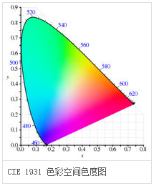

#### Server

##### 属性：

**Attributes of the Color Information Attribute Set**

|  |  |  |  |  |  |  |  |  |  |
| --- | --- | --- | --- | --- | --- | --- | --- | --- | --- |
| **Id** | **Name** | **Type** | | **Range** | | **Access** | | **Default** | **M/O** |
| 0x0000 | *CurrentHue* | uint8 | | 0x00 – 0xfe | | Read Only Reportable | | 0x00 | M0 |
| 0x0001 | *CurrentSaturation* | uint8 | | 0x00 – 0xfe | | Read Only Reportable Scene | | 0x00 | M0 |
| 0x0002 | *RemainingTime* | uint16 | | 0x0000 – 0xfffe | | Read Only | | 0x00 | O |
| 0x0003 | *CurrentX* | uint16 | | 0x0000 - 0xfeff | | Read Only Reportable Scene | | 0x616b (0.381) | M |
| 0x0004 | *CurrentY* | uint16 | | 0x0000 - 0xfeff | | Read Only Reportable  Scene | | 0x607d (0.377) | M |
| 0x0005 | *DriftCompensation* | | enum8 | | 0x00 – 0x04 | | Read Only | - | O |
| 0x0006 | *CompensationText* | | string | | 0 to 25438 chars | | Read Only | - | O |
| 0x0007 | *ColorTemperatureMireds* | | uint16 | | 0x0000 - 0xfeff | | Read Only Reportable | 0x00fa (4000K) | M4 |
| 0x0008 | *ColorMode* | | enum8 | | 0x00 – 0x02 | | Read Only | 0x01 | M |
| 0x4000 | *EnhancedCurrentHue* | | uint16 | | 0x0000 – 0xffff | | Read Only Scene | 0x0000 | M1 |
| 0x4001 | *EnhancedColorMode* | | enum8 | | 0x00 – 0xff | | Read Only | 0x00 | M |
| 0x4002 | *ColorLoopActive* | | uint8 | | 0x00 – 0xff | | Read Only Scene | 0x00 | M2 |
| 0x4003 | *ColorLoopDirection* | | uint8 | | 0x00 – 0xff | | Read Only Scene | 0x00 | M2 |
| 0x4004 | *ColorLoopTime* | | uint16 | | 0x0000 – 0xffff | | Read Only Scene | 0x0019 | M2 |
| 0x4005 | *ColorLoopStartEnhancedHue* | | uint16 | | 0x0000 – 0xffff | | Read Only | 0x2300 | M2 |
| 0x4006 | *ColorLoopStoredEnhancedHue* | | uint16 | | 0x0000 – 0xffff | | Read Only | 0x0000 | M2 |
| 0x400a | *ColorCapabilities ①* | | map16 | | 0x0000 – 0x001f | | Read Only | 0x0000 | M |
| 0x400b | *ColorTempPhysicalMinMireds* | | uint16 | | 0x0000 – 0xfeff | | Read Only | 0x0000 | M4 |
| 0x400c | *ColorTempPhysicalMaxMireds* | | uint16 | | 0x0000 – 0xfeff | | Read Only | 0xfeff | M4 |

1. *ColorCapabilities*

**Bit Values of the *ColorCapabilities* Attribute 根据该属性确定设备支持的内容**

|  |  |  |  |
| --- | --- | --- | --- |
| **Value** | **Description** | **Related Attributes** | **Mandatory Commands** |
| 0 | Hue/saturation sup ported | *CurrentHue CurrentSaturation* | *Move to hue Move hue Step hue Move to saturation Move saturation Step saturation Move to hue and saturation Stop move step* |
| 1 | Enhanced hue support ed **Note:** hue/saturation must also be supported. | *EnhancedCurrentHue* | *Enhanced move to hue Enhanced move hue Enhanced step hue Enhanced move to hue and saturation Stop move step* |
| 2 | Color loop supported **Note:** enhanced hue must also be supported. | *ColorLoopActive ColorLoopDirection ColorLoopTime ColorLoopStartEnhancedHue ColorLoopStoredEnhancedHue* | *Color loop set* |
| 3 | XY attributes supported | *CurrentX CurrentY* | *Move to color Move color Step color Stop move step* |
| 4 | Color temperature supported | *ColorTemperatureMireds ColorTempPhysicalMinMireds ColorTempPhysicalMaxMireds* | *Move to color temperature Move color temperature Step color temperature*  *Stop move step* |

***注意:*** The support of the CurrentX and CurrentY attributes is mandatory regardless of color capabilities.（CurrentX和CurrentY属性任何时候都是必须的）

##### #命令：

**Command IDs for the Color Control Cluster**

|  |  |  |  |
| --- | --- | --- | --- |
| **Command Identifier** | **Description** | **M/O** | **功能及参数描述** |
| 0x00 | Move to Hue | M0 | 设置色度  Hue=uint16（0~360），Direction=enum8，Transition Time=uint16，详见表后 |
| 0x01 | Move Hue | M0 | 调节色度  Move Mode=enum8，Rate=uint8 |
| 0x02 | Step Hue | M0 | 色度步进调节  Step Mode=enum8，Step Size=uint8，Transition Time=uint8 |
| 0x03 | Move to Saturation | M0 | 设置饱和度  Saturation=uint8, Transition Time=uint8 |
| 0x04 | Move Saturation | M0 | 调节饱和度  Move Mode=enum8，Rate=uint8 |
| 0x05 | Step Saturation | M0 | 饱和度步进调节  Step Mode=enum8，Step Size=uint8，Transition Time=uint8 |
| 0x06 | Move to Hue and Saturation | M0 | 设置色度及饱和度  Hue=uint16，Saturation=uint8，Transition Time=uint16 |
| 0x07 | Move to Color | M3 | 设置颜色  ColorX=uint16, ColorY=uint16, Transition Time=uint16 |
| 0x08 | Move Color | M3 |  |
| 0x09 | Step Color | M3 |  |
| 0x0a | Move to Color Temperature | M4 |  |
| 0x40 | Enhanced Move to Hue | M1 |  |
| 0x41 | Enhanced Move Hue | M1 |  |
| 0x42 | Enhanced Step Hue | M1 |  |
| 0x43 | Enhanced Move to Hue and Saturation | M1 |  |
| 0x44 | Color Loop Set | M2 |  |
| 0x47 | Stop Move Step | M0,1,3,4 |  |
| 0x4b | Move Color Temperature | M4 |  |
| 0x4c | Step Color Temperature | M4 |  |

M*i = ColorCapabilities 属性位i的值*

###### move to hue

**Direction 字段**

|  |  |
| --- | --- |
| **Fade Mode Value** | **Description** |
| 0x00 | Shortest最短距离 |
| 0x01 | Longest 最长距离 |
| 0x02 | Up 上 |
| 0x03 | Down 下 |

Transition Time字段

单位0.1s

###### move hue

Move Mode字段

|  |  |
| --- | --- |
| **move Mode Value** | **Description** |
| 0x00 | Stop |
| 0x01 | Up |
| 0x02 | Reserved |
| 0x03 | Down |

Rate字段

表示每秒变化的色相单位数量

###### Step Hue

**Step Mode字段**

|  |  |
| --- | --- |
| **move Mode Value** | **Description** |
| 0x00 | Stop |
| 0x01 | Up |
| 0x02 | Reserved |
| 0x03 | Down |

## 3.4 HVAC 供热通风与空气调节

**Clusters Specified in the HVAC Functional Domain**

|  |  |  |
| --- | --- | --- |
| **ID** | **Cluster Name** | **Description** |
| 0x0200 | Pump Configuration and Control | An interface for configuring and controlling pumps. |
| 0x0201 | Thermostat | An interface for configuring and controlling the function ality of a thermostat |
| 0x0202 | Fan Control | An interface for controlling a fan in a heating / cooling system |
| 0x0203 | Dehumidification Control | An interface for controlling dehumidification |
| 0x0204 | Thermostat User Interface Con figuration | An interface for configuring the user interface of a ther mostat (which MAY be remote from the thermostat) |

### Fan Control 风扇控制

#### Server

**属性**

**Attributes of the Fan Control Cluster**

|  |  |  |  |  |  |  |
| --- | --- | --- | --- | --- | --- | --- |
| **Identifier** | **Name** | **Type** | **Range** | **Access** | **Default** | **M/O** |
| 0x0000 | *FanMode* | enum8 | 0x00 – 0x06 | RW | 0x05 (auto) | M |
| 0x0001 | *FanModeSequence* | enum8 | 0x00 – 0x04 | RW | 0x02 | M |

***FanMode* Attribute Values**

|  |  |
| --- | --- |
| **Value** | **Description** |
| 0x00 | Off |
| 0x01 | Low |
| 0x02 | Medium |
| 0x03 | High |
| 0x04 | On |
| 0x05 | Auto (the fan speed is self-regulated) |
| 0x06 | Smart (when the heated/cooled space is occupied, the fan is always on) |

## 3.5 Closures

**Clusters Specified in the Closures Functional Domain**

|  |  |  |
| --- | --- | --- |
| **Cluster ID** | **Cluster Name** | **Description** |
| 0x0100 | Shade Configuration窗帘配置 | Attributes and commands for configuring a shade |
| 0x0101 | Door Lock | An interface to a generic way to secure a door |
| 0x0102 | Window Covering  窗户 | Commands and attributes for controlling a window covering |

### 3.5.1 Shade Configuration 窗帘配置

Server

属性

**Attributes of the Shade Information Attribute Set**

|  |  |  |  |  |  |  |
| --- | --- | --- | --- | --- | --- | --- |
| **Id** | **Name** | **Type** | **Range** | **Access** | **Default** | **M/O** |
| 0x0000 | *PhysicalClosedLimit* | uint16 | 0x0001 – 0xfffe | Read Only | - | O |
| 0x0001 | *MotorStepSize* | uint8 | 0x00 – 0xfe | Read Only | - | O |
| 0x0002 | *Status* | map8 | 0b0000 xxxx | Read/Write | 0b0000 0000 | M |

**Bit Values for the *Status* Attribute**

|  |  |  |
| --- | --- | --- |
| **Bit Number** | **Meaning** | **Access** |
| 0 | Shade operational 0 = no 1 = yes | Read Only |
| 1 | Shade adjusting 0 = no 1 = yes | Read Only |
| 2 | Shade direction  0 = closing 1 = opening | Read Only |
| 3 | Direction corresponding to forward direction of motor 0 = closing 1 = opening 电机方向配置 | Read/Write |

**Attributes of the Shade Settings Attribute Set**

|  |  |  |  |  |  |  |
| --- | --- | --- | --- | --- | --- | --- |
| **Id** | **Name** | **Type** | **Range** | **Access** | **Default** | **M/O** |
| 0x0010 | ***ClosedLimit*** | uint16 | 0x0001 – 0xfffe | Read/Write | 0x0001 | M |
| 0x0011 | ***Mode*** | enum8 | 0x00 – 0xfe | Read/Write | 0x00 | M |

**Values of the** Mode **Attribute**

|  |  |
| --- | --- |
| **Attribute Value** | **Meaning** |
| 0x00 | Normal |
| 0x01 | Configure |

colosedlimit 表示关闭时的极限位置，用电机步数表示，打开的位置为0。

当mode设置为configure模式时、窗帘处于正开状态，不管窗帘已停止还是已经到达它的物理极限，当前的位置即为电机测量系统的零点位置。

当mode设置为configure模式时，窗帘处于正关状态，不管窗帘已停止还是已经到达它的物理极限，

colosedlimit就设置为当前位置相对零点位置的量。

### 3.5.2 DoorLock 门锁

目前门锁多是传统智能锁提供锁与智能家居厂商提供的模块进行结合，锁厂方提供的锁功能基本都固定，基本与ZCL定义的锁功能无法契合，通常只有的开关锁和事件上报能与标准结合，其他的功能需要扩展。

门锁标准内容比较多，部分细节没提到的可以查阅《ZCL6》的7.3节。

#### Sever

##### 属性：

##### 基本信息Basic Information Attribute Set

**Current Information Attribute Set**

|  |  |  |  |  |  |
| --- | --- | --- | --- | --- | --- |
| **Identifier** | **Name** | **Type** | **Access** | **Def** | **M/O** |
| 0x0000 | ***LockState*** | enum8 | Read Only Reportable | - | M |
| 0x0001 | ***LockType*** | enum8 | Read Only | - | M |
| 0x0002 | ***ActuatorEnabled*** | bool | Read Only | - | M |
| 0x0003 | ***DoorState*** | enum8 | Read Only Reportable | - | O |
| 0x0004 | ***DoorOpenEvents*** | uint32 | Read/Write | - | O |
| 0x0005 | ***DoorClosedEvents*** | uint32 | Read/Write | - | O |
| 0x006 | ***OpenPeriod*** | uint16 | Read/Write | - | O |

##### 密码、计划等等User, PIN, Schedule, Log Information Attribute Set

**User, PIN, Schedule, Log Information Attribute Set**

|  |  |  |  |  |  |
| --- | --- | --- | --- | --- | --- |
| **Id** | **Description** | **Type** | **Access** | **Def** | **M/O** |
| 0x0010 | *NumberOfLogRecordsSupported*  *本地日志通常用于本地查询* | uint16 | Read Only | 0 | O |
| 0x0011 | *NumberOfTotalUsersSupported* | uint16 | Read Only | 0 | O |
| 0x0012 | *NumberOfPINUsersSupported* | uint16 | Read Only | 0 | O |
| 0x0013 | *NumberOfRFIDUsersSupported* | uint16 | Read Only | 0 | O |
| 0x0014 | *NumberOfWeekDaySchedulesSupportedPerUser* *每用户支持的周计划数量* | uint8 | Read Only | 0 | O |
| 0x0015 | *NumberOfYearDaySchedulesSupportedPerUser每用户支持的年计划数量* | uint8 | Read Only | 0 | O |
| 0x0016 | *NumberOfHolidaySchedulesSupported*  *假日调度支持数量* | uint8 | Read Only | 0 | O |
| 0x0017 | *MaxPINCodeLength* | uint8 | Read Only | 0x08 | O |
| 0x0018 | *MinPINCodeLength* | uint8 | Read Only | 0x04 | O |
| 0x0019 | *MaxRFIDCodeLength* | uint8 | Read Only | 0x14 | O |
| 0x001A | *MinRFIDCodeLength* | uint8 | Read Only | 0x08 | O |

##### 操作设置Operational Settings Attribute Set

**Operational Settings Attribute Set**

|  |  |  |  |  |  |
| --- | --- | --- | --- | --- | --- |
| **Id** | **Description** | **Type** | **Access** | **Def** | **M/O** |
| 0x0020 | *EnableLogging* | bool | Read*Write Reportable | 0 | O |
| 0x0021 | *Language* | string (3bytes) | Read*Write Reportable | 0 | O |
| 0x0022 | *LEDSettings* | uint8 | Read*Write Reportable | 0 | O |
| 0x0023 | *AutoRelockTime* | uint32 | Read*Write Reportable | 0 | O |
| 0x0024 | *SoundVolume* | uint8 | Read*Write Reportable | 0 | O |
| 0x0025 | *OperatingMode* | enum8 | Read*Write Reportable | 0 | O |
| 0x0026 | *SupportedOperatingModes* | map16 | Read Only | 0x0001 | O |
| 0x0027 | *DefaultConfigurationRegister* | map16 | Read Only Reportable | 0x0000 | O |
| 0x0028 | *EnableLocalProgramming*  *本地设置使能* | bool | Read*Write Reportable | 0x01 | O |
| 0x0029 | *EnableOneTouchLocking* | bool | Read/Write Reportable | 0 | O |
| 0x002A | *EnableInsideStatusLED* | bool | Read/Write Reportable | 0 | O |
| 0x002B | *EnablePrivacyModeButton* | bool | Read/Write Reportable | 0 | O |

***DefaultConfigurationRegister* Attribute**

|  |  |
| --- | --- |
| **Bitmap Number** | **Description** |
| 0 | 0 - Enable Local Programming Attribute default value is 0 (disabled) 1 - Enable Local Programming Attribute default value is 1 (enabled) |
| 1 | 0 –Keypad Interface default access is disabled 1 - Keypad Interface default access is enabled |
| 2 | 0 - RF Interface default access is disabled 1 - RF Interface default access is enabled |
| 5 | 0 – Sound Volume attribute default value is 0 (Slight Mode) 1 – Sound Volume attribute default value is equal to something other than 0x00 |
| 6 | 0 – Auto Relock Time attribute default value = 0x00 1 – Auto Relock Time attribute default value is equal to something other than 0x00 |
| 7 | 0 – Led Settings attribute default value = 0x00 1 – Led Settings attribute default value is equal to something other than 0x00 |

##### 安全设置Security Settings Attribute Set

Security Settings Attribute Set

|  |  |  |  |  |  |
| --- | --- | --- | --- | --- | --- |
| **Id** | **Description** | **Type** | **Access** | **Def** | **M/O** |
| 0x0030 | *WrongCodeEntryLimit*  *几次错误输入会禁止输入* | uint8 | Read*Write Reportable | 0 | O |
| 0x0031 | *UserCodeTemporaryDisableTime*  *多次输入错误后禁止时间 秒* | uint8 | Read*Write Reportable | 0 | O |
| 0x0032 | *SendPINOverTheAir*  *无线数据是否包含秘密* | bool | Read*Write Reportable | 0 | O |
| 0x0033 | *RequirePINforRFOperation*  *无线操作是否要求密码* | bool | Read*Write Reportable | 0 | O |
| 0x0034 | *ZigBeeSecurityLevel* | enum8 | Read Only Reportable | 0 | O |

##### 报警设置Alarm and Event Masks Attribute Set

细节看《zcl6》7.2.3.15节。该属性集是对报警进行设置的属性。

**Alarm and Event Masks Attribute Set**

|  |  |  |  |  |  |
| --- | --- | --- | --- | --- | --- |
| **Id** | **Description** | **Type** | **Access** | **Default** | **M/O** |
| 0x0040 | *AlarmMask* | map16 | Read/Write Reportable | 0x000053 | O |
| 0x0041 | *KeypadOperationEventMask*  *操作事件* | map16 | Read/Write Reportable | 0x0000 | O |
| 0x0042 | *RFOperationEventMask* | map16 | Read/Write Reportable | 0x0000 | O |
| 0x0043 | *ManualOperationEventMask* | map16 | Read/Write Reportable | 0x0000 | O |
| 0x0044 | *RFIDOperationEventMask* | map16 | Read/Write Reportable | 0x0000 | O |
| 0x0045 | *KeypadProgrammingEventMask*  *设置事件* | map16 | Read/Write Reportable | 0x0000 | O |
| 0x0046 | *RFProgrammingEventMask* | map16 | Read/Write Reportable | 0x0000 | O |
| 0x0047 | *RFIDProgrammingEventMask* | map16 | Read/Write Reportable | 0x0000 | O |

**Alarm Code Table for** *AlarmMask*

|  |  |  |
| --- | --- | --- |
| **Alarm Code** | **Bitmap Number** | **Alarm Condition** |
| 0x00 | 0 | Deadbolt Jammed门栓堵塞 |
| 0x01 | 1 | Lock Reset to Factory Defaults 门锁恢复出厂 |
| 0x02 | 2 | Reserved |
| 0x03 | 3 | RF Module Power Cycled重新上电？ |
| 0x04 | 4 | Tamper Alarm – wrong code entry limit输入错误次数超限 |
| 0x05 | 5 | Tamper Alarm - front escutcheon removed from main  前锁眼盖被移开 |
| 0x06 | 6 | Forced Door Open under Door Locked Condition暴力开门 |

其他掩码属性见《zcl6》7.2.3.15节

##### 命令：

**Commands Received by the Server Cluster 接收：**

|  |  |  |  |
| --- | --- | --- | --- |
| **Command ID** | **Description** | **M/O** | |
| 0x00 | Lock Door | M | |
| 0x01 | Unlock Door | M | |
| 0x02 | Toggle | O | |
| 0x03 | Unlock with Timeout | | O | |
| 0x04 | Get Log Record | | O | |
| 0x05 | Set PIN Code | | O | |
| 0x06 | Get PIN Code | | O | |
| 0x07 | Clear PIN Code | | O | |
| 0x08 | Clear All PIN Codes | | O | |
| 0x09 | Set User Status | | O | |
| 0x0A | Get User Status | | O | |
| 0x0B | Set Weekday Schedule | | O | |
| 0x0C | Get Weekday Schedule | | O | |
| 0x0D | Clear Weekday Schedule | | O | |
| 0x0E | Set Year Day Schedule | | O | |
| 0x0F | Get Year Day Schedule | | O | |
| 0x10 | Clear Year Day Schedule | | O | |
| 0x11 | Set Holiday Schedule | | O | |
| 0x12 | Get Holiday Schedule | | O | |
| 0x13 | Clear Holiday Schedule | | O | |
| 0x14 | Set User Type | | O | |
| 0x15 | Get User Type | | O | |
| 0x16 | Set RFID Code | | O | |
| 0x17 | Get RFID Code | | O | |
| 0x18 | Clear RFID Code | | O | |
| 0x19 | Clear All RFID Codes | | O | |

**Commands Generated by the Server Cluster 发送：**

|  |  |  |
| --- | --- | --- |
| **Command ID** | **Description** | **M/O** |
| 0x00-0x19 | xxx Response |  |
| 0x20 | Operating Event Notification 操作事件通知 | O |
| 0x21 | Programming Event Notification 设置事件通知 | O |

**操作事件码**

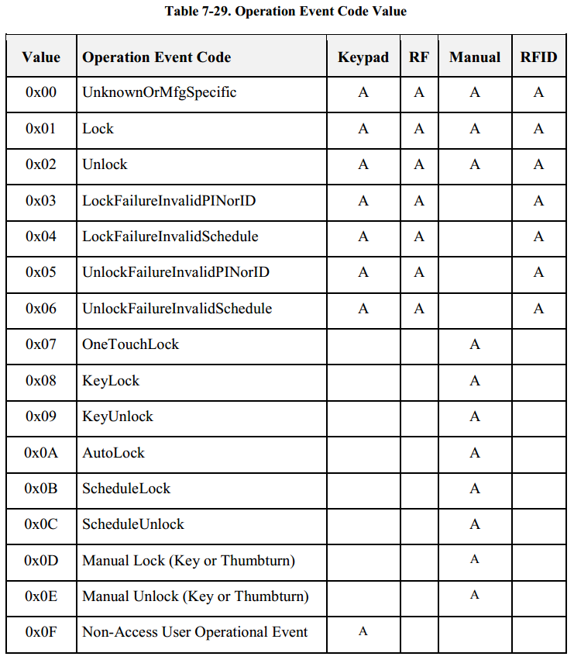

**设置事件码：**

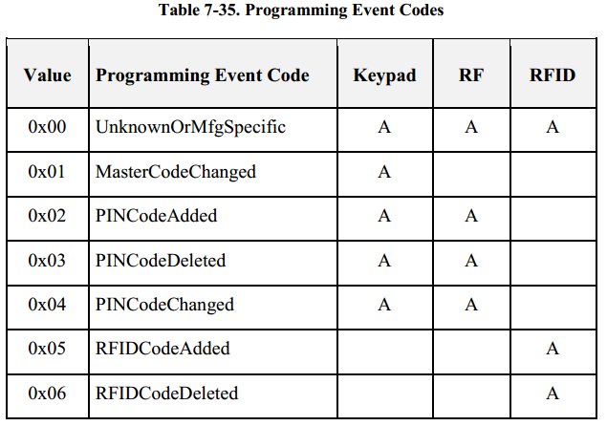

### 3.5.3 *Window Covering 窗户遮盖

#### Server

属性：

**Window Covering Information Attribute Set**

|  |  |  |  |  |  |  |  |
| --- | --- | --- | --- | --- | --- | --- | --- |
| **Id** | **Name** | **Unit** | **Type** | **Range** | **Acc** | **Default** | **M/O** |
| 0x0000 | *WindowCoveringType* | enum8 | 0x00 – 0x09 | R | 0x00 | M |  |
| 0x0001 | *PhysicalClosedLimit – Lift*  *升降式* | *cm* | uint16 | 0x0000 – 0xffff | R | 0x0000 | O |
| 0x0002 | *PhysicalClosedLimit – Tilt*  *翻转式* | *0.1°* | uint16 | 0x0000 – 0xffff | R | 0x0000 | O |
| 0x0003 | *CurrentPosition – Lift* | *cm* | uint16 | 0x0000 – 0xffff | R | 0x0000 | O |
| 0x0004 | *Current Position – Tilt* | *0.1°* | uint16 | 0x0000 – 0xffff | R | 0x0000 | O |
| 0x0005 | *Number of Actuations – Lift* |  | uint16 | 0x0000 – 0xffff | R | 0x0000 | O |
| 0x0006 | *Number of Actuations – Tilt* |  | uint16 | 0x0000 – 0xffff | R | 0x0000 | O |
| 0x0007 | *Config/Status①*  *该属性规范可能描述不正确* |  | map8 | 0b0xxx xxxx | R | 0b0000 0011 | M |
| 0x0008 | *Current Position Lift Percentage* |  | uint8 | 0-0x64 | R | 0x00 | **M\*** |
| 0x0009 | *Current Position Tilt Percentage* |  | uint8 | 0-0x64 | R | 0x00 | **M\*** |

1. *Config/Status 属性描述访问权限可能存在问题，后续确认再更新*

**Window Covering Type**

|  |  |  |
| --- | --- | --- |
| **Value** | **Window Covering Type** | **Supported Actions** |
| 0x00 | Rollershade 卷式窗户 | Lift升降式 |
| 0x01 | Rollershade - 2 Motor | Lift |
| 0x02 | Rollershade – Exterior | Lift |
| 0x03 | Rollershade - Exterior - 2 Motor | Lift |
| 0x04 | * Drapery大窗帘 | Lift |
| 0x05 | * Awning遮篷 | Lift |
| 0x06 | Shutter 百叶窗 | Tilt翻转式 |
| 0x07 | Tilt Blind - Tilt Only 升降百叶窗 | Tilt |
| 0x08 | Tilt Blind - Lift and Tilt | Lift, Tilt |
| 0x09 | Projector Screen 投影屏幕 | Lift |

## 3.6 Security and safety 隐私与安全

**Clusters of the Security and Safety Functional Domain**

|  |  |  |
| --- | --- | --- |
| **Cluster ID** | **Cluster Name** | **Description** |
| 0x500 | IAS Zone | Attributes and commands for IAS security zone devices. |
| 0x501 | IAS ACE | Attributes and commands for IAS Ancillary Control Equipment. |
| 0x502 | IAS WD | Attributes and commands for IAS Warning Devices |

### 3.6.1 IAS Zone 联防

Zone可译为联防，主设备外每个安防设备都会实现ias zone server，具体联防类型在其属性*ZoneType*中描述。

#### Server

##### 属性

**Attributes of the Zone Information Attribute Set**

|  |  |  |  |  |  |  |
| --- | --- | --- | --- | --- | --- | --- |
| **Id** | **Name** | **Type** | **Range** | **Access** | **Default** | **M/O** |
| 0x0000 | *ZoneState* | enum8 | *All* | Read Only | 0x00 | M |
| 0x0001 | *ZoneType* | enum16 | *All* | Read Only | - | M |
| 0x0002 | *ZoneStatus* | map16 | *All* | Read Only | 0x00 | M |

**Values of the *ZoneState* Attribute**

|  |  |
| --- | --- |
| **Attribute Value** | **Meaning** |
| 0x00 | Not enrolled 未登记 |
| 0x01 | Enrolled 登记后才能正常工作 |

**Values of the *ZoneType* Attribute 所有的安防类型**

|  |  |  |  |
| --- | --- | --- | --- |
| **Value** | **Zone Type** | **Alarm1** | **Alarm2** |
| 0x0000 | Standard CIE 中心设备 | System Alarm | - |
| 0x000d | Motion sensor 移动检测 | Intrusion indication | Presence indication |
| 0x0015 | Contact switch 接触开关（门窗磁） | 1st portal Open-Close | 2nd portal Open-Close |
| 0x0028 | Fire sensor 火灾感应 | Fire indication | - |
| 0x002a | Water sensor 水感应 | Water overflow indication | - |
| 0x002b | Carbon Monoxide (CO) sensor一氧化碳检测 | CO indication | Cooking indication |
| 0x002c | Personal emergency device 紧急按钮 | Fall/Concussion | Emergency button |
| 0x002d | Vibration/Movement sensor 震动移动监测 | Movement indication | Vibration |
| 0x010f | Remote Control 控制设备 | Panic | Emergency |
| 0x0115 | Key fob ？ | Panic | Emergency |
| 0x021d | Keypad 键盘 | Panic | Emergency |
| 0x0225 | Standard Warning Device(see [N1] part 4) 报警设备 | - | - |
| 0x0226 | Glass break sensor 玻璃破碎监测 | Glass breakage detected | - |
| 0x0229 | Security repeater**\* 安全中继器？** | - | - |
| 0x8000-0xfffe | manufacturer specific types | - | - |
| 0xffff | Invalid Zone Type | - | - |

**Values of the *ZoneStatus* Attribute**

|  |  |  |
| --- | --- | --- |
| **Attribute Bit Number** | **Meaning** | **Values** |
| 0 | Alarm1 | 1 – opened or alarmed 0 – closed or not alarmed |
| 1 | Alarm2 | 1 – opened or alarmed  0 – closed or not alarmed |
| 2 | Tamper 篡改？ | 1 – Tampered 0 – Not tampered |
| 3 | Battery | 1 – Low battery 0 – Battery OK |
| 4 | Supervision reports (Note 1) | 1 – Reports 0 – Does not report |
| 5 | Restore reports (Note 2) | 1 – Reports restore 0 – Does not report restore |
| 6 | Trouble | 1 – Trouble/Failure 0 – OK |
| 7 | AC (mains) | 1 – AC/Mains fault 0 – AC/Mains OK |
| 8 | Test | 1 – Sensor is in test mode 0 – Sensor is in operation mode |
| 9 | Battery Defect 电池故障 | 1 – Sensor detects a defective battery 0 – Sensor battery is functioning normally |

**Attributes of the Zone Settings Attribute Set**

|  |  |  |  |  |  |  |
| --- | --- | --- | --- | --- | --- | --- |
| **Id** | **Name** | **Type** | **Range** | **Access** | **Def** | **M/O** |
| 0x0010 | *IAS_CIE_Address* | EUI64 | - | RW | - | M |
| 0x0011 | *ZoneID* | uint8 | 0x00 – 0xFF | R | 0xFF | M |
| 0x0012 | *NumberOfZoneSensitivityLevelsSupported 传感器支持的**灵敏级别数，厂商规定* | uint8 | 0x02 – 0xff | R | 0x02 | O* |
| 0x0013 | *CurrentZoneSensitivityLevel*  *当前灵敏级别* | uint8 | 0x00 – 0xff | RW | 0x00 | O* |

命令：

**Received Command IDs for the IAS Zone Cluster**

|  |  |  |  |
| --- | --- | --- | --- |
| **Command Id** | **Description** | **M/O** |  |
| 0x00 | Zone Enroll Response | M |  |
| 0x01 | Initiate Normal Operation Mode开始普通模式 | O |  |
| 0x02 | Initiate Test Mode 开始测试模式 | O | 测试模式的行为是由厂商决定的，如发送感应命令 |

**Generated Command IDs for the IAS Zone Cluster**

|  |  |  |
| --- | --- | --- |
| **Command Identifier** | **Description** | **M/O** |
| 0x00 | Zone Status Change Notification联防传感器状态通知 | M |
| 0x01 | Zone Enroll Request | M |

### 3.6.3 IAS WD 报警

#### Server

属性：

**Attributes of the IAS WD (Server) Cluster**

|  |  |  |  |  |  |  |
| --- | --- | --- | --- | --- | --- | --- |
| **Identifier** | **Name** | **Type** | **Range** | **Access** | **Default** | **M/O** |
| 0x0000 | *MaxDuration*  *汽笛发声最长时间 秒* | uint16 | 0x0000 – 0fffe | Read/Write | 240 | M |

命令：

**Received Command IDs for the IAS WD Server Cluster**

|  |  |  |  |
| --- | --- | --- | --- |
| **Command Identifier** | **Description** | **M/O** |  |
| 0x00 | Start warning | M | 启动声音报警，可指定模式（盗窃、火灾、紧急情况、警察恐慌？、火灾恐慌？紧急恐慌？、或停止）、持续时间、是否闪灯、音量等级、闪灯占空比。亮度等级 |
| 0x01 | Squawk | M | 布防或撤防提醒，可指定是否闪灯、音量等级 |

## 3.7 Protocol interface

无

## 3.8 Smart energy 智能能源

**Smart Energy Clusters**

|  |  |  |
| --- | --- | --- |
| **Cluster ID** | **Cluster Name** | **Description** |
| 0x0700 | Price | Commands and attributes for reporting price |
| 0x0701 | Demand Response and Load Control | Commands and attributes for providing demand response and load control of devices |
| 0x0702 | Metering | Commands and attributes for reporting metering data |
| 0x0703 | Messaging | Commands and attributes for sending messages to devices |
| 0x0704 | Tunneling | Commands and attributes for establishing and using a tunnel between two devices |
| 0x0800 | Key Establishment | Commands and attributes for application level security establishment |

### Metering

用于测量电量、水量、气量、热量、制冷量、压力等。

#### Server

该簇属性较多，这里仅列出主要的几个属性，详细请参考《zcl6》10.4.2节

|  |  |  |  |  |  |  |
| --- | --- | --- | --- | --- | --- | --- |
| **Id** | **Name** | **Type** | **Range** | **Acc** | **Def** | **M/O** |
| 0x0000 | *CurrentSummationDelivered*  *当前累积交付的量* | uint48 | 0x000000000000 to 0xFFFFFFFFFFFF | R | - | M |

|  |  |  |  |  |  |  |
| --- | --- | --- | --- | --- | --- | --- |
| 0x0200 | *Status详见下表* | map8 | 0x00 to 0xFF | R | 0x00 | M |

**Mapping of the *Status* Attribute (Electricity/gas)状态**

|  |  |  |  |  |  |  |  |  |
| --- | --- | --- | --- | --- | --- | --- | --- | --- |
| **范围** | **Bit 7** | **Bit 6** | **Bit 5** | **Bit 4** | **Bit 3** | **Bit 2** | **Bit 1** | **Bit 0** |
| 电气 | Reserved | Service Disconnect Open | Leak Detect | Power Quality | Power Failure | Tamper Detect | Low Battery | Check Meter |
| 电气 |  | 与房屋失连 | 泄露 | 电源异常 | 电源中断 | 检测到篡改 | 电池低压 | 测量错误 |
| 气体 | Reverse Flow | Service Disconnect | Leak Detect | Low Pres sure | Not De fined | Tamper Detect | Low Bat tery | Check Meter | |
| 气体 | 逆流 | 与房屋失连 | 泄露 | 压力低 | - | 检测到篡改 | 电池低压 | 测量错误 | |

|  |  |  |  |  |  |  |  |  |
| --- | --- | --- | --- | --- | --- | --- | --- | --- |
| 液体 | Reverse Flow | Service Disconnect | Leak Detect | Low Pres sure | Pipe Empty | Tamper Detect | Low Battery | Check Mete |
|  | 逆流 | 与房屋失连 | 泄露 | 压力低 | 空管 | 检测到篡改 | 电池低压 | 测量错误 |

测量单位有：kWh、m³、ft³（立方英尺）、US gl（美制加仑）、IMP gl（英制加仑）、BTUs（英热量单位）、liters（公升）、KPA（千帕相对or绝对），MJ（百万焦耳）

|  |  |  |  |  |  |  |
| --- | --- | --- | --- | --- | --- | --- |
| 0x0306 | *MeteringDeviceType* | map8 | 0x00 to 0xFF | R | - | M |

***MeteringDeviceType* Attribute**

|  |  |
| --- | --- |
| **Values** | **Description** |
| 0 | Electric Metering 电量测量 |
| 1 | Gas Metering 气体 |
| 2 | Water Metering 水 |
| 3 | Thermal Metering (deprecated) |
| 4 | Pressure Metering 压力 |
| 5 | Heat Metering 热量 |
| 6 | Cooling Metering 制冷 |