**Test plan:**

A:

The home page is a public area thereby every visitor of the website can access the home page.

F:

There are two buttons in the search page to submit the search form. The first one is using user’s location information to search all parks within one km. Provided that the page cannot obtain user’s location, this button will be kept disabled. The second one is to submit the user’s location and input of searching options which include suburb, park name as well as minimum rating. When the users press the search button, a JavaScript method will firstly validate if any option has been filled by the users. If any one of the options has been filled, it will return true and leave the page to be addressed by PHP processing methods. Otherwise, it will return false and there will be a message box popping up to remind the user to input at least one searching option. When the users search existing parks from the option lists, the server side will use all submitted selections to query the database to acquire corresponding park data and display in the results page.

G:

The results data after query from database will be suspected to see if it is an empty set of data. Therefore, even though the user is trying to search a non-existing item, or no any item reach the searching requirement (for example, within one km no any parks or no any parks with rating not less than the selection), the results page will display that no result is found.

H:

An individual item can only be access after the user chooses a specific park from the results page. The access of individual item page does not require a secure check. Nevertheless, whenever the users are trying to send reviews, the server side will check if the users have logged in and within the session. Only eligible users can send reviews, or they will be direct to the login page.

N:

When there is no result found, a map without any result marker will be presented on the right side of results page centred with user’s location. On the other hand, when any results are found, there will be a map with all result markers showing the location and information of the results and with a link such that they can be click to go to a specific item page. For instance:

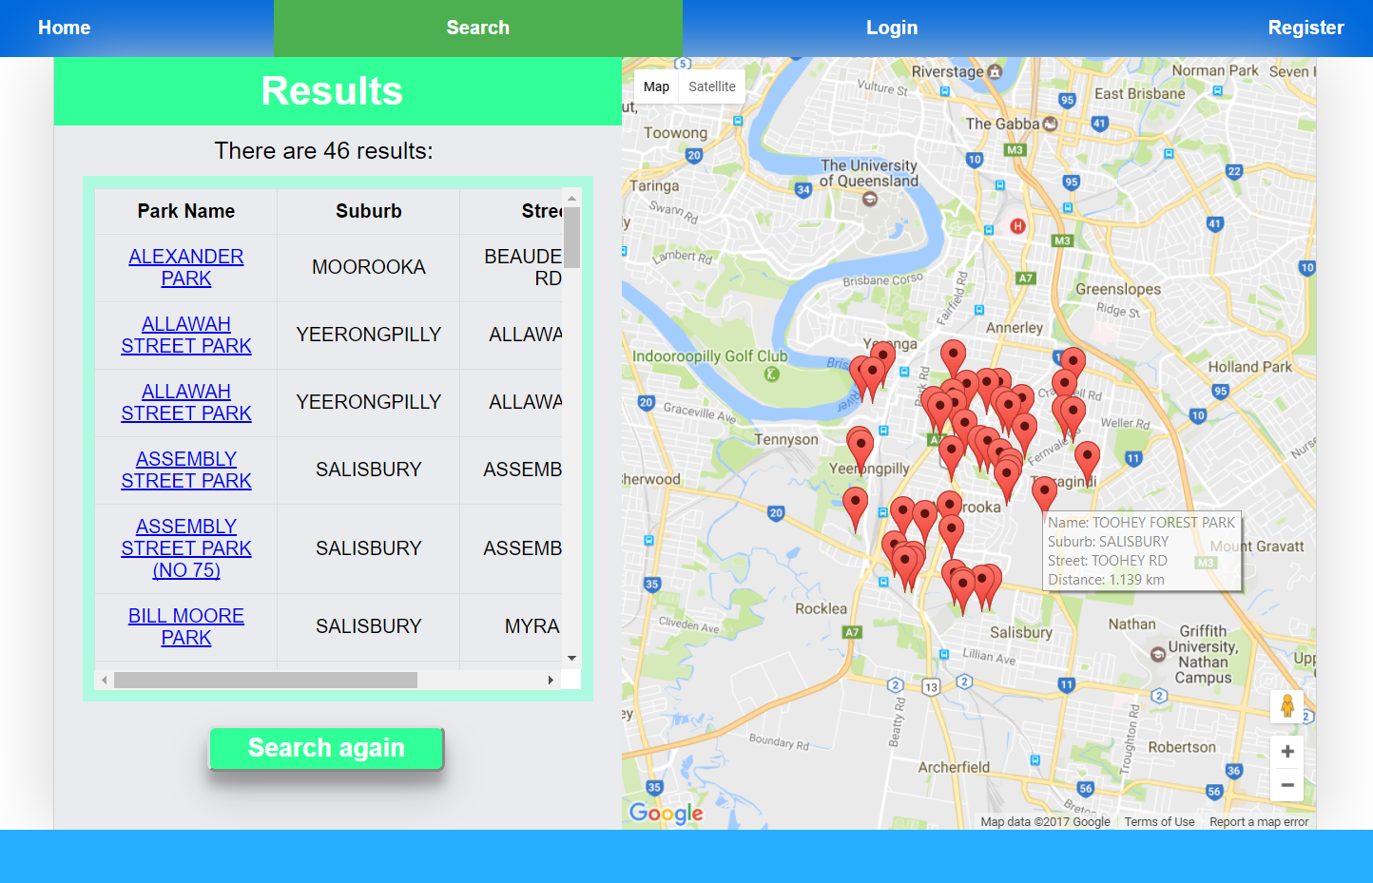

O:

In the item page, there is a small map with large zoom view showing where is the park. For example:

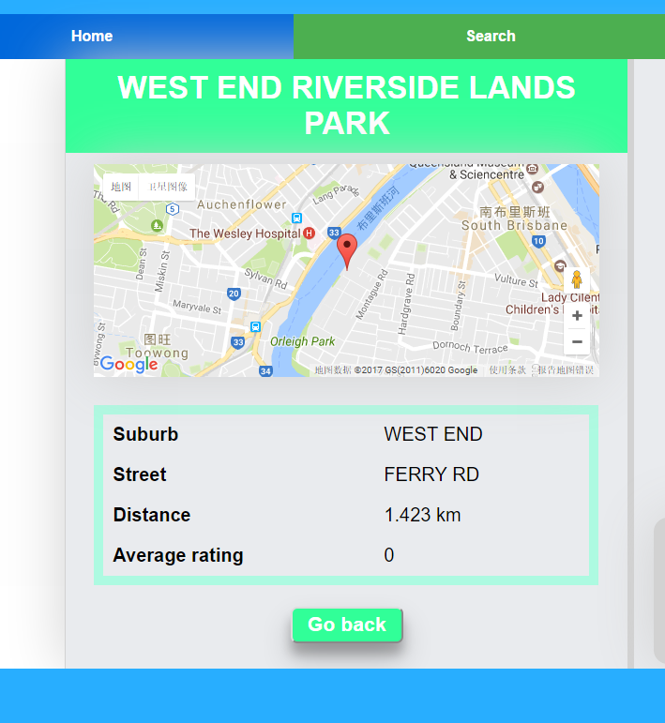

P:

Microdata such as geolocation

3.1:

Our website is used for searching park locations in Brisbane. It is designed and opened to anyone who wants to acquire information of parks in Brisbane. For those users, they mostly expect to search for some parks near their places or in a specific area so that they can go to a park to relax. Normally, they would like to obtain some basic information about the parks such as park location including suburb and street, distance to their places and previous visitors’ ratings. These kinds of information is displayed in our website, thereby they can choose which parks suit them the best and will not be confused by too much data:





As can be seen, in the results page all important information is tidily listed in a table and a map appearing by priority. Likewise, in our item page only needed information is displayed, which is succinct and useful to the users. The users can always easily find out what they need. Therefore, our page meets the Web Design Principles of User Experience.

3.3:

In terms of the page layout, our pages all consist of some clear components such a title, a menu bar with four important links only, a main content and a footer. The first page that our users will see is just a very succinct home page to welcome them and show them with two main pages – search page and login page:

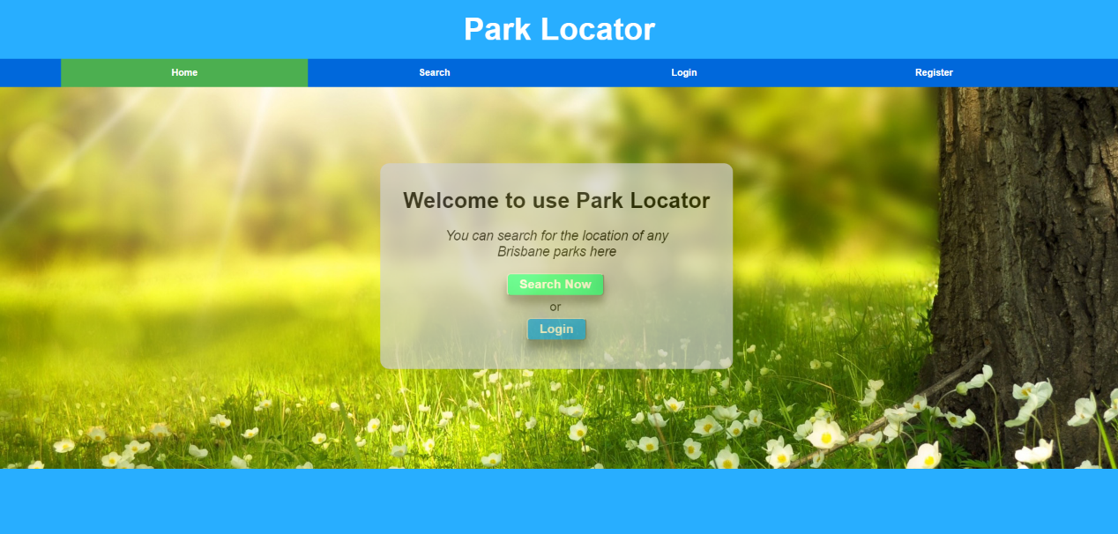

Furthermore, the main content is centred in the pages with a bit of margin space in order that the user will not the page is too large to see all content:

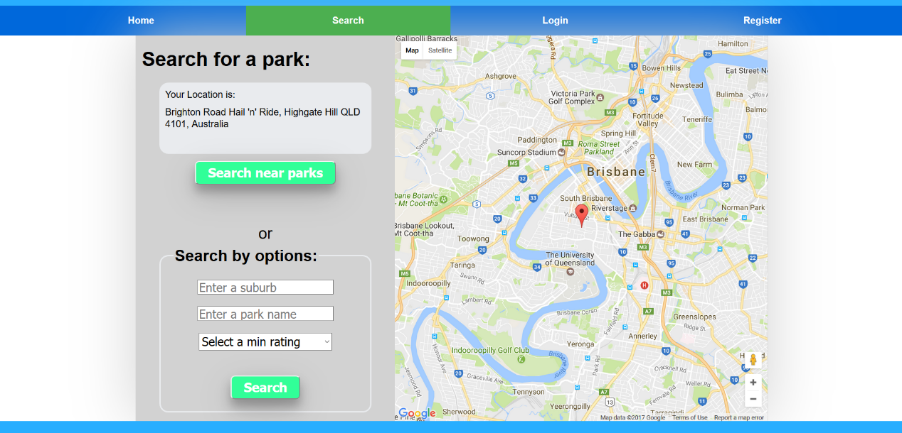

For most pages which involves map or review field, they are divided that the left side is for information and the right side is for map or reviews. Additionally, to the detailed content such as park information in the results page, it is arranged with grid layout in a table. In this case, the pages are logically clear to see:



Overall, the page layout has orderly organizations and views. Therefore, it meets the Web Design Principles of Page Layout.