**Datadog**

**Level 1**

The Datadog agent runs in the background and gathers all the metric data that is displayed in Datadog dashboards. It needs to be configured so it knows what data it needs to gather and for what applications. By default basic information such as memory and cpu utilisations are captured.

These instructions assume you have the Datadog agent installed as the Python pip (package manager).

**Hostmap**

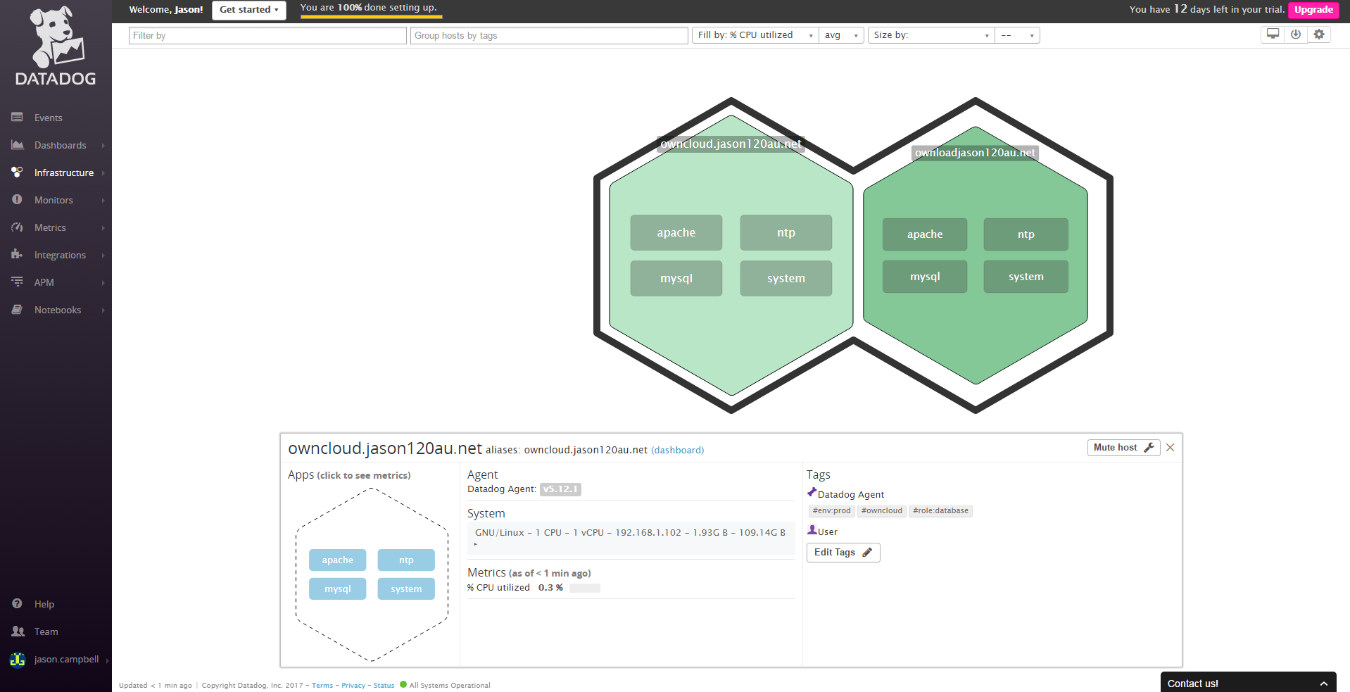

**Installing MySQL (MariaDB)**

Install MySQL if using Centos 7 by default will use MariaDB which is a fork of MySQL. Commands to install the database are as follows:

sudo yum install mariadb mariadb-server

More detailed instructions are [here](https://www.digitalocean.com/community/tutorials/how-to-install-mariadb-on-centos-7)

MariaDB may install by default to a setup which will not be setup to listen on port 3306 for client connections. To fix this open the /etc/my.cnf file comment skip-networking and restart the database(systemctl mariadb restart). This will ensure that the Datadog agent can communicate data correctly.

The next step will be to ensure that Python has the relevant libraries so the Datadog agent can communicate metric data. Installing the Python MySQL library is required by running the following command.

sudo yum install MySQL-python

Next run the following command so python MySQL libraries are configured.

pip install pymysql

Restart the Datadog agent by running the following command

/etc/init.d/datadog-agent restart

Check that the Datadog agent is gathering MySQL data correctly by running the following command.

/etc/init.d/datadog-agent info