**CHAPTER 14**

**Financial Statement Analysis**

**ASSIGNMENT CLASSIFICATION TABLE**

|  |  |  |  |  |  |  |  |  |  |  |
| --- | --- | --- | --- | --- | --- | --- | --- | --- | --- | --- |
| **Learning Objectives** |  | **Questions** |  | **Brief**  **Exercises** |  | **Do It!** |  | **Exercises** |  | **Problems** |
|  |  |  |  |  |  |  |  |  |  |  |
| 1. Discuss the need for comparative  analysis. |  | 1, 2 |  | 1 |  |  |  |  |  |  |
|  |  |  |  |  |  |  |  |  |  |  |
| 2. Identify the tools of financial statement analysis. |  | 3, 5 |  | 2 |  |  |  |  |  |  |
|  |  |  |  |  |  |  |  |  |  |  |
| 3. Explain and apply horizontal analysis. |  | 3, 4 |  | 2, 3, 5, 6, 7 |  | 1, 4 |  | 1, 3, 4 |  |  |
|  |  |  |  |  |  |  |  |  |  |  |
| 4. Describe and apply vertical analysis. |  | 3, 4 |  | 2, 4, 8 |  |  |  | 2, 3, 4 |  | 1 |
|  |  |  |  |  |  |  |  |  |  |  |
| 5. Identify and compute ratios used  in analyzing a firm’s liquidity,  profitability, and solvency. |  | 5, 6, 7, 8, 9, 10, 11,12, 13, 14, 15, 16, 17, 18, 19 |  | 2, 9, 10, 11, 12, 13 |  | 2, 4 |  | 5, 6, 7, 8, 9, 10, 11 |  | 1, 2, 3, 4, 5, 6, 7 |
|  |  |  |  |  |  |  |  |  |  |  |
| 6. Understand the concept of earning power, and how discontinued operations are presented. |  | 20, 21, 22 |  | 14, 15, 16 |  | 3, 4 |  | 12, 13 |  | 8, 9 |
|  |  |  |  |  |  |  |  |  |  |  |
| 7. Understand the concept of quality  of earnings. |  | 23 |  |  |  | 4 |  |  |  |  |

**ASSIGNMENT CHARACTERISTICS TABLE**

|  |  |  |  |  |  |  |
| --- | --- | --- | --- | --- | --- | --- |
| **Problem**  **Number** |  | **Description** |  | **Difficulty**  **Level** |  | **Time Allotted (min.)** |
|  |  |  |  |  |  |  |
| 1 |  | Prepare vertical analysis and comment on profitability. |  | Simple |  | 20–30 |
|  |  |  |  |  |  |  |
| 2 |  | Compute ratios from statement of financial position and income statement. |  | Simple |  | 20–30 |
|  |  |  |  |  |  |  |
| 3 |  | Perform ratio analysis, and evaluate financial position  and operating results. |  | Simple |  | 20–30 |
|  |  |  |  |  |  |  |
| 4 |  | Compute ratios, and comment on overall liquidity and profitability. |  | Moderate |  | 30–40 |
|  |  |  |  |  |  |  |
| 5 |  | Compute selected ratios, and compare liquidity, profitability, and solvency for two companies. |  | Moderate |  | 50–60 |
|  |  |  |  |  |  |  |
| 6 |  | Compute numerous ratios. |  | Simple |  | 30–40 |
|  |  |  |  |  |  |  |
| 7 |  | Compute missing information given a set of ratios. |  | Complex |  | 30–40 |
|  |  |  |  |  |  |  |
| 8 |  | Prepare statement of comprehensive income with discontinued operations. |  | Moderate |  | 30–40 |
|  |  |  |  |  |  |  |
| 9 |  | Prepare statement of comprehensive income with non-typical items. |  | Moderate |  | 30–40 |

**WEYGANDT FINANCIAL ACCOUNTING, IFRS EDITION, 3e**

**CHAPTER 14**

**FINANCIAL STATEMENT ANALYSIS**

|  |  |  |  |  |  |  |  |  |
| --- | --- | --- | --- | --- | --- | --- | --- | --- |
| **Number** |  | **LO** |  | **BT** |  | **Difficulty** |  | **Time (min.)** |
| BE1 |  | 1 |  | C |  | Moderate |  | 10–12 |
| BE2 |  | 2–5 |  | K, AP |  | Simple |  | 8–10 |
| BE3 |  | 3 |  | AP |  | Simple |  | 6–8 |
| BE4 |  | 4 |  | AP |  | Simple |  | 6–8 |
| BE5 |  | 3 |  | AP |  | Simple |  | 4–6 |
| BE6 |  | 3 |  | AP |  | Simple |  | 4–6 |
| BE7 |  | 3 |  | AP |  | Simple |  | 4–6 |
| BE8 |  | 4 |  | AP |  | Simple |  | 5–7 |
| BE9 |  | 5 |  | AP |  | Simple |  | 4–6 |
| BE10 |  | 5 |  | AP |  | Simple |  | 3–5 |
| BE11 |  | 5 |  | AN |  | Simple |  | 6–8 |
| BE12 |  | 5 |  | AN |  | Moderate |  | 6–8 |
| BE13 |  | 5 |  | AN |  | Moderate |  | 6–8 |
| BE14 |  | 6 |  | AP |  | Simple |  | 4–6 |
| BE15 |  | 6 |  | AP |  | Simple |  | 3–5 |
| BE16 |  | 6 |  | AP |  | Simple |  | 4–6 |
| DI1 |  | 3 |  | AP |  | Simple |  | 6–8 |
| DI2 |  | 5 |  | AP |  | Simple |  | 10–12 |
| DI3 |  | 6 |  | AP |  | Simple |  | 6–8 |
| DI4 |  | 3, 5–7 |  | C |  | Simple |  | 3–5 |
| EX1 |  | 3 |  | AP |  | Simple |  | 10–12 |
| EX2 |  | 4 |  | AP |  | Simple |  | 10–12 |
| EX3 |  | 3, 4 |  | AP |  | Simple |  | 12–15 |
| EX4 |  | 3, 4 |  | AP |  | Simple |  | 10–12 |
| EX5 |  | 5 |  | AN |  | Simple |  | 8–10 |
| EX6 |  | 5 |  | AP |  | Simple |  | 8–10 |
| EX7 |  | 5 |  | AP |  | Simple |  | 6–8 |
| EX8 |  | 5 |  | AP |  | Simple |  | 6–8 |
| EX9 |  | 5 |  | AP |  | Simple |  | 6–8 |
| EX10 |  | 5 |  | AP |  | Moderate |  | 8–10 |

**FINANCIAL STATEMENT ANALYSIS (Continued)**

|  |  |  |  |  |  |  |  |  |
| --- | --- | --- | --- | --- | --- | --- | --- | --- |
| **Number** |  | **LO** |  | **BT** |  | **Difficulty** |  | **Time (min.)** |
| EX11 |  | 5 |  | AP |  | Simple |  | 10–12 |
| EX12 |  | 6 |  | AN |  | Moderate |  | 8–10 |
| EX13 |  | 6 |  | AP |  | Simple |  | 6–8 |
| P1 |  | 4, 5 |  | AP, AN |  | Simple |  | 20–30 |
| P2 |  | 5 |  | AP |  | Simple |  | 20–30 |
| P3 |  | 5 |  | AP, AN |  | Simple |  | 20–30 |
| P4 |  | 5 |  | AP, AN |  | Moderate |  | 30–40 |
| P5 |  | 5 |  | AP, AN |  | Moderate |  | 50–60 |
| P6 |  | 5 |  | AP |  | Simple |  | 30–40 |
| P7 |  | 5 |  | AN |  | Complex |  | 30–40 |
| P8 |  | 6 |  | AP |  | Moderate |  | 30–40 |
| P9 |  | 6 |  | AP |  | Moderate |  | 30–40 |
| BYP1 |  | 5 |  | AN, E |  | Moderate |  | 20–25 |
| BYP2 |  | 3 |  | AN, E |  | Simple |  | 15–20 |
| BYP3 |  | 5 |  | C, E |  | Moderate |  | 15–20 |
| BYP4 |  | 6 |  | AP |  | Moderate |  | 20–25 |
| BYP5 |  | 5 |  | C |  | Simple |  | 15–20 |
|  |  |  |  |  |  |  |  |  |



**ANSWERS TO QUESTIONS**

**1.** (a) Kurt is not correct. There are three characteristics: liquidity, profitability, and solvency.

(b) The three parties are not primarily interested in the same characteristics of a company. Short-term creditors are primarily interested in the liquidity of the company. In contrast, long-term creditors and shareholders are primarily interested in the profitability and solvency of the company.

**2.** (a) Comparison of financial information can be made on an intracompany basis, an intercompany basis, and an industry average basis (or norms).

(1) An **intracompany basis** compares an item or financial relationship within a company in the current year with the same item or relationship in one or more prior years.

(2) The **industry averages basis** compares an item or financial relationship of a company with industry averages (or norms) published by financial rating services.

(3) An **intercompany basis** compares an item or financial relationship of one company with the same item or relationship in one or more competing companies.

(b) The **intracompany basis** of comparison is useful in detecting changes in financial relationships and significant trends within a company.

The **industry averages basis** provides information as to a company’s relative performance within the industry.

The **intercompany basis** of comparison provides insight into a company’s competitive position.

**3.** Horizontal analysis (also called trend analysis) measures the dollar and percentage increase or decrease of an item over a period of time. In this approach, the amount of the item on one statement is compared with the amount of that same item on one or more earlier statements. Vertical analysis (also called common-size analysis) expresses each item within a financial statement in terms of a percent of a base amount.

**4.** (a) €350,000 X 1.224 = €428,400, 2017 net income.

(b) €350,000 ÷ .05 = €7,000,000, 2016 revenue.

**5.** A ratio expresses the mathematical relationship between one quantity and another. The relationship is expressed in terms of either a percentage (200%), a rate (2 times), or a simple proportion (2:1). Ratios can provide clues to underlying conditions that may not be apparent from individual financial statement components. The ratio is more meaningful when compared to the same ratio in earlier periods or to competitors’ ratios or to industry ratios.

**6.** (a) Liquidity ratios: Current ratio, acid-test ratio, accounts receivable turnover, and inventory turnover.

(b) Solvency ratios: Debt to assets and times interest earned.

**7.** Gordon is correct. A single ratio by itself may not be very meaningful and is best interpreted by comparison with: (1) past ratios of the same company, (2) ratios of other companies, or (3) industry norms or predetermined standards. In addition, other ratios of the company are necessary to determine overall financial well-being.

**8.** (a) Liquidity ratios measure the short-term ability of a company to pay its maturing obligations and to meet unexpected needs for cash.

(b) Profitability ratios measure the income or operating success of a company for a given period of time.

(c) Solvency ratios measure the ability of the company to survive over a long period of time.

**Questions Chapter 14** (Continued)

**9.** The current ratio relates current assets to current liabilities. The acid-test ratio relates cash, short-term investments, and net receivables to current liabilities. The current ratio includes inventory and prepaid expenses while the acid-test ratio excludes these. The acid-test ratio provides additional information about short-term liquidity and is an important complement to the current ratio.

**10.** Monte Company does not necessarily have a problem. The accounts receivable turnover can be misleading in that some companies encourage credit and revolving charge sales and slow collections in order to earn a healthy return on the outstanding accounts receivable in the form of high rates of interest.

**11.** (a) Asset turnover.

(b) Inventory turnover.

(c) Return on ordinary shareholders’ equity.

(d) Times interest earned.

**12.** The price earnings (P/E) ratio is a reflection of investors’ assessments of a company’s future earnings. In this question, investors favor Microsoft because it has the higher P/E ratio. The investors feel that Microsoft will be able to generate even higher future earnings and so the investors are willing to pay more for the shares.

**13.** The payout ratio is cash dividends declared on ordinary shares divided by net income. In a growth company, the payout ratio is often low because the company is reinvesting earnings in the business.

**14.** (a) The increase in profit margin is good news because it means that a greater percentage of net sales is going towards income.

(b) The decrease in inventory turnover signals bad news because it is taking the company longer to sell the inventory and consequently there is a greater chance of inventory obsolescence.

(c) An increase in the current ratio signals good news because the company improved its ability to meet maturing short-term obligations.

(d) The earnings per share ratio is a deceptive ratio. The decrease might be bad news to the company because it could mean a decrease in net income. If there is an increase in shareholders’ investment (as a result of issuing additional shares) and a decrease in EPS, then this means that the additional investment is earning a lower return (as compared to the return on ordinary shareholders’ equity before the additional investment). Generally, this is undesirable.

(e) The increase in the price-earnings ratio is generally good news because it means that the market price per share has increased and investors are willing to pay that higher price for the shares. An increase in the P/E ratio is good news for investors who own the shares and don’t want to buy any more. It is bad news for investors who want to buy (or buy more of) the shares.

(f) The increase in the debt to assets ratio is bad news because it means that the company has increased its obligations to creditors and has lowered its equity “buffer.”

(g) The decrease in the times interest earned ratio is bad news because it means that the company’s ability to meet interest payments as they come due has weakened.

**Questions Chapter 14** (Continued)

|  |  |  |  |  |  |
| --- | --- | --- | --- | --- | --- |
| **15.** | Return on assets  (7.6%) | = |  | | |
|  | Return on ordinary shareholders’ equity  (12.8%) | | | = |  |

The difference between the two rates can be explained by looking at the denominator value and by remembering the basic accounting equation, A = L + E. The asset value will clearly be the larger of the two denominator values; therefore, it will also give the smaller return.

**16.** (a) The times interest earned ratio, which is an indication of the company’s ability to meet interest payments, and the debt to assets ratio, which indicates the company’s ability to withstand losses without impairing the interests of creditors.

(b) The current ratio and the acid-test ratio, which indicate a company’s liquidity and short-term debt-paying ability.

(c) The earnings per share and the return on ordinary shareholders’ equity, both of which indicate the earning power of the investment.

**17.** Earnings per share means earnings per ordinary share. Preference share dividends are subtracted from net income in computing EPS in order to obtain income available to ordinary shareholders.

**18.** (a) Trading on the equity means that the company has borrowed money at a lower rate of interest than it is able to earn by using the borrowed money. Simply stated, it is using money supplied by non-owners to increase the return to the owners.

(b) A comparison of the return on total assets with the rate of interest paid for borrowed money indicates the profitability of trading on the equity.

**19.**  = Earnings per share

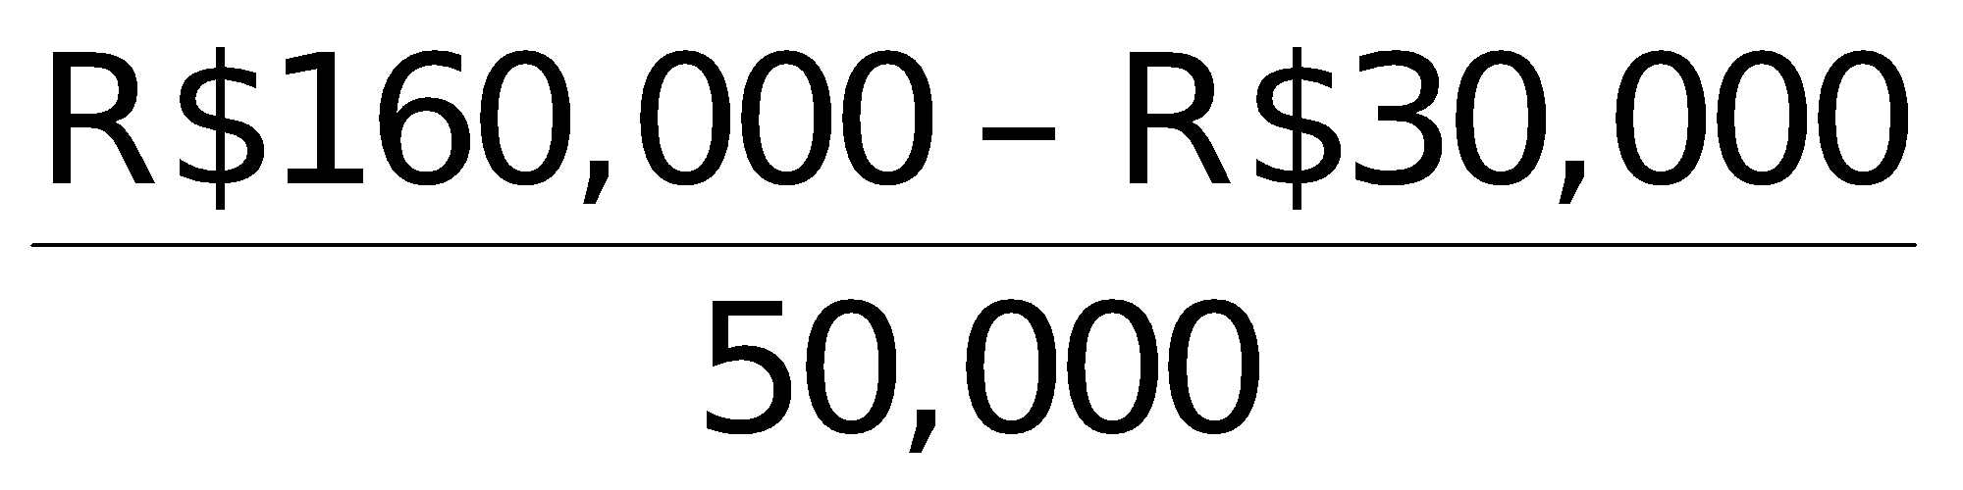 = R$2.60

EPS of R$2.60 is high relative to what? Is it high relative to last year’s EPS? The president may be comparing the EPS of R$2.60 to the market price of the company’s stock.

**20.** Discontinued operations refers to the disposal of a significant component of the business such as the stopping of an entire activity or eliminating a major class of customers. It is important to report discontinued operations separately from continuing operations because the discontinued component will not affect future income statements.

**21.** EPS on income from continuing operations usually is more relevant to an investment decision than EPS on net income. Income from continuing operations represents the results of continuing and ordinary business activity. It is therefore a better basis for predicting future operating results than an EPS figure which includes the effect of discontinued operations that are not expected to recur again in the foreseeable future.

**Questions Chapter 14** (Continued)

**22.** When comparing EPS trends, discontinued operations should be omitted since they are not reflective of normal operations. In this example, the trend is unfavorable because EPS, exclusive of discontinued operations, has decreased from £3.20 to £2.99.

**23.** (1) Use of alternative accounting methods. Variations among companies in the application of IFRS may hamper comparability.

(2) Use of pro forma income measures that do not follow IFRS. Pro forma income is calculated by excluding items that the company believes are unusual or nonrecurring. It is often difficult to determine what was included and excluded.

(3) Improper revenue and expense recognition. Many high-profile cases of inappropriate accounting involve recording items in the wrong period.

**SOLUTIONS TO BRIEF EXERCISES**

**BRIEF EXERCISE 14-1**

**Dear Uncle Liam,**

**It was so good to hear from you! I hope you and Aunt Doreen are still enjoying your new house.**

**You asked some interesting questions. They relate very well to the material that we are studying now in my financial accounting class. You said you heard that different users of financial statements are interested in different characteristics of companies. This is true. A short-term creditor, such as a bank, is interested in the company’s liquidity, or ability to pay obligations as they become due. The liquidity of a borrower is extremely important in evaluating the safety of a loan. A long-term creditor, such as a bondholder, would be interested in solvency, the company’s ability to survive over a long period of time. A long-term creditor would also be interested in profitability. They are interested in the likelihood that the company will survive over the life of the debt and be able to meet interest payments. Shareholders are also interested in profitability, and in the solvency of the company. They want to assess the likelihood of dividends and the growth potential of the shares.**

**It is important to compare different financial statement elements to other items. The amount of a financial statement element such as cash does not have much meaning unless it is compared to something else. Comparisons can be done on an intracompany basis. This basis compares an item or financial relationship within a company for the current year to one or more previous years. Intracompany comparisons are useful in detecting changes in financial relationships and significant trends. Comparisons can also be done with industry averages. This basis compares an item or financial relationship with industry averages or norms. Comparisons with industry averages provide information as to a company’s relative performance within the industry. Finally, comparisons can be done on an intercompany basis. This basis compares   
an item or financial relationship with the same item or relationship in one or more competing companies. Intercompany comparisons are useful in determining a company’s competitive position.**

**I hope this answers your questions. If it does not, or you have more questions, please write me again or call. We could even meet for lunch sometime; it would be great to see you!**

**Love,**

**Your niece (or nephew)**

**BRIEF EXERCISE 14-2**

**(a) The three tools of financial statement analysis are horizontal analysis, vertical analysis, and ratio analysis. Horizontal analysis evaluates a series of financial statement data over a period of time. Vertical analysis evaluates financial statement data by expressing each item in a financial statement as a percent of a base amount. Ratio analysis expresses the relationship among selected items of financial statement data.**

**(b) Horizontal Analysis**

|  |  |  |  |  |  |  |
| --- | --- | --- | --- | --- | --- | --- |
|  |  | **2015** |  | **2016** |  | **2017** |
| **Current assets** |  | **100%** |  | **105%** |  | **109%** |

**(105% = €230,000/€220,000; 109% = €240,000/€220,000)**

**Vertical Analysis**

|  |  |  |  |  |  |  |
| --- | --- | --- | --- | --- | --- | --- |
|  |  | **2015** |  | **2016** |  | **2017** |
| **Current assets\*** |  | **44%** |  | **38%** |  | **38%** |

**\*as a percentage of total assets**

**(44% = €220,000/€500,000; 38% = €230,000/€600,000;**

**38% = €240,000/€630,000)**

**Ratio Analysis**

|  |  |  |  |  |  |  |
| --- | --- | --- | --- | --- | --- | --- |
|  |  | **2015** |  | **2016** |  | **2017** |
| **Current ratio** |  | **1.38** |  | **1.35** |  | **1.30** |

**(1.38 = €220,000/€160,000; 1.35 = €230,000/€170,000;**

**1.30 = €240,000/€184,000)**

**BRIEF EXERCISE 14-3**

**Horizontal analysis:**

|  |  |  |  |  |  |  |  |  |
| --- | --- | --- | --- | --- | --- | --- | --- | --- |
|  |  |  |  |  |  | **Increase**  **or (Decrease)** | | |
|  |  |  |  |  |  |  |  |  |
|  |  | **Dec. 31, 2017** |  | **Dec. 31, 2016** |  | **Amount** |  | **Percentage** |
|  |  |  |  |  |  |  |  |  |
| **Inventory**  **Accounts receivable**  **Total assets** |  | **€  840,000 €  520,000**  **€2,500,000** |  | **€  500,000   € 350,000**  **€3,000,000** |  | **€340,000  €170,000**  **(€500,000)** |  | **68%**  **49%**  **(17)%** |

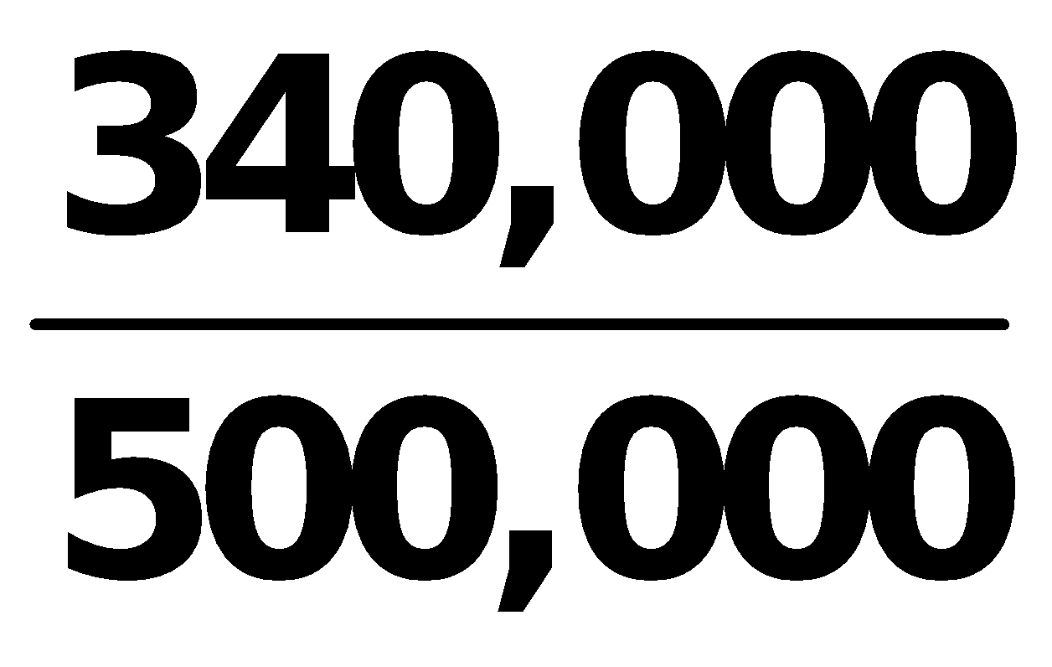 **= .68  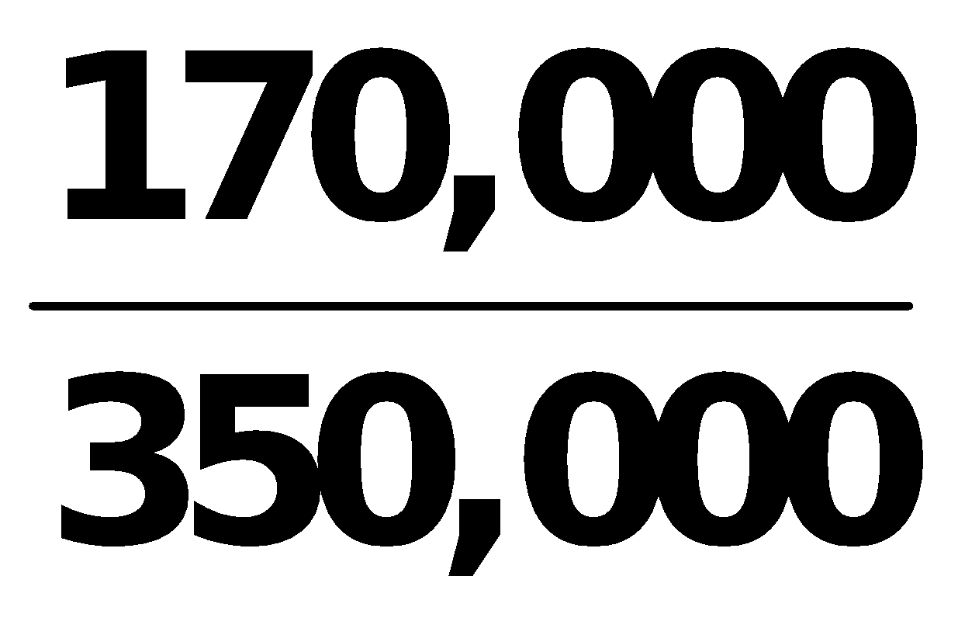 = .49  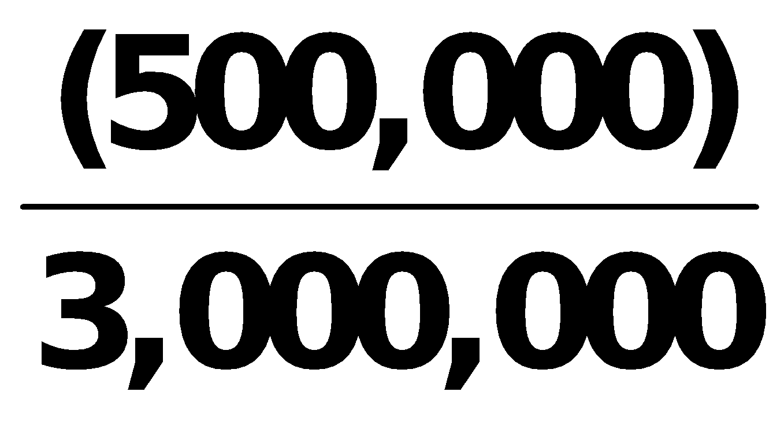 = (.17)**

**BRIEF EXERCISE 14-4**

**Vertical analysis:**

|  |  |  |  |  |  |  |  |  |
| --- | --- | --- | --- | --- | --- | --- | --- | --- |
|  |  | **Dec. 31, 2017** | | |  | **Dec. 31, 2016** | | |
|  |  |  |  |  |  |  |  |  |
|  |  | **Amount** |  | **Percentage\*** |  | **Amount** |  | **Percentage\*\*** |
|  |  |  |  |  |  |  |  |  |
| **Inventory**  **Accounts receivable Total assets** |  | **€  840,000**  **€  520,000 €2,500,000** |  | **33.6%**  **20.8%**  **100%** |  | **€  500,000 €  350,000 €3,000,000** |  | **16.7%**  **11.7%**  **100%** |

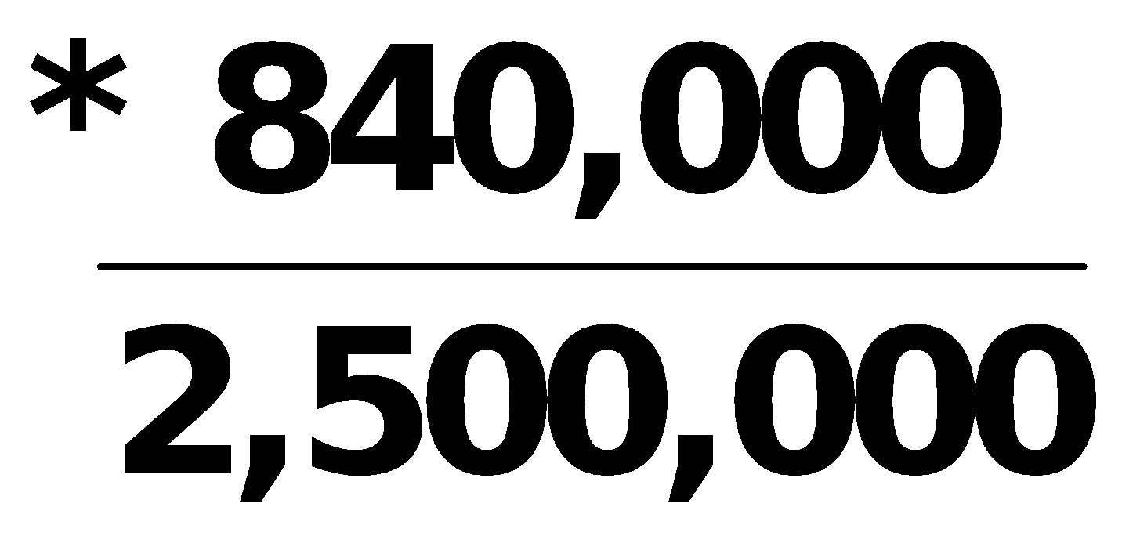 **= .336       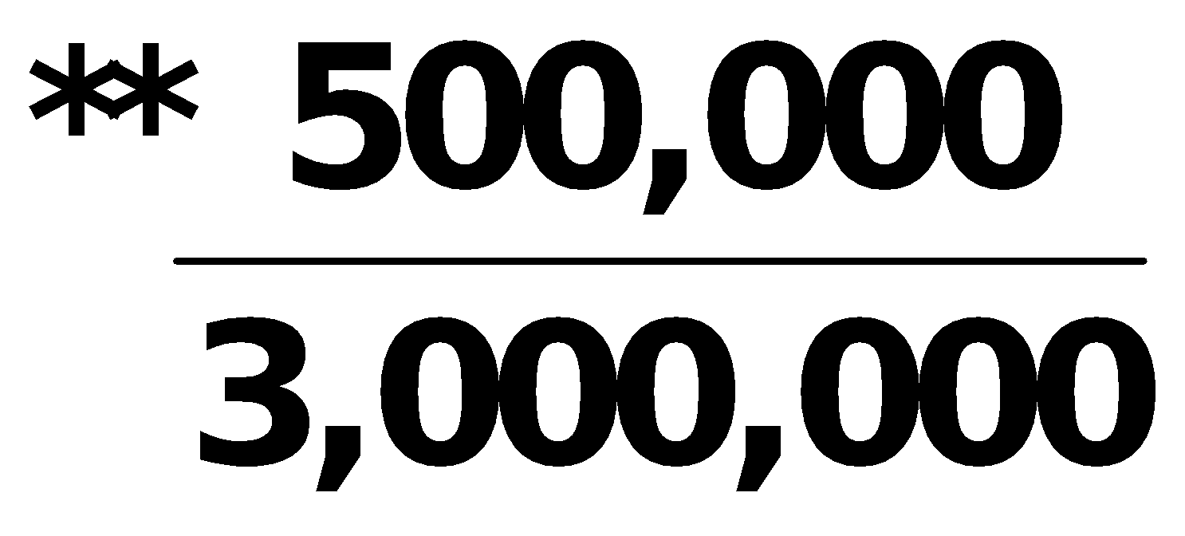 = .167**

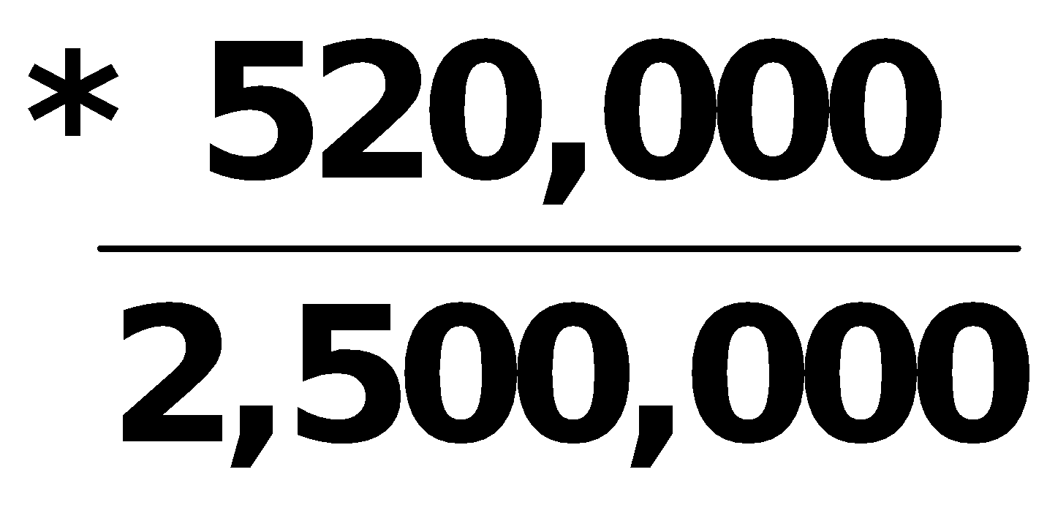 **= .208        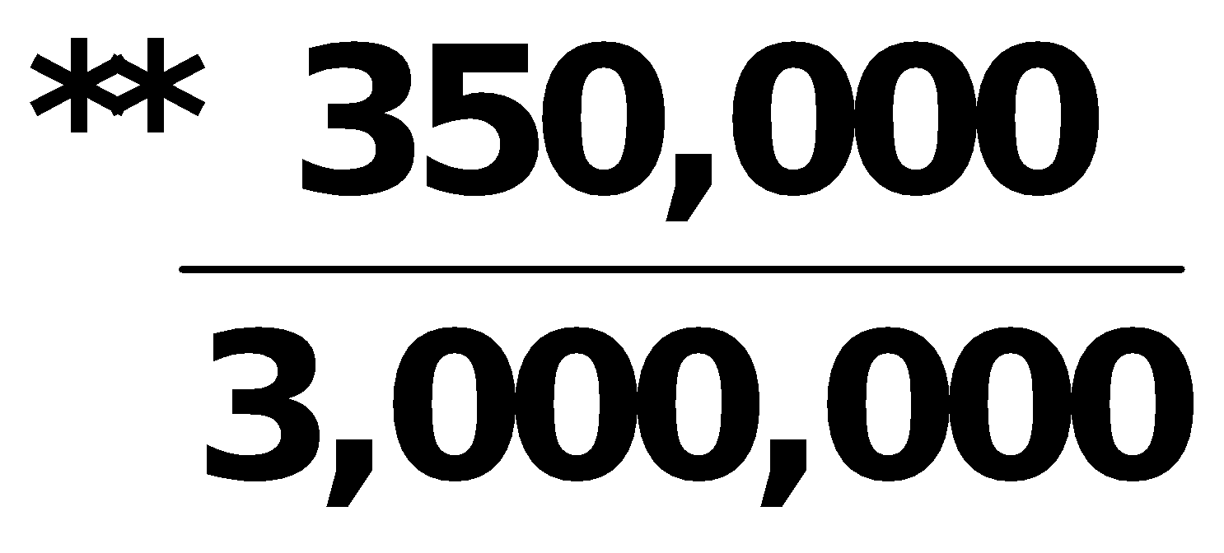 = .117**

**BRIEF EXERCISE 14-5**

|  |  |  |  |  |  |  |
| --- | --- | --- | --- | --- | --- | --- |
|  |  | **2017** |  | **2016** |  | **2015** |
|  |  |  |  |  |  |  |
| **Net income** |  | **€525,000** |  | **€500,000** |  | **€550,000** |

|  |  |  |  |  |  |
| --- | --- | --- | --- | --- | --- |
|  |  |  | **Increase or (Decrease)** | | |
|  |  |  |  |  |  |
|  |  |  | **Amount** |  | **Percentage** |
|  |  |  |  |  |  |
| **(a)**  **(b)** | **2015–2016**  **2016–2017** |  | **(50,000)**  **(25,000)** |  | **(9%)**  **(5%)** |

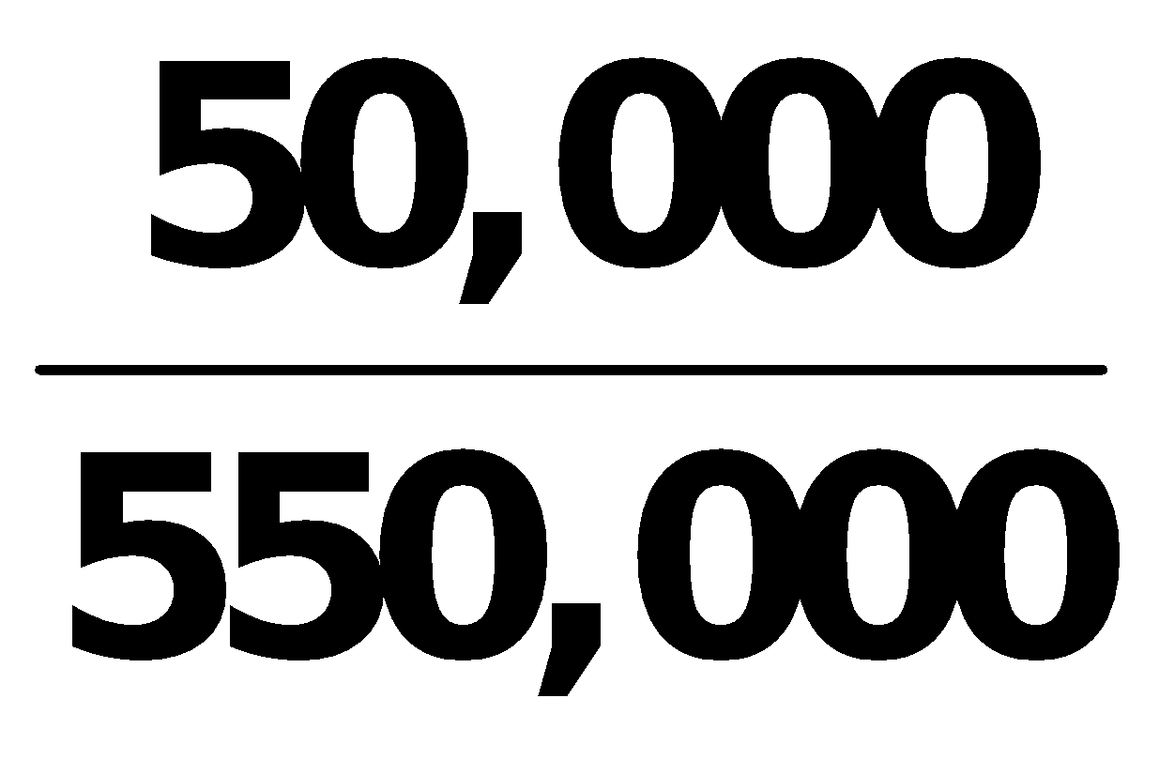 **= .09        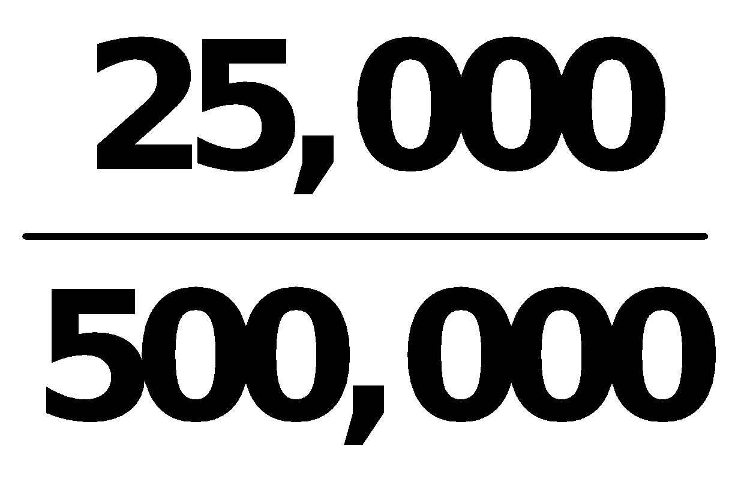 = .05**

**BRIEF EXERCISE 14-6**

|  |  |  |  |  |  |  |
| --- | --- | --- | --- | --- | --- | --- |
|  |  | **2017** |  | **2016** |  | **Increase** |
|  |  |  |  |  |  |  |
| **Net income** |  | **£560,000** |  | **X** |  | **40%** |

**X .40 =** 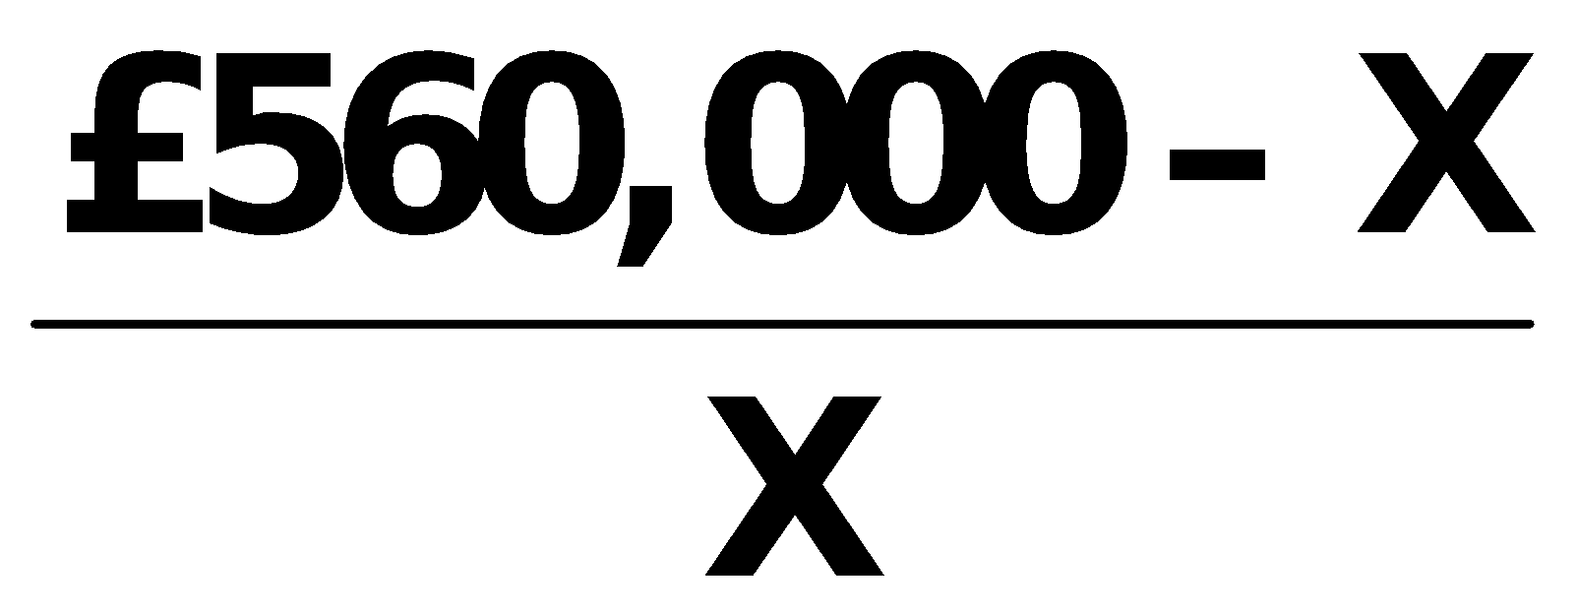

**.40X = £560,000 – X**

**BRIEF EXERCISE 14-6 (Continued)**

**1.40X = £560,000**

**X = £400,000**

**2016 Net income = £400,000**

**BRIEF EXERCISE 14-7**

**Comparing the percentages presented results in the following conclusions: The net income for Kemplar increased in 2016 because of the combination of an increase in sales revenue and a decrease in both cost of goods sold and expenses. However, the reverse was true in 2017 as sales revenue decreased while both cost of goods sold and expenses increased. This resulted in a decrease in net income.**

**BRIEF EXERCISE 14-8**

|  |  |  |  |  |  |  |
| --- | --- | --- | --- | --- | --- | --- |
|  |  | **2017** |  | **2016** |  | **2015** |
|  |  |  |  |  |  |  |
| **Sales revenue**  **Cost of goods sold**  **Expenses**  **Net income** |  | **100.0**  **59.2**  **25.0**  **15.8** |  | **100.0**  **62.4**  **25.6**  **12.0** |  | **100.0**  **64.5**  **27.5**  **8.0** |

**Net income as a percent of sales revenue for Dagman increased over the three-year period because cost of goods sold and expenses both decreased as a percent of sales every year.**

**BRIEF EXERCISE 14-9**

**(a) Working capital = Current assets – Current liabilities**

**Current assets £46,690,000**

**Current liabilities  41,200,000**

**Working capital £ 5,490,000**

**BRIEF EXERCISE 14-9 (Continued)**

**(b) Current ratio:**

** =** 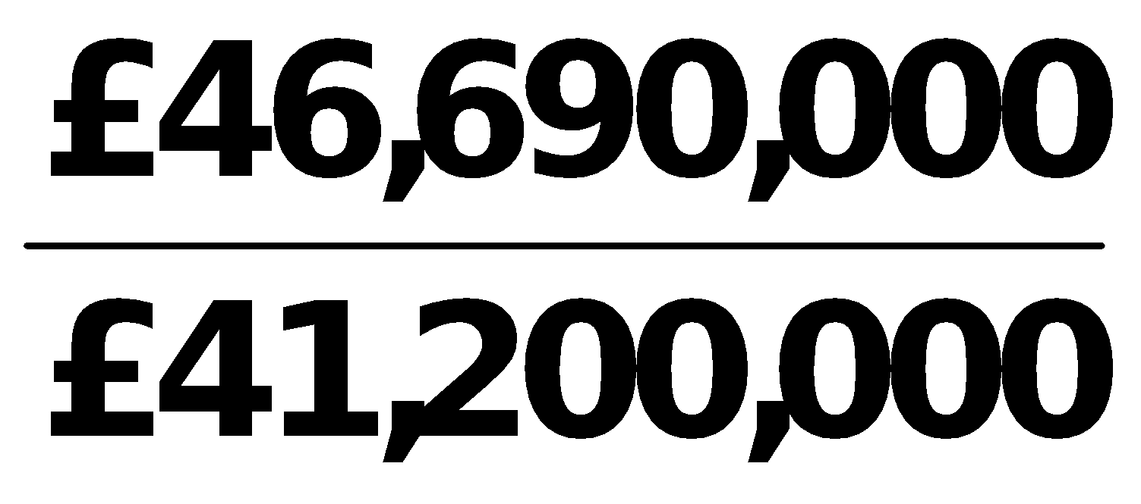

**= 1.13:1**

**(c) Acid-test ratio:**

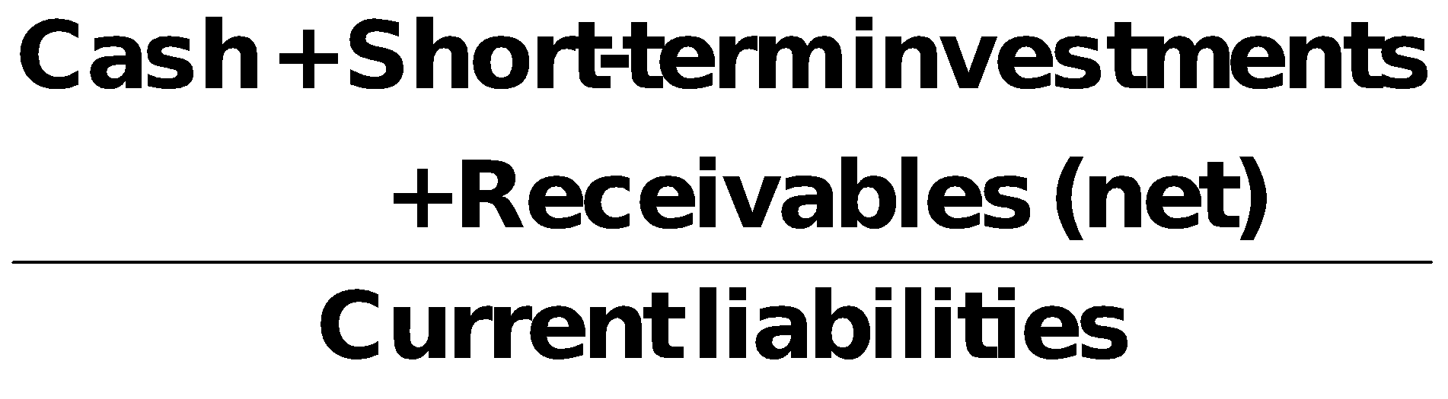 **=** 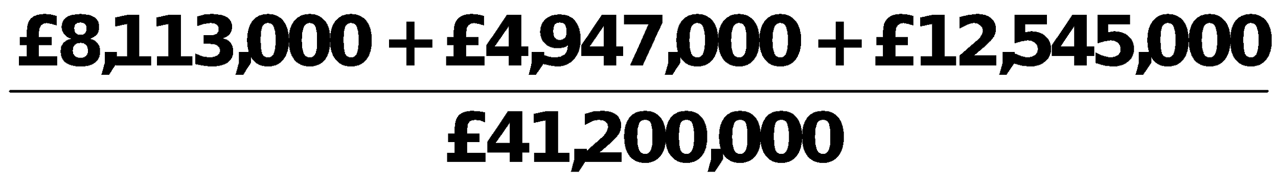

**=** 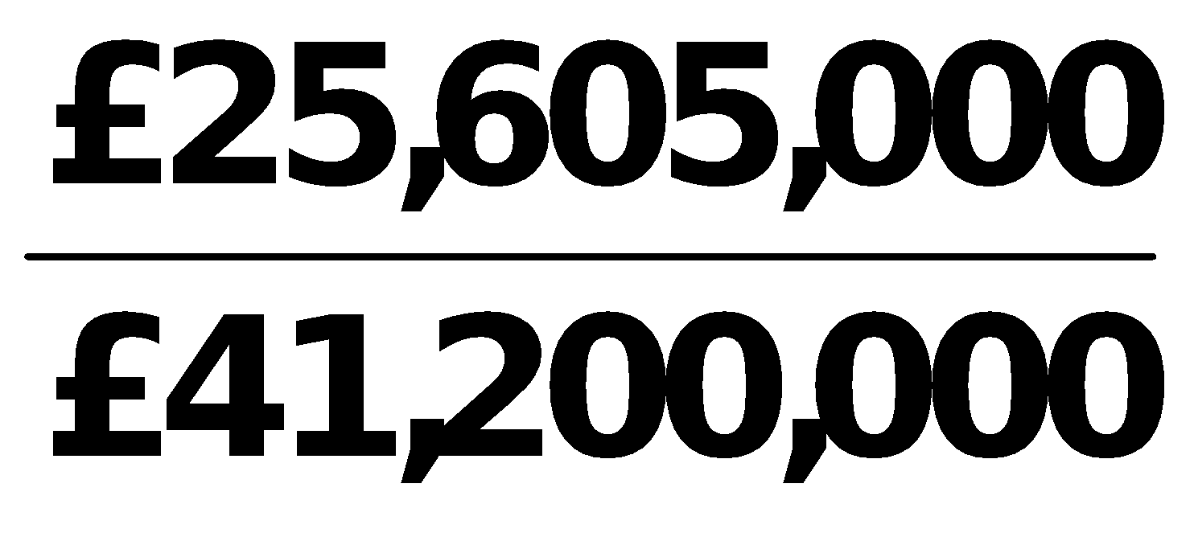

**= .62:1**

**BRIEF EXERCISE 14-10**

**(a) Asset turnover = **

**=** 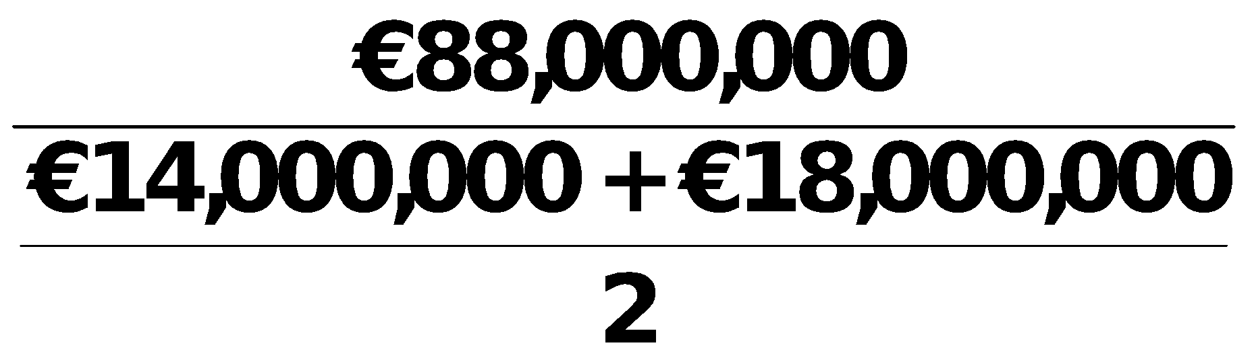

**= 5.5 times**

**(b) Profit margin = **

**=** 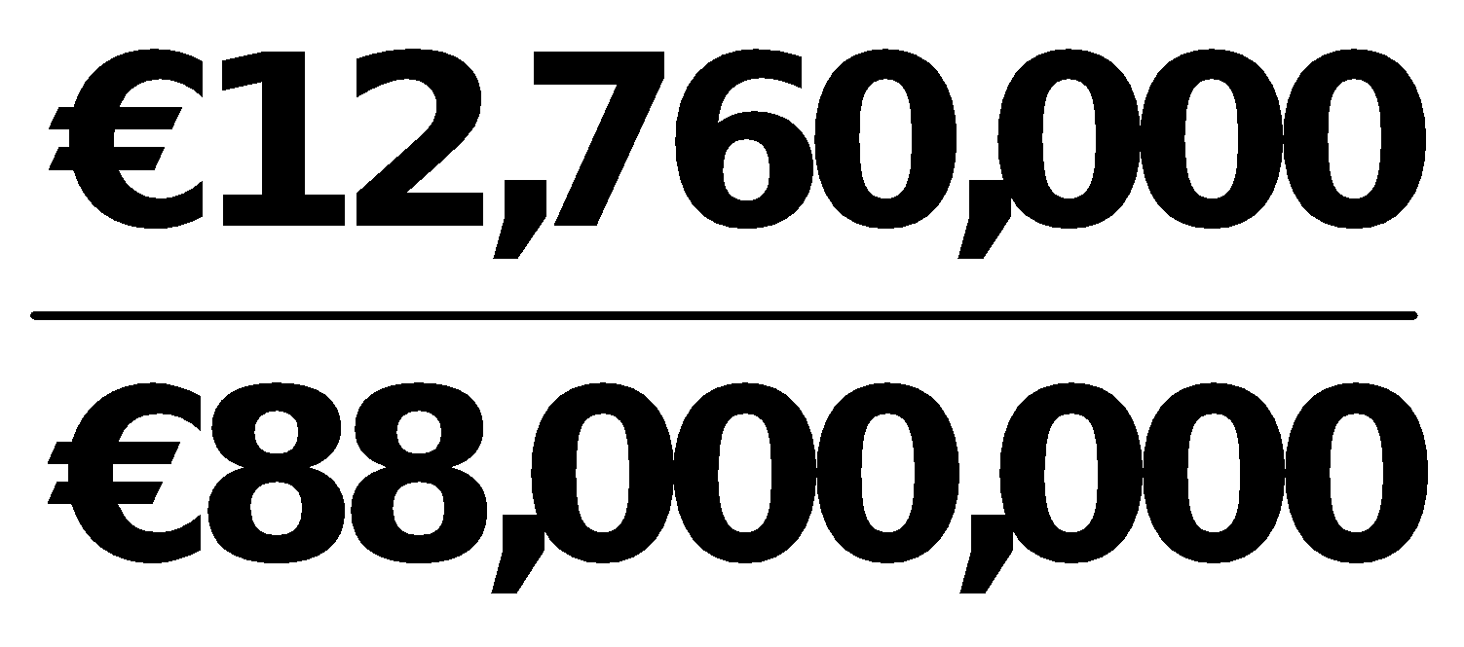

**= 14.5%**

**BRIEF EXERCISE 14-11**

**(a) Accounts receivable turnover = **

|  |  |  |  |  |
| --- | --- | --- | --- | --- |
|  |  | **2017** |  | **2016** |
|  |  |  |  |  |
|  | **(1)** | **= 6.9 times** |  | **= 6.0 times** |
|  |  | **\*($520,000 + $550,000) ÷ 2** |  | **\*\*($480,000 + $520,000) ÷ 2** |
|  |  |  |  |  |
|  | **(2)** | **Average collection period**  **= 52.9 days** |  | **= 60.8 days** |

**(b) Gladow Company should be pleased with the effectiveness of its credit and collection policies. The company has decreased the average collection period by 7.9 days and the collection period of approximately 53 days is well within the 60 days allowed in the credit terms.**

**BRIEF EXERCISE 14-12**

**(a) Inventory turnover =** 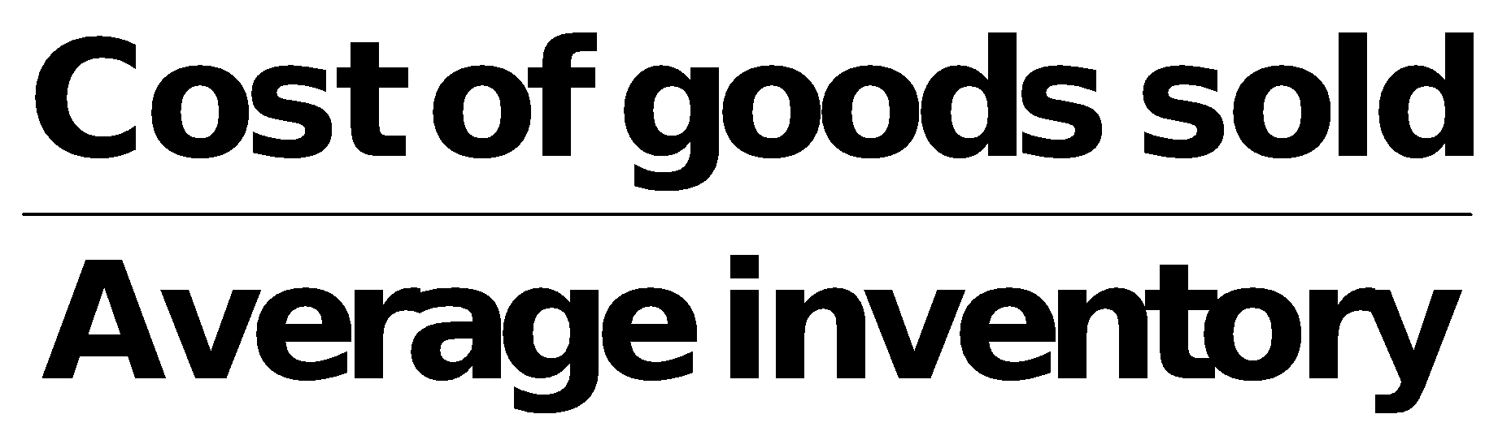

|  |  |  |  |  |  |  |  |  |  |  |
| --- | --- | --- | --- | --- | --- | --- | --- | --- | --- | --- |
|  | **(1)** | **2017** | | |  | **2016** | | | | |
|  |  |  | | |  |  | | | | |
|  |  | **4,400,000** | **= 4.4 times** |  | | **4,600,000** | | **= 5.0 times** | | |
|  |  | **980,000 + 1,020,000** |  | | **860,000 + 980,000** | |
|  |  | **2** |  |  | | **2** | |  | | |
|  |  | **Beginning inventory   980,000**  **Purchases   4,440,000**  **Goods available for sale  5,420,000**  **Ending inventory   1,020,000**  **Cost of goods sold 4,400,000** | | |  |  |  | | **860,000**  **4,720,000**  **5,580,000**  **980,000**  **4,600,000** | |

**(2) Days in inventory**

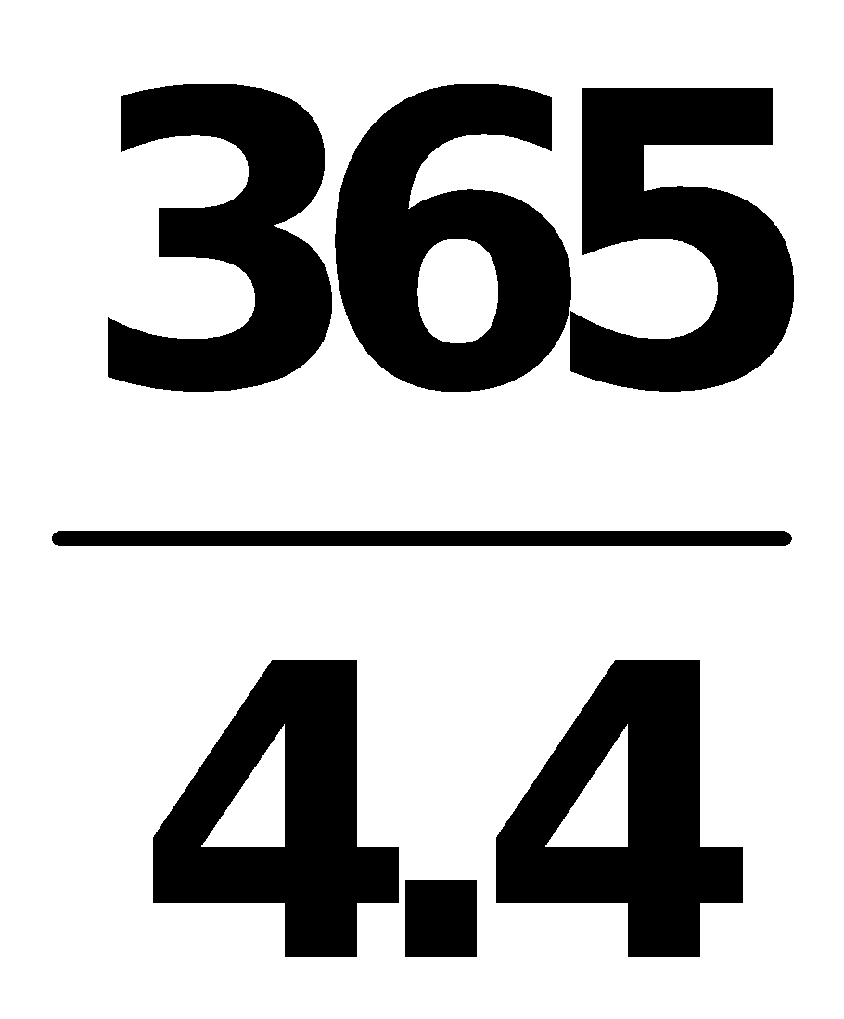 **= 83.0 days        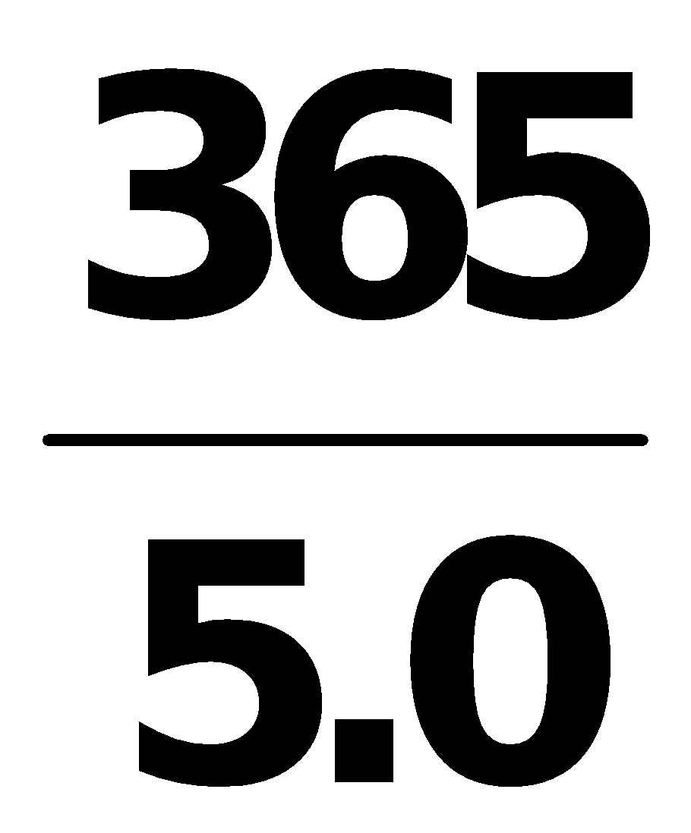 = 73.0 days**

**BRIEF EXERCISE 14-12 (Continued)**

**(b) Management should be concerned with the fact that inventory is moving slower in 2017 than it did in 2016. The decrease in the turnover could be because of poor pricing decisions or because the company is stuck with obsolete inventory.**

**BRIEF EXERCISE 14-13**

**Payout ratio = **

**.22 = **

**X = HK$680,000 (.22) = HK$149,600**

**Cash dividends = HK$149,600**

**Return on assets = **

**.16 = **

**.16X = HK$680,000**

**X = **

**X = HK$4,250,000**

**Average assets = HK$4,250,000**

**BRIEF EXERCISE 14-14**

**MING LIMITED**

**Partial Income Statement**

**Income before income taxes ₤400,000**

**Income tax expense (₤400,000 X 30%) 120,000**

**Income from continuing operations 280,000**

**Discontinued operations**

**Income from operations of retail division,**

**net of ₤3,000 tax (₤10,000 X 30%)……………… ₤ 7,000**

**Loss on disposal of retail division, net of**

**₤24,000 tax saving (₤80,000 X 30%)………….. (56,000) (49,000)**

**Net income ₤231,000**

**BRIEF EXERCISE 14-15**

**BLEVINS ASA**

**Partial Income Statement**

**Loss from operations of European facilities, net**

**of €96,000 income tax saving (€320,000 X 30%) €224,000**

**Loss on disposal of European facilities, net of**

**€45,000 income tax saving (€150,000 X 30%) 105,000 €329,000**

**BRIEF EXERCISE 14-16**

**SILVA AG**

**Partial Statement of Comprehensive Income**

**Income before income taxes €450,000**

**Income tax expense (€450,000 X 25%) 112,500**

**Net income 337,500**

**Other comprehensive income**

**Unrealized gain on non-trading securities,**

**net of €17,500 tax (€70,000 X 25%) 52,500**

**Comprehensive income €390,000**

**SOLUTIONS FOR DO IT! REVIEW EXERCISES**

**DO IT! 14-1**

|  |  |  |  |
| --- | --- | --- | --- |
|  | **Increase (Decrease) in 2017** | | |
|  | **Amount** |  | **Percent** |

**Plant assets ₤71,000 9.5% [(₤821,000 – ₤750,000) ÷ ₤750,000]**

**Current assets (37,000) (16.4)% [(₤188,000 – ₤225,000) ÷ ₤225,000]**

**Total assets ₤34,000 3.5% [(₤1,009,000 – ₤975,000) ÷ ₤975,000]**

**DO IT! 14-2**

**2017     2016**

**(a) Current ratio:**

**€1,350 ÷ €900 = 1.50:1**

**€1,343 ÷ €810 = 1.66:1**

**(b) Inventory turnover:**

**€984/[(€430 + €390) ÷ 2)] = 2.40 times**

**€895/[(€390 + €326) ÷ 2)]= 2.50 times**

**(c) Profit margin:**

**€364 ÷ €4,000 = 9.1%**

**€213 ÷ €3,600 = 5.9%**

**(d) Return on assets:**

**€364/[(€2,310 + €2,243) ÷ 2)] = 16.0%**

**€213/[(€2,243 + €2,100) ÷ 2)] = 9.8%**

**(e) Return on ordinary shareholders’ equity:**

**€364/[(€1,020 + €1,040) ÷ 2)] = 35.3%**

**€213/[€1,040 + €960) ÷ 2)] = 21.3%**

**(f) Debt to assets ratio:**

**€1,290 ÷ €2,310 = 55.8%**

**€1,203 ÷ €2,243 = 53.6%**

**(g) Times interest earned:**

**(€364 + €242 + €10) ÷ €10 = 62 times**

**(€213 + €142 + €20) ÷ €20 = 19 times**

**DO IT! 14-3**

**GRINDERS LIMITED**

**Partial statement of Comprehensive Income**

**Income before income taxes ₤500,000**

**Income tax expense   160,000**

**Income from continuing operations 340,000**

**Discontinued operations**

**Loss from operations of music**

**division, net of ₤19,200 income tax savings ₤40,800**

**Gain from disposal of music**

**division, net of ₤16,000 taxes   34,000    (6,800)**

**Net income 333,200**

**Other comprehensive income:**

**Unrealized loss on non-trading**

**securities, net of ₤9,600 tax savings 20,400**

**Comprehensive Income ₤312,800**

**DO IT! 14-4**

|  |  |  |
| --- | --- | --- |
| **1.** | **Current ratio:** | **A measure used to evaluate a company’s liquidity.** |
| **2.** | **Pro forma income:** | **Usually excludes items that a company thinks are unusual or non-recurring.** |
| **3.** | **Quality of earnings:** | **Indicates the level of full and transparent information provided to users of the  financial statements.** |
| **4.** | **Discontinued operations:** | **The disposal of a significant component of a business.** |
| **5.** | **Horizontal analysis:** | **Determines increases or decreases in a series of financial statement data.** |
| **6.** | **Comprehensive income:** | **Includes all changes in equity during a period except those resulting from investments by shareholders and distributions to shareholders.** |

**SOLUTIONS TO EXERCISES**

**EXERCISE 14-1**

**GALLUP SA**

**Condensed Statements of Financial Position**

**December 31**

|  |  |  |  |  |  |  |  |  |
| --- | --- | --- | --- | --- | --- | --- | --- | --- |
|  |  |  |  |  |  | **Increase or (Decrease)** | | |
|  |  |  |  |  |  |  |  |  |
|  |  | **2017** |  | **2016** |  | **Amount** |  | **Percentage** |
|  |  |  |  |  |  |  |  |  |
| **Assets** |  |  |  |  |  |  |  |  |
|  |  |  |  |  |  |  |  |  |
| **Plant assets (net)**  **Current assets**  **Total assets** |  | **€396,000**  **128,000**  **€524,000** |  | **€320,000**  **110,000**  **€430,000** |  | **(€76,000**  **( 18,000**  **€94,000** |  | **(23.8%)**  **(16.4%)**  **(21.9%)** |
|  |  |  |  |  |  |  |  |  |
| **Equity** |  |  |  |  |  |  |  |  |
|  |  |  |  |  |  |  |  |  |
| **Share capital—  ordinary, €1 par**  **Retained earnings**  **Total equity** |  | **€ 159,000**  **135,300**  **294,300** |  | **€ 115,000**  **150,000**  **265,000** |  | **(**  **€44,000)**  **((14,700))**  **(  29,300)** |  | **(38.3%)**  **(((9.8%))**  **( 11.1%)** |
|  |  |  |  |  |  |  |  |  |
| **Liabilities** |  |  |  |  |  |  |  |  |
|  |  |  |  |  |  |  |  |  |
| **Non-current liabilities**  **Current liabilities**  **Total liabilities**  **Total equity and**  **liabilities** |  | **138,700**  **91,000**  **229,700**  **€524,000** |  | **95,000**  **70,000**  **165,000**  **€430,000** |  | **( 43,700 (15,000 )**  **21,000**  **( 64,700)**  **(€94,000)** |  | **(46.0%)**  **30.0%**  **(  39.2%)**  **21.9%** |

**EXERCISE 14-2**

**CONARD LIMITED**

**Condensed Income Statements**

**For the Years Ended December 31**

|  |  |  |  |  |  |  |  |  |  |
| --- | --- | --- | --- | --- | --- | --- | --- | --- | --- |
|  |  | **2017** | | |  | | **2016** | | |
|  |  |  |  |  |  |  | |  |  |
|  |  | **Amount** |  | **Percent** |  | **Amount** | |  | **Percent** |
|  |  |  |  |  |  |  | |  |  |
| **Net sales**  **Cost of goods sold**  **Gross profit**  **Selling expenses**  **Administrative expenses**  **Total operating expenses**  **Income before income taxes**  **Income tax expense**  **Net income** |  | **£750,000**  **480,000**  **270,000**  **105,000**  **75,000**  **180,000**  **90,000**  **36,000**  **£ 54,000** |  | **100.0%**  **64.0%**  **36.0%**  **14.0%**  **10.0%**  **24.0%**  **12.0%**  **4.8%**  **7.2%** |  | **£600,000**  **408,000**  **192,000**  **84,000**  **54,000**  **138,000**  **54,000**  **18,000**  **£ 36,000** | |  | **100.0%**  **68.0%**  **32.0%**  **14.0%**  **9.0%**  **23.0%**  **9.0%**  **3.0%**  **6.0%** |

**EXERCISE 14-3**

**(a) GARCIA SLU**

**Condensed Statements of Financial Position**

**December 31**

|  |  |  |  |  |  |  |  |  |  |
| --- | --- | --- | --- | --- | --- | --- | --- | --- | --- |
|  |  |  | **2017** |  | **2016** |  | **Increase**  **(Decrease)** |  | **Percentage**  **Change**  **from 2016** |
|  |  |  |  |  |  |  |  |  |  |
|  | **Assets**  **Intangibles**  **Property, plant &**  **equipment (net)**  **Current assets**  **Total assets** |  | **€ 24,000**  **100,000**  **76,000**  **€200,000** |  | **€ 40,000**  **92,000**  **82,000**  **€214,000** |  | **€ (16,000)**  **( 8,000)**  **(6,000)**  **€ (14,000)** |  | **(40.0%)**  **( 8.7%)**  **(7.3%)**  **(6.5%)** |

**EXERCISE 14-3 (Continued)**

**GARCIA SLU**

**Condensed Statements of Financial Position (Continued)**

**December 31**

|  |  |  |  |  |  |  |  |  |  |
| --- | --- | --- | --- | --- | --- | --- | --- | --- | --- |
|  |  |  | **2017** |  | **2016** |  | **Increase**  **(Decrease)** |  | **Percentage**  **Change**  **from 2016** |
|  |  |  |  |  |  |  |  |  |  |
|  | **Equity and liabilities**  **Equity**  **Non-current**  **liabilities**  **Current liabilities**  **Total equity and**  **liabilities** |  | **€ 20,000**  **140,000**  **40,000**  **€200,000** |  | **€ 16,000**  **150,000**  **48,000**  **€214,000** |  | **€ 4,000**  **(10,000)**  **(8,000)**  **€(14,000)** |  | **25.0%**  **(6.7%)**  **((16.7%))**  **(6.5%)** |

**(b) GARCIA SLU**

**Condensed Statements of Financial Position**

**December 31, 2017**

|  |  |  |  |  |  |
| --- | --- | --- | --- | --- | --- |
|  |  |  | **Amount** |  | **Percent** |
|  |  |  |  |  |  |
|  | **Assets**  **Intangibles**  **Property, plant, and equipment (net)**  **Current assets**  **Total assets**  **Equity and liabilities**  **Equity**  **Non-current liabilities**  **Current liabilities**  **Total equity and liabilities** |  | **€ 24,000**  **100,000**  **76,000**  **€200,000**  **€ 20,000**  **140,000**  **40,000**  **€200,000** |  | **12.0%**  **50.0%**  **38.0% 100.0%**  **10%**  **70%**  **20%**  **100%** |

**EXERCISE 14-4**

**(a) HENDI COMPANY A.S.**

**Condensed Income Statements**

**For the Years Ended December 31**

|  |  |  |  |  |  |  |  |  |  |
| --- | --- | --- | --- | --- | --- | --- | --- | --- | --- |
|  |  |  |  |  |  |  | **Increase or (Decrease)**  **During 2016** | | |
|  |  |  |  |  |  |  |  |  |  |
|  |  |  | **2017** |  | **2016** |  | **Amount** |  | **Percentage** |
|  |  |  |  |  |  |  |  |  |  |
|  | **Net sales**  **Cost of goods sold**  **Gross profit**  **Operating expenses**  **Net income** |  | **600,000**  **468,000**  **132,000**  **60,000**  **72,000** |  | **500,000**  **400,000**  **100,000**  **54,000**  **46,000** |  | **100,000**  **68,000**  **32,000**  **6,000**  **26,000** |  | **20.0%**  **17.0%**  **32.0%**  **11.1%**  **56.5%** |

**(b) HENDI COMPANY A.S.**

**Condensed Income Statements**

**For the Years Ended December 31**

|  |  |  |  |  |  |  |  |  |  |
| --- | --- | --- | --- | --- | --- | --- | --- | --- | --- |
|  |  |  | **2017** | | |  | **2016** | | |
|  |  |  |  |  |  |  |  |  |  |
|  |  |  | **Amount** |  | **Percent** |  | **Amount** |  | **Percent** |
|  |  |  |  |  |  |  |  |  |  |
|  | **Net sales**  **Cost of goods sold**  **Gross profit**  **Operating expenses**  **Net income** |  | **600,000**  **468,000**  **132,000**  **60,000**  **72,000** |  | **100.0%**  **78.0%**  **22.0%**  **10.0%**  **12.0%** |  | **500,000**  **400,000**  **100,000**  **54,000**  **46,000** |  | **100.0%**  **80.0%**  **20.0%**  **10.8%**  **9.2%** |

**EXERCISE 14-5**

**(a) Current ratio = 2.1:1 ($5,228 ÷ $2,541)**

**Acid-test ratio = 1.3:1 ($3,371 ÷ $2,541)**

**Accounts receivable turnover = 5.7 times ($12,166 ÷ $2,153)\***

**Inventory turnover = 5.4 times ($7,737 ÷ $1,445.5)\*\***

**\*($2,177 + $2,129) ÷ 2**

**\*\*(1,531 + 1,360) ÷ 2**

**EXERCISE 14-5 (Continued)**

|  |  |  |  |  |  |  |  |
| --- | --- | --- | --- | --- | --- | --- | --- |
| **(b)** | **Ratio** |  | **Nordstrom** |  | **Park Street** |  | **Industry** |
|  |  |  |  |  |  |  |  |
|  | **Current**  **Acid-test**  **Accounts receivable turnover**  **Inventory turnover** |  | **2.1:1**  **1.3:1**  **5.7**  **5.4** |  | **2.05:1**  **1.05:1**  **37.2**  **3.1** |  | **1.70:1**  **.70:1**  **46.4**  **4.3** |

**Nordstrom is similar to Park Street for the current and acid-test ratios but significantly below for the accounts receivable turnover. Nordstrom is much better than Park Street for the inventory turnover.**

**Nordstrom is better than the industry average for the current and acid-test ratios but below the industry average for the accounts receivable turnover. Its inventory turnover ratio however is higher than the industry average.**

**EXERCISE 14-6**

**(a) Current ratio as of February 1, 2017 = 2.8:1 (R$140,000 ÷ R$50,000).**

**Feb. 3 2.8:1 No change in total current assets or liabilities.**

**7 2.2:1 (R$112,000 ÷ R$50,000).**

**11 2.2:1 No change in total current assets or liabilities.**

**14 2.6:1 (R$100,000 ÷ R$38,000).**

**18 2.3:1 (R$100,000 ÷ R$43,000).**

**(b) Acid-test ratio as of February 1, 2017 = 2.5:1 (R$125,000* ÷ R$50,000).**

**\* R$140,000 – R$10,000 – R$5,000**

**Feb. 3 2.5:1 No change in total quick assets or current liabilities.**

**7 1.9:1 (R$97,000 ÷ R$50,000).**

**11 1.9:1 (R$94,000 ÷ R$50,000).**

**14 2.2:1 (R$82,000 ÷ R$38,000).**

**18 1.9:1 (R$82,000 ÷ R$43,000).**

**EXERCISE 14-7**

**(a) 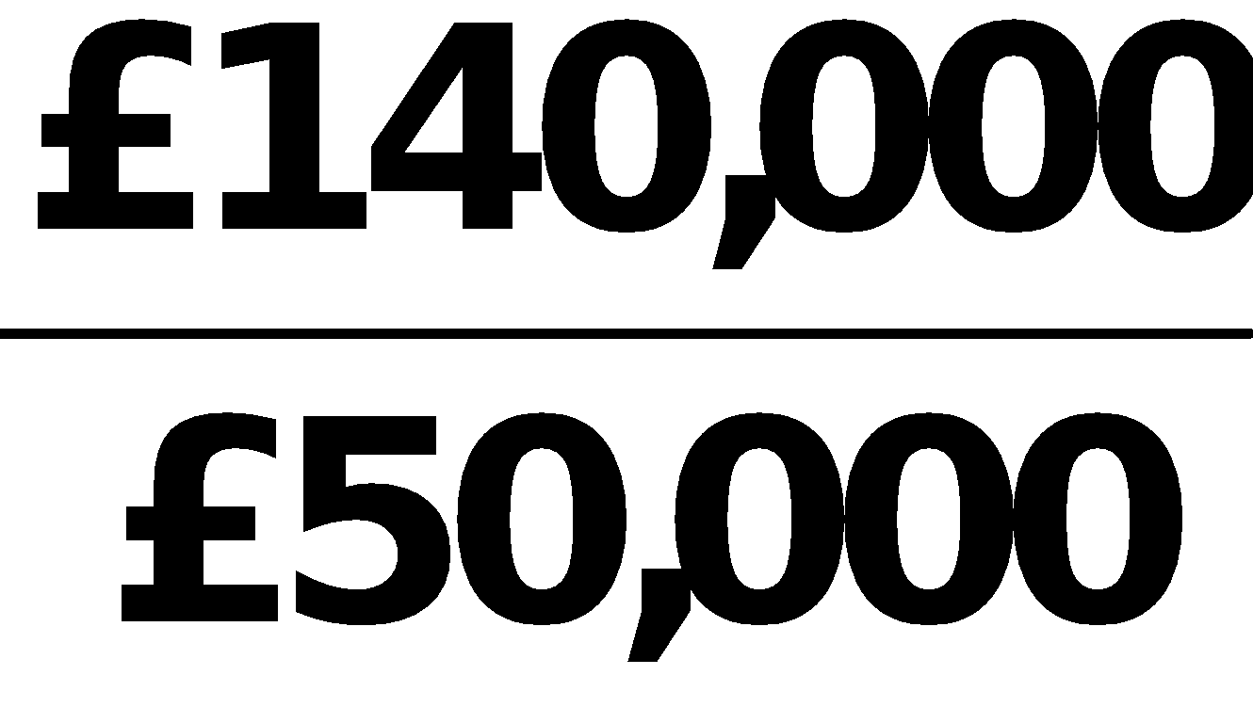 = 2.8:1.**

**(b) 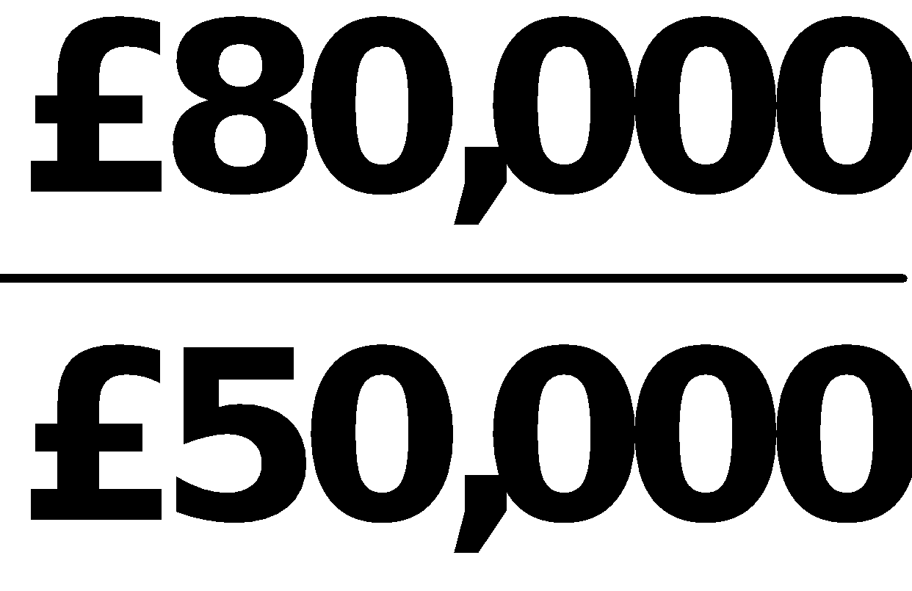 = 1.6:1.**

**(c) 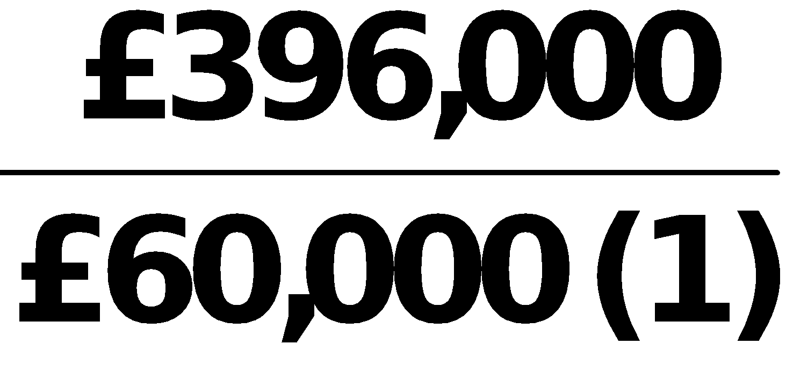 = 6.6 times.**

**(d) 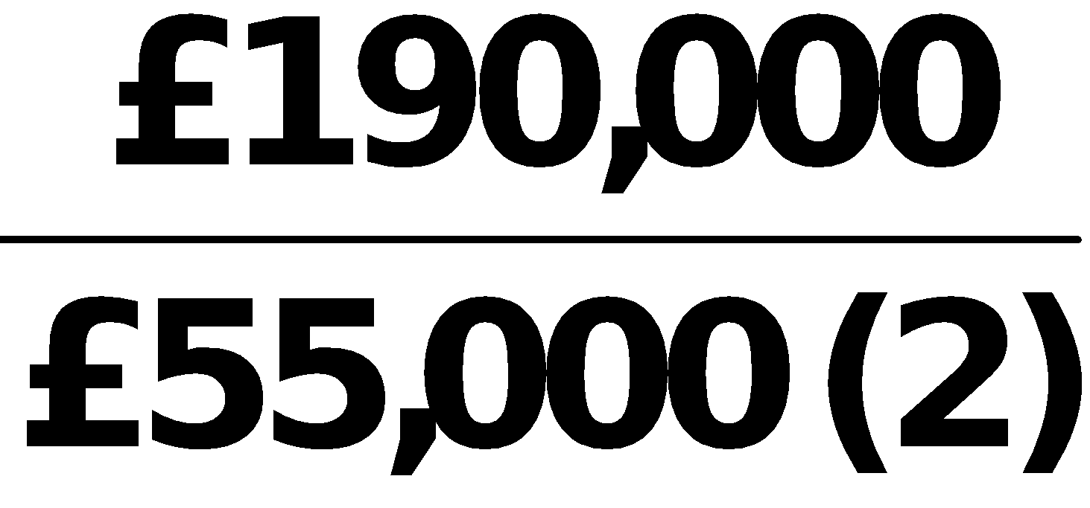 = 3.5 times.**

|  |  |  |  |  |  |
| --- | --- | --- | --- | --- | --- |
|  | **(1)** |  |  |  |  |
|  |  |  |  |  |  |
|  | **(2)** |  |  |  |  |

**EXERCISE 14-8**

**(a) Profit margin 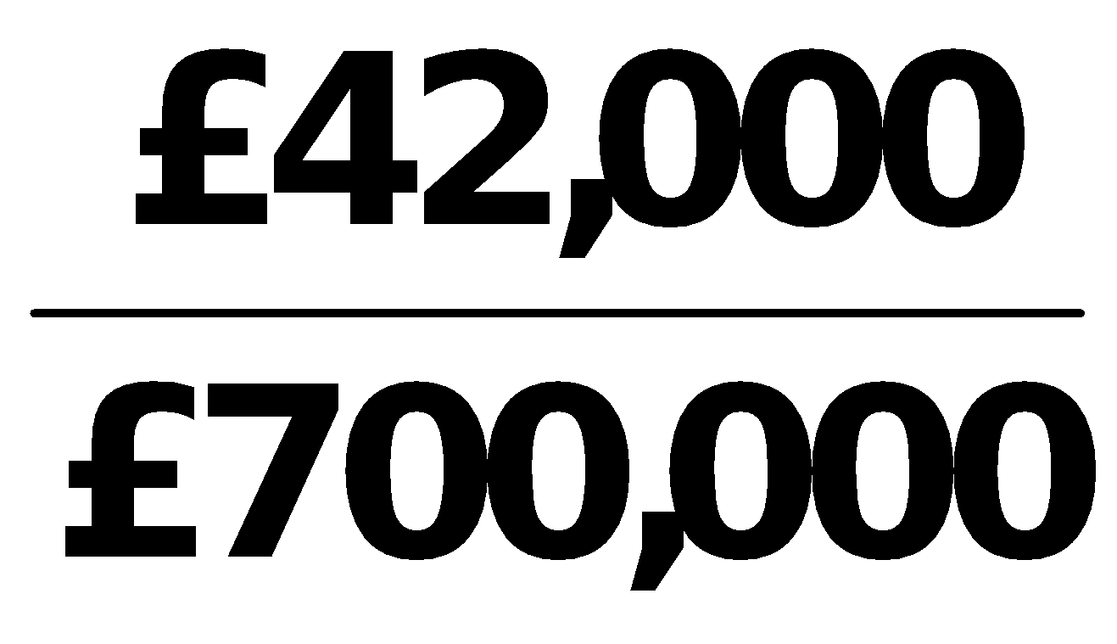 = 6.0%.**

**(b) Asset turnover 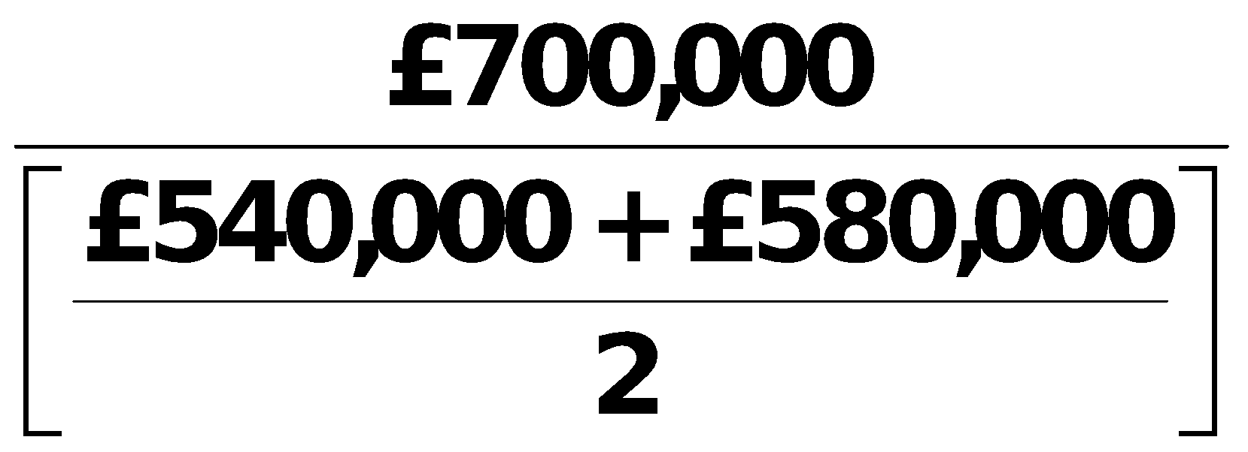 = 1.25 times.**

**(c) Return on assets 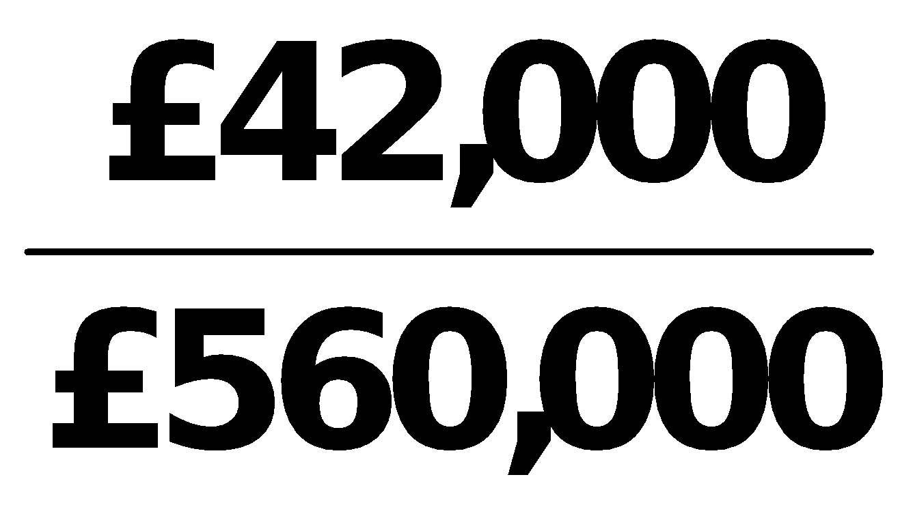 = 7.5%.**

|  |  |  |  |
| --- | --- | --- | --- |
| **(d)** | **Return on ordinary shareholders’ equity** |  | **= 11.2%.** |

**EXERCISE 14-9**

**(a) 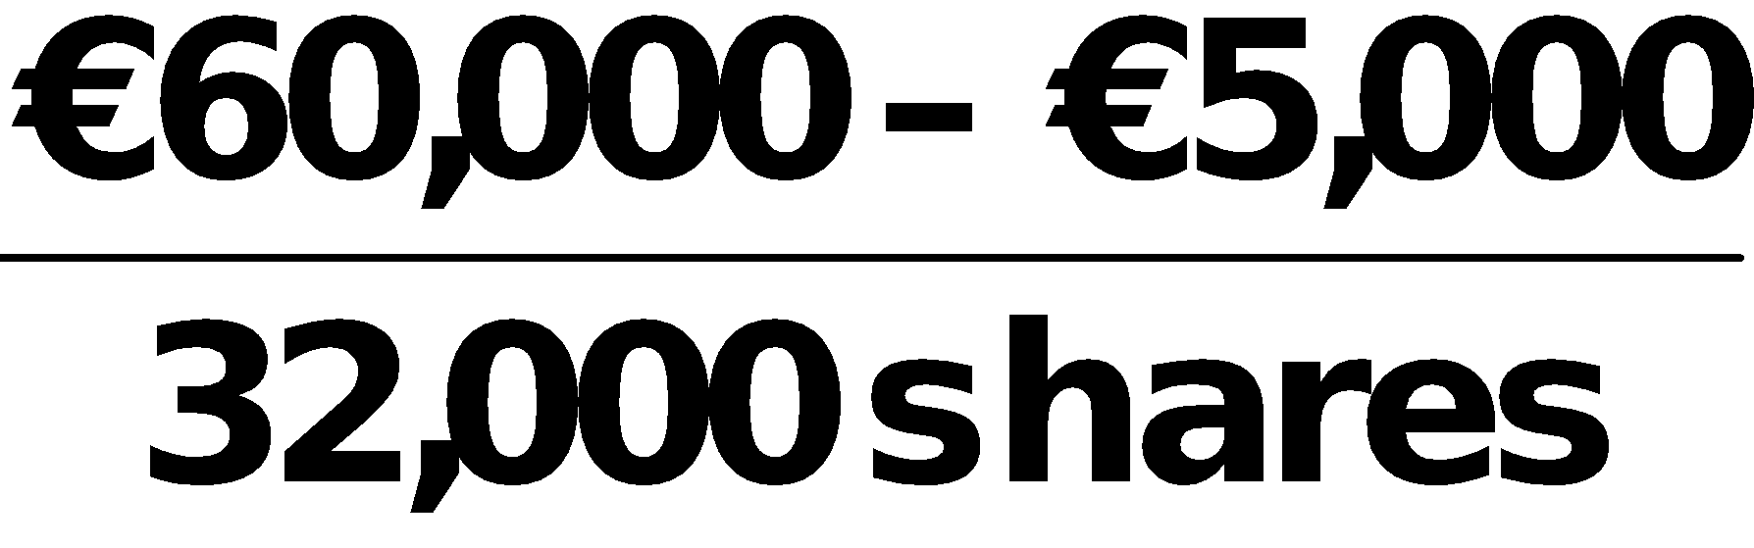 = €1.72.**

**(b) 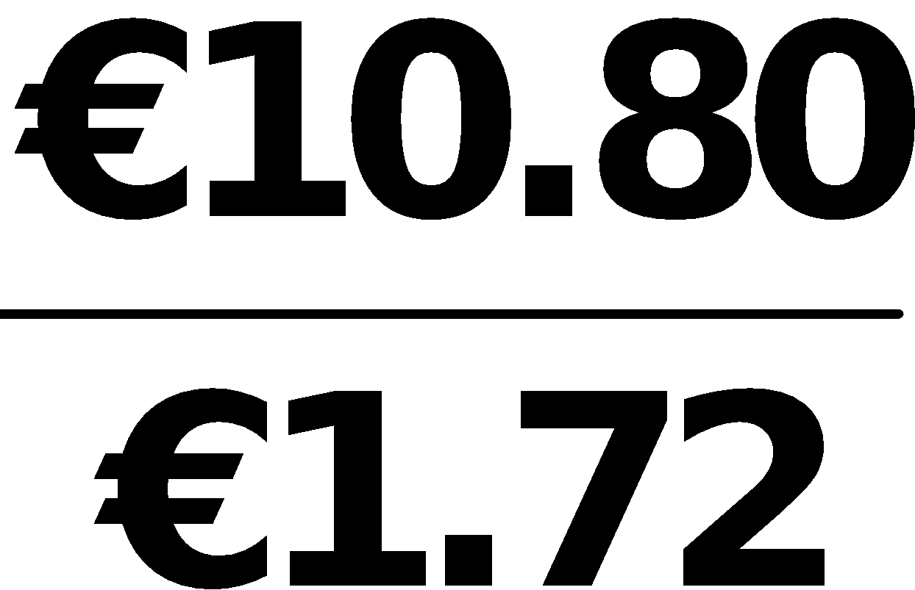 = 6.3 times.**

**(c) 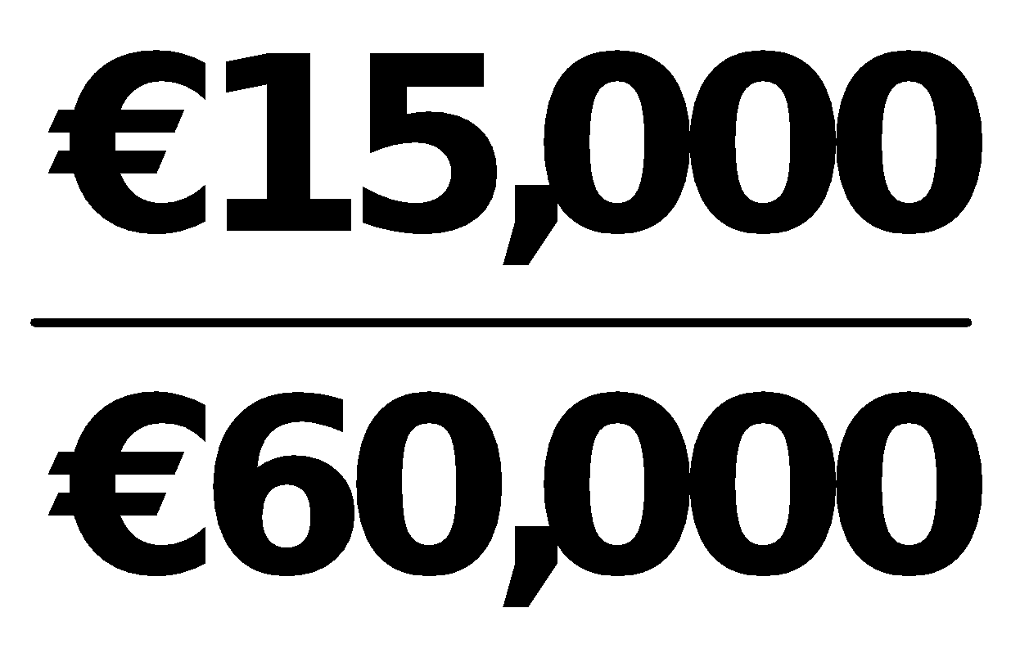 = 25%.**

**(d) 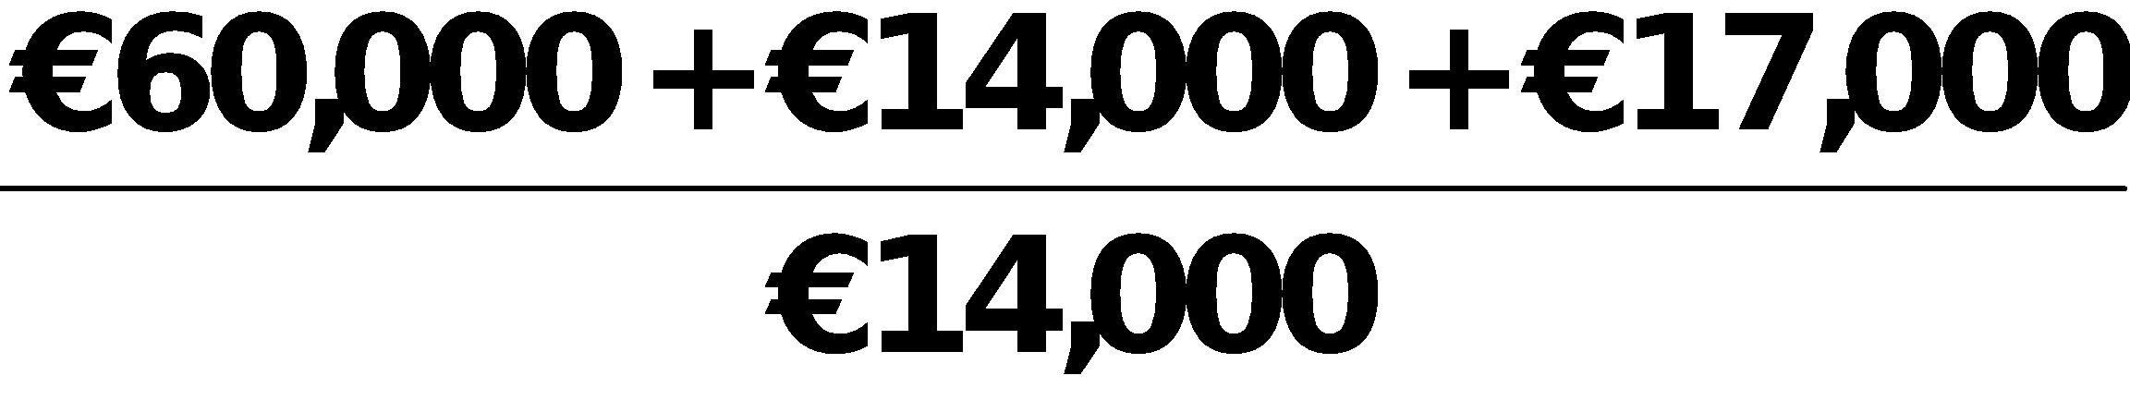 = 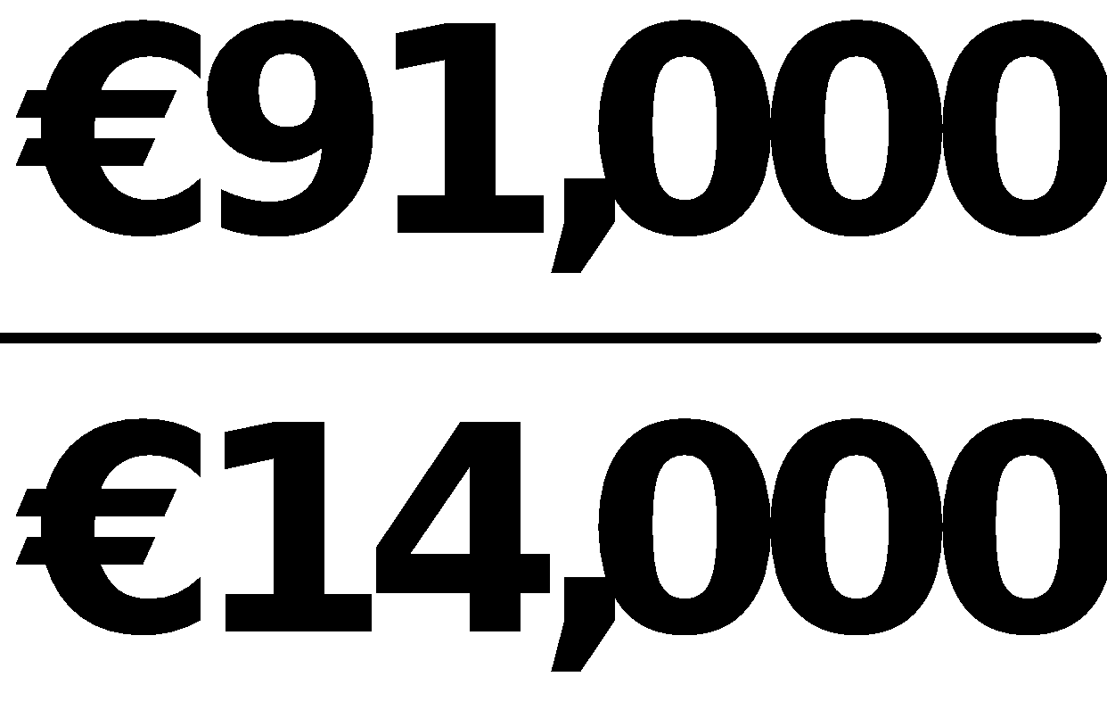 = 6.5 times.**

**EXERCISE 14-10**

**(a) Inventory turnover = 3.4 =** 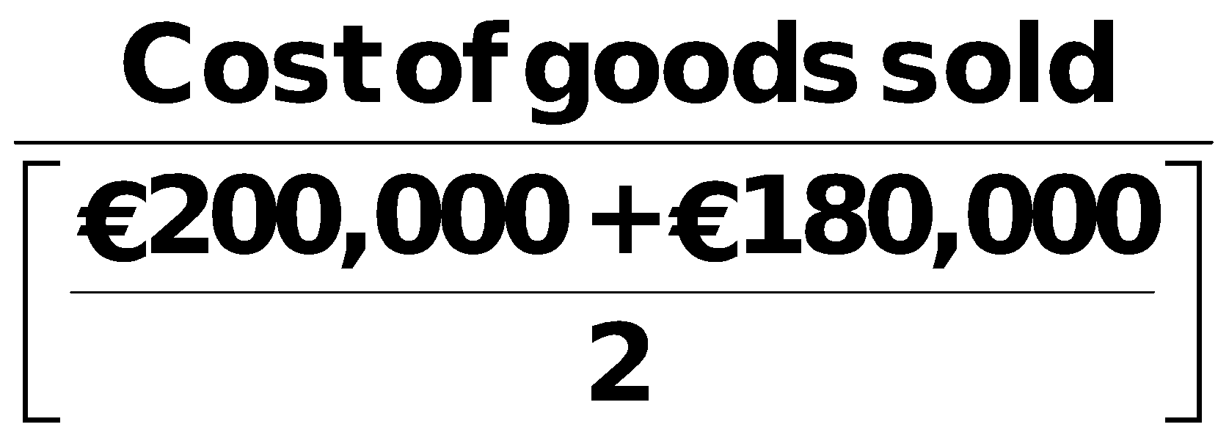

**3.4 X €190,000 = Cost of goods sold**

**Cost of goods sold = €646,000.**

**(b) Accounts receivable turnover = 8.8 =** 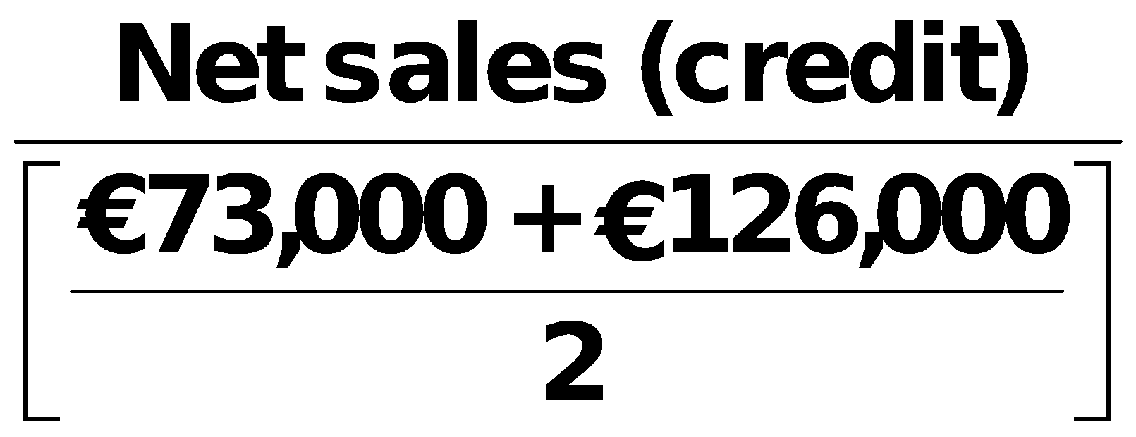

**8.8 X €99,500 = Net sales (credit) = €875,600.**

**(c) Return on ordinary shareholders’ equity = 25% =**

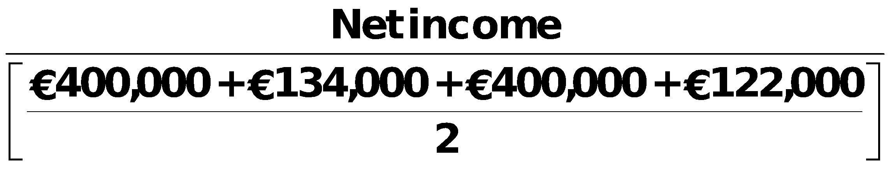

**.25 X €528,000 = Net income = €132,000.**

**EXERCISE 14-10 (Continued)**

**(d) Return on assets = 20% =** 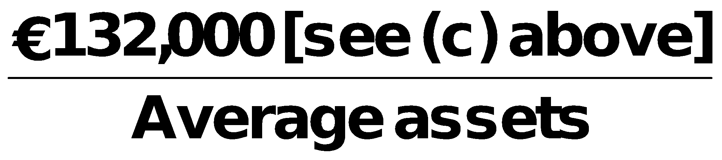

**Average assets = 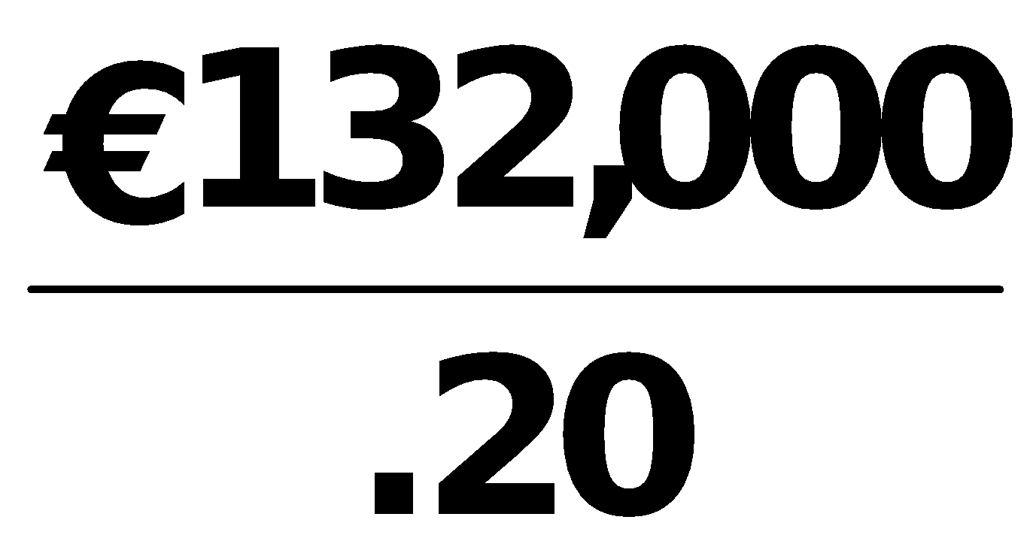 = €660,000**

** = €660,000**

**Total assets (Dec. 31, 2017) = (€660,000 X 2) – €650,000 = €670,000.**

**EXERCISE 14-11**

**(a) (€4,300 + €22,000+ €10,000)/€15,000 = 2.42:1**

**(b) (€4,300 + €22,000)/€15,000 = 1.75:1**

**(c) €100,000/[(€22,000 + €24,000)/2] = 4.35 times**

**(d) €60,350/[(€10,000 + €7,000)/2] = 7.10 times**

**(e) €14,000/€100,000 = 14%**

**(f) €100,000/[(€111,300 + €120,700)/2] = .86 times**

**(g) €14,000/[(€111,300 + €120,700)/2] = 12.1%**

**(h) €14,000/[(€96,300 + €89,600)/2] = 15.1%**

**(i) €15,000/€111,300 = 13.5%**

**EXERCISE 14-12**

**(a) DOUGLAS LIMITED**

**Partial Income Statement**

**For the Year Ended October 31, 2017**

**Income before income taxes £550,000**

**Income tax expense (£550,000 X 30%) 165,000**

**Income from continuing operations………………… 385,000**

**Discontinued operations**

**Loss from operations of discontinued**

**division, net of £18,000 income**

**tax saving……………………………………………. £42,000**

**Loss from disposal of discontinued**

**division, net of £27,000 income**

**tax savings………………………………………… 63,000 (105,000)**

**Net income £280,000**

**(b) To: Ch ief Accountant**

**From: Your name, Independent Auditor**

**After reviewing your income statement for the year ended 10/31/17, we believe it is misleading for the following reasons:**

**The amount reported for income before discontinued operations is overstated by £45,000. The income tax expense should be 30% of £550,000, or £165,000, not £120,000.**

**Also, the effect of the loss from the discontinued division on net income**

**is only £105,000, not £150,000. An income tax savings of £45,000 should**

**be netted against the loss on the discontinued division.**

**EXERCISE 14-13**

**TRAYER PLC**

**Partial Statement of Comprehensive Income**

**For the Year Ended December 31, 2017**

**Income from continuing operations ₤290,000**

**Discontinued operations**

**Loss from operations, net of ₤2,000**

**income taxes ₤8,000**

**Gain from disposal, net of ₤8,000**

**income taxes 32,000 24,000**

**Net income ₤314,000**

**Other comprehensive income**

**Unrealized loss on non-trading securities,**

**net of ₤16,000 income taxes 64,000**

**Comprehensive income ₤250,000**

**SOLUTIONS TO PROBLEMS**

|  |
| --- |
| **PROBLEM 14-1** |

**(a) Condensed Income Statement**

**For the Year Ended December 31, 2017**

|  |  |  |  |  |  |  |  |  |  |
| --- | --- | --- | --- | --- | --- | --- | --- | --- | --- |
|  |  |  | **Lionel Company** | | |  | **Barrymore Company** | | |
|  |  |  |  |  |  |  |  |  |  |
|  |  |  | **Pounds** |  | **Percent** |  | **Pounds** |  | **Percent** |
|  |  |  |  |  |  |  |  |  |  |
|  | **Net sales**  **Cost of goods sold**  **Gross profit**  **Operating expenses**  **Income from operations**  **Interest expense**  **Income before income taxes**  **Income tax expense**  **Net income** |  | **₤1,549,035**  **1,053,345**  **495,690**  **263,336**  **232,354**  **7,745**  **224,609**  **61,960**  **₤  162,649** |  | **100.0%**  **68.0%**  **32.0%**  **17.0%**  **15.0%**  **.5%**  **14.5%**  **4.0%**  **10.5%** |  | **₤339,038**  **237,325**  **101,713**  **77,979**  **23,734**  **2,034**  **21,700**  **8,476**  **₤ 13,224** |  | **100.0%**  **70.0%**  **30.0%**  **23.0%**  **7.0%**  **.6%**  **6.4%**  **2.5%**  **3.9%** |

**(b) Lionel Company appears to be more profitable. It has higher relative**

**gross profit, income from operations, income before taxes, and net income.**

**Lionel’s return on assets of 16.6% 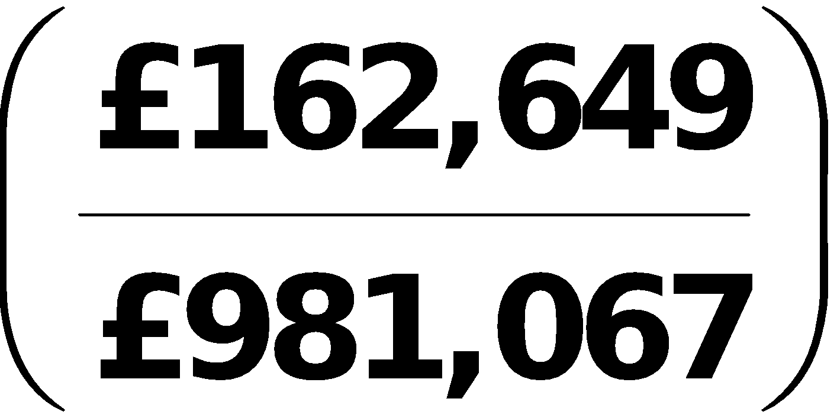a is higher than Barrymore’s return on assets of 6.6% 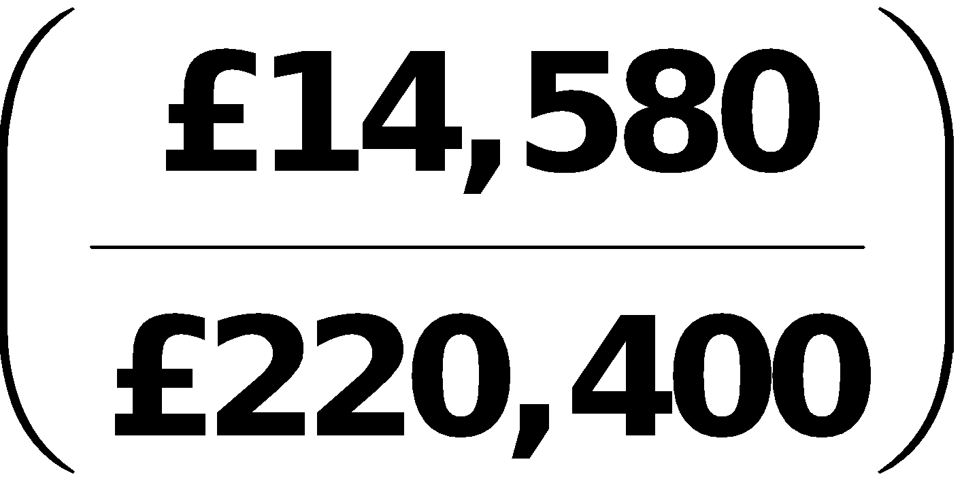b. Also, Lionel’s return on ordinary shareholders’ equity of 19.9% 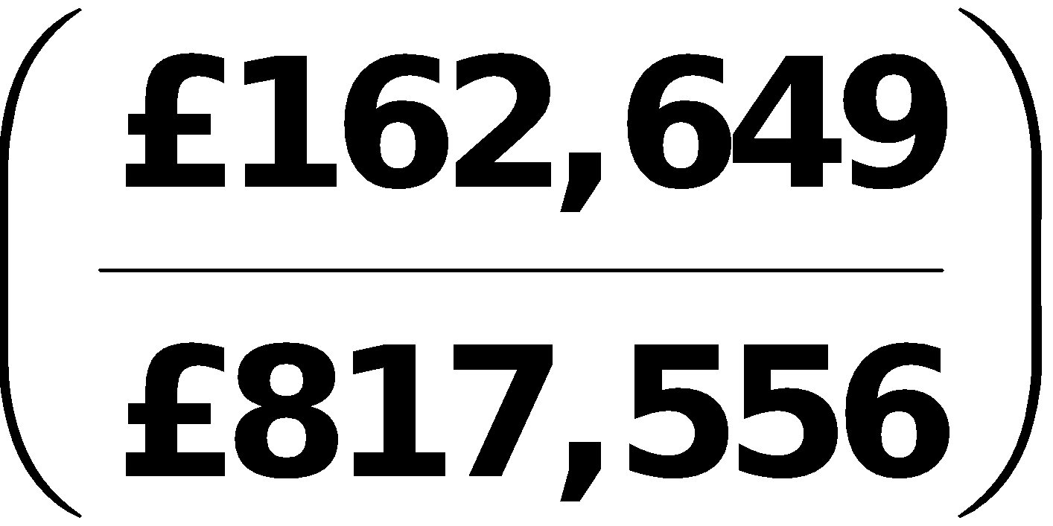c is higher than Barrymore’s return on ordinary shareholders’ equity of 7.7% 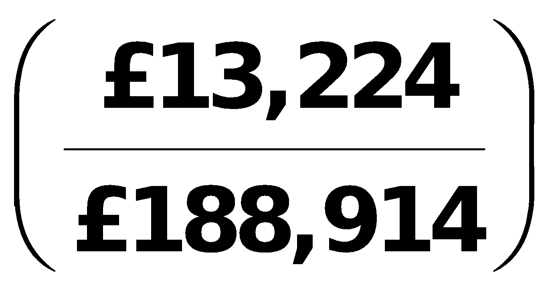d.**

**PROBLEM 14-1 (Continued)**

**a₤162,649 is Lionel’s 2017 net income. ₤981,067 is Lionel’s 2017 average assets:**

|  |  |  |  |  |  |  |  |  |
| --- | --- | --- | --- | --- | --- | --- | --- | --- |
|  |  |  | **2017** |  | **2016** |  |  |  |
|  | **Plant assets Current assets**  **Total assets** |  | **₤596,920  401,584**  **₤998,504** | **+** | **₤575,610**  **388,020**  **₤963,630** | **=** |  |  |

**b₤13 ,224 is Barrymore’s 2017 net income. $220,400 is Barrymore’s 2017 average assets:**

|  |  |  |  |  |  |  |  |  |
| --- | --- | --- | --- | --- | --- | --- | --- | --- |
|  |  |  | **2017** |  | **2016** |  |  |  |
|  | **Plant assets**  **Current assets Total assets** |  | **₤142,842   86,450**  **₤229,292** | **+** | **₤128,927**  **82,581**  **₤211,508** | **=** |  |  |

**c₤162,649 is Lionel’s 2017 net income. $817,556 is Lionel’s 2017 average ordinary shareholders’ equity:**

|  |  |  |  |  |  |  |  |  |
| --- | --- | --- | --- | --- | --- | --- | --- | --- |
|  |  |  | **2017** |  | **2016** |  |  |  |
|  | **Share capital ordinary**  **Retained earnings**  **Total equity** |  | **₤578,765**  **252,224**  **₤830,989** | **+** | **₤578,765**  **225,358**  **₤804,123** | **=** |  |  |

**d₤13,224 is Barrymore’s 2017 net income. ₤188,914 is Barrymore’s 2017 average ordinary shareholders’ equity:**

|  |  |  |  |  |  |  |  |  |
| --- | --- | --- | --- | --- | --- | --- | --- | --- |
|  |  |  | **2017** |  | **2016** |  |  |  |
|  | **Share capital ordinary**  **Retained earnings**  **Total equity** |  | **₤137,435**  **55,528**  **₤192,963** | **+** | **₤137,435**  **47,430**  **₤184,865** | **=** |  |  |

|  |
| --- |
| **PROBLEM 14-2** |

**(a) Earnings per share = 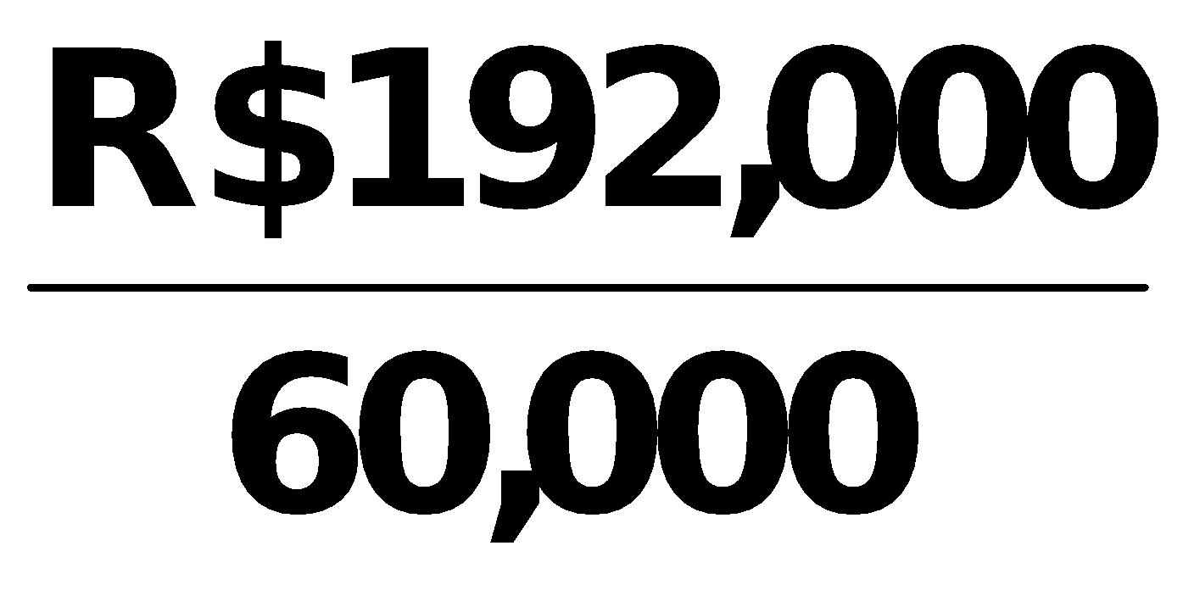 = R$3.20.**

**(b) Return on ordinary shareholders’ equity =** 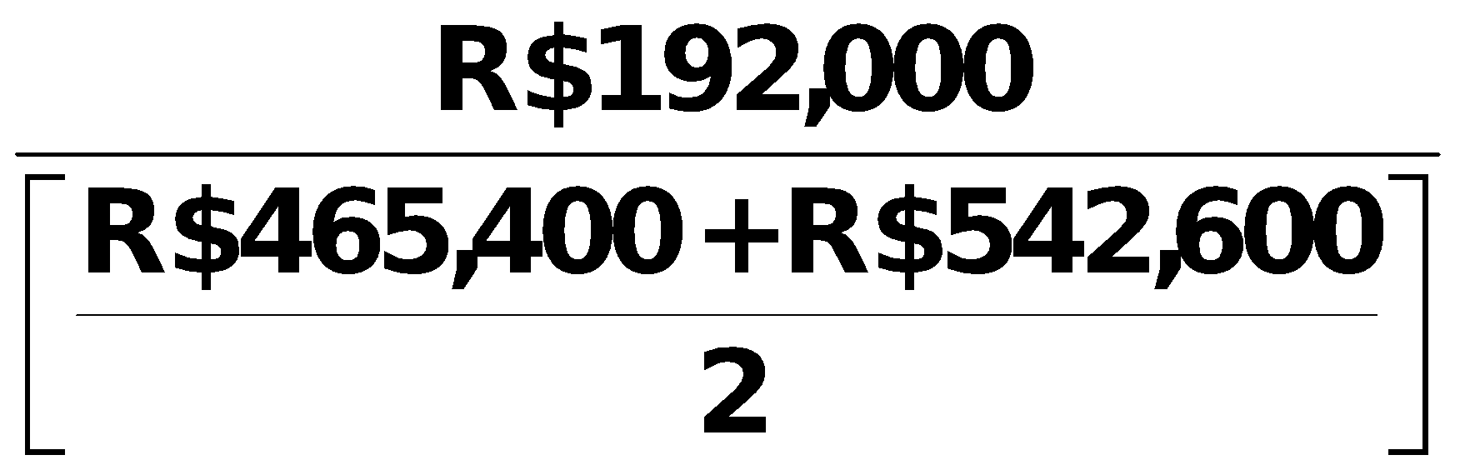

**=** 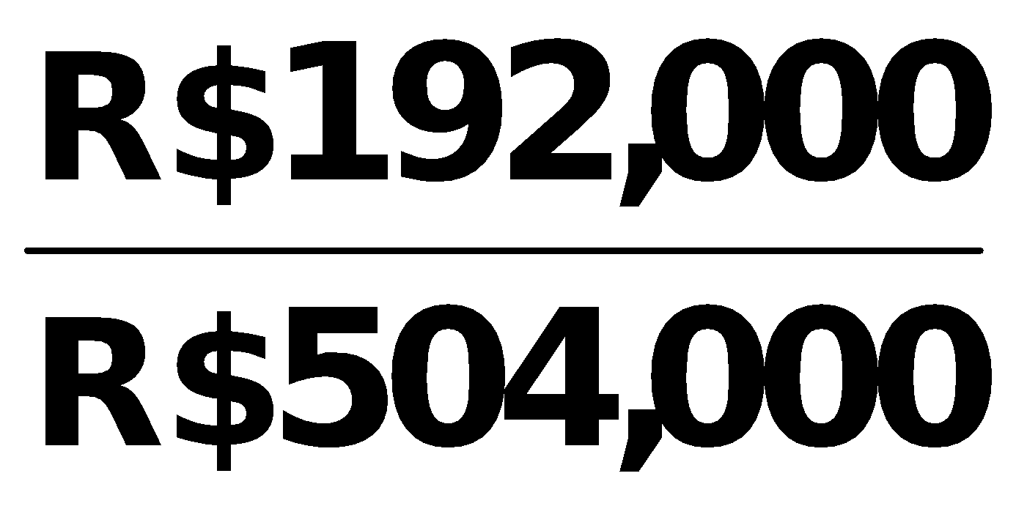

**= 38.1%.**

**(c) Return on assets = 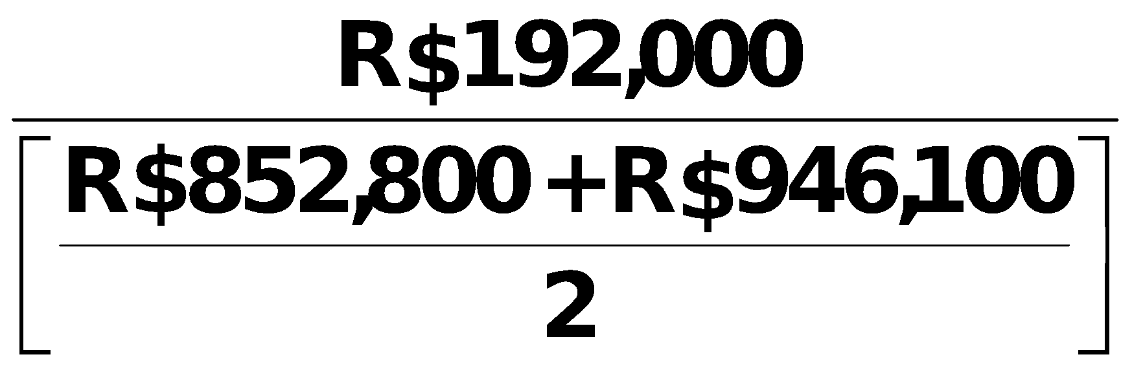 = 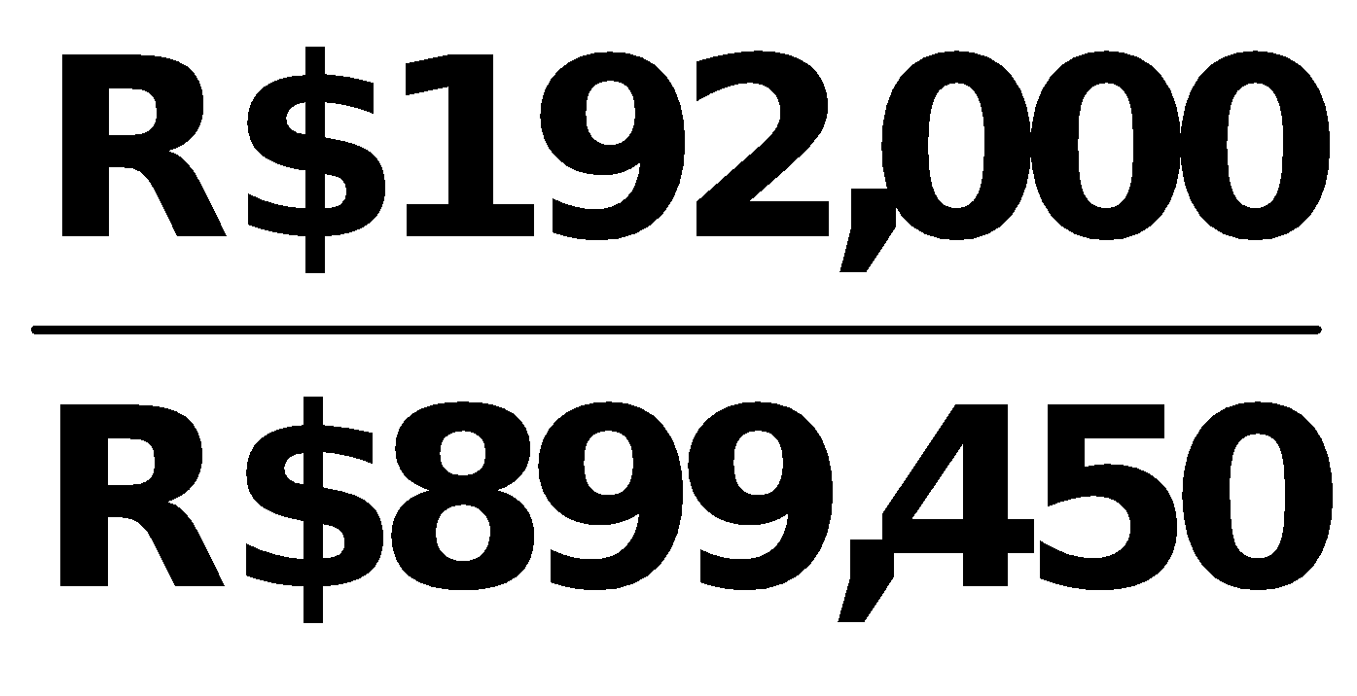 = 21.3%.**

**(d) Current ratio = 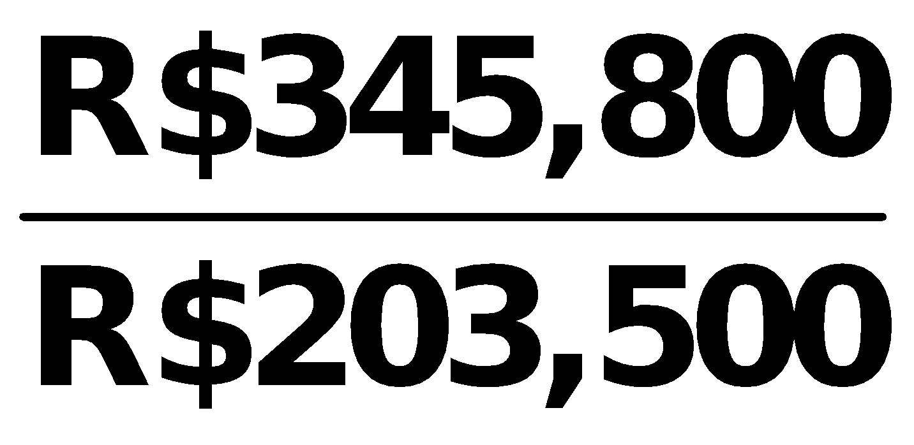 = 1.70:1**

**(e) Acid-test ratio = 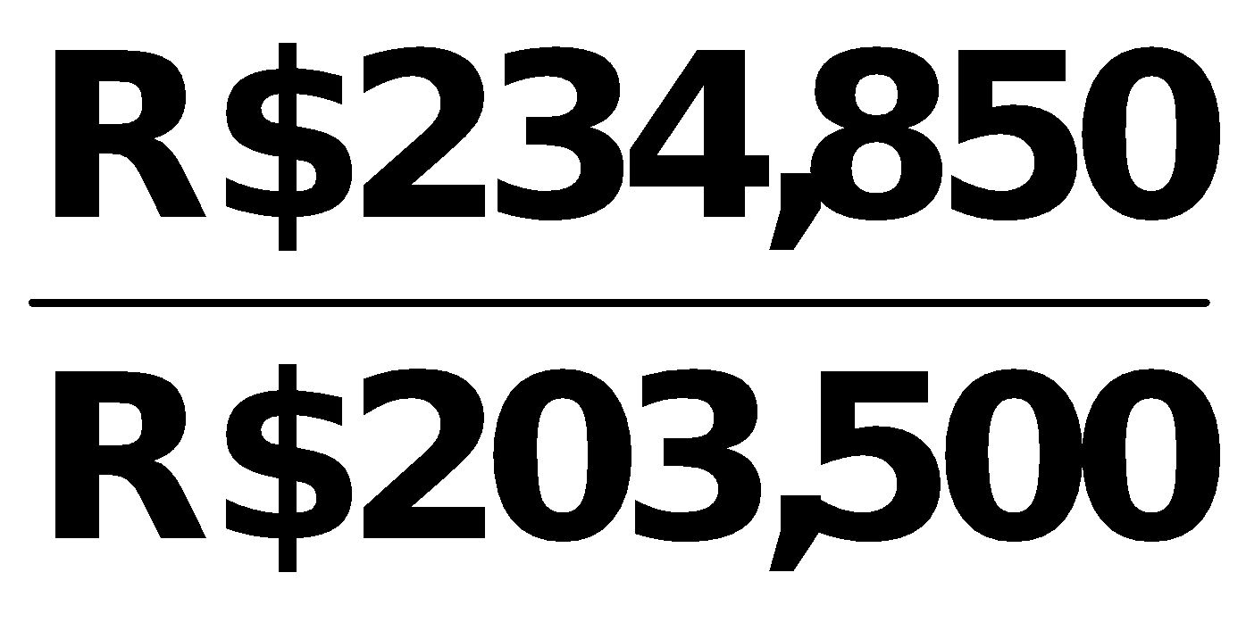 = 1.15:1**

**(f) Accounts receivable turnover =** 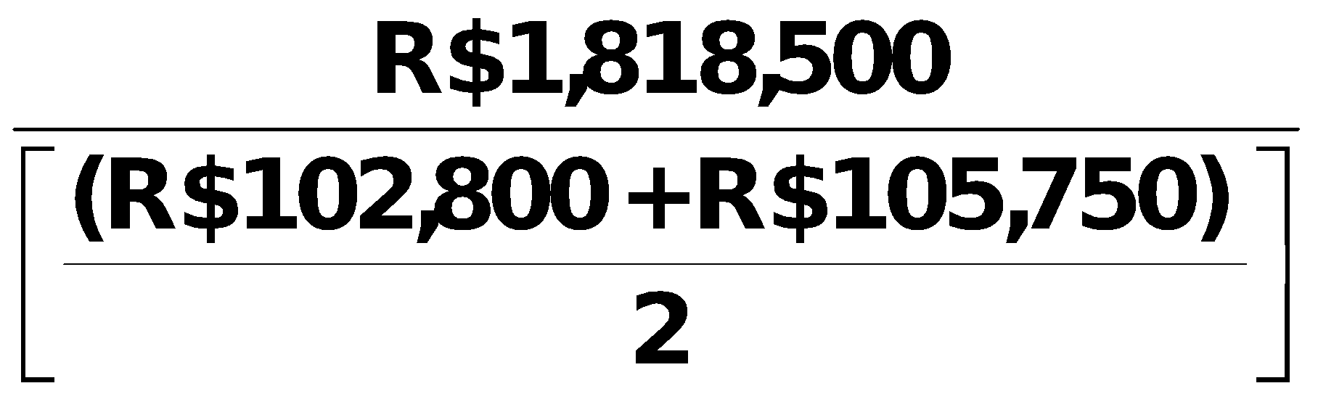

**=** 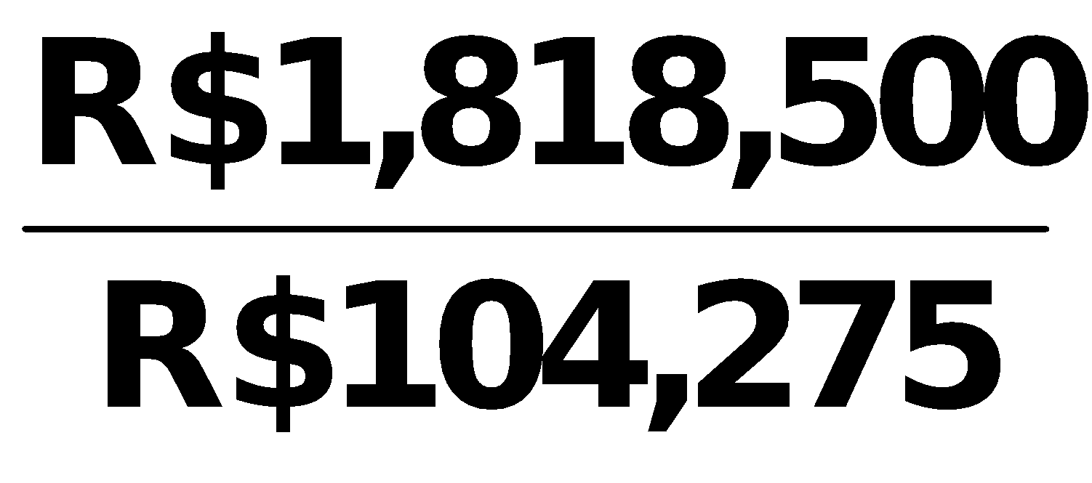

**= 17.4 times.**

**PROBLEM 14-2 (Continued)**

**(g) Inventory turnover = 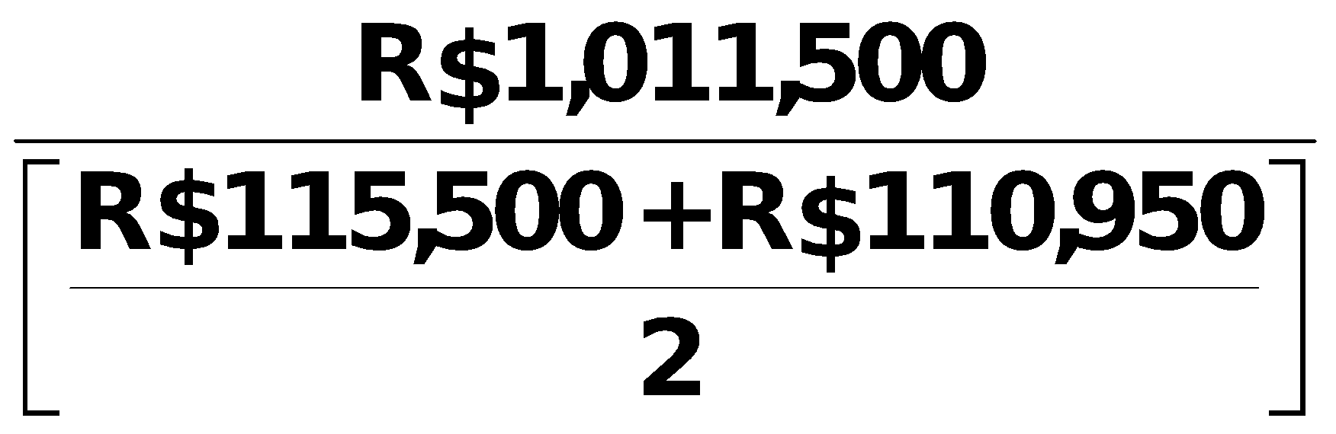 =** 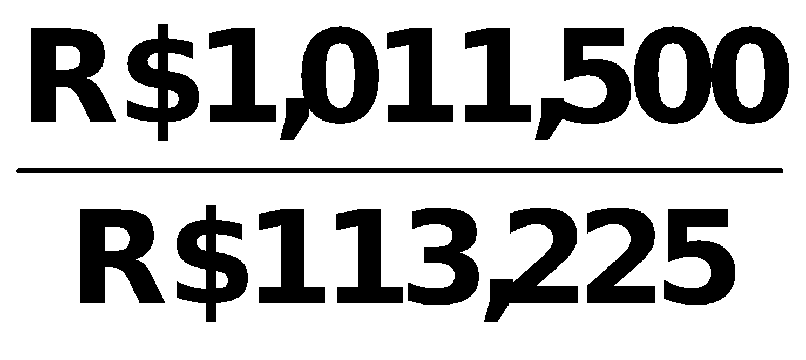

**= 8.9 times.**

**(h) Times interest earned = 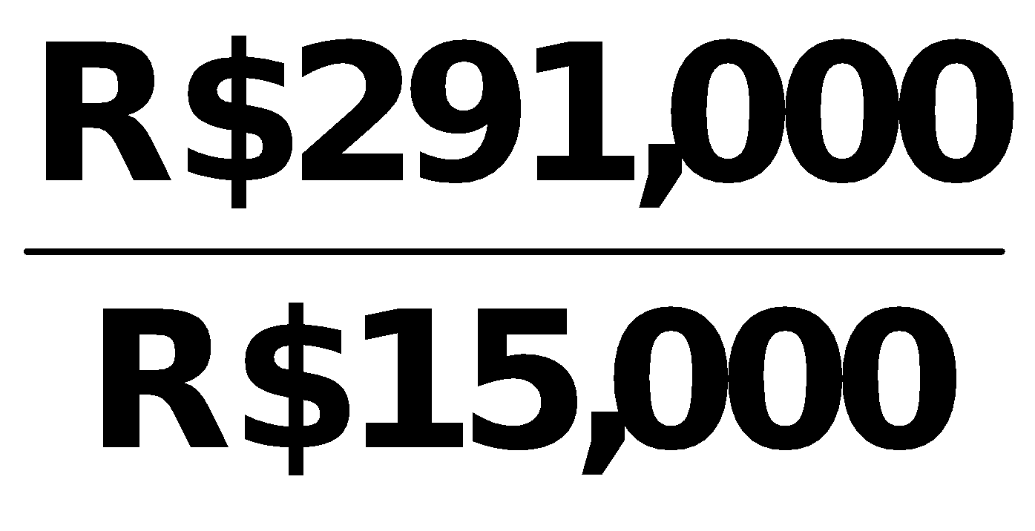 = 19.4 times.**

**(i) Asset turnover = 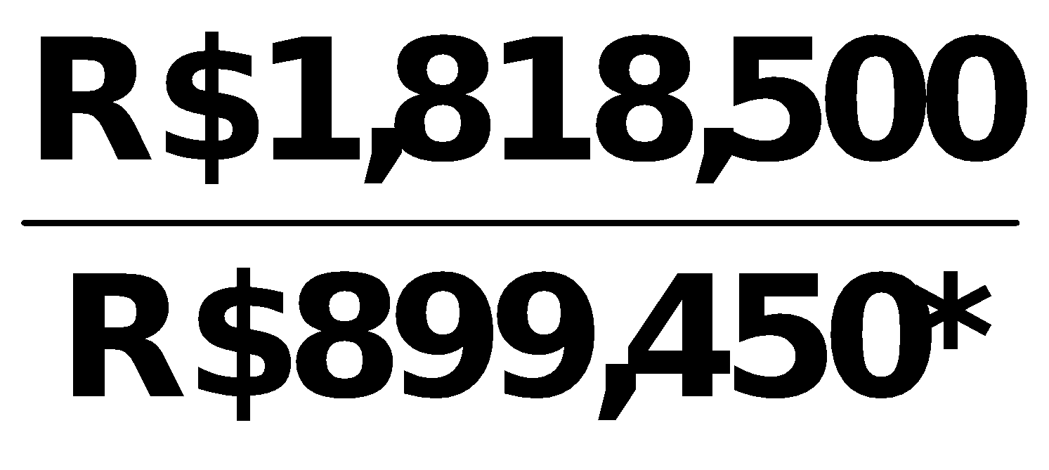 = 2.0 times.**

**\*(R$852,800 + R$946,100) ÷ 2**

**(j) Debt to assets = 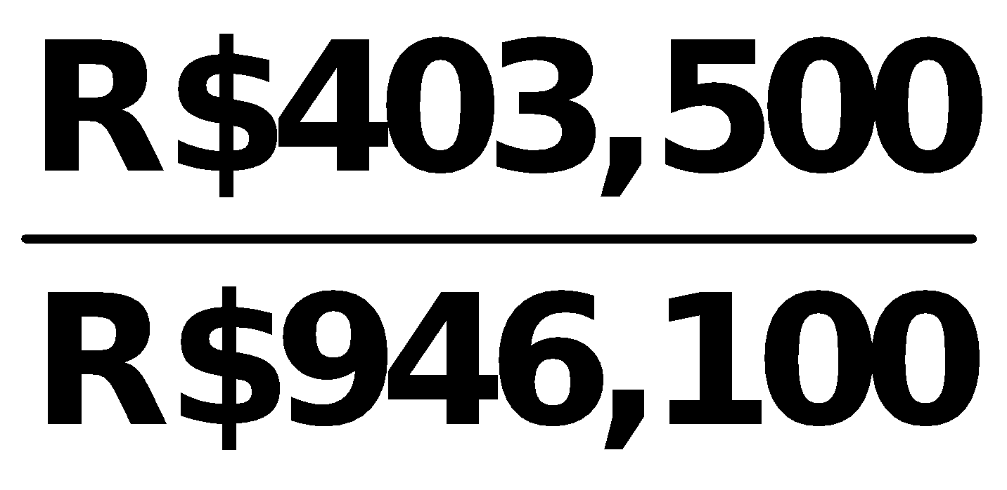 = 42.6%.**

|  |
| --- |
| **PROBLEM 14-3** |

|  |  |  |  |  |
| --- | --- | --- | --- | --- |
| **(a)** |  | **2016** |  | **2017** |
|  |  |  |  |  |
|  | **(1)** | **Profit margin.**  **= 4.7%** |  | **= 6.3%** |
|  |  |  |  |  |
|  | **(2)** | **Asset turnover.**  **= 1.1 times** |  | **= 1.1 times** |
|  |  |  |  |  |
|  | **(3)** | **Earnings per share.**  **= ₤0.97** |  | **= ₤1.38** |
|  |  |  |  |  |
|  | **(4)** | **Price-earnings ratio.**  **= 5.2 times** |  | **= 5.1 times** |
|  |  |  |  |  |
|  | **(5)** | **Payout ratio.**  **= 66.7%**  **\*(₤113,000 + ₤30,000 – ₤123,000)** |  | **= 50.0%**  **\*\*(₤123,000 + ₤44,000 – ₤145,000)** |
|  |  |  |  |  |
|  | **(6)** | **Debt to assets.**  **= 27.0%** |  | **= 23.4%** |

**PROBLEM 14-3 (Continued)**

**(b) The underlying profitability of the corporation appears to have improved. For example, profit margin and earnings per share have both increased. Also, the corporation appears to be involved in attempting to reduce its debt burden as its debt to assets ratio has decreased. Similarly, its payout ratio has decreased, which should help its overall solvency.**

|  |
| --- |
| **PROBLEM 14-4** |

**(a) LIQUIDITY**

|  |  |  |  |  |  |  |  |
| --- | --- | --- | --- | --- | --- | --- | --- |
|  |  |  | **2015** |  | **2016** |  | **Change** |
|  |  |  |  |  |  |  |  |
|  | **Current** |  | **= 1.9:1** |  | **=1.9:1** |  | **No change** |
|  |  |  |  |  |  |  |  |
|  | **Acid-test** |  | **= 1.0:1** |  | **= 1.1:1** |  | **Increase** |
|  |  |  |  |  |  |  |  |
|  | **Accounts receivable**  **turnover** |  | **= 9.5 times** |  | **= 9.6 times** |  | **Increase** |

**\*(€88,000 + €80,000) ÷ 2 **(€80,000 + €98,000) ÷ 2**

|  |  |  |  |  |  |  |  |
| --- | --- | --- | --- | --- | --- | --- | --- |
|  | **Inventory**  **turnover** |  | **= 4.5 times** |  | **= 4.7 times** |  | **Increase** |

\***(€118,000 + €135,000) ÷ 2 **(€135,000 + €125,000) ÷ 2**

**An overall increase in short-term liquidity has occurred.**

**PROFITABILITY**

|  |  |  |  |  |  |  |  |  |  |
| --- | --- | --- | --- | --- | --- | --- | --- | --- | --- |
|  | **Profit**  **margin** |  | **= 5.3%** | |  | **= 5.0%** | |  | **Decrease** |
|  |  |  |  | |  |  | |  |  |
|  | **Asset**  **turnover** |  | **= 1.2 times** | |  | **= 1.3 times** | |  | **Increase** |
|  | **\*(€632,000 + €648,000) ÷ 2 **(€648,000 + €672,000) ÷ 2** | | | | | | | | |
|  | **Return on**  **assets** |  | **= 6.6%** |  | | | **= 6.4%** |  | **Decrease** |
|  |  |  |  |  | | |  |  |  |
|  | **Earnings**  **per share** |  | **= €2.10** |  | | | **= €2.13** |  | **Increase** |

**Profitability has remained relatively the same.**

**PROBLEM 14-4 (Continued)**

|  |  |  |  |  |  |  |  |  |
| --- | --- | --- | --- | --- | --- | --- | --- | --- |
| **(b)** |  |  |  | **2016** |  | **2017** |  | **Change** |
|  |  |  |  |  |  |  |  |  |
|  | **1.** | **Return on**  **ordinary**  **shareholders’ equity** |  | **= 13.2%** |  | **= 11.2%** |  | **Decrease** |
|  |  |  |  |  |  |  |  |  |
|  | **2.** | **Debt to assets** |  | **= 50.9%** |  | **= 34.6%** |  | **Decrease** |
|  |  |  |  |  |  |  |  |  |
|  | **3.** | **Price-earnings**  **ratio** |  | **= 4.2 times** |  | **= 5.0 times** |  | **Increase** |

**(a) (€200,000 + €130,000 + €200,000 + €116,000) ÷ 2.**

**(b) (€380,000 + €180,000 + €200,000 + €130,000) ÷ 2.**

**(c) €100,000 + €48,000 + €44,000 + €150,000.**

**(d) €50,000 ÷ 20,000.**

|  |
| --- |
| **PROBLEM 14-5** |

|  |  |  |  |  |  |
| --- | --- | --- | --- | --- | --- |
| **(a)** | **Ratio** |  | **Target** |  | **Wal-Mart** |
|  |  |  |  |  |  |
|  |  |  | **(All Dollars Are in Millions)** |  |  |
|  |  |  |  |  |  |
| **(1)**  **(2)**    **(3)**  **(4)**  **(5)**  **(6)**  **(7)**  **(8)**  **(9)**  **(10)**  **(11)** | **Current**  **Accounts receivable   turnover**  **Average collection**  **period**  **Inventory turnover**  **Days in inventory**  **Profit margin**  **Asset turnover**  **Return on assets**  **Return on ordinary**  **shareholders’ equity**  **Debt to total assets**  **Times interest earned** |  | **.9:1 ($11,573 ÷ $12,777)**    **24.9 ($72,596 ÷ $2,921)**    **14.7 (365 ÷ 24.9)**  **6.1 ($51,160 ÷ $8,335)**  **59.8 (365 ÷ 6.1)**  **2.7% ($1,971 ÷ $72,596)**  **1.6 ($72,596 ÷ $46,358a)**  **4.3 % ($1,971 ÷ $46,358a)**  **12.0 % ($1,971 ÷ $16,394.5b)**  **63.6% ($28,322 ÷ $44,553)**  **3.8 ($4,229 ÷ $1,126)** |  | **.9:1 ($61,185 ÷ $69,345)**    **70.8 ($476,294 ÷ $6,723)**    **5.2 (365 ÷ 70.8)**  **8.1 ($358,069 ÷ $44,331)**  **45.1 (365 ÷ 8.1)**  **3.3% ($16,022 ÷ $476,294)**  **2.3 ($476,294 ÷ $203,928c)**  **7.9 % ($16,022 ÷ $203,928c)**  **19.7% ($16,022 ÷ $81,538.5d)**  **60.3% ($123,412 ÷ $204,751)**  **11.3 ($26,462 ÷ $2,335)** |
|  |  |  |  |  |  |

**a($44,553 + $48,163) ÷ 2 c($204,751 + $203,105) ÷ 2**

**b($16,231 + $16,558) ÷ 2 d($81,339 + $81,738) ÷ 2**

**(b) The comparison of the two companies shows the following:**

**Liquidity—Target’s current ratio of .9:1 is the same as Wal-Mart’s, .9:1. However, Wal-Mart has a better inventory turnover ratio than Target and its accounts receivable turnover is substantially better than Target’s.**

**Profitability—Wal-Mart betters Target in all of the profitability ratios. Thus, it is more profitable than Target.**

**Solvency—Wal-Mart betters Target in both of the solvency ratios. Thus, it is more solvent than Target.**

|  |
| --- |
| **PROBLEM 14-6** |

**(a) Current ratio = 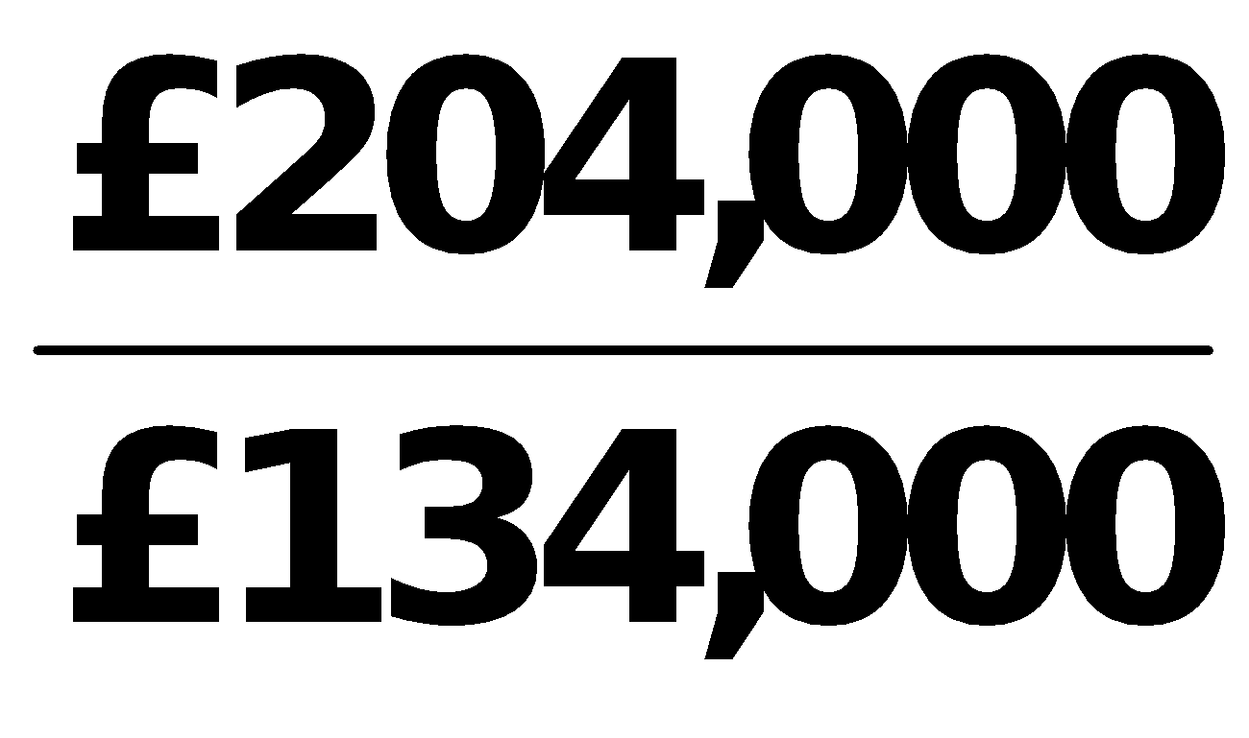 = 1.5:1.**

**(b) Acid-test ratio = 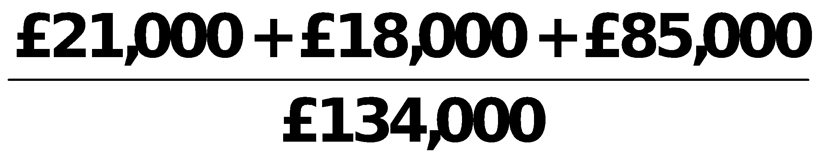 = 0.93:1.**

**(c) Accounts receivable turnover =** 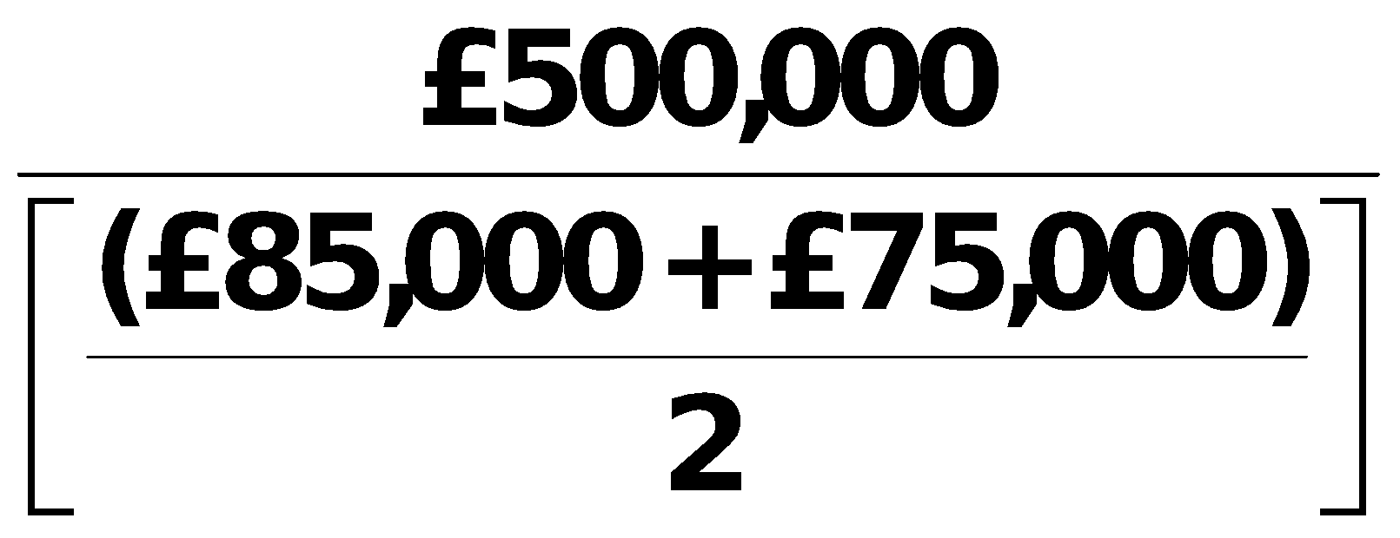

**= 6.3 times.**

**(d) Inventory turnover = 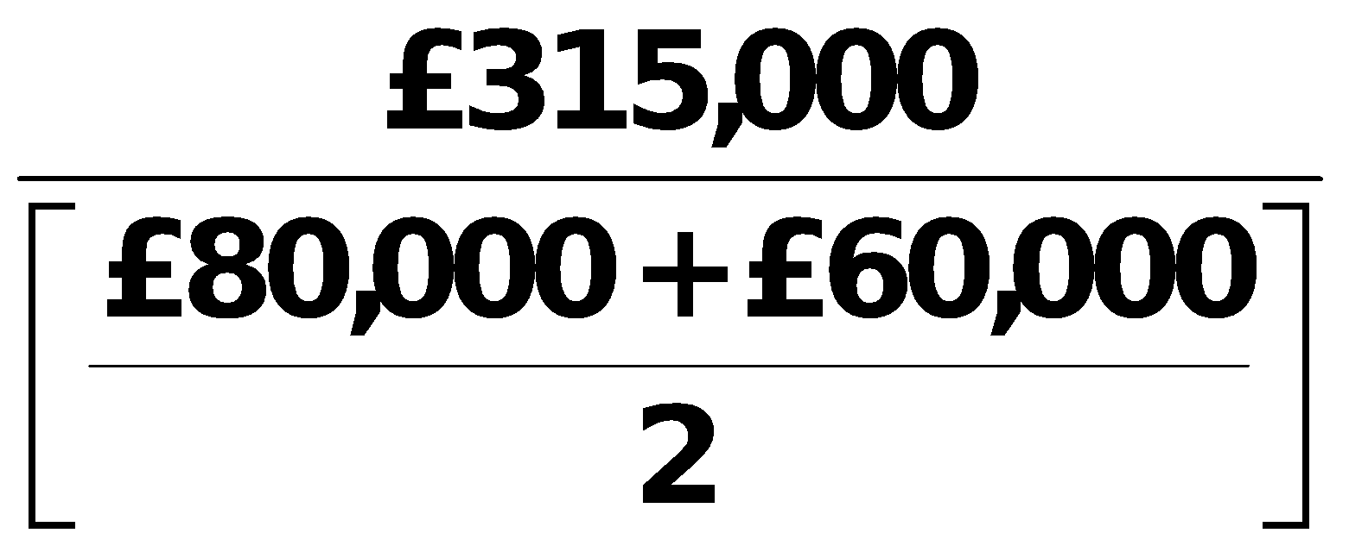 = 4.5 times.**

**(e) Profit margin ratio = 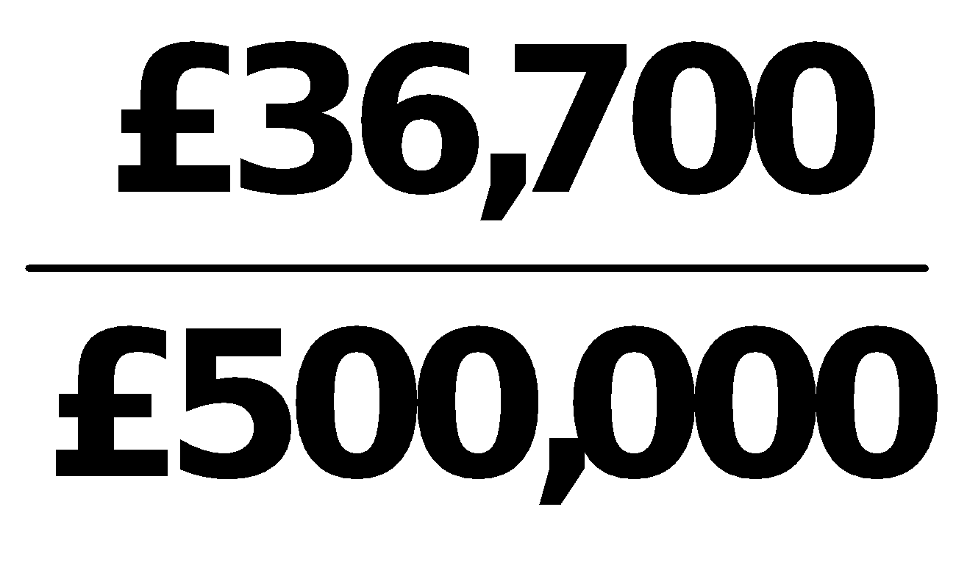 = 7.3%.**

**(f) Asset turnover = 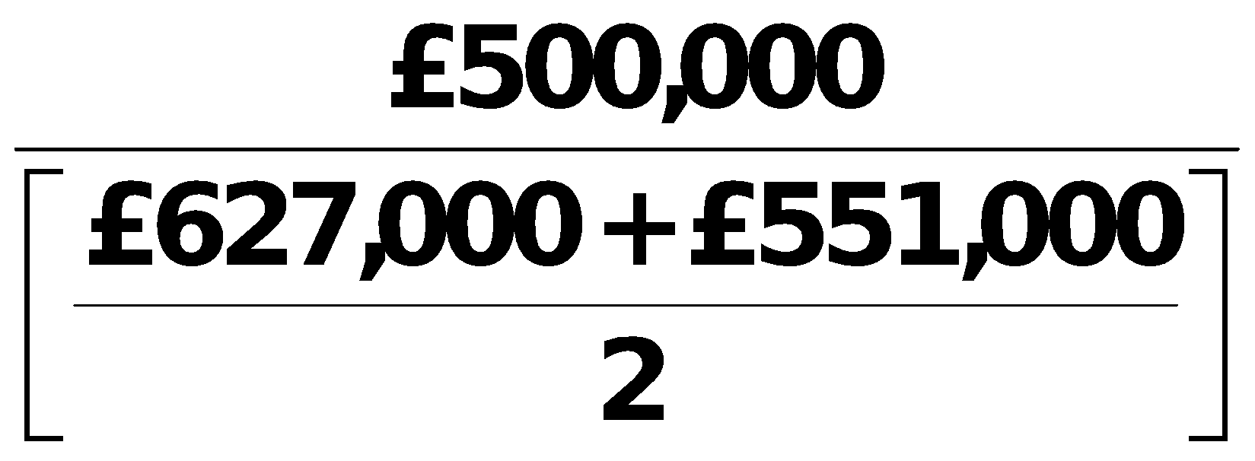 = 0.8 times.**

**(g) Return on assets = 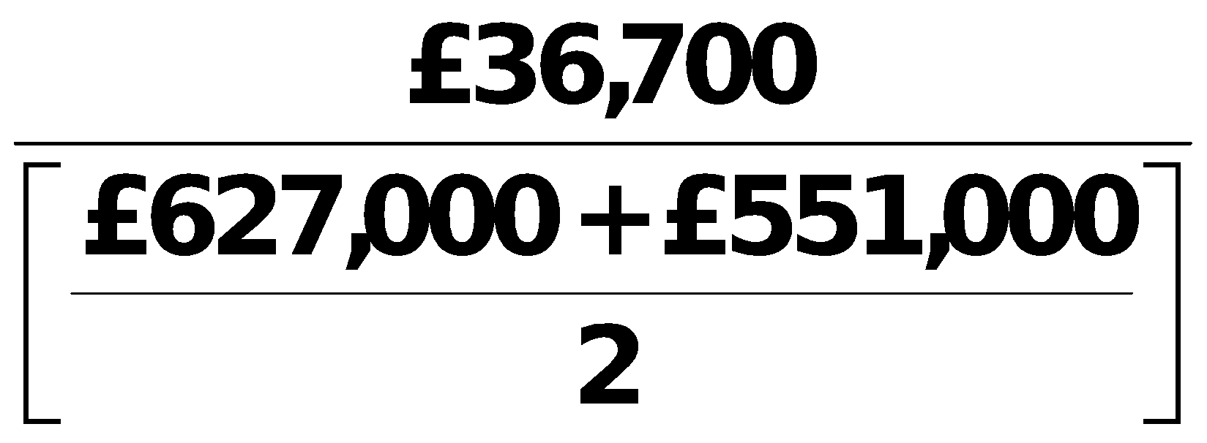 = 6.2%.**

**(h) Return on ordinary shareholders’ equity =** 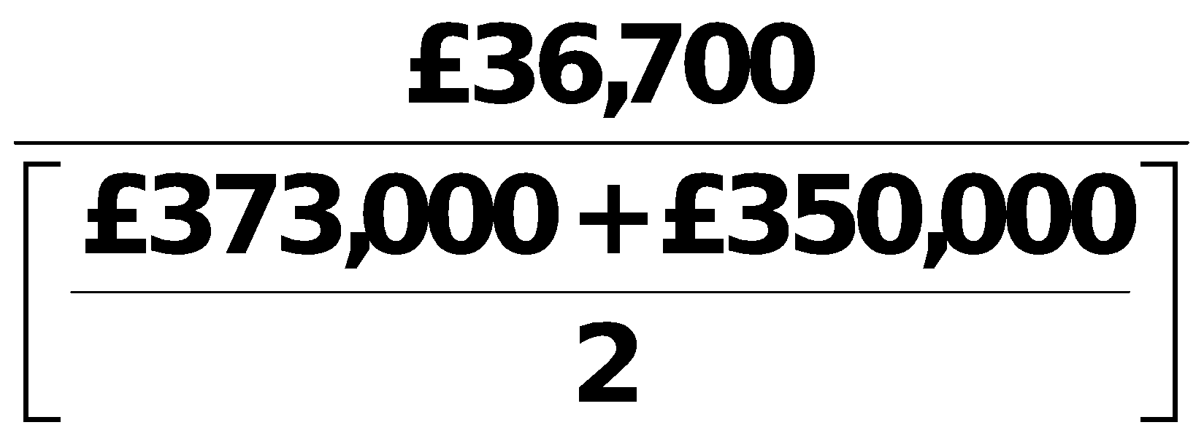

**= 10.2%.**

**PROBLEM 14-6 (Continued)**

**(i) Earnings per share = 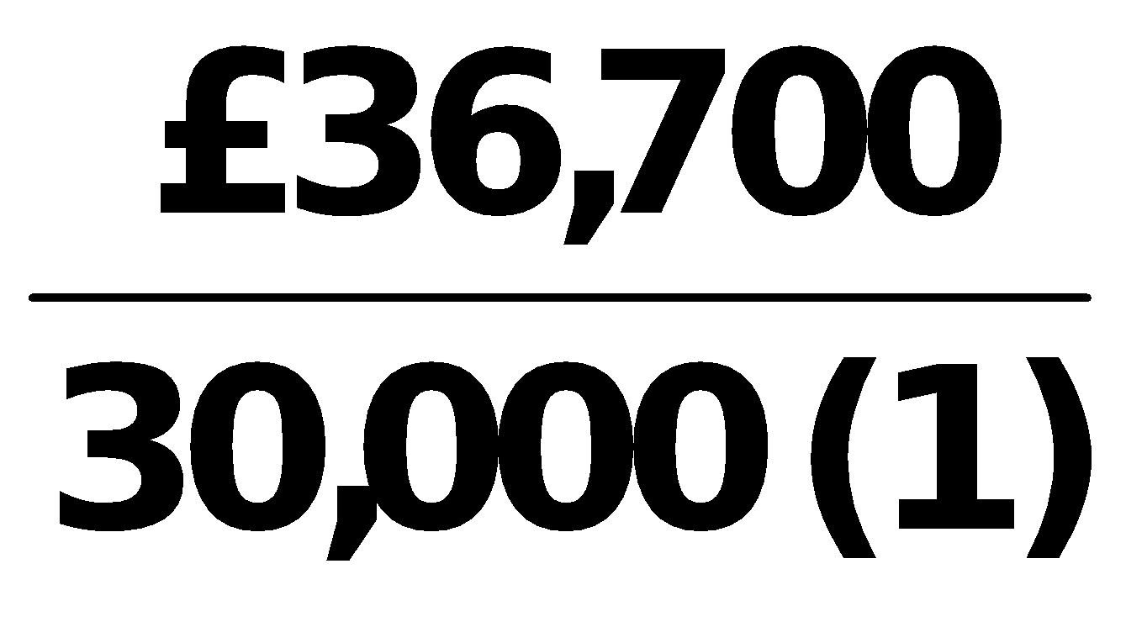 = £1.22.**

**(1) £150,000 ÷ £5.00**

**(j) Price-earnings ratio = 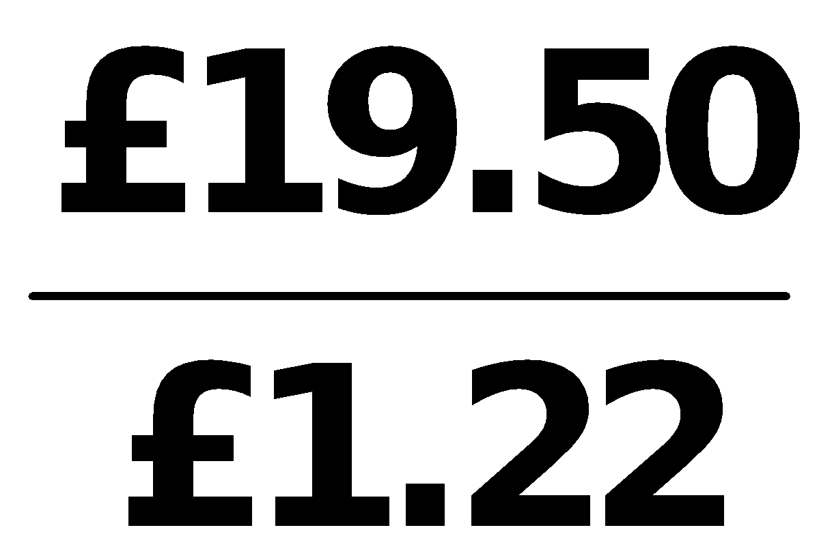 = 16.0 times.**

**(k) Payout ratio = 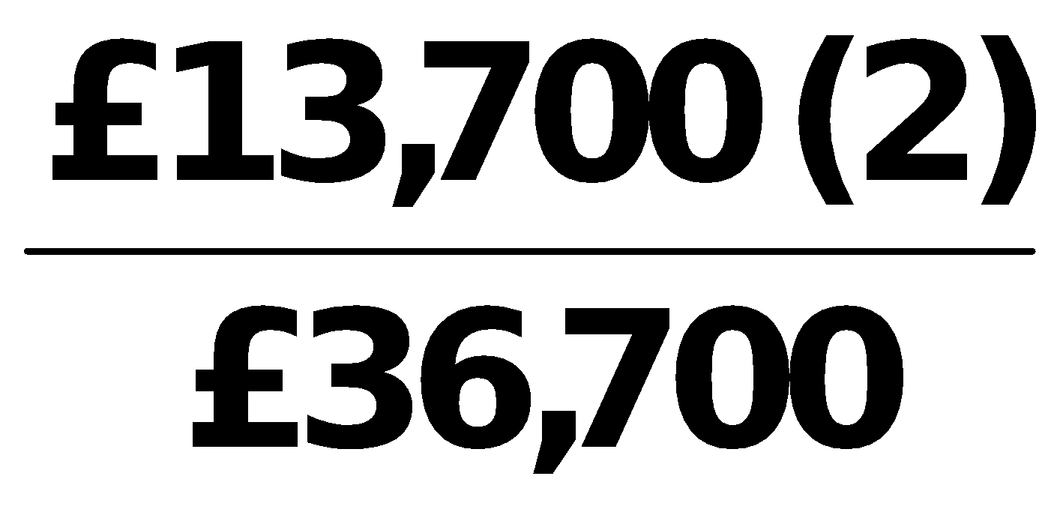 = 37.3%.**

**(2) £200,000 + £36,700 – £223,000**

**(l) Debt to assets = 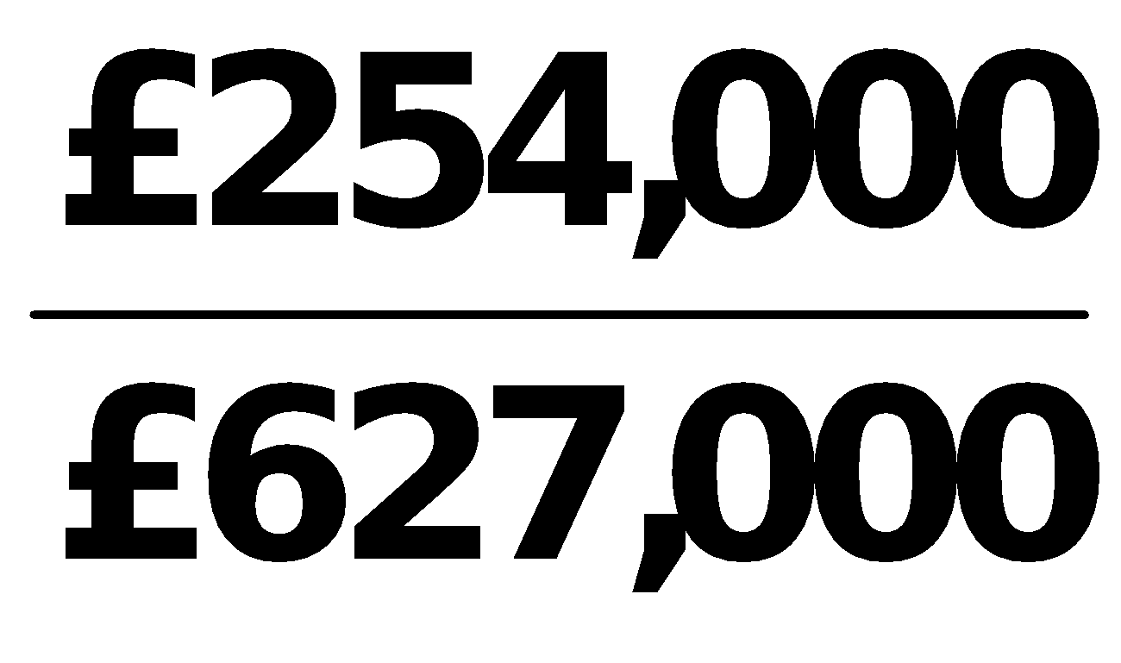 = 40.5%.**

**(m) Times interest earned = 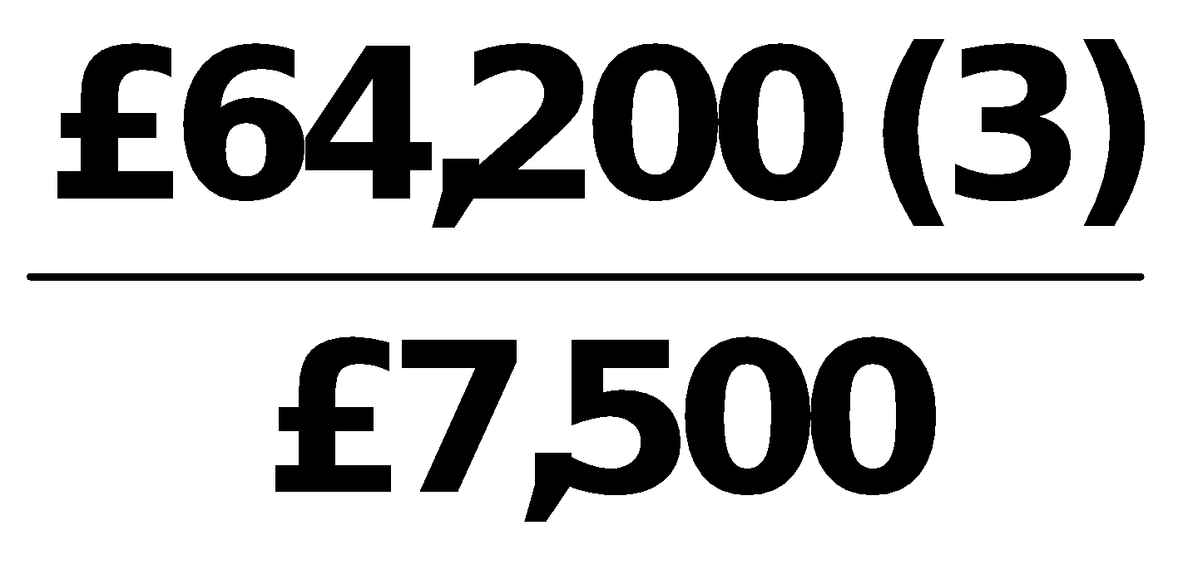 = 8.6 times.**

**(3) £36,700 + £20,000 + £7,500**

|  |
| --- |
| **PROBLEM 14-7** |

**Accounts receivable turnover = 8 = **

**Average net accounts receivable = 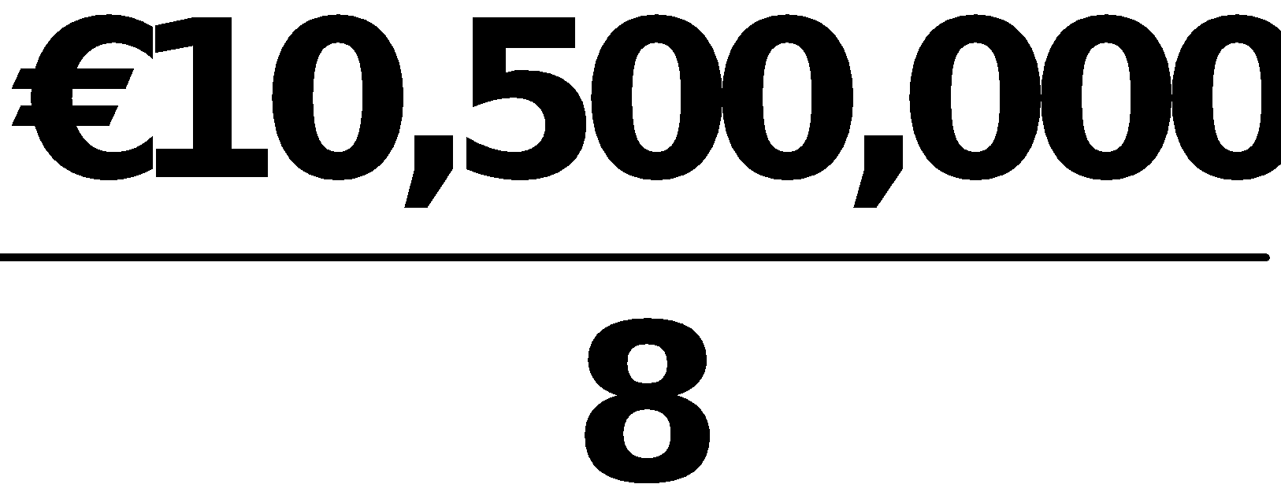 = €1,312,500**

** = €1,312,500**

**Net accounts receivable 12/31/17 + €1,050,000 = €2,625,000**

**Net accounts receivable 12/31/17 = €1,575,000**

**Profit margin = 14.5% = .145 = **

**Net income = €10,500,000 X .145 = €1,522,500**

**Income before income taxes = €1,522,500 + €550,000 = €2,072,500**

**Return on assets = 20% = .20 =** 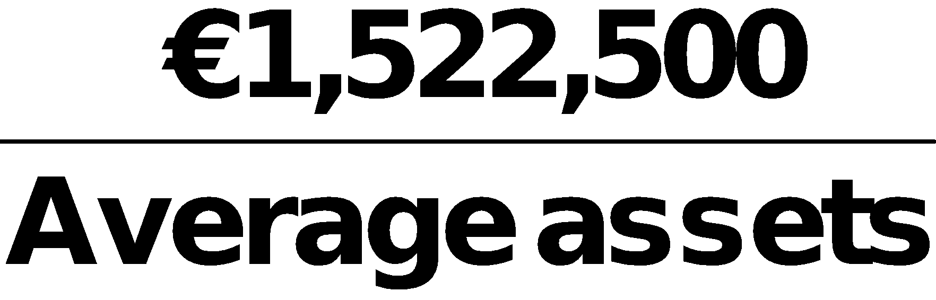

**Average assets = €1,522,500 ÷ .20 = €7,612,500**

** = €7,612,500**

**Assets (12/31/17) = €7,725,000**

**Total current assets = €7,725,000 – €4,620,000 = €3,105,000**

**Inventory = €3,105,000 – € 1,575,000 – €480,000 = €1,050,000**

**Total liabilities and equity = €7,725,000**

**Total liabilities = €7,725,000 – €3,400,000 = €4,325,000**

**PROBLEM 14-7 (Continued)**

**Current ratio = 2.5 = **

**Current liabilities = €3,105,000 ÷ 2.5 = $1,242,000**

**Long-term notes payable = $4,325,000 – $1,242,000 = $3,083,000**

**Inventory turnover = 4.2 =** 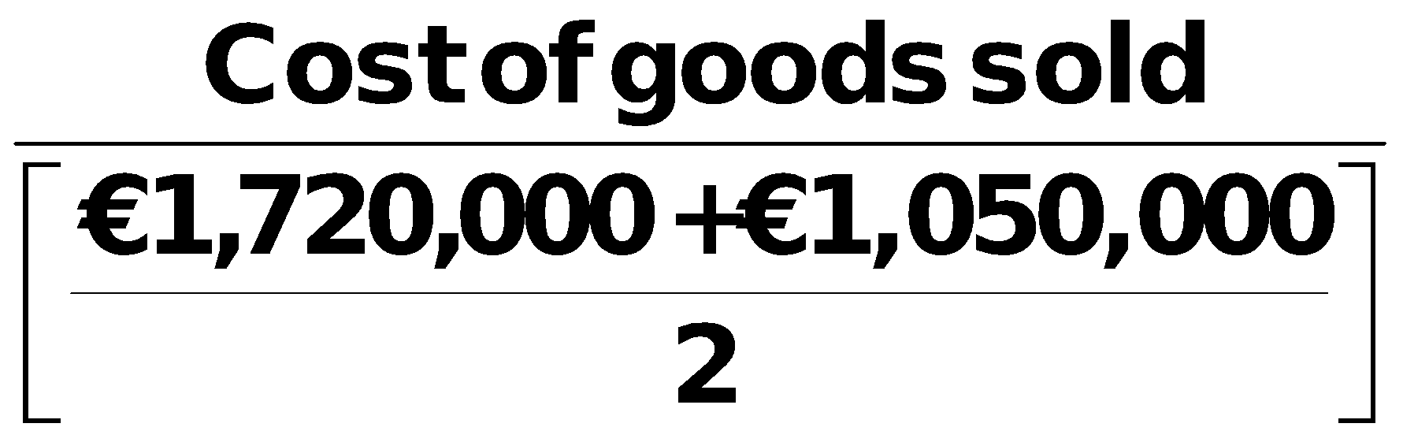

**Cost of goods sold = €1,385,000 X 4.9 = €6,786,500**

**Gross profit = €10,500,000 – €6,786,500 = €3,713,500**

**Income from operations = €3,713,500 – €1,500,000 = €2,213,500**

**Interest expense = €2,213,500 – €2,072,500 = €141,000**

|  |
| --- |
| **PROBLEM 14-8** |

**VIOLET BICK SA**

**Condensed Statement of Comprehensive Income**

**For the Year Ended December 31, 2017**

**Operating revenues**

**(€12,900,000 – €2,000,000) €10,900,000**

**Operating expenses**

**(€8,700,000 – €2,500,000) 6,200,000**

**Income from operations  4,700,000**

**Other expenses and losses 200,000**

**Income before income taxes  4,500,000**

**Income tax expense (€4,500,000 X 30%) 1,350,000**

**Income from continuing operations  3,150,000**

**Discontinued operations**

**Loss from operations of hotel**

**chain*, net of €150,000 income**

**tax saving (€350,000)**

**Gain on sale of hotels, net of**

**€90,000 income taxes 210,000 (140,000)**

**Net income 3,010,000**

**Other comprehensive income**

**Unrealized gain on**

**non-trading securities, net of**

**€45,000 income tax 105,000**

**Comprehensive income € 3,115,000**

**\*€2,000,000 – €2,500,000 = (€500,000)**

|  |
| --- |
| **PROBLEM 14-9** |

**GOWER LIMITED**

**Statement of Comprehensive Income**

**For the Year Ended December 31, 2017**

**Net sales ₤1,580,000**

**Cost of goods sold 1,100,000**

**Gross profit    480,000**

**Selling and administrative expenses 160,000**

**Income from operations    320,000**

**Other income and expense (6,000)**

**Income before income taxes    314,000**

**Income tax expense (₤314,000 X 30%) 94,200**

**Income from continuing operations    219,800**

**Discontinued operations**

**Income from operations of discontinued**

**division, net of ₤4,500 income taxes  10,500**

**Loss on sale of discontinued division,**

**net of ₤22,200 income tax saving (51,800) (41,300)**

**Net income 178,500**

**Other Comprehensive income**

**Unrealized gain on**

**nontrading securities, net of**

**₤36,000 income taxes 84,000**

**Comprehensive income ₤ 262,500**

|  |
| --- |
| **MC14 MATCHA CREATIONS** |

|  |  |  |
| --- | --- | --- |
| **(a)** | **1.** | **Current ratio**  **$107,366**  **$38,976**  **= 2.75:1** |
|  |  |  |
|  | **2.** | **Accounts receivable turnover**  **= 142.3 times** |
|  |  |  |
|  | **3.** | **Inventory turnover**  **= 12.9 times** |
|  |  |  |
|  | **4.** | **Debt to assets**  **= 30.2%** |
|  |  |  |
|  | **5.** | **Times interest earned**    **= 239 times** |
|  |  |  |
|  | **6.** | **Gross profit rate**  **= 50.0%** |
|  |  |  |
|  | **7.** | **Profit margin**  **= 17.0%** |

**MC14 (Continued)**

**(a) (Continued)**

|  |  |  |
| --- | --- | --- |
|  | **8.** | **Asset turnover**  **= 3.1 times** |
|  |  |  |
|  | **9.** | **Return on assets**  **= 52.8%** |
|  |  |  |
|  | **10.** | **Return on common stockholders’ equity**  **= 75.6%** |

**(b) The company had a very good year. It was very profitable and has a healthy balance sheet. The company is carrying very little debt and can cover the interest charges easily. There are no liquidity or solvency problems.**

**(c) The bank should have no qualms about lending money to the company. The new debt ratio would still be reasonably low [($44,976 + $20,000) ÷ ($149,166 + $20,000) = 38.4%]. Even if there were no increases in revenue, operating income would still be more than adequate to cover the additional interest expense. The company is very profitable and is an acceptable credit risk for the bank.**

**(d) Instead of bank financing, Matcha & Coffee Creations could lease the equipment. The company could also consider equity financing or paying cash for the equipment.**

|  |
| --- |
| **BYP 14-1 FINANCIAL REPORTING PROBLEM** |

**(a) (Taiwan new dollar amounts in millions)**

**(1) Profit Margin**

**2013:   NT$183,849.7 ÷ NT$597,024.2 = 30.8%**

**2012:   NT$159,286.4 ÷ NT$506,745.3 = 31.4%**

**(2) Asset Turnover**

**2013:   NT$597,024.2 ÷ [(NT$1,262,800.7 + NT$961,343.7) ÷ 2] = .54 times**

**2012:   NT$506,745.3 ÷ [(NT$961,343.7 + NT$779,541.6) ÷ 2] = .58 times**

**(3) Return on Assets**

**2013:   NT$183,849.7 ÷ [(NT$1,262,800.7 + NT$961,343.7) ÷ 2] = 16.5%**

**2012:   NT$159,286.4÷ [(NT$961,343.7 + NT$779,541.6) ÷ 2] = 18.3%**

**BYP 14-1 (Continued)**

**(4) Return on Ordinary Shareholders’ Equity**

**2013:   NT$183,849.7 ÷ [(NT$834,113.0 + NT$713,594.3) ÷ 2] = 23.8%**

**2012:   NT$159,286.4 ÷ [(NT$713,594.3 + NT$779,541.6) ÷ 2] = 21.3%**

**TSMC’S profitability decreased from 2012 to 2013.**

**(b) (dollar amounts in millions)**

**(1) Debt to Total Assets**

**2013:  NT$428,687.7 ÷ NT$1,262,800.7 = 34.0%**

**2012:  NT$247,749.4 ÷ NT$961,343.7 = 25.8%**

**(2) Times Interest Earned**

**2013:  (NT$215,961.5 + NT$2,646.8) ÷ NT$2,646.8 = 82.6 times**

**2012:  (NT$159,286.4 + NT$1,020.4) ÷ NT$1,020.4 = 157.1 times**

**Creditors provide roughly one-third of TSMC’s total assets, so its long-term solvency is not in jeopardy. TSMC’s times interest earned ratio is very high indicating that the company has the ability to pay the interest on its debt.**

**(c) Substantial amounts of important information about a company are not in its financial statements. Events involving such things as industry changes, management changes, competitors’ actions, technological developments, governmental actions, and union activities are often critical to the successful operation of a company. Financial reports in the media and publications of financial service firms (Standard & Poors, Dun & Bradstreet) will provide relevant information not usually found in the annual report.**

|  |
| --- |
| **BYP 14-2 COMPARATIVE ANALYSIS PROBLEM** |

|  |  |  |  |  |  |  |  |  |  |  |  |  |
| --- | --- | --- | --- | --- | --- | --- | --- | --- | --- | --- | --- | --- |
| **(a)** |  |  |  |  | **Petra Foods** | | |  | **Nestlé** | | | |
|  |  |  |  |  |  | | |  |  | | | |
|  | **(1)** | **(i)** | **Percentage  increase**  **in net sales** |  | **US$508,800 − US$471,647** | | **= 7.9%** |  | **CHF92,158 − CHF89,721** | | | **= 2.7%** |
| **US$471,647** | | **CHF89,721** | | |
|  |  |  |  |  |  | | |  |  | | | |
|  |  | **(ii)** | **Percentage  increase  (decrease) in  net income** |  | **US$20,555 − US$25,826** | | **= (20.4%)** |  | **CHF10,015 − CHF10,228** | | **= (2.1%)** | |
| **US$25,826** | | **CHF10,228** | |
|  |  |  |  |  |  | | |  |  | | | |
|  | **(2)** | **(i)** | **Percentage  increase**  **(decrease) in  total assets** |  | **US$465,896 − US$1,219,770** | | **= (61.8%)** |  | **CHF120,442 − CHF125,877** | | | **= (4.3%)** |
| **US$1,219,770** | | **CHF125,877** | | |
|  |  |  |  |  |  | | |  |  | | | |
|  |  | **(ii)** | **Percentage  increase  (decrease) in  total ordinary shareholders’  equity** |  | **US$290,386 − US$326,817** | | **= (11.2%)** |  | **CHF64,139 − CHF62,664** | | **= 2.4%** | |
| **US$326,817** | | **CHF62,664** | |
|  | |  |  | |  |  | | |

**Both companies had decreases in net income and total assets but Petra Foods’ amounts were much more significant, Nestle’s total Shareholders’ equity increased 2.4% white Petra Foods’ decreased.**

|  |
| --- |
| **BYP 14-3 DECISION-MAKING ACROSS THE ORGANIZATION** |

**The current ratio increase is a favorable indication as to liquidity, but alone tells little about the going-concern prospects of the client. From this ratio change alone, it is impossible to know the amount and direction of the changes in individual accounts, total current assets, and total current liabilities. Also unknown are the reasons for the changes.**

**The acid-test ratio decrease is an unfavorable indication as to liquidity, especially when the current-ratio increase is also considered. This decline is also unfavorable as to the going-concern prospects of the client because it reflects a declining cash position and raises questions as to reasons for the increases in other current assets, such as inventories.**

**The change in asset turnover cannot alone tell anything about either solvency or going-concern prospects. There is no way to know the amount and direction of the changes in sales and assets. An increase in sales would be favorable for going-concern prospects, while a decrease in assets could represent a number of possible scenarios and would need to be investigated further.**

**The increase in net income is a favorable indicator for both solvency and going-concern prospects, although much depends on the quality of receivables generated from sales and how quickly they can be converted into cash. If there has been a decline in sales, a significant factor is that management has been able to reduce costs to produce an increase in earnings. Indirectly, the improved income picture may have a favorable impact on solvency and going-concern potential by enabling the client to borrow currently (if it needs to do so) to meet cash requirements.**

**The 32-percent increase in earnings per share, which is identical to the percentage increase in net income, is an indication that there has probably been no change in the number of ordinary shares outstanding. This, in turn, indicates that financing was not obtained through the issuance of ordinary shares. It is not possible to reach conclusions about solvency and going-concern prospects without additional information about the nature and extent of financing.**

**BYP 14-3 (Continued)**

**The collective implications of these data alone are that the client entity is about as solvent and as viable a going concern at the end of the current year as it was at the beginning although there may be a need for short-term operating cash.**

|  |
| --- |
| **BYP 14-4 COMMUNICATION ACTIVITY** |

**To: Kyle Benson**

**From: Accounting Major**

**Subject: Financial Statement Analysis**

**There are two fundamental considerations in financial statement analysis: (1) the bases of comparison and (2) the factors affecting quality of earnings. Each of these considerations is explained below.**

**1. Bases of comparison. The bases of comparison are:**

**a. Intracompany—This basis compares an item or financial relationship within a company in the current year with the same item or relationship in one or more prior years.**

**b. Industry averages—This basis compares an item or financial relationship of a company with industry averages (or norms).**

**c. Intercompany—This basis compares an item or financial relationship of one company with the same item or relationship in one or more competing companies.**

**2. Factors affecting quality of earnings are:**

**a. Alternative accounting methods—Variations among companies in the application of IFRS may hamper comparability and reduce quality of earnings.**

**b. Pro forma income—This income figure usually excludes items that the company thinks are unusual or nonrecurring.**

**c. Improper recognition—Because some managers feel pressure from investors to continually increase earnings, they manipulate the earnings numbers to meet these expectations.**

|  |
| --- |
| **BYP 14-5 ETHICS CASE** |

**(a) The stakeholders in this case are:**

* **Robert Turnbull, president of Turnbull Industries.**
* **Perry Jarvis, public relations director.**
* **You, as controller of Turnbull Industries.**
* **Shareholders of Turnbull Industries.**
* **Potential investors in Turnbull Industries.**
* **Any readers of the press release.**

**(b) The president’s press release is deceptive and incomplete and to that extent his actions are unethical.**

**(c) As controller you should at least inform Perry, the public relations director, about the biased content of the release. He should be aware that the information he is about to release, while factually accurate, is deceptive and incomplete. Both the controller and the public relations director (if he agrees) have the responsibility to inform the president of the bias of the about to be released information.**

|  |
| --- |
| **GAAP EXERCISES** |

**GAAP 14-1**

**CHEN COMPANY**

**Statement of Comprehensive Income**

**For the Year Ended December 31, 2017**

**Sales revenue $1,000,000**

**Cost of goods sold 700,000**

**Gross profit    300,000**

**Operating expenses 200,000**

**Net income    100,000**

**Other comprehensive income**

**Unrealized gain on non-trading securities 75,000**

**Comprehensive income $ 175,000**

**GAAP 14-2**

**CHEN COMPANY**

**Income Statement**

**For the Year Ended December 31, 2017**

**Sales revenue $1,000,000**

**Cost of goods sold 700,000**

**Gross profit    300,000**

**Operating expenses 200,000**

**Net income $  100,000**

**CHEN COMPANY**

**Comprehensive Income Statement**

**For the Year Ended December 31, 2017**

**Net income $100,000**

**Other comprehensive income**

**Unrealized gain on non-trading**

**securities 75,000**

**Comprehensive income $175,000**

|  |
| --- |
| **GAAP 14-3 GAAP FINACIAL REPORTING PROBLEM** |

**(a) APPLE, INC.**

**Trend Analysis of Net Sales and Net Income**

**For the Three Years Ended 2013**

**Base Period 2011—(in millions)**

|  |  |  |  |  |  |  |  |  |  |
| --- | --- | --- | --- | --- | --- | --- | --- | --- | --- |
|  |  |  |  | **2013** |  | **2012** |  | **2011** |  |
|  |  |  |  |  |  |  |  |  |  |
|  | **(1)** | **Net sales**  **Trend** |  | **$170,910**  **158%** |  | **$156,508**  **144%** |  | **$108,429**  **100%** |  |
|  |  |  |  |  |  |  |  |  |  |
|  | **(2)** | **Net income**  **Trend** |  | **37,037**  **143%** |  | **41,733**  **161%** |  | **25,922**  **100%** |  |

**Between 2013 and 2011 Apple’s net sales increased by 58%. Apple’s net income increased by 61% between 2011 and 2012 and increased by almost 43% from 2011 to 2013.**

**(b) (dollar amounts in millions)**

**(1) Debt to Assets ratio**

**2013:  $83,451 ÷ $207,000 = 40.3%**

**2012:  $57,854 ÷ $176,064 = 32.9%**

**(2) Times Interest Earned**

**2013:  ($50,155 + $136) ÷ $136 = 369.8 times**

**2012:  No interest expense incurred**

**Since creditors are providing about 40% of Apple's total assets, its long-term solvency is not in jeopardy. Apple very easily has the ability to pay the interest on its debt as indicated by the times interest earned of over 300 times in 2013.**

**GAAP 14-3 (Continued)**

**(c) (dollar amounts in millions)**

**(1) Profit Margin**

**2013:  $37,037 ÷ $170,910 = 21.6%**

**2012:  $41,733 ÷ $156,508 = 26.7%**

**(2) Asset Turnover**

**2013:  $170,910 ÷ [($207,000 + $176,064) ÷ 2] = .89 times**

**2012:  $156,608 ÷ [($176,064 + $116,371) ÷ 2] = 1.07 times**

**(3) Return on Assets**

**2013:  $37,037 ÷ [($207,000 + $176,064) ÷ 2] = 19.3%**

**2012:  $41,733 ÷ [($176,064 + $116,371) ÷ 2] = 28.5%**

**(4) Return on Common Stockholders’ Equity**

**2013:  $37,037 ÷ [($123,549 + $118,210) ÷ 2] = 30.6%**

**2012:  $41,733 ÷ [($118,210 + $76,6 15) ÷ 2] = 42.8%**

**In general, Apple’s profitability has decreased from 2012 to 2013.**

**(d) Substantial amounts of important information about a company are not in its financial statements. Events involving such things as industry changes, management changes, competitors’ actions, technological developments, governmental actions, and union activities are often critical to the successful operation of a company. Financial reports in the media and publications of financial service firms (Standard & Poors, Dun & Bradstreet) will provide relevant information not usually found in the annual report.**