CHAPTER 14

Financial Statement Analysis

ASSIGNMENT CLASSIFICATION TABLE

Learning Objectives |  | Questions |  | Brief  Exercises |  | Do It! |  | Exercises |  | Problems
1. Discuss the need for comparative  analysis. |  | 1, 2 |  | 1
2. Identify the tools of financial statement analysis. |  | 3, 5 |  | 2
3. Explain and apply horizontal analysis. |  | 3, 4 |  | 2, 3, 5, 6, 7 |  | 1, 4 |  | 1, 3, 4
4. Describe and apply vertical analysis. |  | 3, 4 |  | 2, 4, 8 |  |  |  | 2, 3, 4 |  | 1
5. Identify and compute ratios used  in analyzing a firm’s liquidity,  profitability, and solvency. |  | 5, 6, 7, 8, 9, 10, 11,12, 13, 14, 15, 16, 17, 18, 19 |  | 2, 9, 10, 11, 12, 13 |  | 2, 4 |  | 5, 6, 7, 8,  9, 10, 11 |  | 1, 2, 3, 4, 5, 6, 7
6. Understand the concept of earning power, and how discontinued operations are presented. |  | 20, 21, 22 |  | 14, 15, 16 |  | 3, 4 |  | 12, 13 |  | 8, 9
7. Understand the concept of quality  of earnings. |  | 23 |  |  |  | 4

ASSIGNMENT CHARACTERISTICS TABLE

Problem  Number |  | Description |  | Difficulty  Level |  | Time  Allotted (min.)
1 |  | Prepare vertical analysis and comment on profitability. |  | Simple |  | 20–30
2 |  | Compute ratios from statement of financial position and income statement. |  | Simple |  | 20–30
3 |  | Perform ratio analysis, and evaluate financial position  and operating results. |  | Simple |  | 20–30
4 |  | Compute ratios, and comment on overall liquidity and profitability. |  | Moderate |  | 30–40
5 |  | Compute selected ratios, and compare liquidity, profitability, and solvency for two companies. |  | Moderate |  | 50–60
6 |  | Compute numerous ratios. |  | Simple |  | 30–40
7 |  | Compute missing information given a set of ratios. |  | Complex |  | 30–40
8 |  | Prepare statement of comprehensive income with discontinued operations. |  | Moderate |  | 30–40
9 |  | Prepare statement of comprehensive income with non-typical items. |  | Moderate |  | 30–40

WEYGANDT FINANCIAL ACCOUNTING, IFRS EDITION, 3e

CHAPTER 14

FINANCIAL STATEMENT ANALYSIS

Number |  | LO |  | BT |  | Difficulty |  | Time (min.)
BE1 |  | 1 |  | C |  | Moderate |  | 10–12
BE2 |  | 2–5 |  | K, AP |  | Simple |  | 8–10
BE3 |  | 3 |  | AP |  | Simple |  | 6–8
BE4 |  | 4 |  | AP |  | Simple |  | 6–8
BE5 |  | 3 |  | AP |  | Simple |  | 4–6
BE6 |  | 3 |  | AP |  | Simple |  | 4–6
BE7 |  | 3 |  | AP |  | Simple |  | 4–6
BE8 |  | 4 |  | AP |  | Simple |  | 5–7
BE9 |  | 5 |  | AP |  | Simple |  | 4–6
BE10 |  | 5 |  | AP |  | Simple |  | 3–5
BE11 |  | 5 |  | AN |  | Simple |  | 6–8
BE12 |  | 5 |  | AN |  | Moderate |  | 6–8
BE13 |  | 5 |  | AN |  | Moderate |  | 6–8
BE14 |  | 6 |  | AP |  | Simple |  | 4–6
BE15 |  | 6 |  | AP |  | Simple |  | 3–5
BE16 |  | 6 |  | AP |  | Simple |  | 4–6
DI1 |  | 3 |  | AP |  | Simple |  | 6–8
DI2 |  | 5 |  | AP |  | Simple |  | 10–12
DI3 |  | 6 |  | AP |  | Simple |  | 6–8
DI4 |  | 3, 5–7 |  | C |  | Simple |  | 3–5
EX1 |  | 3 |  | AP |  | Simple |  | 10–12
EX2 |  | 4 |  | AP |  | Simple |  | 10–12
EX3 |  | 3, 4 |  | AP |  | Simple |  | 12–15
EX4 |  | 3, 4 |  | AP |  | Simple |  | 10–12
EX5 |  | 5 |  | AN |  | Simple |  | 8–10
EX6 |  | 5 |  | AP |  | Simple |  | 8–10
EX7 |  | 5 |  | AP |  | Simple |  | 6–8
EX8 |  | 5 |  | AP |  | Simple |  | 6–8
EX9 |  | 5 |  | AP |  | Simple |  | 6–8
EX10 |  | 5 |  | AP |  | Moderate |  | 8–10

FINANCIAL STATEMENT ANALYSIS (Continued)

Number |  | LO |  | BT |  | Difficulty |  | Time (min.)
EX11 |  | 5 |  | AP |  | Simple |  | 10–12
EX12 |  | 6 |  | AN |  | Moderate |  | 8–10
EX13 |  | 6 |  | AP |  | Simple |  | 6–8
P1 |  | 4, 5 |  | AP, AN |  | Simple |  | 20–30
P2 |  | 5 |  | AP |  | Simple |  | 20–30
P3 |  | 5 |  | AP, AN |  | Simple |  | 20–30
P4 |  | 5 |  | AP, AN |  | Moderate |  | 30–40
P5 |  | 5 |  | AP, AN |  | Moderate |  | 50–60
P6 |  | 5 |  | AP |  | Simple |  | 30–40
P7 |  | 5 |  | AN |  | Complex |  | 30–40
P8 |  | 6 |  | AP |  | Moderate |  | 30–40
P9 |  | 6 |  | AP |  | Moderate |  | 30–40
BYP1 |  | 5 |  | AN, E |  | Moderate |  | 20–25
BYP2 |  | 3 |  | AN, E |  | Simple |  | 15–20
BYP3 |  | 5 |  | C, E |  | Moderate |  | 15–20
BYP4 |  | 6 |  | AP |  | Moderate |  | 20–25
BYP5 |  | 5 |  | C |  | Simple |  | 15–20

BLOOM’S TAXONOMY TABLE
Correlation Chart between Bloom’s Taxonomy, Learning Objectives and End-of-Chapter Exercises and Problems

Learning Objective | Knowledge | Comprehension |  |  | Application |  | Analysis |  | Synthesis | Evaluation
1. Discuss the need for comparative analysis. |  | Q14-1  Q14-2 | BE14-1
2. Identify the tools of financial statement analysis. | BE14-2 | Q14-3 | Q14-5 |  | BE14-2
3. Explain and apply horizontal analysis. | BE14-2 | Q14-3  D1 14-4 |  |  | Q14-4  BE14-2  BE14-3  BE14-5  BE14-6 | BE14-7  DI14-1  E14-1  E14-3  E14-4
4. Describe and apply vertical  analysis. | BE14-2 | Q14-3 |  |  | Q14-4  BE14-2  BE14-4  BE14-8 | E14-2  E14-3  E14-4 | P14-1
5. Identify and compute ratios  used in analyzing a firm’s  liquidity, profitability, and  solvency. | Q14-6  Q14-8  BE14-2 | Q14-5  Q14-7  Q14-9  Q14-10  Q14-11  Q14-12  Q14-13 |  | Q14-14  Q14-15  Q14-16  Q14-17  Q14-18  DI14-4 | Q14-19  BE14-2  BE14-9  BE14-10  DI14-2  E14-6  E14-7 | E14-8  E14-9  E14-10  E14-11  P14-1  P14-2  P14-3  P14-4  P14-5  P14-6 | BE14-11  BE14-12  BE14-13  E14-5  P14-1 | P14-2  P14-3  P14-4  P14-7
6. Understand the concept of  earning power, and how  discontinued operations are presented. |  | Q14-20  Q14-21  Q14-22 |  | DI14-4 | BE14-14  BE14-15  BE14-16  DI14-3 | E14-13  P14-8  P14-9 | E14-12
7. Understand the concept of  quality of earnings. |  | Q14-23  DI14-4
8. Broadening Your Perspective |  | Decision-Making Across the Organization Communication |  |  |  |  | Financial Reporting Comp. Analysis |  |  | Financial Reporting  Comp. Analysis  Decision-Making Across the Organization.  Ethics Case

ANSWERS TO QUESTIONS

1. (a) Kurt is not correct. There are three characteristics: liquidity, profitability, and solvency.
(b) The three parties are not primarily interested in the same characteristics of a company. Short-term creditors are primarily interested in the liquidity of the company. In contrast, long-term creditors and shareholders are primarily interested in the profitability and solvency of the company.

2. (a) Comparison of financial information can be made on an intracompany basis, an intercompany basis, and an industry average basis (or norms).
(1) An intracompany basis compares an item or financial relationship within a company in the current year with the same item or relationship in one or more prior years.
(2) The industry averages basis compares an item or financial relationship of a company with industry averages (or norms) published by financial rating services.
(3) An intercompany basis compares an item or financial relationship of one company with the same item or relationship in one or more competing companies.
(b) The intracompany basis of comparison is useful in detecting changes in financial relationships and significant trends within a company.
The industry averages basis provides information as to a company’s relative performance within the industry.
The intercompany basis of comparison provides insight into a company’s competitive position.

3. Horizontal analysis (also called trend analysis) measures the dollar and percentage increase or decrease of an item over a period of time. In this approach, the amount of the item on one statement is compared with the amount of that same item on one or more earlier statements. Vertical analysis (also called common-size analysis) expresses each item within a financial statement in terms of a percent of a base amount.

4. (a) €350,000 X 1.224 = €428,400, 2017 net income.
(b) €350,000 ÷ .05 = €7,000,000, 2016 revenue.

5. A ratio expresses the mathematical relationship between one quantity and another. The relationship is expressed in terms of either a percentage (200%), a rate (2 times), or a simple proportion (2:1). Ratios can provide clues to underlying conditions that may not be apparent from individual financial statement components. The ratio is more meaningful when compared to the same ratio in earlier periods or to competitors’ ratios or to industry ratios.

6. (a) Liquidity ratios: Current ratio, acid-test ratio, accounts receivable turnover, and inventory turnover.
(b) Solvency ratios: Debt to assets and times interest earned.

7. Gordon is correct. A single ratio by itself may not be very meaningful and is best interpreted by comparison with: (1) past ratios of the same company, (2) ratios of other companies, or (3) industry norms or predetermined standards. In addition, other ratios of the company are necessary to determine overall financial well-being.

8. (a) Liquidity ratios measure the short-term ability of a company to pay its maturing obligations and to meet unexpected needs for cash.
(b) Profitability ratios measure the income or operating success of a company for a given period of time.
(c) Solvency ratios measure the ability of the company to survive over a long period of time.
Questions Chapter 14 (Continued)

9. The current ratio relates current assets to current liabilities. The acid-test ratio relates cash, short-term investments, and net receivables to current liabilities. The current ratio includes inventory and prepaid expenses while the acid-test ratio excludes these. The acid-test ratio provides additional information about short-term liquidity and is an important complement to the current ratio.

10. Monte Company does not necessarily have a problem. The accounts receivable turnover can be misleading in that some companies encourage credit and revolving charge sales and slow collections in order to earn a healthy return on the outstanding accounts receivable in the form of high rates of interest.

11. (a) Asset turnover.
(b) Inventory turnover.
(c) Return on ordinary shareholders’ equity.
(d) Times interest earned.

12. The price earnings (P/E) ratio is a reflection of investors’ assessments of a company’s future earnings. In this question, investors favor Microsoft because it has the higher P/E ratio. The investors feel that Microsoft will be able to generate even higher future earnings and so the investors are willing to pay more for the shares.

13. The payout ratio is cash dividends declared on ordinary shares divided by net income. In a growth company, the payout ratio is often low because the company is reinvesting earnings in the business.

14. (a) The increase in profit margin is good news because it means that a greater percentage of net sales is going towards income.
(b) The decrease in inventory turnover signals bad news because it is taking the company longer to sell the inventory and consequently there is a greater chance of inventory obsolescence.
(c) An increase in the current ratio signals good news because the company improved its ability to meet maturing short-term obligations.
(d) The earnings per share ratio is a deceptive ratio. The decrease might be bad news to the company because it could mean a decrease in net income. If there is an increase in shareholders’ investment (as a result of issuing additional shares) and a decrease in EPS, then this means that the additional investment is earning a lower return (as compared to the return on ordinary shareholders’ equity before the additional investment). Generally, this is undesirable.
(e) The increase in the price-earnings ratio is generally good news because it means that the market price per share has increased and investors are willing to pay that higher price for the shares. An increase in the P/E ratio is good news for investors who own the shares and don’t want to buy any more. It is bad news for investors who want to buy (or buy more of) the shares.
(f) The increase in the debt to assets ratio is bad news because it means that the company has increased its obligations to creditors and has lowered its equity “buffer.”
(g) The decrease in the times interest earned ratio is bad news because it means that the company’s ability to meet interest payments as they come due has weakened.
Questions Chapter 14 (Continued)

15. | Return on assets  (7.6%) | = | 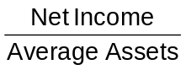
 | Return on ordinary shareholders’ equity  (12.8%) |  |  | = | 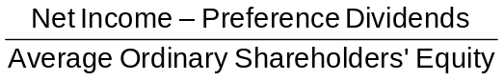

The difference between the two rates can be explained by looking at the denominator value and by remembering the basic accounting equation, A = L + E. The asset value will clearly be the larger of the two denominator values; therefore, it will also give the smaller return.

16. (a) The times interest earned ratio, which is an indication of the company’s ability to meet interest payments, and the debt to assets ratio, which indicates the company’s ability to withstand losses without impairing the interests of creditors.
(b) The current ratio and the acid-test ratio, which indicate a company’s liquidity and short-term debt-paying ability.
(c) The earnings per share and the return on ordinary shareholders’ equity, both of which indicate the earning power of the investment.

17. Earnings per share means earnings per ordinary share. Preference share dividends are subtracted from net income in computing EPS in order to obtain income available to ordinary shareholders.

18. (a) Trading on the equity means that the company has borrowed money at a lower rate of interest than it is able to earn by using the borrowed money. Simply stated, it is using money supplied by non-owners to increase the return to the owners.
(b) A comparison of the return on total assets with the rate of interest paid for borrowed money indicates the profitability of trading on the equity.

19. 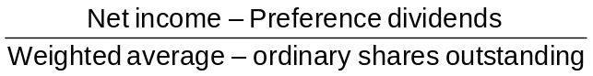 = Earnings per share

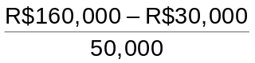 = R$2.60
EPS of R$2.60 is high relative to what? Is it high relative to last year’s EPS? The president may be comparing the EPS of R$2.60 to the market price of the company’s stock.

20. Discontinued operations refers to the disposal of a significant component of the business such as the stopping of an entire activity or eliminating a major class of customers. It is important to report discontinued operations separately from continuing operations because the discontinued component will not affect future income statements.

21. EPS on income from continuing operations usually is more relevant to an investment decision than EPS on net income. Income from continuing operations represents the results of continuing and ordinary business activity. It is therefore a better basis for predicting future operating results than an EPS figure which includes the effect of discontinued operations that are not expected to recur again in the foreseeable future.
Questions Chapter 14 (Continued)

22. When comparing EPS trends, discontinued operations should be omitted since they are not reflective of normal operations. In this example, the trend is unfavorable because EPS, exclusive of discontinued operations, has decreased from £3.20 to £2.99.

23. (1) Use of alternative accounting methods. Variations among companies in the application of IFRS may hamper comparability.

(2) Use of pro forma income measures that do not follow IFRS. Pro forma income is calculated by excluding items that the company believes are unusual or nonrecurring. It is often difficult to determine what was included and excluded.

(3) Improper revenue and expense recognition. Many high-profile cases of inappropriate accounting involve recording items in the wrong period.

SOLUTIONS TO BRIEF EXERCISES

BRIEF EXERCISE 14-1

Dear Uncle Liam,

It was so good to hear from you! I hope you and Aunt Doreen are still enjoying your new house.

You asked some interesting questions. They relate very well to the material that we are studying now in my financial accounting class. You said you heard that different users of financial statements are interested in different characteristics of companies. This is true. A short-term creditor, such as a bank, is interested in the company’s liquidity, or ability to pay obligations as they become due. The liquidity of a borrower is extremely important in evaluating the safety of a loan. A long-term creditor, such as a bondholder, would be interested in solvency, the company’s ability to survive over a long period of time. A long-term creditor would also be interested in profitability. They are interested in the likelihood that the company will survive over the life of the debt and be able to meet interest payments. Shareholders are also interested in profitability, and in the solvency of the company. They want to assess the likelihood of dividends and the growth potential of the shares.

It is important to compare different financial statement elements to other items. The amount of a financial statement element such as cash does not have much meaning unless it is compared to something else. Comparisons can be done on an intracompany basis. This basis compares an item or financial relationship within a company for the current year to one or more previous years. Intracompany comparisons are useful in detecting changes in financial relationships and significant trends. Comparisons can also be done with industry averages. This basis compares an item or financial relationship with industry averages or norms. Comparisons with industry averages provide information as to a company’s relative performance within the industry. Finally, comparisons can be done on an intercompany basis. This basis compares
an item or financial relationship with the same item or relationship in one or more competing companies. Intercompany comparisons are useful in determining a company’s competitive position.

I hope this answers your questions. If it does not, or you have more questions, please write me again or call. We could even meet for lunch sometime; it would be great to see you!

Love,

Your niece (or nephew)
BRIEF EXERCISE 14-2

(a) The three tools of financial statement analysis are horizontal analysis, vertical analysis, and ratio analysis. Horizontal analysis evaluates a series of financial statement data over a period of time. Vertical analysis evaluates financial statement data by expressing each item in a financial statement as a percent of a base amount. Ratio analysis expresses the relationship among selected items of financial statement data.

(b) Horizontal Analysis
 |  | 2015 |  | 2016 |  | 2017
Current assets |  | 100% |  | 105% |  | 109%

(105% = €230,000/€220,000; 109% = €240,000/€220,000)

Vertical Analysis
 |  | 2015 |  | 2016 |  | 2017
Current assets* |  | 44% |  | 38% |  | 38%

*as a percentage of total assets
(44% = €220,000/€500,000; 38% = €230,000/€600,000;
38% = €240,000/€630,000)

Ratio Analysis
 |  | 2015 |  | 2016 |  | 2017
Current ratio |  | 1.38 |  | 1.35 |  | 1.30

(1.38 = €220,000/€160,000; 1.35 = €230,000/€170,000;
1.30 = €240,000/€184,000)

BRIEF EXERCISE 14-3

Horizontal analysis:
Increase
or (Decrease)
 |  | Dec. 31, 2017 |  | Dec. 31, 2016 |  | Amount |  | Percentage
Inventory  Accounts receivable  Total assets |  | € 840,000 € 520,000  €2,500,000 |  | € 500,000 € 350,000  €3,000,000 |  | €340,000  €170,000  (€500,000) |  | 68%  49%  (17)%

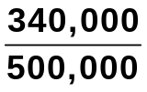 = .68 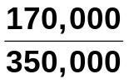 = .49 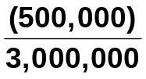 = (.17)
BRIEF EXERCISE 14-4

Vertical analysis:
 |  | Dec. 31, 2017 |  |  |  | Dec. 31, 2016
 |  | Amount |  | Percentage* |  | Amount |  | Percentage**
Inventory  Accounts receivable Total assets |  | € 840,000  € 520,000 €2,500,000 |  | 33.6%  20.8%  100% |  | € 500,000 € 350,000 €3,000,000 |  | 16.7%  11.7%  100%

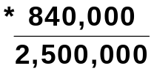 = .336 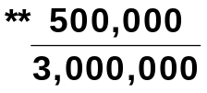 = .167

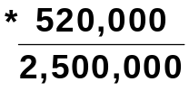 = .208 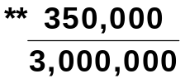 = .117

BRIEF EXERCISE 14-5

 |  | 2017 |  | 2016 |  | 2015
Net income |  | €525,000 |  | €500,000 |  | €550,000

 |  |  | Increase or (Decrease)
 |  |  | Amount |  | Percentage
(a)  (b) | 2015–2016  2016–2017 |  | (50,000)  (25,000) |  | (9%)  (5%)

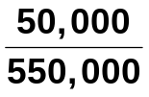 = .09 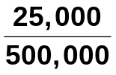 = .05

BRIEF EXERCISE 14-6

 |  | 2017 |  | 2016 |  | Increase
Net income |  | £560,000 |  | X |  | 40%

X .40 = 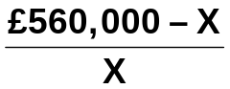
.40X = £560,000 – X

BRIEF EXERCISE 14-6 (Continued)

1.40X = £560,000
X = £400,000

2016 Net income = £400,000

BRIEF EXERCISE 14-7

Comparing the percentages presented results in the following conclusions: The net income for Kemplar increased in 2016 because of the combination of an increase in sales revenue and a decrease in both cost of goods sold and expenses. However, the reverse was true in 2017 as sales revenue decreased while both cost of goods sold and expenses increased. This resulted in a decrease in net income.

BRIEF EXERCISE 14-8

 |  | 2017 |  | 2016 |  | 2015
Sales revenue  Cost of goods sold  Expenses  Net income |  | 100.0  59.2  25.0  15.8 |  | 100.0  62.4  25.6  12.0 |  | 100.0  64.5  27.5  8.0

Net income as a percent of sales revenue for Dagman increased over the three-year period because cost of goods sold and expenses both decreased as a percent of sales every year.

BRIEF EXERCISE 14-9

(a) Working capital = Current assets – Current liabilities

Current assets £46,690,000
Current liabilities 41,200,000
Working capital £ 5,490,000
BRIEF EXERCISE 14-9 (Continued)

(b) Current ratio:

 = 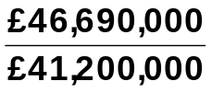

= 1.13:1

(c) Acid-test ratio:

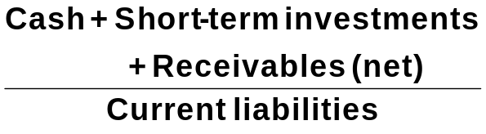 = 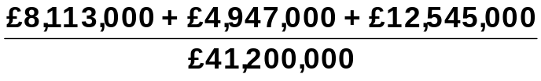

= 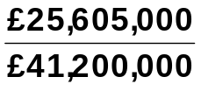

= .62:1

BRIEF EXERCISE 14-10

(a) Asset turnover = 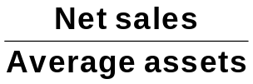

= 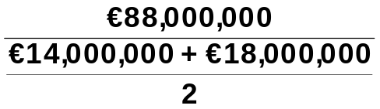

= 5.5 times

(b) Profit margin = 

= 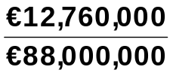

= 14.5%
BRIEF EXERCISE 14-11

(a) Accounts receivable turnover = 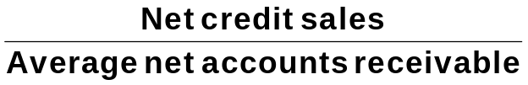

 |  | 2017 |  | 2016
 | (1) | 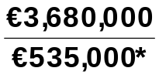 = 6.9 times |  | 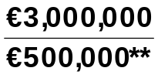 = 6.0 times
 |  | *($520,000 + $550,000) ÷ 2 |  | **($480,000 + $520,000) ÷ 2
 | (2) | Average collection period  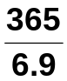 = 52.9 days |  | 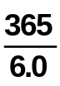 = 60.8 days

(b) Gladow Company should be pleased with the effectiveness of its credit and collection policies. The company has decreased the average collection period by 7.9 days and the collection period of approximately 53 days is well within the 60 days allowed in the credit terms.

BRIEF EXERCISE 14-12

(a) Inventory turnover = 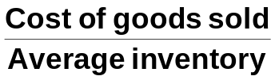

 | (1) | 2017 |  |  |  | 2016
 |  | 4,400,000 | = 4.4 times |  |  | 4,600,000 |  | = 5.0 times
 |  | 980,000 + 1,020,000 | = 4.4 times |  |  | 860,000 + 980,000
 |  | 2 |  |  |  | 2
 |  | Beginning inventory 980,000  Purchases 4,440,000  Goods available for sale 5,420,000  Ending inventory 1,020,000  Cost of goods sold 4,400,000 |  |  |  |  |  |  | 860,000  4,720,000  5,580,000  980,000  4,600,000

(2) Days in inventory

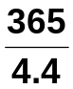 = 83.0 days 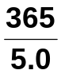 = 73.0 days

BRIEF EXERCISE 14-12 (Continued)
(b) Management should be concerned with the fact that inventory is moving slower in 2017 than it did in 2016. The decrease in the turnover could be because of poor pricing decisions or because the company is stuck with obsolete inventory.

BRIEF EXERCISE 14-13

Payout ratio = 

.22 = 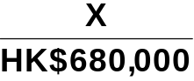

X = HK$680,000 (.22) = HK$149,600

Cash dividends = HK$149,600

Return on assets = 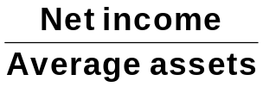

.16 = 

.16X = HK$680,000

X = 

X = HK$4,250,000

Average assets = HK$4,250,000

BRIEF EXERCISE 14-14

MING LIMITED
Partial Income Statement

Income before income taxes ₤400,000
Income tax expense (₤400,000 X 30%) 120,000
Income from continuing operations 280,000
Discontinued operations
Income from operations of retail division,
net of ₤3,000 tax (₤10,000 X 30%)……………… ₤ 7,000
Loss on disposal of retail division, net of
₤24,000 tax saving (₤80,000 X 30%)………….. (56,000) (49,000)
Net income ₤231,000

BRIEF EXERCISE 14-15

BLEVINS ASA
Partial Income Statement

Loss from operations of European facilities, net
of €96,000 income tax saving (€320,000 X 30%) €224,000
Loss on disposal of European facilities, net of
€45,000 income tax saving (€150,000 X 30%) 105,000 €329,000

BRIEF EXERCISE 14-16

SILVA AG
Partial Statement of Comprehensive Income

Income before income taxes €450,000
Income tax expense (€450,000 X 25%) 112,500
Net income 337,500
Other comprehensive income
Unrealized gain on non-trading securities,
net of €17,500 tax (€70,000 X 25%) 52,500
Comprehensive income €390,000

SOLUTIONS FOR DO IT! REVIEW EXERCISES

DO IT! 14-1

 | Increase (Decrease) in 2017
 | Amount |  | Percent
Plant assets ₤71,000 9.5% [(₤821,000 – ₤750,000) ÷ ₤750,000]
Current assets (37,000) (16.4)% [(₤188,000 – ₤225,000) ÷ ₤225,000]
Total assets ₤34,000 3.5% [(₤1,009,000 – ₤975,000) ÷ ₤975,000]

DO IT! 14-2

2017 2016
(a) Current ratio:
€1,350 ÷ €900 = 1.50:1
€1,343 ÷ €810 = 1.66:1

(b) Inventory turnover:
€984/[(€430 + €390) ÷ 2)] = 2.40 times
€895/[(€390 + €326) ÷ 2)]= 2.50 times

(c) Profit margin:
€364 ÷ €4,000 = 9.1%
€213 ÷ €3,600 = 5.9%

(d) Return on assets:
€364/[(€2,310 + €2,243) ÷ 2)] = 16.0%
€213/[(€2,243 + €2,100) ÷ 2)] = 9.8%

(e) Return on ordinary shareholders’ equity:
€364/[(€1,020 + €1,040) ÷ 2)] = 35.3%
€213/[€1,040 + €960) ÷ 2)] = 21.3%

(f) Debt to assets ratio:
€1,290 ÷ €2,310 = 55.8%
€1,203 ÷ €2,243 = 53.6%

(g) Times interest earned:
(€364 + €242 + €10) ÷ €10 = 62 times
(€213 + €142 + €20) ÷ €20 = 19 times

DO IT! 14-3

GRINDERS LIMITED
Partial statement of Comprehensive Income

Income before income taxes ₤500,000
Income tax expense 160,000
Income from continuing operations 340,000
Discontinued operations
Loss from operations of music
division, net of ₤19,200 income tax savings ₤40,800
Gain from disposal of music
division, net of ₤16,000 taxes 34,000 (6,800)
Net income 333,200
Other comprehensive income:
Unrealized loss on non-trading
securities, net of ₤9,600 tax savings 20,400
Comprehensive Income ₤312,800

DO IT! 14-4

1. | Current ratio: | A measure used to evaluate a company’s liquidity.
2. | Pro forma income: | Usually excludes items that a company thinks are unusual or non-recurring.
3. | Quality of earnings: | Indicates the level of full and transparent information provided to users of the  financial statements.
4. | Discontinued operations: | The disposal of a significant component of a business.
5. | Horizontal analysis: | Determines increases or decreases in a series of financial statement data.
6. | Comprehensive income: | Includes all changes in equity during a period except those resulting from investments by shareholders and distributions to shareholders.

SOLUTIONS TO EXERCISES

EXERCISE 14-1

GALLUP SA
Condensed Statements of Financial Position
December 31

 |  |  |  |  |  | Increase or (Decrease)
 |  | 2017 |  | 2016 |  | Amount |  | Percentage
Assets
Plant assets (net)  Current assets  Total assets |  | €396,000  128,000  €524,000 |  | €320,000  110,000  €430,000 |  | (€76,000  ( 18,000  €94,000 |  | (23.8%)  (16.4%)  (21.9%)
Equity
Share capital—  ordinary, €1 par  Retained earnings  Total equity |  | € 159,000  135,300  294,300 |  | € 115,000  150,000  265,000 |  | (  €44,000)  ((14,700))  ( 29,300) |  | (38.3%)  (((9.8%))  ( 11.1%)
Liabilities
Non-current liabilities  Current liabilities  Total liabilities  Total equity and  liabilities |  | 138,700  91,000  229,700  €524,000 |  | 95,000  70,000  165,000  €430,000 |  | ( 43,700 (15,000 )  21,000  ( 64,700)  (€94,000) |  | (46.0%)  30.0%  ( 39.2%)  21.9%

EXERCISE 14-2

CONARD LIMITED
Condensed Income Statements
For the Years Ended December 31

 |  | 2017 |  |  |  |  | 2016
 |  | Amount |  | Percent |  | Amount |  |  | Percent
Net sales  Cost of goods sold  Gross profit  Selling expenses  Administrative expenses  Total operating expenses  Income before income taxes  Income tax expense  Net income |  | £750,000  480,000  270,000  105,000  75,000  180,000  90,000  36,000  £ 54,000 |  | 100.0%  64.0%  36.0%  14.0%  10.0%  24.0%  12.0%  4.8%  7.2% |  | £600,000  408,000  192,000  84,000  54,000  138,000  54,000  18,000  £ 36,000 |  |  | 100.0%  68.0%  32.0%  14.0%  9.0%  23.0%  9.0%  3.0%  6.0%

EXERCISE 14-3

(a) GARCIA SLU
Condensed Statements of Financial Position
December 31

 |  |  | 2017 |  | 2016 |  | Increase  (Decrease) |  | Percentage  Change  from 2016
 | Assets  Intangibles  Property, plant &  equipment (net)  Current assets  Total assets |  | € 24,000  100,000  76,000  €200,000 |  | € 40,000  92,000  82,000  €214,000 |  | € (16,000)  ( 8,000)  (6,000)  € (14,000) |  | (40.0%)  ( 8.7%)  (7.3%)  (6.5%)

EXERCISE 14-3 (Continued)

GARCIA SLU
Condensed Statements of Financial Position (Continued)
December 31

 |  |  | 2017 |  | 2016 |  | Increase  (Decrease) |  | Percentage  Change  from 2016
 | Equity and liabilities  Equity  Non-current  liabilities  Current liabilities  Total equity and  liabilities |  | € 20,000  140,000  40,000  €200,000 |  | € 16,000  150,000  48,000  €214,000 |  | € 4,000  (10,000)  (8,000)  €(14,000) |  | 25.0%  (6.7%)  ((16.7%))  (6.5%)

(b) GARCIA SLU
Condensed Statements of Financial Position
December 31, 2017

 |  |  | Amount |  | Percent
 | Assets  Intangibles  Property, plant, and equipment (net)  Current assets  Total assets  Equity and liabilities  Equity  Non-current liabilities  Current liabilities  Total equity and liabilities |  | € 24,000  100,000  76,000  €200,000  € 20,000  140,000  40,000  €200,000 |  | 12.0%  50.0%  38.0% 100.0%  10%  70%  20%  100%

EXERCISE 14-4

(a) HENDI COMPANY A.S.
Condensed Income Statements
For the Years Ended December 31

Increase or (Decrease)
During 2016
 |  |  | 2017 |  | 2016 |  | Amount |  | Percentage
 | Net sales  Cost of goods sold  Gross profit  Operating expenses  Net income |  | 600,000  468,000  132,000  60,000  72,000 |  | 500,000  400,000  100,000  54,000  46,000 |  | 100,000  68,000  32,000  6,000  26,000 |  | 20.0%  17.0%  32.0%  11.1%  56.5%

(b) HENDI COMPANY A.S.
Condensed Income Statements
For the Years Ended December 31

 |  |  | 2017 |  |  |  | 2016
 |  |  | Amount |  | Percent |  | Amount |  | Percent
 | Net sales  Cost of goods sold  Gross profit  Operating expenses  Net income |  | 600,000  468,000  132,000  60,000  72,000 |  | 100.0%  78.0%  22.0%  10.0%  12.0% |  | 500,000  400,000  100,000  54,000  46,000 |  | 100.0%  80.0%  20.0%  10.8%  9.2%

EXERCISE 14-5

(a) Current ratio = 2.1:1 ($5,228 ÷ $2,541)
Acid-test ratio = 1.3:1 ($3,371 ÷ $2,541)
Accounts receivable turnover = 5.7 times ($12,166 ÷ $2,153)*
Inventory turnover = 5.4 times ($7,737 ÷ $1,445.5)**

*($2,177 + $2,129) ÷ 2
**(1,531 + 1,360) ÷ 2
EXERCISE 14-5 (Continued)

(b) | Ratio |  | Nordstrom |  | Park Street |  | Industry
 | Current  Acid-test  Accounts receivable turnover  Inventory turnover |  | 2.1:1  1.3:1  5.7  5.4 |  | 2.05:1  1.05:1  37.2  3.1 |  | 1.70:1  .70:1  46.4  4.3

Nordstrom is similar to Park Street for the current and acid-test ratios but significantly below for the accounts receivable turnover. Nordstrom is much better than Park Street for the inventory turnover.

Nordstrom is better than the industry average for the current and acid-test ratios but below the industry average for the accounts receivable turnover. Its inventory turnover ratio however is higher than the industry average.

EXERCISE 14-6

(a) Current ratio as of February 1, 2017 = 2.8:1 (R$140,000 ÷ R$50,000).

Feb. 3 2.8:1 No change in total current assets or liabilities.
7 2.2:1 (R$112,000 ÷ R$50,000).
11 2.2:1 No change in total current assets or liabilities.
14 2.6:1 (R$100,000 ÷ R$38,000).
18 2.3:1 (R$100,000 ÷ R$43,000).

(b) Acid-test ratio as of February 1, 2017 = 2.5:1 (R$125,000* ÷ R$50,000).

* R$140,000 – R$10,000 – R$5,000

Feb. 3 2.5:1 No change in total quick assets or current liabilities.
7 1.9:1 (R$97,000 ÷ R$50,000).
11 1.9:1 (R$94,000 ÷ R$50,000).
14 2.2:1 (R$82,000 ÷ R$38,000).
18 1.9:1 (R$82,000 ÷ R$43,000).

EXERCISE 14-7

(a) 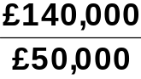 = 2.8:1.

(b) 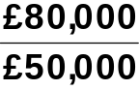 = 1.6:1.

(c) 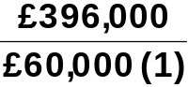 = 6.6 times.

(d) 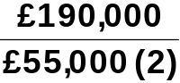 = 3.5 times.

 | (1) | 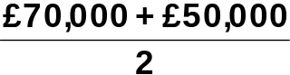
 | (2) | 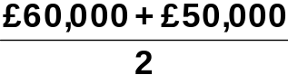

EXERCISE 14-8

(a) Profit margin 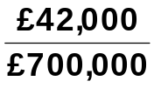 = 6.0%.

(b) Asset turnover 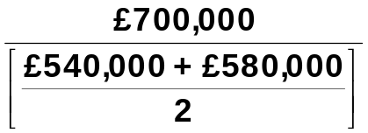 = 1.25 times.

(c) Return on assets 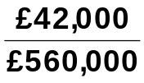 = 7.5%.

(d) | Return on ordinary shareholders’  equity |  | 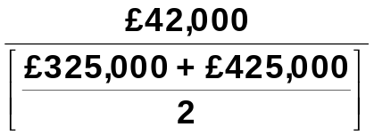 = 11.2%.
EXERCISE 14-9

(a) 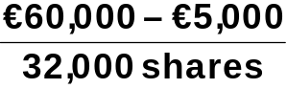 = €1.72.

(b) 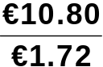 = 6.3 times.

(c) 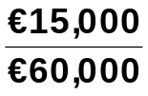 = 25%.

(d) 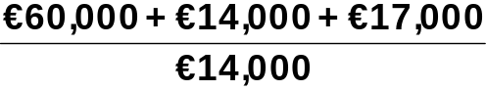 = 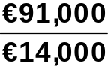 = 6.5 times.

EXERCISE 14-10

(a) Inventory turnover = 3.4 = 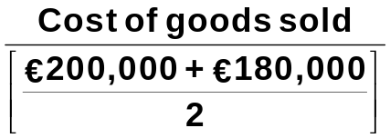

3.4 X €190,000 = Cost of goods sold
Cost of goods sold = €646,000.

(b) Accounts receivable turnover = 8.8 = 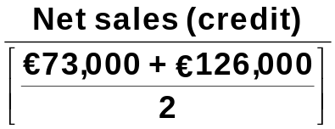

8.8 X €99,500 = Net sales (credit) = €875,600.

(c) Return on ordinary shareholders’ equity = 25% =

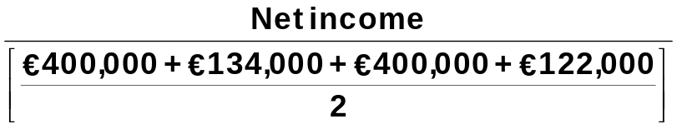

.25 X €528,000 = Net income = €132,000.
EXERCISE 14-10 (Continued)

(d) Return on assets = 20% = 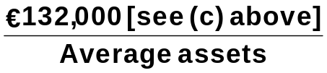

Average assets = 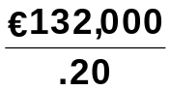 = €660,000

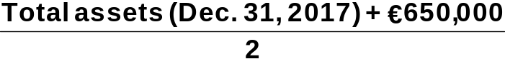 = €660,000

Total assets (Dec. 31, 2017) = (€660,000 X 2) – €650,000 = €670,000.

EXERCISE 14-11

(a) (€4,300 + €22,000+ €10,000)/€15,000 = 2.42:1
(b) (€4,300 + €22,000)/€15,000 = 1.75:1
(c) €100,000/[(€22,000 + €24,000)/2] = 4.35 times
(d) €60,350/[(€10,000 + €7,000)/2] = 7.10 times
(e) €14,000/€100,000 = 14%
(f) €100,000/[(€111,300 + €120,700)/2] = .86 times
(g) €14,000/[(€111,300 + €120,700)/2] = 12.1%
(h) €14,000/[(€96,300 + €89,600)/2] = 15.1%
(i) €15,000/€111,300 = 13.5%

EXERCISE 14-12

(a) DOUGLAS LIMITED
Partial Income Statement
For the Year Ended October 31, 2017

Income before income taxes £550,000
Income tax expense (£550,000 X 30%) 165,000
Income from continuing operations………………… 385,000
Discontinued operations
Loss from operations of discontinued
division, net of £18,000 income
tax saving……………………………………………. £42,000
Loss from disposal of discontinued
division, net of £27,000 income
tax savings………………………………………… 63,000 (105,000)
Net income £280,000

(b) To: Ch ief Accountant

From: Your name, Independent Auditor

After reviewing your income statement for the year ended 10/31/17, we believe it is misleading for the following reasons:

The amount reported for income before discontinued operations is overstated by £45,000. The income tax expense should be 30% of £550,000, or £165,000, not £120,000.

Also, the effect of the loss from the discontinued division on net income
is only £105,000, not £150,000. An income tax savings of £45,000 should
be netted against the loss on the discontinued division.

EXERCISE 14-13

TRAYER PLC
Partial Statement of Comprehensive Income
For the Year Ended December 31, 2017

Income from continuing operations ₤290,000
Discontinued operations
Loss from operations, net of ₤2,000
income taxes ₤8,000
Gain from disposal, net of ₤8,000
income taxes 32,000 24,000
Net income ₤314,000
Other comprehensive income
Unrealized loss on non-trading securities,
net of ₤16,000 income taxes 64,000
Comprehensive income ₤250,000

SOLUTIONS TO PROBLEMS

PROBLEM 14-1

(a) Condensed Income Statement
For the Year Ended December 31, 2017

 |  |  | Lionel Company |  |  |  | Barrymore Company
 |  |  | Pounds |  | Percent |  | Pounds |  | Percent
 | Net sales  Cost of goods sold  Gross profit  Operating expenses  Income from operations  Interest expense  Income before income taxes  Income tax expense  Net income |  | ₤1,549,035  1,053,345  495,690  263,336  232,354  7,745  224,609  61,960  ₤ 162,649 |  | 100.0%  68.0%  32.0%  17.0%  15.0%  .5%  14.5%  4.0%  10.5% |  | ₤339,038  237,325  101,713  77,979  23,734  2,034  21,700  8,476  ₤ 13,224 |  | 100.0%  70.0%  30.0%  23.0%  7.0%  .6%  6.4%  2.5%  3.9%

(b) Lionel Company appears to be more profitable. It has higher relative

gross profit, income from operations, income before taxes, and net income.
Lionel’s return on assets of 16.6% 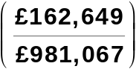ª is higher than Barrymore’s return on assets of 6.6% 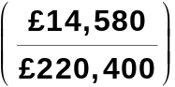^{b}. Also, Lionel’s return on ordinary shareholders’ equity of 19.9% 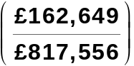^{c} is higher than Barrymore’s return on ordinary shareholders’ equity of 7.7% 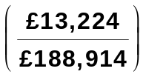^{d}.

PROBLEM 14-1 (Continued)

ª₤162,649 is Lionel’s 2017 net income. ₤981,067 is Lionel’s 2017 average assets:

 |  |  | 2017 |  | 2016
 | Plant assets Current assets  Total assets |  | ₤596,920 401,584  ₤998,504 | + | ₤575,610  388,020  ₤963,630 | = | 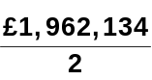

^{b}₤13 ,224 is Barrymore’s 2017 net income. $220,400 is Barrymore’s 2017 average assets:

 |  |  | 2017 |  | 2016
 | Plant assets  Current assets Total assets |  | ₤142,842  86,450  ₤229,292 | + | ₤128,927  82,581  ₤211,508 | = | 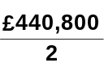

^{c}₤162,649 is Lionel’s 2017 net income. $817,556 is Lionel’s 2017 average ordinary shareholders’ equity:

 |  |  | 2017 |  | 2016
 | Share capital ordinary  Retained earnings  Total equity |  | ₤578,765  252,224  ₤830,989 | + | ₤578,765  225,358  ₤804,123 | = | 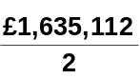

^{d}₤13,224 is Barrymore’s 2017 net income. ₤188,914 is Barrymore’s 2017 average ordinary shareholders’ equity:

 |  |  | 2017 |  | 2016
 | Share capital ordinary  Retained earnings  Total equity |  | ₤137,435  55,528  ₤192,963 | + | ₤137,435  47,430  ₤184,865 | = | 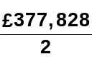

PROBLEM 14-2

(a) Earnings per share = 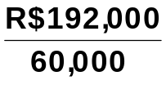 = R$3.20.

(b) Return on ordinary shareholders’ equity = 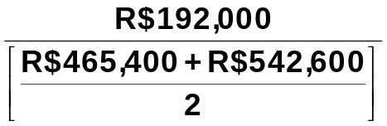

= 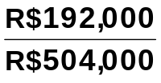

= 38.1%.

(c) Return on assets = 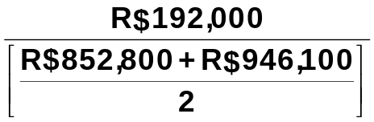 = 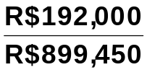 = 21.3%.

(d) Current ratio = 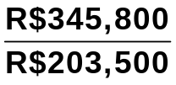 = 1.70:1

(e) Acid-test ratio = 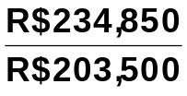 = 1.15:1

(f) Accounts receivable turnover = 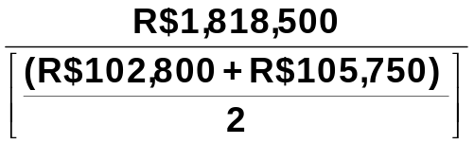

= 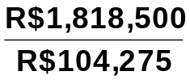

= 17.4 times.
PROBLEM 14-2 (Continued)

(g) Inventory turnover = 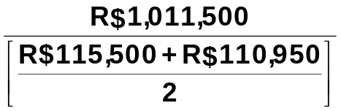 = 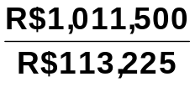
= 8.9 times.

(h) Times interest earned = 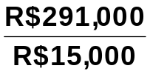 = 19.4 times.

(i) Asset turnover = 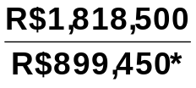 = 2.0 times.
*(R$852,800 + R$946,100) ÷ 2

(j) Debt to assets = 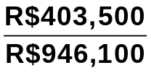 = 42.6%.

PROBLEM 14-3

(a) |  | 2016 |  | 2017
 | (1) | Profit margin.  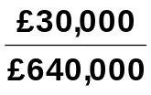 = 4.7% |  | 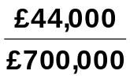 = 6.3%
 | (2) | Asset turnover.  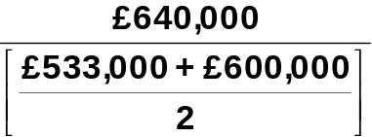 = 1.1 times |  | 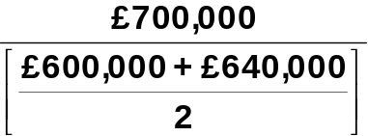 = 1.1 times
 | (3) | Earnings per share.  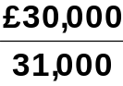 = ₤0.97 |  | 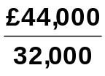 = ₤1.38
 | (4) | Price-earnings ratio.  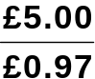 = 5.2 times |  | 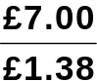 = 5.1 times
 | (5) | Payout ratio.  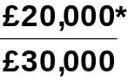 = 66.7%  *(₤113,000 + ₤30,000 – ₤123,000) |  | 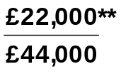 = 50.0%  **(₤123,000 + ₤44,000 – ₤145,000)
 | (6) | Debt to assets.  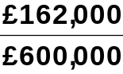 = 27.0% |  | 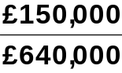 = 23.4%

PROBLEM 14-3 (Continued)

(b) The underlying profitability of the corporation appears to have improved. For example, profit margin and earnings per share have both increased. Also, the corporation appears to be involved in attempting to reduce its debt burden as its debt to assets ratio has decreased. Similarly, its payout ratio has decreased, which should help its overall solvency.

PROBLEM 14-4

(a) LIQUIDITY

 |  |  | 2015 |  | 2016 |  | Change
 | Current |  | 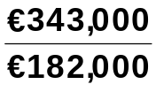= 1.9:1 |  | 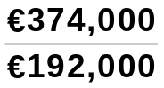 =1.9:1 |  | No change
 | Acid-test |  | 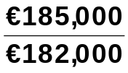= 1.0:1 |  | 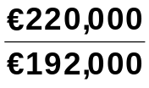 = 1.1:1 |  | Increase
 | Accounts receivable  turnover |  | 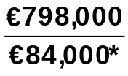 = 9.5 times |  | 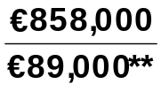 = 9.6 times |  | Increase
*(€88,000 + €80,000) ÷ 2 **(€80,000 + €98,000) ÷ 2

 | Inventory  turnover |  | 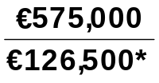 = 4.5 times |  | 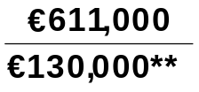 = 4.7 times |  | Increase
*(€118,000 + €135,000) ÷ 2 **(€135,000 + €125,000) ÷ 2

An overall increase in short-term liquidity has occurred.

PROFITABILITY

 | Profit  margin |  | 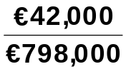 = 5.3% |  |  | 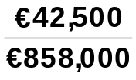 = 5.0% |  |  | Decrease
 | Asset  turnover |  | 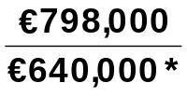 = 1.2 times |  |  | 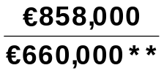 = 1.3 times |  |  | Increase
 | *(€632,000 + €648,000) ÷ 2 **(€648,000 + €672,000) ÷ 2
 | Return on  assets |  | 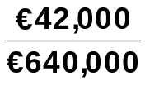 = 6.6% |  |  |  | 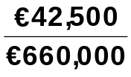 = 6.4% |  | Decrease
 | Earnings  per share |  | 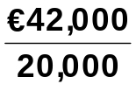 = €2.10 |  |  |  | 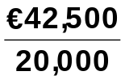 = €2.13 |  | Increase

Profitability has remained relatively the same.
PROBLEM 14-4 (Continued)

(b) |  |  |  | 2016 |  | 2017 |  | Change
 | 1. | Return on  ordinary  shareholders’ equity |  | 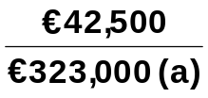 = 13.2% |  | 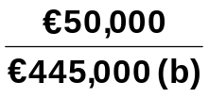 = 11.2% |  | Decrease
 | 2. | Debt to assets |  | 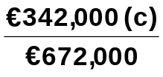 = 50.9% |  | 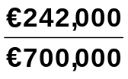 = 34.6% |  | Decrease
 | 3. | Price-earnings  ratio |  | 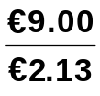 = 4.2 times |  | 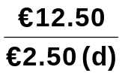 = 5.0 times |  | Increase

(a) (€200,000 + €130,000 + €200,000 + €116,000) ÷ 2.
(b) (€380,000 + €180,000 + €200,000 + €130,000) ÷ 2.
(c) €100,000 + €48,000 + €44,000 + €150,000.
(d) €50,000 ÷ 20,000.

PROBLEM 14-5

(a) | Ratio |  | Target |  | Wal-Mart
 |  |  | (All Dollars Are in Millions)
(1)  (2)  (3)  (4)  (5)  (6)  (7)  (8)  (9)  (10)  (11) | Current  Accounts receivable  turnover  Average collection  period  Inventory turnover  Days in inventory  Profit margin  Asset turnover  Return on assets  Return on ordinary  shareholders’ equity  Debt to total assets  Times interest earned |  | .9:1 ($11,573 ÷ $12,777)  24.9 ($72,596 ÷ $2,921)  14.7 (365 ÷ 24.9)  6.1 ($51,160 ÷ $8,335)  59.8 (365 ÷ 6.1)  2.7% ($1,971 ÷ $72,596)  1.6 ($72,596 ÷ $46,358ª)  4.3 % ($1,971 ÷ $46,358ª)  12.0 % ($1,971 ÷ $16,394.5^{b})  63.6% ($28,322 ÷ $44,553)  3.8 ($4,229 ÷ $1,126) |  | .9:1 ($61,185 ÷ $69,345)  70.8 ($476,294 ÷ $6,723)  5.2 (365 ÷ 70.8)  8.1 ($358,069 ÷ $44,331)  45.1 (365 ÷ 8.1)  3.3% ($16,022 ÷ $476,294)  2.3 ($476,294 ÷ $203,928^{c})  7.9 % ($16,022 ÷ $203,928^{c})  19.7% ($16,022 ÷ $81,538.5^{d})  60.3% ($123,412 ÷ $204,751)  11.3 ($26,462 ÷ $2,335)

ª($44,553 + $48,163) ÷ 2 ^{c}($204,751 + $203,105) ÷ 2
^{b}($16,231 + $16,558) ÷ 2 ^{d}($81,339 + $81,738) ÷ 2

(b) The comparison of the two companies shows the following:

Liquidity—Target’s current ratio of .9:1 is the same as Wal-Mart’s, .9:1. However, Wal-Mart has a better inventory turnover ratio than Target and its accounts receivable turnover is substantially better than Target’s.

Profitability—Wal-Mart betters Target in all of the profitability ratios. Thus, it is more profitable than Target.

Solvency—Wal-Mart betters Target in both of the solvency ratios. Thus, it is more solvent than Target.

PROBLEM 14-6

(a) Current ratio = 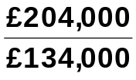 = 1.5:1.

(b) Acid-test ratio = 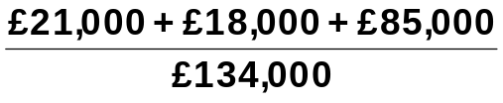 = 0.93:1.

(c) Accounts receivable turnover = 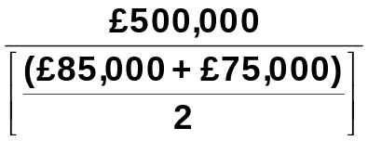
= 6.3 times.

(d) Inventory turnover = 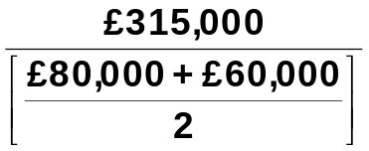 = 4.5 times.

(e) Profit margin ratio = 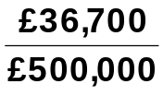 = 7.3%.

(f) Asset turnover = 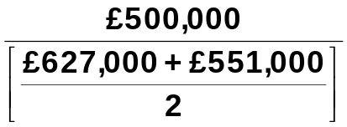 = 0.8 times.

(g) Return on assets = 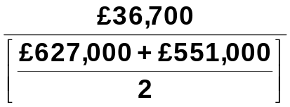 = 6.2%.

(h) Return on ordinary shareholders’ equity = 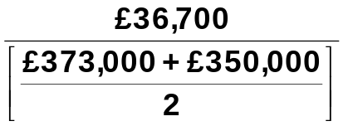
= 10.2%.
PROBLEM 14-6 (Continued)

(i) Earnings per share = 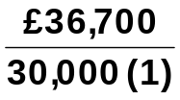 = £1.22.

(1) £150,000 ÷ £5.00

(j) Price-earnings ratio = 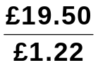 = 16.0 times.

(k) Payout ratio = 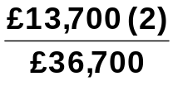 = 37.3%.

(2) £200,000 + £36,700 – £223,000

(l) Debt to assets = 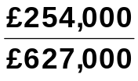 = 40.5%.

(m) Times interest earned = 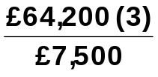 = 8.6 times.

(3) £36,700 + £20,000 + £7,500

PROBLEM 14-7

Accounts receivable turnover = 8 = 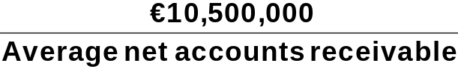

Average net accounts receivable = 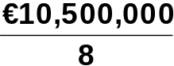 = €1,312,500

= €1,312,500

Net accounts receivable 12/31/17 + €1,050,000 = €2,625,000

Net accounts receivable 12/31/17 = €1,575,000

Profit margin = 14.5% = .145 = 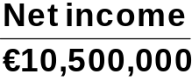

Net income = €10,500,000 X .145 = €1,522,500

Income before income taxes = €1,522,500 + €550,000 = €2,072,500

Return on assets = 20% = .20 = 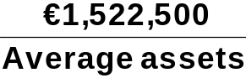

Average assets = €1,522,500 ÷ .20 = €7,612,500

 = €7,612,500

Assets (12/31/17) = €7,725,000

Total current assets = €7,725,000 – €4,620,000 = €3,105,000

Inventory = €3,105,000 – € 1,575,000 – €480,000 = €1,050,000

Total liabilities and equity = €7,725,000

Total liabilities = €7,725,000 – €3,400,000 = €4,325,000
PROBLEM 14-7 (Continued)

Current ratio = 2.5 = 

Current liabilities = €3,105,000 ÷ 2.5 = $1,242,000

Long-term notes payable = $4,325,000 – $1,242,000 = $3,083,000

Inventory turnover = 4.2 = 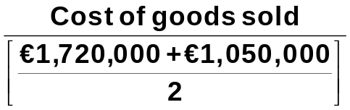

Cost of goods sold = €1,385,000 X 4.9 = €6,786,500

Gross profit = €10,500,000 – €6,786,500 = €3,713,500

Income from operations = €3,713,500 – €1,500,000 = €2,213,500

Interest expense = €2,213,500 – €2,072,500 = €141,000

PROBLEM 14-8

VIOLET BICK SA
Condensed Statement of Comprehensive Income
For the Year Ended December 31, 2017

Operating revenues
(€12,900,000 – €2,000,000) €10,900,000
Operating expenses
(€8,700,000 – €2,500,000) 6,200,000
Income from operations 4,700,000
Other expenses and losses 200,000
Income before income taxes 4,500,000
Income tax expense (€4,500,000 X 30%) 1,350,000
Income from continuing operations 3,150,000
Discontinued operations
Loss from operations of hotel
chain*, net of €150,000 income
tax saving (€350,000)
Gain on sale of hotels, net of
€90,000 income taxes 210,000 (140,000)
Net income 3,010,000
Other comprehensive income
Unrealized gain on
non-trading securities, net of
€45,000 income tax 105,000
Comprehensive income € 3,115,000
*€2,000,000 – €2,500,000 = (€500,000)

PROBLEM 14-9

GOWER LIMITED
Statement of Comprehensive Income
For the Year Ended December 31, 2017

Net sales ₤1,580,000
Cost of goods sold 1,100,000
Gross profit 480,000
Selling and administrative expenses 160,000
Income from operations 320,000
Other income and expense (6,000)
Income before income taxes 314,000
Income tax expense (₤314,000 X 30%) 94,200
Income from continuing operations 219,800
Discontinued operations
Income from operations of discontinued
division, net of ₤4,500 income taxes 10,500
Loss on sale of discontinued division,
net of ₤22,200 income tax saving (51,800) (41,300)
Net income 178,500
Other Comprehensive income
Unrealized gain on
nontrading securities, net of
₤36,000 income taxes 84,000
Comprehensive income ₤ 262,500

MC14 MATCHA CREATIONS

(a) | 1. | Current ratio  $107,366  $38,976 = 2.75:1
 | 2. | Accounts receivable turnover  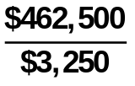= 142.3 times
 | 3. | Inventory turnover  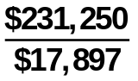= 12.9 times
 | 4. | Debt to assets  $44,976  $149,166  = 30.2%
 | 5. | Times interest earned  $98,863  $413  = 239 times
 | 6. | Gross profit rate  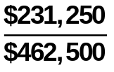 = 50.0%
 | 7. | Profit margin  $78,760  $462,500  = 17.0%
MC14 (Continued)

(a) (Continued)

 | 8.  $462,500  $149,166 | Asset turnover  = 3.1 times
 | 9. | Return on assets  = 52.8%  $78,760  $149,166
 | 10. | Return on common stockholders’ equity  = 75.6%  $78,760  $104,190

(b) The company had a very good year. It was very profitable and has a healthy balance sheet. The company is carrying very little debt and can cover the interest charges easily. There are no liquidity or solvency problems.

(c) The bank should have no qualms about lending money to the company. The new debt ratio would still be reasonably low [($44,976 + $20,000) ÷ ($149,166 + $20,000) = 38.4%]. Even if there were no increases in revenue, operating income would still be more than adequate to cover the additional interest expense. The company is very profitable and is an acceptable credit risk for the bank.

(d) Instead of bank financing, Matcha & Coffee Creations could lease the equipment. The company could also consider equity financing or paying cash for the equipment.

BYP 14-1 FINANCIAL REPORTING PROBLEM

(a) (Taiwan new dollar amounts in millions)

(1) Profit Margin

2013: NT$183,849.7 ÷ NT$597,024.2 = 30.8%
2012: NT$159,286.4 ÷ NT$506,745.3 = 31.4%

(2) Asset Turnover

2013: NT$597,024.2 ÷ [(NT$1,262,800.7 + NT$961,343.7) ÷ 2] = .54 times
2012: NT$506,745.3 ÷ [(NT$961,343.7 + NT$779,541.6) ÷ 2] = .58 times

(3) Return on Assets

2013: NT$183,849.7 ÷ [(NT$1,262,800.7 + NT$961,343.7) ÷ 2] = 16.5%
2012: NT$159,286.4÷ [(NT$961,343.7 + NT$779,541.6) ÷ 2] = 18.3%

BYP 14-1 (Continued)

(4) Return on Ordinary Shareholders’ Equity

2013: NT$183,849.7 ÷ [(NT$834,113.0 + NT$713,594.3) ÷ 2] = 23.8%
2012: NT$159,286.4 ÷ [(NT$713,594.3 + NT$779,541.6) ÷ 2] = 21.3%

TSMC’S profitability decreased from 2012 to 2013.

(b) (dollar amounts in millions)

(1) Debt to Total Assets

2013: NT$428,687.7 ÷ NT$1,262,800.7 = 34.0%
2012: NT$247,749.4 ÷ NT$961,343.7 = 25.8%

(2) Times Interest Earned

2013: (NT$215,961.5 + NT$2,646.8) ÷ NT$2,646.8 = 82.6 times
2012: (NT$159,286.4 + NT$1,020.4) ÷ NT$1,020.4 = 157.1 times

Creditors provide roughly one-third of TSMC’s total assets, so its long-term solvency is not in jeopardy. TSMC’s times interest earned ratio is very high indicating that the company has the ability to pay the interest on its debt.

(c) Substantial amounts of important information about a company are not in its financial statements. Events involving such things as industry changes, management changes, competitors’ actions, technological developments, governmental actions, and union activities are often critical to the successful operation of a company. Financial reports in the media and publications of financial service firms (Standard & Poors, Dun & Bradstreet) will provide relevant information not usually found in the annual report.

BYP 14-2 COMPARATIVE ANALYSIS PROBLEM

(a) |  |  |  |  | Petra Foods |  |  |  | Nestlé
 | (1) | (i) | Percentage  increase  in net sales |  | US$508,800 − US$471,647 |  | = 7.9% |  | CHF92,158 − CHF89,721 |  |  | = 2.7%
 |  |  |  |  | US$471,647 |  | = 7.9% |  | CHF89,721 |  |  | = 2.7%
 |  | (ii) | Percentage  increase  (decrease) in  net income |  | US$20,555 − US$25,826 |  | = (20.4%) |  | CHF10,015 − CHF10,228 |  | = (2.1%)
 |  |  |  |  | US$25,826 |  | = (20.4%) |  | CHF10,228
 | (2) | (i) | Percentage  increase  (decrease) in  total assets |  | US$465,896 − US$1,219,770 |  | = (61.8%) |  | CHF120,442 − CHF125,877 |  |  | = (4.3%)
 |  |  |  |  | US$1,219,770 |  | = (61.8%) |  | CHF125,877 |  |  | = (4.3%)
 |  | (ii) | Percentage  increase  (decrease) in  total ordinary shareholders’  equity |  | US$290,386 − US$326,817 |  | = (11.2%) |  | CHF64,139 − CHF62,664 |  | = 2.4%
 |  |  |  |  | US$326,817 |  | = (11.2%) |  | CHF62,664

Both companies had decreases in net income and total assets but Petra Foods’ amounts were much more significant, Nestle’s total Shareholders’ equity increased 2.4% white Petra Foods’ decreased.

BYP 14-3 DECISION-MAKING ACROSS THE ORGANIZATION

The current ratio increase is a favorable indication as to liquidity, but alone tells little about the going-concern prospects of the client. From this ratio change alone, it is impossible to know the amount and direction of the changes in individual accounts, total current assets, and total current liabilities. Also unknown are the reasons for the changes.

The acid-test ratio decrease is an unfavorable indication as to liquidity, especially when the current-ratio increase is also considered. This decline is also unfavorable as to the going-concern prospects of the client because it reflects a declining cash position and raises questions as to reasons for the increases in other current assets, such as inventories.

The change in asset turnover cannot alone tell anything about either solvency or going-concern prospects. There is no way to know the amount and direction of the changes in sales and assets. An increase in sales would be favorable for going-concern prospects, while a decrease in assets could represent a number of possible scenarios and would need to be investigated further.

The increase in net income is a favorable indicator for both solvency and going-concern prospects, although much depends on the quality of receivables generated from sales and how quickly they can be converted into cash. If there has been a decline in sales, a significant factor is that management has been able to reduce costs to produce an increase in earnings. Indirectly, the improved income picture may have a favorable impact on solvency and going-concern potential by enabling the client to borrow currently (if it needs to do so) to meet cash requirements.

The 32-percent increase in earnings per share, which is identical to the percentage increase in net income, is an indication that there has probably been no change in the number of ordinary shares outstanding. This, in turn, indicates that financing was not obtained through the issuance of ordinary shares. It is not possible to reach conclusions about solvency and going-concern prospects without additional information about the nature and extent of financing.
BYP 14-3 (Continued)

The collective implications of these data alone are that the client entity is about as solvent and as viable a going concern at the end of the current year as it was at the beginning although there may be a need for short-term operating cash.

BYP 14-4 COMMUNICATION ACTIVITY

To: Kyle Benson

From: Accounting Major

Subject: Financial Statement Analysis

There are two fundamental considerations in financial statement analysis: (1) the bases of comparison and (2) the factors affecting quality of earnings. Each of these considerations is explained below.

1. Bases of comparison. The bases of comparison are:

a. Intracompany—This basis compares an item or financial relationship within a company in the current year with the same item or relationship in one or more prior years.

b. Industry averages—This basis compares an item or financial relationship of a company with industry averages (or norms).

c. Intercompany—This basis compares an item or financial relationship of one company with the same item or relationship in one or more competing companies.

2. Factors affecting quality of earnings are:

a. Alternative accounting methods—Variations among companies in the application of IFRS may hamper comparability and reduce quality of earnings.

b. Pro forma income—This income figure usually excludes items that the company thinks are unusual or nonrecurring.

c. Improper recognition—Because some managers feel pressure from investors to continually increase earnings, they manipulate the earnings numbers to meet these expectations.

BYP 14-5 ETHICS CASE

(a) The stakeholders in this case are:

- Robert Turnbull, president of Turnbull Industries.
- Perry Jarvis, public relations director.
- You, as controller of Turnbull Industries.
- Shareholders of Turnbull Industries.
- Potential investors in Turnbull Industries.
- Any readers of the press release.

(b) The president’s press release is deceptive and incomplete and to that extent his actions are unethical.

(c) As controller you should at least inform Perry, the public relations director, about the biased content of the release. He should be aware that the information he is about to release, while factually accurate, is deceptive and incomplete. Both the controller and the public relations director (if he agrees) have the responsibility to inform the president of the bias of the about to be released information.

GAAP EXERCISES

GAAP 14-1

CHEN COMPANY
Statement of Comprehensive Income
For the Year Ended December 31, 2017

Sales revenue $1,000,000
Cost of goods sold 700,000
Gross profit 300,000
Operating expenses 200,000
Net income 100,000
Other comprehensive income
Unrealized gain on non-trading securities 75,000
Comprehensive income $ 175,000

GAAP 14-2

CHEN COMPANY
Income Statement
For the Year Ended December 31, 2017

Sales revenue $1,000,000
Cost of goods sold 700,000
Gross profit 300,000
Operating expenses 200,000
Net income $ 100,000

CHEN COMPANY
Comprehensive Income Statement
For the Year Ended December 31, 2017

Net income $100,000
Other comprehensive income
Unrealized gain on non-trading
securities 75,000
Comprehensive income $175,000

GAAP 14-3 GAAP FINACIAL REPORTING PROBLEM

(a) APPLE, INC.
Trend Analysis of Net Sales and Net Income
For the Three Years Ended 2013

Base Period 2011—(in millions)

 |  |  |  | 2013 |  | 2012 |  | 2011
 | (1) | Net sales  Trend |  | $170,910  158% |  | $156,508  144% |  | $108,429  100%
 | (2) | Net income  Trend |  | 37,037  143% |  | 41,733  161% |  | 25,922  100%

Between 2013 and 2011 Apple’s net sales increased by 58%. Apple’s net income increased by 61% between 2011 and 2012 and increased by almost 43% from 2011 to 2013.

(b) (dollar amounts in millions)

(1) Debt to Assets ratio

2013: $83,451 ÷ $207,000 = 40.3%
2012: $57,854 ÷ $176,064 = 32.9%

(2) Times Interest Earned

2013: ($50,155 + $136) ÷ $136 = 369.8 times
2012: No interest expense incurred
Since creditors are providing about 40% of Apple's total assets, its long-term solvency is not in jeopardy. Apple very easily has the ability to pay the interest on its debt as indicated by the times interest earned of over 300 times in 2013.

GAAP 14-3 (Continued)
(c) (dollar amounts in millions)

(1) Profit Margin

2013: $37,037 ÷ $170,910 = 21.6%
2012: $41,733 ÷ $156,508 = 26.7%

(2) Asset Turnover

2013: $170,910 ÷ [($207,000 + $176,064) ÷ 2] = .89 times
2012: $156,608 ÷ [($176,064 + $116,371) ÷ 2] = 1.07 times

(3) Return on Assets

2013: $37,037 ÷ [($207,000 + $176,064) ÷ 2] = 19.3%
2012: $41,733 ÷ [($176,064 + $116,371) ÷ 2] = 28.5%

(4) Return on Common Stockholders’ Equity

2013: $37,037 ÷ [($123,549 + $118,210) ÷ 2] = 30.6%
2012: $41,733 ÷ [($118,210 + $76,6 15) ÷ 2] = 42.8%

In general, Apple’s profitability has decreased from 2012 to 2013.

(d) Substantial amounts of important information about a company are not in its financial statements. Events involving such things as industry changes, management changes, competitors’ actions, technological developments, governmental actions, and union activities are often critical to the successful operation of a company. Financial reports in the media and publications of financial service firms (Standard & Poors, Dun & Bradstreet) will provide relevant information not usually found in the annual report.

