Chapter 1 Problems
P4, P6, P8, P9, P18, P20, P24, P31, P33（此部分自行練習不須繳交）

P4
- Between the switch in the upper left and the switch in the upper right we can have 4 connections. Similarly we can have four connections between each of the 3 other pairs of adjacent switches. Thus, this network can support up to 16 connections.
- We can 4 connections passing through the switch in the upper-right-hand corner and another 4 connections passing through the switch in the lower-left-hand corner, giving a total of 8 connections.
- Yes. For the connections between A and C, we route two connections through B and two connections through D. For the connections between B and D, we route two connections through A and two connections through C. In this manner, there are at most 4 connections passing through any link.

P6
a) 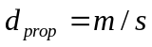 seconds.
b) 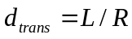 seconds.
c) 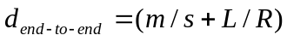 seconds.
d) The bit is just leaving Host A.
e) The first bit is in the link and has not reached Host B.
f) The first bit has reached Host B.
g) Want
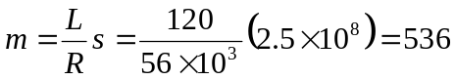km.

P8
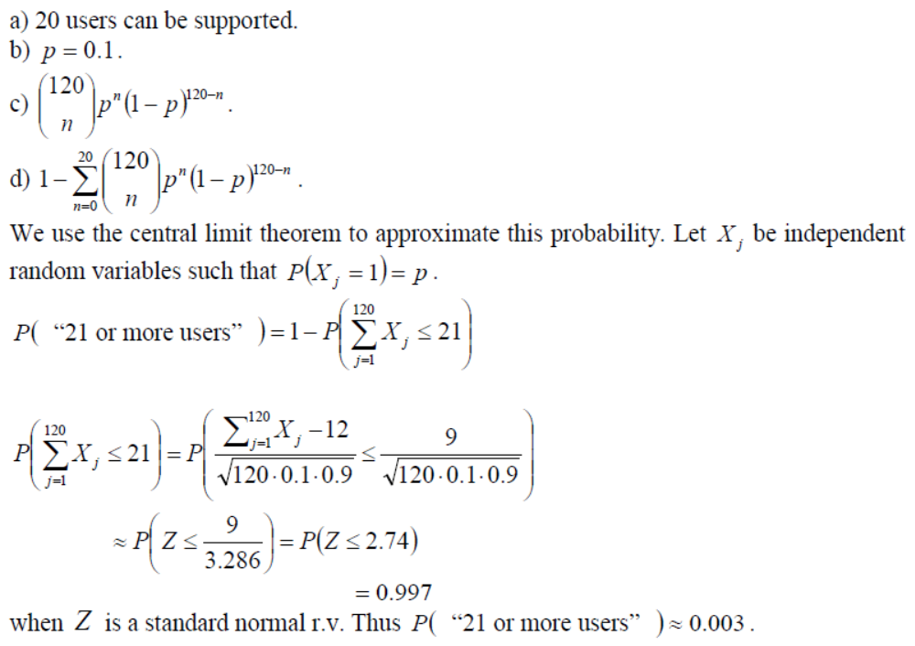

P9
- 10,000
- 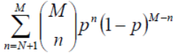

P18
On linux you can use the command
traceroute www.targethost.com
and in the Windows command prompt you can use
tracert www.targethost.com
In either case, you will get three delay measurements. For those three measurements you can calculate the mean and standard deviation. Repeat the experiment at different times of the day and comment on any changes.
Here is an example solution:
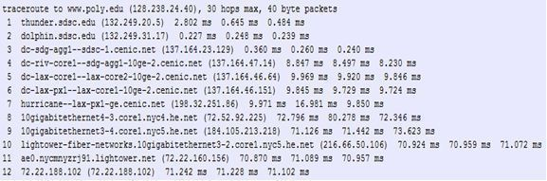

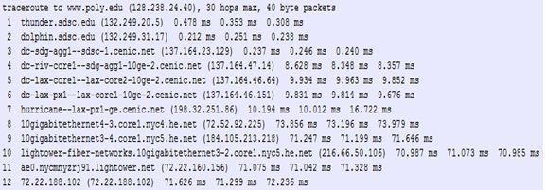

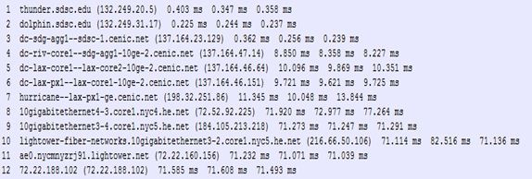

Traceroutes between San Diego Super Computer Center and www.poly.edu
- The average (mean) of the round-trip delays at each of the three hours is 71.18 ms, 71.38 ms and 71.55 ms, respectively. The standard deviations are 0.075 ms, 0.21 ms, 0.05 ms, respectively.
- In this example, the traceroutes have 12 routers in the path at each of the three hours. No, the paths didn’t change during any of the hours.
- Traceroute packets passed through four ISP networks from source to destination. Yes, in this experiment the largest delays occurred at peering interfaces between adjacent ISPs.
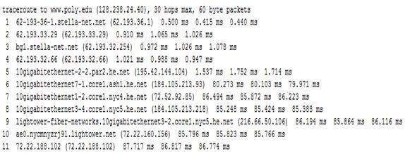
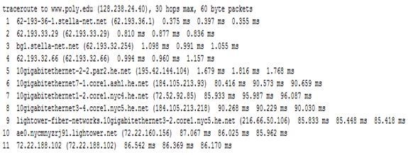
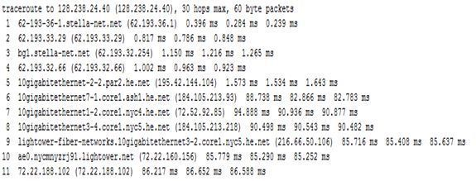
Traceroutes from www.stella-net.net (France) to www.poly.edu (USA).
- The average round-trip delays at each of the three hours are 87.09 ms, 86.35 ms and 86.48 ms, respectively. The standard deviations are 0.53 ms, 0.18 ms, 0.23 ms, respectively. In this example, there are 11 routers in the path at each of the three hours. No, the paths didn’t change during any of the hours. Traceroute packets passed three ISP networks from source to destination. Yes, in this experiment the largest delays occurred at peering interfaces between adjacent ISPs.

P20
Throughput = min{R_{s}, R_{c}, R/M}

P24
Transmitting 1.5 GB = 1.5 × 10⁹ × 8 bits with dial-up takes 12 × 10⁹ / (56 × 10³) s = 214,286 s = 59.5 hours = 2.5 days. Transmitting the data with the bus takes: one day (in the worst case) to wait for the bus; 12 × 10⁹ / (100 × 10⁶) s = 120 s = 2 mins through WiFi at the small town; 150 km / 60 km/h = 2.5 h for the bus to arrive in the city; 12 × 10⁹ / (1 × 10⁹) s = 12 s to transmit the data to the server. So it is faster to transmit the data with the bus.

P31
- Time to send message from source host to first packet switch = 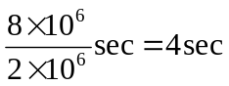With store-and-forward switching, the total time to move message from source host to destination host = 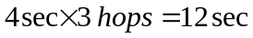
- Time to send 1st packet from source host to first packet switch = 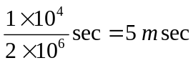. Time at which 2nd packet is received at the first switch = time at which 1st packet is received at the second switch = 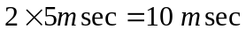
- Time at which 1st packet is received at the destination host = 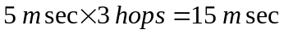. After this, every 5msec one packet will be received; thus time at which last (800th) packet is received = . It can be seen that delay in using message segmentation is significantly less (almost 1/3rd).

- Without message segmentation, if bit errors are not tolerated, if there is a single bit error, the whole message has to be retransmitted (rather than a single packet).
- Without message segmentation, huge packets (containing HD videos, for example) are sent into the network. Routers have to accommodate these huge packets. Smaller packets have to queue behind enormous packets and suffer unfair delays.

- Packets have to be put in sequence at the destination.
- Message segmentation results in many smaller packets. Since header size is usually the same for all packets regardless of their size, with message segmentation the total amount of header bytes is more.

P33
There are F/S packets. Each packet is S=80 bits. Time at which the last packet is received at the first router is 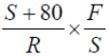sec. At this time, the first F/S-2 packets are at the destination, and the F/S-1 packet is at the second router. The last packet must then be transmitted by the first router and the second router, with each transmission taking 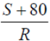sec. Thus delay in sending the whole file is 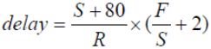
To calculate the value of S which leads to the minimum delay,
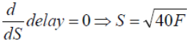

Chapter 2 Problems
P1, P4, P5, P10, P17, P22, P25, P26, P31（此部分自行練習不須繳交）

P1
a) F; b) T; c) F; d) F; e) F

P4
- The document request was http://gaia.cs.umass.edu/cs453/index.html. The Host: field indicates the server's name and /cs453/index.html indicates the file name.
- The browser is running HTTP version 1.1, as indicated just before the first <cr><lf> pair.
- The browser is requesting a persistent connection, as indicated by the Connection: keep-alive.
- This is a trick question. This information is not contained in an HTTP message anywhere. So there is no way to tell this from looking at the exchange of HTTP messages alone. One would need information from the IP datagrams (that carried the TCP segment that carried the HTTP GET request) to answer this question.
- Mozilla/5.0. The browser type information is needed by the server to send different versions of the same object to different types of browsers.

P5
- The status code of 200 and the phrase OK indicate that the server was able to locate the document successfully. The reply was provided on Tuesday, 07 Mar 2008 12:39:45 Greenwich Mean Time.
- The document index.html was last modified on Saturday 10 Dec 2005 18:27:46 GMT.
- There are 3874 bytes in the document being returned.
- The first five bytes of the returned document are: <!doc. The server agreed to a persistent connection, as indicated by the Connection: Keep-Alive field

P10
The total download time is:
- 2 ⋅ 100 ms + 8 ⋅ 10³ bits / 10⁶ bits/s + 5 ⋅ (2 ⋅ 100 ms + 4 ⋅ 10⁵ bits / 10⁶ bits/s) = 3.208 s
- 2 ⋅ 100 ms + 3 ⋅ (4 ⋅ 10⁵ bits / 10⁶ bits/s) = 1.4 s
- 2 ⋅ 100 ms + 4 ⋅ 10⁵ bits / 10⁶ bits/s = 0.6 s
- 2 ⋅ 100 ms + 8 ⋅ 10³ bits / 10⁶ bits/s + 5 ⋅ (4 ⋅ 10⁵ bits / 10⁶ bits/s) = 2.208 s

P17
- C: dele 1
C: retr 2
S: (blah blah …
S: ………..blah)
S: .
C: dele 2
C: quit
S: +OK POP3 server signing off
- C: retr 2
S: blah blah …
S: ………..blah
S: .
C: quit
S: +OK POP3 server signing off
- C: list
S: 1 498
S: 2 912
S: .
C: retr 1
S: blah …..
S: ….blah
S: .
C: retr 2
S: blah blah …
S: ………..blah
S: .
C: quit
S: +OK POP3 server signing off

P22
For calculating the minimum distribution time for client-server distribution, we use the following formula:
D_{cs} = max {NF/u_{s}, F/d_{min}}
Similarly, for calculating the minimum distribution time for P2P distribution, we use the following formula:
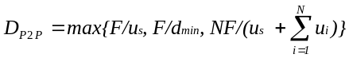
Where, F = 15 Gbits = 15 * 1024 Mbits
u_{s} = 30 Mbps
d_{min =} d_{i} = 2 Mbps
Note, 300Kbps = 300/1024 Mbps.

Client Server
 |  | N
 |  | 10 | 100 | 1000
u | 300 Kbps | 7680 | 51200 | 512000
u | 700 Kbps | 7680 | 51200 | 512000
u | 2 Mbps | 7680 | 51200 | 512000

Peer to Peer
 |  | N
 |  | 10 | 100 | 1000
u | 300 Kbps | 7680 | 25904 | 47559
u | 700 Kbps | 7680 | 15616 | 21525
u | 2 Mbps | 7680 | 7680 | 7680

P25
Yes. His first claim is possible, as long as there are enough peers staying in the swarm for a long enough time. Bob can always receive data through optimistic unchoking by other peers.
His second claim is also true. He can run a client on each host, let each client “free-ride,” and combine the collected chunks from the different hosts into a single file. He can even write a small scheduling program to make the different hosts ask for different chunks of the file. This is actually a kind of Sybil attack in P2P networks.

P26
- N files, under the assumption that we do a one-to-one matching by pairing video versions with audio versions in a decreasing order of quality and rate.
- 2N files.

P31
As Netflix has its own servers deployed at both ISPs and IXPs, it employs a combination of the “enter deep” and “bring home” placement strategies. The number of servers deployed at each location varies, but usually more servers are located at the IXPs and they may contain the whole Netflix library. The content is updated on the servers according to a push strategy. This allows Netflix to schedule video transfers to the servers in its CDN during the hours with less traffic, thus avoiding congestion.

Chapter 3 Problems
P1, P4, P25, P27, P34, P40, P44（此部分自行練習不須繳交）

P1
The well-known port for HTTP is 80.
a. Source port: 33000, destination port: 80.
b. Source port: 80, destination port: 33000 (they are inverted).
c. No, the HTTP protocol runs over a TCP connection.
d. Yes, if supported by the server (almost all web servers do).

P4
The host needs to add all values in the relevant fields of the received segment to understand if the packet is corrupted or not, including the checksum:
01011101 11110010
00110010 00001101
10001111 11111111
As the obtained value is different from 11111111 11111111, the receiver considers the segment as corrupted. It can either discard the segment or notify the application layer that a corrupted segment has been received (along with the corresponding data).

P25
Remember that Telnet operates at the character level, so the “Hello” input is considered as a sequence of 5 application-level messages.
- As TCP is connection-oriented, the application simply writes data to the connection send buffer. TCP will take bytes according to its own rules without necessarily putting a single message in a TCP segment. Thus, it is not possible to know a priori how many segments will be created at Host A.
- No, as TCP runs the flow and congestion control algorithms and may delay giving the application data to the network layer.
- The PSH bit in the TCP header.
- Yes. As the channel is reliable, the application is guaranteed that each message will correctly be delivered from the source to the destination. So the additional mechanisms provided by TCP are not needed. Moreover, UDP encapsulates exactly one character in a segment, since the application sends the input as a sequence of one character messages. The segment is immediately sent to the network layer, thus reducing delays and improving the user experience.

P27
- In the second segment from Host A to B, the sequence number is 207, source port number is 302 and destination port number is 80.
- If the first segment arrives before the second, in the acknowledgement of the first arriving segment, the acknowledgement number is 207, the source port number is 80 and the destination port number is 302.
- If the second segment arrives before the first segment, in the acknowledgement of the first arriving segment, the acknowledgement number is 127, indicating that it is still waiting for bytes 127 and onwards.

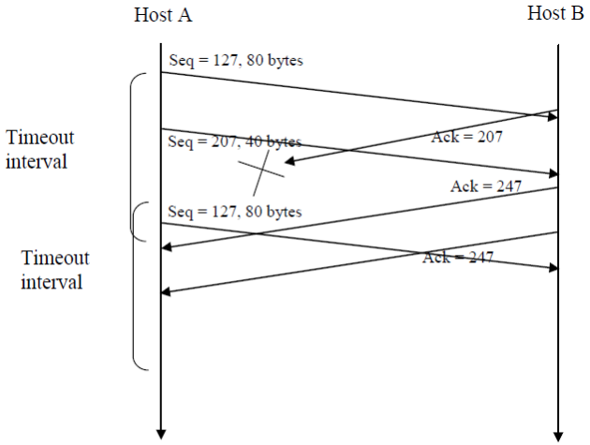

P34
At any given time t, SendBase – 1 is the sequence number of the last byte that the sender knows has been received correctly, and in order, at the receiver. The actually last byte received (correctly and in order) at the receiver at time t may be greater if there are acknowledgements in the pipe. Thus
SendBase–1 ≤ LastByteRcvd

P40
- TCP slowstart is operating in the intervals [1,6] and [23,26]
- TCP congestion avoidance is operating in the intervals [6,16] and [17,22]
- After the 16th transmission round, packet loss is recognized by a triple duplicate ACK. If there was a timeout, the congestion window size would have dropped to 1.
- After the 22nd transmission round, segment loss is detected due to timeout, and hence the congestion window size is set to 1.
- The threshold is initially 32, since it is at this window size that slow start stops and congestion avoidance begins.
- The threshold is set to half the value of the congestion window when packet loss is detected. When loss is detected during transmission round 16, the congestion windows size is 42. Hence the threshold is 21 during the 18th transmission round.
- The threshold is set to half the value of the congestion window when packet loss is detected. When loss is detected during transmission round 22, the congestion windows size is 29. Hence the threshold is 14 (taking lower floor of 14.5) during the 24th transmission round.
- During the 1st transmission round, packet 1 is sent; packet 2-3 are sent in the 2nd transmission round; packets 4-7 are sent in the 3rd transmission round; packets 8-15 are sent in the 4th transmission round; packets 16-31 are sent in the 5th transmission round; packets 32-63 are sent in the 6th transmission round; packets 64 – 96 are sent in the 7th transmission round. Thus packet 70 is sent in the 7th transmission round.
- The threshold will be set to half the current value of the congestion window (8) when the loss occurred and congestion window will be set to the new threshold value + 3 MSS. Thus the new values of the threshold and window will be 4 and 7 respectively.
- threshold is 21, and congestion window size is 1.
- round 17, 1 packet; round 18, 2 packets; round 19, 4 packets; round 20, 8 packets; round 21, 16 packets; round 22, 21 packets. So, the total number is 52.

P44
- It takes 1 RTT to increase CongWin to 6 MSS; 2 RTTs to increase to 7 MSS; 3 RTTs to increase to 8 MSS; 4 RTTs to increase to 9 MSS; 5 RTTs to increase to 10 MSS; 6 RTTs to increase to 11 MSS; and 7 RTTs to increase to 12MSS.
- In the first RTT 5 MSS was sent; in the second RTT 6 MSS was sent; in the third RTT 7 MSS was sent; in the fourth RTT 8 MSS was sent; in the fifth RTT, 9 MSS was sent; and in the sixth RTT, 10 MSS was sent. Thus, up to time 6 RTT, 5+6+7+8+9+10 = 45 MSS were sent (and acknowledged). Thus, we can say that the average throughput up to time 6 RTT was (45 MSS)/(6 RTT) = 7.5 MSS/RTT.

Chapter 4 Problems
P5, P8, P10, P11, P14（此部分自行練習不須繳交）

P5

Prefix Match | Link Interface
11100000 00000000 | 0
11100000 00000001 | 1
1110000 | 2
11100010 | 3
otherwise | 3
- Prefix match for first address is 5th entry: link interface 3
Prefix match for second address is 1st entry: link interface 0
Prefix match for third address is 4th entry: link interface 2

P8
223.1.17.0/26
223.1.17.128/25
223.1.17.192/28

P10
In a P2P application, any participating Peer A should be able to initiate a TCP connection to any other participating Peer B. The essence of the problem is that if Peer B is behind a NAT, it cannot act as a server and accept TCP connections. This NAT problem can be circumvented if Peer A is not behind a NAT. In this case, Peer A can first contact Peer B through an intermediate Peer C, which is not behind a NAT and to which B has established an ongoing TCP connection. Peer A can then ask Peer B, via Peer C, to initiate a TCP connection directly back to Peer A. Once the direct P2P TCP connection is established between Peers A and B, the two peers can exchange messages or files. This strategy is called connection reversal.

P11
Any IP address in range 192.168.56.128 to 192.168.56.191.
Four equal size subnets: 192.168.56.32/28, 192.168.56.48/28, 128.119.40.64/28, 192.168.56.80/28.

P14
The maximum size of data field in each fragment = 480 (because there are 20 bytes IP header). Thus the number of required fragments = 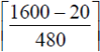 = 4
Each fragment will have Identification number 291. Each fragment except the last one will be of size 500 bytes (including IP header). The last datagram will be of size 160 bytes (including IP header). The offsets of the 4 fragments will be 0, 60, 120, 180. Each of the first 3 fragments will have flag=1; the last fragment will have flag=0.

