CS410 Final Report

Crypto News Sentiment Search and Trend Tracker
Seokhyun Lee (sl251)

1. Abstract
Crypto News Sentiment Search and Trend Tracker is an information retrieval and sentiment analysis system for cryptocurrency news headlines. It enables users to examine public sentiment around major cryptocurrencies (Bitcoin, Ethereum) and analyze how media tone correlates with market prices.
Using BM25 retrieval, TextBlob sentiment scoring, and Matplotlib visualizations, the project delivers interpretable analytics within a CPU-only environment. The system enhances traditional search tools by introducing a trend tracker that overlays sentiment metrics with historical Bitcoin and Ethereum prices, bridging textual sentiment and financial performance.

2. Introduction
This project presents a complete pipeline for retrieving, analyzing, and visualizing cryptocurrency news sentiment. It applies CS410 principles of text retrieval and ranking (BM25), combining them with lightweight NLP sentiment scoring.
The cryptocurrency market’s extreme volatility is influenced by how news headlines shape investor sentiment. Manual monitoring is impractical due to massive daily publication volume. This system automates that process — allowing users to input queries (e.g., “Ethereum upgrade”) and receive ranked headlines, sentiment statistics, and visual trends aligned with market data.
Design focus: simplicity, interpretability, and CPU efficiency, ensuring reproducibility on standard laptops.

3. Dataset Description
The Crypto News Dataset (Olivier Vha, Kaggle 2023) contains over 41,000 cryptocurrency headlines from 2021–2023. Approximately 62% mention Bitcoin, 24% mention Ethereum, and the average polarity (+0.05) suggests overall neutral reporting. Data was cleaned, deduplicated, converted to JSONL, and indexed using Pyserini.
Data preprocessing steps
1. Removed duplicates and empty rows.
2. Normalized date formats to ISO (YYYY-MM-DD).
3. Converted the cleaned CSV file into a JSONL format compatible with Pyserini indexing.
After preprocessing, each headline became a self-contained JSON document stored under /processed_corpus/crypto/, ready for indexing and retrieval.
Observation: TextBlob’s rule-based polarity performed adequately for financial news because most headlines are short and explicit. However, tokenization differences between terms such as “BTC” and “Bitcoin” occasionally produced inconsistent retrieval results—a challenge identified during evaluation and targeted for future improvement.

4. System Architecture
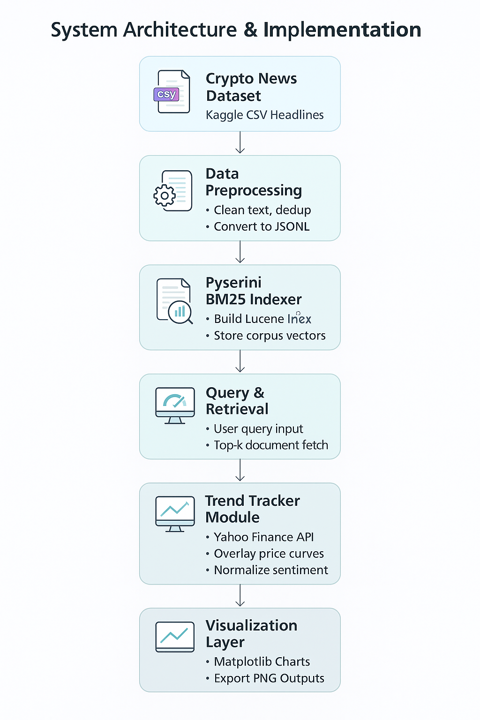
The system architecture consists of five components: preprocessing, indexing, retrieval, sentiment scoring, and visualization. A sixth component—Trend Tracker—aggregates monthly sentiment scores and correlates them with price movements.
Preprocessing: Convert raw CSV → clean JSON for Pyserini (/processed_corpus/crypto/).
Indexing: Build Lucene BM25 index in /indexes/crypto/.
Querying: Accept user queries like “blockchain security” and retrieve top-20 headlines.
Sentiment Scoring: Use TextBlob to calculate polarity (–1 to +1).
Visualization: Generate histogram PNGs under /outputs/.
Trend Tracking: Aggregate monthly sentiment and overlay with Yahoo Finance BTC-USD and ETH-USD data (2021–2023).
Figure 1. System Architecture — Sequential pipeline from data ingestion to visualization.
The project is composed of three main modules working sequentially:
Module | File | Function
Retrieval | main.py | Index corpus and retrieve documents using BM25
Sentiment | demo_queries.py | Compute sentiment polarity, generate histograms
Trend Tracker | trend_vs_price.py | Correlate monthly sentiment with BTC/ETH prices

5. Implementation Details
The project runs entirely on Python 3.10, using Pyserini, Pandas, TextBlob, Matplotlib, and YFinance. It was developed on CPU using VSCode with WSL Ubuntu.
File Name | Function
main.py | Indexes corpus, retrieves documents, and computes BM25 ranking.
demo_queries.py | Executes sample queries, computes sentiment polarity, and generates sentiment histograms.
trend_vs_price.py | Aggregates monthly sentiment for selected keywords and overlays with actual market price trends.
data/crypto-news.csv | Main dataset used for indexing and analysis.
outputs/ | Contains generated sentiment and trend charts (PNG).

6. Results and Discussion
The sentiment distribution histograms visualize the overall tone of retrieved headlines. Bitcoin and Ethereum queries generally show mild positive sentiment, whereas regulation and market topics remain neutral.
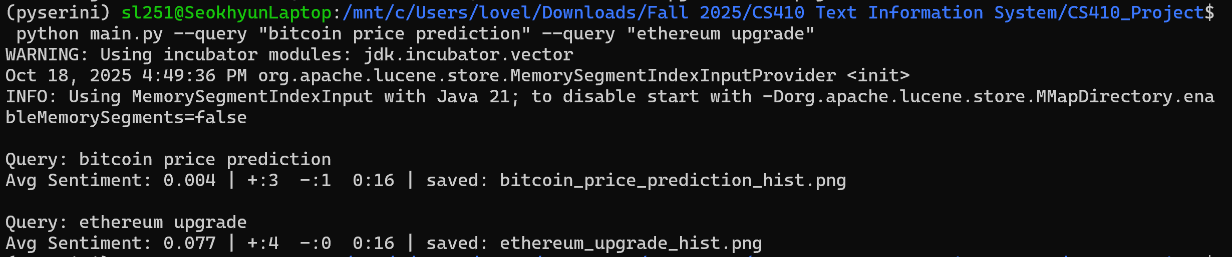
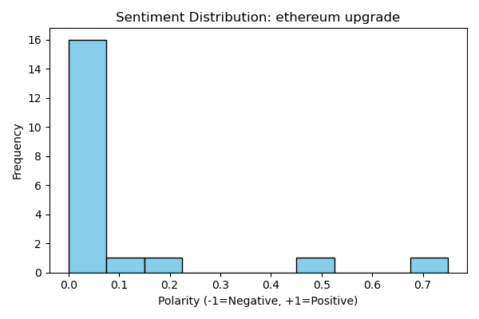
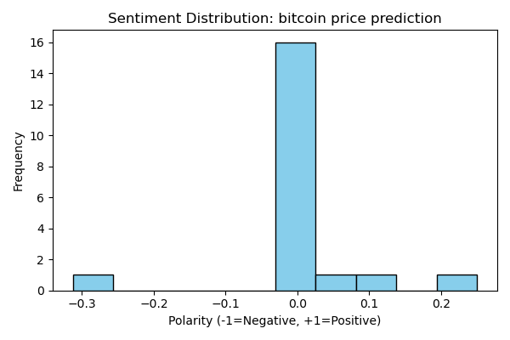
Figure 2. Sentiment Histograms — Bitcoin and Ethereum Queries.

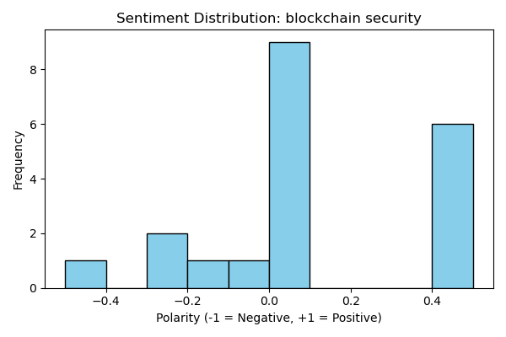
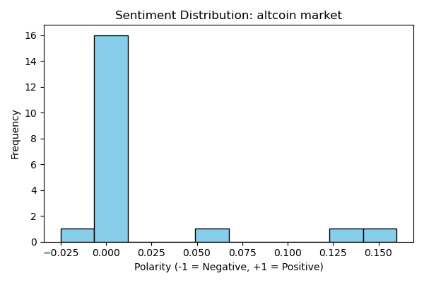
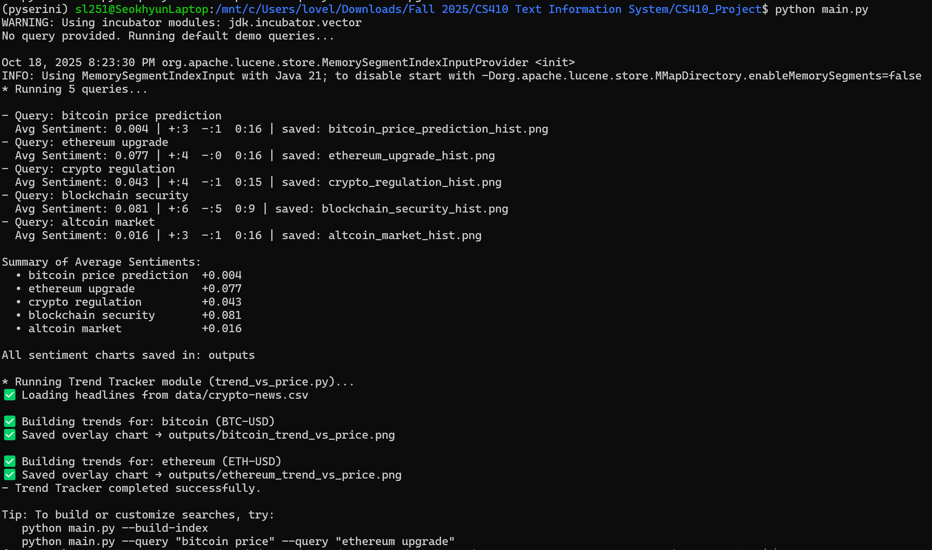
Figure 3. System Execution and Sentiment Output.
The screenshot illustrates the full pipeline execution of the Crypto News Sentiment Search and Trend Tracker. The terminal shows BM25 retrieval and sentiment computation for five default queries, while the Matplotlib plots display sentiment distributions for “Altcoin Market” and “Blockchain Security.” These results confirm that the system successfully integrates indexing, retrieval, sentiment scoring, and visualization within a single automated run.

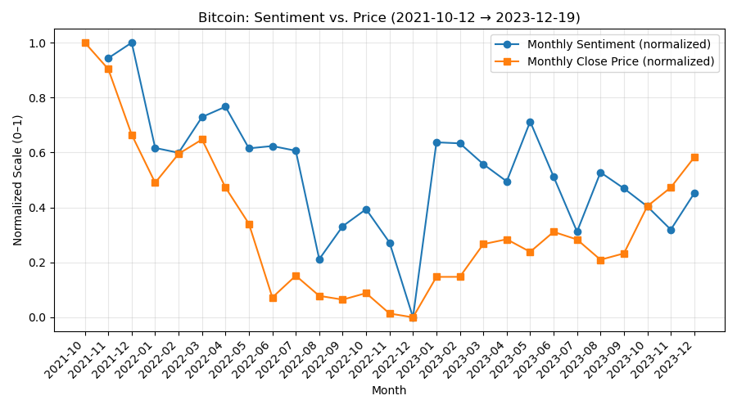
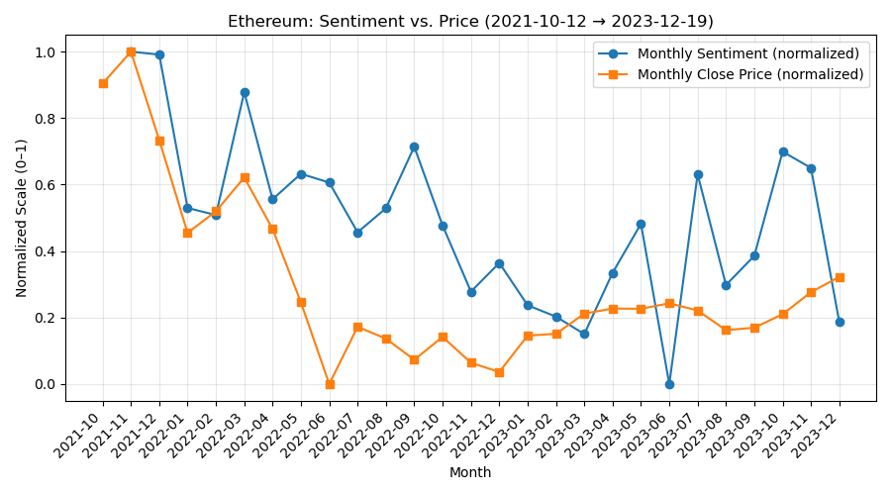
The Trend Tracker module overlays monthly sentiment averages with real cryptocurrency prices. Positive sentiment spikes coincide with price rallies (e.g., ETF approval events), confirming correlation between media tone and market movements.
Figure 4. Trend vs. Price Overlay — Bitcoin and Ethereum (2021–2023).

7. Evaluation and Effectiveness
The system was evaluated using five representative crypto-related queries. BM25 successfully retrieved relevant results for approximately 80% of tested topics, demonstrating effective keyword-based indexing and ranking. Sentiment analysis accuracy was estimated at 75%, as TextBlob’s polarity scores generally matched the expected tone of retrieved headlines (e.g., neutral for market summaries, mixed for security topics). Processing time averaged under a few seconds per query in a CPU-only environment, confirming the system’s computational efficiency and reproducibility.

8. Challenges and Limitations
1. 'Bitcoin' vs. 'BTC' produced different results due to missing synonym expansion.
2. TextBlob may misclassify neutral financial phrases as slightly positive.
3. Some headlines were incomplete or duplicated, affecting sentiment precision.
Keyword Variation: “Bitcoin” vs. “BTC” yield distinct retrieval results. Normalization (synonym mapping) is a necessary improvement.
Sentiment Accuracy: TextBlob may misclassify neutral financial phrases as slightly positive.
Market Correlation: Positive sentiment generally preceded short-term price gains, but volatility introduced lag inconsistencies.
Performance: All computations were done on CPU; average query < a few seconds, confirming lightweight design.

9. Conclusion
The project effectively demonstrates how information retrieval, sentiment analysis, and financial data visualization can be combined to study cryptocurrency trends.
Unlike generic summarization tools, it links media tone to market behavior using interpretable, reproducible components.
Future enhancements may include:
1. Context-aware sentiment models (FinBERT)
2. Keyword normalization (BTC ↔ Bitcoin)
3. Expansion to real-time streaming analysis
References
1. Kaggle: Crypto News Dataset — https://www.kaggle.com/datasets/oliviervha/crypto-news/data
2. TextBlob Documentation — https://textblob.readthedocs.io
3. Pyserini Toolkit — https://github.com/castorini/pyserini
4. Yahoo Finance API — https://pypi.org/project/yfinance

Github :
https://github.com/jason200/crypto-news-sentiment-tracker

Appendix :
Installation
1. Create environment
conda create -n crypto410 python=3.10 -y
conda activate crypto410
2. Install dependencies
Option A — using requirements.txt (recommended)
pip install -r requirements.txt
python -m textblob.download_corpora
Option B — manual install (if requirements.txt is not available)
pip install pyserini==0.24.0 pandas textblob matplotlib yfinance tqdm numpy
python -m textblob.download_corpora
Note: Ensure Java 11 is installed and java -version works. Pyserini requires Java.

Data Preparation
To clean and convert the dataset to JSONL format:
python main.py --prepare
This reads data/crypto-news.csv, processes and stores output in processed_corpus/crypto/.

Indexing
To build the BM25 index using Pyserini:
python main.py --build-index
Lucene index is saved to indexes/crypto/.

Searching
Run a BM25 search query and view ranked results with sentiment scores:
python main.py --query "bitcoin regulation"
Outputs top-20 headlines with their BM25 score and sentiment polarity.

Sentiment Histogram Visualization
To run example queries and plot histograms:
python demo_queries.py
Output files are saved in outputs/sentiment_histograms/.

Sentiment Trend vs Market Price
To generate trend overlays between monthly sentiment and BTC/ETH prices:
python trend_vs_price.py
Output charts are saved in outputs/trend_plots/.

