Question 1

number = input(‘Pls input number:’)

result=””

number2 = ‘abc’

number3=’def’

number4=’ghi’

number5=’jkl’

number6=’mno’

number7=’pqrs’

number8=’tuv’

number9=’wxyz’

def phonenumber(number) :

for char in number:

if char in number2:

result += ‘2’

if char in number3:

result += ‘3’

#similar with the other number

Print(result)

Question 2: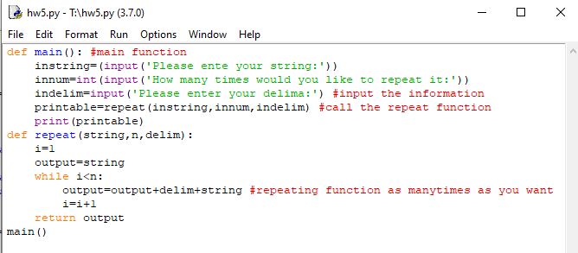

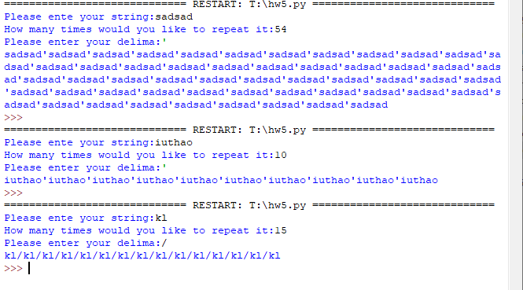

Question 3:

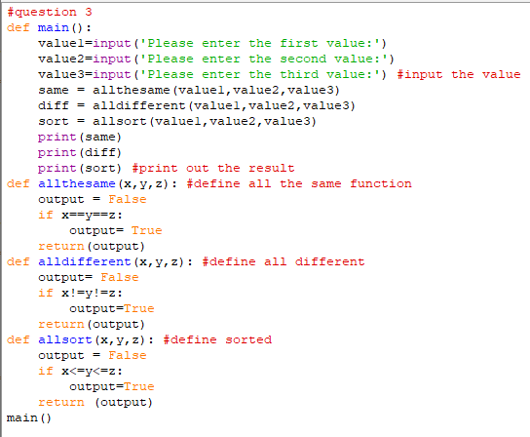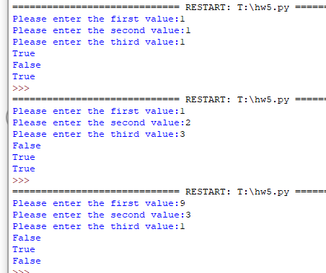

Question 4:

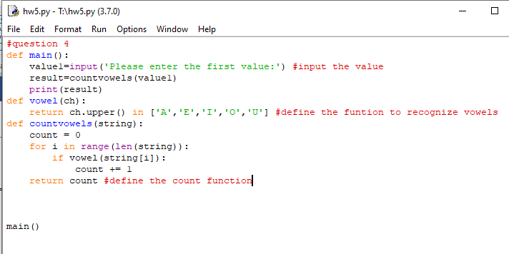

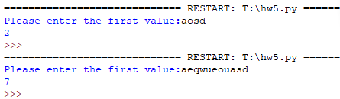

Question 5: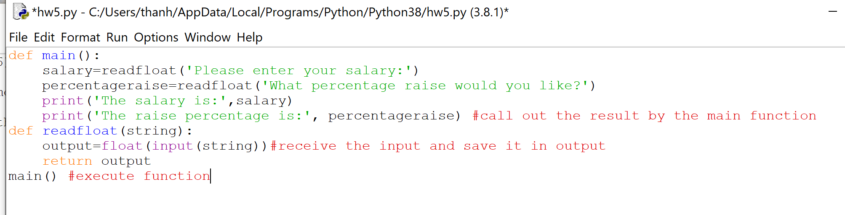

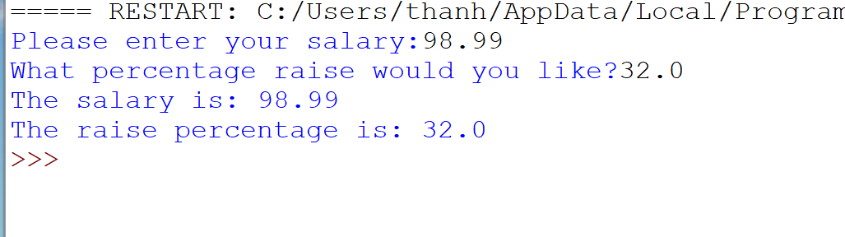

Question 6:

