Question 1:

Creat list #the original list

Creat new_list #create a new one to save the result

While i in range from i to len(list)

If list[i]>0:

Add to new_list

Print new_list

Question 2:

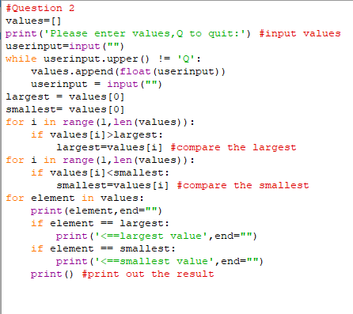

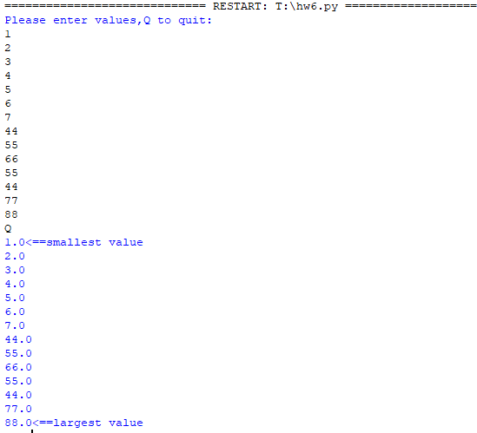

Question 3

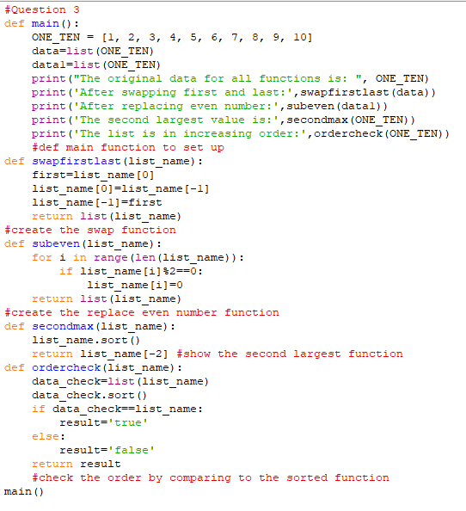

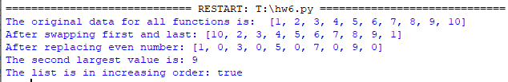

Question 4

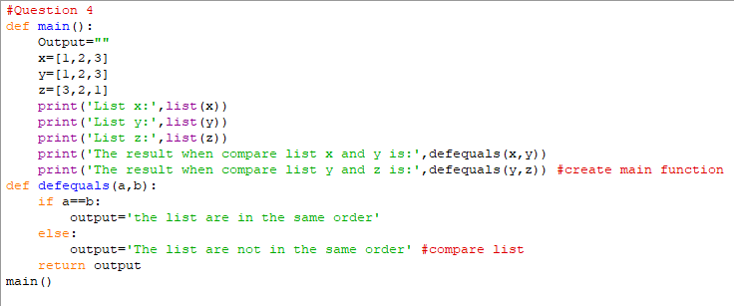

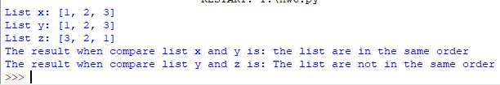

Question 5

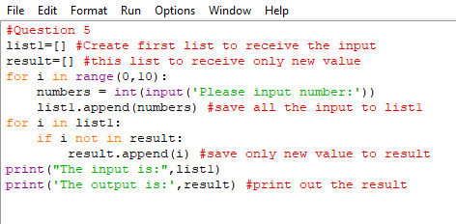

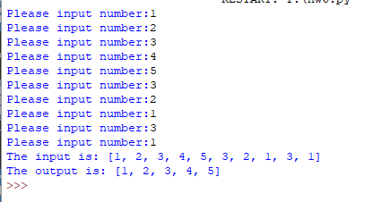

Question 6

