Question 1:

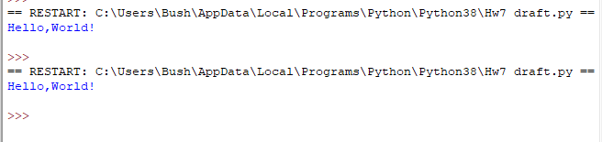

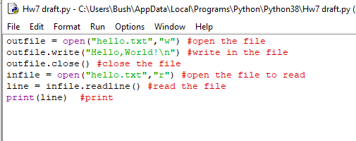

Question 2:

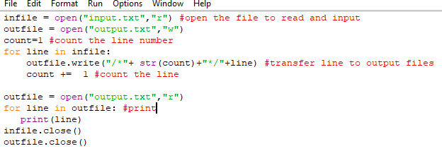

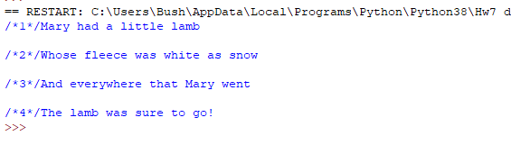

Question 3:

Question 4:

Question 5:

Question 6:

