Question 1:

Accept Input integer = test grade

If 90 =< test grade =< 100 then grade = A

If 80=< test grade =< 89 then grade = B

If 70 =< test grade =< 79 then grade = C

If 60 =< test grade =< 69 then grade = D

If test grade < 60 then grade = F

Question 2:

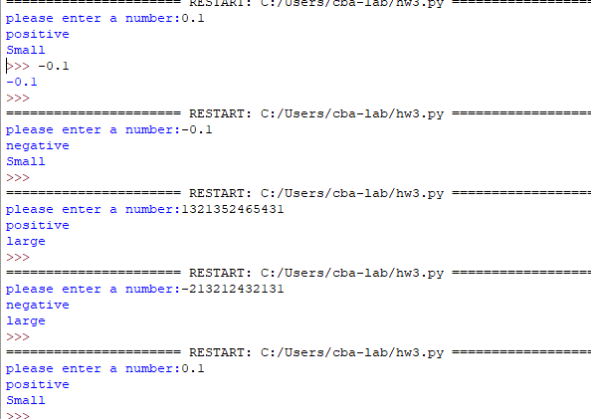

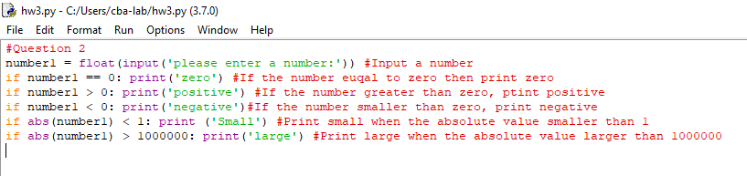

Question 3:

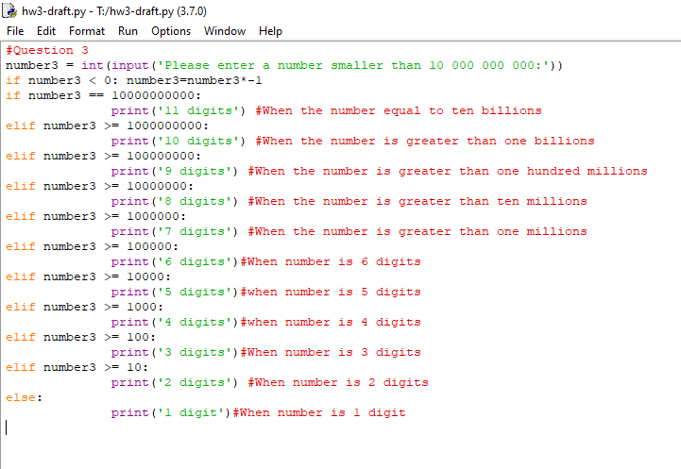

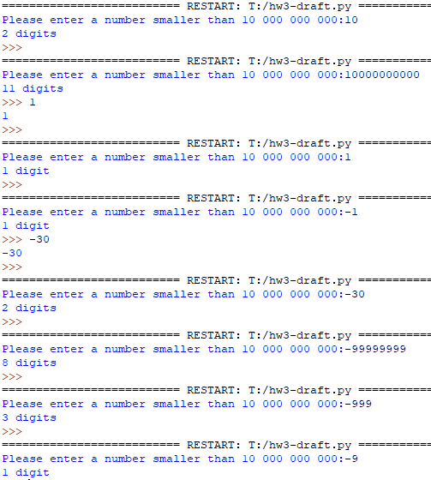

Question 4:

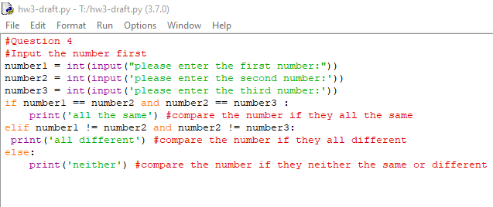

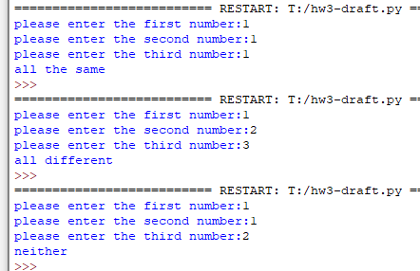

Question 5:

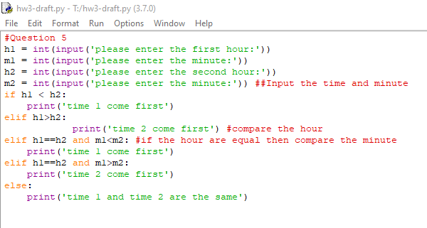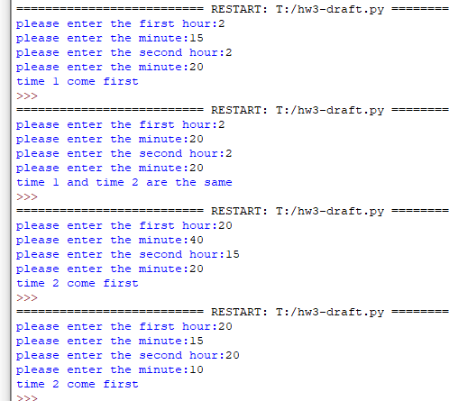

Question6:

