1.

PAPER_WIDTH = 8.5 inches #CONSTANT

PAPER_HEIGHT = 11 inches #CONSTANT

MILIMETTERS_PER_INCHES = 24.3 MILIMETTERS #CONSTANT

WIDTH_IN_MILIMETTERS = PAPER_WIDTH * MILIMETTERS_PER_INCHES

HEIGHT_IN_MILIMETTERS = PAPER_HEIGHT * MILIMETTERS_PER_INCHES

2.

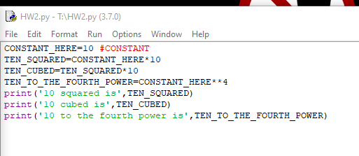

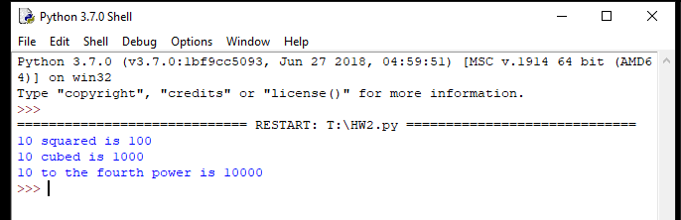

3.

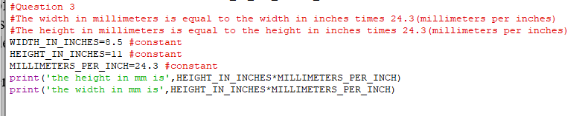



4.

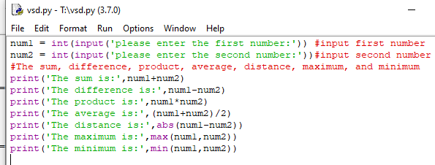

5.

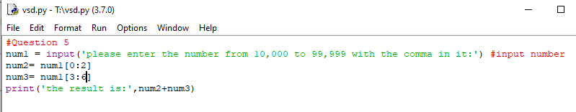



6.

