Question1:

Input Student First name and Last name.

Total grade = 0

Count = 0

While grade >= 0:

Grade = input student grade and input -1 to end

Total grade = Total grade + Grade

Count = Count + 1

If count > 0:

Average score = Total grade/Count

Print (“the average score is:”, Average score)

Else:

Print(‘no date was entered’)

Question 2:

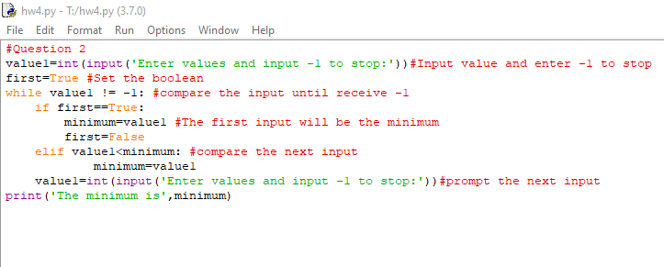

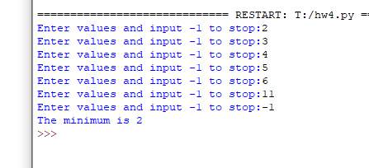

Question 3:

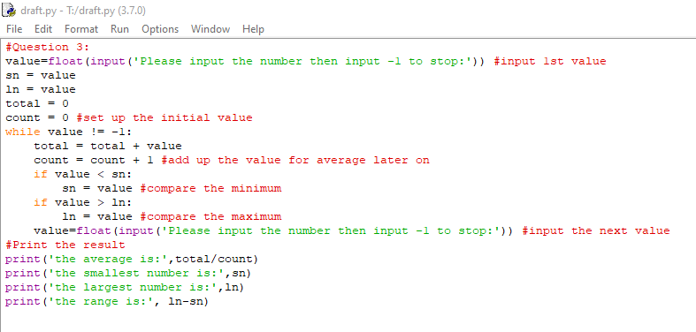

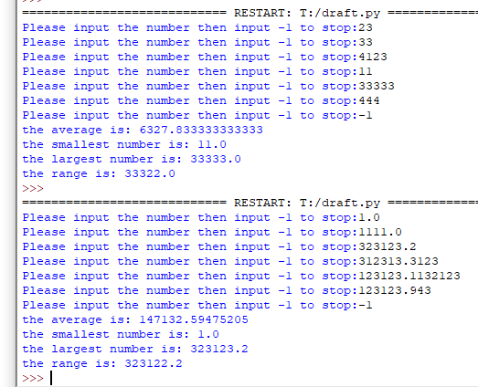

Question 4:

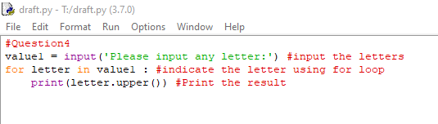

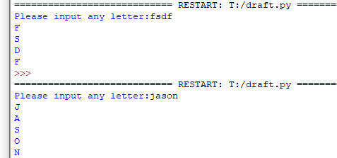

Question 5:

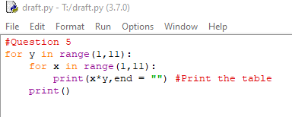

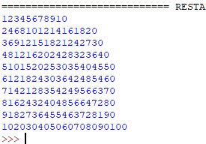

Question 6:

