電通二乙微處理器實驗 實驗結報

實驗名稱 | Lab01-LED Blink
組別 | 03 | 組員 | 04050174陳定邦 / 04050696 張澄鄗

- 實驗目的
使用 circuits.io 模擬 Arduino UNO 電路及程式
繪製電路圖
觀察 Arduino UNO 之輸出
學習將程式碼及實驗報告上傳至 Github
- 實驗步驟
填寫分組表單
啓動 Arduino IDE, 載入 Blink 程式碼
至 circuits.io 註冊帳號，啟動 Arduino 模擬器
接上 LED 電路
修改程式，將 LED 輸出改為 Pin 9
觀察 LED 之閃爍間隔
修改程式, 使 LED 閃爍間隔分別增加為 2 倍及 ½ 倍, 重新量測並截圖
畫出電路圖
- 程式碼
/*
Blink
Turns on an LED on for one second, then off for one second, repeatedly.

Most Arduinos have an on-board LED you can control. On the Uno and
Leonardo, it is attached to digital pin 13. If you're unsure what
pin the on-board LED is connected to on your Arduino model, check
the documentation at http://arduino.cc

This example code is in the public domain.

modified 8 May 2014
by Scott Fitzgerald
*/

// the setup function runs once when you press reset or power the board
void setup() {
// initialize digital pin 13 as an output.
pinMode(13, OUTPUT);
}

// the loop function runs over and over again forever
void loop() {
digitalWrite(13, HIGH); // turn the LED on (HIGH is the voltage level)
delay(1000); // wait for a second
digitalWrite(13, LOW); // turn the LED off by making the voltage LOW
delay(1000); // wait for a second
}
- 實驗結果及分析
在未修改之前因HIGH和LOW的delay都是1000ms 故亮的時間1000ms暗的時間1000ms
修改之後 變為暗的時間0.5秒 亮的時間為2秒
- 心得討論
讓我學會如何用circuits.io這個模擬網站 和 如何使用github的網站
- 修正電路圖
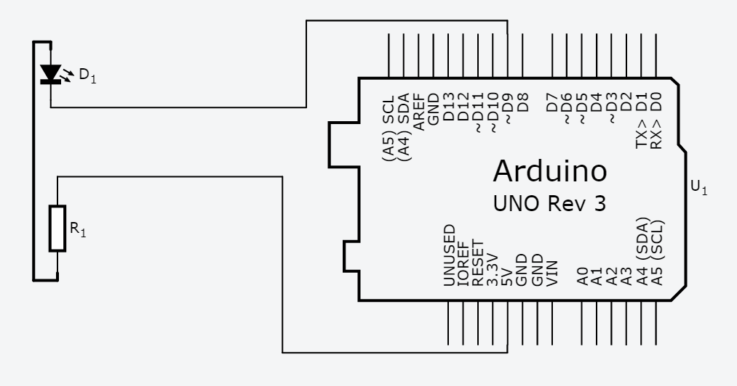
- 修正程式碼
/*
Blink
Turns on an LED on for one second, then off for one second, repeatedly.

Most Arduinos have an on-board LED you can control. On the Uno and
Leonardo, it is attached to digital pin 9. If you're unsure what
pin the on-board LED is connected to on your Arduino model, check
the documentation at http://arduino.cc

This example code is in the public domain.

modified 8 May 2014
by Scott Fitzgerald
*/

// the setup function runs once when you press reset or power the board
void setup() {
// initialize digital pin 9 as an output.
pinMode(9, OUTPUT);
}

// the loop function runs over and over again forever
void loop() {
digitalWrite(9, HIGH); // turn the LED on (HIGH is the voltage level)
delay(500); // wait for a second
digitalWrite(9, LOW); // turn the LED off by making the voltage LOW
delay(2000); // wait for a second
}

