電通二甲微處理器實驗 實驗結報

實驗名稱 | Lab 08 –I 2C通訊
組別 | 2 | 組員 | 04050696張澄鄗 04050174陳定邦

- 實驗目的
使用 Arduino wire 程式庫, 實現多台 Arduino 透過 I2C 介面 通訊.
1. 一台 Arduino, 作為 Master 端，讀取 slave 端之溫濕度 感測器讀值, 顯示在 LCD 螢幕上
2. 一台 Arduino, 作為 Slave 端，將溫濕度感測器之讀值， 傳送到 Master 及 PC
- 實驗步驟
實驗步驟 1: 讀取 DHT-11
實驗步驟 2: Slave 端
實驗步驟 3: Master 端
- 程式碼
(1)
#include #define dht_dpin 2 //定義訊號要從Pin A0 進來 dht DHT; void setup(){ Serial.begin(9600); delay(300); Serial.println("Humidity and temperature\n\n"); delay(700); } void loop(){ DHT.read11(dht_dpin); //去library裡面找DHT.read11 Serial.print("Humidity = "); Serial.print(DHT.humidity); Serial.print("% "); Serial.print("temperature = ");Serial.print(DHT.temperature); Serial.println("C "); delay(1000); //每1000ms更新一次 }
(2)
#include const int SLAVE_ADDRESS = 1; void setup(){ Wire.begin(SLAVE_ADDRESS); // join I2C bus as a slave with addres Wire.onRequest(requestEvent); // register event } void loop() { } void requestEvent() { DHT.read11(dht_dpin); //讀取DHT-11 Wire.write(”XXX“); //將溫濕度讀值輸出 }
(3)
#include const int SLAVE_ADDRESS = 1; char incomingByte = 0; void setup() { Wire.begin(); // join I2C bus as a Master } void loop() { Wire.requestFrom(SLAVE_ADDRESS, X); // request X bytes from slave while (Wire.available()) { incomingByte = Wire.read(); // receive a byte // Display at LCD } delay(1000); // LCD 換行 }
- 實驗結果及分析
1. Slave 端, 可透過 I 2C 傳出溫濕度感測器之讀值
2. Master 端, 可透過 I 2C 讀取溫濕度感測器之讀值
- 心得討論
這次用到兩台arduino，一開始接線有點問題，LCD無法顯示所要的數值，
最後在兩組一起討論下，終於完成這次的實驗。
- 修正電路圖
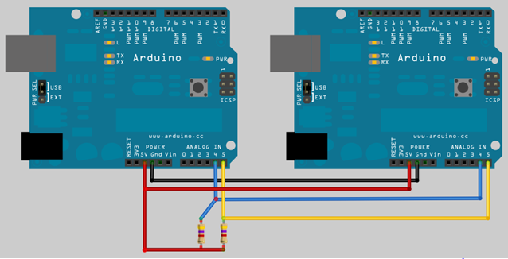
- 修正程式碼

(1)
#include <dht.h>
#define dht_dpin 2 //定義訊號要從Pin A0 進來
dht DHT;
void setup(){
Serial.begin(9600); delay(300);
Serial.println("Humidity and temperature\n\n");
delay(700); }
void loop(){
DHT.read11(dht_dpin); //去library裡面找DHT.read11
Serial.print("Humidity = "); Serial.print(DHT.humidity);
Serial.print("% ");
Serial.print("temperature = ");Serial.print(DHT.temperature);
Serial.println("C ");
delay(1000); //每1000ms更新一次
}
(2)master
#include <Wire.h>
#include <LiquidCrystal.h> // include the library code
LiquidCrystal lcd(12, 11, 5, 4, 3, 2);
const int SLAVE_ADDRESS = 1;
char incomingByte;
void setup() {
Serial.begin(9600);
lcd.begin(20, 2);
Wire.begin(); // join I2C bus as a Master
}
void loop() {
Wire.requestFrom(SLAVE_ADDRESS,5);
// request 1 bytes from slave
while (Wire.available()) {
incomingByte = Wire.read(); // receive a byte
//Serial.print(incomingByte);
lcd.print(incomingByte);// Display at LCD

}
-delay(1000);
// LCD 換行
}
(3)slave
#include <Wire.h>
#include <LiquidCrystal.h> // include the library code
LiquidCrystal lcd(12, 11, 5, 4, 3, 2);
const int SLAVE_ADDRESS = 1;
char incomingByte;
void setup() {
Serial.begin(9600);
lcd.begin(20, 2);
Wire.begin(); // join I2C bus as a Master
}
void loop() {
Wire.requestFrom(SLAVE_ADDRESS,5);
// request 1 bytes from slave
while (Wire.available()) {
incomingByte = Wire.read(); // receive a byte
//Serial.print(incomingByte);
lcd.print(incomingByte);// Display at LCD

}
-delay(1000);
// LCD 換行
}

