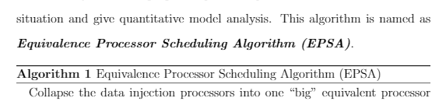

equivalence of  equivalent

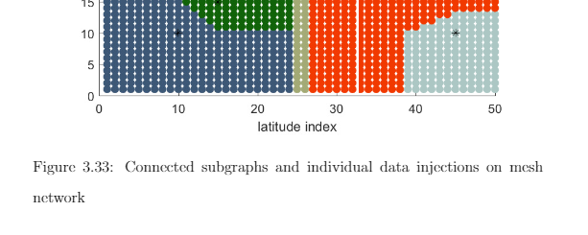

commnet the first one is captial..

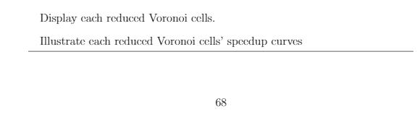

One user case, not 1000 round general sampling experiments...

The timing diagram

Or Gantt-diagram

The timing diagram **for** 3*3 boundary data injection on $P_{0}$ }

The timing diagram **of** 3*3 boundary data injection on $P_{0}$ }