Wireless Network

Experiment Three:

Queuing Theory

**ABSTRACT**

This experiment is designed to learn the fundamentals of the queuing theory. Mainly about the M/M/S and M/M/n/n queuing MODELS.

***KEY WORDS:*** *queuing theory, M/M/s, M/M/n/n,* Erlang B, Erlang C*.*

**INTRODUCTION**

A queue is a waiting line and queueing theory is the mathematical theory of waiting lines. More generally, queueing theory is concerned with the mathematical modeling and analysis of systems that provide service to random demands. In communication networks, queues are encountered everywhere. For example, the incoming data packets are randomly arrived and buffered, waiting for the router to deliver. Such situation is considered as a queue. A queueing model is an abstract description of such a system. Typically, a queueing model represents (1) the system's physical configuration, by specifying the number and arrangement of the servers, and (2) the stochastic nature of the demands, by specifying the variability in the arrival process and in the service process.

The essence of queueing theory is that it takes into account the randomness of the arrival process and the randomness of the service process. The most common assumption about the arrival process is that the customer arrivals follow a Poisson process, where the times between arrivals are exponentially distributed. The probability of the exponential distribution function is .

* **Erlang B model**

One of the most important queueing models is the Erlang B model (i.e., M/M/n/n). It assumes that the arrivals follow a Poisson process and have a finite n servers. In Erlang B model, it assumes that the arrival customers are blocked and cleared when all the servers are busy. The blocked probability of a Erlang B model is given by the famous Erlang B formula,



where n is the number of servers and A= is the offered load in Erlangs, is the arrival rate and is the average service time. Formula (1.1) is hard to calculate directly from its right side when n and A are large. However, it is easy to calculate it using the following iterative scheme:



* **Erlang C model**

The Erlang delay model (M/M/n) is similar to Erlang B model, except that now it assumes that the arrival customers are waiting in a queue for a server to become available without considering the length of the queue. The probability of blocking (all the servers are busy) is given by the Erlang C formula,



Where if and if . The quantity indicates the server utilization. The Erlang C formula (1.3) can be easily calculated by the following iterative scheme



where is defined in Eq.(1.1).

**DESCRIPTION OF THE EXPERIMENTS**

1. **Using the formula (1.2), calculate the blocking probability of the Erlang B model. Draw the relationship of the blocking probability PB(n,A) and offered traffic A with n = 1,2, 10, 20, 30, 40, 50, 60, 70, 80, 90, 100. Compare it with the table in the text book (P.281, table 10.3).**

From the introduction, we know that when the n and A are large, it is easy to calculate the blocking probability using the formula 1.2 as follows.

it use the theory of recursion for the calculation. But the denominator and the numerator of the formula both need to recurs() when doing the matlab calculation, it waste time and reduce the matlab calculation efficient. So we change the formula to be :

Then the calculation only need recurs once time and is more efficient.

*The matlab code for the formula is:* **erlang_b.m**

%**************************************

% File: erlanb_b.m

% A = offered traffic in Erlangs.

% n = number of truncked channels.

% Pb is the result blocking probability.

%**************************************

function [ Pb ] = erlang_b( A,n )

if n==0

Pb=1; % P(0,A)=1

else

Pb=1/(1+n/(A*erlang_b(A,n-1))); % use recursion "erlang(A,n-1)"

end

end

As we can see from the table on the text books, it uses the logarithm coordinate, so we also use the logarithm coordinate to plot the result. We divide the number of servers(n) into three parts, for each part we can define a interval of the traffic intensity(A) based on the figure on the text books :

1. when 0<n<10, 0.1<A<10.

2. when 10<n<20, 3<A<20.

3. when 30<n<100, 13<A<120.

For each part, use the “erlang_b” function to calculate and then use “loglog” function to figure the logarithm coordinate.

*The matlab code is :*

%*****************************************

% for the three parts.

% n is the number servers.

% A is the traffic indensity.

% P is the blocking probability.

%*****************************************

n_1 = [1:2];

A_1 = linspace(0.1,10,50); % 50 points between 0.1 and 10.

n_2 = [10:10:20];

A_2 = linspace(3,20,50);

n_3 = [30:10:100];

A_3 = linspace(13,120,50);

%*****************************************

% for each part, call the erlang_b() function.

%*****************************************

for i = 1:length(n_1)

for j = 1:length(A_1)

p_1(j,i) = erlang_b(A_1(j),n_1(i));

end

end

for i = 1:length(n_2)

for j = 1:length(A_2)

p_2(j,i) = erlang_b(A_2(j),n_2(i));

end

end

for i = 1:length(n_3)

for j = 1:length(A_3)

p_3(j,i) = erlang_b(A_3(j),n_3(i));

end

end

%*****************************************

% use loglog to figure the result within logarithm coordinate.

%*****************************************

loglog(A_1,p_1,'k-',A_2,p_2,'k-',A_3,p_3,'k-');

xlabel('Traffic indensity in Erlangs (A)')

ylabel('Probability of Blocking (P)')

axis([0.1 120 0.001 0.1])

text(.115, .115,'n=1')

text(.6, .115,'n=2')

text(7, .115,'10')

text(17, .115,'20')

text(27, .115,'30')

text(45, .115,'50')

text(100, .115,'100')

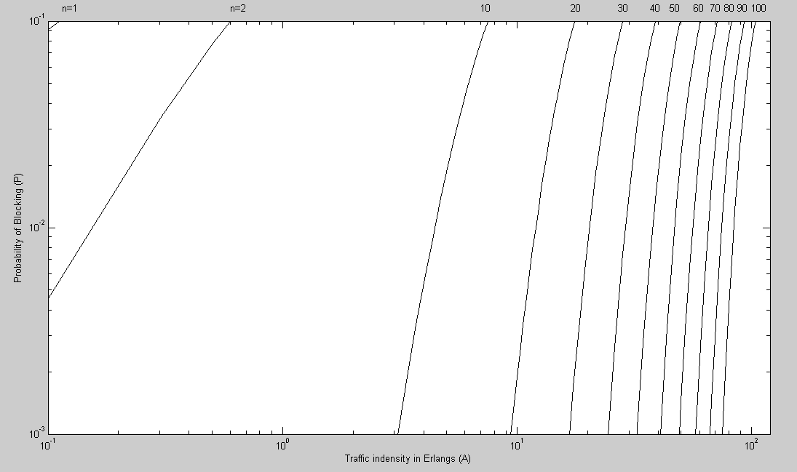

The figure on the text books is as follow:

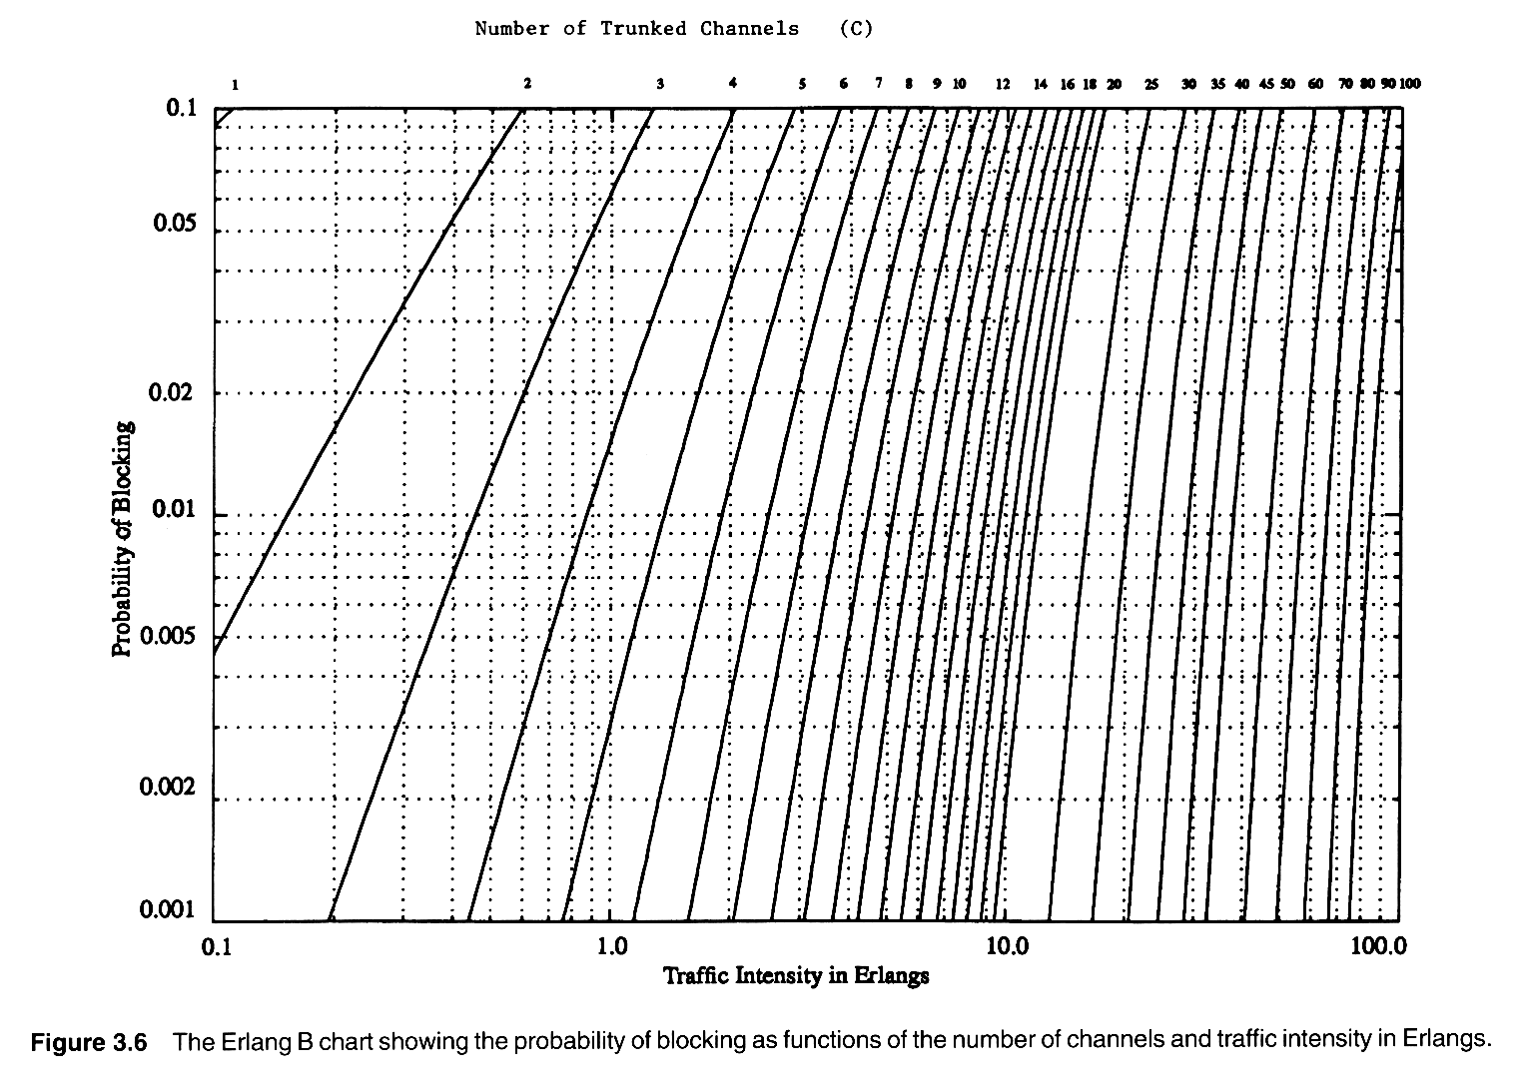

We can see from the two pictures that, they are exactly the same with each other except that the result of the experiment have not considered the situation with n=3,4,5,…,12,14,16,18.

1. **Using the formula (1.4), calculate the blocking probability of the Erlang C model. Draw the relationship of the blocking probability PC(n,A) and offered traffic A with n = 1,2, 10, 20, 30, 40, 50, 60, 70, 80, 90, 100.**

From the introduction, we know that the formula 1.4 is :

Since each time we calculate the , we need to recurs n times, so the formula is not efficient. We change it to be:

Then we only need recurs once. is calculated by the “erlang_b” function as step 1.

*The matlab code for the formula is :* **erlang_c.m**

%**************************************

% File: erlanb_b.m

% A = offered traffic in Erlangs.

% n = number of truncked channels.

% Pb is the result blocking probability.

% erlang_b(A,n) is the function of step 1.

%**************************************

function [ Pc ] = erlang_c( A,n )

Pc=1/((A/n)+(n-A)/(n*erlang_b(A,n)));

end

Then to figure out the table in the logarithm coordinate as what shown in the step 1.

*The matlab code is :*

%*****************************************

% for the three parts.

% n is the number servers.

% A is the traffic indensity.

% P_c is the blocking probability of erlangC model.

%*****************************************

n_1 = [1:2];

A_1 = linspace(0.1,10,50); % 50 points between 0.1 and 10.

n_2 = [10:10:20];

A_2 = linspace(3,20,50);

n_3 = [30:10:100];

A_3 = linspace(13,120,50);

%*****************************************

% for each part, call the erlang_c() function.

%*****************************************

for i = 1:length(n_1)

for j = 1:length(A_1)

p_1_c(j,i) = erlang_c(A_1(j),n_1(i));

%µ÷ÓÃº¯Êýerlang_c

end

end

for i = 1:length(n_2)

for j = 1:length(A_2)

p_2_c(j,i) = erlang_c(A_2(j),n_2(i));

end

end

for i = 1:length(n_3)

for j = 1:length(A_3)

p_3_c(j,i) = erlang_c(A_3(j),n_3(i));

end

end

%*****************************************

% use loglog to figure the result within logarithm coordinate.

%*****************************************

loglog(A_1,p_1_c,'g*-',A_2,p_2_c,'g*-',A_3,p_3_c,'g*-');

xlabel('Traffic indensity in Erlangs (A)')

ylabel('Probability of Blocking (P)')

axis([0.1 120 0.001 0.1])

text(.115, .115,'n=1')

text(.6, .115,'n=2')

text(6, .115,'10')

text(14, .115,'20')

text(20, .115,'30')

text(30, .115,'40')

text(39, .115,'50')

text(47, .115,'60')

text(55, .115,'70')

text(65, .115,'80')

text(75, .115,'90')

text(85, .115,'100')

The result of blocking probability table of erlang C model.

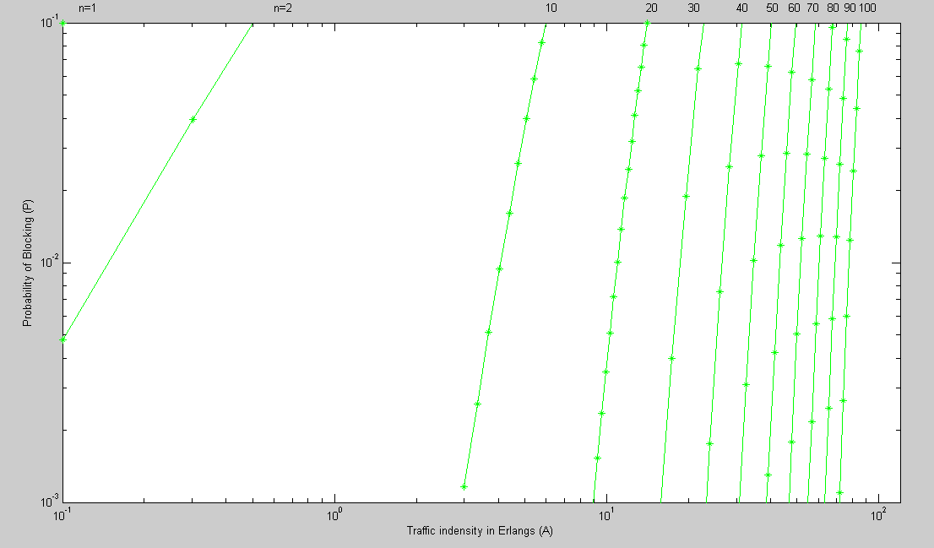

Then we put the table of erlang B and erlang C in the one figure, to compare their characteristic.

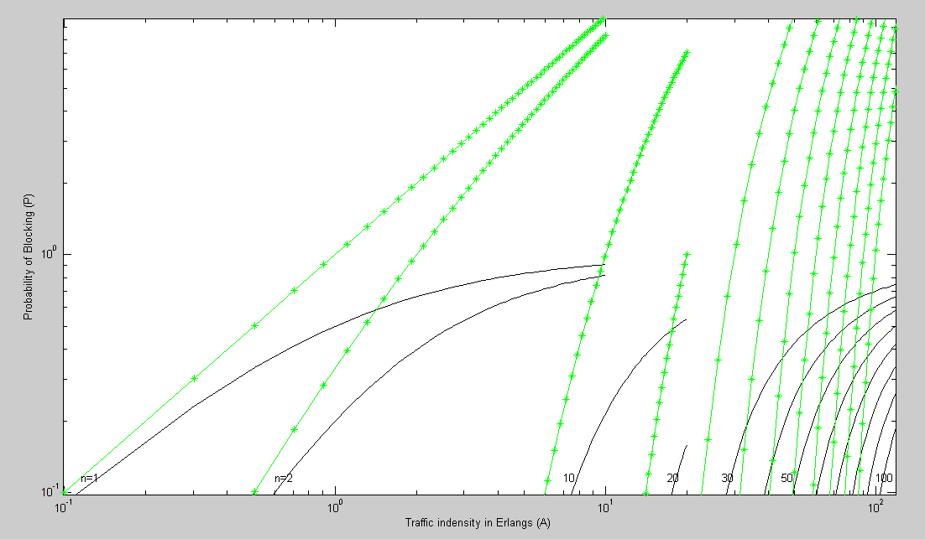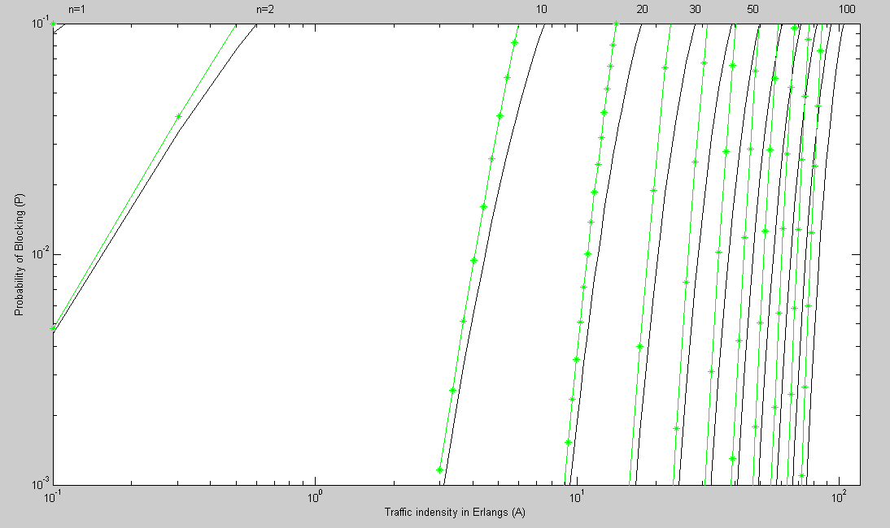

The line with ‘ * ’ is the erlang C model, the line without ‘ * ’ is the erlang B model. We can see from the picture that, for a constant traffic intensity (A), the erlang C model has a higher blocking probability than erlang B model. The blocking probability is increasing with traffic intensity. The system performs better when has a larger n.

**ADDITIONAL BONUS**

**Write a program to simulate a M/M/k queue system with input parameters of lamda, mu, k.**

In this part, we will firstly simulate the M/M/k queue system use matlab to get the figure of the performance of the system such as the leave time of each customer and the queue length of the system.

About the simulation, we firstly calculate the arrive time and the leave time for each customer. Then analysis out the queue length and the wait time for each customer use “for” loops.

Then we let the input to be lamda = 3, mu = 1 and S = 3, and analysis performance of the system for the first 10 customers in detail.

Finally, we will do two test to compared the performance of the system with input lamda = 1, mu = 1 and S = 3 and the input lamda = 4, mu = 1 and S = 3.

*The matlab code is:* **mms_function.m**

function[block_rate,use_rate]=MMS_function(mean_arr,mean_serv,peo_num,server_num)

%%%%%%%%%%%%%%%%%%%%%%%%%%%%%%%%%%%%%%%%%%%%%%%%%%%%%%%%%%%%%%%%%%%%%%%%

%first part: compute the arriving time interval, service time

%interval,waiting time, leaving time during the whole service interval

%%%%%%%%%%%%%%%%%%%%%%%%%%%%%%%%%%%%%%%%%%%%%%%%%%%%%%%%%%%%%%%%%%%%%%%%

state=zeros(5,peo_num);

%represent the state of each customer by

%using a 5*peo_num matrix

%the meaning of each line is: arriving time interval, service time

%interval, waiting time, queue length when NO.ncustomer

%arrive, leaving time

state(1,:)=exprnd(1/mean_arr,1,peo_num);

%arriving time interval between each

%customer follows exponetial distribution

state(2,:)=exprnd(1/mean_serv,1,peo_num);

%service time of each customer follows exponetial distribution

for i=1:server_num

state(3,1:server_num)=0;

end

arr_time=cumsum(state(1,:));

%accumulate arriving time interval to compute

%arriving time of each customer

state(1,:)=arr_time;

state(5,1:server_num)=sum(state(:,1:server_num));

%compute living time of first NO.server_num

%customer by using fomular arriving time + service time

serv_desk=state(5,1:server_num);

%create a vector to store leaving time of customers which is in service

for i=(server_num+1):peo_num

if arr_time(i)>min(serv_desk)

state(3,i)=0;

else

state(3,i)=min(serv_desk)-arr_time(i);

%when customer NO.i arrives and the

%server is all busy, the waiting time can be compute by

%minus arriving time from the minimum leaving time

end

state(5,i)=sum(state(:,i));

for j=1:server_num

if serv_desk(j)==min(serv_desk)

serv_desk(j)=state(5,i);

break

end

%replace the minimum leaving time by the first waiting customer's leaving time

end

end

%%%%%%%%%%%%%%%%%%%%%%%%%%%%%%%%%%%%%%%%%%%%%%%%%%%%%%%%%%%%%%%%%%%%%%%%

%second part: compute the queue length during the whole service interval

%%%%%%%%%%%%%%%%%%%%%%%%%%%%%%%%%%%%%%%%%%%%%%%%%%%%%%%%%%%%%%%%%%%%%%%

zero_time=0;

%zero_time is used to identify which server is empty

serv_desk(1:server_num)=zero_time;

block_num=0;

block_line=0;

for i=1:peo_num

if block_line==0

find_max=0;

for j=1:server_num

if serv_desk(j)==zero_time

find_max=1; %means there is empty server

break

else continue

end

end

if find_max==1

%update serv_desk

serv_desk(j)=state(5,i);

for k=1:server_num

if serv_desk(k)<arr_time(i) %before the NO.i customer actually arrives there maybe some customer leave

serv_desk(k)=zero_time;

else continue

end

end

else

if arr_time(i)>min(serv_desk)

%if a customer will leave before the NO.i

%customer arrive

for k=1:server_num

if arr_time(i)>serv_desk(k)

serv_desk(k)=state(5,i);

break

else continue

end

end

for k=1:server_num

if arr_time(i)>serv_desk(k)

serv_desk(k)=zero_time;

else continue

end

end

else %if no customer leave before the NO.i customer arrive

block_num=block_num+1;

block_line=block_line+1;

end

end

else %the situation that the queue length is not zero

n=0;

%compute the number of leaing customer before the NO.i customer arrives

for k=1:server_num

if arr_time(i)>serv_desk(k)

n=n+1;

serv_desk(k)=zero_time;

else continue

end

end

for k=1:block_line

if arr_time(i)>state(5,i-k)

n=n+1;

else continue

end

end

if n<block_line+1

% n<block_line+1 means the queue length is still not zero

block_num=block_num+1;

for k=0:n-1

if state(5,i-block_line+k)>arr_time(i)

for m=1:server_num

if serv_desk(m)==zero_time

serv_desk(m)=state(5,i-block_line+k)

break

else continue

end

end

else

continue

end

end

block_line=block_line-n+1;

else %n>=block_line+1 means the queue length is zero

%update serv_desk and queue length

for k=0:block_line

if arr_time(i)<state(5,i-k)

for m=1:server_num

if serv_desk(m)==zero_time

serv_desk(m)=state(5,i-k)

break

else continue

end

end

else

continue

end

end

block_line=0;

end

end

state(4,i)=block_line;

end

plot(state(1,:),'*-');

figure

plot(state(2,:),'g');

figure

plot(state(3,:),'r*');

figure

plot(state(4,:),'y*');

figure

plot(state(5,:),'*-');

Since the system is M/M/S which means the arriving rate and service rate follows Poisson distribution while the number of server is S and the buffer length is infinite, we can compute all the arriving time, service time, waiting time and leaving time of each customer.

We can test the code with input lamda = 3, mu = 1 and S = 3. Figures are below.

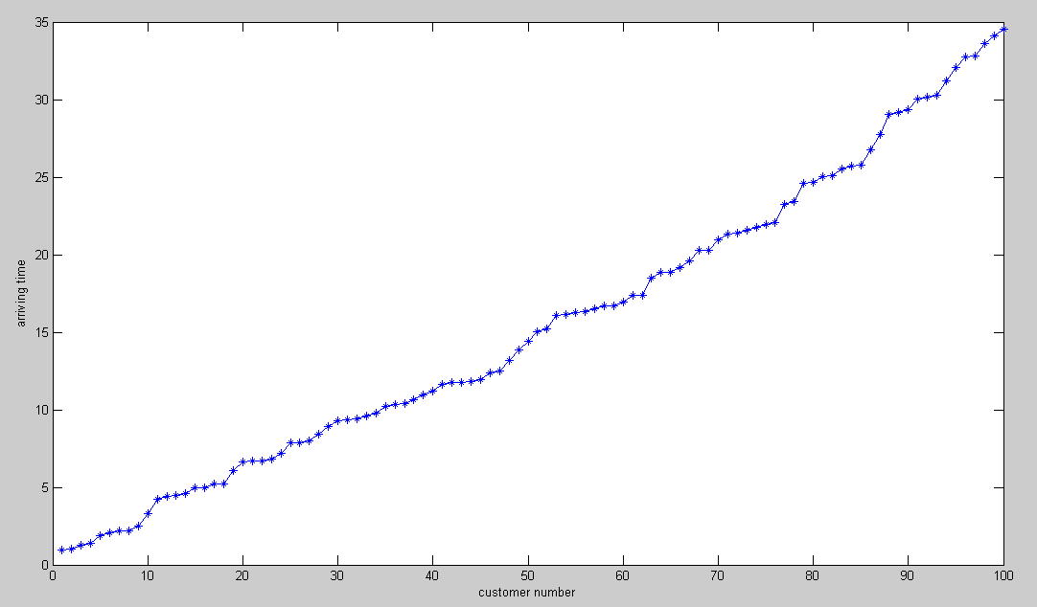

**Arriving time of each customer**

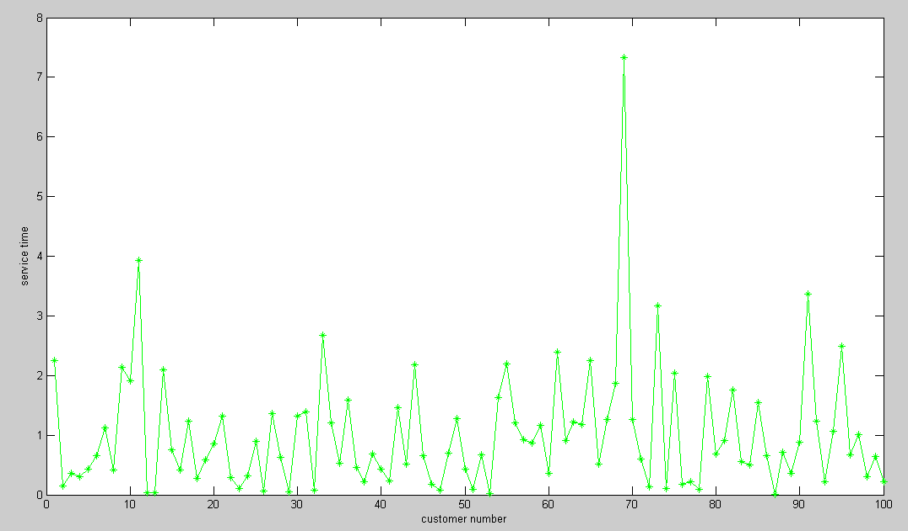

**Service time of each customer**

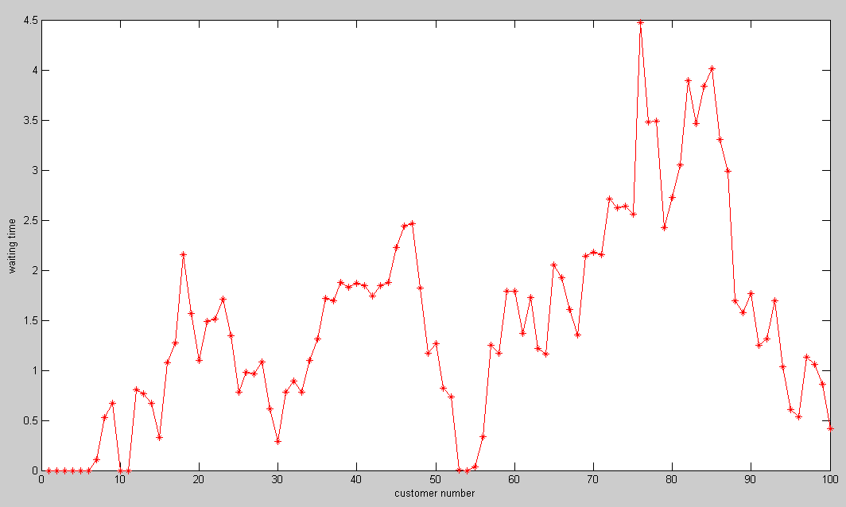

**Waiting time of each customer**

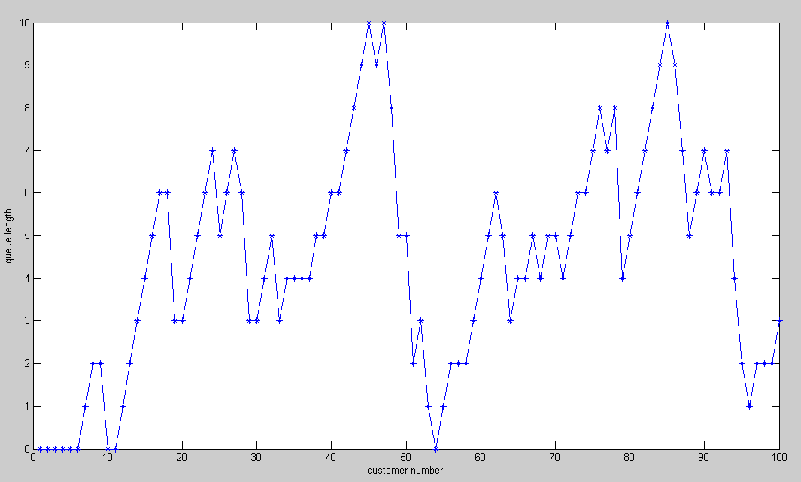

**Queue length when each customer arrive**

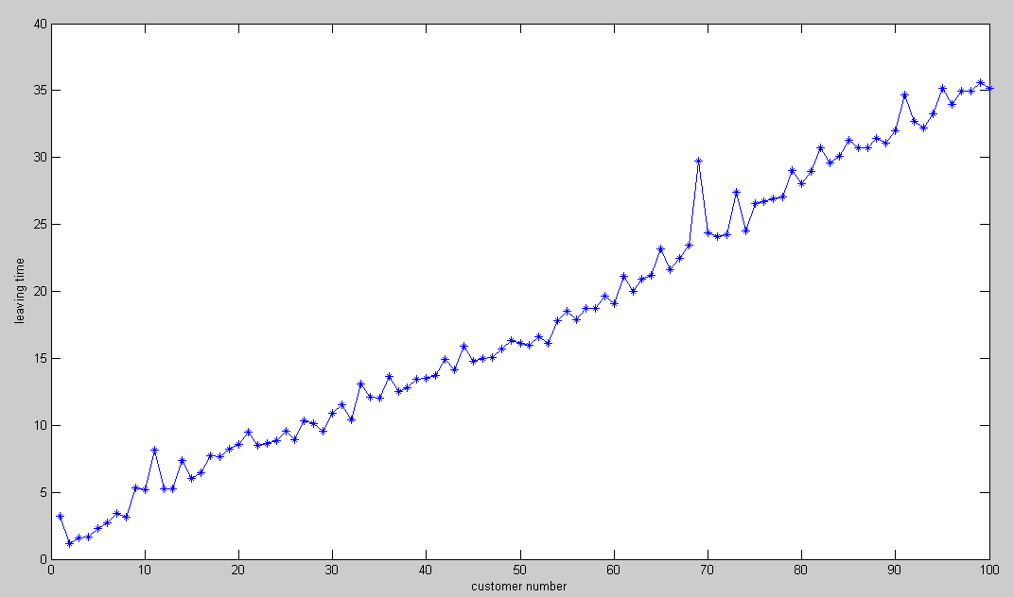

**Leaving time of each customer**

As lamda == mu*server_num, the load of the system could be very high.

* **Then we will zoom in the result pictures to analysis the performance of the system for the firstly 10 customer.**

**The first customer enter the system at about 1s.**

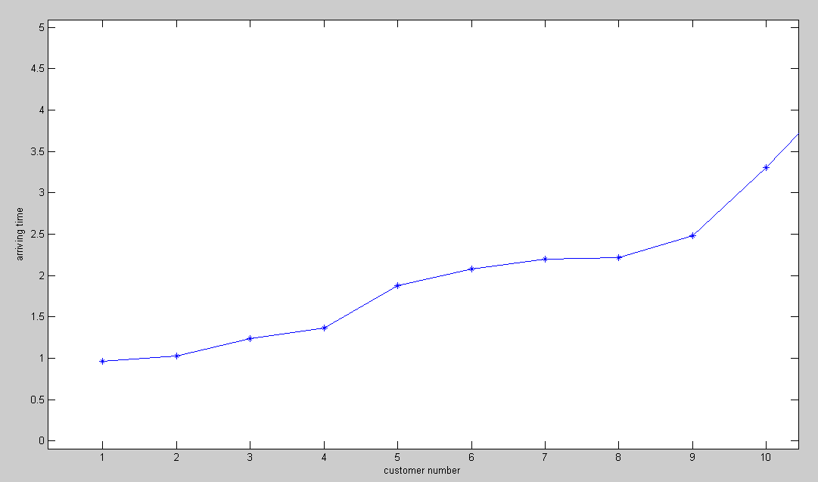

**Arriving time of first 10 customer**

**The queue length is 1 for the 7th customer.**

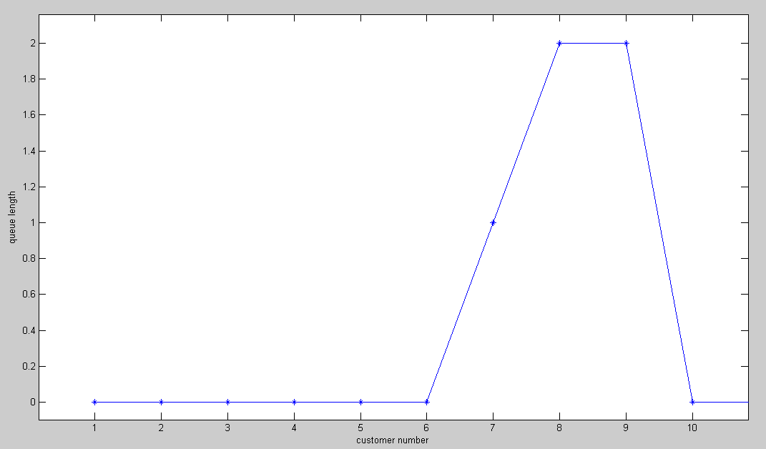

**Queue length of first 10 customer**

**The second customer leaves the system at about 1.3s**

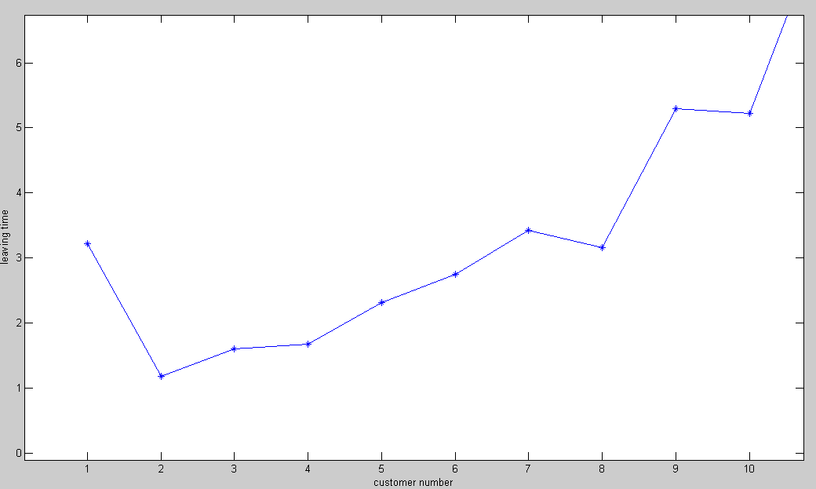

**Leaving time of first 10 customer**

1. As we have 3 server in this test, the first 3 customer will be served without any delay.
2. The arriving time of customer 4 is about 1.4 and the minimum leaving time of customer in service is about 1.2. So customer 4 will be served immediately and the queue length is still 0.
3. Customer 1, 4, 3 is in service.
4. The arriving time of customer 5 is about 1.8 and the minimum leaving time of customer in service is about 1.6. So customer 5 will be served immediately and the queue length is still 0.
5. Customer 1, 5 is in service.
6. The arriving time of customer 6 is about 2.1 and there is a empty server. So customer 6 will be served immediately and the queue length is still 0.
7. Customer 1, 5, 6 is in service.
8. The arriving time of customer 7 is about 2.2 and the minimum leaving time of customer in service is about 2.5. So customer 7 cannot be served immediately and the queue length will be 1.
9. Customer 1, 5, 6 is in service and customer 7 is waiting.
10. The arriving time of customer 8 is about 2.4 and the minimum leaving time of customer in service is about 2.5. So customer 8 cannot be served immediately and the queue length will be 2.
11. Customer 1, 5, 6 is in service and customer 7, 8 is waiting.
12. The arriving time of customer 9 is about 2.5 and the minimum leaving time of customer in service is about 2.5. So customer 7 can be served and the queue length will be 2.
13. Customer 1, 7, 6 is in service and customer 8, 9 is waiting.
14. The arriving time of customer 10 is about 3.3 and the minimum leaving time of customer in service is about 2.5. So customer 8, 9, 10 can be served and the queue length will be 0.
15. Customer 7, 9, 10 is in service.

* **Test 2:**

lamda = 1, mu = 1 and S = 3

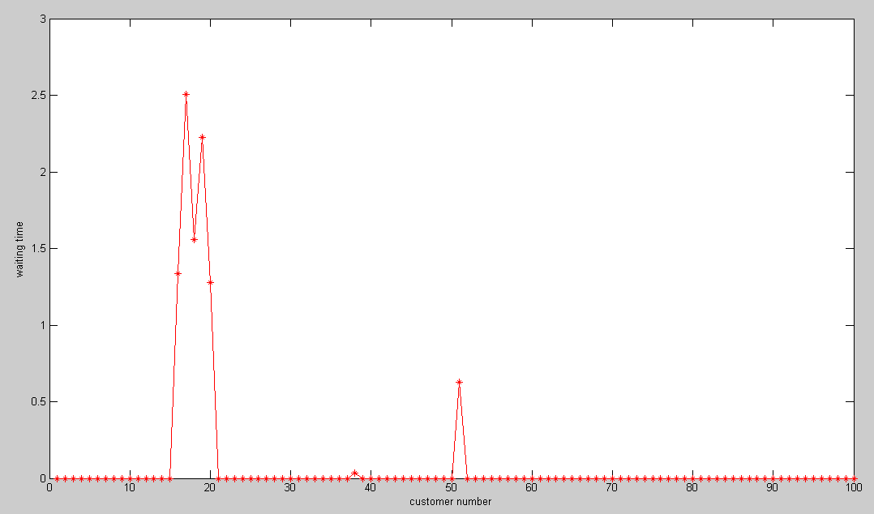

**Waiting time of customer**

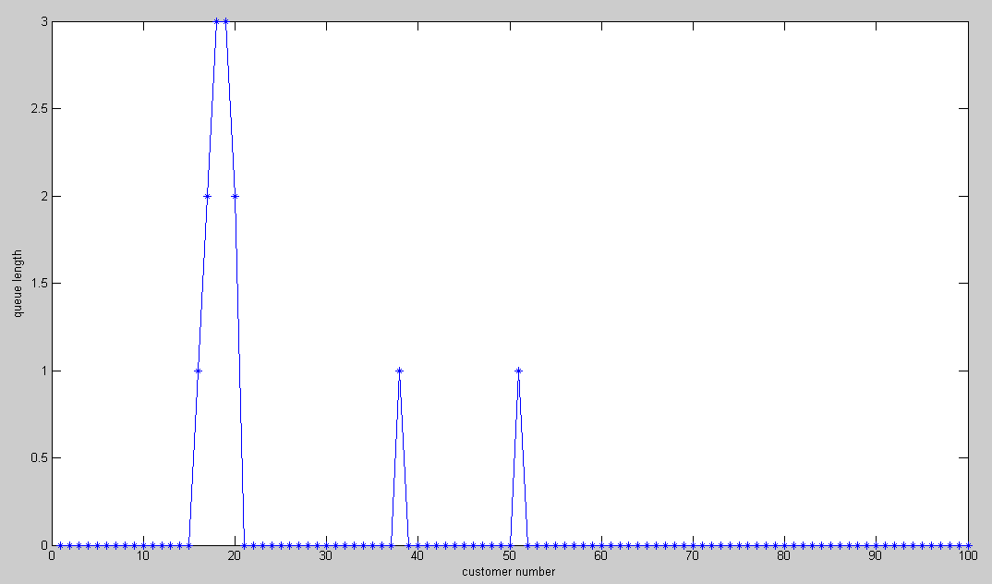

**Queue length when each customer arrive**

As lamda < mu*server_num, the performance of the system is much better.

* **Test 3:**

lamda = 4, mu = 1 and S = 3

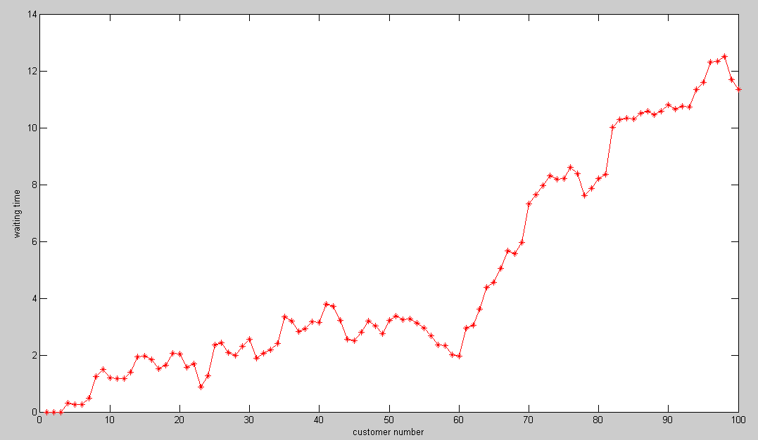

**Waiting time of customer**

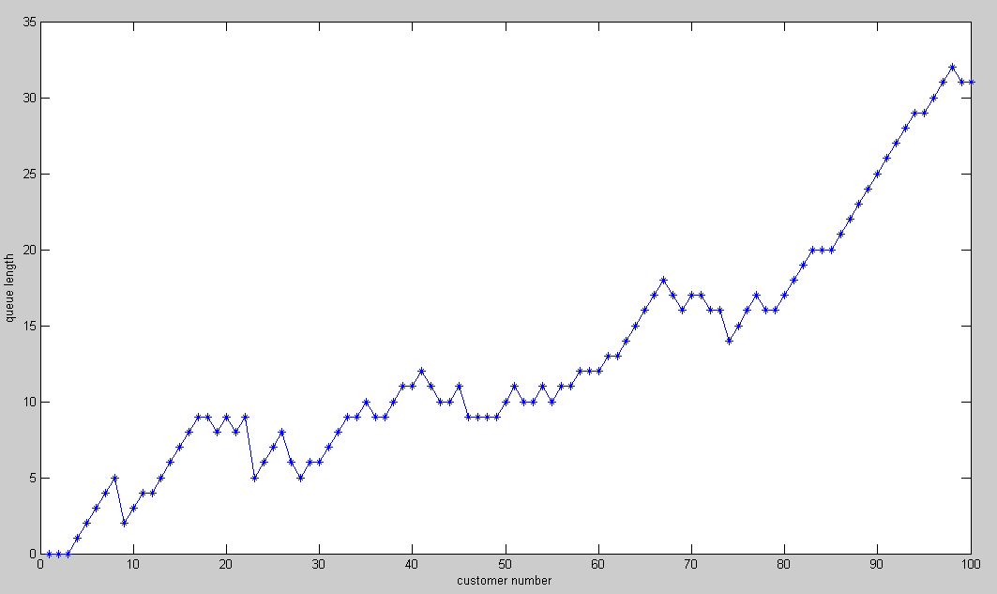

**Queue length when each customer arrive**

As lamda > mu*server_num, system will crash as the waiting time and queue length increases as new customer arrives. For the situation of lamda<mu*server_num, the system performs better when mu and server_num are both not small. If the mu is smaller than lamda or we only have one server though with large mu, the system works not very good. It is may be because that the server time for each customer is a Poisson distribution, it may be a large time though the mu is large enough, so the more number of server, the better of the performance of the system.

**CONCLUSTION**

After the experiment, we have a deeply understanding of the queuing theory, including the erlang B model and the erlang C model. What’s more, we are familiar with how to simulate the queue system for M/M/s. Through the simulation, we have known how the queue system works and the performance of the system with different input parameter.