Project Writeup
for Spring 2012’s CS133 Quarter Project

Name | Student ID
Tran Dam | 003-392-585
Steven Nguyen | 603-666-445
Rouel Soberano | 503-629-024
Jason Tan | 003-670-742
Tony Truong | 803-638-395
Jason Tsao | 003-660-050

Overall

Guide to Source Code
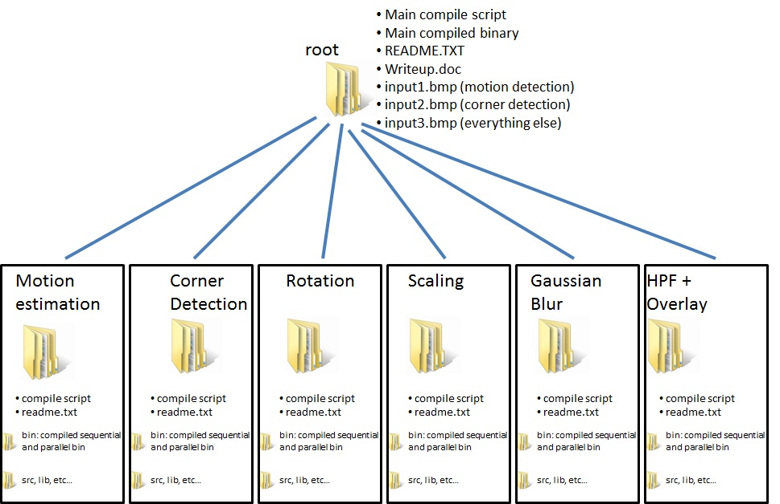

Writeup.doc is this document.

In each of the six folders, there will also be individual readmes. These individual readmes explain the directory structure of each person’s directory (such as what is in the tmp folder if there is one).

The standard files/folders found in each of the six folders are:
- (DIR) bin: contains the sequential and parallel binary
- (FILE) compile: compile script for this respective function
- readme.txt: one of six readmes explaining the respective directory structure, which can differ between team members since each team member developed independently.

Project Breakdown (Work Breakdown Structure)

Motion detection | Jason Tan
Corner detection | Steven Nguyen
Rotation | Rouel Soberano
Scaling | Jason Tsao
Gaussian Blur | Tony Truong
Sharpen using high pass filter + overlay | Tran Dam

NOTE: Please refer to each person’s section for individual completeness.

Motion Estimation

Guide to Source Code
The motion estimation code compiles using the makefile found in the motion estimation folder. Follow the readme in that folder for instructions for compilation. All sections of the code are complete.

There are three parallel OpenMP pragma locations in the code.
Line 27: Parallelizes the reading of the color indexes into a 2D array.
Line 178: Assigns rows of blocks to the threads for block matching.
Line 251: Parallelizes setting array colors to the bmp file at the end of processing.

Project Breakdown
I chose to use OpenMP because the Block Matching algorithm I implemented is easily parallelized using domain decomposition.

The main parallelization of the code is the on line 127, which parallelizes the block matching algorithm. Block matching algorithms work by dividing the image into blocks, and then searching for where each block could have moved to. My placement of of the parallel pragma assigns rows of the blocks to each thread. I chose to parallelize this outer loop to reduce the overhead of joining threads.

Lines 27 and lines 251 parallelizes the reading and setting of bmp colors. While they had a small impact compared to parallelizing the block matching algorithm, I saw some speed improvement when working with very large images, and specifying a small search region around each block.

No other synchronization was needed.

Bugs & Challenges
The main bugs I ran into were in the conversion of images to the correct format. At first, I converted my images into a wrong version of BMP, which had a longer header length than expected.

Luckily, since the problem lent itself so well to domain decomposition, I did not run into any challenges using the framework.

One thing I learned about parallel programming from this project is the difficulty in predicting how much improvement can be made from parallelization. I thought that the performance would keep increasing as I increased the number of threads, but I saw very similar performance between using 8 threads and 16 threads.

Final Results
The parallelized version of the code had about a (number of threads)/2 speedup when compared to the sequential version.
Sample output:
Image 1

Image 2


Motion Estimation Output:


The following graphs show the performance of my parallel code with different sized inputs and with different number of threads on the lnxsrv machines. The times are recorded within my code to only include algorithm time, excluding the time it takes for bmpfile to open and save the images.

For both the small and large images, the parallel code exhibited a speedup linear to the number of threads except for the 16 thread case. This could be due to other users using lnxsrv, keeping the program from completely using all 16 threads.
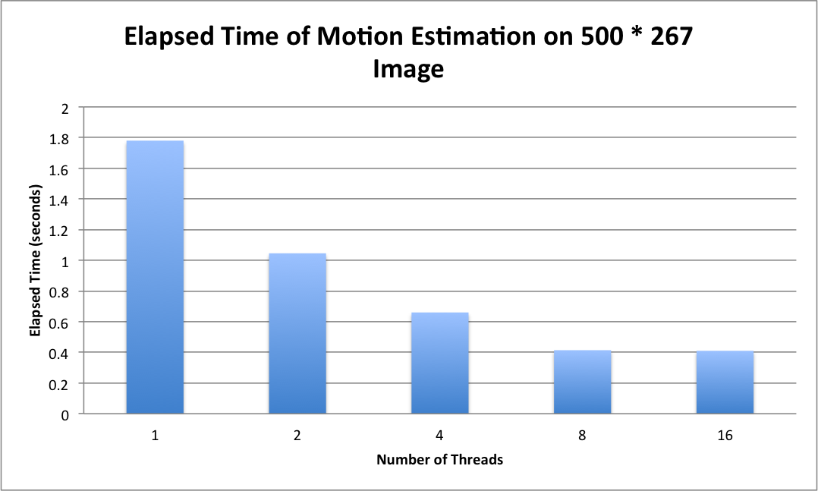
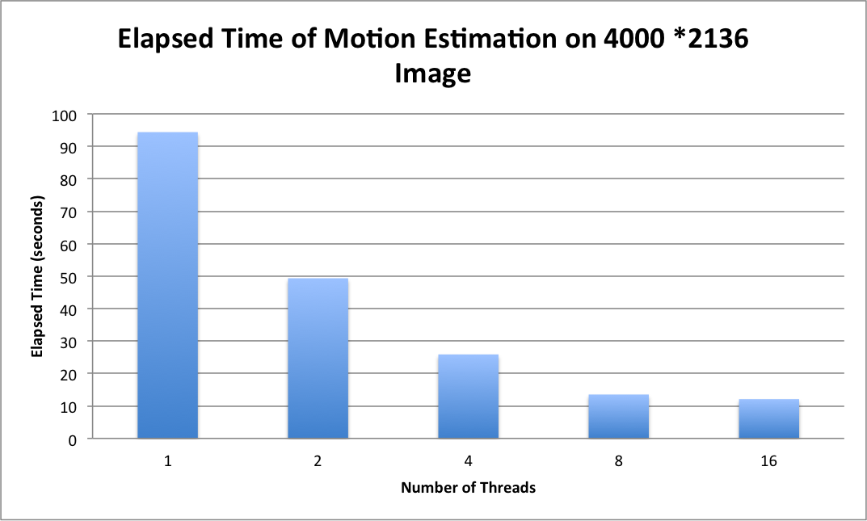

Corner Detection

Guide to Source Code
The code for the corner detection compiles using the make file found in the corner-detection folder. Run
make all
to compile everything and run using
./bin/corner-detection-sequential input-file output-file [threshold]
for the sequential version and
./bin/corner-detection-parallel input-file output-file [threshold] [num_threads]
for the parallel version.

The corner detection code works and is able to detect some corners marking them with a blue dot. Some outstanding issues occur, however, if you supply an image that does not have a blue pixel in its color map. Because the original bmp does not have the blue pixel, when the program tries to color in corners with blue, it won’t be able to. It will try to choose a color close to that but that color may not be visible enough.

The code contains two main for loops. One loop discovers the corner pixels and the other draws the highlighted pixel onto the original image. I parallelized the two for loops using OpenMP. These pragmas can be seen in corner-detection-parallel.c in the src folder.

Project Breakdown
I chose to use OpenMP because OpenMP excels at domain decomposition. In addition, I feel most comfortable with OpenMP, which will make it easier for me to parallelize the code. More specifically, More specifically, for the first for loop, I chose to parallelize the outer most for loop because it allows for creating the most amount of work for each thread reducing redundant work and the overhead of thread spawning.

There was no need for any synchronization mechanisms because each thread only wrote to their independent pixel position. Threads read other pixels, but because it was a read after read operation, there was no risk for concurrency issues.

Quality of the corner detection was the only thing that may have been sacrificed. The program was able to discover some corners, but not all corners. This may have been due to the way the non-maximal suppression was implemented.

For the image library, I used the modified libbmp library supplied by the TA.

Bugs & Challenges
The first bug was with images. After writing my code (without non-maximal suppression) and running the program, I was able to see edges highlighted, but the color of the image was distorted. I had a gray-scaled image, but the resulting image had some of the grays colored blue-ish. After a great deal of debugging and consulting with my partners, I discovered the issue was with the image itself. Apparently, because of the implementation of the image library and the limited depth of 8 bit bmp's, new images are not created with the same color indexes as images read in. To remedy the issue, I modified the image to not eliminate unused colors from the color index such that blue is one of the pixels in the color table.

The second bug was with the non-maximal suppression. My first implementation of the non-maximal suppression didn't work and I wasn't able to see any corners highlighted. I mostly saw odd lines. After debugging the code, I was able to find small errors in my code and get the corner detection working. I think another issue that made it more difficult to fix was the first bug I had in which the image was missing the highlight color. Fixing that problem first helped me discover what was actually wrong and solve the problem.

I also faced small issues with OpenMP because I didn't properly make sure to specify the nested loop variables as private. This lead to segmentation faults and printing out stuff didn't help me find the problem at all. It just took time and more attention to detail to find the bug and remedy it.

Another annoyance I faced was waiting for 2-10 minutes to test the program on large images...

I found that it was difficult to debug parallel programs because I wasn't able to clearly see the control flow from output to the screen. I had to rely more on looking at the code to find bugs.

Final Results
The parallelized version of the code did a good amount better than the sequential version. The speedup was not not perfect but made sense because of the overhead of thread creation and the sequential part of the code. The best speedup was a ~6x speedup on lnxsrv with 8 threads and an image with a size of 100MB (10,000px x 10,000px).

Below, you will see the result of running the program on two images and below the images you

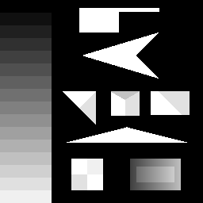 | 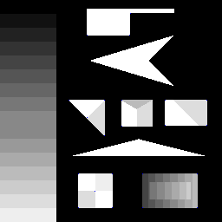
Before | After

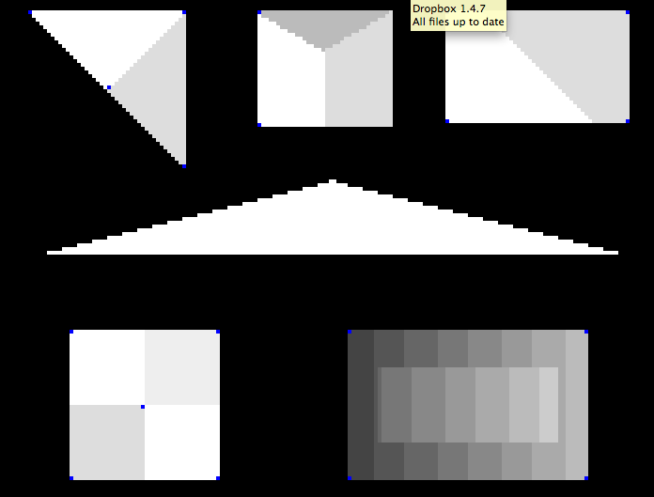
Zoomed in to Better Show the Corner Highlights

 | 
Before | After

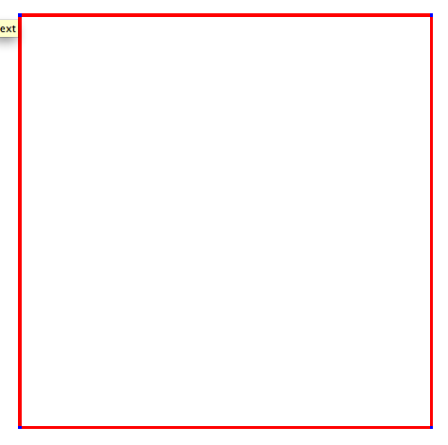
Zoomed in to Better Show the Corner Highlights

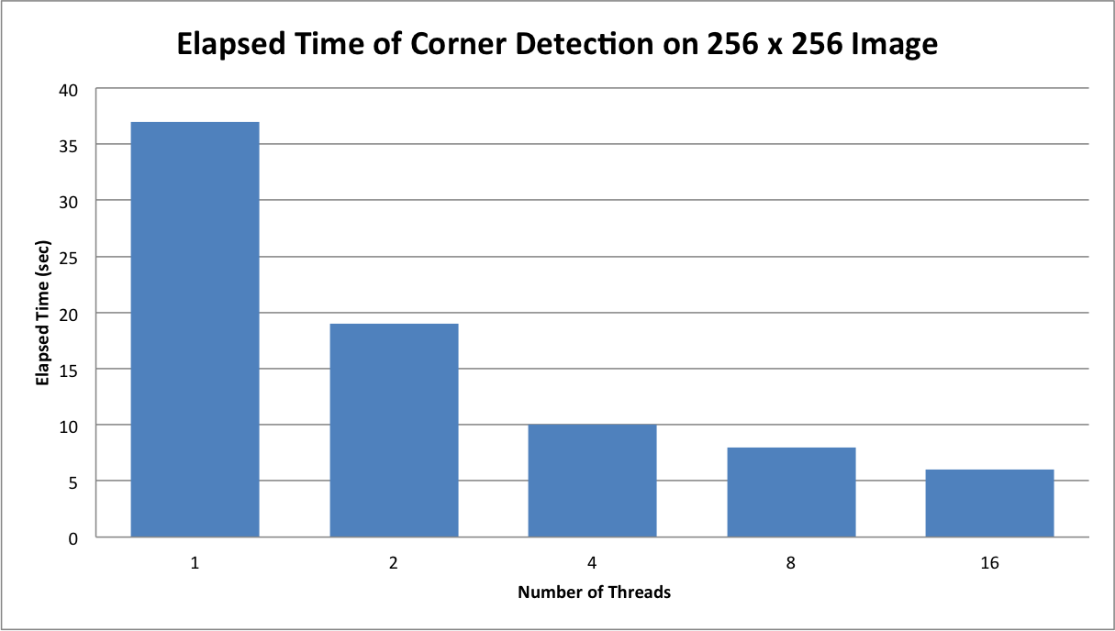

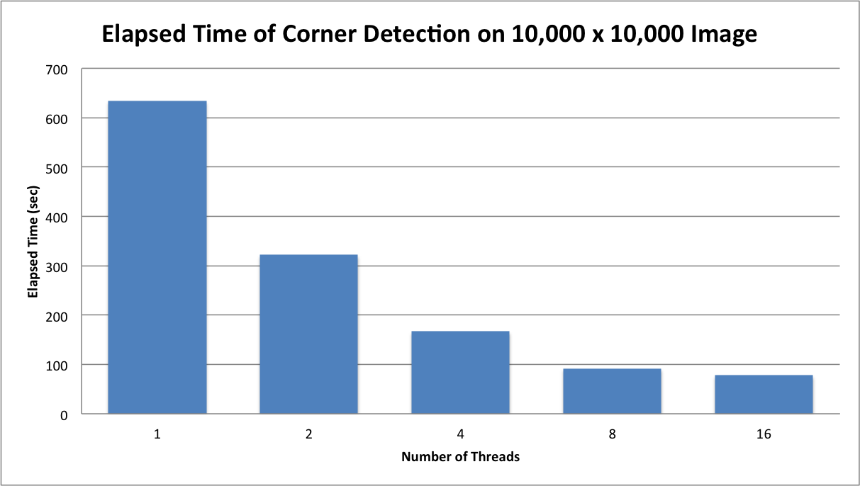

Rotation

Guide to Source Code
The code for rotation is compiled using the Makefile found in the rotation folder. Run
make all
to compile the code using gcc. In order to run the program, from the rotation folder run
./bin/rotate-seq [image file] [rotation-degrees]
for the sequential version of the code and
./bin/rotate-parallel [image-file] [rotation-degrees] [nthreads]
for the parallel version of the code. The image-file parameter specifies the image to rotate, the rotation-degrees parameter specifies the number of degrees to rotate the image, and the nthreads parameter specifies the number of threads to use for the parallel version of the code.

In terms of the source code, with the makefile, the source code should compile successfully without any errors or warnings (I’ve tested this both on my local Ubuntu machine and the SEAS Linux Servers). Furthermore, this is a complete implementation, as all sections of the code should work correctly and produce correct output. Given an image and a number of degrees to rotate it by, the program will give you an output image rotated by the given number of degrees.

As for the location of the thread code, the main function of the thread calls a function called rotate to perform the actual rotation. Within this function, there is one big for loop that traverses the new rotated image to create it pixel by pixel. I parallelized this loop using OpenMP, as it is a very natural loop to perform domain/data decomposition on. The pragma omp parallel for is located at the top of this loop.

Project Breakdown
I decided to use OpenMP because it seemed like the most efficient way to implement parallelization in terms of problem space and ease of use. OpenMP excels at domain decomposition problems, and as most of the parallelization with rotating an image occurs in the domain decomposition of constructing the rotated image, OpenMP was the obvious choice to make, especially because parallelizing the big for loop only took one pragma. As a side note, the parallelization of the for loop uses dynamic scheduling, as dynamic scheduling provides better performance over static scheduling.

While I could have parallelized other aspects of the code besides the for loop such as the initialization and initial calculations performed before the big for loop, these extra parallelizations would have minimal impact on performance because a disproportionate amount of work is done within the for loop, especially in larger images. As such, it was more efficient to target this for loop as opposed to other sections of the code.

In terms of synchronization, no extra barriers or conditions were needed, as the pragma omp parallel for construct handled all of the synchronization in between threads both during runtime and at the end of the parallel section. Private variables are also utilized to prevent the threads from overwriting each other’s variables.

Lastly, no features had to be sacrificed for the parallel implementation of rotation. As both versions utilize practically the same exact code, both versions do the same work. All features of rotation were completed and implemented.

Bugs & Challenges
The main bugs that I ran into were concerned mainly with the implementation of the rotation algorithm. My initial implementation effectively rotated the original image about the top left corner of the image, and thus the rotated image would have sections off-image and thus missing; the solution meant that I would have to rotate the image about its center instead. In order to implement this solution, I figured out a way to first translate the original image to the center of the rotation, then perform the rotation, and then translate the rotated image back to its correct location within bounds of the image. Naturally, this implementation took a bit of head-scratching and linear algebra review to figure out, but I was able to implement it successfully after a bit of work.

As for parallel bugs and challenges, the only challenge I ran into was remembering to declare certain variables as private. With my first version of the parallel code, I had forgotten to do this and I was receiving many segmentation faults as a result. Once I remembered to use private variables, however, I ran into no further issues with the parallel implementation. In a way, the parallel implementation (in this case, at least), seemed to be trivial once the sequential implementation was completed.

If there’s anything I had a challenge with, however, it’s just the fact that you can’t really debug parallel code using a debugger such as GDB or Visual Studio. Since I couldn’t transparently see the way the data was split in between the threads and what each thread was doing, I had to rely on looking at the code itself and its test outputs to determine whether or not my program worked.

Final Results
The performance testing results are included here in visual form using Excel spreadsheets. As a sidenote, in order to time these results, I used timing functions present in <sys/time.h>. Because the bmp_save routine of the provided libbmp takes a massive amount of time to complete compared to the actual image rotation (~60s for bmp_save vs < 3s for actual rotation for a 3500 x 3500 image), I inserted these timing functions in a way that would only time the calculations related to the rotation of the image. These results are shown below:
Sample Output:
These images are the sample output of the program, shown here to demonstrate the rotation capabilities of the program. In order, the images are as follows: original, rotated by 45 degrees, rotated by 180 degrees, rotated by 256.78 degrees:

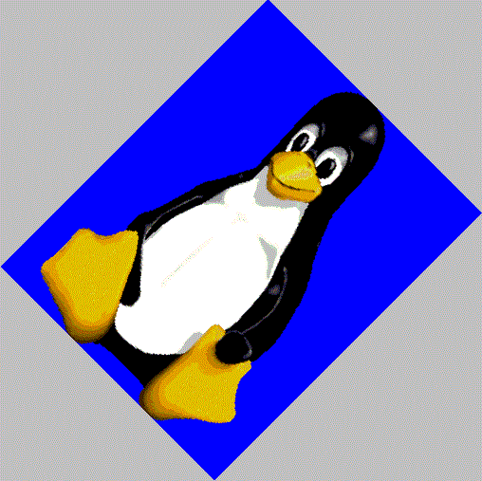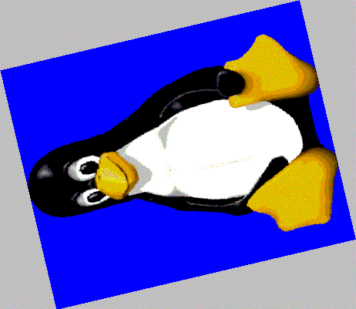

Performance Comparisons
The following graphs represent the performance test results for rotating a 320x400 image, a 1600x1200 image, and a 3500x3500 image by 45 degrees:

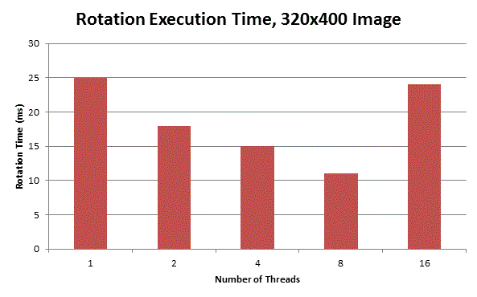

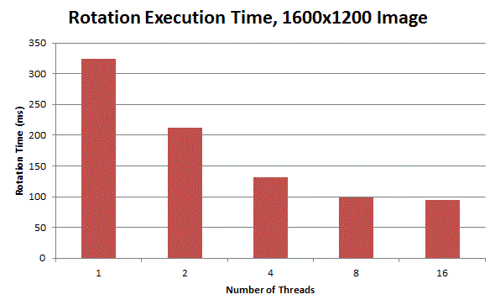

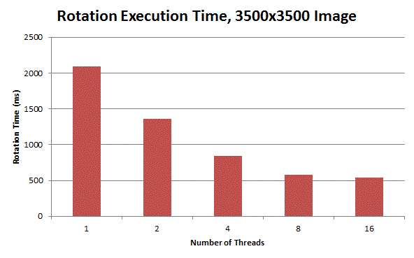
As we can see from these results, there is a general trend of decreasing execution time as the number of threads goes up, with the exception being the 16 threads case in the 320x400 image. This exception most likely occurs because in an image as small as 320x400, the performance gain from 8 threads to 16 threads is negligible, but the overhead cost from spawning and syncing so many threads outweighs this performance gain.

In general, it seems that although there is a performance increase as number of threads goes up, we never really see the perfect 2x/4x/8x/16x speedup. The largest speedup occurs in the 16 threads test for the 3500x3500 image, in which 16 threads achieved a 3.92x speedup over the sequential case. These non-ideal speedups may be due to the fact that the actual rotation algorithm doesn’t take too long anyways to execute, so the performance speedup caused by adding more threads is diminished by the overhead it takes to spawn and sync them. Regardless, however, the performance gains do still exist, and I would imagine these gains would be much more pronounced with absurdly large images (10,000x10,000 pixels, for example).

Scaling

Guide to Source Code
The sequential and parallel portions of the scaling cod run by calling
gcc -lm bmpfile.c scale_sequential.c
/usr/bin/time -v ./a.out test.bmp 2
and
gcc -lm -fopenmp bmpfile.c scale_parallel.c
usr/bin/time -v ./a.out test.bmp 2 8
respectively, where the 2’s stand for the scale factor and the 8 stands for the number of threads.
All of the portions are complete, although it cannot handle very large images for some reason. Also, for scaling ratios larger than 10, the program will segfault. The parallel pragmas are located in the bmp_to_array function where it reads the given bmp image into a single dimensional array. It parallelizes by allowing each thread to take care of a row. Similarly in bilinear_resize when creating the new image, there is a pragma to allow each thread to fill in the pixels for a row.

Project Breakdown
I chose to parallelize the code this way because as an image and based on the bilinear interpolation algorithm I chose, it fit data decomposition very naturally. Each pixel in the resized image could be calculated independently of the pixels around it so a simple pragma omp parallel for on the double for loop allows each row to be calculated in parallel. There was no need for synchronization because each pixel can be computed independently, the code just has to be set up so that no thread can work on the same row as another, which the pragma omp for syntax does. Jason Tsao worked on this portion of the code. All features of scaling were implemented.

Bugs & Challenges
Some bugs I ran into were that in the beginning for some reason when the new image was made and each pixel was calculated it could not be viewed. Then I realized that I had the outer loop calculating height when it should have been calculating width so the calculation was all off. Also when calculating the color, to check if the output was correct I used “%i” to try to print out a float representation so it kept giving me 0’s and 255’s. So I thought I was doing the wrong math for the longest time but I was just printing it out wrong.
Challenges in using the chosen frameworks:
- Hard to get used to using the bmp library provided by the TA at first
Other Challenges
- Couldn’t get the program to handle large files ( 170 mb) without cancelling immediately

Final Results

( Scaling 320x400 pixel picture by 1.8x)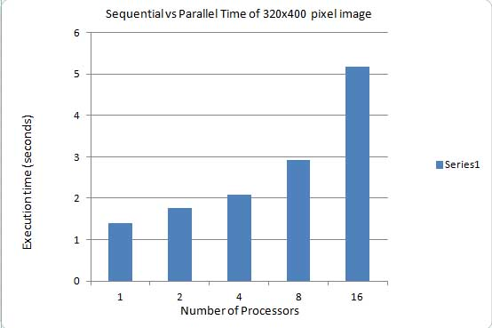

( Scaling 1280x1600 pixel picture by 0.5x)
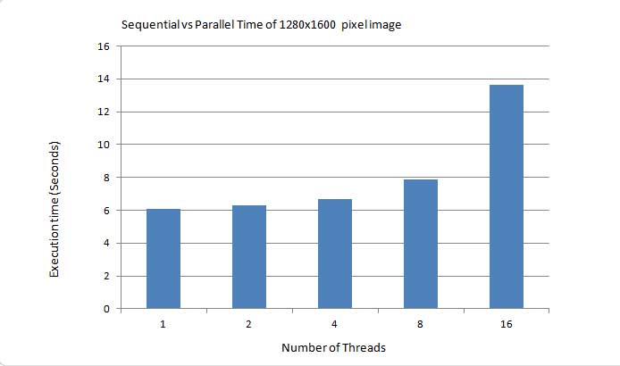

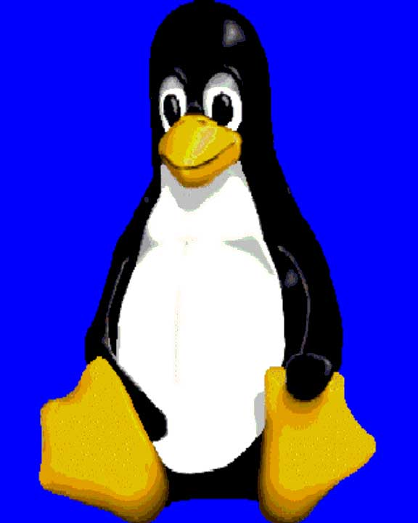
Sample Output: (320x400)

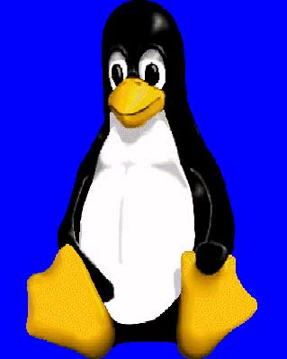

Gaussian Blur

Guide to Source Code
- The source code is written in C++ using open-source library “EasyBMP” provided by Paul Macklin, which can be downloaded from http://easybmp.sourceforge.net.
- The source code compiles for both the sequential and parallel implementation:
  - g++ -o gb-sequential gb-sequential.cpp EasyBMP.cpp
  - g++ -fopenmp -o gb-parallel gb-parallel.cpp EasyBMP.cpp
Alternatively, the source code can be compiled by running the compile.sh included in the gaussianblur folder
- The code is complete for both the sequential and parallel implementation.
- The code uses OpenMP API for parallelization. The parallel pragmas are located at line 52, 55, and 76 which covers the 1D horizontal and vertical Gaussian filter of the image.

Project Breakdown
- Since each pixel of the image can be processed independently, each thread is assigned different rows for 1D horizontal filter and different columns for 1D vertical filter to process. By choosing to parallelize at the row and column level instead of pixel level, the number of barrier is minimized (only 1 barrier) and the number of work per thread is maximized.
- The 2D Gaussian filter is broken down into two 1D Gaussian filter stages. Although the order of the filter stages does not matter if the horizontal or vertical filter is applied first, the last filter stage has to be processed on the filtered output of the first stage. Hence, synchronization (barrier) is needed to guarantee that the output of the first stage is completely processed by all threads. The barrier is located between the 1D horizontal Gaussian filter and 1D vertical Gaussian filter.
- The source code of Gaussian blur algorithm is solely done by Tony Truong.
- No features of the implementation needed to be sacrificed.

Bugs & Challenges
- During the implementation of the algorithm, the author did not run into any bugs nor stuck on any part.
- The challenge in using this framework includes:
  - Choosing an appropriate open-source library for BMP image processing and learning its API
  - No difficulty in extracting good performance from the threads
- The project shows that:
  - It is important to select an algorithm best suited for parallel implementation. An algorithm with a good performance for sequential implementation may not be good for parallel implementation

Final Results

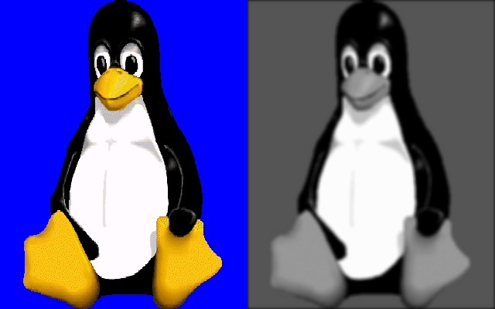
(a) (b)
Original image (a) v.s. filtered image (b) (sigma = 2)

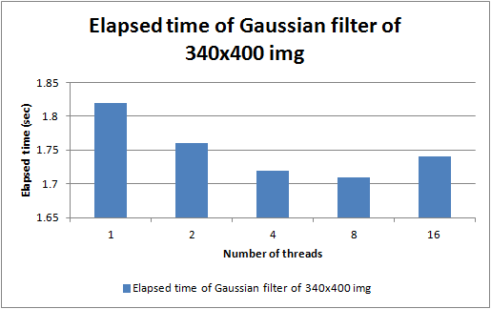
Elapsed time vs. NumThreads (340x400 image)

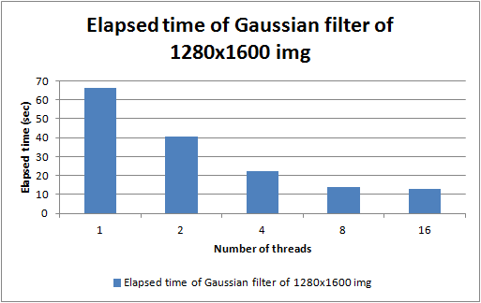
Elapsed time vs. NumThreads (1280x1600 image)

- The parallelized code has a significant improved performance compared to the sequential code when applying the Gaussian filter on large images (e.g. 1280x1600). The speedup almost doubles when going from 1 to 2 threads, from 2 to 4 threads, or from 4 to 8 threads. The execution time appears to remain the same when going from 8 to 16 threads. This could be due to the fact that the server was occupied by other users.
- On small images (e.g. 340x400) the parallelized code has a minimal improved performance. For small images, the cost of parallelization overhead (i.e. forking/joining threads) accounts for a large amount of the execution time (excluding the time for reading and writing images from/to physical storage).

Sharpen Using High Pass Filter + Overlay

Guide to Source Code
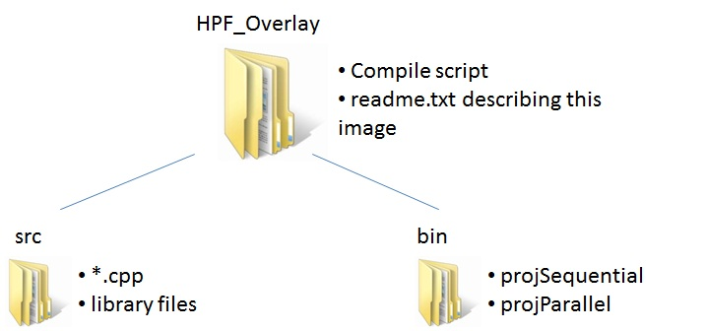

- Does the source code compile or not?
  - Yes, the source code compiles.
  - Language: C++, using OpenMP and EasyBMP image libraries.
  - How to compile: run [ ./compile ] inside HPF_Overlay directory
  - How to run:
    - ./projSequential input.bmp output.bmp strength[1-10]
    - ./projParallel input.bmp output.bmp strength[1-10] numThreads[1-16]
    - Strength indicates how strong to sharpen (with 10 being strongest), and numThreads indicate the number of threads to run with.
- Which sections of the code work (i.e. are complete) and which don’t?
  - All sections of the code work and are complete.
- Where in the code is the thread code?
  - This image method uses OpenMP. The thread code can be found in two parts of the program, right before applying the high pass filter (HPF) and right before applying the overlay blend.

Project Breakdown
- Why did you choose to parallelize the code this way?
  - As stated previously, there are two parallel sections in the code: one for the HPF and one for the overlay blend.
  - Each parallel section is composed of a double for loop, with the outer for loop being parallelized instead of the inner in order to make the granularity as big as possible.
    - Since each pixel only has about 10 operations or less (which is too small to be forking a thread for), forking was delegated to rows of pixels to maximize granularity.
    - Also, each thread is given chunks of rows to work with rather than chunks of columns. This to take advantage of spatial locality in terms of how a 2-D matrix of pixels is stored in memory.
- Was synchronization needed (in the form of locks/mutexes, condition variables, critical sections, barriers, etc.)? If so, where was it needed?
  - Synchronization, specifically a barrier, was needed after the HPF and again after the overlay (before saving the BMP to disk).
    - The first barrier is needed because all of the pixels must be HPF’ed before applying the overlay blending.
    - The second barrier is needed because the overlay blending must finish on all pixels before saving the BMP to disk.
- Which sections of the code did each team member work on?
  - Each team member was responsible for one of the six image methods.
  - This is further discussed in the main section of the report, titled Work Breakdown Structure.
- What features of the implementation needed to be sacrificed? Which were completed and which were not?
  - All requested features were implemented and none were sacrificed.

Bugs & Challenges
- What bugs did you run into, if any? Did your team get stuck on any part of the implementation?
  - The Sharpen Method of this image toolkit did not run into any bugs.
- What challenges existed in using this framework?
  - EasyBMP challenges:
    - Since this library treats 8bpp images same as 32bpp images, when it came time to save the file to disk, the program would have to search through all possible color combinations in order to save the 8bpp image. This is 16 million unnecessary operations instead of 256, and it affects our running time.
      - In order to alleviate the above problem, we insert timers in the parallel section of the code (before the HPF and after the overlay) as well as the beginning and end of the program. This allowed us to distinguish the parallel improvement while isolating the slow save problem.
  - C++ and OpenMP:
    - At first it seemed like a good idea to give each thread one pixel. However, it resulted in too small of a granularity and slowed down the program. In order to alleviate this problem, threads were given chunks of rows instead of individual pixels in order to maximize granularity.
- What have you learned about parallel programming from this project?
  - Incremental parallelization (or, more like trial and error parallelization) using OpenMP.
  - It is a bit tricky to debug parallel programs, so it is essential to keep the code as clean as possible and use print statements a lot.
  - It takes some thought to parallelize an operation successfully.

Final Results
Original => | +HPF => | +Overlay
 | 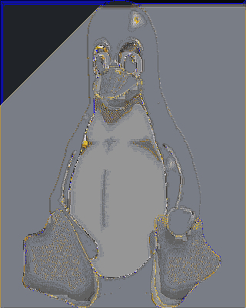 | 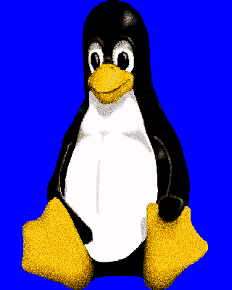
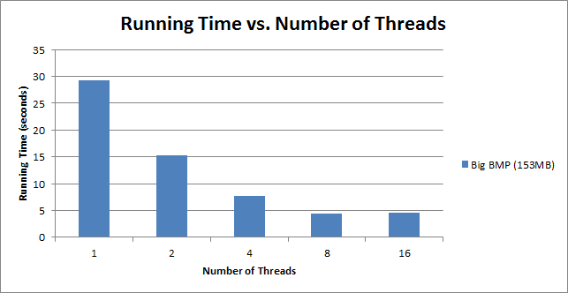
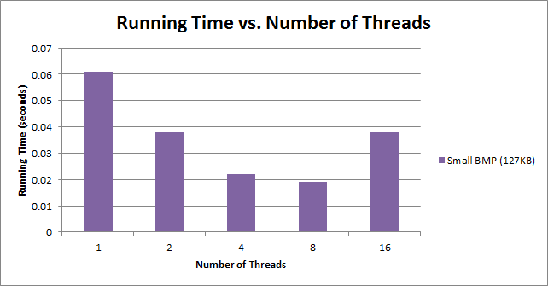

- How did the parallelized code compare to a sequential (or single-threaded..or non-GPU-enhanced...) version of the code in performance?
  - Parallel code had a big performance improvement over sequential code.
  - However, for small-size BMP, when we went to 16 threads, we actually our performance degrade. This can be for several reasons:
    - For small-size BMP, having 16 threads might be too much, thus making the granularity too small.
    - The overhead of forking 16 threads is taking longer than doing the actual work, whereas for 8 threads and fewer the overhead is not as big.
- Please include sample output of your code.
  - Please refer to the above images.
- How fast can your parallel code process inputs of different sizes.
  - Please refer to the above Excel graphs comparing small-size BMP (~127KB) and large-size BMP (~153MB).
  - For lage-size BMP, parallel execution provides a very apparent performance gain. For small-size BMP, the performance gain isn’t as obvious, mainly because the sample size is too small and comparable to the overhead of forking threads.
- How does the performance of your parallel code scale with different numbers of threads? (This will depend on the platform you use, but you should be able to use at least up to 16 threads on the lnxsrv machines.)
  - For both small and big BMPs, performance improves as the number of threads increases.
    - However, performance seems unchanged when going from 8 threads to 16 threads for a large BMP. For a small BMP, the performance is actually worse.
    - For the large BMP, the performance stall can be due to the overhead of forking 16 threads, which makes the granularity of the parallel program smaller, and thus we don’t see any improvement.
      - Also, with that many threads, system overhead of context swiching may also take its toll, so perhaps we won’t see much of an improvement unless we have datasets that are gigabytes in size.
    - For the small BMP, we actually see a performance degradation with 16 threads, perhaps due to the overhead of 16 threads being greater than the actual workload.

