Jason’s Flash Video Outline.

Grand Strand Gamers promotional video.

Will feature animation of rolling dice (motion path, mask effect)



Waving meeples (using bone tool and shape morph)



Pictures of the gamers/games with audio narration (provided by yours truly)

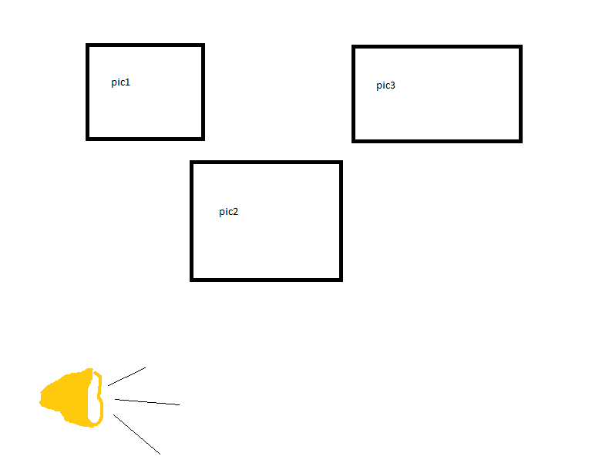

Embedded video review of a board game.