Furthermore, todayFor pre-print publication and draft submission

INITIATOR SET Now Identified Through Informatics of Alternative Translational Organisation of RNAs & Sequence Editing Techniques
Daniel Steven Davies, Erin San Juan, Ondrej Bačo, Akasha, Lucianna Osucha, Jordan Eckhoff, Ryan Miller, Kenric D’Souza, Marcos Zuriaga
Vulpine Designs Ltd, UK & Ireland, Draft Completed 27th August 2022

Lay Summary
The ‘notes’ (mRNA) taken by your body’s cells from their ‘instruction manual’ (genes in DNA) before they make tools (enzymes) and parts (proteins) for the body’s systems and cells to use, can be read in many different ways depending on lots of variables. A lot of these variables alter where in the notes that reading is more likely to start, under a given set of conditions. The software described in this paper is intended to work out the probabilities of different possible proteins and enzymes being made from the same mRNA notes, and which mRNA notes from which genes most likely produced specific proteins and enzymes. These probabilities will help to inform us how to edit genes safely, and what effects different edits and mutations would have.
The software is designed to work by itself or to connect to other software packages which, once developed, will collectively form a system called The GUESS, to simulate all aspects of the body sufficiently to have a very safe idea of how to edit the genes in the body, and a means to convert a model and a sample of an individual person into a set of gene edits in a ‘vector’ package. which can solve genetic problems in that individual as an adult.
The GUESS is expected to take a while to develop, so this is just one small software package which will be useful stand-alone too. More such software packages (modules) are anticipated for availability into the future.
Abstract
INITIATOR SET is a software module of The GUESS Universal Editing Suite and System Development Kit (Davies et al. 2017), and is intended to allow the calculation of the probabilities of Alternative Initiation Codons (AICs) (Stewart et al. 2015; Cowan et al. 2014; Lee et al. 2012; Ingolia, Lareau, and Weissman 2011; M. Kozak 1987) affecting the translation of mRNA strands of nucleotides (A, G, C, U (RNA has U instead of the T seen in DNA. Artificial nucleotides (Walsh and Beuning 2012) may also be simulated here)) into proteins. By doing this, it will provide data for other software modules handling protein folding and pathways. It is also intended for the origins of particular proteins to be possible to deduce in terms of mRNA sequences via calculating the AICs that would be present and thus the likelihood of mutations being included in particular proteins, and which genes need to be edited or epigenetically adjusted, for example. Its output data will also have applications in tracking the causes of prion and amyloid diseases, and it can be used in working out which type of gene edit is safest to make where one has a choice and how mutations cause cancer.
INITIATOR SET is intended to be the first of many modules to be developed for The GUESS in such a way as will work standalone for some studies (as an example of the sorts of studies that may benefit: H. H. Wang et al. 2012) as well as connected to other modules.

Terminology and Jargon Glossary

5` and 3`: the ends of a nucleotide chain are identified by whether the nucleotides at the ends have
the 5th atom or the 3rd atom of their structures the most prominent for attachment of
further nucleotides.
A: Adenine, one of the most common nucleotide molecule types used in biological cells.
C: Cytosine, one of the most common nucleotide molecule types used in biological cells.
G: Guanine, one of the most common nucleotide molecule types used in biological cells.
T: Thymine, one of the most common nucleotide molecule types used in biological cells and used in
DNA but not RNA.
U: Uracil, one of the most common nucleotide molecule types used in biological cells and used in
RNA but not DNA.
AIC: Alternative initiation codon, that is, a different codon from the usual expected codon to start
mRNA translation to proteins, which may also or instead be used for initiating mRNA
translation to proteins.
Cap and tail: The ‘cap’ of an mRNA is a Guanine nucleotide at the 5` end of the mRNA molecule,
protected at its 7th atom by a methyl group. The ‘tail’ is a long chain of Adenine
nucleotides. When these are removed, the mRNA degrades and is removed from use.
Codon: any set of three consecutive nucleotides in an mRNA chain, with which tRNAs can be
aligned to assemble polypeptide chains for construction of proteins.
DNA: Deoxyribonucleic acid, the long chains of nucleotide molecules used by biological cells as a
programmatic instruction manual.
FASTA: A standard format for bioinformatic nucleotide and peptide sequence data.
Initiation/Start Codon: A codon which is almost always ‘AUG’ in mRNA, and forms the most likely
place on the mRNA chain for ribosomal translation of the mRNA to make
proteins, to begin.
Kozak Context: The sequence of nucleotides before and after an initiation codon or an AIC, which
affects likelihood of ribosomal assembly at that codon.
Motif: a folded structural shape in a long chain molecule. This can have profound impacts on the
utility of said molecule.
mRNA: messenger ribonucleic acid, the long chains of nucleotide molecules used by biological
cells as a notepad to transfer relevant excerpts of instructions from the nucleus to the
ribosomes.
Nucleotides: molecules which form repeatable structured chains and consist of a ribose sugar group
and a phosphate group. The phosphates form the ‘backbone’ of DNA and RNA.
ORF: Open Reading Frame. This refers to how the sequential position of the initiation codon sets
the alignment of the ribosome and its tRNAs to the rest of the sequence thereafter, setting the
‘reading frame’ which dictates which nucleotides are part of which codons from the
ribosome’s perspective.
Ribosomes: biological cellular protein factories, which assemble around mRNA initiation codons
(or around AICs) and then read each codon in turn until they reach a STOP codon,
producing a polypeptide chain as they go, using tRNAs to do so.
RNA: Ribonucleic acid, long chains of nucleeotide molecules used in various forms by biological
cells.
rRNA: Ribosomal Ribonucleic acid, used for the construction and specialisation of ribosomes.
STOP codon: a codon which under normal conditions (notwithstanding leaky scanning), forces
ribosomal translation to cease and the ribosome to disassemble when it reaches this
point in the mRNA chain.
tRNA: Transfer ribonucleic acid, the chains of nucleotide molecules which are folded into a
convenient shape for ribosomes to handle and which carry amino acids (peptide molecules)
for the construction of polypeptide chains.
UTR: the untranslated region of an mRNA before the initiation codon (5`UTR) and after the STOP
codon (3`UTR).

Introduction
Since Marilyn Kozak developed the concept of the Kozak Consensus (or Kozak Context) and elucidated some of the mechanisms of ribosomes selecting where to read the amino acid code (split into three-letter ‘codons’ made of three nucleotide bases) of mRNA from (M. Kozak 1987), understanding of mRNA translation to amino acid chains to make proteins, has grown greatly. It is now clear that a plethora of variables affect the translation of an mRNA’s code, and these variables have multiple sources and multiple impacts. To understand how they operate, the lead author spoke to and attended lectures by Dr Mark Coldwell and Dr Jo Cowan at the University of Southampton as part of his undergraduate degree in Biochemistry (2013 to 2016). In their studies, Coldwell and Cowan had used datasets from Lee (Lee et al. 2012) and from Ingolia (Ingolia, Lareau, and Weissman 2011) to pinpoint the most likely genes from each dataset to contain alternative initiation codons (AICs) (Cowan et al. 2014; Stewart et al. 2015). These are codons which the ribosome may also start translating from, if the usual initiation codon of a Methionine (AUG) is not available, weakened in terms of its Kozak Context or otherwise rendered less likely to be utilised (Kochetov 2008). Their use may be evolutionarily advantageous for the control of translation speed (Novoa and Ribas de Pouplana 2012). One may regard translatomics as an extension of the genetic code (Mauger, Siegfried, and Weeks 2013). A general but non-exhaustive overview of factors affecting translation is the paper by Pestova et al. from 2001.
Dr Coldwell had a specific disagreement with Marilyn Kozak’s assertion (Marilyn Kozak 2002) that there are limits to which codons can initiate translation at all, which would exclude a set of non-STOP codons from utilisation in initiation of translation. Instead, he hypothesised in his lectures that all codons are at least a little capable of being initiation codons, except for STOP codons, which are the codons that specifically deactivate ribosomes upon reaching them, and trigger the removal of those ribosomes from the mRNA.
He and Dr Cowan also explained about leaky scanning, untranslated open reading frames, hairpin loops, Internal Ribosomal Entry Sites for viruses to hijack translation processes (IRESes), ribosomal assembly factors, small nucleolar RNAs (snoRNAs), localisation sequences and the cap and tail of each mRNA, all factors which affect translation. He advised the lead author that he was disappointed by the limitations of bioinformatics tools and the computational power available at the time, to process the variables for larger numbers of potential initiation codons and the mRNAs they are in.
The lead author agreed, and proposed that he would assemble a team to develop as the first module of a larger system (the GUESS) (Davies et al. 2017), a software package specifically intended to address each variable in turn (including the relative likelihood of any codon to be used as a start codon) and to create an output based on the cumulative data, which would identify the list of proteins an mRNA can be used to produce, from most likely to least (or to a cut-off point once all cell types and variables of interest have been covered), and also the list of mRNAs a protein is most likely to be made using.

The proposed module shall be named INITIATOR SET Now Identified Through Informatics of Alternative Translational Organisation of RNAs & Sequence Editing Techniques. The latter part, mentioning Sequence Editing Techniques, is to say that this module can in some applications receive some of its data inputs from other systems intended for evaluating potential edits to the genome, to work as part of a larger pipeline.
It should be noted that many genes do not have known alternative initiation codons in use (Cowan et al. 2014). This module becomes much more useful, however, in the context of gene edits and mutations, which may introduce, induce, remove or deactivate alternative initiation sites. Pre-existing systems with similar aims are analysed in the section titled ‘Parallels With Other Tools’ later in this document.
In 2016, the lead author made an initial foray into assembling that team in Cork, Ireland (Davies 2016). There were, however, shortcomings in the lead author’s proposal at the time to utilise the open source code of Intermine (Kalderimis et al. 2014) to handle some of INITIATOR SET’s needs, and so that part of the architecture was abandoned in favour of the design set out below, which is based on the theory that mRNA translation can be characterised by probabilities associated with each codon (Boersma et al. 2019).

Alternative codons for translation initiation can be modified with precision in eukaryotes (at least, in yeast) (Petersen et al. 2018). INITIATOR SET is intended to assist this process and other studies into translatomics.

Design and Implementation: Overview
INITIATOR SET is divided loosely into three sections. The submodules from which it is constructed are arranged into these sections by a combination of difficulty to code, and data logic. These represent simpler, medium and more complex variables to assess. The order in which data from one submodule is passed to another is intended to minimise duplication of effort.
We start with an input of test datasets including those from Cowan, Lee and Ingolia. These are put together with an input of FASTA formatted mRNA codes for mutations, edits and cDNA which lack information regarding alternative initiation codons. We then use the test data to map AICs to probabilities of initiation from each codon, initially just based on those test datasets’ conclusions.
In the first section, the FASTA codes, annotated for those test data, are analysed for indications of whether the mRNAs will be targeted to the cytoplasm, the endoplasmic reticulum or to specific cellular regions for translation into proteins. The annotations thus made are matched up to the FASTA data and used to adjust the probabilities of initiation from those codons. A functional comparison between the amino acid codes from using different AICs can then be made.
In the second section, the FASTA codes are also routed to a Kozak context calculator to determine the strength of likelihood of an AIC being selected based on nearby codons being more or less suited to a ribosome assembling there, then to a leaky scanning detector to determine the likelihood that ribosomes might overrun the STOP codon of one translatable region and initiate on a start codon thereafter. Again, the results are compiled and aligned for a functional comparison of predicted amino acid chains to be made.
In the third section, the number of Gs and Cs (see the GC Count chapter below) in close proximity to one another is counted (also potentially taking account of the numbers of XNA nucleotides and G quartets), and that count is used to inform the Motif Predictor so that it can deduce the folding structures and their locations in the mRNA. Another possible method is the use of a Nearest Neighbour model. Inputs may be provided from other modules here for calculation of the impacts of other proteins and polynucleotide molecules on the mRNA. Armed with knowledge of these structures as part of the adjustments to initiation likelihoods, we can then seek relevant untranslated open reading frames and deduce the effects of their proximity on translation initiation likelihood. The presences of these structures and uORFs will also have impacts on the ribosomal assembly process, so we will finally check the way that is affected and thus how that impacts AIC usage likelihood before matching these annotations up with the rest and producing a complete functional comparison between predicted amino acid chains which accounts for the cumulative effects of all of these variables. This allows the end user to make a much more comprehensively informed decision about the gene edits they may be intending to use, or about what to do with a mutation. The architecture will be designed for extensibility in future, as more mechanisms of translation influence are elucidated.

Genetic Data Inputs

INITIATOR SET will receive genetic data from various sources, each with their specific quirks and differences. Some may already have annotations, some may not. Our Genetic Data Inputs will include:
  - Experimentally verified eORFs, e.g. from Human Embryonic Kidney (HEK) 293 standard cell cultures
  - Genes downloaded based on a list of gene names, from external databases such as Ensembl. These may include transcript variants of those genes, if relevant to the user for the task in hand.
  - Untranslated Regions (UTRs?) - both 5` (five-prime) and 3` (three-prime); and Coding Sequences (CDS?)
  - Ribosome profiling predicted genes
  - Sequences containing mutations as input from sequencing the DNA of the patient, or from manually testing for mutational significance
  - Sequences containing edits we've input to the Transcription module.
It is possible that this submodule will be augmented or inspired by pre-existing tools (Ashburner et al. 2000; Gene Ontology Consortium 2019; Stelzer et al. 2016; Blischak, Wenzel, and Wolfe 2014) for gene ontology.

eORFs

Extra open reading frames are the other possible sequences which can be used to make proteins from an mRNA. In yeast, ‘eORF’ stands for ‘Essential Open Reading Frame’ (Snyder and Gernstein 2003). Extended open reading frames include the 5` and 3` UTRs, allowing for a broader search for AICs than a mere CDS would. An Extended open reading frame may include some Extra open reading frames. In our context, when we say we are inputting eORFs we refer to Extended open reading frames. This is, the 5`, the CDS and the 3` are all together in one sequence.
Our experimentally verified eORF inputs, e.g. from a paper by Lee et al. 2012, are from studies which have confirmed that these eORF sequences are the ones which one can find AICs in. These provide a baseline test dataset. To highlight further eORFs, we may take a look at software like ESTScan (Iseli, Jongeneel, and Bucher 1999) to inspire our handling of these data.

Gene Names
Gene names are often around 5 characters, sometimes more or fewer, and may be technical or whimsical or some combination of both. In our context for INITIATOR SET, a pool of gene names is being provided as a test dataset in which AICs are predicted to exist, from Ingolia, Lareau, and Weissman’s 2011 paper. It may be possible to deduce further test data from the 1000 Genomes project (Fairley et al. 2020).
UTR & CDS
UTRs (Untranslated Regions) are the sections of mRNA before and after the CDS sequence (Mignone et al. 2002). Consider them like the publishing information, title pages, contents, acknowledgements, preface, prologue (all in the 5` UTR) and the epilogue, references, index, appendices and advertisements of other interesting books (all in the 3` UTR) to the main chapters of the CDS. Just as different books include different mixtures of the above materials in their fore- and after-pages, so too do different genes include different metadata and features in their 5` UTRs and 3` UTRs. Sometimes, if you read a book without reading its preface and prologue, it has a different meaning to you than if you include them. Likewise, different initiation codons may be placed before or after the start of the usual or intended protein coding sequence, changing the results if they are used for translation initiation. Short open reading frames may be in the UTR of an mRNA for a more substantial protein too (Vilela and McCarthy 2003).

The length of the 5`UTR is seen as being more evolutionarily conserved than that of the 3` UTR (Lin and Li 2012). However, it is possible that this is due to short Poly-A tails and damage to the mRNA being more likely to occur at the 3` end.

In our usage, INITIATOR SET requires the UTR and CDS regions to be both included from any downloaded genes based on their gene names from our test datasets or elsewhere. They need to be identified by the UTR & CDS submodule, and AICs mapped against them by the Map new AICs submodule.
The 3`UTR Poly-A tail is analysed by Lakshmanan et al. 2016. The stability of an mRNA is affected in a codon-dependent manner by translation (Wu et al. 2019).
The CDS sequence is the part of the mRNA that codes for a protein (Twyman 2003).
Ribosome Profiling Predicted Genes
Animal/Human datasets
The dataset from Cowan et al. 2014 has the Coldwell lab's ribosome profiling data based on the gene names and eORFs in Ingolia and Lee's datasets, among others. These data will be provided as a more thorough baseline for INITIATOR SET testing and calibration, ensuring we can accurately predict and map AICs and their likelihoods of use.

Microbiomic translation datasets
Additional Ribo-Seq (Ribosomal profiling using enzymes) dataset at NCBI from Gorochowski et al. 2019; ‘SRP144594 - SRA - NCBI’ n.d.. This was used in their study for E-coli only so it is less relevant for modelling eukaryotic systems, but it will be transferrable to microbiomics usage of INITIATOR SET.
We may wish to take a look at existing tools for inspiration, such as Genemark.hmm (Lukashin and Borodovsky 1998) and BRAKER (Gaius-Augustus/BRAKER [2018] 2020; Hoff et al. 2019; 2016; Stanke et al. 2008; 2006). Additionally, we may need to look at Polysome profiling to see the degree of translation of an mRNA under specific parameters.
The ‘SunTag and MoonTag’ study (Boersma et al. 2019) is essentially able to give the same kind of data as ribosome profiling, but using fluorescent tags to profile them in real time. This study should also offer insights in protein targeting and localisation at the mRNA and alternative translation stages.
Polysome Profiling generates very different data from regular Ribosome Profiling (Hanebuth et al. 2016) and observes the number of ribosomes per mRNA. This may also be of use.
Mutations
When our data input from Transcription or other modules of The GUESS contains mutations, we will be able to trace them through INITIATOR SET via annotations and highlighting. This will allow us to see what the precise effects of a mutation are.
For example, say an mRNA sequence includes an inserted codon. The properties of the amino acid which that codon codes for will change the folding of the protein as will be elucidated when it’s processed in the future ‘PAMM’ software module, but before even that, the properties of the codon itself will change the likelihood of usage of AICs and the capability for ribosome assembly to take place on that mRNA. This may speed up or slow down translation, alter the size of the amino acid chain produced and affect the accessibility of uORFs?. It may also render some annotations for that gene moot, affect leaky scanning and the potential for the formation of IRESes or hairpin loops.
Therefore, when running the other submodules of INITIATOR SET it will be handy to know where those mutations and their effects are as we proceed.
Fusion RNAs are often found in cancer cells, and they are formed when the antisense (reverse direction) strands of two genes are mimicked in RNA. It is possible that RNAs produced for other purposes, or mutated from them, may cause chromosomal translocation and the fusion of some genes (Gupta, Luo, and Yen 2018). RNAs therefore ought to be checked for antisense matching to more than one gene in chromosomal DNA.
By aligning DNA between standardised genomes and the actual genome being worked on, we will be able to identify mutations. Tools such as BLAST2 (Lopez et al. 2003), Blast2GO (Conesa et al. 2005), ClustalW (Thompson, Higgins, and Gibson 1994) and ClustalW2 (Larkin et al. 2007) may provide useful inspiration here.
Edits

Essentially, an edit is an artificial mutation. With a deliberate choice, one would hope it will have a specific positive outcome. The purpose of The GUESS is to take the guesswork out of making such choices for editing genes, to let the computer make the best judgement it can based on far more data than a person can process.
However, the impacts of an edit within and beyond INITIATOR SET are of equal importance and scope to those of a mutation. Therefore, this may not strictly need to be a separate submodule from Mutations. The edits we input will be simply in the FASTA format as an edited version of the mRNA or cDNA.
If there are any signatures of edits, it would be good to be able to spot and account for them. These may vary between editing techniques, if present at all. If there is no signature or other way of telling an edit apart from a mutation, inherent to the genetic code in DNA or RNA form, then the only difference between an edit and a mutation is how intentionally it was created. The way both are processed and checked for their impacts will be the same.

Map New AICs
The submodule for mapping AICs needs to be written with consideration of the Ribosome profiling studies (Cowan et al. 2014) and 'ExTATIC' (Schofield 2015; Knight 2017; Edwards 2011) tools previously used at the University of Southampton. However, unlike these it needs to account for the probabilities of ALL codons' potential for use as initiation codons, initially just by providing a statistical baseline from existing literature, which is then modified by the other submodules in INITIATOR SET. It should therefore have a count of the occurrences of AICs and their uses in its sample data, and thus be able to highlight AICs in the sequence with prominence of highlighting being used to indicate the likelihood (so far) of that codon being used as an AIC. These likelihoods are conserved in eukaryotic genomes (Bazykin and Kochetov 2011).
It needs to use a list of all possible codons and use logic to define based on its statistical baseline, which codons are most likely to be used as start points and which are least likely, mapping those likelihoods out along the mRNA sequence in order for the Kozak Context submodule and others to identify the contextual effects on each codon of its neighbours.

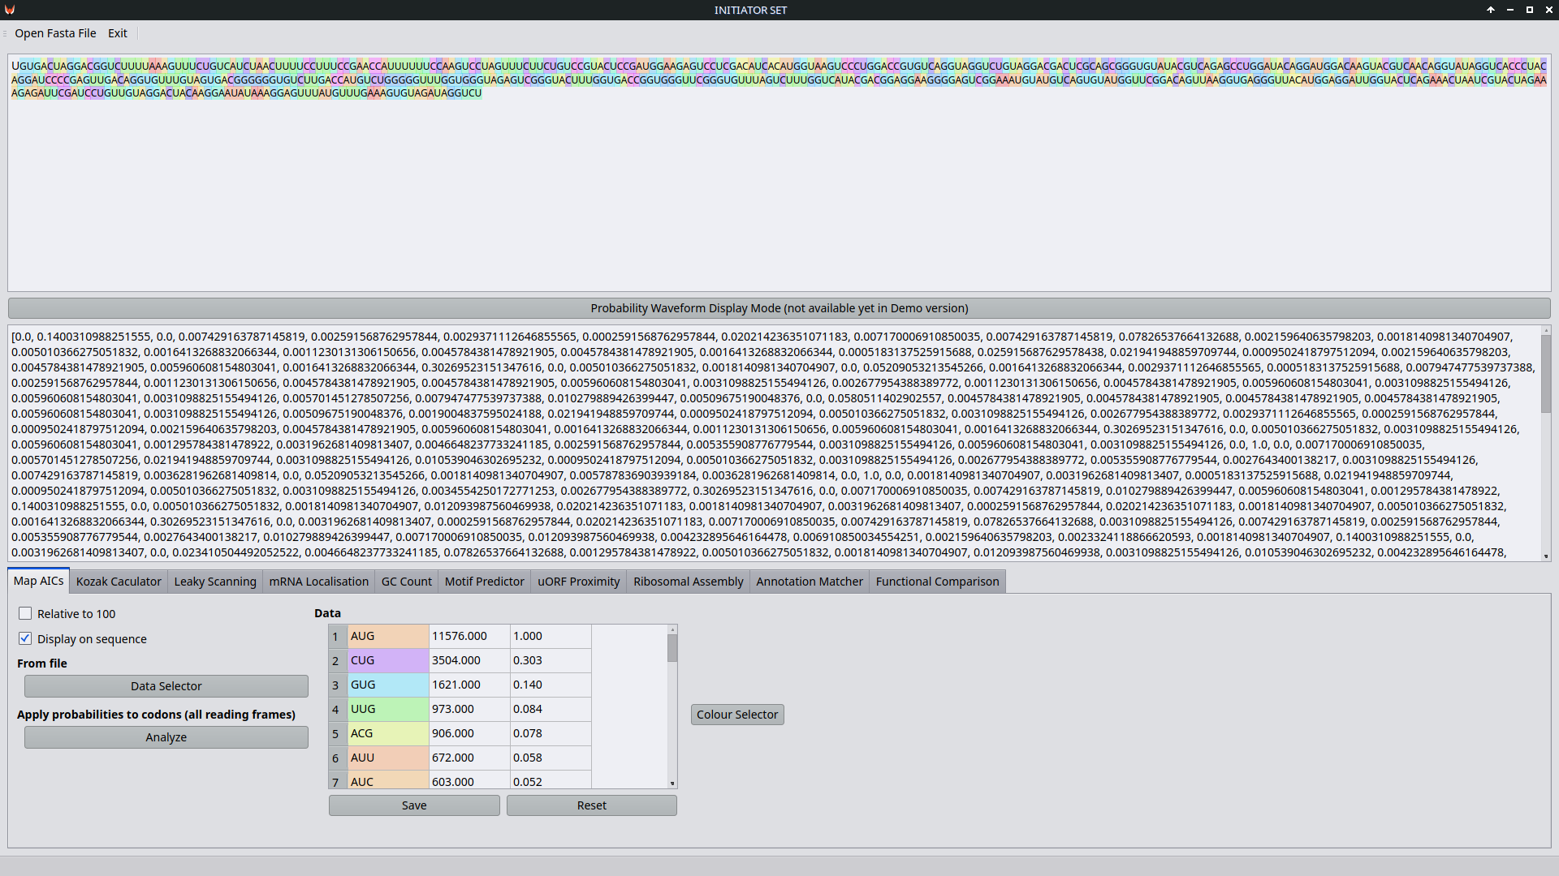
As of 27th August 2022, the demo of INITIATOR SET includes a basic working prototype of this submodule.

FASTA

The FASTA format (described concisely in Yang Zhang Lab’s undated web page) was developed as a loosely defined format-of-convenience for the FASTA bioinformatics program (Pearson and Lipman 1988), a derivative of FASTP (Lipman and Pearson 1985).
The FASTA submodule handles genetic data inputs and ensures they are sanitised to a standard FASTA format for further processing. To standardise inputs, our FASTA submodule analyses various forms of FASTA cDNA and mRNA inputs and converts them all to mRNA code with standard header structures for annotation.
Some questions remain outstanding: since our annotations are not sequence quality scores; does that mean we are making another derivative of FASTA? Some of our inputs might be FASTQ (Cock et al. 2010) files, what do we do with them? Should INITIATOR SET also be prepared to handle encrypted FASTA (CryFa) input (Pratas, Hosseini, and Pinho 2017) or should that all be dealt with by Vectron?
This submodule also needs to handle non-standard amino acid encoding and inclusion, for example selenocystine (‘SelenoDB: Selenoproteins Database’ 2018). Furthermore, it could also point out when a CDS aligns or diverges annotation-wise with different species’ CDSes (Pruitt et al. 2009). As of 27th August 2022, the demo of INITIATOR SET includes a basic working prototype of this submodule (which runs in the backend only for the time being).

Protein Targeting & Localisation
This submodule of INITIATOR SET will find protein targeting and localisation sequences, and calculate whether the use of a specific AIC will lead to such a localisation sequence in the mRNA sequence being used or not.
Do the mRNAs also get localised? They do, but the only localisation affecting them we need to consider at this stage is whether they are translated in the endoplasmic reticulum or the cytoplasm (Pyhtila et al. 2008; Cui 2015). AICs and other variables can affect translation after localisation to the endoplasmic reticulum too (Reid and Nicchitta 2015).
This localisation sequence is usually within the translated region of the mRNA and so can be looked for in the amino acid code. 3`UTR localisation sequences can decide localisation of mRNAs within neurons (Tushev et al. 2018). All other localisations which this submodule deals with are post-translational.
This submodule just tags the localisation sequences, regardless of how likely they are to be used.
So:
AMINOACIDSEQUENCEWITHLOCALISATIONSEQUENCE
becomes
AMINOACIDSEQUENCEWITH--LOCALISATION--SEQUENCE
(other forms of annotation are likely to be used, this is just for simple illustration purposes).

The localisation process is facilitated by the Signal Recognition Particle (SRP) (Akopian et al. 2013).
In-vivo, prenylation acts as a biomarker, while farnesylation and geranylgeranylation are used by the body to affect sequence usage and the likelihood of its use in different locations in the cell (Berndt and Sebti 2011). We intend to handle the effects of these modifications in this submodule too, if and when they affect mRNA localisation prior to or during translation. The EMBL-EBI Gene Expression Atlas may provide a good calibration reference (Achim et al. 2015).

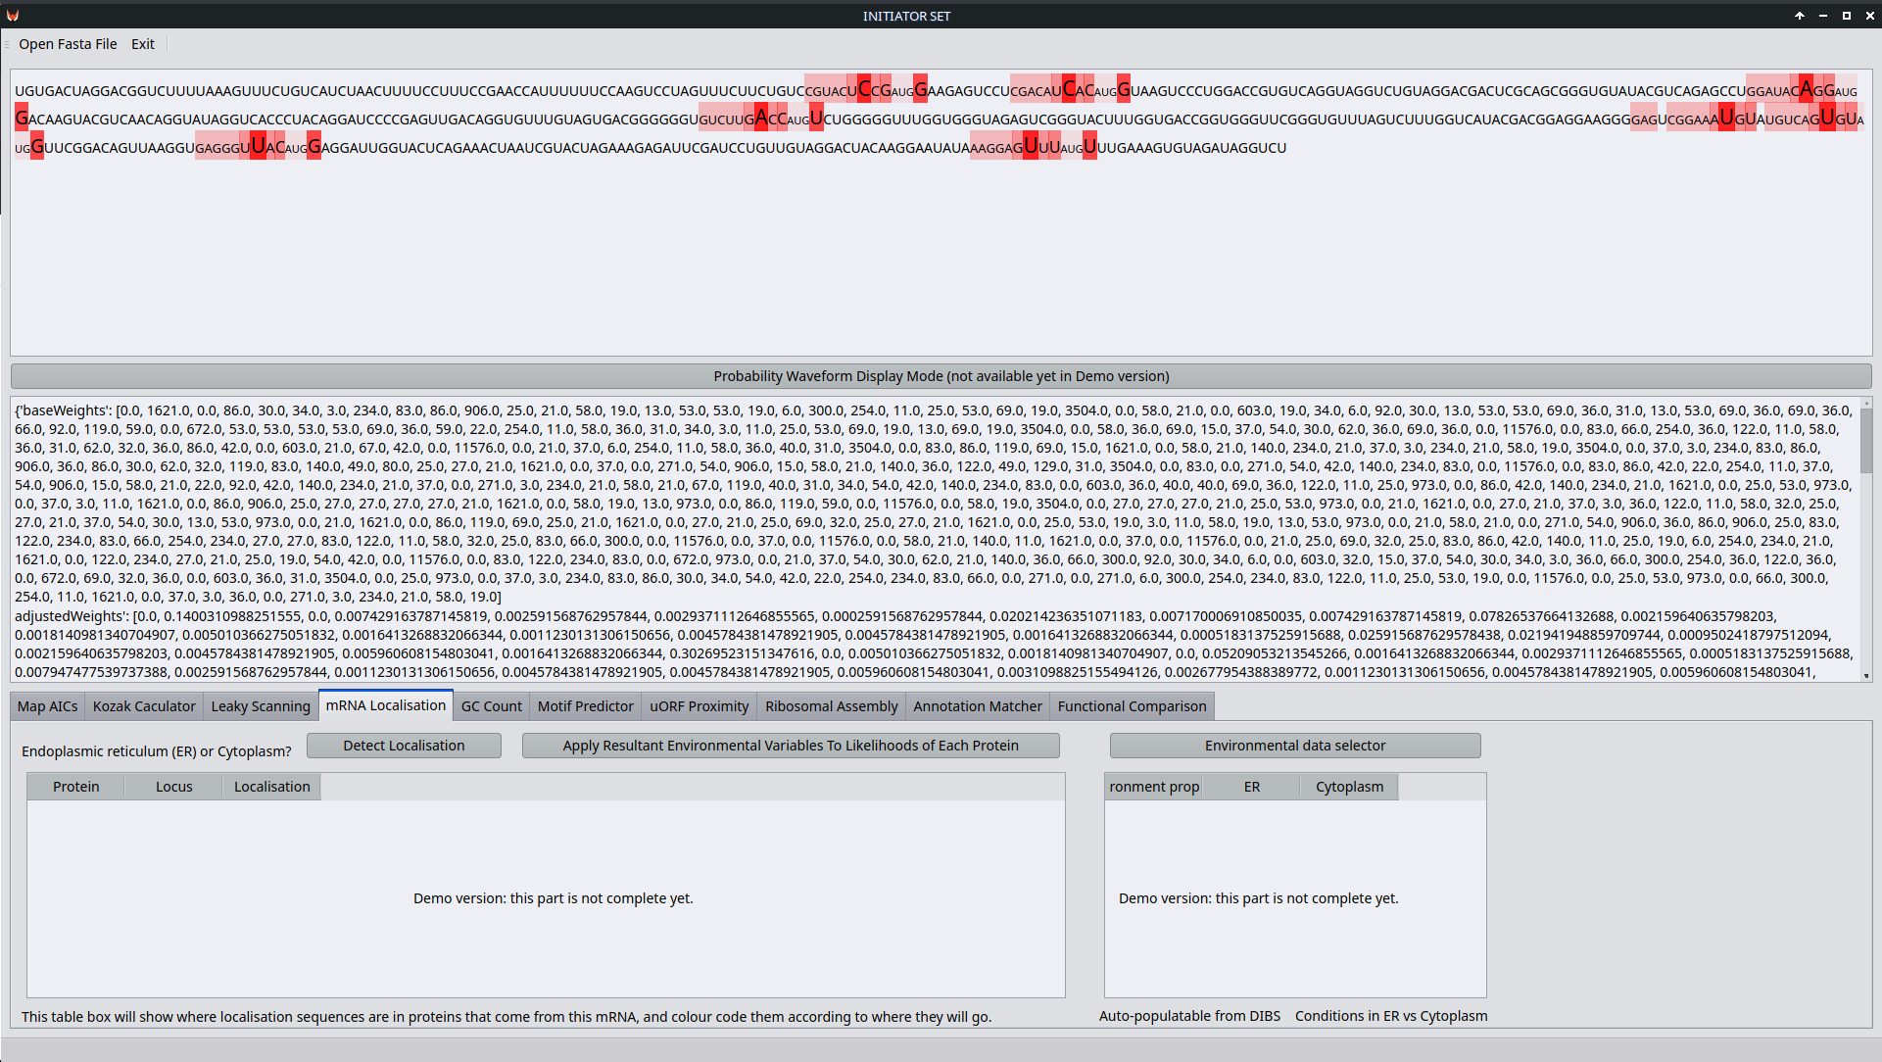
As of 27th August 2022, the demo of INITIATOR SET includes a basic mockup of this submodule.
Annotation Matcher
This INITIATOR SET submodule will automatically tag annotations onto genetic sequences, based on the following criteria:
- Does an exact match for the sequence exist already in an external or internal database with annotations already included? If so, copy these.
- Has the sequence been changed in The GUESS? If so, annotate the changes made.
- Do certain motifs or components of the genetic code here match to annotated features in other genes saved locally or externally? If so, copy those annotations under a 'motif only' header.
- Are those motifs likely to be used or are they out of reading frame, obscured by other factors (e.g. IRESes or AIC positioning) or otherwise rendered unlikely to be used? Adjust annotation metadata accordingly.
This is all decided by the other submodules. Annotation Matcher gets those results together in one place, logically aligned with the DNA, RNA and/or Amino Acid sequence. Since this is for internal uses (mainly within the same module), it does not have to match with external database formatting, however requests to make adaptations of output from here for specific purposes may be honoured additionally.
Inspiration may be drawn from GeneCards (Stelzer et al. 2016). The annotated likelihoods of translation of codons may also inform us about the effects of that translation action on the stability of the mRNA (Wu et al. 2019).

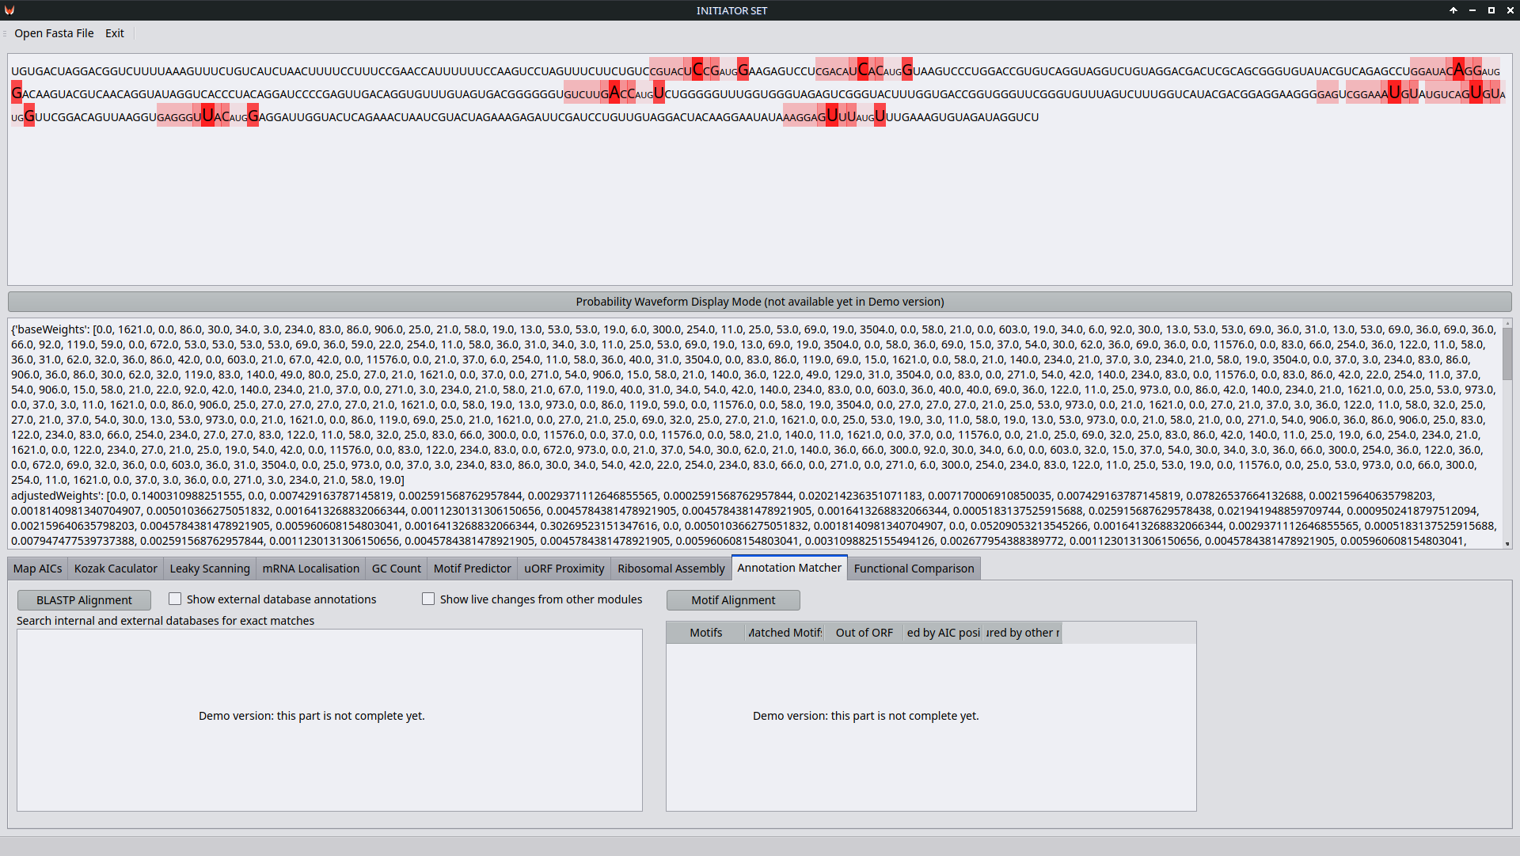
As of 27th August 2022, the demo of INITIATOR SET includes a basic mockup of this submodule.
Functional Comparison
When we have processed our mRNA data through INITIATOR SET, we will be able to compare the functions of the proteins so produced from different AICs in a similar manner to studies which generated protein isoform diversity in the lab (Touriol et al. 2003). Thereby, we will be able to see whether one AIC or another is the one which produces the better protein for a specific task, we will be able to see what the proteinaceous result of a mutation or gene edit is as compared to an unedited or unmutated alternative, or to the most recent or accurate ‘reference human genome’ (Genome Reference Consortium 2019).

To be clear, the output here is without yet doing any folding of the proteins (that’s done in PAMM). This submodule is the staging point for then going onwards into using PAMM, or for comparing mRNAs from which a protein could have come, into using Transcription.
Therefore, this is a place to compare multiple annotated sequences manually and to be provided them for other tools. It should have a synchronised scrolling option, whereby a marker can be placed in each sequence at a common motif or other reference point, and then the scrolling of one sequence in its pane scrolls the others together with it. The annotations should be possible to highlight by type. The sequences being compared should be possible to organise by AIC position, by annotation parameters, by length, by GC count and by likelihood to be used. An overall likelihood of use should be displayed, and if possible one should be able to select cell types from a long scrollable dropdown, which includes the option to load a new cell type. This latter part may be added in later versions.
This submodule should be calibrated using SABER data (Kishi et al. 2019). Absolute quantification of translational regulation and burden has been achieved in a prokaryotic model organism (E. coli) (Gorochowski et al. 2019), and so is shown to be possible. To quantify in more complex organisms involves more complex analysis and a lot more data, but it is not an impossibility given that E. coli is based on the same fundamental parts as all other known life on Earth.

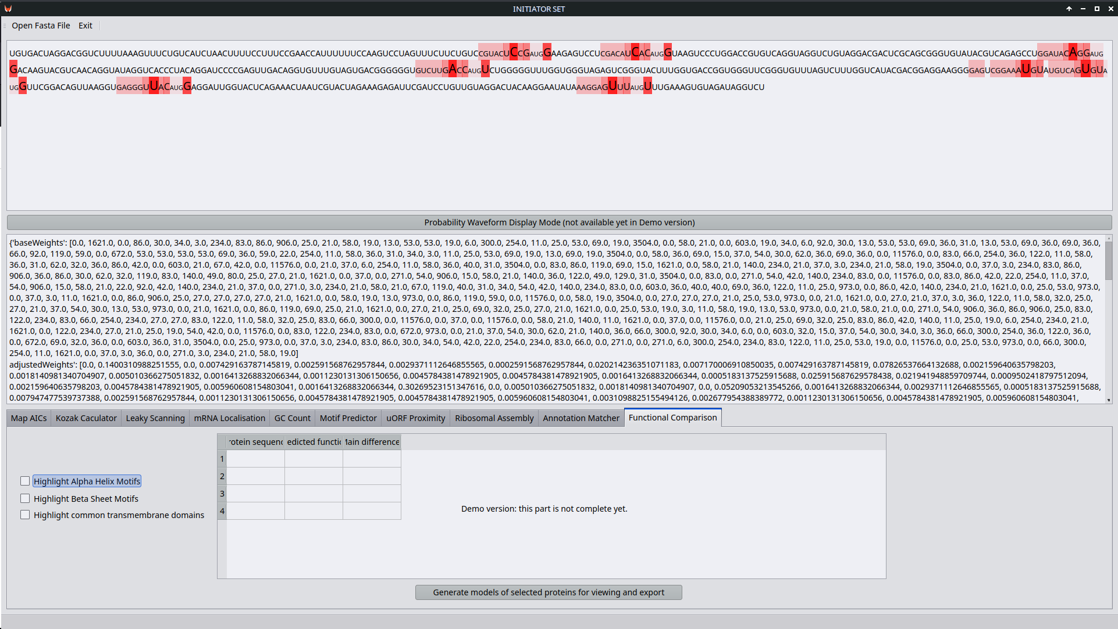
As of 27th August 2022, the demo of INITIATOR SET includes a basic mockup of this submodule.
Kozak Calculator
This submodule of INITIATOR SET will work out what the Kozak context (M. Kozak 1987; Marilyn Kozak 2002) of a given codon is, and how this affects its likelihood of initiation usage. The Kozak context is the effect of a set of nucleotides before and after a codon on a ribosome's ability to assemble there. Different codons have different chemical and steric properties. This affects the electrical charge, the 'grip' a ribosomal subunit can attain and the Van der Waals force 'field' around the mRNA chain (Batool et al. 2020; Khusenov et al. 2016). There are differences in Kozak contexts and their usage between species (Lütcke et al. 1987). Mutations in the Kozak sequence can cause developmental abnormalities and diseases by altering translation rates of critical proteins (Mohan et al. 2014).
An example of the Kozak context impacting AIC usage in overlapping open reading frames is in POLG (DNA Polymerase Gamma) (Khan et al. 2020). Yeast also demonstrates alternative initiation and the impact of context on it (Chen et al. 2008).
Additionally, future versions of the Kozak Calculator will handle the presence of SINEUP lncRNAs (Schein et al. 2016). They will also be able to handle Shine-Dalgarno sequences, which are the prokaryotic equivalent, e.g. for microbiome purposes (Jin et al. 2006).
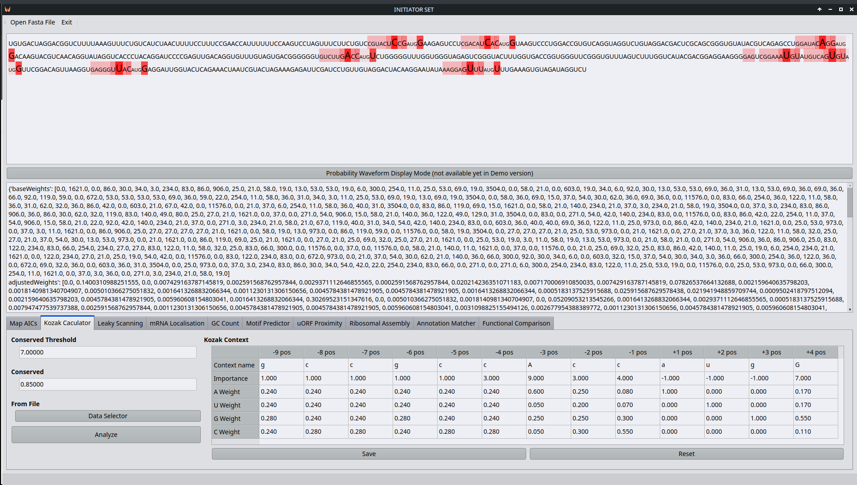
As of 27th August 2022, the demo of INITIATOR SET includes a basic working prototype of this submodule.
Leaky Scanning Detector
In INITIATOR SET, translation initiation likelihood determination heavily involves the movement of the small ribosomal subunit along mRNA molecules from 5` to 3` (Aitken and Lorsch 2012; Hinnebusch, Ivanov, and Sonenberg 2016), selectively passing by start codons and selecting specific AICs in the process of leaky scanning, which can be an effect of unfavourable Kozak sequences (Herzog, Guilley, and Fritsch 1995). Factors contributing to this process include pretty much all of the submodules of INITIATOR SET.
Leaky scanning also affects the efficacy of STOP codons in some scenarios, and the ability of a ribosome to start from an AIC near to a STOP codon. In turn, cellular composition, chemical and environmental conditions will impact the likelihoods of all factors contributing to this. There are also some proteins which prevent the ribosome from ‘translocating’ (Darnell et al. 2011).
Examples of leaky scanning in action include Human Papillomavirus (Stacey et al. 2000), and Avian Reovirus (Racine and Duncan 2010). Precise control of protein translation may involve the deliberate engineering of leaky scanning (Ferreira et al. 2014).

5-Methylation of Cytosine in mRNA by NSUN2 is inversely correlated with ribosome association, and so may affect translation likelihood (Schumann et al. 2020).
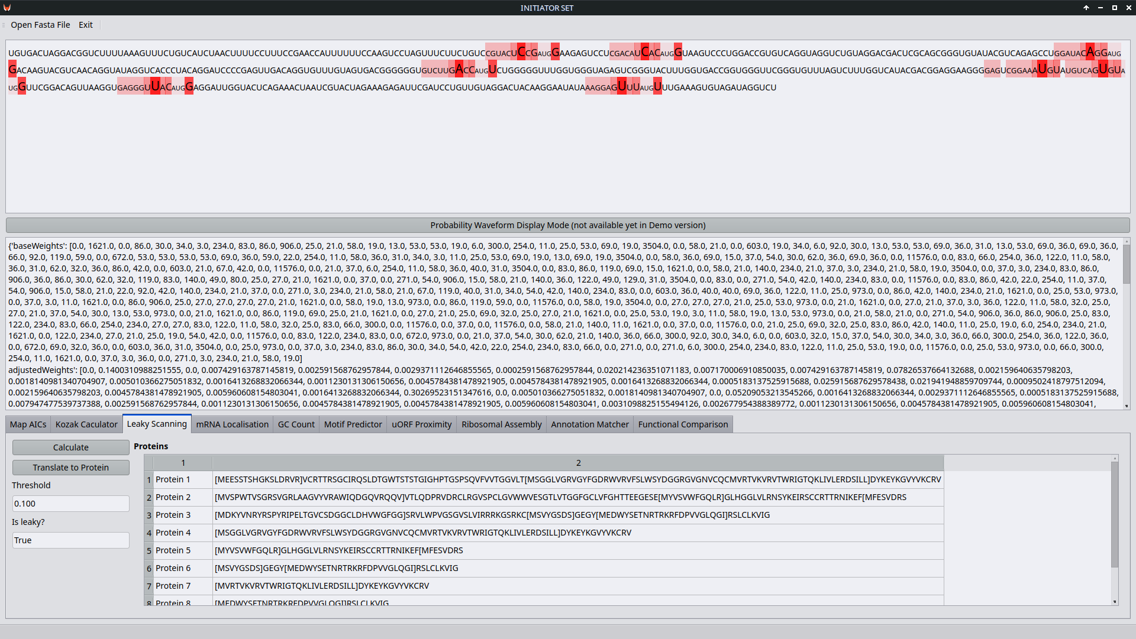
As of 27th August 2022, the demo of INITIATOR SET includes a basic working prototype of this submodule.
GC Count
The number of Guanines and Cytosines in an mRNA sequence (in particular, the percentage of the sequence which is made up of them in a specific region of the mRNA) affects how likely it is to hold specific motifs or to allow the ribosomal subunits to perform leaky scanning (Vinogradov 2003). Consider Gs and Cs to be 'more sticky' to each other - both in base pairing and in ribosomal contexts. However, this difference is not as important as the pairing of C and G nucleotides side by side in the sequence (‘CpG islands’ included) (Yakovchuk, Protozanova, and Frank-Kamenetskii 2006) and does not strongly affect overall gene expression (Sémon, Mouchiroud, and Duret 2005). Other peculiar collections of nucleotides, modified nucleotides and even xenonucleotides will cause differences in the behaviour and utility of DNA and RNA, including mRNA. The way mRNA folds is affected, as is the optimal temperature of growth in prokaryotes (thus affecting the Microbiome and mitochondria) (Galtier and Lobry 1997). We therefore want INITIATOR_SET to have a count of how many Gs and Cs there are in our sequences, and where they are concentrated, thus whether this will likely affect e.g. AIC selection. A couple of basic tools for GC counting already exist (Science Buddies 2002; Collet [2012] 2013). Often, areas affected by the GC Count and the way it causes the mRNA to fold, will be towards the 5` direction from the AIC which is used, and thus the effect of GC Count is usually a matter of the 5` UTR and how it regulates translation (Araujo et al. 2012). Test data may come from flow cytometry studies (Vinogradov 1994). However, GC Count was not mentioned as a major factor in IRES formation in at least one study which went into detail about several other factors (Gritsenko et al. 2017). More detail on this follows in the Motif Predictor.
Extensions for this submodule will include:
- handling of XNA (artificial nucleotides) and how they affect the properties of the mRNA and its likelihood to fold (Acevedo‐Rocha and Budisa 2016). The way they bind to proteins may also differ from regular nucleotides (Vanmeert et al. 2019) and so too might their replication mechanisms (Yu et al. 2013).
- Lin28 recognition and remodelling of G-quartets in miRNA and mRNA (O’Day et al. 2015) – the likelihood of which will be affected by the production of Lin28 in the first place.

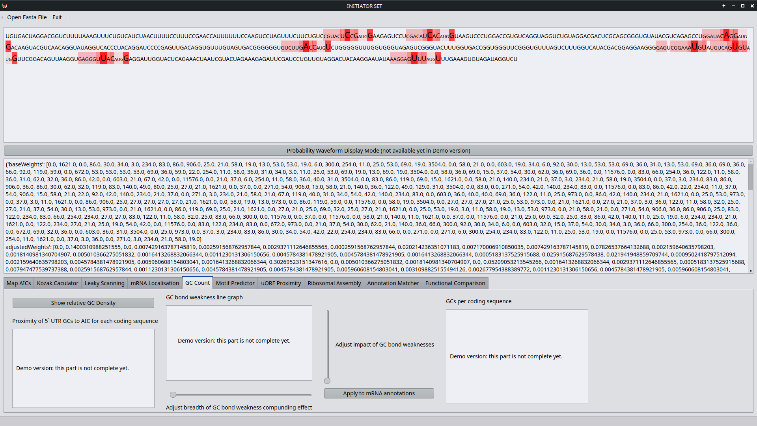
As of 27th August 2022, the demo of INITIATOR SET includes a basic mockup of this submodule.
Motif Predictor
To predict hairpin loops and IREses, we should analyse our sequences based on collections of known IRES sites and hairpin loops and other motifs (Baird et al. 2006), from annotated examples in online datasets (Bonnal et al. 2003; Mokrejš et al. 2006). This submodule of INITIATOR SET will be for that purpose. There are several resources and tools already available online for mRNA folding, hairpin structures and IRESes (Wang and Gribskov 2019; Mathews and Reuter 2012; Kochetov et al. 2007; Aldwairi et al. 2009; Meng and Aalberts 2013). There is also a study which has characterised some IRES structures using RNA Helicase EIF4A inhibition (Bordeleau et al. 2006) and a study which has shown the necessity of an IRES for a specific isoform of ACAT1 (J. Chen et al. 2008). The Motif Predictor will need to integrate such online data sources with information from other submodules about the current mRNA being analysed and the modifications of probabilities generated by other factors so far checked.
The mRNAs from which histones are produced are known to be regulated via hairpin loops (Zhang et al. 2012). Some RNAs are produced to interact with chromatin structures (Sridhar et al. 2017). Therefore, this submodule will impact the understanding of DNA availability for our Transcription module. The energy requirements for folding and stretching mRNA loops may also inhibit small RNA binding (Meng and Aalberts 2013), this may effect the actions of snoRNA and ribosomal assembly.

When applied to the microbiome and bacterial infection immunity, 5`-terminal stem-loop structures in mRNA can stabilise mRNA in E. coli (Emory, Bouvet, and Belasco 1992) Hairpin loop motifs inhibit ribosomal translation by steric hindrance of tRNA binding (Loerch et al. 2020). The combination of these both may serve to highlight the degradation process of mRNA over time as it is translated more.

In general, RNA-mediated gene regulation is not seen to evolve as frequently as transcriptional regulation (Payne, Khalid, and Wagner 2018). This might imply a lower tolerance for change to these mechanisms. However, some RNAs have functions in the activation of viral replication enzymes (Pyle and Whelan 2019). This needs to be considered when designing new RNA sequences.

RNA fold calculation and code design has been significantly sped up by EternaBrain, an AI tool which learns from videogame players (Koodli et al. 2019).

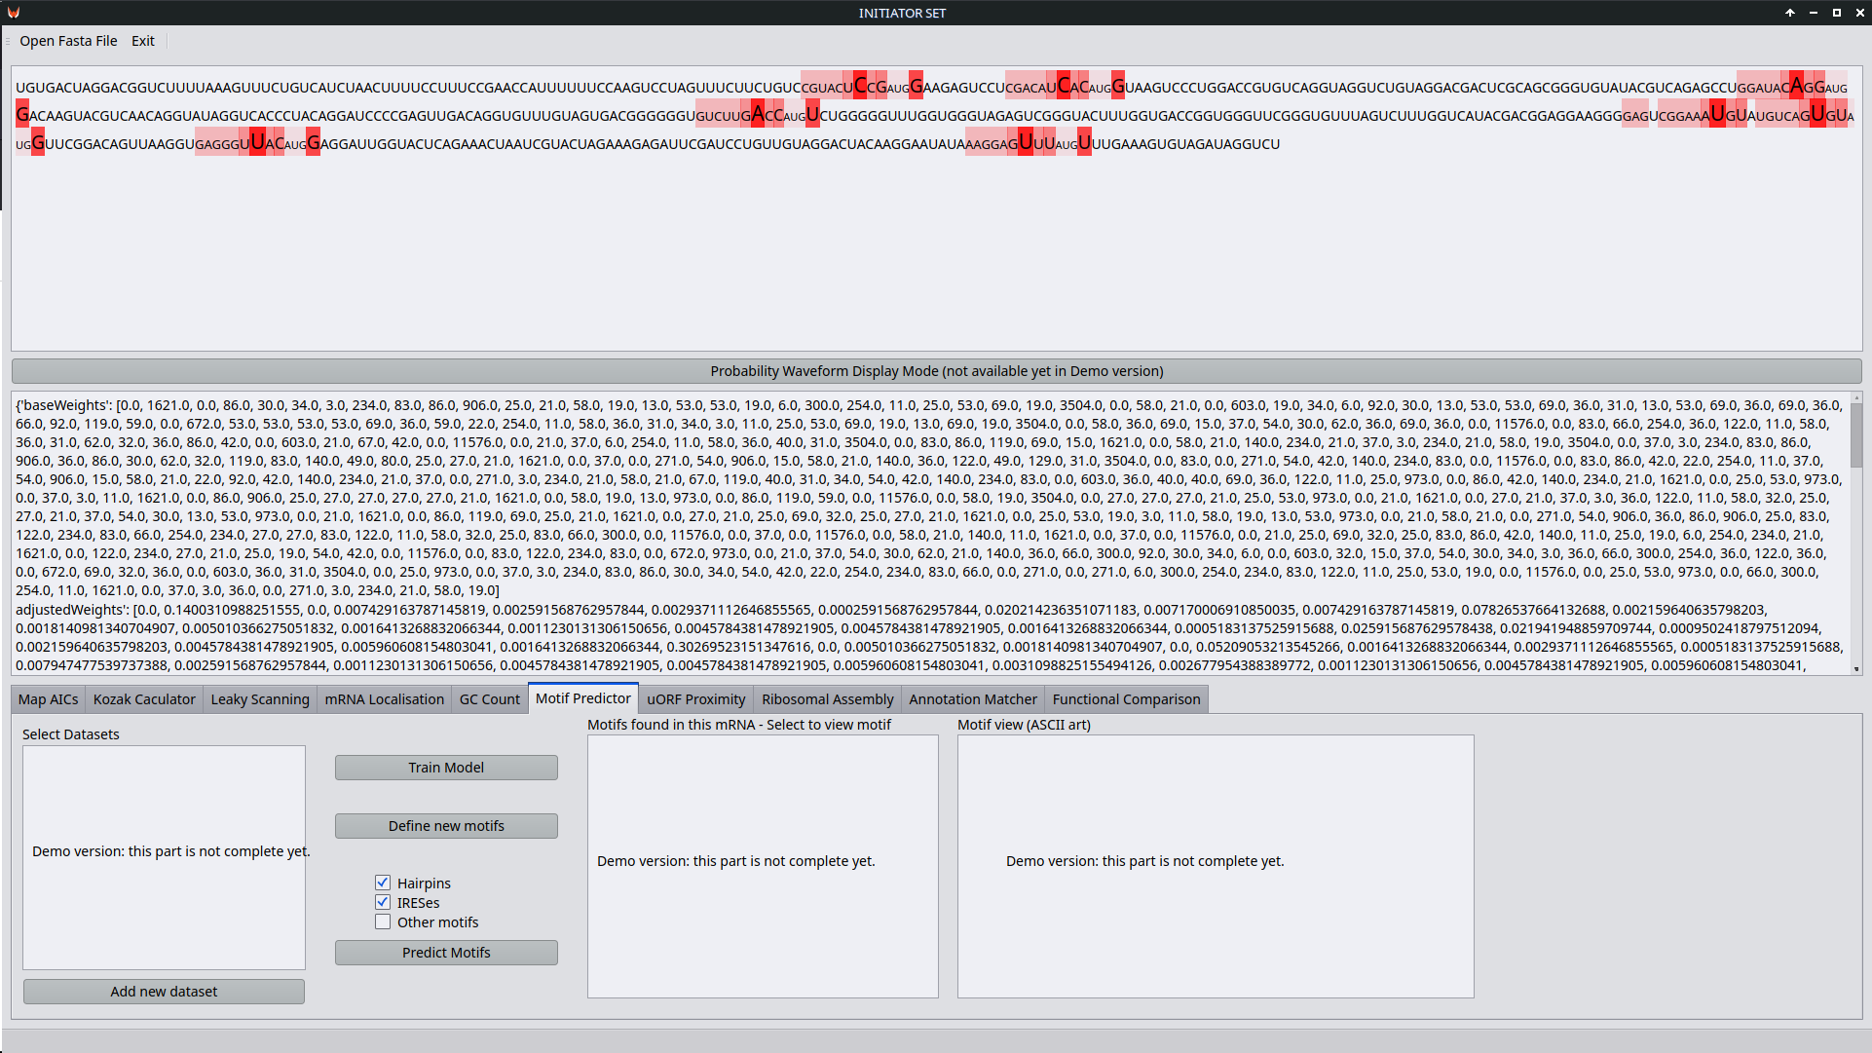
NB: the degeneracy of genetic code has an effect on this stage. Take note that different codons which code for the same amino acids may produce different folds in the mRNA (Shabalina, Ogurtsov, and Spiridonov 2006).
As of 27th August 2022, the demo of INITIATOR SET includes a basic mockup of this submodule.
uORF Proximity
A uORF, for our purposes, is another viable section of reading frame which a ribosome can use to produce a polypeptide chain from our mRNA. It might be in a different reading frame or the same, it might overlap or be before or after the CDS (Morris and Geballe 2000; Kochetov et al. 2008). Other viable reading frames might be on the reverse or opposite strand in the DNA, though in this latter case there would be a different mRNA produced during Transcription. INITIATORSET needs to know how close uORF AICs are to the AICS, stop codons and other features of the CDS and of each other. This affects ribosomal assembly probabilities, leaky scanning and other things.
In fungi, short open reading frames regulate gene expression (Vilela and McCarthy 2003). In humans, they encode small peptides (Slavoff et al. 2013). UORFs are present in roughly 50% of human genes, and when present, they reduce protein expression (Calvo, Pagliarini, and Mootha 2009).
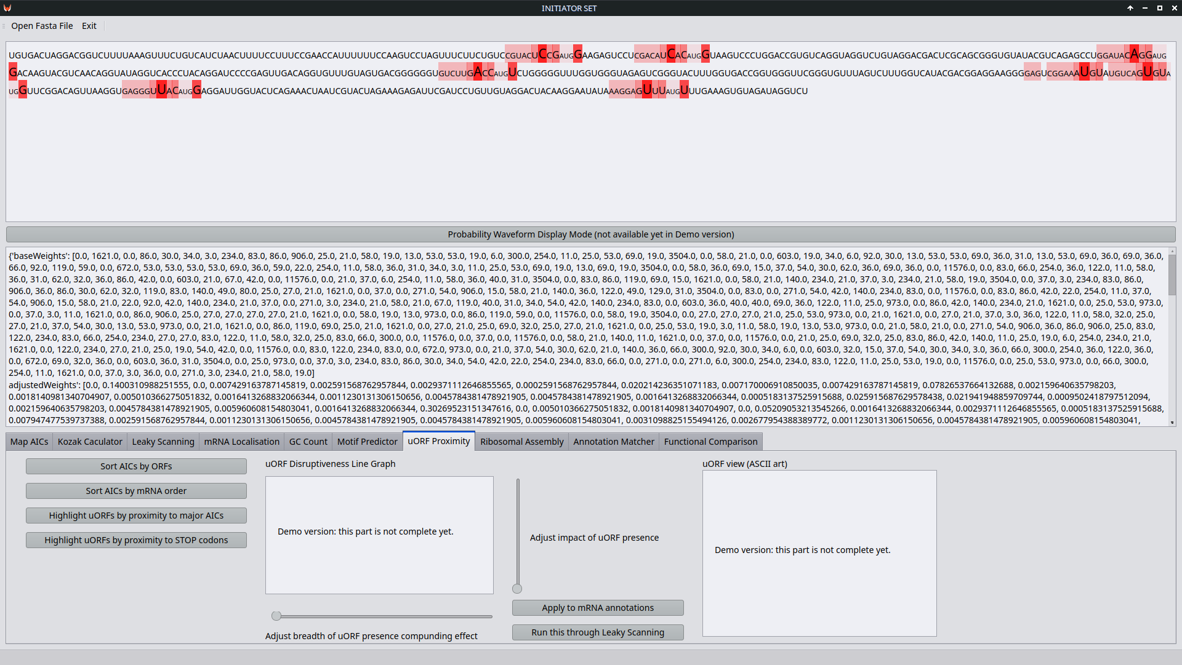
As of 27th August 2022, the demo of INITIATOR SET includes a basic mockup of this submodule.
Ribosomal Assembly Checker

A ribosome in a eukaryotic organism is made from a '40S' small subunit, and a '60S' large subunit (Anandita 2014; Warner et al. 1972). Confusingly, the numbers don't add up to 100S, blame Svedberg units (Slonczewski and Foster 2009). Subunits of other sizes can be found in prokaryotes, and are well studied (Jomaa et al. 2011; Yusupov et al. 2001). These may be handy for handling microbiomic translation. Eukaryotic ribosomal proteins can be identified based on their extensions before they are assembled into the small subunit (Ghosh and Komar 2015).
There may also be different variations among the core proteins of ribosomes within the same cells, for specific purposes (Slavov et al. 2015).
The 40S subunit performs (sometimes leaky) scanning, and upon finding a suitable initiation codon (or an AIC), it will bind a 60S subunit (Kressler, Hurt, and Baβler 2010). Complex mechanisms construct the ribosome for translation of mRNA (Pestova et al. 2001; Baßler and Hurt 2019). The Kozak context, the presence of any motifs, uORF positions and various eIFs, rRNA and snoRNA may affect the translation speed, assembly speed and viability (Thomson, Ferreira-Cerca, and Hurt 2013). RNA compaction, molecular switches and molecular mimicry, irreversible assembly checkpoints and proof-reading processes all take part in the assembly of a ribosome (Klinge and Woolford 2019; Dlakić 2005; Fromont-Racine et al. 2003; Kim et al. 2014). If part of the ribosomal assembly process is disrupted, the imbalance in usage of subunit components can lead to accumulations of components (Rahman, Shamsuzzaman, and Lindahl 2020; Peña, Hurt, and Panse 2017). Ribosomal proteins can be acetylated (Liew and Gornall 1973). This appears to be a necessary process to maintain their function (Kamita et al. 2011).

RNA folding as elucidated in the Motif Predictor, influences ribosomal assembly not only due to mRNA folding, but also the folding of tRNAs, rRNAs, snoRNAs and so forth. The folding ‘energy landscape’ of these molecules contains multiple metastable hollows and ledges, which can stall and slow ribosomal assembly and RNA folding processes (Woodson 2011).
The initial formation of rRNA will affect the availability of it for ribosomal assembly and the shapes it folds into, and the biogenesis and function of the ribosome (Sardana et al. 2015; Sloan et al. 2016). This is demonstrated in muscle wasting (Connolly et al. 2018). rRNA binding to proteins is affected by numerous features of the rRNA (Urlaub et al. 1995). The processes by which ribosomes are degraded and disposed of will affect the total availability of them too (Lafontaine 2010). rRNA gene annotation data may be available from RNAmmer (Lagesen et al. 2007). It should be used to remain vigilant of the possibility of cancer, since human rRNA gene clusters are recombinational hotspots in cancer (Stults et al. 2009). Sequences of rRNA are unique enough between prokaryotic species to be used as a means to identify them (useful for when INITIATOR SET is applied to the microbiome, for example) (Chun et al. 2007). The stability of the ribosome relies on a cluster of methylations in domain IV of 25S rRNA in yeast (Gigova et al. 2014). In mammalian mitochondria, similar methylation is necessary on the 12S rRNA for in-vivo stability of the small subunit (Metodiev et al. 2009). Pseudouridination is needed for timely pre-rRNA processing of 18S rRNA in yeast (Liang, Liu, and Fournier 2009). Heterochromatin formation promotes longevity and represses ribosomal RNA synthesis (Larson et al. 2012).
The effect of the nascent peptide chain itself on the ribosome may need to be considered (Lovett and Rogers 1996).

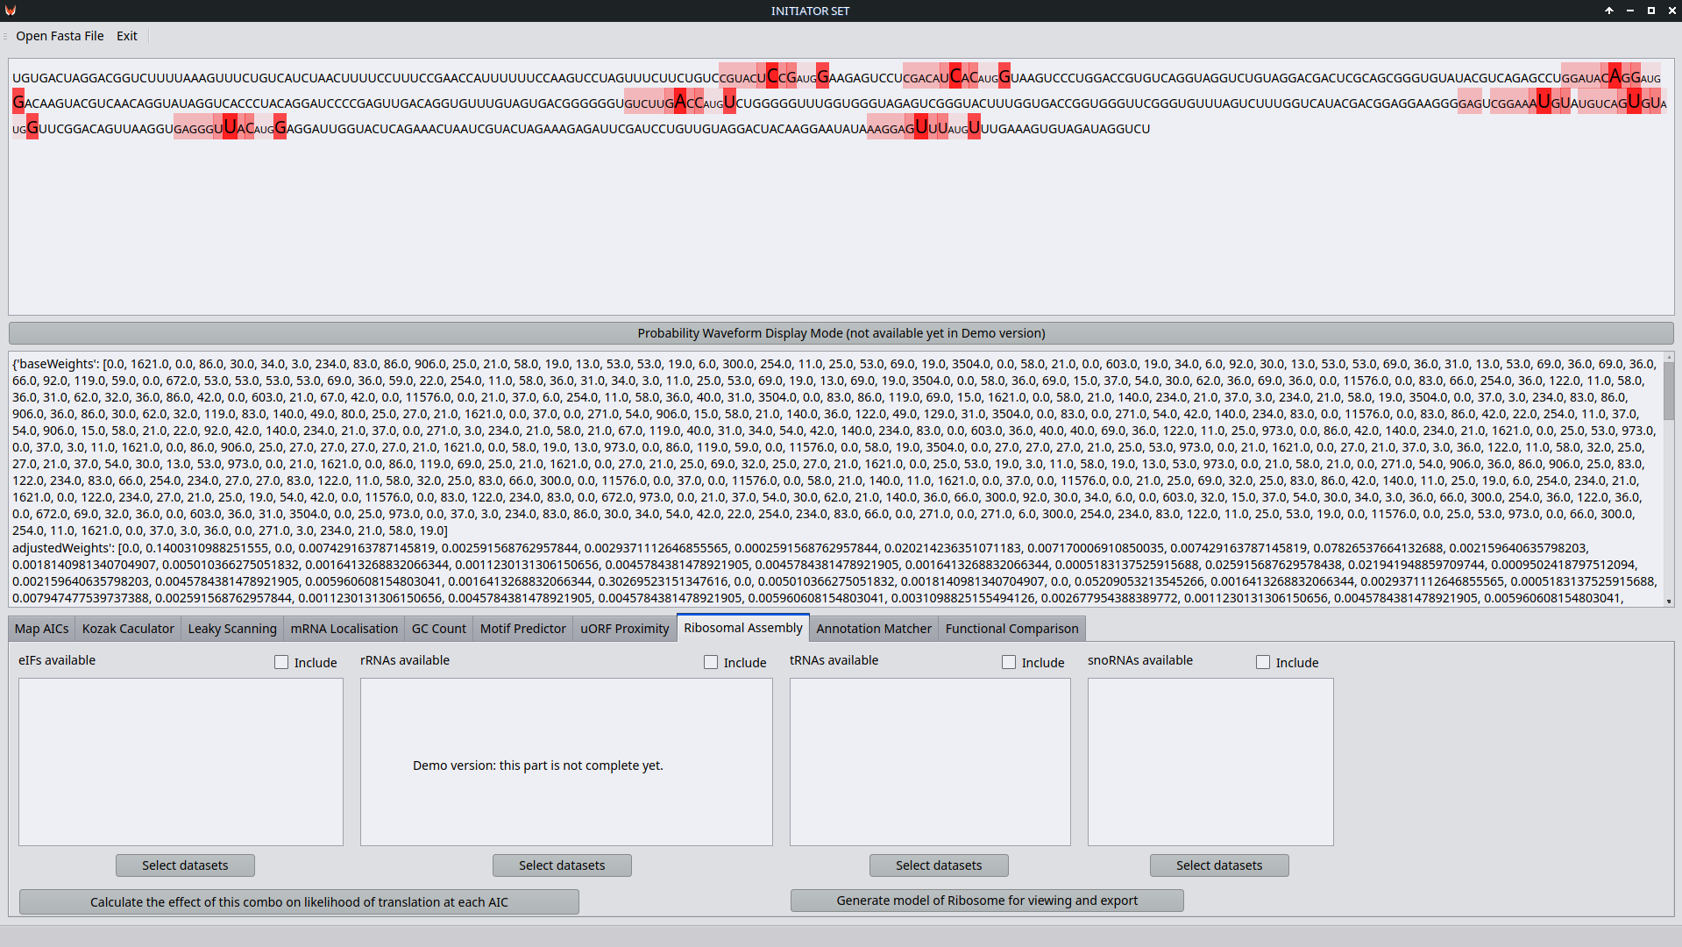
As of 27th August 2022, the demo of INITIATOR SET includes a basic mockup of this submodule.
This ribosomal assembly checker will be taking a lot of data from other submodules and using it to find out if an mRNA with all its likelihoods and effects added up, is possible to translate at all in terms of building an actual ribosome to read it, and how quickly that might then be able to progress.
Its output will feed into the Annotation Matcher.
Results
The results produced by INITIATOR SET will take the form of enriched, annotated data regarding the mRNAs and the proteins they can be used to produce. It will be possible to identify the likelihoods of each alternative initiation codon being used, what protein sequences each of them make, and to constrain the data to only show probabilities above a user-defined threshold. It will be possible to either input mRNA and receive the above, or to input protein amino acid sequences and receive a list of possible mRNAs the protein could be from.
Users of INITIATOR SET are asked to share their results with the developers and the authors of this paper, for the purposes of further improvement of the software and our research.
Parallels With Other Tools
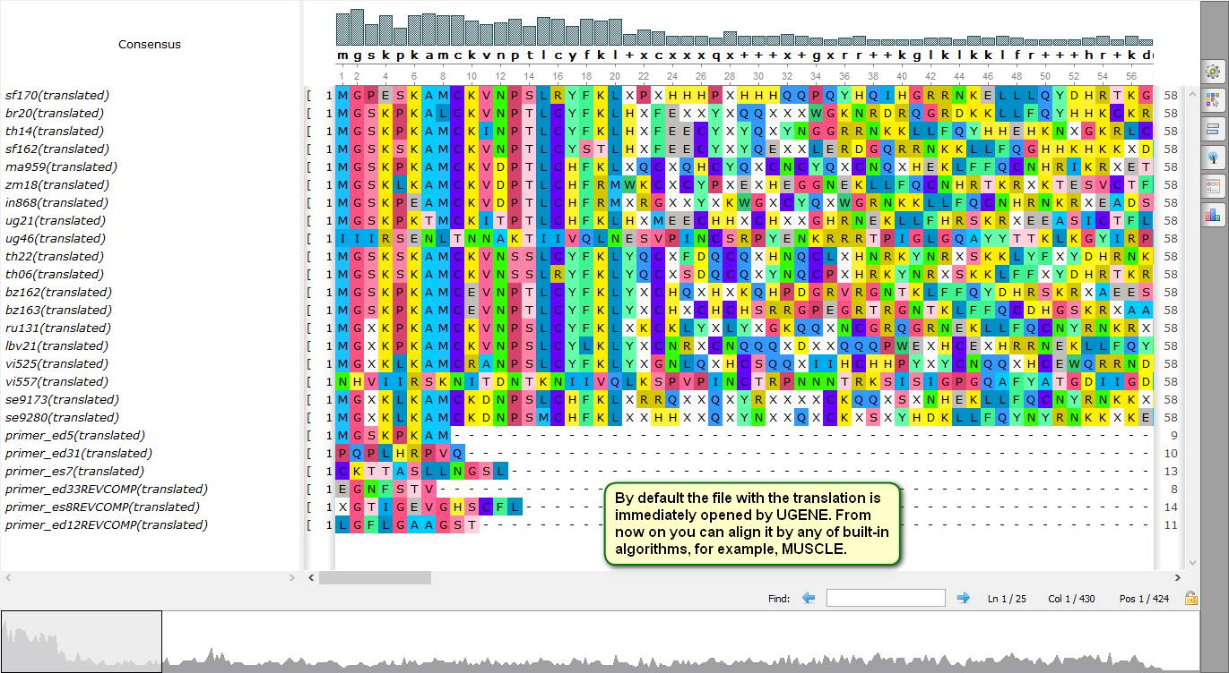
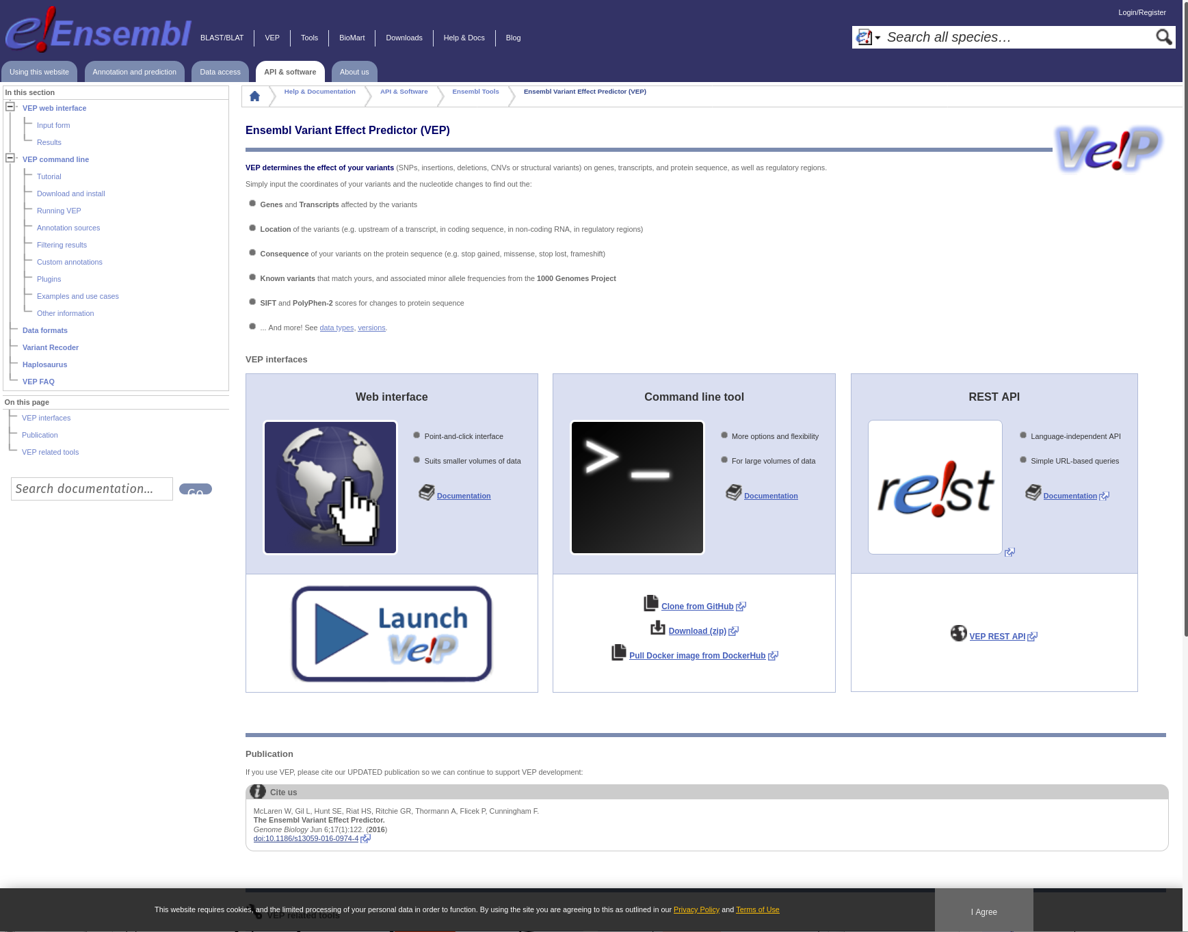
Screenshot courtesy of ugene.net: Some features of UGENE’s Amino-translation tools are worth bearing in mind as inspiration for INITIATOR SET’s own handling and interface.
INITIATOR SET is not the first tool in the field, though it is intended to be the most integrated and user-friendly once complete. Like UGENE (Okonechnikov et al. 2012; Golosova et al. 2014; Auton et al. 2015; Rose et al. 2019), INITIATOR SET shall have a user-friendly GUI environment and handle multiple bioinformatics processes. However, unlike UGENE, INITIATOR SET will not presuppose that the user knows which tools need to be assembled into which order to form a valid pipeline to get from mRNA to protein while taking account of all variables. The pre-defined workflows in INITIATOR SET will be set up such that they can both provide laboratory customers data at any stage needed, and contribute to the GUESS. It does not appear to be yet directly proven to be possible to use UGENE to replicate INITIATOR SET’s functions. If UGENE develops further in convergence with INITIATOR SET or with the GUESS as a whole, questions may be raised over which approach is best and whether we ought to incorporate or allow our systems to be incorporated by UGENE, which is also an open source software package. However, understanding other people’s code can be as difficult as building from scratch, and having multiple systems with similar purposes increases choice and the ‘health’ of the market for bioinformatics tools.
UGENE is aimed at an already scientifically savvy laboratory and bioinformatics environment. While this will be the initial target market of INITIATOR SET too, it is clear that the different approaches of these tools should lead to a divergence of ease of use, in favour of INITIATOR SET, including for the types of researchers who really aren’t focussing on Translation as the core of their work, but do want accurate translation data to use for their studies into the entire pathway from genes to proteins.
The Ensembl Variable Effect Predictor is ‘a powerful toolset for the analysis, annotation, and prioritization of genomic variants in coding and non-coding regions’ (McLaren et al. 2016). Unlike INITIATOR SET, it runs as a web service, although it can be run offline. It also appears to be more focussed on transcription than translation. Therefore, it may be possible to use the output of the Ensemble VEP as an input for the standalone INITIATOR SET module until the more comprehensive Transcription module is coded. The ways it detects variants may offer insights into how INITIATOR SET might detect AICs. However, Ensembl’s main strength is in the quantity of data it is intended to handle. This is going to be a more interesting challenge for INITIATOR SET to replicate and may be primarily limited by the hardware of the computers it is installed on, and their access to data. Notably, Ensembl’s VEP has been used in analysis in the 1000 Genomes and Exome Aggregation Consortium projects. These might be possible to use as benchmarks. Ensembl VEP also is used for providing inputs to a variant annotation program called GEMINI, which would be analogous to the INITIATOR SET Annotation Matcher. Here, INITIATOR SET’s strength is in its integration, promoting the spending of less time on workflows, and the ease of data processing without intervention being necessary.
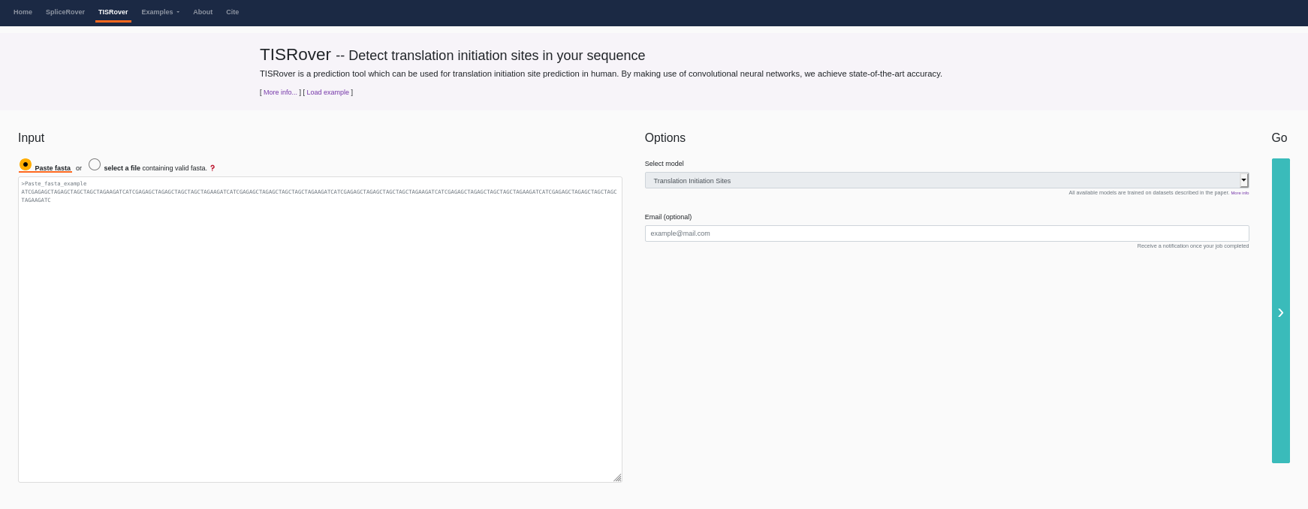
TISRover (Zuallaert et al. 2018) applies ‘deep’ neural network based machine learning techniques to figuring out alternative initiation codons. The downside of this approach is it creates a ‘black box’ and then requires studying to understand what it is doing – a process which the machine learning algorithm itself may alter many times before and after its methods are elucidated. It is therefore difficult to know whether such a system is still operating on correct training and assumptions, or whether it has misunderstood something critical just after its methods were last checked. INITIATOR SET avoids this by being divided into submodules, and in as large a part as possible, classically programmed. This limits the likelihood of machine learning problems ruining the outputs. TISRover is, according to its web page at Ghent University, limited to a minimum sequence length of 203 and a maximum sequence length of 30000. The model’s training excludes chromosome 21 and its prediction appears to be limited to positive classification of the ATG triplet, based on 60 nucleotides upstream and 140 nucleotides downstream. This is significantly less flexible than the combined variant effects prediction INITIATOR SET intends to provide. It also does not seem to allow for the use of non-ATG/AUG start codons. Therefore, INITIATOR SET will have significant advantages over this tool.
Availability and Future Directions
The module of software herein described shall be made available during and after its development at https://gitlab.vulpinedesigns.com/TheGUESSUniversalEditingSuiteandSDK/INITIATOR_SET/tree/master under the GNU General Public License version 2 (Stallman 1991). The choice of license and version is not up for debate. This availability and licensing will allow the software to be improved upon by the wider community, without significant risk to the originators.
This module when complete will allow the full tracing of which proteins can form from which mRNAs, and which mRNAs must have originated which proteins. Significant time savings for bioinformaticians and laboratories are expected, since where previously there were dozens of old and incompatible tools of varying states of maintenance, now there will be a single integrated module of software supported by a company dedicated to its use as part of a greater system. One foreseeable example usage would be in tracing cellular differentiation lineages. Keygenes (Roost et al. 2015) provides a tool to do this at the transcriptional level, but does not extend to translation.

In future, environmental variables and data from other GUESS modules will be used to enhance the accuracy of INITIATOR SET’s output. Furthermore, it is expected that more scientific studies in the field of translatomics, including a significant proportion benefitting directly from using the earlier versions of INITIATOR SET, will be completed and their data will be possible to utilise to refine and improve this module. Over time, the more it is used, the better we can make it.
Acknowledgements

Our heartfelt gratitude continually goes to all who have contributed to this work so far, and to supporting us while we work on it. To those who have put up with our lack of money, let it be known you are not forgotten. To those who invested early, your money is still bearing fruit four years later. To Cathal Garvey and Patrick Looney, Justin Clark-Casey and everyone at the hackerspaces in Bournemouth, Southampton and Cork, thank you. To Alynna Trypnotk, Kradorex Xeron and Keiro Ituralde, whose servers keep the dream alive, and to everyone at Kitsunet, Digibase and the United Collective of Systems and Networks, thank you for being our rock. To Arkadiusz, whose work laid the foundations. To Aleksia Vridos and to Lucianna Osucha, whose unbelievable work really got us moving when we felt stuck. To Akasha, for keeping on top of the coding and keeping trying no matter how hard it gets. To Ondrej Bačo, for making it possible to write this paper. To Dr Mark Coldwell and Dr Jo Cowan, for the idea. To Dr Michael Norsworthy for the careful encouragement, and to Dr Michael Fraylich for the careful discouragement (waaaay back). To everyone who didn’t immediately come to mind but whose contributions meant they really should have. To the late Jemma Redmond, may your middle finger never be raised in vain.

References
Acevedo‐Rocha, Carlos G., and Nediljko Budisa. 2016. ‘Xenomicrobiology: A Roadmap for Genetic Code Engineering’. Microbial Biotechnology 9 (5): 666–76. https://doi.org/10.1111/1751-7915.12398.
Achim, Kaia, Jean-Baptiste Pettit, Luis R. Saraiva, Daria Gavriouchkina, Tomas Larsson, Detlev Arendt, and John C. Marioni. 2015. ‘High-Throughput Spatial Mapping of Single-Cell RNA-Seq Data to Tissue of Origin’. Nature Biotechnology 33 (5): 503–9. https://doi.org/10.1038/nbt.3209.
Aitken, Colin Echeverría, and Jon R. Lorsch. 2012. ‘A Mechanistic Overview of Translation Initiation in Eukaryotes’. Nature Structural & Molecular Biology 19 (6): 568–76. https://doi.org/10.1038/nsmb.2303.
Akopian, David, Kuang Shen, Xin Zhang, and Shu-ou Shan. 2013. ‘Signal Recognition Particle: An Essential Protein Targeting Machine’. Annual Review of Biochemistry 82: 693–721. https://doi.org/10.1146/annurev-biochem-072711-164732.
Aldwairi, Monther, Rehab Duwairi, Wafa&#39 Alqarqaz, and a. 2009. ‘A Classification System for Predicting RNA Hairpin Loops’. 2009 International Joint Conference on Bioinformatics, Systems Biology and Intelligent Computing. https://www.academia.edu/29187453/A_Classification_System_for_Predicting_RNA_Hairpin_Loops.
Anandita. 2014. ‘Ribosomes: Structure, Composition, and Assembly (With Diagram)’. Biology Discussion (blog). 26 September 2014. https://www.biologydiscussion.com/cell-biology/ribosomes-structure-composition-and-assembly-with-diagram/4282.
Araujo, Patricia R., Kihoon Yoon, Daijin Ko, Andrew D. Smith, Mei Qiao, Uthra Suresh, Suzanne C. Burns, and Luiz O. F. Penalva. 2012. ‘Before It Gets Started: Regulating Translation at the 5′ UTR’. Review Article. Comparative and Functional Genomics. Hindawi. 28 May 2012. https://doi.org/10.1155/2012/475731.
Ashburner, Michael, Catherine A. Ball, Judith A. Blake, David Botstein, Heather Butler, J. Michael Cherry, Allan P. Davis, et al. 2000. ‘Gene Ontology: Tool for the Unification of Biology’. Nature Genetics 25 (1): 25–29. https://doi.org/10.1038/75556.
Auton, Adam, Gonçalo R. Abecasis, David M. Altshuler, Richard M. Durbin, Gonçalo R. Abecasis, David R. Bentley, Aravinda Chakravarti, et al. 2015. ‘A Global Reference for Human Genetic Variation’. Nature 526 (7571): 68–74. https://doi.org/10.1038/nature15393.
Baird, Stephen D., Marcel Turcotte, Robert G. Korneluk, and Martin Holcik. 2006. ‘Searching for IRES’. RNA 12 (10): 1755–85. https://doi.org/10.1261/rna.157806.
Baßler, Jochen, and Ed Hurt. 2019. ‘Eukaryotic Ribosome Assembly’. Annual Review of Biochemistry 88 (1): 281–306. https://doi.org/10.1146/annurev-biochem-013118-110817.
Batool, Zahra, Ivan B. Lomakin, Yury S. Polikanov, and Christopher G. Bunick. 2020. ‘Sarecycline Interferes with TRNA Accommodation and Tethers MRNA to the 70S Ribosome’. Proceedings of the National Academy of Sciences 117 (34): 20530–37. https://doi.org/10.1073/pnas.2008671117.
Bazykin, Georgii A., and Alex V. Kochetov. 2011. ‘Alternative Translation Start Sites Are Conserved in Eukaryotic Genomes’. Nucleic Acids Research 39 (2): 567–77. https://doi.org/10.1093/nar/gkq806.
Berndt, Norbert, and Saïd M Sebti. 2011. ‘Measurement of Protein Farnesylation and Geranylgeranylation in Vitro, in Cultured Cells and in Biopsies, and the Effects of Prenyl Transferase Inhibitors’. Nature Protocols 6 (11): 1775–91. https://doi.org/10.1038/nprot.2011.387.
Blischak, Paul D., Aaron J. Wenzel, and Andrea D. Wolfe. 2014. ‘Gene Prediction and Annotation in Penstemon (Plantaginaceae): A Workflow for Marker Development from Extremely Low-Coverage Genome Sequencing’. Applications in Plant Sciences 2 (12): 1400044. https://doi.org/10.3732/apps.1400044.
Boersma, Sanne, Deepak Khuperkar, Bram M. P. Verhagen, Stijn Sonneveld, Jonathan B. Grimm, Luke D. Lavis, and Marvin E. Tanenbaum. 2019. ‘Multi-Color Single-Molecule Imaging Uncovers Extensive Heterogeneity in MRNA Decoding’. Cell 178 (2): 458-472.e19. https://doi.org/10.1016/j.cell.2019.05.001.
Bonnal, Sophie, Christel Boutonnet, Leonel Prado-Lourenço, and Stéphan Vagner. 2003. ‘IRESdb: The Internal Ribosome Entry Site Database’. Nucleic Acids Research 31 (1): 427–28. https://doi.org/10.1093/nar/gkg003.
Bordeleau, Marie-Eve, Ayaka Mori, Monika Oberer, Lisa Lindqvist, Louisa S. Chard, Tatsuo Higa, Graham J. Belsham, Gerhard Wagner, Junichi Tanaka, and Jerry Pelletier. 2006. ‘Functional Characterization of IRESes by an Inhibitor of the RNA Helicase EIF4A’. Nature Chemical Biology 2 (4): 213–20. https://doi.org/10.1038/nchembio776.
Calvo, S. E., D. J. Pagliarini, and V. K. Mootha. 2009. ‘Upstream Open Reading Frames Cause Widespread Reduction of Protein Expression and Are Polymorphic among Humans’. Proceedings of the National Academy of Sciences 106 (18): 7507–12. https://doi.org/10.1073/pnas.0810916106.
Chen, Jia, Xiao-Nan Zhao, Li Yang, Guang-Jing Hu, Ming Lu, Ying Xiong, Xin-Ying Yang, et al. 2008. ‘RNA Secondary Structures Located in the Interchromosomal Region of Human ACAT1 Chimeric MRNA Are Required to Produce the 56-KDa Isoform’. Cell Research 18 (9): 921–36. https://doi.org/10.1038/cr.2008.66.
Chen, Shun-Jia, Grace Lin, Kuang-Jung Chang, Lu-Shu Yeh, and Chien-Chia Wang. 2008. ‘Translational Efficiency of a Non-AUG Initiation Codon Is Significantly Affected by Its Sequence Context in Yeast’. Journal of Biological Chemistry 283 (6): 3173–80. https://doi.org/10.1074/jbc.M706968200.
Chun, Jongsik, Jae-Hak Lee, Yoonyoung Jung, Myungjin Kim, Seil Kim, Byung Kwon Kim, and Young-Woon Lim. 2007. ‘EzTaxon: A Web-Based Tool for the Identification of Prokaryotes Based on 16S Ribosomal RNA Gene Sequences’. International Journal of Systematic and Evolutionary Microbiology, 57 (10): 2259–61. https://doi.org/10.1099/ijs.0.64915-0.
Cock, Peter J. A., Christopher J. Fields, Naohisa Goto, Michael L. Heuer, and Peter M. Rice. 2010. ‘The Sanger FASTQ File Format for Sequences with Quality Scores, and the Solexa/Illumina FASTQ Variants’. Nucleic Acids Research 38 (6): 1767–71. https://doi.org/10.1093/nar/gkp1137.
Collet, Guillaume. (2012) 2013. Gcollet/GC_count. C. https://github.com/gcollet/GC_count.
Conesa, A., S. Gotz, J. M. Garcia-Gomez, J. Terol, M. Talon, and M. Robles. 2005. ‘Blast2GO: A Universal Tool for Annotation, Visualization and Analysis in Functional Genomics Research’. Bioinformatics 21 (18): 3674–76. https://doi.org/10.1093/bioinformatics/bti610.
Connolly, Martin, Richard Paul, Roser Farre‐Garros, Samantha A. Natanek, Susannah Bloch, Jen Lee, Jose P. Lorenzo, et al. 2018. ‘MiR‐424‐5p Reduces Ribosomal RNA and Protein Synthesis in Muscle Wasting’. Journal of Cachexia, Sarcopenia and Muscle 9 (2): 400–416. https://doi.org/10.1002/jcsm.12266.
Cowan, Joanne L., Lisa S. Perry, Richard J. Edwards, David Damerell, A. Poppy Roworth, Harvey E. Johnston, and Mark J. Coldwell. 2014. ‘Identification of Non-AUG Initiated, N-Terminally Extended Open Reading Frames in Human Genes by an Experimentally-Informed Bioinformatics Workflow’. Nucleic Acids Research Unpublished.
Cui, Xianying Amy. 2015. ‘Investigation of the Ribosome Independent MRNA Localization to the Endoplasmic Reticulum’.
Darnell, Jennifer C., Sarah J. Van Driesche, Chaolin Zhang, Ka Ying Sharon Hung, Aldo Mele, Claire E. Fraser, Elizabeth F. Stone, et al. 2011. ‘FMRP Stalls Ribosomal Translocation on MRNAs Linked to Synaptic Function and Autism’. Cell 146 (2): 247–61. https://doi.org/10.1016/j.cell.2011.06.013.
Davies, Danfox. 2016. ‘Are Your Ribosomes in a Twist?’ O’Reilly Media. 6 October 2016. https://www.oreilly.com/ideas/are-your-ribosomes-in-a-twist.
Davies, Danfox, Adolphus L. Cammack, Jordan Eckhoff, Mircea Filipescu Alexandru, Taylor J. Conway, Declan Lordan, Roland Metivier, and Jess Golden. 2017. ‘Setting the Scene for Freedom of Form: An Evolution Revolution - Introduction’. Journal of Freedom of Form. https://doi.org/10.21428/15150.
Dlakić, Mensur. 2005. ‘The Ribosomal Subunit Assembly Line’. Genome Biology 6 (10): 234. https://doi.org/10.1186/gb-2005-6-10-234.
Edwards, Richard. 2011. ‘BIOL3050 Bioinformatics Analysis’. Unpublished.
Emory, Sheri A., Philippe Bouvet, and Joel G. Belasco. 1992. ‘A 5`-Terminal Stem-Loop Structure Can Stabilize MRNA in Escherichia Coli’. Genes & Development 6 (1): 135–48.
Fairley, Susan, Ernesto Lowy-Gallego, Emily Perry, and Paul Flicek. 2020. ‘The International Genome Sample Resource (IGSR) Collection of Open Human Genomic Variation Resources’. Nucleic Acids Research 48 (D1): D941–47. https://doi.org/10.1093/nar/gkz836.
Ferreira, Joshua P, William L Noderer, Alexander J Diaz de Arce, and Clifford L Wang. 2014. ‘Engineering Ribosomal Leaky Scanning and Upstream Open Reading Frames for Precise Control of Protein Translation’. Bioengineered 5 (3): 186–92. https://doi.org/10.4161/bioe.27607.
Fromont-Racine, Micheline, Bruno Senger, Cosmin Saveanu, and Franco Fasiolo. 2003. ‘Ribosome Assembly in Eukaryotes’. Gene 313 (August): 17–42. https://doi.org/10.1016/S0378-1119(03)00629-2.
Gaius-Augustus/BRAKER. (2018) 2020. Perl. Gaius-Augustus. https://github.com/Gaius-Augustus/BRAKER.
Galtier, Nicolas, and J.R. Lobry. 1997. ‘Relationships Between Genomic G+C Content, RNA Secondary Structures, and Optimal Growth Temperature in Prokaryotes’. Journal of Molecular Evolution 44 (6): 632–36. https://doi.org/10.1007/PL00006186.
Gene Ontology Consortium, The. 2019. ‘The Gene Ontology Resource: 20 Years and Still GOing Strong’. Nucleic Acids Research 47 (D1): D330–38. https://doi.org/10.1093/nar/gky1055.
Genome Reference Consortium. 2019. ‘Homo Sapiens (ID 51) - Genome - NCBI’. 2019. https://www.ncbi.nlm.nih.gov/genome/51?genome_assembly_id=582967.
Ghosh, Arnab, and Anton A. Komar. 2015. ‘Eukaryote-Specific Extensions in Ribosomal Proteins of the Small Subunit: Structure and Function’. Translation 3 (1): e999576. https://doi.org/10.1080/21690731.2014.999576.
Gigova, Andriana, Sujitha Duggimpudi, Tim Pollex, Matthias Schaefer, and Martin Koš. 2014. ‘A Cluster of Methylations in the Domain IV of 25S RRNA Is Required for Ribosome Stability’. RNA 20 (10): 1632–44. https://doi.org/10.1261/rna.043398.113.
Gkogkas, Christos G., Arkady Khoutorsky, Ruifeng Cao, Seyed Mehdi Jafarnejad, Masha Prager-Khoutorsky, Nikolaos Giannakas, Archontia Kaminari, et al. 2014. ‘Pharmacogenetic Inhibition of EIF4E-Dependent Mmp9 MRNA Translation Reverses Fragile X Syndrome-like Phenotypes’. Cell Reports 9 (5): 1742–55. https://doi.org/10.1016/j.celrep.2014.10.064.
Golosova, Olga, Ross Henderson, Yuriy Vaskin, Andrei Gabrielian, German Grekhov, Vijayaraj Nagarajan, Andrew J. Oler, et al. 2014. ‘Unipro UGENE NGS Pipelines and Components for Variant Calling, RNA-Seq and ChIP-Seq Data Analyses’. PeerJ 2 (November): e644. https://doi.org/10.7717/peerj.644.
Gorochowski, Thomas E., Irina Chelysheva, Mette Eriksen, Priyanka Nair, Steen Pedersen, and Zoya Ignatova. 2019. ‘Absolute Quantification of Translational Regulation and Burden Using Combined Sequencing Approaches’. Molecular Systems Biology 15 (5). https://doi.org/10.15252/msb.20188719.
Gritsenko, Alexey A., Shira Weingarten-Gabbay, Shani Elias-Kirma, Ronit Nir, Dick de Ridder, and Eran Segal. 2017. ‘Sequence Features of Viral and Human Internal Ribosome Entry Sites Predictive of Their Activity’. PLOS Computational Biology 13 (9): e1005734. https://doi.org/10.1371/journal.pcbi.1005734.
Gupta, Sachin Kumar, Liming Luo, and Laising Yen. 2018. ‘RNA-Mediated Gene Fusion in Mammalian Cells’. Proceedings of the National Academy of Sciences 115 (52): E12295–304. https://doi.org/10.1073/pnas.1814704115.
Hanebuth, Marie A., Roman Kityk, Sandra J. Fries, Alok Jain, Allison Kriel, Veronique Albanese, Tancred Frickey, et al. 2016. ‘Multivalent Contacts of the Hsp70 Ssb Contribute to Its Architecture on Ribosomes and Nascent Chain Interaction’. Nature Communications 7 (1): 13695. https://doi.org/10.1038/ncomms13695.
Herzog, E., H. Guilley, and C. Fritsch. 1995. ‘Translation of the Second Gene of Peanut Clump Virus RNA 2 Occurs by Leaky Scanning in Vitro’. Virology 208 (1): 215–25. https://doi.org/10.1006/viro.1995.1145.
Hinnebusch, Alan G., Ivaylo P. Ivanov, and Nahum Sonenberg. 2016. ‘Translational Control by 5’-Untranslated Regions of Eukaryotic MRNAs’. Science (New York, N.Y.) 352 (6292): 1413–16. https://doi.org/10.1126/science.aad9868.
Hoff, Katharina J., Simone Lange, Alexandre Lomsadze, Mark Borodovsky, and Mario Stanke. 2016. ‘BRAKER1: Unsupervised RNA-Seq-Based Genome Annotation with GeneMark-ET and AUGUSTUS’. Bioinformatics 32 (5): 767–69. https://doi.org/10.1093/bioinformatics/btv661.
Hoff, Katharina J., Alexandre Lomsadze, Mark Borodovsky, and Mario Stanke. 2019. ‘Whole-Genome Annotation with BRAKER’. In Gene Prediction, edited by Martin Kollmar, 1962:65–95. Methods in Molecular Biology. New York, NY: Springer New York. https://doi.org/10.1007/978-1-4939-9173-0_5.
Ingolia, Nicholas T., Liana F. Lareau, and Jonathan S. Weissman. 2011. ‘Ribosome Profiling of Mouse Embryonic Stem Cells Reveals the Complexity and Dynamics of Mammalian Proteomes’. Cell 147 (4): 789–802. https://doi.org/10.1016/j.cell.2011.10.002.
Iseli, Christian, C Victor Jongeneel, and Philipp Bucher. 1999. ‘ESTScan: A Program for Detecting, Evaluating, and Reconstructing Potential Coding Regions in EST Sequences’, 10.
Jin, Haining, Qing Zhao, Ernesto I. Gonzalez de Valdivia, David H. Ardell, Magnus Stenström, and Leif A. Isaksson. 2006. ‘Influences on Gene Expression in Vivo by a Shine-Dalgarno Sequence’. Molecular Microbiology 60 (2): 480–92. https://doi.org/10.1111/j.1365-2958.2006.05110.x.
Jomaa, Ahmad, Geordie Stewart, Jaime Martín-Benito, Ryszard Zielke, Tracey L. Campbell, Janine R. Maddock, Eric D. Brown, and Joaquin Ortega. 2011. ‘Understanding Ribosome Assembly: The Structure of in Vivo Assembled Immature 30S Subunits Revealed by Cryo-Electron Microscopy’. RNA 17 (4): 697–709. https://doi.org/10.1261/rna.2509811.
Kalderimis, Alex, Rachel Lyne, Daniela Butano, Sergio Contrino, Mike Lyne, Joshua Heimbach, Fengyuan Hu, et al. 2014. ‘InterMine: Extensive Web Services for Modern Biology’. Nucleic Acids Research 42 (W1): W468–72. https://doi.org/10.1093/nar/gku301.
Kamita, Masahiro, Yayoi Kimura, Yoko Ino, Roza M. Kamp, Bogdan Polevoda, Fred Sherman, and Hisashi Hirano. 2011. ‘Nα-Acetylation of Yeast Ribosomal Proteins and Its Effect on Protein Synthesis’. Journal of Proteomics 74 (4): 431–41. https://doi.org/10.1016/j.jprot.2010.12.007.
Khan, Yousuf A., Irwin Jungreis, James C. Wright, Jonathan M. Mudge, Jyoti S. Choudhary, Andrew E. Firth, and Manolis Kellis. 2020. ‘Evidence for a Novel Overlapping Coding Sequence in POLG Initiated at a CUG Start Codon’. BMC Genetics 21 (1): 25. https://doi.org/10.1186/s12863-020-0828-7.
Khusenov, M. A., E. B. Dushanov, Kh T. Kholmurodov, M. M. Zaki, and N. H. Sweilam. 2016. ‘On Correlation Effect of the Van-Der-Waals and Intramolecular Forces for the Nucleotide Chain - Metallic Nanoparticles - Carbon Nanotube Binding’. The Open Biochemistry Journal 10 (1). https://doi.org/10.2174/1874091X01610010017.
Kim, Hajin, Sanjaya C. Abeysirigunawarden, Ke Chen, Megan Mayerle, Kaushik Ragunathan, Zaida Luthey-Schulten, Taekjip Ha, and Sarah A. Woodson. 2014. ‘Protein-Guided RNA Dynamics during Early Ribosome Assembly’. Nature 506 (7488): 334–38. https://doi.org/10.1038/nature13039.
Kishi, Jocelyn Y., Sylvain W. Lapan, Brian J. Beliveau, Emma R. West, Allen Zhu, Hiroshi M. Sasaki, Sinem K. Saka, Yu Wang, Constance L. Cepko, and Peng Yin. 2019. ‘SABER Amplifies FISH: Enhanced Multiplexed Imaging of RNA and DNA in Cells and Tissues’. Nature Methods 16 (6): 533–44. https://doi.org/10.1038/s41592-019-0404-0.
Klinge, Sebastian, and John L. Woolford. 2019. ‘Ribosome Assembly Coming into Focus’. Nature Reviews Molecular Cell Biology 20 (2): 116–31. https://doi.org/10.1038/s41580-018-0078-y.
Knight, Helen Coral. 2017. ‘Alternative Non-Canonical Translation Initiation Codons Are Used To Synthesise Novel Isoforms of the Transcription Factor GATAD’. PhD, Southampton, UK: University of Southampton. https://eprints.soton.ac.uk/413444/1/Helen_Knight_FINAL_thesis.pdf.
Kochetov, Alex V. 2008. ‘Alternative Translation Start Sites and Hidden Coding Potential of Eukaryotic MRNAs’. BioEssays 30 (7): 683–91. https://doi.org/10.1002/bies.20771.
Kochetov, Alex V., Shandar Ahmad, Vladimir Ivanisenko, Oxana A. Volkova, Nikolay A. Kolchanov, and Akinori Sarai. 2008. ‘UORFs, Reinitiation and Alternative Translation Start Sites in Human MRNAs’. FEBS Letters 582 (9): 1293–97. https://doi.org/10.1016/j.febslet.2008.03.014.
Kochetov, Alex V, Andrey Palyanov, Igor I Titov, Dmitry Grigorovich, Akinori Sarai, and Nikolay A Kolchanov. 2007. ‘AUG_hairpin: Prediction of a Downstream Secondary Structure Influencing the Recognition of a Translation Start Site’. BMC Bioinformatics 8 (August): 318. https://doi.org/10.1186/1471-2105-8-318.
Koodli, Rohan V., Benjamin Keep, Katherine R. Coppess, Fernando Portela, Eterna Participants, and Rhiju Das. 2019. ‘EternaBrain: Automated RNA Design through Move Sets and Strategies from an Internet-Scale RNA Videogame’. PLOS Computational Biology 15 (6): e1007059. https://doi.org/10.1371/journal.pcbi.1007059.
Kozak, M. 1987. ‘An Analysis of 5’-Noncoding Sequences from 699 Vertebrate Messenger RNAs’. Nucleic Acids Research 15 (20): 8125–48.
Kozak, Marilyn. 2002. ‘Pushing the Limits of the Scanning Mechanism for Initiation of Translation’. Gene 299 (1–2): 1–34.
Kressler, Dieter, Ed Hurt, and Jochen Baβler. 2010. ‘Driving Ribosome Assembly’. Biochimica et Biophysica Acta (BBA) - Molecular Cell Research, Molecular Chaperones and Intracellular Protein Transport, 1803 (6): 673–83. https://doi.org/10.1016/j.bbamcr.2009.10.009.
Lafontaine, Denis L. J. 2010. ‘A “Garbage Can” for Ribosomes: How Eukaryotes Degrade Their Ribosomes’. Trends in Biochemical Sciences 35 (5): 267–77. https://doi.org/10.1016/j.tibs.2009.12.006.
Lagesen, Karin, Peter Hallin, Einar Andreas Rødland, Hans-Henrik Stærfeldt, Torbjørn Rognes, and David W. Ussery. 2007. ‘RNAmmer: Consistent and Rapid Annotation of Ribosomal RNA Genes’. Nucleic Acids Research 35 (9): 3100–3108. https://doi.org/10.1093/nar/gkm160.
Lakshmanan, Vairavan, Dhiru Bansal, Jahnavi Kulkarni, Deepak Poduval, Srikar Krishna, Vidyanand Sasidharan, Praveen Anand, Aswin Seshasayee, and Dasaradhi Palakodeti. 2016. ‘Genome-Wide Analysis of Polyadenylation Events in Schmidtea Mediterranea’. G3: Genes, Genomes, Genetics 6 (10): 3035–48. https://doi.org/10.1534/g3.116.031120.
Larkin, M. A., G. Blackshields, N. P. Brown, R. Chenna, P. A. McGettigan, H. McWilliam, F. Valentin, et al. 2007. ‘Clustal W and Clustal X Version 2.0’. Bioinformatics (Oxford, England) 23 (21): 2947–48. https://doi.org/10.1093/bioinformatics/btm404.
Larson, Kimberly, Shian-Jang Yan, Amy Tsurumi, Jacqueline Liu, Jun Zhou, Kriti Gaur, Dongdong Guo, Thomas H. Eickbush, and Willis X. Li. 2012. ‘Heterochromatin Formation Promotes Longevity and Represses Ribosomal RNA Synthesis’. PLoS Genetics 8 (1). https://doi.org/10.1371/journal.pgen.1002473.
Lee, S., B. Liu, S. Lee, S.-X. Huang, B. Shen, and S.-B. Qian. 2012. ‘Global Mapping of Translation Initiation Sites in Mammalian Cells at Single-Nucleotide Resolution’. Proceedings of the National Academy of Sciences 109 (37): E2424–32. https://doi.org/10.1073/pnas.1207846109.
Liang, Xue-hai, Qing Liu, and Maurille J. Fournier. 2009. ‘Loss of RRNA Modifications in the Decoding Center of the Ribosome Impairs Translation and Strongly Delays Pre-RRNA Processing’. RNA 15 (9): 1716–28. https://doi.org/10.1261/rna.1724409.
Liew, Choong-Chin, and Allan G. Gornall. 1973. ‘Acetylation of Ribosomal Proteins’. The Journal of Biological Chemistry 248 (3): 977–83.
Lin, Z., and W.-H. Li. 2012. ‘Evolution of 5’ Untranslated Region Length and Gene Expression Reprogramming in Yeasts’. Molecular Biology and Evolution 29 (1): 81–89. https://doi.org/10.1093/molbev/msr143.
Lipman, D., and W. Pearson. 1985. ‘Rapid and Sensitive Protein Similarity Searches’. Science 227 (4693): 1435–41. https://doi.org/10.1126/science.2983426.
Loerch, Sarah, Clarence Ling, Andrei A Korostelev, and Dmitri N Ermolenko. 2020. ‘MRNA Stem-Loops Can Pause the Ribosome by Hindering A-Site TRNA Binding’, February, 55.
Lopez, Rodrigo, Ville Silventoinen, Stephen Robinson, Asif Kibria, and Warren Gish. 2003. ‘WU-Blast2 Server at the European Bioinformatics Institute’. Nucleic Acids Research 31 (13): 3795–98. https://doi.org/10.1093/nar/gkg573.
Lovett, P. S., and E. J. Rogers. 1996. ‘Ribosome Regulation by the Nascent Peptide’. Microbiological Reviews 60 (2): 366–85.
Lukashin, A V, and M Borodovsky. 1998. ‘GeneMark.Hmm: New Solutions for Gene Finding.’ Nucleic Acids Research 26 (4): 1107–15.
Lütcke, H A, K C Chow, F S Mickel, K A Moss, H F Kern, and G A Scheele. 1987. ‘Selection of AUG Initiation Codons Differs in Plants and Animals.’ The EMBO Journal 6 (1): 43–48.
Mathews, David, and Jessica S. Reuter. 2012. ‘RNA Structure: Web Servers for RNA Secondary Structure Prediction: Welcome to the Predict a Secondary Structure Web Server’. Bioinformatics tool. RNA Structure: Web Servers for RNA Secondary Structure Prediction. 2017 2012. https://rna.urmc.rochester.edu/RNAstructureWeb/Servers/Predict1/Predict1.html.
Mauger, David M., Nathan A. Siegfried, and Kevin M. Weeks. 2013. ‘The Genetic Code as Expressed through Relationships between MRNA Structure and Protein Function’. FEBS Letters 587 (8): 1180–88. https://doi.org/10.1016/j.febslet.2013.03.002.
McLaren, William, Laurent Gil, Sarah E. Hunt, Harpreet Singh Riat, Graham R. S. Ritchie, Anja Thormann, Paul Flicek, and Fiona Cunningham. 2016. ‘The Ensembl Variant Effect Predictor’. Genome Biology 17 (1): 122. https://doi.org/10.1186/s13059-016-0974-4.
Meng, Yuzhong, and Daniel P. Aalberts. 2013. ‘Free Energy Cost of Stretching MRNA Hairpin Loops Inhibits Small RNA Binding’. Biophysical Journal 104 (2): 482–87. https://doi.org/10.1016/j.bpj.2012.12.017.
Metodiev, Metodi D., Nicole Lesko, Chan Bae Park, Yolanda Cámara, Yonghong Shi, Rolf Wibom, Kjell Hultenby, Claes M. Gustafsson, and Nils-Göran Larsson. 2009. ‘Methylation of 12S RRNA Is Necessary for In Vivo Stability of the Small Subunit of the Mammalian Mitochondrial Ribosome’. Cell Metabolism 9 (4): 386–97. https://doi.org/10.1016/j.cmet.2009.03.001.
Mignone, Flavio, Carmela Gissi, Sabino Liuni, and Graziano Pesole. 2002. ‘Untranslated Regions of MRNAs’. Genome Biology 3 (3): reviews0004.1. https://doi.org/10.1186/gb-2002-3-3-reviews0004.
Mohan, Rajiv A., Klaartje van Engelen, Sonia Stefanovic, Phil Barnett, Aho Ilgun, Marieke J. H. Baars, Berto J. Bouma, Barbara J. M. Mulder, Vincent M. Christoffels, and Alex V. Postma. 2014. ‘A Mutation in the Kozak Sequence of GATA4 Hampers Translation in a Family with Atrial Septal Defects’. American Journal of Medical Genetics. Part A 164A (11): 2732–38. https://doi.org/10.1002/ajmg.a.36703.
Mokrejš, Martin, Václav Vopálenský, Ondřej Kolenatý, Tomáš Mašek, Zuzana Feketová, Petra Sekyrová, Barbora Škaloudová, Vítězslav Kříž, and Martin Pospíšek. 2006. ‘IRESite: The Database of Experimentally Verified IRES Structures (Www.Iresite.Org)’. Nucleic Acids Research 34 (suppl_1): D125–30. https://doi.org/10.1093/nar/gkj081.
Morris, David R., and Adam P. Geballe. 2000. ‘Upstream Open Reading Frames as Regulators of MRNA Translation’. Molecular and Cellular Biology 20 (23): 8635–42.
Novoa, Eva Maria, and Lluís Ribas de Pouplana. 2012. ‘Speeding with Control: Codon Usage, TRNAs, and Ribosomes’. Trends in Genetics 28 (11): 574–81. https://doi.org/10.1016/j.tig.2012.07.006.
O’Day, Elizabeth, Minh T. N. Le, Shunsuke Imai, Shen Mynn Tan, Rory Kirchner, Haribabu Arthanari, Oliver Hofmann, Gerhard Wagner, and Judy Lieberman. 2015. ‘An RNA-Binding Protein, Lin28, Recognizes and Remodels G-Quartets in the MicroRNAs (MiRNAs) and MRNAs It Regulates’. The Journal of Biological Chemistry 290 (29): 17909–22. https://doi.org/10.1074/jbc.M115.665521.
Okonechnikov, Konstantin, Olga Golosova, Mikhail Fursov, and the UGENE Team. 2012. ‘Unipro UGENE: A Unified Bioinformatics Toolkit’. Bioinformatics 28 (8): 1166–67. https://doi.org/10.1093/bioinformatics/bts091.
Oliver, José L., and Antonio Marín. 1996. ‘A Relationship between GC Content and Coding-Sequence Length’. Journal of Molecular Evolution 43 (3): 216–23. https://doi.org/10.1007/BF02338829.
Payne, Joshua L., Fahad Khalid, and Andreas Wagner. 2018. ‘RNA-Mediated Gene Regulation Is Less Evolvable than Transcriptional Regulation’. Proceedings of the National Academy of Sciences 115 (15): E3481–90. https://doi.org/10.1073/pnas.1719138115.
Pearson, W R, and D J Lipman. 1988. ‘Improved Tools for Biological Sequence Comparison.’ Proceedings of the National Academy of Sciences of the United States of America 85 (8): 2444–48.
Peña, Cohue, Ed Hurt, and Vikram Govind Panse. 2017. ‘Eukaryotic Ribosome Assembly, Transport and Quality Control’. Nature Structural & Molecular Biology 24 (9): 689–99. https://doi.org/10.1038/nsmb.3454.
Pestova, T. V., V. G. Kolupaeva, I. B. Lomakin, E. V. Pilipenko, I. N. Shatsky, V. I. Agol, and C. U. T. Hellen. 2001. ‘Molecular Mechanisms of Translation Initiation in Eukaryotes’. Proceedings of the National Academy of Sciences 98 (13): 7029–36. https://doi.org/10.1073/pnas.111145798.
Petersen, Søren D., Jie Zhang, Jae S. Lee, Tadas Jakočiūnas, Lise M. Grav, Helene F. Kildegaard, Jay D. Keasling, and Michael K. Jensen. 2018. ‘Modular 5′-UTR Hexamers for Context-Independent Tuning of Protein Expression in Eukaryotes’. Nucleic Acids Research 46 (21): e127–e127. https://doi.org/10.1093/nar/gky734.
Pratas, Diogo, Morteza Hosseini, and Armando J. Pinho. 2017. ‘Cryfa: A Tool to Compact and Encrypt FASTA Files’. In 11th International Conference on Practical Applications of Computational Biology & Bioinformatics, edited by Florentino Fdez-Riverola, Mohd Saberi Mohamad, Miguel Rocha, Juan F. De Paz, and Tiago Pinto, 305–12. Advances in Intelligent Systems and Computing. Cham: Springer International Publishing. https://doi.org/10.1007/978-3-319-60816-7_37.
Pruitt, K. D., J. Harrow, R. A. Harte, C. Wallin, M. Diekhans, D. R. Maglott, S. Searle, et al. 2009. ‘The Consensus Coding Sequence (CCDS) Project: Identifying a Common Protein-Coding Gene Set for the Human and Mouse Genomes’. Genome Research 19 (7): 1316–23. https://doi.org/10.1101/gr.080531.108.
Pyhtila, Brook, Tianli Zheng, Patrick J. Lager, Jack D. Keene, Mary C. Reedy, and Christopher V. Nicchitta. 2008. ‘Signal Sequence- and Translation-Independent MRNA Localization to the Endoplasmic Reticulum’. RNA 14 (3): 445–53. https://doi.org/10.1261/rna.721108.
Pyle, Jesse D., and Sean P. J. Whelan. 2019. ‘RNA Ligands Activate the Machupo Virus Polymerase and Guide Promoter Usage’. Proceedings of the National Academy of Sciences 116 (21): 10518–24. https://doi.org/10.1073/pnas.1900790116.
Racine, Trina, and Roy Duncan. 2010. ‘Facilitated Leaky Scanning and Atypical Ribosome Shunting Direct Downstream Translation Initiation on the Tricistronic S1 MRNA of Avian Reovirus’. Nucleic Acids Research 38 (20): 7260–72. https://doi.org/10.1093/nar/gkq611.
Rahman, Nusrat, Md Shamsuzzaman, and Lasse Lindahl. 2020. ‘Interaction between the Assembly of the Ribosomal Subunits: Disruption of 40S Ribosomal Assembly Causes Accumulation of Extra-Ribosomal 60S Ribosomal Protein UL18/L5’. PLoS ONE 15 (1). https://doi.org/10.1371/journal.pone.0222479.
Reid, David W., and Christopher V. Nicchitta. 2015. ‘Diversity and Selectivity in MRNA Translation on the Endoplasmic Reticulum’. Nature Reviews Molecular Cell Biology 16 (4): 221–31. https://doi.org/10.1038/nrm3958.
Roost, Matthias S., Liesbeth van Iperen, Yavuz Ariyurek, Henk P. Buermans, Wibowo Arindrarto, Harsha D. Devalla, Robert Passier, et al. 2015. ‘KeyGenes, a Tool to Probe Tissue Differentiation Using a Human Fetal Transcriptional Atlas’. Stem Cell Reports 4 (6): 1112–24. https://doi.org/10.1016/j.stemcr.2015.05.002.
Rose, Rebecca, Olga Golosova, Dmitrii Sukhomlinov, Aleksey Tiunov, and Mattia Prosperi. 2019. ‘Flexible Design of Multiple Metagenomics Classification Pipelines with UGENE’. Bioinformatics 35 (11): 1963–65. https://doi.org/10.1093/bioinformatics/bty901.
Sardana, Richa, Xin Liu, Sander Granneman, Jieyi Zhu, Michael Gill, Ophelia Papoulas, Edward M. Marcotte, David Tollervey, Carl C. Correll, and Arlen W. Johnson. 2015. ‘The DEAH-Box Helicase Dhr1 Dissociates U3 from the Pre-RRNA to Promote Formation of the Central Pseudoknot’. PLoS Biology 13 (2). https://doi.org/10.1371/journal.pbio.1002083.
Schein, Aleks, Silvia Zucchelli, Sakari Kauppinen, Stefano Gustincich, and Piero Carninci. 2016. ‘Identification of Antisense Long Noncoding RNAs That Function as SINEUPs in Human Cells’. Scientific Reports 6 (1): 33605. https://doi.org/10.1038/srep33605.
Schofield, James Philip Robertson. 2015. ‘Control of Translation Initiation and Neuronal Subcellular Localisation of MRNAs by G-Quadruplex Structures’. PhD, Southampton, UK: University of Southampton. https://eprints.soton.ac.uk/397956/1/James%2520SchofieldPhDFinalThesis.pdf.
Schumann, Ulrike, He-Na Zhang, Tennille Sibbritt, Anyu Pan, Attila Horvath, Simon Gross, Susan J. Clark, Li Yang, and Thomas Preiss. 2020. ‘Multiple Links between 5-Methylcytosine Content of MRNA and Translation’. BMC Biology 18 (1): 40. https://doi.org/10.1186/s12915-020-00769-5.
Science Buddies. 2002. ‘Science Buddies: Genomics %G~C Content Calculator’. Science Buddies. 2020 2002. https://www.sciencebuddies.org/science-fair-projects/references/genomics-g-c-content-calculator.
‘SelenoDB: Selenoproteins Database’. 2018. 15 December 2018. https://web.archive.org/web/20181215121533/http://www.selenodb.org/cgi-perl/species-family-search.pl?species=Homo+sapiens&family=All.
Sémon, Marie, Dominique Mouchiroud, and Laurent Duret. 2005. ‘Relationship between Gene Expression and GC-Content in Mammals: Statistical Significance and Biological Relevance’. Human Molecular Genetics 14 (3): 421–27. https://doi.org/10.1093/hmg/ddi038.
Shabalina, Svetlana A., Aleksey Y. Ogurtsov, and Nikolay A. Spiridonov. 2006. ‘A Periodic Pattern of MRNA Secondary Structure Created by the Genetic Code’. Nucleic Acids Research 34 (8): 2428–37. https://doi.org/10.1093/nar/gkl287.
Slavoff, Sarah A., Andrew J. Mitchell, Adam G. Schwaid, Moran N. Cabili, Jiao Ma, Joshua Z. Levin, Amir D. Karger, Bogdan A. Budnik, John L. Rinn, and Alan Saghatelian. 2013. ‘Peptidomic Discovery of Short Open Reading Frame-Encoded Peptides in Human Cells’. Nature Chemical Biology 9 (1): 59–64. https://doi.org/10.1038/nchembio.1120.
Slavov, Nikolai, Stefan Semrau, Edoardo Airoldi, Bogdan Budnik, and Alexander van Oudenaarden. 2015. ‘Differential Stoichiometry among Core Ribosomal Proteins’. Cell Reports 13 (5): 865–73. https://doi.org/10.1016/j.celrep.2015.09.056.
Sloan, Katherine E., Ahmed S. Warda, Sunny Sharma, Karl-Dieter Entian, Denis L. J. Lafontaine, and Markus T. Bohnsack. 2016. ‘Tuning the Ribosome: The Influence of RRNA Modification on Eukaryotic Ribosome Biogenesis and Function’. RNA Biology 14 (9): 1138–52. https://doi.org/10.1080/15476286.2016.1259781.
Slonczewski, Joan, and John W. Foster. 2009. Microbiology: An Evolving Science. 1st ed. New York: W.W. Norton & Co.
Snyder, Michael, and Mark Gernstein. 2003. ‘Science -- Snyder and Gerstein 300 (5617): 258’. 2003. https://web.archive.org/web/20060220235419/http://papers.gersteinlab.org/e-print/whatisgene/reprint.html.
Sridhar, Bharat, Marcelo Rivas-Astroza, Tri C. Nguyen, Weizhong Chen, Zhangming Yan, Xiaoyi Cao, Lucie Hebert, and Sheng Zhong. 2017. ‘Systematic Mapping of RNA-Chromatin Interactions In Vivo’. Current Biology 27 (4): 602–9. https://doi.org/10.1016/j.cub.2017.01.011.
‘SRP144594 - SRA - NCBI’. n.d. Accessed 28 September 2020. https://www.ncbi.nlm.nih.gov/sra/?term=SRP144594.
Stacey, Simon N., Deborah Jordan, Andrew J. K. Williamson, Michael Brown, Joanna H. Coote, and John R. Arrand. 2000. ‘Leaky Scanning Is the Predominant Mechanism for Translation of Human Papillomavirus Type 16 E7 Oncoprotein from E6/E7 Bicistronic MRNA’. Journal of Virology 74 (16): 7284–97. https://doi.org/10.1128/JVI.74.16.7284-7297.2000.
Stallman, Richard. 1991. ‘Gnu.Org: GNU General Public License, Version 2’. 2 June 1991. https://www.gnu.org/licenses/old-licenses/gpl-2.0.html.
Stanke, Mario, Mark Diekhans, Robert Baertsch, and David Haussler. 2008. ‘Using Native and Syntenically Mapped CDNA Alignments to Improve de Novo Gene Finding’. Bioinformatics 24 (5): 637–44. https://doi.org/10.1093/bioinformatics/btn013.
Stanke, Mario, Oliver Schöffmann, Burkhard Morgenstern, and Stephan Waack. 2006. ‘Gene Prediction in Eukaryotes with a Generalized Hidden Markov Model That Uses Hints from External Sources’. BMC Bioinformatics 7 (February): 62. https://doi.org/10.1186/1471-2105-7-62.
Stelzer, Gil, Naomi Rosen, Inbar Plaschkes, Shahar Zimmerman, Michal Twik, Simon Fishilevich, Tsippi Iny Stein, et al. 2016. ‘The GeneCards Suite: From Gene Data Mining to Disease Genome Sequence Analyses’. Current Protocols in Bioinformatics 54 (1): 1.30.1-1.30.33. https://doi.org/10.1002/cpbi.5.
Stewart, Joanna D., Joanne L. Cowan, Lisa S. Perry, Mark J. Coldwell, and Christopher G. Proud. 2015. ‘ABC50 Mutants Modify Translation Start Codon Selection’. Biochemical Journal 467 (2): 217–29. https://doi.org/10.1042/BJ20141453.
Stults, D. M., M. Killen, Erica P. Williamson, Jon S. Hourigan, H. Vargas, S. Arnold, J. Moscow, and A. Pierce. 2009. ‘Human RRNA Gene Clusters Are Recombinational Hotspots in Cancer.’ Cancer Research. https://doi.org/10.1158/0008-5472.CAN-09-2680.
Thompson, J. D., D. G. Higgins, and T. J. Gibson. 1994. ‘CLUSTAL W: Improving the Sensitivity of Progressive Multiple Sequence Alignment through Sequence Weighting, Position-Specific Gap Penalties and Weight Matrix Choice’. Nucleic Acids Research 22 (22): 4673–80. https://doi.org/10.1093/nar/22.22.4673.
Thomson, Emma, Sébastien Ferreira-Cerca, and Ed Hurt. 2013. ‘Eukaryotic Ribosome Biogenesis at a Glance’. Journal of Cell Science 126 (21): 4815–21. https://doi.org/10.1242/jcs.111948.
Touriol, Christian, Stéphanie Bornes, Sophie Bonnal, Sylvie Audigier, Hervé Prats, Anne-Catherine Prats, and Stéphan Vagner. 2003. ‘Generation of Protein Isoform Diversity by Alternative Initiation of Translation at Non-AUG Codons’. Biology of the Cell 95 (3–4): 169–78. https://doi.org/10.1016/S0248-4900(03)00033-9.
Tushev, Georgi, Caspar Glock, Maximilian Heumüller, Anne Biever, Marko Jovanovic, and Erin M. Schuman. 2018. ‘Alternative 3’ UTRs Modify the Localization, Regulatory Potential, Stability, and Plasticity of MRNAs in Neuronal Compartments’. Neuron 98 (3): 495-511.e6. https://doi.org/10.1016/j.neuron.2018.03.030.
Twyman, Richard. 2003. ‘Gene Structure’. Scientific research organisation. Wellcome Trust: The Human Genome. 8 January 2003. https://web.archive.org/web/20070328214808/http://genome.wellcome.ac.uk/doc_WTD020755.html.
Urlaub, H, V Kruft, O Bischof, E C Müller, and B Wittmann-Liebold. 1995. ‘Protein-RRNA Binding Features and Their Structural and Functional Implications in Ribosomes as Determined by Cross-Linking Studies.’ The EMBO Journal 14 (18): 4578–88.
Vanmeert, Michiel, Jamoliddin Razzokov, Muhammad Usman Mirza, Stephen D. Weeks, Guy Schepers, Annemie Bogaerts, Jef Rozenski, et al. 2019. ‘Rational Design of an XNA Ligase through Docking of Unbound Nucleic Acids to Toroidal Proteins’. Nucleic Acids Research 47 (13): 7130–42. https://doi.org/10.1093/nar/gkz551.
Vilela, Cristina, and John E. G. McCarthy. 2003. ‘Regulation of Fungal Gene Expression via Short Open Reading Frames in the MRNA 5’untranslated Region’. Molecular Microbiology 49 (4): 859–67.
Vinogradov, Alexander E. 1994. ‘Measurement by Flow Cytometry of Genomic AT/GC Ratio and Genome Size’. Cytometry 16 (1): 34–40. https://doi.org/10.1002/cyto.990160106.
———. 2003. ‘DNA Helix: The Importance of Being GC‐rich’. Nucleic Acids Research 31 (7): 1838–44. https://doi.org/10.1093/nar/gkg296.
Walsh, Jason M., and Penny J. Beuning. 2012. ‘Synthetic Nucleotides as Probes of DNA Polymerase Specificity’. Journal of Nucleic Acids 2012. https://doi.org/10.1155/2012/530963.
Wang, Harris H., Hwangbeom Kim, Le Cong, Jaehwan Jeong, Duhee Bang, and George M. Church. 2012. ‘Genome-Scale Promoter Engineering by Coselection MAGE’. Nature Methods 9 (6): 591–93. https://doi.org/10.1038/nmeth.1971.
Wang, Junhui, and Michael Gribskov. 2019. ‘IRESpy: An XGBoost Model for Prediction of Internal Ribosome Entry Sites’. BMC Bioinformatics 20 (1): 409. https://doi.org/10.1186/s12859-019-2999-7.
Warner, J. R., A. Kumar, S. A. Udem, and R. S. Wu. 1972. ‘Ribosomal Proteins and the Assembly of Ribosomes in Eukaryotes’. Biochemical Journal 129 (3): 29P-30P. https://doi.org/10.1042/bj1290029P.
Woodson, Sarah A. 2011. ‘Pathways of RNA Folding and Ribosome Assembly from Time-Resolved Footprinting’. Accounts of Chemical Research 44 (12): 1312–19. https://doi.org/10.1021/ar2000474.
Wu, Qiushuang, Santiago Gerardo Medina, Gopal Kushawah, Michelle Lynn DeVore, Luciana A Castellano, Jacqelyn M Hand, Matthew Wright, and Ariel Alejandro Bazzini. 2019. ‘Translation Affects MRNA Stability in a Codon-Dependent Manner in Human Cells’. Edited by Nahum Sonenberg, Kevin Struhl, and Jonathan S Weissman. ELife 8 (April): e45396. https://doi.org/10.7554/eLife.45396.
Yakovchuk, Peter, Ekaterina Protozanova, and Maxim D. Frank-Kamenetskii. 2006. ‘Base-Stacking and Base-Pairing Contributions into Thermal Stability of the DNA Double Helix’. Nucleic Acids Research 34 (2): 564–74. https://doi.org/10.1093/nar/gkj454.
Yang Zhang Lab. undated. ‘FASTA Format’. undated. https://zhanglab.ccmb.med.umich.edu/FASTA/.
Yu, Hanyang, Su Zhang, Matthew R. Dunn, and John C. Chaput. 2013. ‘An Efficient and Faithful in Vitro Replication System for Threose Nucleic Acid’. Journal of the American Chemical Society 135 (9): 3583–91. https://doi.org/10.1021/ja3118703.
Yusupov, M., G. Yusupova, A. Baucom, K. Lieberman, T. Earnest, J. Cate, and H. Noller. 2001. ‘Crystal Structure of the Ribosome at 5.5 Å Resolution’. Science. https://doi.org/10.1126/SCIENCE.1060089.
Zhang, Minyou, TuKiet T. Lam, Marco Tonelli, William F. Marzluff, and Roopa Thapar. 2012. ‘Interaction of the Histone MRNA Hairpin with Stem–Loop Binding Protein (SLBP) and Regulation of the SLBP–RNA Complex by Phosphorylation and Proline Isomerization’. Biochemistry 51 (15): 3215–31. https://doi.org/10.1021/bi2018255.
Zuallaert, Jasper, Mijung Kim, Arne Soete, Yvan Saeys, and Wesley De Neve. 2018. ‘TISRover: ConvNets Learn Biologically Relevant Features for Effective Translation Initiation Site Prediction’. International Journal of Data Mining and Bioinformatics 20 (3): 267–84. https://doi.org/10.1504/IJDMB.2018.094781.

