

BIOL3050 Bioinformatics Analysis
R.Edwards@Southampton.ac.uk

General Information

How to use this document
This document will continue to be developed during the course of the project and revisions uploaded to Blackboard for reference. Although this should provide a good source of information and protocols etc. it is not designed as a replacement for your own record keeping.

File naming
It is important to manage your files well both for you own reference in future and for the benefit of others who might want to make use of your work. Whilst file names like “gene1.txt” and “alignment trimmed.txt” might make sense to you now, they are unlikely to in three months time when you are writing your projects. They will certainly not mean anything to colleagues!

File Organisation
File organisation involves three considerations:
- Directory structure. Don’t keep all your files in a single muddled directory, or on your desktop. (You will lose this in the Teaching Labs, anyway.)
  - Make yourself a BIOL3050 folder somewhere in your “My Documents” directory. [NB. “Directory” and “Folder” mean the same thing.]
  - Within this, create a subfolder for storing all your bioinformatics data (e.g. Data) and, within this, create a directory for each gene. For now, create a “EIF4G1” folder, as this will be the first example gene.
Sometimes it is useful to include the data in the folder name, in the form 2011-10-01, in order to sort folders by date. This is especially true when an analysis might be performed multiple times – you want to know quickly which is the most recent! There is no hard and fast rule regarding how many subfolders and subfolders within subfolders to have but try to keep the contents manageable.
- Base file names. The root of each filename should be something meaningful and easy to associate with the data within and other related files.
  - For example, it makes sense to name all files analysing gene EIF4G1 with “eif4g1”.
  - Because database entries etc change, it is also generally a good idea to include the date in YYMMDD format: “eif4g1.111003”. This allows you to easily identify/cluster/locate files corresponding to the same version of the same gene. Alternatively, you might want to use the database version when downloading data: “eif4g1.59.*” – just make sure you know what your code means! [NB. * means “anything”.]
  - Finally, it is useful to have an indication of the specific file content, e.g. “eif4g1.111003.gene”, “eif4g1.111003.protein” or “eif4g1.111003.gene_ontology” etc.
- File extensions. Some file extensions are explicitly linked to Windows programs. In bioinformatics, files that are, strictly speaking, raw text are also given characteristic file extensions to indicate the format of their content. E.g. fasta files, a particular sequence format, are usually called *.fas, *.fsa or *.fasta. “eif4g1.111003.gene.fas” therefore indicates that the file is a fasta-formatted gene (DNA) sequence for EIF4G1, downloaded or created on 3rd October 2011. All without having to open the file to see!

Record keeping
Good record-keeping is important in the lab (particularly in industry) as any published work has to be able to be traced back to the original data. For your project, in addition to your lab books for bench work, you will need to keep records of the files that you generate during your bioinformatics analysis. Along with your lab books, this will be assessed as part of your general laboratory skills, and will count towards your final project grade.
This is best done as one or more tables. You can use the standard wildcard symbol (*) to indicate groups of files. If you are not sure that you are doing this right, feel free to ask.

Date | File/Folder | Description | Notes
03/10/11 | EIF4G1/ | Directory for files generated during the analysis of gene EIF4G1 | Example gene
03/10/11 | eif4g1.* | Files generated during the analysis of gene EIF4G1 | Example gene
03/10/11 | *.fas | Unaligned fasta files
03/10/11 | *.aln.fas | Aligned fasta files (DNA or Protein)
03/10/11 | *.cds.* | Coding sequence (CDS) DNA sequences | Downloaded from EnsEMBL

Using this table, it should be possible to deconstruct the files you generate. E.g. “eif4g1.111123.cds.aln.fas” is an alignment of EIF4G1 coding sequences in fasta format, generated on 23/11/2011. In your lab book, for Nov 23rd you should have a corresponding entry stating that CDS alignments were made. [NB. Although the above table contains a mixture, you might find it easier to have separate tables for directories, files and file extensions.]
The easiest way to maintain these tables is probably in an Excel Workbook. It is also good practice to print out the relevant entries and stick them into your lab book for specific analyses as an additional reference.

Downloading EnsEMBL data
The initial bioinformatics analysis involves identifying putative candidate genes for alternative initiation using an Excel Macro written specifically for this task. To use this macro, we first need to download the appropriate data in the right format:
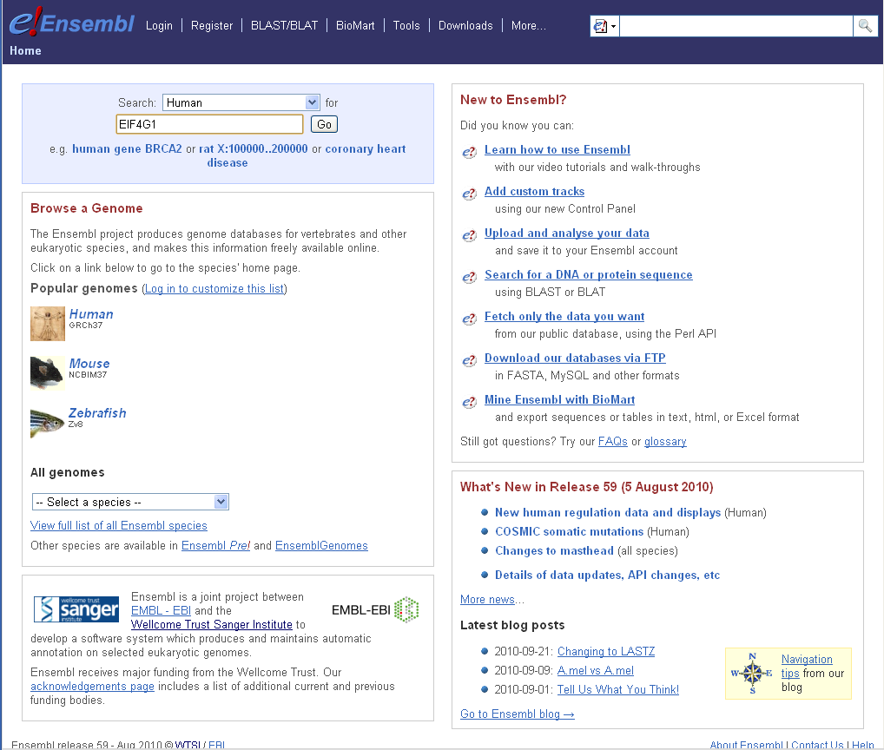
- Select a gene of interest to study. Initially, we will look at the example genes EIF4G1 and BAG1 but you will need to select your own genes to analyse. Use the UniProt (www.uniprot.org) and GeneCards (www.genecards.org) websites to get more information on your gene and see if it looks interesting. Use the GeneCards website to identify the official HGNC Gene Symbol. [Genes have many different names, so it is important to note what the official gene symbol is to ensure that you are analysing the correct gene.]
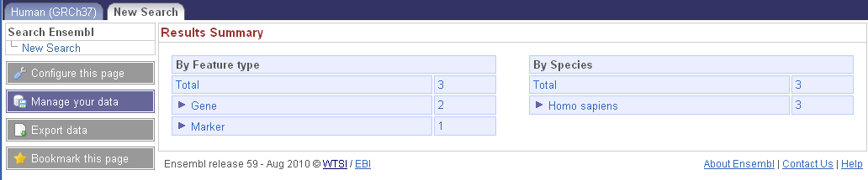
- Go to the Ensembl website (www.ensembl.org) and enter your gene into the Search box (select Human first) and hit “Go”.
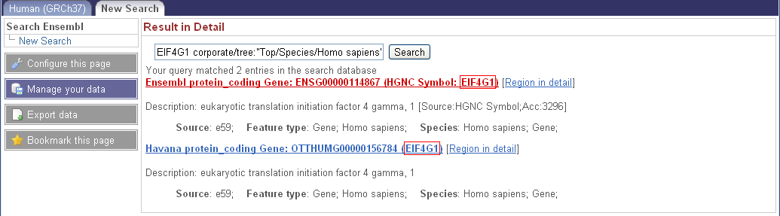
- You will probably be given several choices of several entries. One of these should be an Ensembl protein_coding gene with the correct HGNC Symbol matching your gene. Click on this entry.
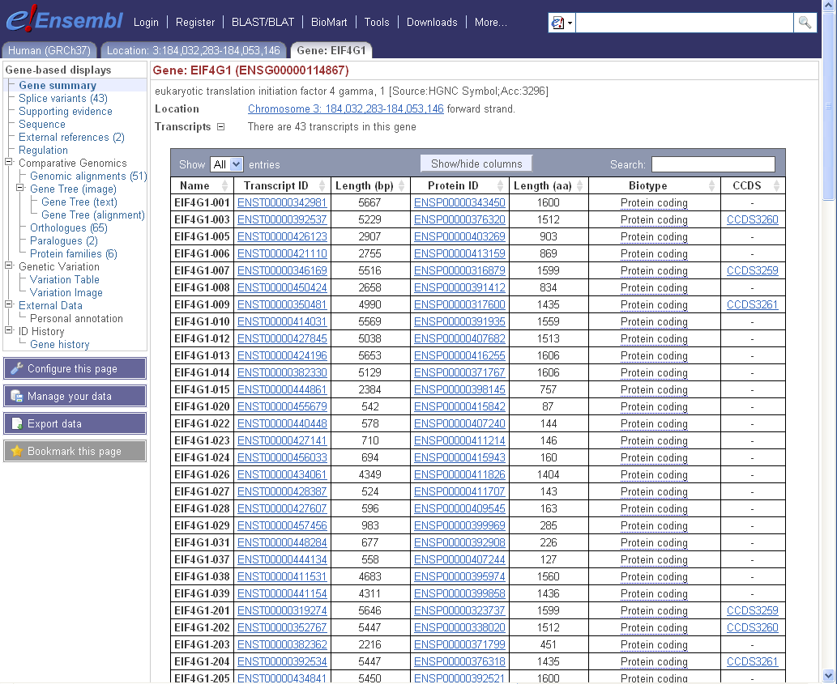
- This will open the Ensembl Gene Page for your gene, listing all the transcripts and proteins predicted to be expressed from this locus. Feel free to explore the different data for your gene – some of this will be useful later. Note the Biotype listed for your different transcripts – for this analysis, we are only interested in those annotated as “Protein_coding”.
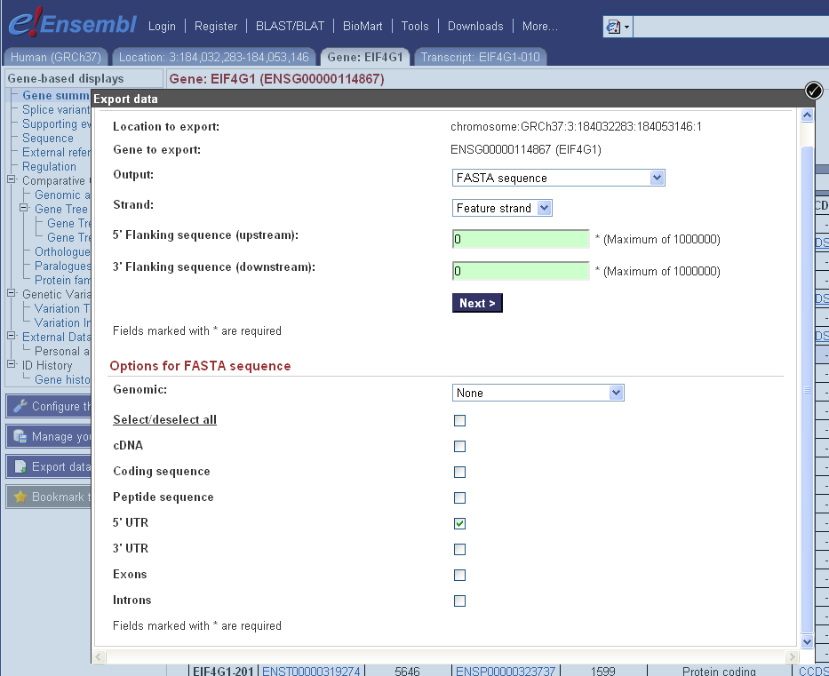
- For the initial alternative translation initiation codon (ATIC) analysis, we will need the Coding Sequence (CDS) and 5’ untranslated region (UTR) as DNA sequences:
  - Click “Export Data” (bottom left)
  - See “Options for FASTA sequence”. Make sure “Genomic” is set to “None”.
  - “Deselect all” features and then check the “5’ UTR” box. Click “Next >”.
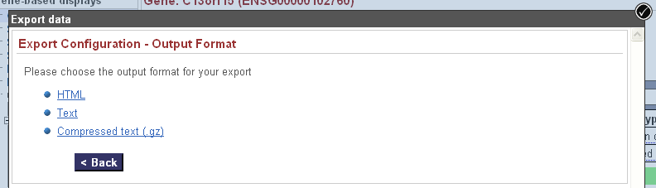
  - Right-click on “Text” and Save link as… Name the file according to the Gene, Version, Feature and Filetype (FASTA), e.g. eif4g1.59.utr5.fas.
  - Click “< Back” and repeat for the Coding sequence, saving as eif4g1.59.cds.fas.
Make sure you save the files in an appropriate location! We are now ready to use the Macro. This will be demonstrated in the lab on BAG1 before you analyse EIF4G1 yourselves.

Running the BIOL3050 Macro
The Excel macro should be fairly self-explanatory to run, although interpretation of the results will obviously take extra effort. The current version of the Macro, which you should use until directed otherwise, is Version 2.0.

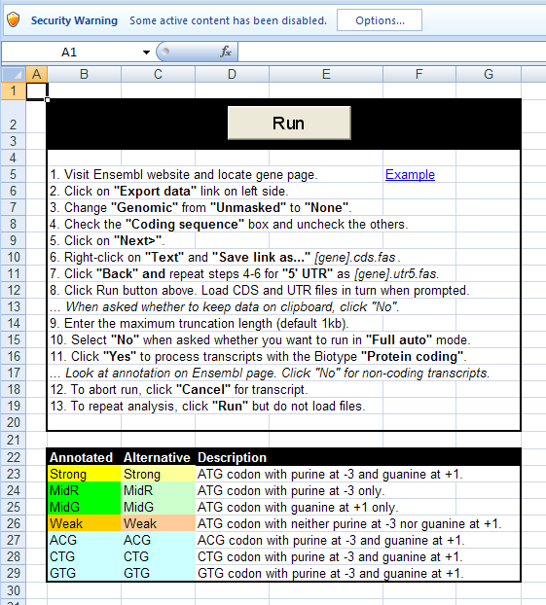
Opening the Macro
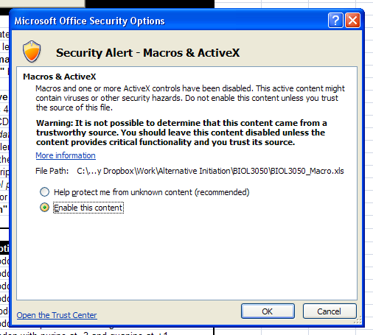
To use the macro, it will need to be enabled. When the macro is opened, a security warning will appear notifying you that “some active content has been disabled”. Click “Options...” and then “Enable this content” and click “OK”.

Running the Macro
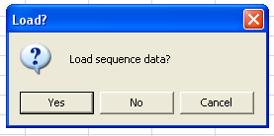
The main Instructions page contains a summary of the instructions for use and the “Run” button. Click on this to run the macro. You can also run the macro (“fullScan”) from the View tab.

Loading sequence data
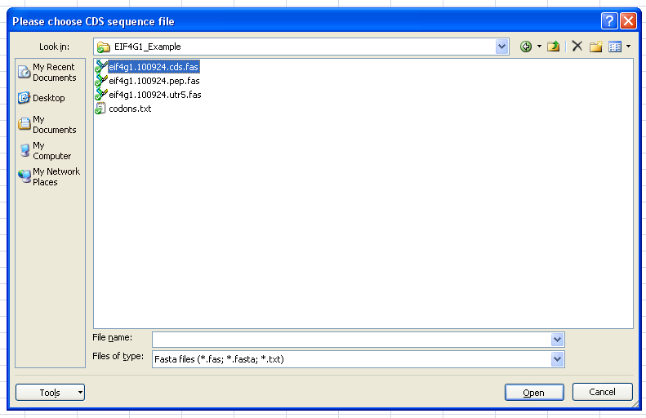
You will first be given the option to load the sequence data exported from the Ensembl website – click “Yes”. First select the CDS file and click “Open”. Next, repeat with the 5’ UTR file.
This only needs to be done the first time the macro is run for a given gene. After that, click “No” and the macro will use the data in the “UTR” and “CDS” worksheets. [If these have been deleted, you will need to reload the data.]
Once both files have been selected, they will be opened and the data entered into “UTR” and “CDS” worksheets.
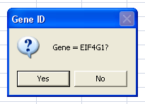
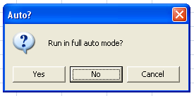
Finally, if the files are named as recommended, the Gene name will be automatically extracted. If it is correct, click “Yes”, if not click “No” and enter the correct gene.

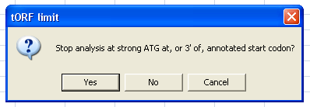
Run options
You will now be given the option to run in “full auto” mode. Select “No”. When asked if you want to “Stop analysis at strong ATG at, or 3’ of, annotated start codon”, click “Yes”. These options will be explained at a later date.

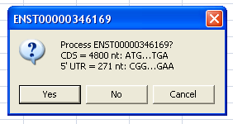
Transcript processing
Each transcript is taken in turn from the “CDS” worksheet and, if a UTR sequence is also found, summarised with the option to process. Cross-reference the transcript ID to the Ensembl website: if the annotated “Biotype” is “Protein coding” then select “Yes” and process the transcript; if not, select “No”.
As the transcript (5’ UTR + CDS) is processed, in-frame codons with positions and translations will be reported on the left hand side. Possible initiation sites will be highlighted. Until the annotated start codon and an ATG in strong context ([AG]nnATGG) has been encountered, these will be reported on the right hand side as predicted alternative initiation codons. Different colours will indicate the predicted strength of the sequence context of the codon. Once the transcript is processed, the number of predicted alternative initiation sites will be reported. Click “OK” to move onto the next transcript. Once all transcripts have been processed, you will be notified.
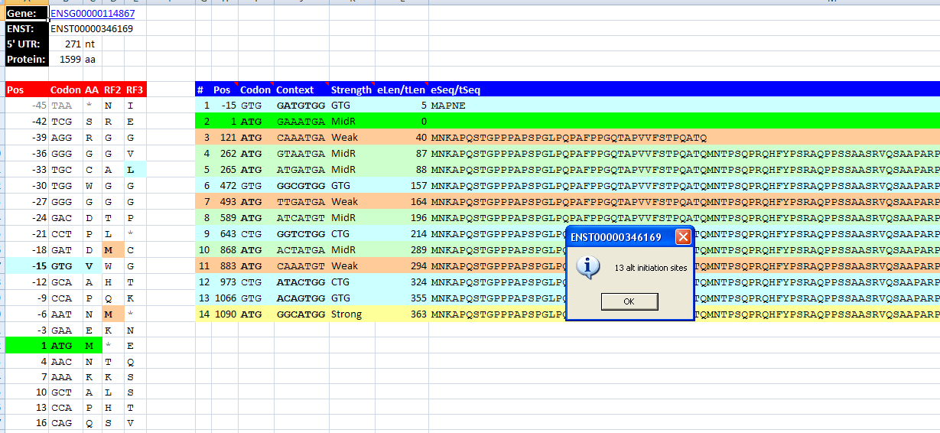

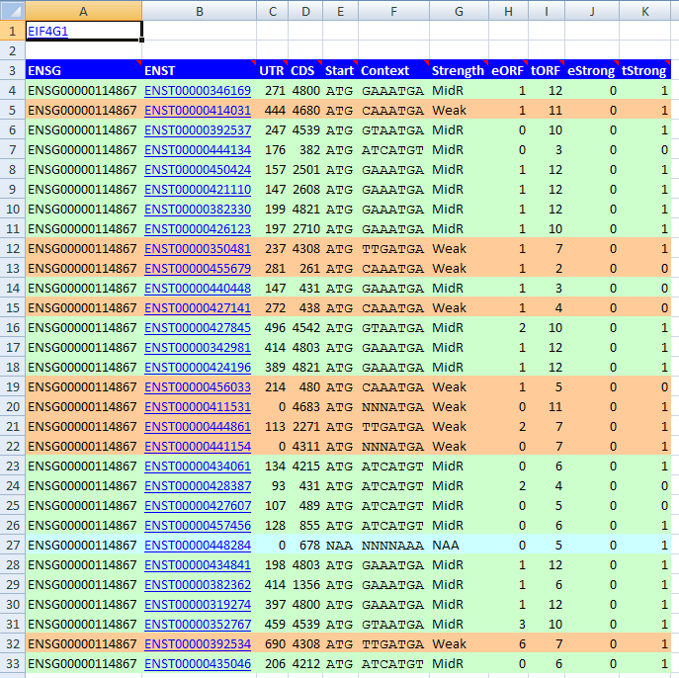
Gene Summary
Once all the transcripts have been processed, you will be returned to the BIOL3050 sheet, where there is a summary table of all the transcripts processed. The gene ID will be in cell A1, hyperlinked to the GeneCards website entry. Each transcript ID should link to the Ensembl website. Colours indicate the predicted strength of the annotated start codon. The number of in-frame 5’ extended open reading frames (eORF) and 3’ truncated open reading frames (tORF) relative to the annotated start codon is also reported. This table can be used to direct attention to the most interesting transcript pages first.

Save the workbook
Once the macro is run, save the workbook in the same directory as the exported sequence data under an appropriate name, e.g. eif4g1.59.macro.xls. All the worksheets and cells can now be treated as with any other Excel file and copied, pasted or reformatted etc. Be aware, however, that re-running the macro will over-write and reformat the same data-containing cells from the first run. (Cells outside of this area will not be altered.)

Choosing the right transcript(s)
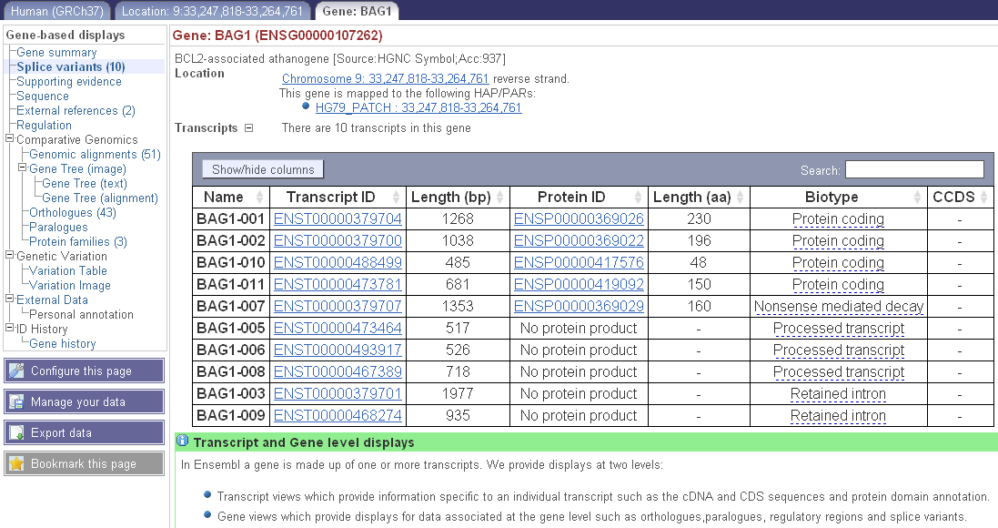
One of the “features” of Ensembl is the presence of multiple transcripts, not all of which are biologically interesting. Some of them will be based purely on gene prediction tools. Others represent genuinely expressed sequences that nonetheless do not have functions, or represent truncated sequences from EST libraries etc. A particular problem for this analysis are transcripts with incorrect 5’ UTR annotation that are really in the middle of another coding transcript and therefore seem to have very long extended ORFs. Fortunately, visualisations of the alternative splice variants on the Ensembl page can help identify these. In addition, cross-referencing sequences with the “supporting evidence” for a given transcript might also yield useful clues.

Ensembl splice variant data
The “Splice variants” view of the Ensembl gene provides the best overview of which transcripts are partial or complete overlaps with each other:
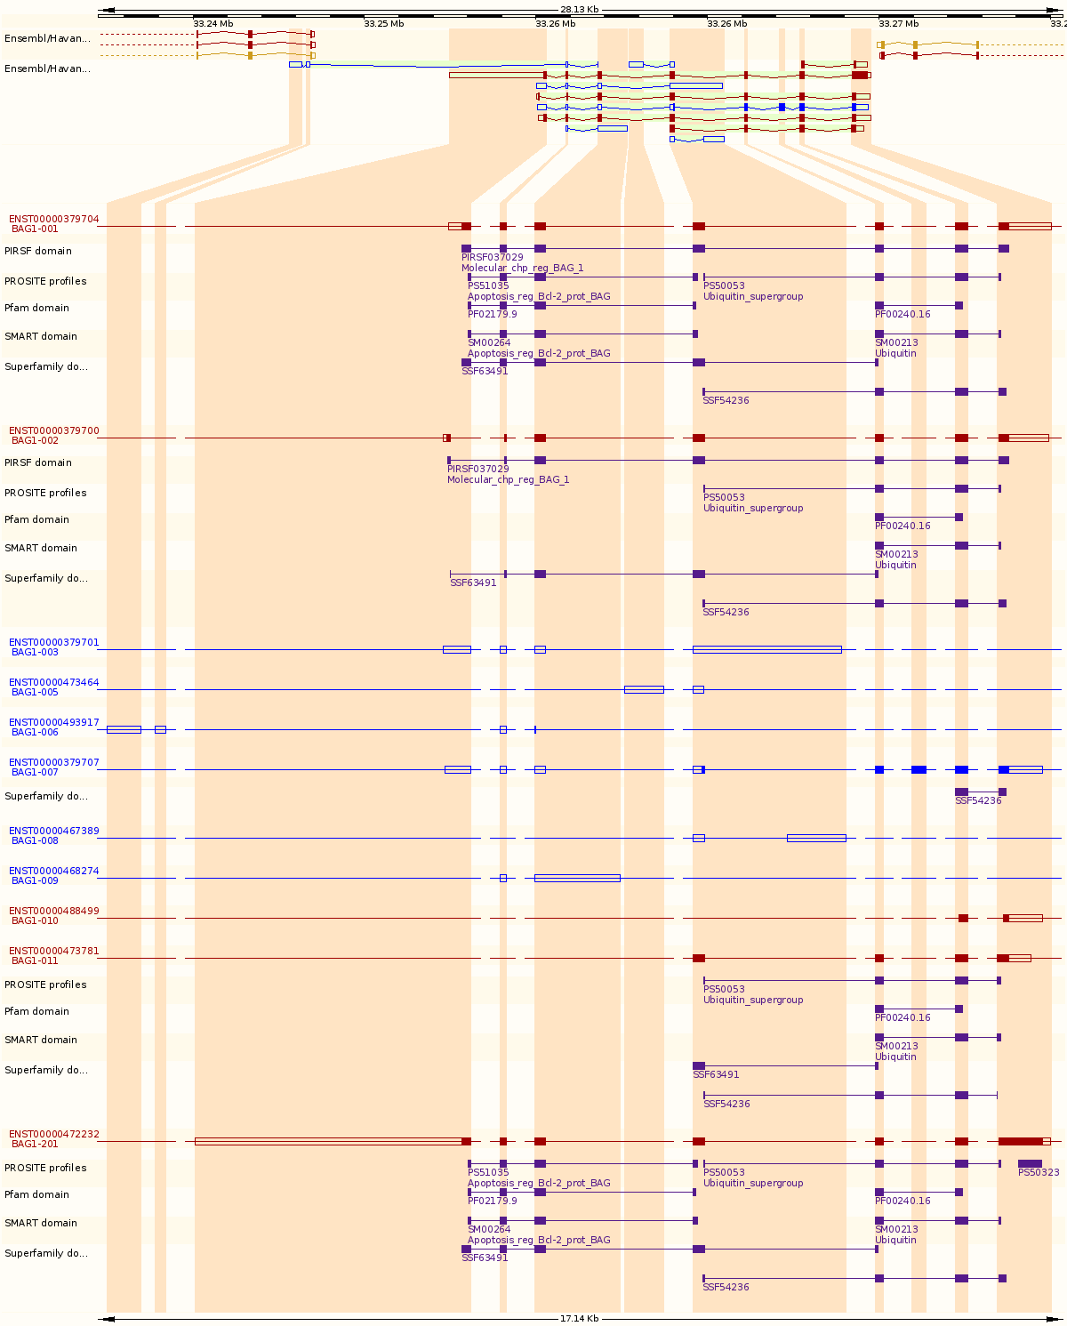
The shaded areas correspond to exons that form part of any of the transcripts for the gene being viewed. Each transcript then has its own track, with thin lines representing “missing” (i.e. non-transcribed or excised) exons, untranslated exonic sequence as open boxes and translated exonic sequence as filled boxes. Pay particular attention to the 5’ (left) end of the transcripts. In the example above, BAG1-001 and BAG1-002 clearly have different 5’ exons and are therefore worth looking at. BAG1-011, on the other hand, clearly starts with what is an internal protein coding exon in BAG1-001 and BAG1-002. BAG1-011 is therefore not worth consideration at this point.

Comparing splicing with BioEdit
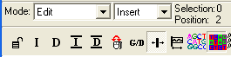
The program BioEdit can also be used to compare transcripts. This will be demonstrated in the lab and the handout updated in time. Ensure that you have set the Mode to “Edit” and then the submode to “Insert” (not “Overwrite”). It also helps to select “Back-colored view mode” for clarity. Export the cDNA sequence from Ensembl and open in BioEdit.
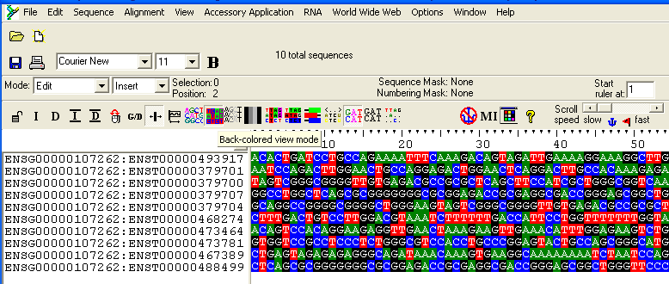
Delete any unwanted (non-protein-coding) transcripts. You can then try doing a multiple alignment, using “Accessory Application -> ClustalW Multiple Alignment”. This will not always work and often, even when it works for much of the sequence, you will get some regions that do not match:
This usually happens pairs of sequences contain regions not found in each other. For example, the bit that went wrong above includes a partial overlap at the 3’ end of the second sequence but much of the incorrectly aligned regions are unique to each. (Alignment programs will try to align sequences even if they are different.)

Further analysis
Further analysis will be covered later. Among other things, you will want to check the ORF extensions/truncations for sequence features (from database annotation, the literature, and using the provided sequences for bioinformatics predictions) and search for existing western blot images indicating possible alternative initiation (i.e. multiple bands).

Candidate eORF selection: experimental considerations
Once the macro has been run on a gene, additional sequence features can be used to identify the most interesting extended/truncated ORF candidates. In addition, there are a number of experimental considerations to be made, including eORF length and (in)appropriate restriction enzyme cut sites.

Favoured alternative initiation codons

Not all alternative initiation codons are equal. Previous experiments have indicated that AUG and CUG codons are more efficient than GUG and ACG codons. YnnAUGG (“MidG”) codons are also more efficient that RnnAUGH (“MidR”) codons and almost as efficient as the “strong” RnnAUGG codons.

Code | Base
A | Adenine
C | Cytosine
G | Guanine
T (or U) | Thymine (or Uracil)
R | A or G
Y | C or T
S | G or C
W | A or T
K | G or T
M | A or C
B | C or G or T
D | A or G or T
H | A or C or T
V | A or C or G
N | any base
. or - | gap

The other predicted AICs will help interpret experimental results but, for now, limit candidates to sequences with a “Weak” or “non-AUG” codon (as the most 5’ predicted AIC.

Minimum eORF length
For these experiments, a length difference of at least 40aa is needed to visualise the different bands on the Western Blot. To retain a candidate, there should be at least 40aa between the 5’ MidR/Weak/CUG codon and the 3’ Strong codon. Preferably, no MidG codons will occur in this interval.

Premade clone availability & transcript alignments
For this experiment, we will be ordering clones from Open Biosystems. If a transcript meets the codon and length criteria, check to see whether an appropriate clone is available:
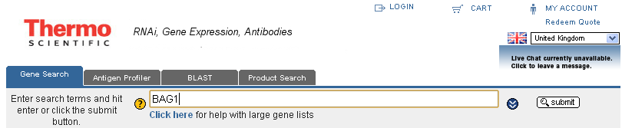
- Go to http://www.openbiosystems.com/.
- Make sure “Gene Search” tab is selected, enter Gene Symbol (e.g. BAG1) into Search box and click “Submit”.
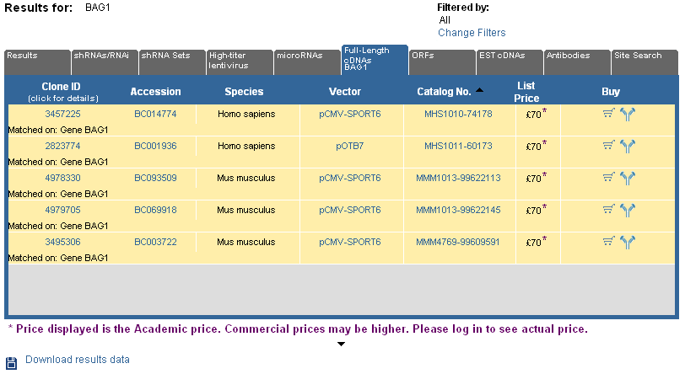
- In the results page, select “Full-length cDNAs”. Check the species for each one – we need human (Homo sapiens) sequences. If you get lots of results, you can filter by species using the “Change filters” function. If there are no full-lenth cDNAs available, then we cannot go any further with that gene.

Clone & transcript alignments
If one or more clones have been identified for your gene of interest, the next step is to determine whether one of them corresponds to the transcript(s) of choice from your analysis using the macro.

Downloading clone sequences
- Click on the “Accession” link to open the corresponding GenBank entry in a new window/tab. Do this for each human clone that is available.
- For each clone, click “Send” and choose the destination “Clipboard”.
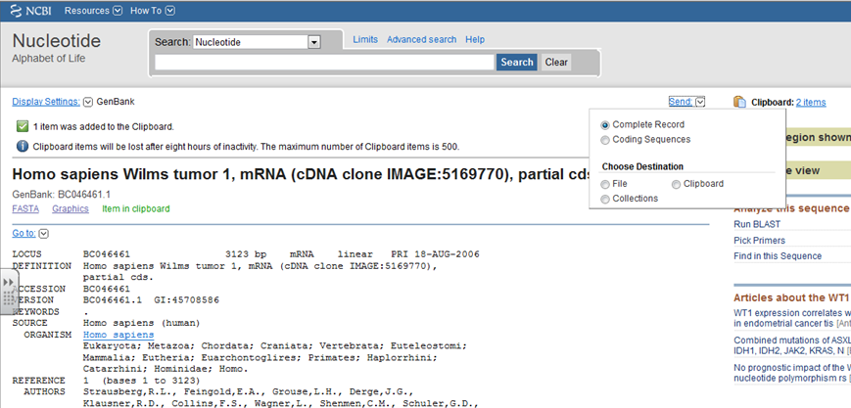

- Once all clones have been sent to the clipboard, open the Clipboard. (Click on the “Clipboard: X items” link to the right of the “Send” button. Check that all the clones are present. Save the clone sequences using “Send” to “File” – make sure you choose “FASTA” format. Name the file in line with your other file naming, e.g. WT1.101001.clones.fas.
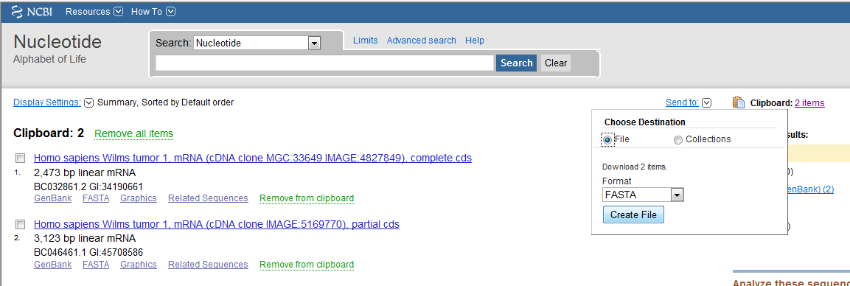

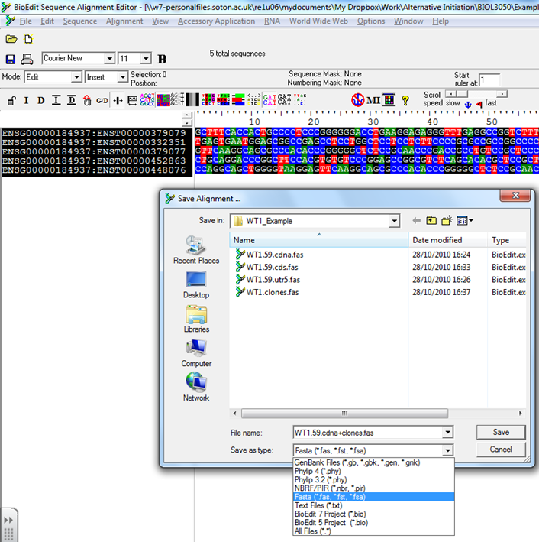
Generating clone/transcript alignments
You now want to check that one of the clone sequences (or, at least the 5’ end upto 300nt beyond the strong ATG) matches up with the one from the Transcript of interest. To do this, open them up in BioEdit to compare them to your Ensembl cDNA sequences.
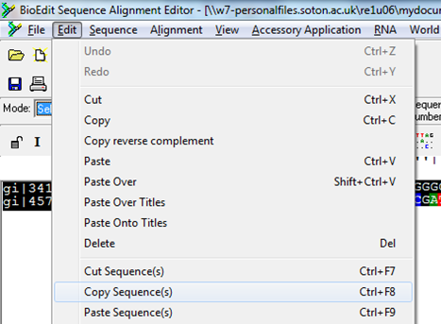
- Open up the saved cDNA sequences for your gene in BioEdit. Because you are going to add the clone sequences to this file, immediately save it as *.cdna+clones.fas to avoid accidentally overwriting the cDNA sequences.
- Open up the clones fasta file you exported from GenBank. Select them (CTRL+A) and Copy Sequence(s). Change to the cDNA sequence window and Paste Sequence(s).
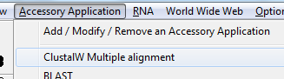
- Select all cDNA and clone sequences (CTRL+A) and align them using ClustalW. You may need to manually adjust the alignment. (Ensure that you have set the Mode to “Edit” and then the submode to “Insert” (not “Overwrite”).)
- Save the aligned file. (E.g. *.cdna+clones.aln.fas)

Mapping alternative initiation sites
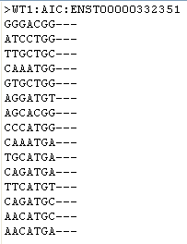
As a preliminary check, you can manually scan the relevant positions using BioEdit and the Excel macro. Ultimately, however, you will want to visually demonstrate the overlap. For this, you want to create an additional file of the alternative initiation codons and their context (-3/+4).
- Open a blank text file. Create a header line containing the gene, transcript and indication that this is the AIC regions, e.g. “>WT1:AIC:ENST00000332351”. Don’t forget the FASTA “new sequence” symbol, “>”.
- Copy the “Context” column from the macro of the appropriate transcript, and paste it below the sequence header in the text file. Add a few gaps (“---”) after each codon region to ease visualisation in BioEdit.
- Save the file as *.aic.fas and open it up in BioEdit. Copy and paste the sequences onto the end of the cDNA/clone alignment you made above.
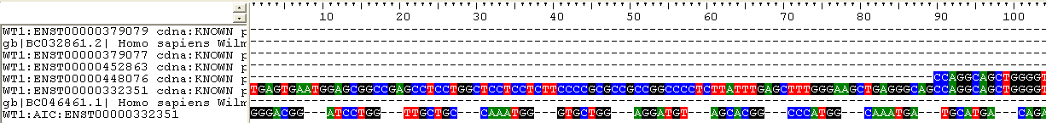
- Manually insert gaps, using the Excel macro to guide you, to align the putative initiation codons (and surrounding context) with the transcripts/clones. If two codons are very close, you may need to delete some of the residues to make them overlap correctly.
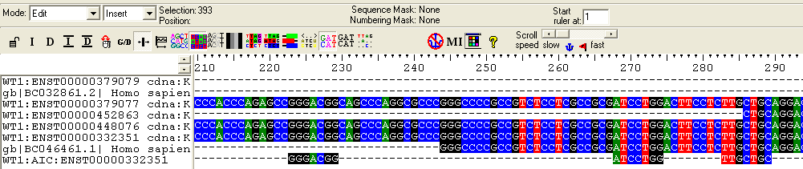

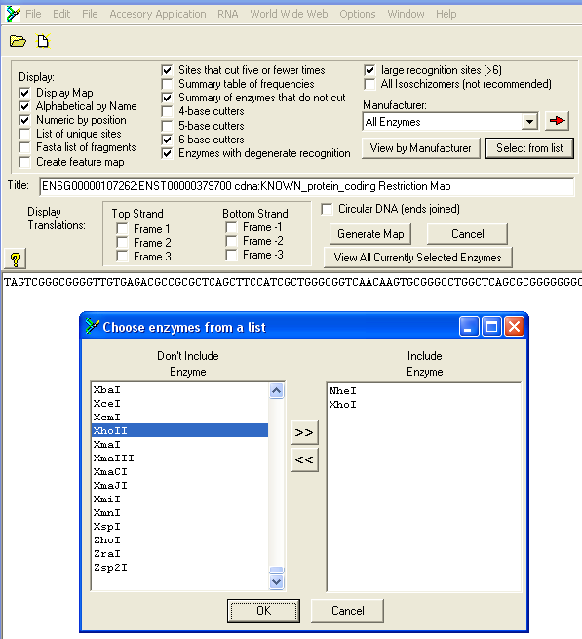
Restriction mapping
You will be cloning a sequence including the 5’ UTR and the beginning of the CDS, upto 100 aa (300 nt) 3’ of the first strong ATG. This cloning will involve PCR amplification and then digestion with restriction enzymes NheI (G’CTAG_C) or XhoI (C’TCGA_G). BioEdit can be used to check for inappropriate restriction sites within the region of interest.
- Select the cDNA sequence corresponding to your transcript of interest.
- Click “Sequence -> Nucleic Acid -> Restriction Map”. This will open up the restriction map page.
- Under where it says “All Enzymes”, click “Select from list”. Find NheI and XhoI and add them to the “Include” side. Click “OK”.
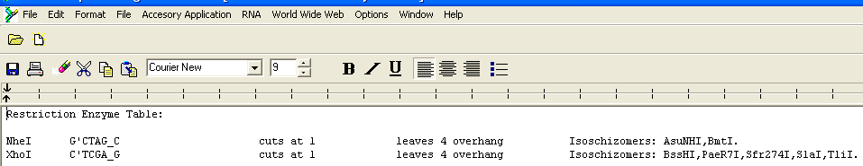
- Click “View All Currently Selected Enzymes” and check that the information is correct:
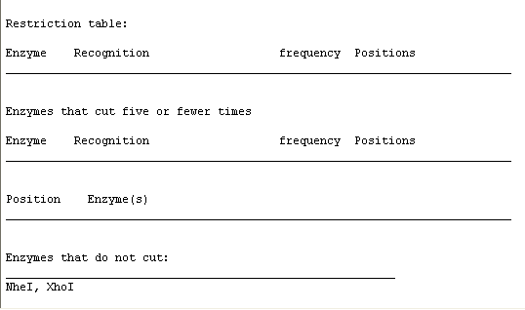
- Click “Generate Map”. This will perform an in silico digestion and summarise results at the bottom. To be a viable candidate, either or both enzymes must be reported under “Enzymes that do not cut”. Alternatively, the enzymes may cut but not in the region you intend to clone. Save the restriction map as *.remap.txt for future reference.

Candidate eORF selection: biological considerations
If several candidate genes meet the initial criteria, N-terminal sequence features that may be gained or lost through extension/truncation can be used to prioritise sequences. The Ensembl pages themselves contain some of this information but additional external resources should also be consulted. These features can also be used to identify biologically interesting candidates that do not fulfil all the criteria for experimental analysis.

Annotated sequence features

UniProt
This is a protein-centric database with good annotation for “SwissProt” entries. “TrEMBL” entries are computationally annotated.

OMIM
Part of the NCBI site, this manually curated database contains good information on gene function as well as mutations and regions implicated in various diseases.

Genecards
Genecards has a breadth of information about genes, including some details of functionally important sites.

Genbank
Genbank provides good nucleotide-centric annotation and can give clues regarding Ensembl-predicted splice variants and AICs.

Predicted sequence features
Annotation for all genes is incomplete and bioinformatics webservers can be used to predict additional features. It must be remembered that these are just predictions, however, and experimental evidence is required before any firm inferences of protein function can be made. The macro enables just the sequence of the extension/truncation to be copied. For transcripts without strong annotated start codons, however, you will probably want to concatenate potential extended and truncated sequences.
A number of different tools can be found at the EBI (http://www.ebi.ac.uk/) and ExPASY (http://www.expasy.org/tools/), although additional bespoke webservers also exist that may be better for specific functions. Results are always best interpreted in the context of the literature and existing sequence annotation.

PFam domain predictions
PFam

Short Linear Motif prediction
Known function: ELM and Minimotif Miner.
Unkown function: SLiMPrints

Post-translational modifications
Scansite and phosphoELM. See also the Expasy tools for different PTM.

Subcellular localisation
SignalP etc.
TMHMM
Learn also from PTMs and Motifs.

Evidence for alternative initiation
It is plausible that experiments performed for other reasons (including the antibody staining found at the Open Biosystems website) may have produced evidence supporting the notion of alternative initiation in your gene of interest. Performing a Google image search with your gene name and scrutinising gel images can sometimes reveal such evidence, where multiple bands are found on a gel for a single transcript/cDNA. In this case, use an online molecular weight (MWt) calculator to calculate the predicted molecular weight of the full length and extended/truncated proteins.
A good one to use is the Expasy pi tool: http://www.expasy.ch/tools/pi_tool.html. This allows you to upload a text file containing one sequence on each line (just the protein sequence, no names/headers etc.) and quickly calculate the predicted pi and MWt for each sequence. For example, you can copy the “eSeq/tSeq” entries into a text file, which you then upload to the server; this way, you can calculate the predicted changes in molecular weight. (Note that this latter approach does not calculate the full MWt for the protein.)

