Manuscript type: Rapid Communication
Title: Epidemiological characteristics of Andes virus and implications for monitoring outbreaks

Authors: Jason R. Andrews, MD,¹ and Isaac I Bogoch, MD^{2*}
Affiliations:
1. Division of Infectious Diseases and Geographic Medicine, Department of Medicine, Stanford University School of Medicine, Stanford, California.
2. Department of Medicine, University of Toronto, Toronto, Ontario, Canada

Keyworks: Andes virus; Hantavirus; Outbreak; Cruise; Travel

Abstract word count: 52
Manuscript word count: 560
References: 6
Author Contributions: Both authors were responsible for conceiving the idea, analysis, writing, and revising.
Funding: JRA is funded by the National Institutes of Health (K24 AI182647), IIB is funded by the Canadian Institutes for Health Research
Author Statements: IIB consults to the Weapons Threat Reduction Program at Global Affairs Canada.
*Correspondence to:

Highlight:
A cluster of Andes virus (ANDV) cases aboard the MV Hondius prompted epidemiological risk assessment. Retrospective analysis of the 1996 El Bolsón and 2018 Epuyén outbreaks identified prolonged incubation, substantial early transmission, and superspreading potential (k=0.23). Despite monitoring challenges, branching-process simulations suggest most introductions result in stochastic extinction, limiting large-scale outbreak risk.

Hantavirus Pulmonary Syndrome (HPS) is a severe respiratory disease with a case fatality rate historically exceeding 30%. While most hantaviruses are transmitted exclusively via inhalation of aerosolized rodent excreta, the Andes orthohantavirus (ANDV) also has capacity for human-to-human transmission. Following the notification of an ANDV cluster aboard the MV Hondius cruise ship (Supplementary Figure S1), we re-evaluated historical data of ANDV transmission to inform public health monitoring and intervention strategies. We utilized contact networks from the two most extensively documented historical ANDV outbreaks; the 1996 cluster in El Bolsón, Argentina (18 cases) [1], and the 2018–2019 outbreak in Epuyén, Argentina (34 cases) [2]. We define the fundamental epidemiological parameters.
Patient-level line lists detailing exposure windows, symptom onset dates, and infector-infectee pairs were extracted from primary literature appendices [1, 2]. To calculate the incubation period, we applied an interval-censored Maximum Likelihood Estimation (MLE) framework [3] to the bounded social exposures in the 2018 Epuyén cohort. Generation times and the infectiousness profile were deconvoluted mathematically from the empirical serial intervals recorded in the 1996 El Bolsón transmission network [4]. Transmission heterogeneity was assessed by fitting a Negative Binomial distribution to the aggregated offspring distribution of both outbreaks, enabling the calculation of the basic reproduction number ($R_{0}$) and the dispersion parameter ($k$) [5]. Finally, we conducted a 50,000-iteration branching process simulation parameterized by the derived $R_{0}$ and $k$ values to estimate the probability of stochastic extinction versus large-scale epidemic growth following a single ship-board introduction. Code and underlying data are available at: github.com/jasonandr/Andes-virus-epi
Interval-censored MLE demonstrated a median human-to-human incubation period of 20.1 days (IQR XX.X-YY.Y). We conducted comparative lognormal modeling against historically established environmental (rodent-to-human) incubation periods (median 18.5 days, IQR XX.X-YY.Y) [6]. The resulting density distributions were very similar (Figure 1A), demonstrating that the prolonged incubation period is intrinsic to ANDV pathogenesis and not specific to exposure route. Analysis of the empirical generation time curves revealed that approximately 24% of transmission occurs during a presymptomatic, subclinical, or early prodromal phase, prior to the onset of severe febrile illness (Figure 1B).
Negative binomial regression on the combined empirical offspring distribution yielded an overall $R_{0}$ of 0.96, but low dispersion parameter ($k$) of 0.23 (Figure 1C), suggestive of superspreading dynamics [5]. The majority of infected individuals (>80%) generated zero or single secondary cases, while a minority of “superspreaders” were responsible for multi-generational transmission chains.
Utilizing these parameters in the branching process simulation, we found that 78.5% of single-case introductions resulted in immediate stochastic extinction (generating zero secondary cases). However, outbreaks that evaded early extinction had a small probability of explosive growth (Supplementary Figure S2).
These epidemiological characteristics complicate monitoring in high-density settings such as a cruise ship. A prolonged incubation period combined with presymptomatic, subclinical, or prodromal shedding limits the effectiveness of symptom-based screening, as secondary transmission may occur before overt symptoms emerge. Forty-five day quarantine of exposed individuals with periodic testing irrespective of symptoms is appropriate. Because most infected individuals do not transmit the virus, large uncontained outbreaks are statistically unlikely. Branching process simulations show that most introductions end in rapid stochastic extinction, making exponential spread improbable despite the risk of localized superspreading events in enclosed environments.

References:
- Padula PJ, Edelstein A, Miguel SD, López NM, Francos CM, Suárez VC. Epidemic outbreak of hantavirus pulmonary syndrome in Argentina. Molecular evidence for person-to-person transmission of Andes virus. Virology. 1998;241(2):323-330.
- Martinez VP, Di Paola N, Alonso DO, et al. “Super-Spreaders” and Person-to-Person Transmission of Andes Virus in Argentina. New England Journal of Medicine. 2020;383(23):2230-2241.
- Lauer SA, Grantz KH, Bi Q, et al. The Incubation Period of Coronavirus Disease 2019 (COVID-19) From Publicly Reported Confirmed Cases: Estimation and Application. Annals of Internal Medicine. 2020;172(9):577-582.
- He X, Lau EHY, Wu P, et al. Temporal dynamics in viral shedding and transmissibility of COVID-19. Nature Medicine. 2020;26(5):672-675.
- Lloyd-Smith JO, Schreiber SJ, Kopp PE, Getz WM. Superspreading and the effect of individual variation on disease emergence. Nature. 2005;438(7066):355-359.
- Vial PA, Valdivieso F, Mertz G, et al. Incubation period of hantavirus cardiopulmonary syndrome. Emerging Infectious Diseases. 2006;12(8):1271-1273.

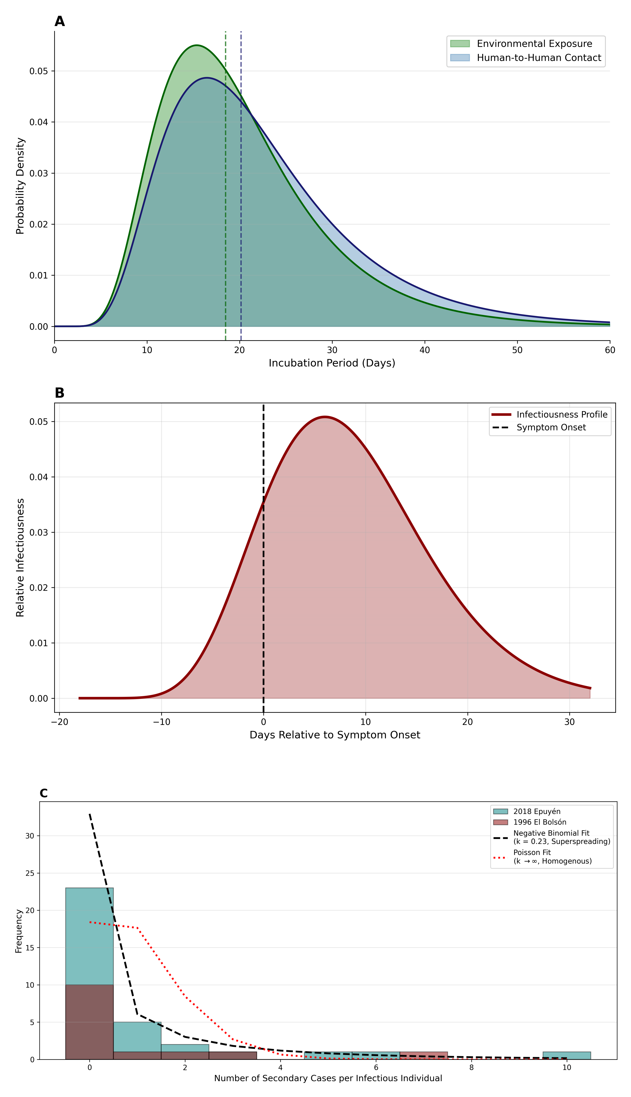
Figure 1. Synthesized Transmission Dynamics of Andes Virus. (A) Comparative incubation dynamics showing overlaid lognormal probability density functions of the human-to-human incubation period (median 20.1 days, derived via MLE) against the established environmental exposure period (median 18.5 days; Vial et al., 2006). (B) Infectiousness profile relative to symptom onset, deconvoluted from the 1996 El Bolsón serial intervals, illustrating approximately 24% presymptomatic shedding. (C) Negative binomial regression fit to the empirical offspring distribution (1996 and 2018 combined data), revealing extreme transmission heterogeneity ($R_{0}=0.96$, $k=0.23$).

Supplementary Appendices

Empirical Timeline of the MV Hondius Outbreak
We reconstructed the empirical patient-level timeline of the outbreak as of May 15, 2026 using notification data from the World Health Organization. The visualization strictly adheres to reported milestones, documenting the duration of exposure on the vessel, clinical symptom onset, and dates of death for the primary and secondary clusters, highlighting the rapid clinical deterioration of the initial three cases prior to and during the initial May 2nd notification.
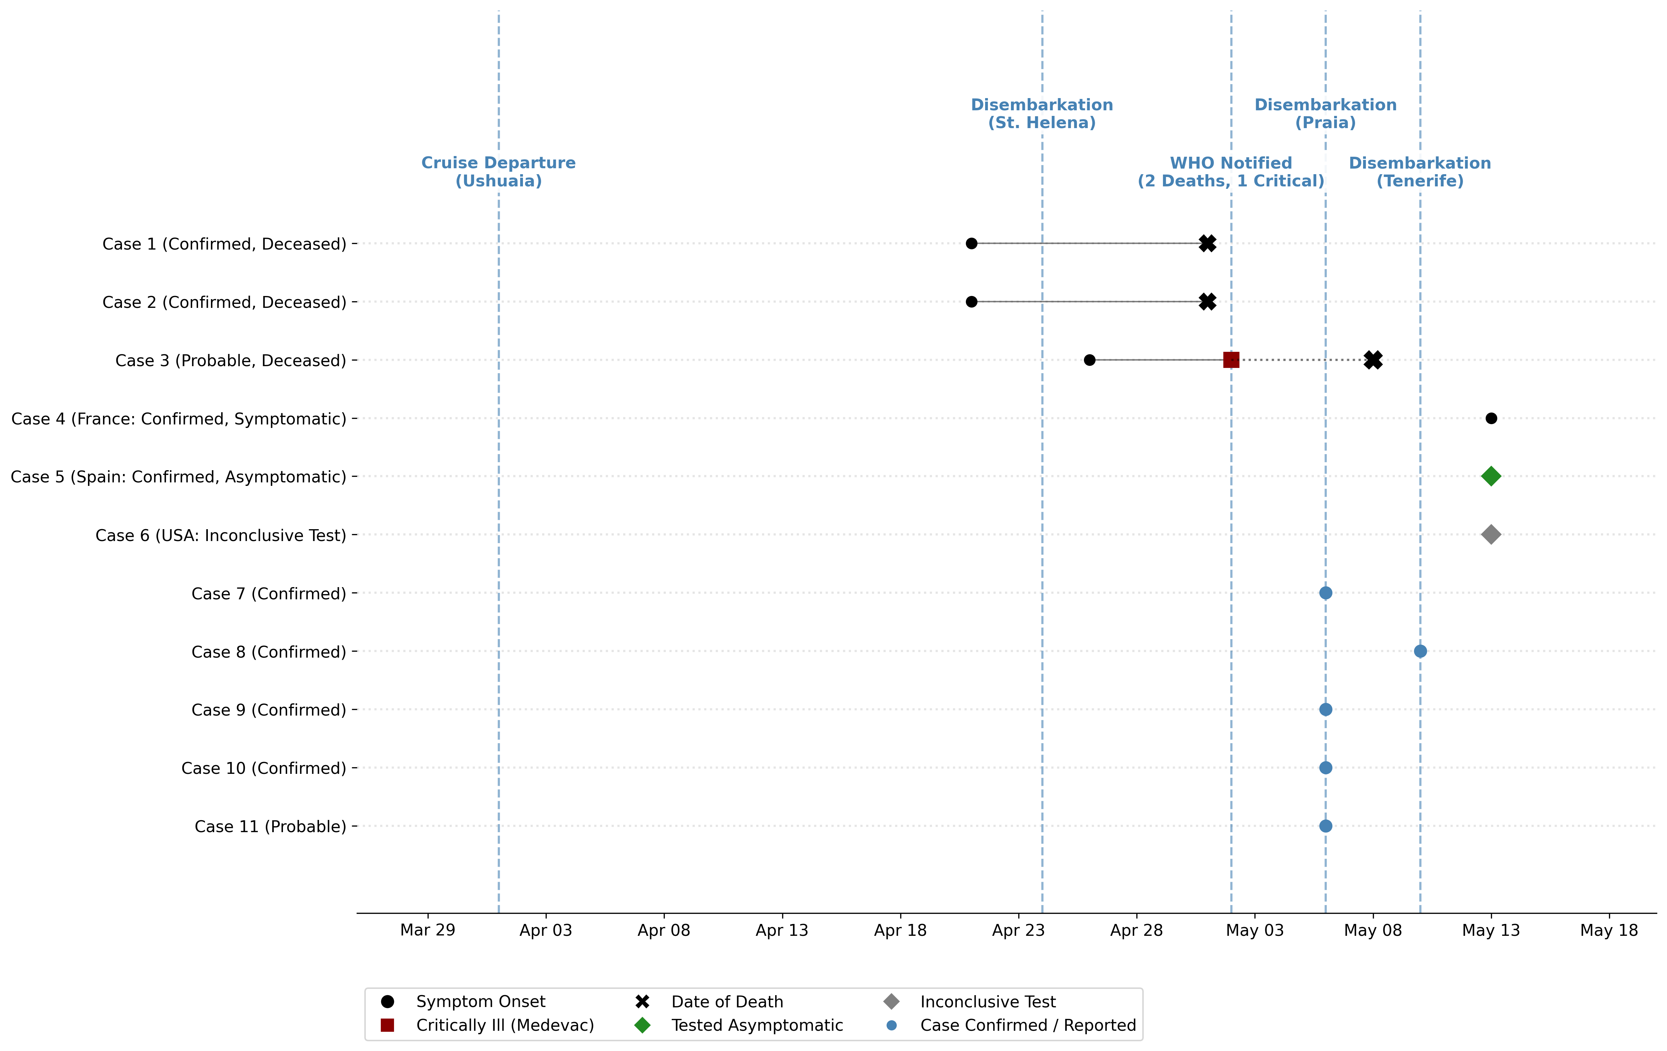 Supplementary Figure S1. Patient-Level Timeline of the MV Hondius Andes Virus Outbreak. Gantt chart illustrating the time spent on the vessel by the 11 identified cases, ending in specific reported events (death, critical illness medevac, symptom onset, or testing).

Stochastic Extinction Simulation
We executed a branching process simulation utilizing the empirical transmission parameters ($R_{0}=0.96$, $k=0.23$) to model 50,000 theoretical virus introductions. The resulting raincloud plot demonstrates the paradox of the dispersion parameter: while the probability of stochastic extinction at the index case is elevated compared to homogenous pathogens, outbreaks that survive the first generation occasionally result in a large numbers of cases.
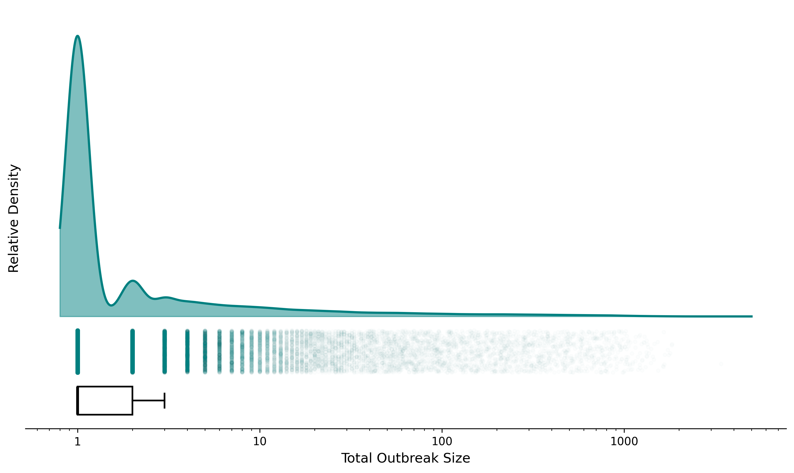 Supplementary Figure S2. Outbreak Size Probability Density. Raincloud plot (log-scaled KDE, jittered raw iterations, and boxplot) representing the total outbreak sizes over 50,000 simulated generations. The explicit log-scale x-axis highlights extreme long-tail clustering events.

Demographic Stratification
Analysis of the 2018 Epuyén line list mapped patient age against individual reproduction numbers. Infectiousness did not linearly correlate with age; rather, superspreading was bound to high-risk social behavioral events (e.g., attending specific indoor gatherings while infectious).
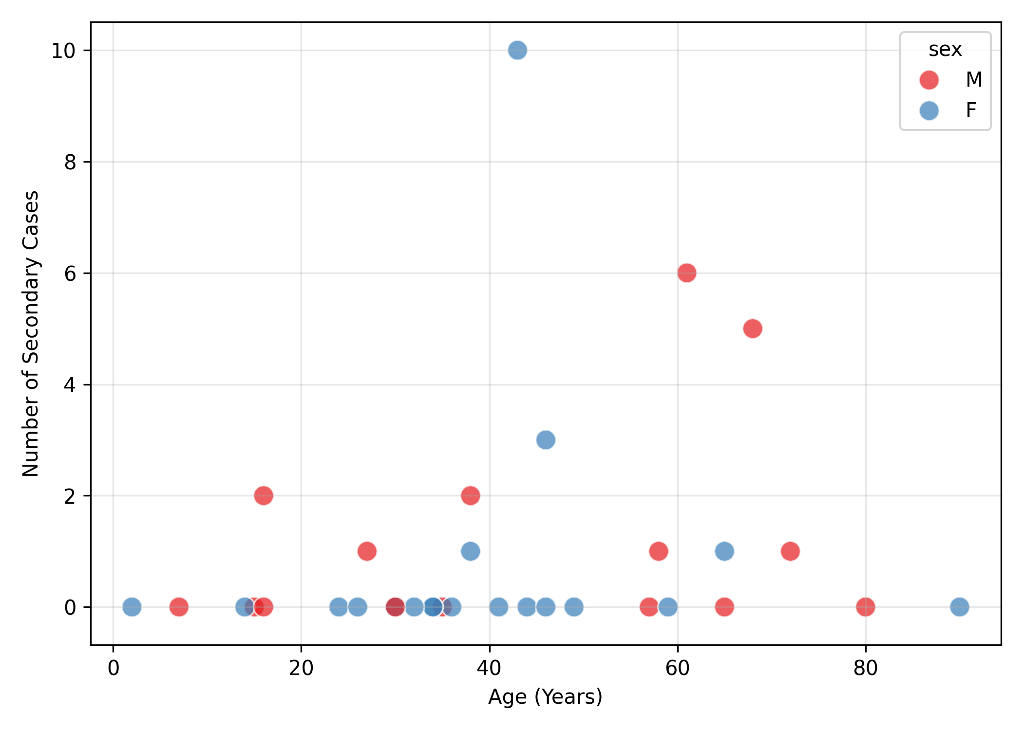 Supplementary Figure S3. Demographic Infectiousness Profiles. Scatter plot mapping the age of index cases against their respective number of secondary infections in the 2018 Epuyén outbreak.

