Manuscript type: Rapid Communication
Title: Epidemiological characteristics of Andes virus and implications for monitoring outbreaks

Authors: Jason R. Andrews, MD,¹ and Isaac I Bogoch, MD^{2*}
Affiliations:
1. Division of Infectious Diseases and Geographic Medicine, Department of Medicine, Stanford University School of Medicine, Stanford, California.
2. Department of Medicine, University of Toronto, Toronto, Ontario, Canada

Keyworks: Andes virus; Hantavirus; Outbreak; Cruise; Travel

Abstract word count: 52
Manuscript word count: 594
References: 6
Author Contributions: Both authors were responsible for conceiving the idea, analysis, writing, and revising.
Funding: JRA is funded by the National Institutes of Health (K24 AI182647), IIB is funded by the Canadian Institutes for Health Research
Author Statements: IIB consults to the Weapons Threat Reduction Program at Global Affairs Canada.
*Correspondence to: Isaac I. Bogoch, Toronto General Hospital, 200 Elizabeth Street, Toronto, ON, Canada, M5G 2C4. Isaac.bogoch@uhn.ca.

Highlight:
A cluster of Andes virus (ANDV) cases aboard the MV Hondius prompted an epidemiological risk assessment. Retrospective analysis of the 1996 El Bolsón and 2018 Epuyén outbreaks identified prolonged incubation, substantial early transmission, and transmission heterogeneity (k=0.24). Despite monitoring challenges, branching-process simulations suggest most introductions result in stochastic extinction, limiting large-scale outbreak risk.

Hantavirus Pulmonary Syndrome (HPS) is a severe respiratory disease with a case fatality rate historically exceeding 30%. While most hantaviruses are transmitted mainly via inhalation of aerosolized rodent excreta, the Andes orthohantavirus (ANDV) has capacity for more significant human-to-human transmission. Following the notification of an ANDV cluster aboard the MV Hondius cruise ship (Supplementary Figure S1), we re-evaluated historical data of ANDV transmission from outbreak settings to inform public health monitoring and intervention strategies. We utilized contact networks from the two most extensively documented historical ANDV outbreaks: the 1996 cluster in El Bolsón, Argentina (18 cases) [1], and the 2018–2019 outbreak in Epuyén, Argentina (34 cases) [2]. We define the fundamental epidemiological parameters from these outbreak settings.
Patient-level line lists detailing exposure windows, symptom onset dates, and infector-infectee pairs were extracted from primary literature appendices [1, 2]. To calculate the incubation period, we applied an interval-censored Maximum Likelihood Estimation (MLE) framework [3] to the bounded social exposures in the 2018 Epuyén cohort. For comparison, we modeled the distribution of environmental (rodent-to-human) incubation periods using 20 point-source exposures from historical literature [6]. Generation times and the infectiousness profile were deconvoluted mathematically from the empirical serial intervals recorded in the 1996 El Bolsón transmission network [4]. Transmission heterogeneity was assessed by fitting a negative binomial distribution to the aggregated offspring distribution of both outbreaks, enabling the calculation of the basic reproduction number ($R_{0}$) and the dispersion parameter ($k$) [5]. Finally, we conducted a 50,000-iteration branching process simulation parameterized by the derived $R_{0}$ and $k$ values to estimate the probability of stochastic extinction versus large-scale epidemic growth following a single ship-board introduction. Code and underlying data are available at: github.com/jasonandr/Andes-virus-epi
Interval-censored MLE demonstrated a median human-to-human incubation period of 20.1 days (IQR 14.8-27.2) and environmental (rodent-to-human) incubation period of 18.3 days (IQR 13.8-24.7) [6]. The resulting density distributions were very similar (Figure 1A), demonstrating that the prolonged incubation period is intrinsic to ANDV pathogenesis and not specific to exposure route. Analysis of the empirical generation time curves revealed that approximately 24% of transmission occurs during a presymptomatic, subclinical, or early prodromal phase, prior to the onset of severe febrile illness (Figure 1B).
The empirical offspring distribution (Figure 1C) highlights the preponderance of zero or single secondary cases juxtaposed against rare superspreading events. To quantify this transmission heterogeneity, we fit a negative binomial model to the combined data, yielding an overall of 0.96, but low dispersion parameter ($k$) of 0.24. Using the framework by Lloyd-Smith et al. [5], we plotted the proportion of transmission driven by the most infectious cases (Figure 1D). This confirms extreme heterogeneity: the top 20% of infectious individuals generate an estimated 81% of all secondary infections. In branching process simulations, we found that 69% of single-case introductions resulted in immediate stochastic extinction (generating zero secondary cases) and 13% generated a single secondary case. However, outbreaks that evaded early extinction had a small probability of explosive growth (Supplementary Figure S2).
These epidemiological characteristics complicate managing outbreaks in high-density settings such as a cruise ship. A prolonged incubation period combined with either presymptomatic, subclinical, or prodromal shedding limits the effectiveness of symptom-based screening, as secondary transmission may occur before overt symptoms emerge. Longer (e.g. 42 day) isolation or quarantine of exposed individuals with periodic testing irrespective of symptoms would minimize exposure to others. Because most infected individuals do not transmit the virus, much larger uncontained outbreaks are statistically unlikely. Branching process simulations show that most introductions end in rapid stochastic extinction, making sustained spread improbable despite the risk of localized superspreading events in higher-risk environments.

References:
- Padula PJ, Edelstein A, Miguel SD, López NM, Francos CM, Suárez VC. Epidemic outbreak of hantavirus pulmonary syndrome in Argentina. Molecular evidence for person-to-person transmission of Andes virus. Virology. 1998;241(2):323-330.
- Martinez VP, Di Paola N, Alonso DO, et al. “Super-Spreaders” and Person-to-Person Transmission of Andes Virus in Argentina. New England Journal of Medicine. 2020;383(23):2230-2241.
- Lauer SA, Grantz KH, Bi Q, et al. The Incubation Period of Coronavirus Disease 2019 (COVID-19) From Publicly Reported Confirmed Cases: Estimation and Application. Annals of Internal Medicine. 2020;172(9):577-582.
- He X, Lau EHY, Wu P, et al. Temporal dynamics in viral shedding and transmissibility of COVID-19. Nature Medicine. 2020;26(5):672-675.
- Lloyd-Smith JO, Schreiber SJ, Kopp PE, Getz WM. Superspreading and the effect of individual variation on disease emergence. Nature. 2005;438(7066):355-359.
- Vial PA, Valdivieso F, Mertz G, et al. Incubation period of hantavirus cardiopulmonary syndrome. Emerging Infectious Diseases. 2006;12(8):1271-1273.

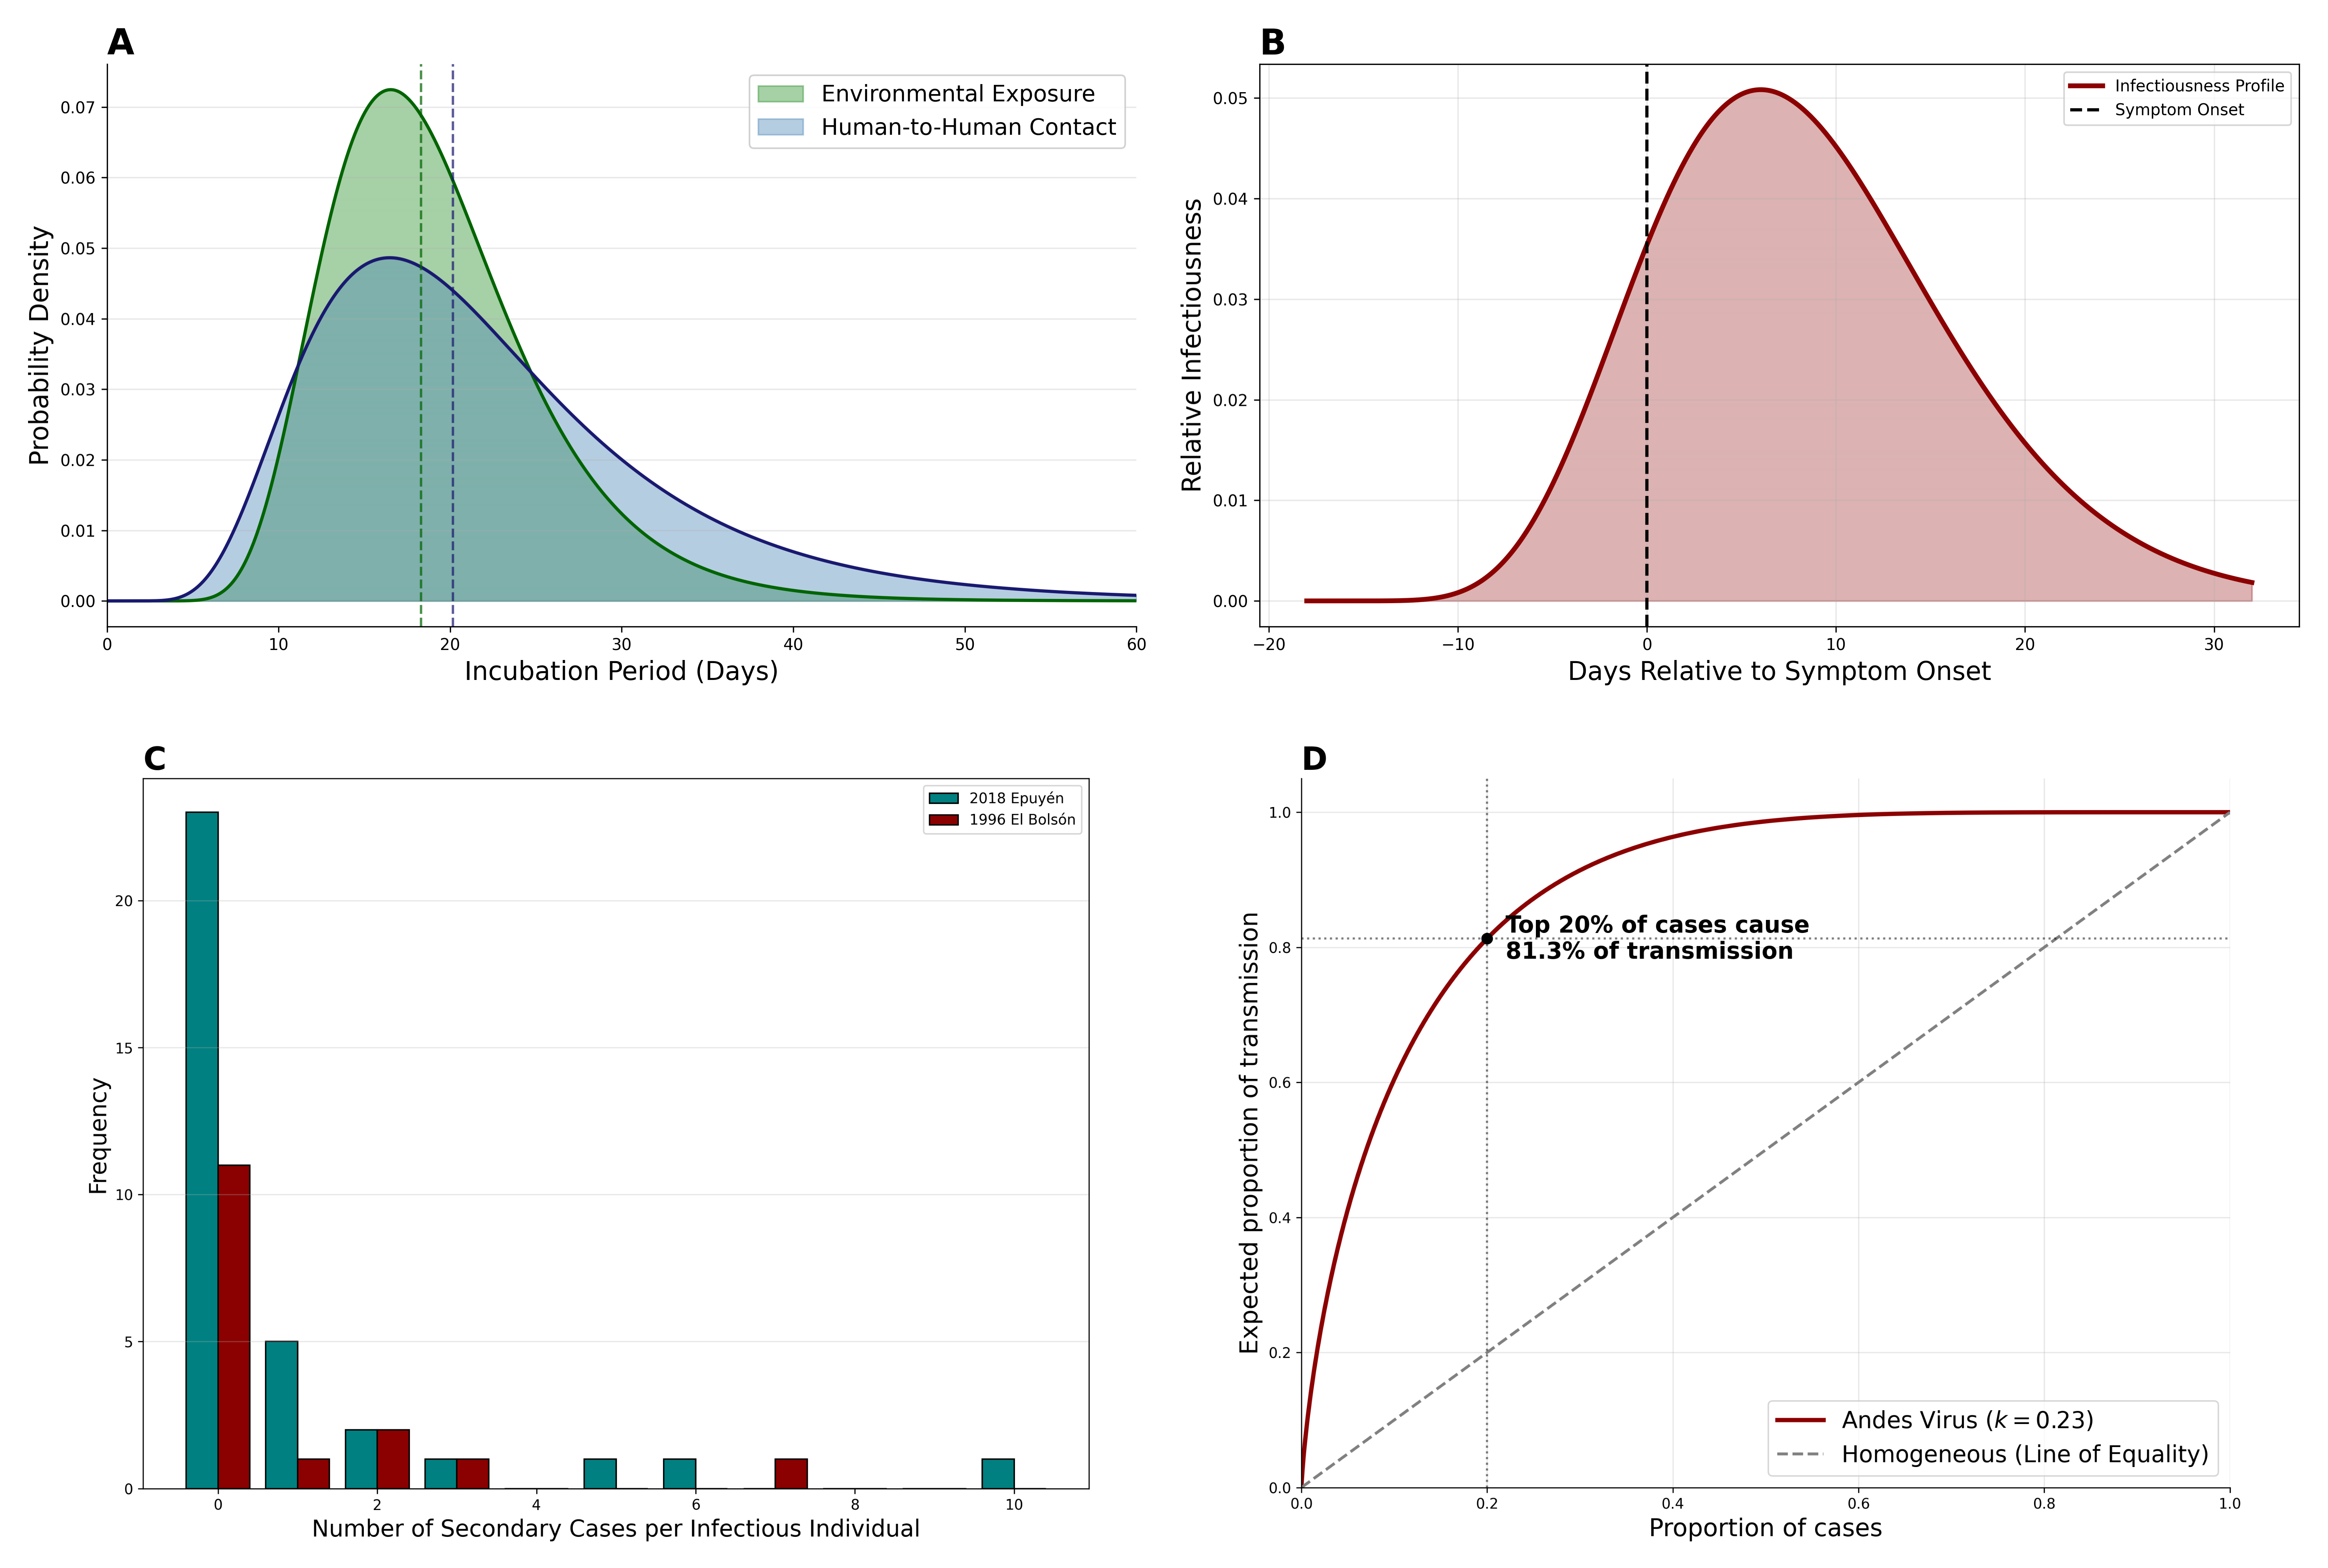

Figure 1. Synthesized Transmission Dynamics of Andes Virus. (A) Comparative incubation dynamics showing overlaid lognormal probability density functions of the human-to-human incubation period (median 20.1 days, derived via MLE) against the established environmental exposure period (median 18.3 days; Vial et al., 2006). (B) Infectiousness profile relative to symptom onset, deconvoluted from the 1996 El Bolsón serial intervals, illustrating approximately 24% presymptomatic shedding. (C) Empirical offspring distribution plotted as side-by-side (dodged) histograms comparing transmission network data from the 1996 El Bolsón and 2018 Epuyén outbreaks. (D) Expected proportion of transmission caused by a given proportion of infectious cases, calculated analytically using the derived dispersion parameter (k=0.24) based on the framework by Lloyd-Smith et al. (2005). The curve demonstrates severe transmission heterogeneity, with the top 20% of cases expected to be responsible for 81.3% of all secondary infections. (, ).

Supplementary Appendices

Empirical Timeline of the MV Hondius Outbreak
We reconstructed the empirical patient-level timeline of the outbreak as of May 15, 2026 using notification data from the World Health Organization. The visualization strictly adheres to reported milestones, documenting the duration of exposure on the vessel, clinical symptom onset, and dates of death for the primary and secondary clusters, highlighting the rapid clinical deterioration of the initial three cases prior to and during the initial May 2nd notification.
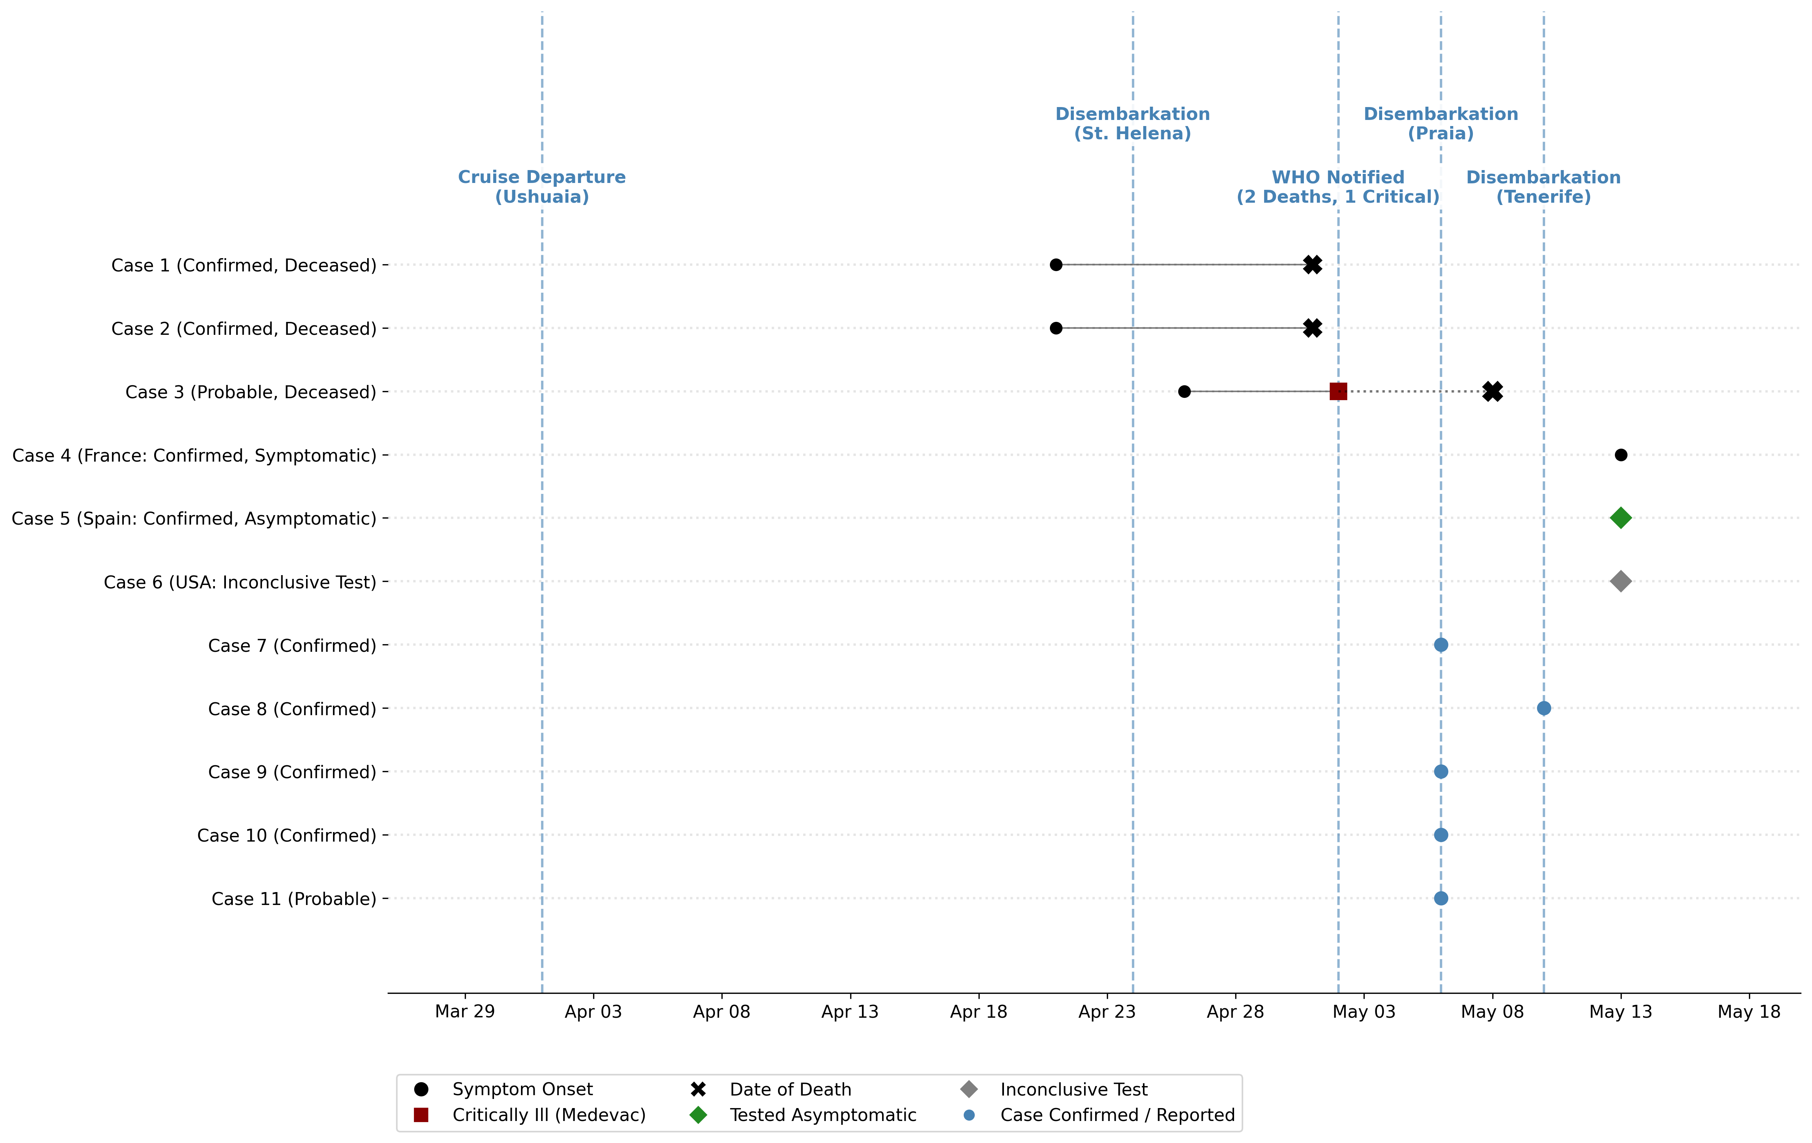 Supplementary Figure S1. Patient-Level Timeline of the MV Hondius Andes Virus Outbreak. Gantt chart illustrating the time spent on the vessel by the 11 identified cases, ending in specific reported events (death, critical illness medevac, symptom onset, or testing).

Stochastic Extinction Simulation
We executed a branching process simulation utilizing the empirical transmission parameters ($R_{0}=0.96$, $k=0.23$) to model 50,000 theoretical virus introductions. The results demonstrate the effect of the dispersion parameter: while the probability of stochastic extinction at the index case is elevated compared to homogenous pathogens, outbreaks that survive the first generation occasionally result in a large number of cases.
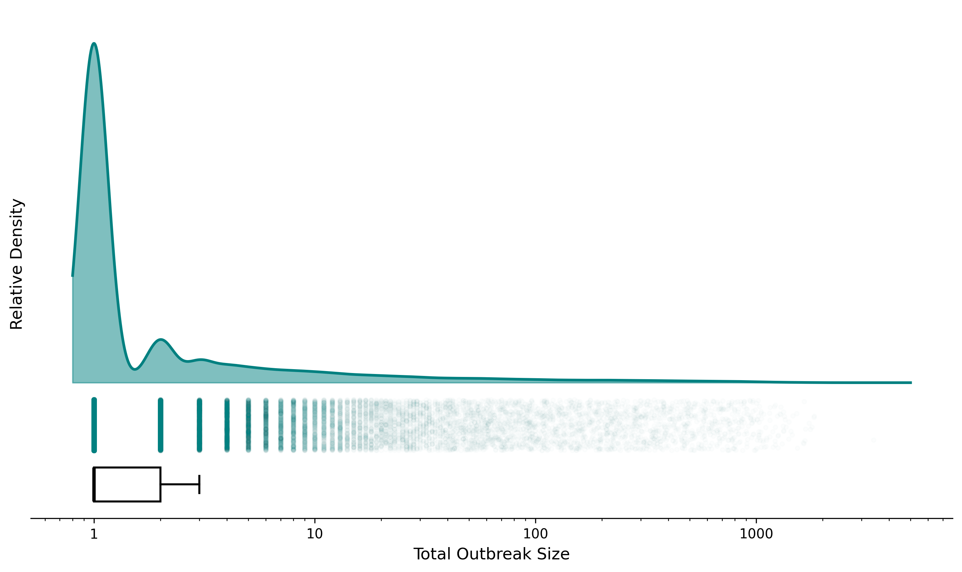 Supplementary Figure S2. Outbreak Size Probability Density. Raincloud plot (log-scaled KDE, jittered raw iterations, and boxplot) representing the total outbreak sizes over 50,000 simulated generations. The explicit log-scale x-axis highlights extreme long-tail clustering events.

Demographic Stratification
Analysis of the 2018 Epuyén line list mapped patient age against individual reproduction numbers. Infectiousness did not linearly correlate with age; rather, superspreading was bound to high-risk social behavioral events (e.g., attending specific indoor gatherings while infectious).
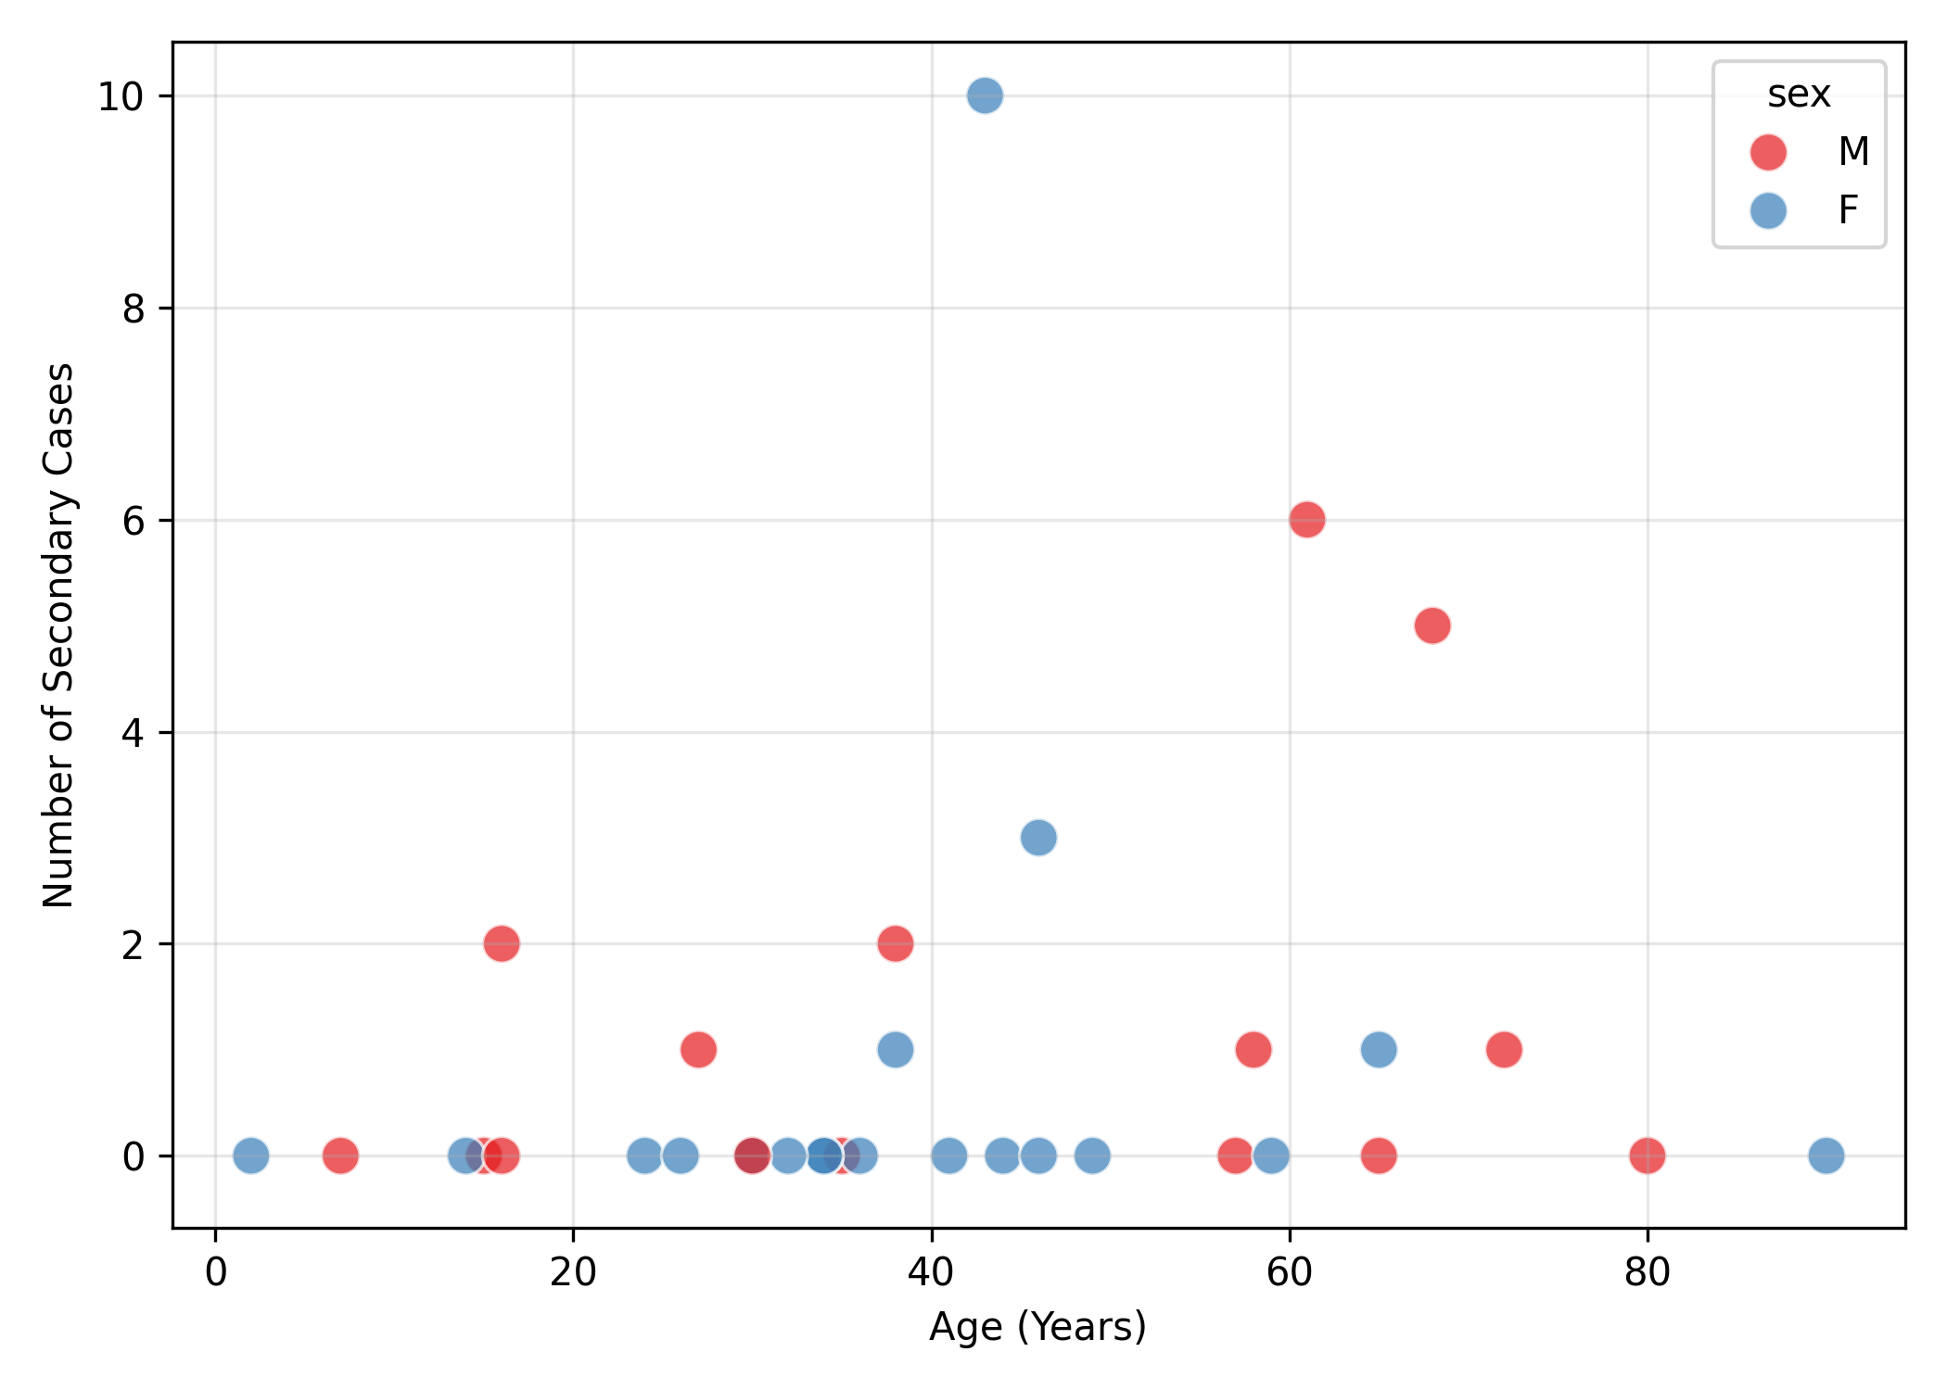 Supplementary Figure S3. Demographic Infectiousness Profiles. Scatter plot mapping the age of index cases against their respective number of secondary infections in the 2018 Epuyén outbreak.

