The First Astronomy…

What would a purblind member of an ancient civilization see upon looking into the night sky? What would he first notice about what appear to be an infinite amount of stars? Well, after a few hours of looking up at the sky, perhaps man would notice that big reddish star that was in the eastern part of the sky is now directly above, and looking closer, one may realize that the rest of the stars have moved along with it.
Man decides to see where it will be the next night. Marking where it is that night, while standing on top of a big rock, the star is located between a pair of dimmer stars underneath it, and a bright star above it. In order to record the time of night, the rising constellation is marked.
Returning the next night, at the same time, upon looking up, the star is in the same spot, and through the night moves with the other stars. Man continues to observe it, keeping a log of its positions in his memory.
One night, looking up, the star is found in its usual spot, or is it… When first observed it was, as is recalled, between the two dimmer stars and the brighter one. On this night, the star is a noticeable distance behind the group of stars it was previously within. With this anomaly in mind you decide to do a more extensive cataloguing of observations.
In deciding to do a more extensive investigation of this motion, man had to develop much more precise means of measurement than a finger and a nearby tree. The first step is to have a common position to stand in. A stationary rock will do the job. Second is to find some means of measuring the horizontal movement. This ushered in the dividing of the horizon into 360 parts. And after defining a starting point, you’re able to start marking off in what direction you see the star. Next you are going to want to determine how high in the sky you see the star. These two measurements are termed right ascension and declination, respectively.

Figure 1: Right Ascension and Declination
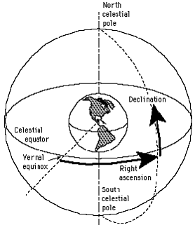

Right Ascension
The development of the astrolabe was an expression of man’s knowledge of the motions of the celestial sphere around them, as this instrument was essentially a map of the heavens. Through stereographic projection, the stars were mapped onto a disc, which, having a second layer that rotated overtop the map, could show to the user the sky visible from that position during any time of the year.

Figure 2: The Astrolabe

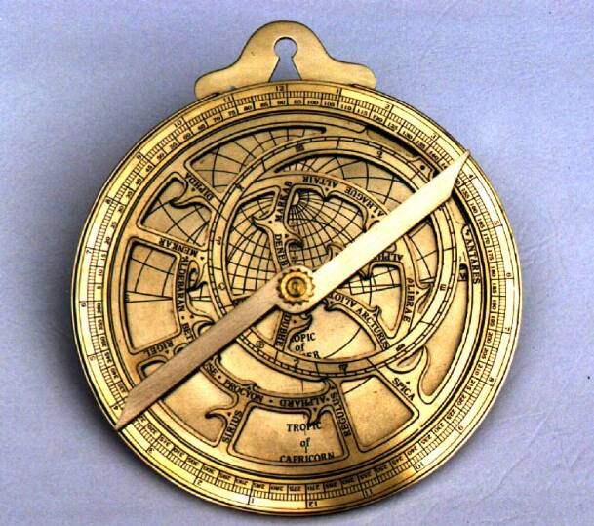
The Astrolabe was used, with a few advancement, until the middle of the 17th Century. The manufacture of pendulum clocks allowed astronomers more accurate means of determining the time and position of star.

Declination
In order to measure the stars’ declination, the sextant was developed. It works by aligning the horizon with the horizon mirror on the front of the instrument. That mirror is clear on one half, letting the other side reflect the star. Holding the sextant in line with the horizon, one moves the index mirror in order to reflect the light of the star down to the horizon mirror, and in doing so, positions the arm of the index mirror over the angle measurement on the graduated slide, revealing the correct angle of the star in the sky.

Figure 3: The Sextant

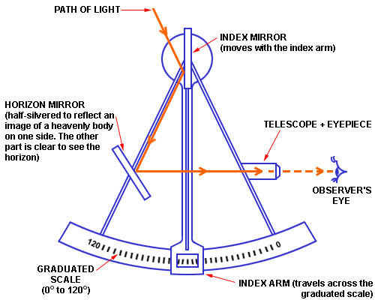

Until the development of the telescope, the sextant was still common among astronomers for measuring the position of stars.

