Grazioso Salvare Dashboard README
Jason Wick | jwick239526874
CS 340 Client Server Development | Project Two
October 18, 2026

Purpose and functionality
This dashboard helps Grazioso Salvare identify shelter dogs that match three search and rescue training profiles. The completed application reads the Austin Animal Center Outcomes collection through my Project One CRUD module, provides interactive rescue filters and an animal table, and displays a breed distribution chart and a map for the selected animal.
The initial view includes all 10,001 records currently in the lab collection. Radio buttons select Water Rescue, Mountain or Wilderness Rescue, Disaster or Individual Tracking, or Reset. The table supports five rows per page, column sorting, column filtering, and one selected animal. Profile changes clear table filters, sort order, and pagination. Reset restores the unfiltered table and both charts.
The Grazioso Salvare logo links to https://www.snhu.edu. My name and username appear in the header and footer and remain visible in every required screenshot.

Tools and application design
MongoDB is the model because its document structure matches the shelter records and supports compound filters on breed, sex, animal type, and numeric age. PyMongo exchanges these query dictionaries and result documents with Python. The existing AnimalShelter.read(query) method materializes the matching documents as a list; the dashboard does not bypass the CRUD module for database queries.
Dash supplies the view components and callback controller. A profile callback retrieves records and updates the table; downstream callbacks use the table's derived virtual data for the breed chart and its selected row for the map. Pandas prepares records and counts breeds, Plotly Express draws a donut chart, and Dash Leaflet displays location tiles and markers. JupyterDash runs the notebook version in Codio.
The verified environment uses Python 3.11, Dash 2.8.1, JupyterDash 0.4.2, Dash Leaflet 0.1.23, Pandas 2.0.1, Plotly 5.14.1, and PyMongo 4.13.2. requirements.txt records these and related installed versions to preserve compatibility with the course environment.

Rescue query rules
Each rescue query requires animal_type equal to Dog. Breed matching uses exact values from the specifications with MongoDB $in. Age bounds are inclusive and use age_upon_outcome_in_weeks. The counts below reflect the existing lab data on the test date, rather than a fixed number built into the dashboard.
Profile | Preferred breeds | Sex | Age in weeks | Count
Water | Labrador Retriever Mix; Chesapeake Bay Retriever; Newfoundland | Intact Female | 26 to 156 | 17
Mountain or Wilderness | German Shepherd; Alaskan Malamute; Old English Sheepdog; Siberian Husky; Rottweiler | Intact Male | 26 to 156 | 5
Disaster or Individual Tracking | Doberman Pinscher; German Shepherd; Golden Retriever; Bloodhound; Rottweiler | Intact Male | 20 to 300 | 4
Reset | All animals with an empty query dictionary | All | All | 10,001

Files in the code package
ProjectTwoDashboard.ipynb contains the completed dashboard source and saved execution output. CRUD_Python_Module.py is the reused Project One database interface. project_two_dashboard.py provides the same dashboard as a standalone script. The package also includes Grazioso Salvare Logo.png, requirements.txt, README.md, and PROJECT_TEST_RESULTS.txt.

Reproduce the database environment
Extract the code ZIP and keep its files together in the ProjectTwo directory. In the existing Codio workspace, use /home/codio/workspace/code_files. The course dataset is already under /home/codio/workspace/datasets and MongoDB must be running on localhost port 27017 with database aac and collection animals.
For a fresh database only, import the course CSV using the following command. Do not repeat the import into an already populated collection, because duplicate records would change the results.
mongoimport --db aac --collection animals --type csv --headerline \
--file /home/codio/workspace/datasets/aac_shelter_outcomes.csv
Use an administrator connection if authentication is enabled. The training login aacuser must authenticate against admin and have readWrite access to aac, as established in Project One. For a new lab instance, create that account from an administrator Mongo shell session:
use admin
db.createUser({user: "aacuser", pwd: "password",
roles: [{role: "readWrite", db: "aac"}]})
The dashboard instantiates AnimalShelter("aacuser", "password") as required by the assignment. The module defaults to auth_source="admin". This account is the course training account; a deployment outside the lab should supply its own credentials and configuration.

Install and run the dashboard
1. Use the supplied Codio Python 3.11 environment. Its dependencies are already installed. For a separate compatible environment, install the recorded versions from the extracted project directory:
python -m pip install -r requirements.txt
2. Open ProjectTwoDashboard.ipynb in JupyterLab with the Python 3 kernel. Set the working directory to the directory containing the notebook, CRUD module, and logo. Select Run All. The main code cell creates the database connection and starts the inline JupyterDash dashboard on port 8053.
3. For a full browser view or a terminal launch, use the standalone script instead of running a second server on the same port:
cd /home/codio/workspace/code_files
DASH_STANDALONE=1 python project_two_dashboard.py
Open the Codio HTTPS preview for port 8053. In this workspace, the tested address is https://jazzsabine-javaeclipse-8053.codio.io. A different Codio box has a different hostname. A local deployment can use http://localhost:8053. Keep the server process running while using the dashboard.
4. Select each rescue profile and inspect the record count, table, breed chart, and selected animal location. Select another table row to move the map. Use Reset to clear table filtering and sorting and restore all shelter animals. The donut chart groups breeds beyond the eight most frequent into Other breeds only when more than eight distinct breeds exist; all matching records still contribute to its total.

Verification and resolved challenges
The completed notebook executed successfully through nbclient without a code-cell error. Direct CRUD queries returned 17 water, 5 mountain or wilderness, 4 disaster or tracking, and 10,001 unfiltered records. Browser testing confirmed the corresponding counts and updates to the table, breed chart, and map. Selecting Sargent changed the map label to A765461. An unmatched Animal Id filter produced an empty table and empty-state messages; Reset cleared that filter and restored the initial view.
MongoDB ObjectId values are not ordinary JSON values, so the display preparation removes _id and converts missing values to None. Map selection uses derived virtual data and derived virtual selected rows so sorting or filtering does not map an unrelated record. Missing names receive an Unnamed animal label; missing or invalid coordinates produce a readable message rather than a callback failure. The chart aggregates less common breeds to keep the initial view readable.
The embedded JupyterLab pane stalled while loading. Notebook execution was verified through a Python kernel with nbclient, and browser testing used the equivalent standalone dashboard. Port 8053 avoids the Module Six dashboard on port 8052. Existing dependencies were retained and recorded to avoid incompatible upgrades. The five screenshots on the following pages show the required starting and filtered states with my username visible.

Resources and references
Southern New Hampshire University. CS 340 Project Two Guidelines and Rubric and Dashboard Specifications Document. Course materials in Brightspace.
Austin Animal Center. Austin Animal Center Outcomes (2020). Course-modified CSV with location and age fields. https://doi.org/10.26000/025.000001
MongoDB. PyMongo documentation for finding documents. https://www.mongodb.com/docs/languages/python/pymongo-driver/current/crud/query/find/
Plotly. Dash documentation and callback-based DataTable behavior. https://dash.plotly.com/ and https://dash.plotly.com/datatable/callbacks
Plotly. JupyterDash source and notebook integration. https://github.com/plotly/jupyter-dash
Dash Leaflet. Map components and getting started. https://www.dash-leaflet.com/docs/getting_started
Pandas. DataFrame and data preparation reference. https://pandas.pydata.org/docs/
Python Software Foundation. PEP 8 style guide. https://peps.python.org/pep-0008/
SNHU AI guidance. Student generative AI guidance: https://snhu.ink/StudentGenAIGuide and citation guidance: https://snhu.ink/CitationAndAI
OpenAI. Codex, AI coding assistant used October 18, 2026. https://openai.com/codex/

Reading the evidence
Figures 1 through 5 are full-page captures of the running dashboard. Each includes the Grazioso Salvare logo, Jason Wick, and jwick239526874. The initial and Reset views include the complete collection, including animals that are not dogs; the rescue profiles restrict the results to dogs matching their specified breed, sex, and age criteria.
The map represents the selected animal, not a marker for every animal in the table. The breed chart represents all rows in the current table filter, including rows on other pages. Counts depend on the collection contents and can change if the dataset is modified.

Initial dashboard
Figure 1. Starting state with all 10,001 shelter records. Reset is selected by default. The logo, username, interactive table, breed chart, and selected animal map are visible.
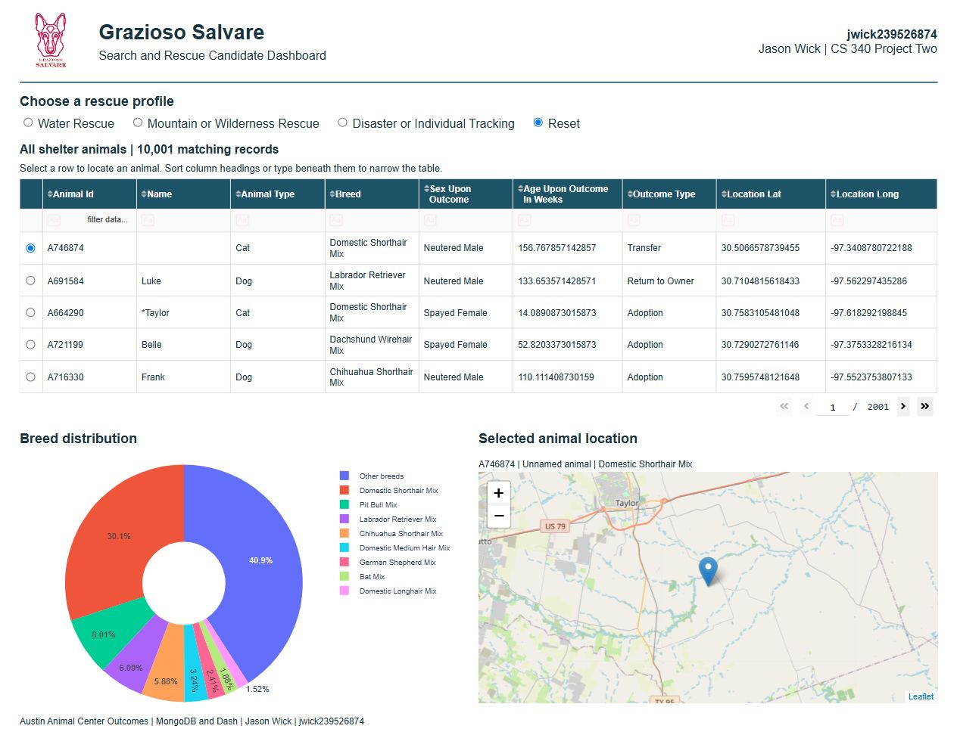

Water rescue results
Figure 2. Water Rescue returns 17 matching dogs. In this lab dataset all 17 are Labrador Retriever Mix, so that breed occupies 100 percent of the chart. The map displays the first selected matching animal.
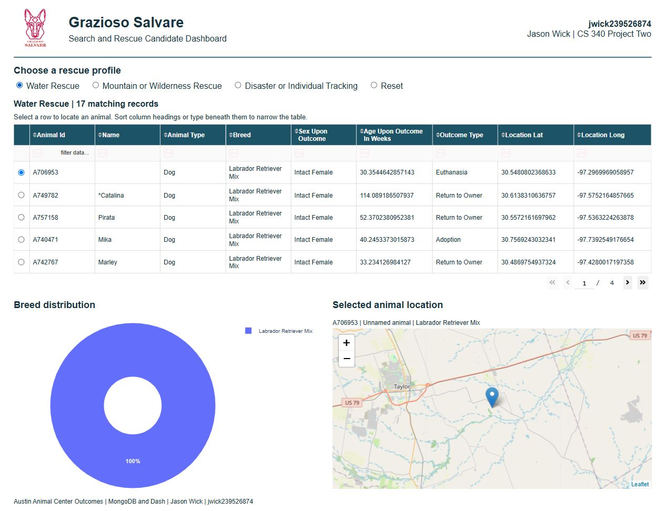

Mountain and wilderness results
Figure 3. Mountain or Wilderness Rescue returns 5 matching dogs. The breed chart displays four breeds, and the selected Papa record appears on the map. The username remains visible above the controls.
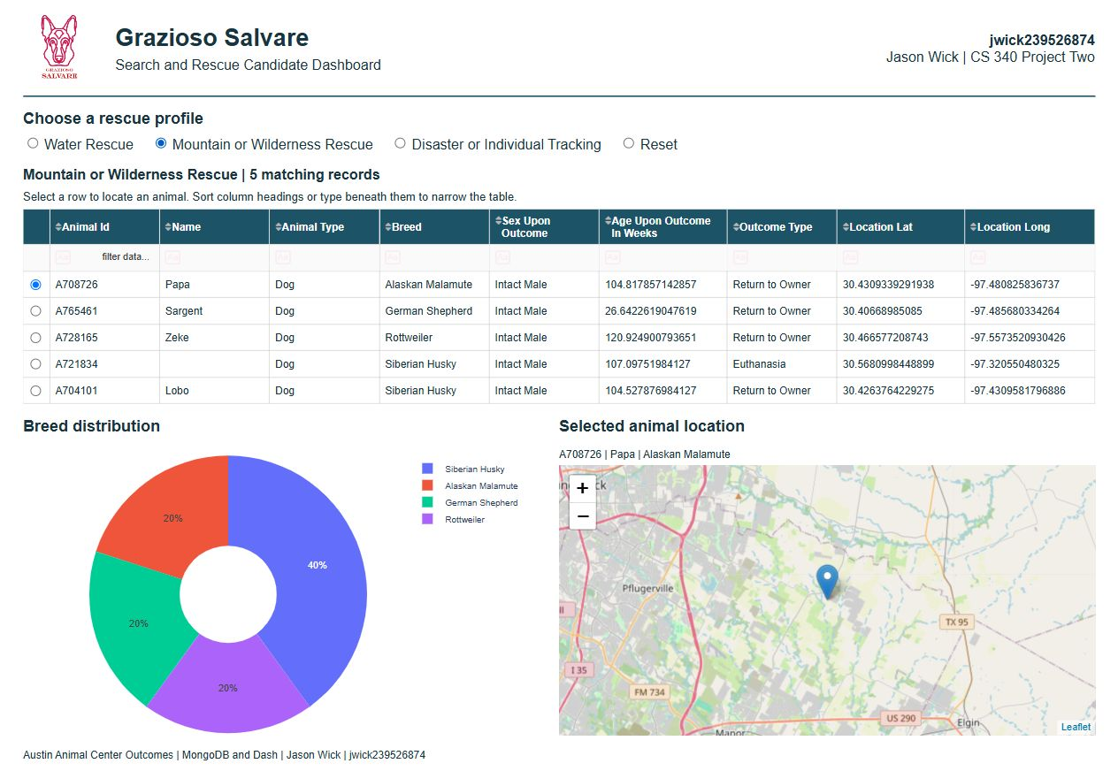

Disaster and tracking results
Figure 4. Disaster or Individual Tracking returns 4 matching dogs. Rottweilers account for half of the results, with Bloodhound and German Shepherd making up the remainder. Boomer is the selected animal on the map.
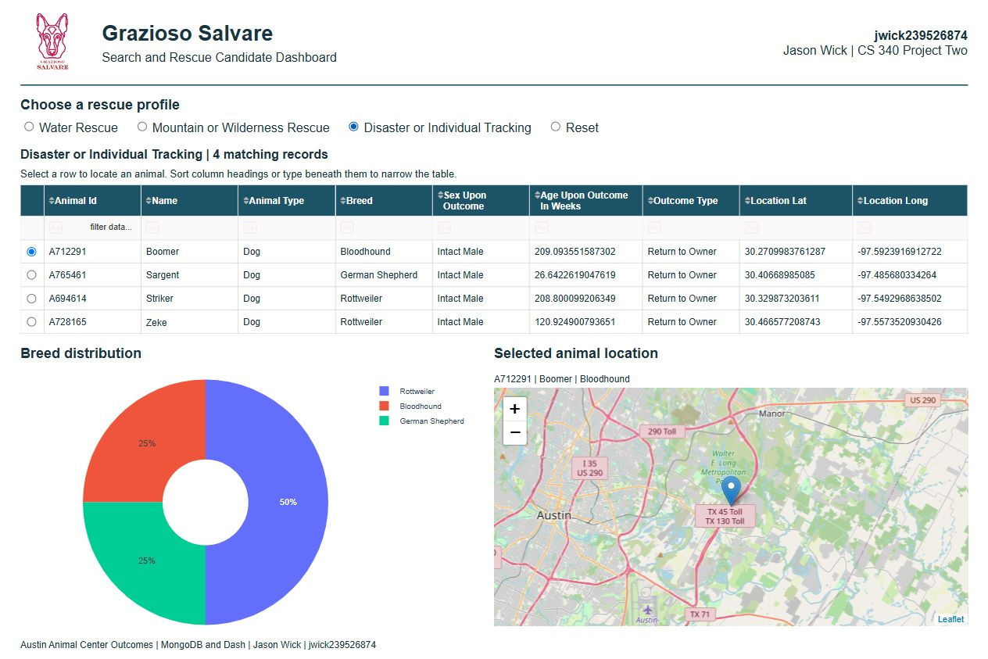

Reset restores the starting state
Figure 5. After an unmatched table filter test, Reset restores all 10,001 records, clears the table filter and sort state, returns to the first page, and restores the initial breed chart and selected animal map.
