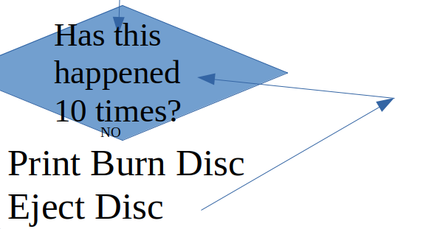
START
Print Burn Disc
Eject Disc
Has this happened 10 times?
NO
Yes
Print Eat An Onion
Stop
Yes

