PLC-Based Sample PLC/ICS Project
OpenPLC Temperature-Control System
Jason Cala | August 2026 | github.com/jasoncala/openplc-temperature-control
Project Summary
This project completes the CPSec & CyFI Labs exploratory assignment by implementing a software-only temperature-control loop using OpenPLC Editor, Structured Text, OpenPLC Runtime v3, Docker, Modbus TCP, Python, and PyModbus. Python simulates the temperature sensor, OpenPLC executes the fan logic, and Python reads the resulting fan output.
Temperature condition | Expected fan
>= 30 C | ON
<= 27 C | OFF
28-29 C | Retain previous state
The separate 30 C ON threshold and 27 C OFF threshold create a 3 C hysteresis band. The final ordered validation passed 9 of 9 cases, including both threshold boundaries and both retained-state cases.
FINAL RESULT: 9 TESTS PASSED, 0 FAILED
Thoughts
Overall, I greatly enjoyed the exploratory work that I tackled in this simple project. I would love to continue with this learning and pursue deeper, cutting-edge research in ICS security, PLC applications, and AI/ML. I would love to hear more about the opportunities and projects available.

Report Sections
Assignment task | Main evidence
1. Setup OpenPLC | Screenshots 01-09; Dockerfile; Runtime notes
2. Learn Structured Text | Boolean project; screenshots 10-14
3. Define scenario | Controller project; screenshots 15-19
4. Deploy and execute | Runtime upload and Running status; screenshots 20-21
5. Establish Modbus | PyModbus client; screenshots 22-24
6. Validate results | Nine-test CSV, console output, plot; screenshots 25-26
Assignment Task 1: Explore and Setup OpenPLC
Install OpenPLC editor and Runtime. Document successful setup.

Steps Performed:
1. Recorded Windows, virtualization, WSL, Git, Python, Docker, and VS Code details.
2. Installed and opened OpenPLC Editor.
- Chose Runtime v3 because its browser dashboard and Programs upload page directly matched the assignment's web-interface requirement. V3 is no longer maintained (archived repo), so for that reason, it was pinned, containerized, restricted to localhost, and used only for this research exercise.
3. Pinned the Runtime source to commit b5d41356dab4aeadca0dd7ca64ba542f870b595d.
4. Built openplc-v3-local with the custom Dockerfile and created the persistent volume openplc-v3-data.
5. Started container openplc-v3 with dashboard port 8080 and Modbus port 1502 bound only to 127.0.0.1.
6. Logged in through the Runtime web interface, changed the default password, and verified the new password.

Recorded component | Value
Host | Windows 11 Home 25H2
Python | 3.11.9
Docker Desktop | 4.84.0
Docker Engine / CLI | 29.6.2
VS Code | 1.108.1
Runtime endpoint | http://127.0.0.1:8080
Modbus endpoint | 127.0.0.1:1502
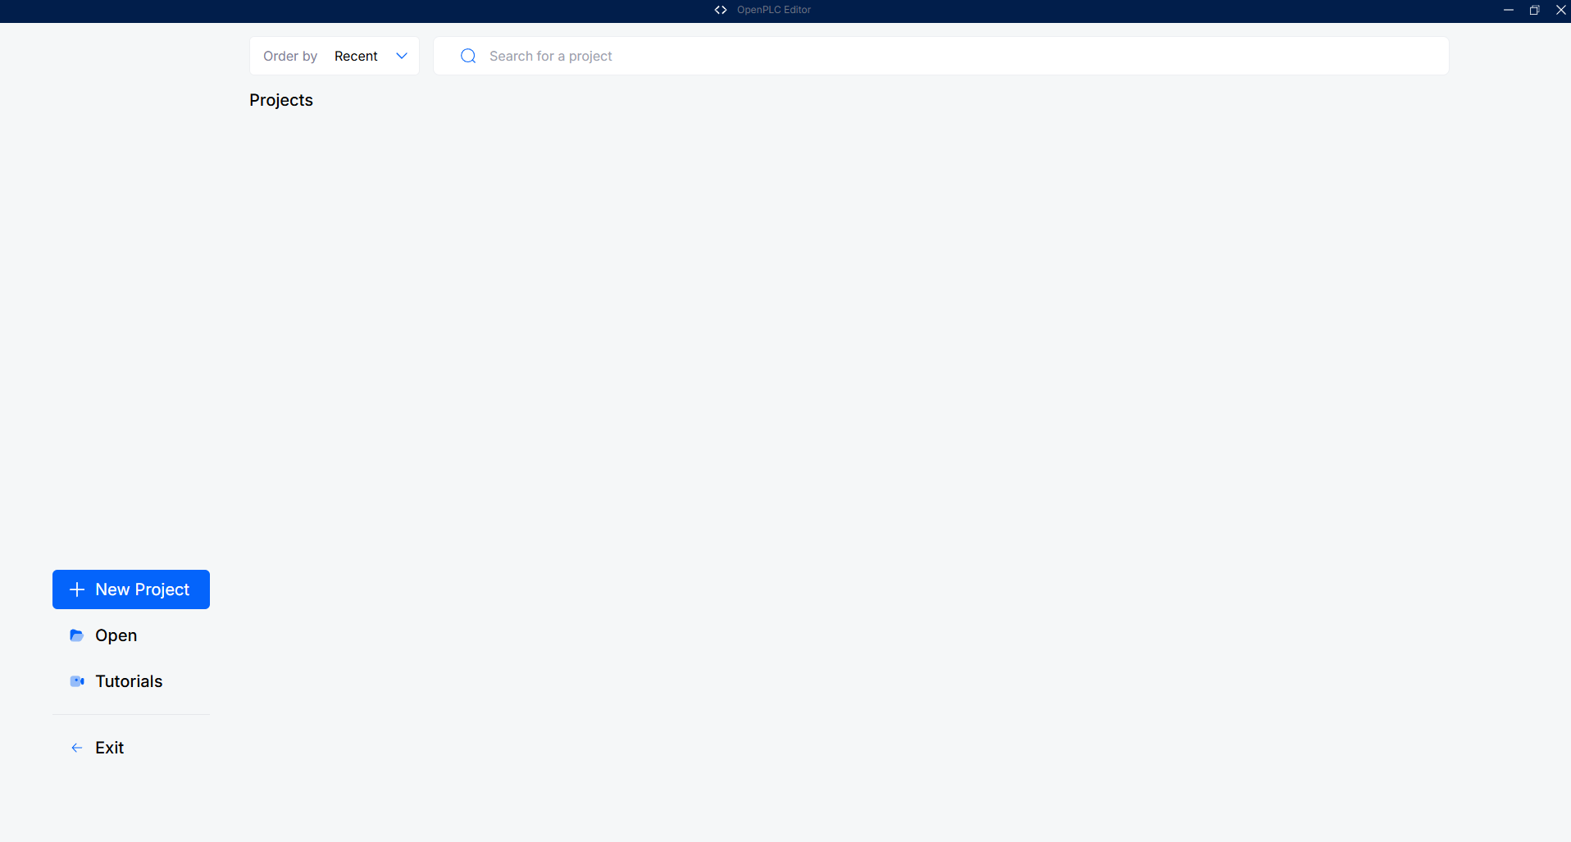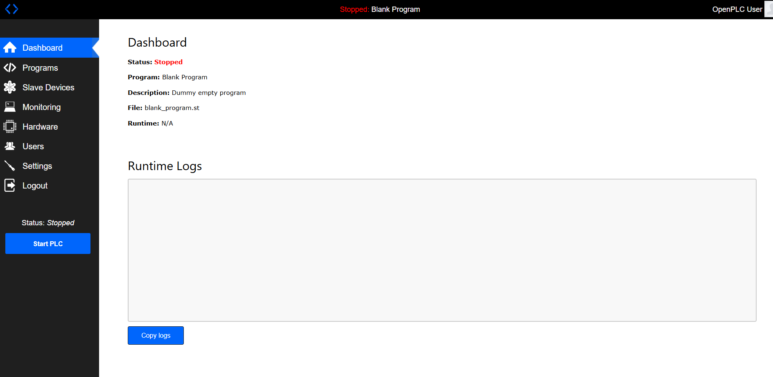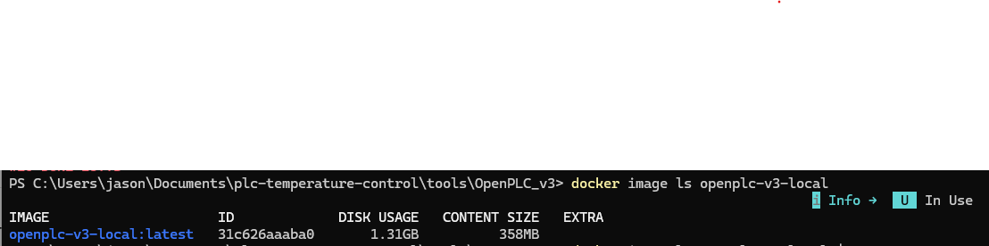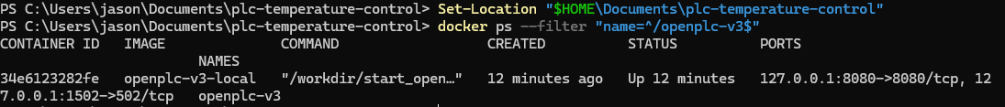
Figures 1-4. Editor installation, Runtime dashboard, Docker image, and localhost port evidence
Assignment Task 2: Learn PLC Programming with Structured Text
Write a small Boolean program and verify the Editor and simulator environment.

Steps Performed:
1. Created plc/boolean_test in OpenPLC Editor.
2. Added TestInput, Enable, and TestOutput as Boolean variables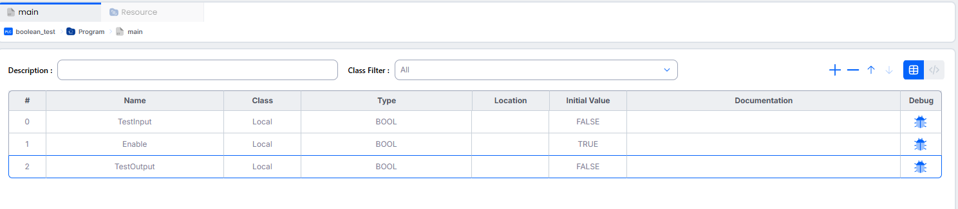3. Implemented the AND expression shown below.
4. Configured a cyclic MainTask and MainInstance.
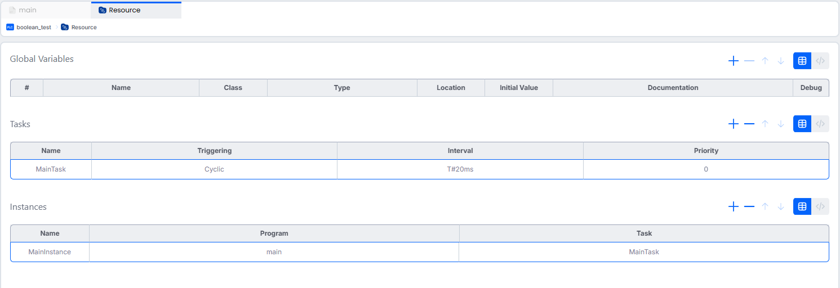
5. Built and ran the project in the simulator.
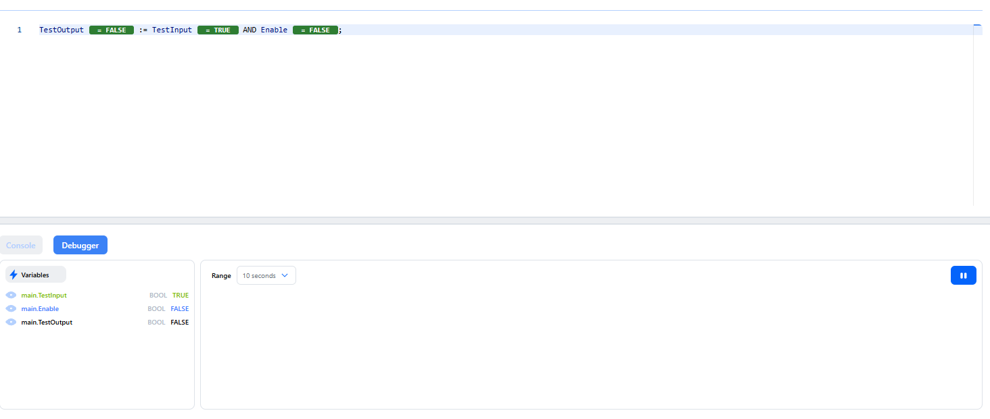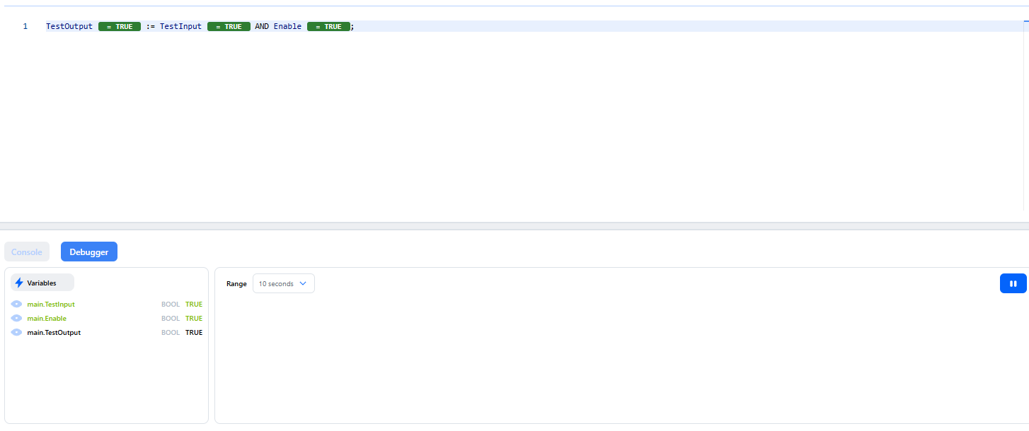
6. Tested all four Boolean combinations; all produced the expected output.

Full Results:
TestOutput := TestInput AND Enable;
TestInput | Enable | Expected | Result
FALSE | FALSE | FALSE | PASS
FALSE | TRUE | FALSE | PASS
TRUE | FALSE | FALSE | PASS
TRUE | TRUE | TRUE | PASS

Assignment Task 3: Define the Temperature-Control Scenario
Define the simulated sensor, fan output, thresholds, logic, and rationale.

Steps Performed:
1. Defined variables:
- Temperature as UINT at %MW0 with initial value 20.
- Fan as BOOL at %QX0.0 with initial value FALSE.
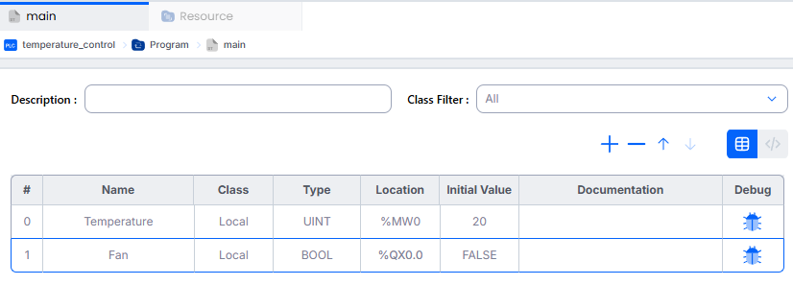
2. Selected 30 C as the ON threshold and 27 C as the OFF threshold.
- Used a 3 C hysteresis band so the middle range preserves the prior state.
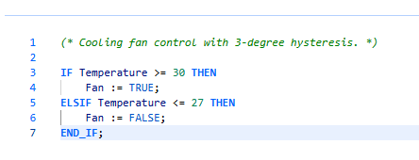
4. Implemented the controller in plc/temperature_control.
5. Configured a 20 ms cyclic task.
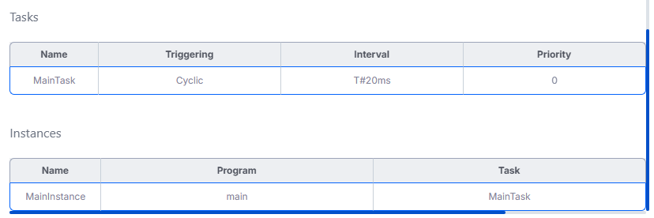
6. Confirmed in simulation that 28 C retained OFF and 29 C retained ON.
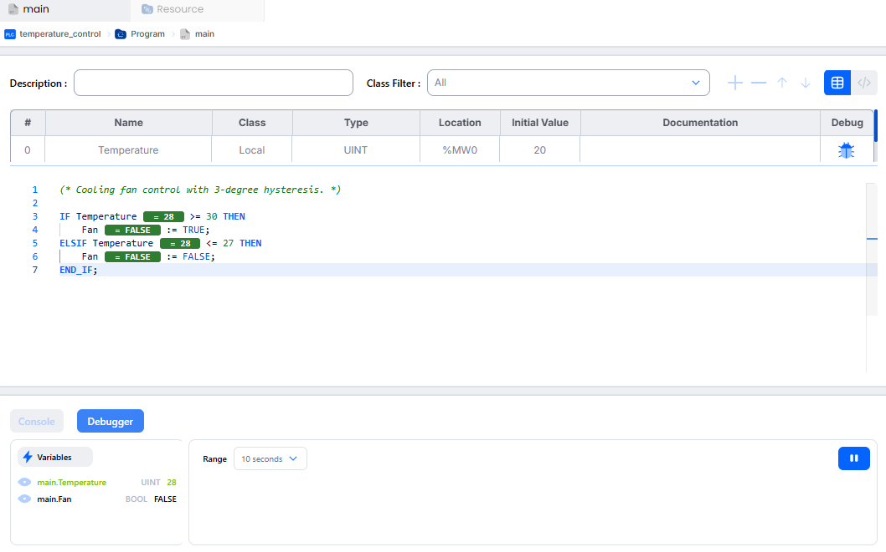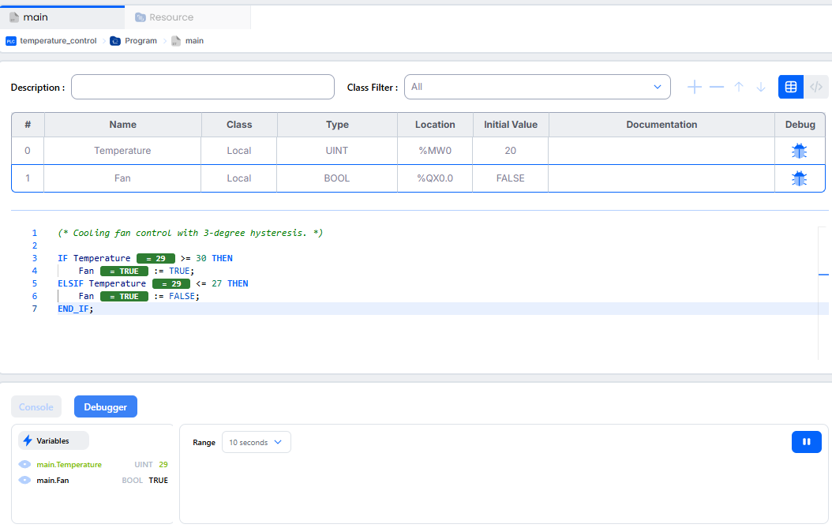
Assignment Task 4: Deploy and Execute the Control Logic
Upload the Structured Text program to Runtime and confirm operation in the web interface.

Steps Performed:
1. Created the complete Runtime file plc/exported/temperature_control_runtime.st.
- This included the program, located variables, hysteresis logic, configuration, resource, cyclic task, and program instance.
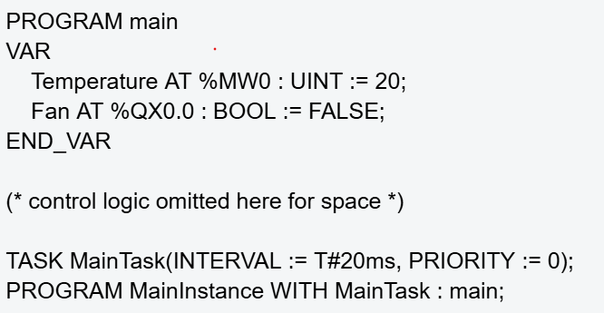
2. Opened the Runtime dashboard at http://127.0.0.1:8080.
3. Uploaded the .st file through the Programs page as Temperature Control.
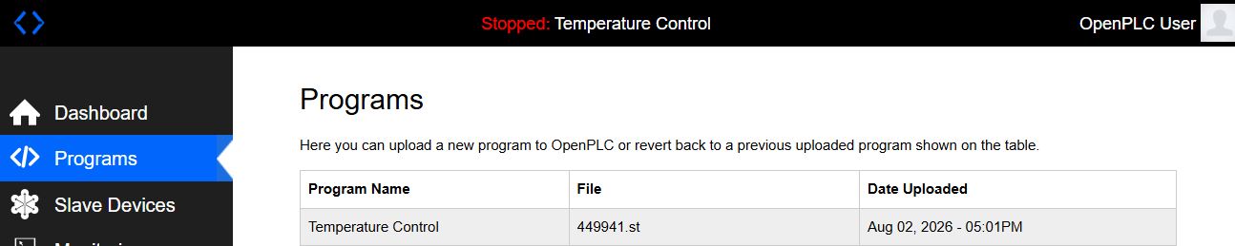
4. Waited for compilation and reviewed the Runtime log.
5. Confirmed the dashboard displayed the program in the Running state.
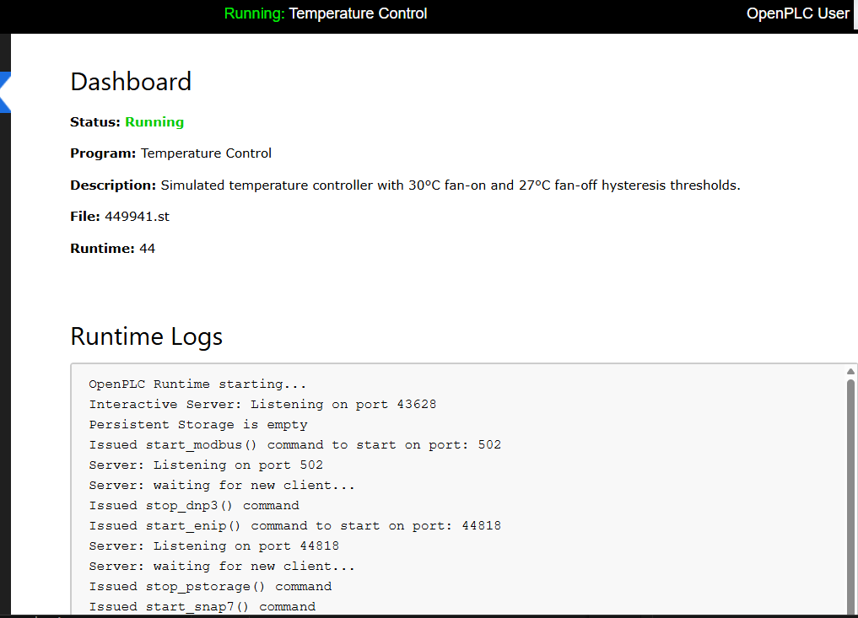
Assignment Task 5: Establish Modbus Communication
Use PyModbus to send simulated temperature data and read the fan control signal.

Steps Performed:
1. Created a Python 3.11 virtual environment and installed PyModbus 3.11.1.
2. Confirmed host port 1502 forwarded to OpenPLC container port 502.
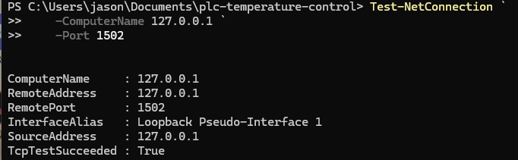
3. Mapped %MW0 to holding register 1024 and %QX0.0 to coil 0.
PLC variable | IEC location | Modbus area | Address
Temperature | %MW0 | Holding register | 1024
Fan | %QX0.0 | Coil | 0
4. Created client/modbus_smoke_test.py with connection, write, read, response-checking, timeout, and cleanup logic.
5. Wrote the requested temperature, waited for PLC scans, read the register back, and read the fan coil.
6. Confirmed 20 C produced fan OFF and 35 C produced fan ON.
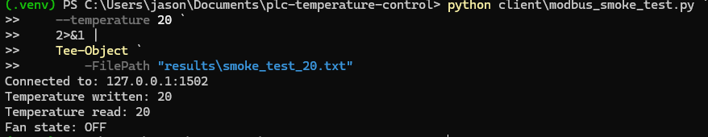
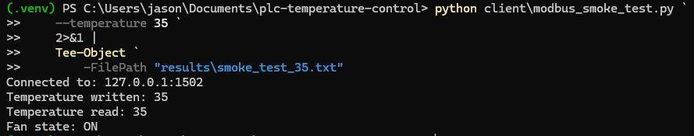

Assignment Task 6: Validate and Document the Results
Vary sensor inputs, compare actual and expected behavior, and document the results.

Steps Performed:
1. Created client/validate_controller.py.
2. Reset the PLC to a deterministic low-temperature OFF state.
3. Applied the ordered sequence 20, 27, 28, 30, 29, 27, 40, 35, and 27 C.
4. Calculated the expected fan state independently in Python.
5. Polled the Runtime until the expected temperature and fan state appeared or the timeout expired.
6. Recorded written val, read val, expected fan, actual fan, elapsed time, and PASS/FAIL result.
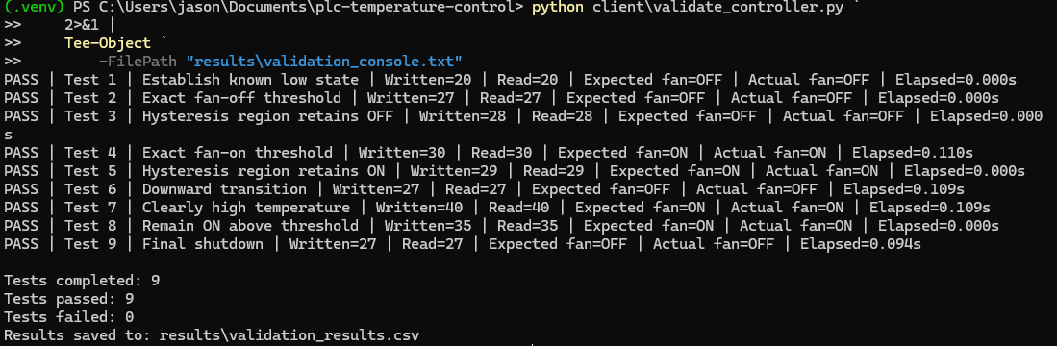
7. Saved results/validation_results.csv and generated results/validation_plot.png.
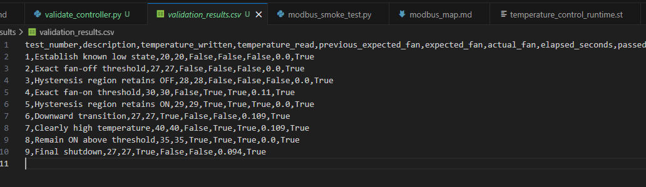
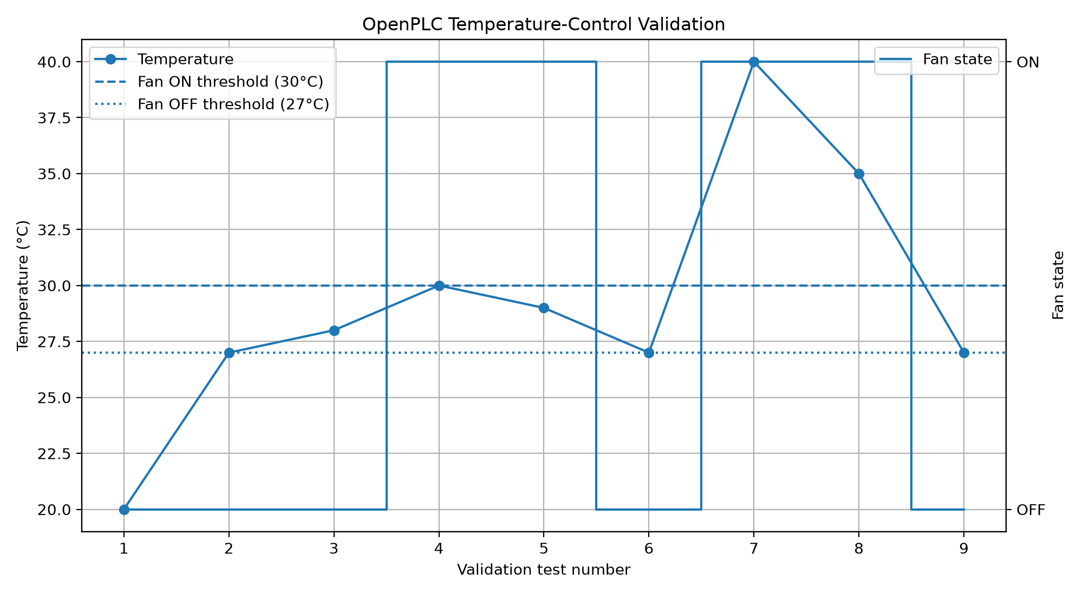
Conclusion

As written in the report above as well as shown in the github repository (https://github.com/jasoncala/openplc-temperature-control), I completed all six requested assignment tasks. This report demonstrates OpenPLC setup, Structured Text programming, a documented temperature-control scenario, deployment through the Runtime web interface, Modbus TCP communication from Python, and repeatable validation. All nine ordered validation cases passed, including exact thresholds and both hysteresis-retention cases.

This assignment has only increased my interest in the CPSec lab further. It matched my interest of software involved with physical systems and I believe further investigating the ways AI and security niches interact with these things would be fascinating to me. I believe my foundations and my commitment would make me a good candidate for the laboratory as a long term investment. I am committed to growth, learning, and delivering results even through hardship.

Repository Evidence & Reproduction
Throughout the repository there are many pieces of evidence I’ve uploaded including screenshots, notes as markdown files, and logs as txt files.

If the project is needed to be reproduced then the repo’s README file will be helpful. For example the following steps could be followed in windows powershell:
