System Overview
*Generated: 2026-09-16 08:00 UTC*

Platform Summary
Platform | Component | Count
Talend | Projects | 1
Talend | ETL Jobs | 289
Talend | DB Connections | 9
Talend | Context Groups | 23

Architecture
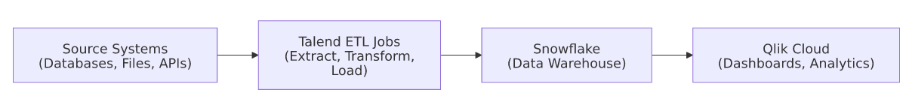

Data Flow Summary
The system follows a standard ETL → Warehouse → BI pattern:
- Talend extracts data from source systems, applies transformations,
and loads results into Snowflake.
- Snowflake serves as the central data warehouse.
- Qlik Cloud connects to Snowflake for analytics and reporting.
*Feed this document along with the detailed job and app documentation* *to Claude or another AI for narrative enrichment and flow diagrams.*

