System Architecture Document — EDW2SF Project

Overview
EDW2SF is a large, mature Talend project: 289 jobs pulling from a mix of legacy MSSQL databases (per subsystem: a general collections database, the "EDWProdHH" operational database, two call-center telephony databases, an HR/timekeeping "HUB" database), a MySQL-based "HOPE" system, and existing Snowflake data, consolidating it all into a Snowflake enterprise data warehouse (multiple logical schemas: a staging area, the main legacy-modeled warehouse, a "HUB" mart, and a "DM" data mart), then republishing curated subsets to a separate Snowflake "publish" schema for reporting (SF_PUB_LW) and to flat files for a long tail of external partners, counties, health systems, and internal report consumers. This project uses genuine job-to-job orchestration: a handful of "Master_Load"/orchestrator jobs (see 06_dependency_matrix.md) call chains of narrower jobs via tRunJob, most visibly a full per-site pipeline in CO_Master_Load (client data → debtor data → transactions → dimensions). No Qlik Cloud metadata was supplied for this generation run either, so any Qlik/Tableau consumption of these Snowflake tables is not documented here beyond noting that a TableauVariables context group and a single TableauOutput component exist.

Detail table
Item | Value
Project / tenant name | EDW2SF
Total Talend jobs | 289
Total DB connections (Talend repository) | 9 — EDWProdHH_0.1, EDWStage_0.1, HOPE_0.1, HUB_0.1, I3_Dialer_40_0.1, I3_GBHQ_0.1, I3_IC_40_0.1, SnowflakeJDBC_0.1, TalendLog_0.1 — all 9 have blank host/port/database/schema in the repository entry itself
Total context/variable groups | 23 (see 06_dependency_matrix.md for which jobs use which)
Total Qlik apps | Unable to determine from metadata — verify with team (no qlik_metadata.json was supplied)
The 9 repository connection *entries* are placeholders — every actual connection a job opens is a component labeled by hand with a logical name (e.g. LEGACY_DW, LEGACY_STAGING, MSSQL_CXN, HERMES), and that logical name's real account/host/credentials live in a same- or similarly-named context group, not in the 9 blank repository rows above. The labels actually used across the 289 jobs' connection components are:
Connection label (as set on the component) | Type | Jobs using it
LEGACY_STAGING | Snowflake | 100
SF_CXN | Snowflake | 44
LEGACY_DW | Snowflake | 38
MSSQL_CXN | MSSQL | 30
SF_PUB_LW | Snowflake | 21
EDWProdHH | MSSQL | 12
I3_Dialer_40 | MSSQL | 7
HERMES | Snowflake | 7
HUB | MSSQL | 6
LEGACY_HUB | Snowflake | 6
I3_IC_40 | MSSQL | 6
PUB_JCHANG | Snowflake | 5
HOPE | MySQL | 4
LEGACY_HOPE | Snowflake | 3
LEGACY_DM | Snowflake | 3
DIALER_I3 | Snowflake | 2
SnowflakeJDBC | JDBC (generic) | 1
SF_STG_CXN, DEDOR_DW, SF_Equabli, SF_Equabli_2, SF_DW, DW | Snowflake | 1 each
SF_Equabli/SF_Equabli_2 and PUB_JCHANG stand out as likely one-off or individual-owned connections (a named external partner and what looks like a personal developer schema) rather than shared platform infrastructure — worth confirming whether these should still be in production use.

Data flow
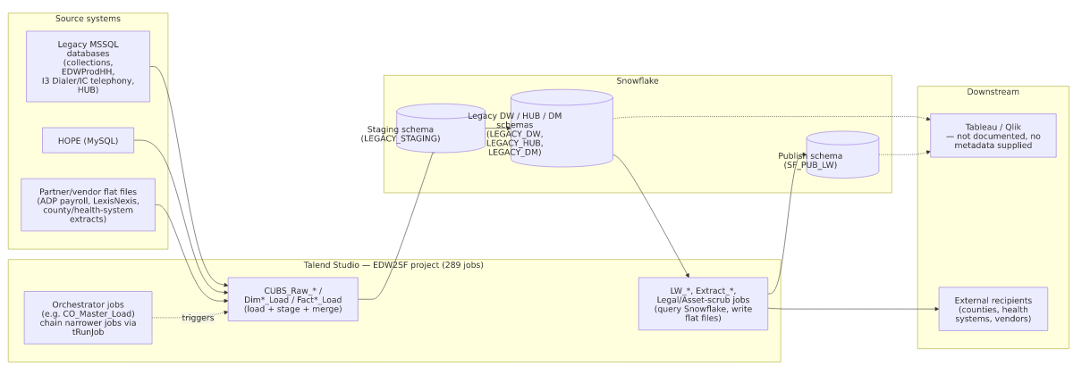

Glossary
Term | Plain-English meaning
Orchestrator / Master_Load job | A job whose only real job is to run other jobs in sequence (and sometimes in parallel) via tRunJob, so a whole multi-step pipeline can be kicked off from one place. CO_Master_Load is the clearest example — it runs 10 other jobs in a defined order.
CUBS | The name embedded in most load-job names (CUBS_Raw_*) — appears to be the legacy collections system this warehouse is built from; not otherwise defined in the metadata.
Site code (CHI / CO / DC / HH / PRE / TOL) | A recurring suffix/infix on many job names (e.g. CUBS_Raw_CO_Debtor_Load) that appears to identify a business unit, office, or client portfolio whose data is loaded through an otherwise-identical job template. Not spelled out anywhere in the metadata — verify the exact meaning with the team.
Staging schema | A landing table that's cleared and reloaded every run, holding only the latest extract.
Publish schema (SF_PUB_LW) | A separate Snowflake schema that curated reporting jobs (the LW_* scorecards/audits) write into — likely the schema a BI tool queries, separate from the raw/staging warehouse.
Context group | A named bundle of settings a job reads at run time. This project has 23 — see 06_dependency_matrix.md.
Reload task / Space (Qlik) | Not documented here — no Qlik metadata was supplied.

