Talend Job: ADP_Employee_Load

Overview
Loads ADP employee-roster data (name, hire/termination dates, job title, department, position, supervisor, pay rate) from a single hardcoded local file into the Snowflake ADP_EMPLOYEE table, replacing the table's contents on each run. The job is extremely minimal — just three components, no connection-management, logging, archiving, or error-handling components at all — and its source filename embeds a specific date ("2.23.22"), strongly suggesting this was built as a one-time or occasional manual load rather than a recurring scheduled job (contrast with ADP_Employee_Raw_Load, its more fully-built near-namesake in this same project).

Detail table
Field | Value
Job name | ADP_Employee_Load
Version | 0.1
Project | EDW2SF
Author | jmach@harriscollect.com
Created | 2022-02-24T15:42:32.335-0800
Last Modified | 2025-09-24T11:00:52.060-0700

Step-by-step data flow
This job has no tPrejob/tPostjob, no tDBConnection/tDBClose, and no logging setup — just a straight-line, three-component flow:
- tFileInputDelimited_1 reads a fixed file, "C:/Data/Employee 2.23.22 Roster Updated.txt" (tab-delimited, header row present, DIE_ON_ERROR=false), using a repository schema generically labeled "...- metadata" rather than anything employee-specific.
- tMap_1 maps the ~17 source columns down to 16 output columns (FIRST_NAME, LAST_NAME, PAYROLL_NAME, HIRE_DATE, TERMINATION_DATE, JOB_TITLE_DESC, HOME_DEPT_DESC, RPT_TO_NAME, WFH, PRIMARY_ADDR_STATE, SUPERVISOR, PAY_DESC, POSITION_ID, FILE_NUMBER, SENIORITY_DATE, JOB_FUNCTION_DESC, PAYROLL_ID).
- tDBOutput_1 writes the rows into Snowflake table ADP_EMPLOYEE (INSERT, tableAction=TRUNCATE — the table is fully cleared and reloaded in a single component step, not via a separate tDBRow TRUNCATE like other ADP jobs in this project).
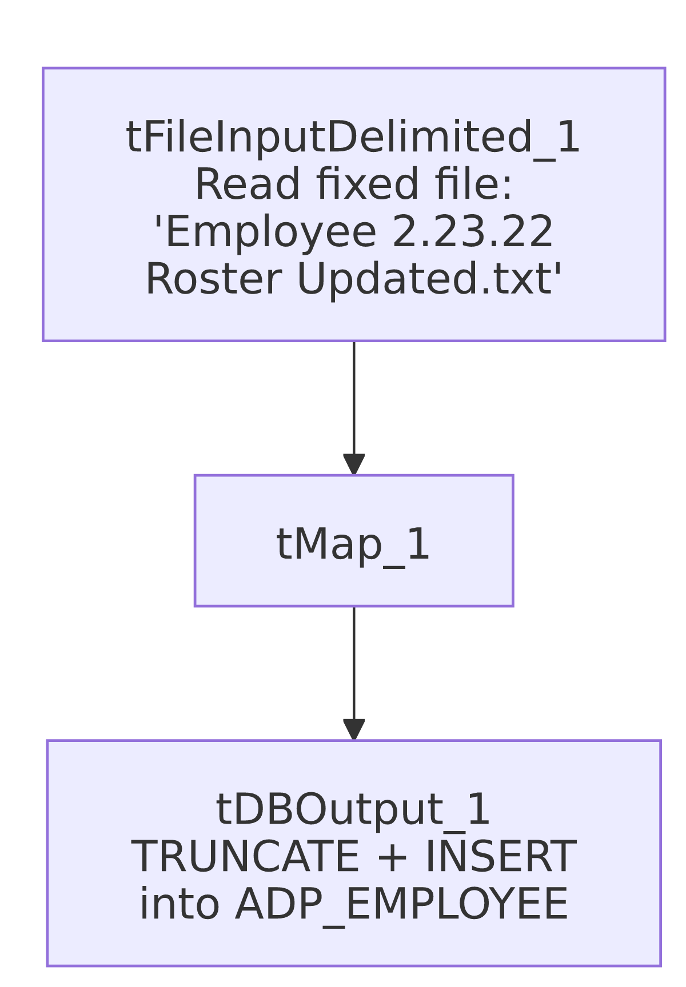

Settings tables

Source: `tFileInputDelimited_1`
Setting | Value | What it means
FILENAME | "C:/Data/Employee 2.23.22 Roster Updated.txt" | A fixed, dated local path — not a context variable, not a directory loop. Points to a specific snapshot file from February 2022.
FIELDSEPARATOR / HEADER | \t / 1 header row | Tab-delimited with a header row skipped.
SCHEMA | Repository schema "...- metadata" | Generically labeled, not tied to "employee" specifically (contrast with ADP_Employee_Raw_Load's correctly-labeled "adp_employee" schema).
DIE_ON_ERROR | false | Malformed rows don't fail the job...
Reject flow | Not wired | ...but there's no connection to catch or record rejected rows — they're silently dropped.

Target: `tDBOutput_1` (`tSnowflakeOutput`)
Setting | Value | What it means
Table | ADP_EMPLOYEE | Destination table.
Output action | INSERT | Appends the freshly read rows.
Table action | TRUNCATE | Clears the table immediately before inserting — a full replace on every run.

Dependencies & configuration
- Triggers/depends on other jobs: none — no tRunJob links found.
- Context variables used: none (context_vars_referenced is empty) — everything in this job is hardcoded.
- 1 hardcoded developer-workstation path in tFileInputDelimited_1.TEMP_DIR (C:/Talend-Studio-20211109_1610-V8.0.1/workspace), the same project-wide risk pattern documented in 05_operational_runbook.md.

Glossary
Component type | Plain-English meaning
tFileInputDelimited | Reads a delimited (CSV/TSV-style) text file according to a schema.
tMap | Maps/transforms columns from one schema to another.
tSnowflakeOutput | Writes rows into a Snowflake table, with configurable insert/truncate behavior.

Issues observed
- The source filename is a fixed, dated snapshot ("Employee 2.23.22 Roster Updated.txt"), not a context variable or directory loop. This is unambiguously a one-time or occasional manual load rather than a job meant to run repeatedly against fresh files. Unable to determine from metadata whether this job is still actively scheduled; if it is, it would keep reloading the same February 2022 file every time it runs. Verify with the team whether this job is still in active use.
- No `tPrejob`/`tPostjob`, no `tDBConnection`/`tDBClose`, and no logging components exist anywhere in this job. Unlike essentially every other job in this project (including its near-namesake ADP_Employee_Raw_Load), it's unclear from this metadata how the job obtains its Snowflake connection at all — it may rely on some implicit/default project-level connection not captured in this extraction, or the connection management may simply be missing. Verify directly in Talend Studio.
- No reject-row handling, no archiving or deletion of the source file, and no downstream merge step — the job writes directly into ADP_EMPLOYEE with TRUNCATE+INSERT and nothing else. This is a much thinner pattern than ADP_Employee_Raw_Load, which loads into a _RAW staging table specifically so a separate merge step can run afterward. Whether ADP_EMPLOYEE here is itself a final, consumed table or an orphaned intermediate one is unable to determine from metadata alone.
- The schema label is generic ("metadata") rather than employee-specific, unlike ADP_Employee_Raw_Load's correctly-labeled "adp_employee" schema — a further sign this job's schema/repository wiring was never fully cleaned up, consistent with its one-off character.

