Talend Job: ADP_Employee_Raw_Load

Overview
Loads ADP employee-roster export files from a shared source directory into the Snowflake TRANSFORM_EMPLOYEE_IMPORT_RAW staging table, archiving each processed file and then deleting all files from the source directory in a separate second pass. The load is gated on a semaphore-style file-existence check (import_adp_employee*.txt) before the staging table is truncated and the directory loop begins — a more fully-built, repeatable counterpart to the ad hoc ADP_Employee_Load job in this same project.

Detail table
Field | Value
Job name | ADP_Employee_Raw_Load
Version | 0.1
Project | EDW2SF
Author | jmach@harriscollect.com
Created | 2022-11-04T12:05:49.503-0700
Last Modified | 2025-11-11T21:58:50.068-0800

Step-by-step data flow
Setup subjob: tPrejob_1 → tJava_1 opens a per-run log file at context.logDir + jobName + "_" + <timestamp> + ".log" → tSetKeystore_1 configures SSL (keystore path via context.keystorePath, but the truststore path is hardcoded to "C:/clientTrustStore.trustStore" — see Issues observed) → tDBConnection_1 opens the Snowflake connection.
Main subjob — runs as a separate top-level chain in this job's diagram, with no visible wiring back to the setup subjob above (see Issues observed):
- tFileExist_1 checks whether context.sourceDir + "import_adp_employee*.txt" exists.
- On success (RUN_IF), tDBRow_1 runs TRUNCATE TABLE TRANSFORM_EMPLOYEE_IMPORT_RAW; — this component's attached schema is a large, unrelated DimDebtor-style column list (LOGON, DEBTOR, CLIENT, NAME1, ...), not an employee schema; since it's just a TRUNCATE statement, this is very likely inert copy-paste residue rather than something that affects execution — see Issues observed.
- On SUBJOB_OK, tFileList_1 lists files in context.sourceDir (EXCLUDEFILEMASK of *.txt is set but IFEXCLUDE=false, so the exclusion is not actually applied).
- For each file (ITERATE), tJava_2 sets context.filePath/context.fileName, then tFileInputDelimited_1 reads the CSV using a repository schema correctly labeled "...- adp_employee".
- tMap_1 → tFlowMeter_2 (row count) → tDBOutput_1 inserts into Snowflake TRANSFORM_EMPLOYEE_IMPORT_RAW (INSERT, tableAction=NONE — the truncate already ran once, upstream of the loop).
- On COMPONENT_OK, tFileArchive_1 zips the just-processed file to context.sourceDir + "archive/" + context.fileName + ".zip" — this runs once per file, inside the loop.
Separately, after tFileList_1's entire iteration finishes (SUBJOB_OK), tFileList_2 re-lists context.sourceDir from scratch, then for each file found (ITERATE), tJava_3 sets context.filePath and tFileDelete_1 deletes it. Deletion therefore happens as a second, independent full pass over the directory, after every file has already been archived — not paired file-by-file with the archive step.
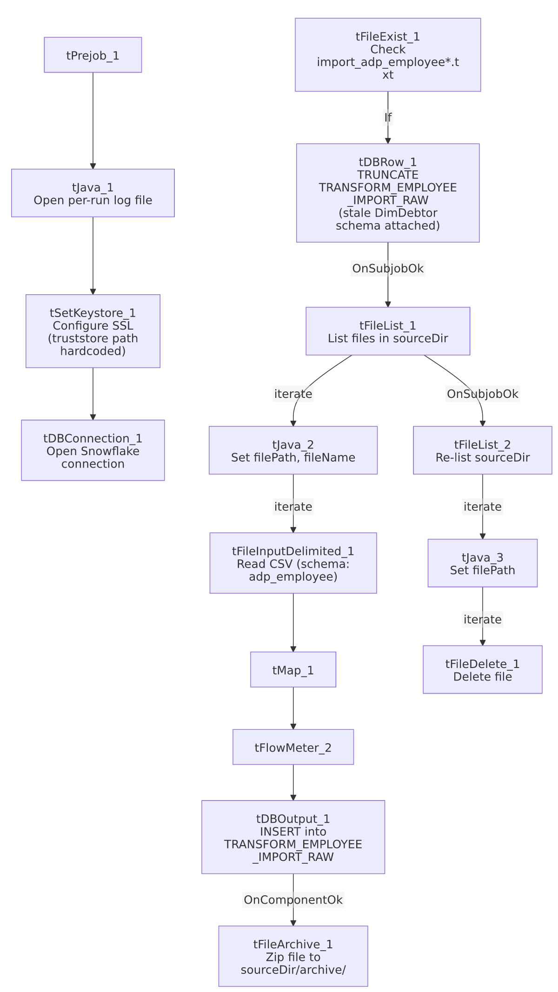

Settings tables

Gate: `tFileExist_1`
Setting | Value | What it means
FILE_NAME | context.sourceDir + "import_adp_employee*.txt" | A semaphore-style check gating the entire load; if no matching file exists, nothing downstream runs.

Source: `tFileInputDelimited_1`
Setting | Value | What it means
FILENAME | context.filePath | Current file from tFileList_1's iteration.
SCHEMA (main + reject) | Repository schema "...- adp_employee" | Correctly labeled for this job, unlike some ADP siblings elsewhere in the project.
DIE_ON_ERROR | false | Malformed rows don't fail the job...
Reject flow | Not wired | ...but there is no connection routing rejected rows anywhere — silently dropped.

Target: `tDBOutput_1` (`tSnowflakeOutput`)
Setting | Value | What it means
Table | TRANSFORM_EMPLOYEE_IMPORT_RAW | Raw staging table for employee-roster data.
Output action / Table action | INSERT / NONE | Appends; relies on the separate upstream tDBRow_1 TRUNCATE to prevent accumulation across runs.

Archive/Delete
Setting | Value | What it means
tFileArchive_1.TARGET | context.sourceDir + "archive/" + context.fileName + ".zip" | Per-file zip, run inside the load loop. PASSWORD is ***REDACTED***.
tFileDelete_1.FILENAME | context.filePath (from the second, independent tFileList_2 pass) | Deletes every file found in a fresh listing of sourceDir, taken after all files have already been archived.

Dependencies & configuration
- Triggers/depends on other jobs: none — no tRunJob links found.
- Context variables used: fileName, filePath, keystorePath, logDir, sourceDir.
- 5 hardcoded developer-workstation paths: tFileInputDelimited_1.TEMP_DIR, tFileArchive_1.SOURCE_FILE (unused placeholder), tFileDelete_1.DIRECTORY/PATH (unused placeholders), and tSetKeystore_1.SSL_TRUSTSERVER_TRUSTSTORE — all C:/Talend-Studio-20211109_1610-V8.0.1/... or C:/clientTrustStore.trustStore, the same risk pattern documented project-wide in 05_operational_runbook.md.

Glossary
Component type | Plain-English meaning
tFileExist | Checks whether a specific file (or file-mask match) exists, without reading it — used here as a load gate.
tFileList | Lists files in a directory for the job to iterate over one at a time.
tSetKeystore | Configures SSL keystore/truststore settings used by the job's database connections.
tFileInputDelimited / tMap / tFlowMeter / tSnowflakeOutput / tSnowflakeConnection / tSnowflakeClose | Same meanings as in other jobs in this project: read a delimited file, transform columns, count rows, write to Snowflake, and manage the Snowflake connection lifecycle.
tFileArchive / tFileDelete | Zip a processed file to an archive location, then delete files from the source directory.

Issues observed
- `tDBRow_1`'s `TRUNCATE TABLE TRANSFORM_EMPLOYEE_IMPORT_RAW;` statement carries an attached schema that matches an unrelated DimDebtor-style table (LOGON, DEBTOR, CLIENT, NAME1, ADD1, ... ~90 columns, tagged REPOSITORY_SCHEMA_TYPE: "...LEGACY_DIMDEBTOR"). Since the component only runs a TRUNCATE (no columns needed), this almost certainly doesn't affect execution — but it's a clear sign this component was copy-pasted from an unrelated debtor-load job and never had its schema binding cleaned up.
- The main subjob (`tFileExist_1` → ... → `tFileList_1`) has no incoming wiring from the setup subjob's `tDBConnection_1`. As drawn, nothing in this job's own diagram guarantees the Snowflake connection is open before tDBRow_1's TRUNCATE and the later tDBOutput_1 insert run. This may work in practice via Talend's own dependency resolution on shared connections, but that isn't visible from this metadata — verify directly in Talend Studio.
- Archiving happens once per file inside the main load loop, but deletion happens in a separate, independent second full directory listing (tFileList_2) after all files are already archived. If a new file were to land in context.sourceDir between the two passes, it could be picked up (and deleted) by the second pass without ever having gone through the archive/load pass, or vice versa. Low likelihood in a well-behaved drop folder, but worth knowing the two loops aren't tied to the same captured file set.
- `tFileList_1`'s `EXCLUDEFILEMASK` (`*.txt`) is configured but `IFEXCLUDE=false`, so the exclusion never actually applies — every file in sourceDir is picked up regardless of extension, the same non-functioning-exclusion pattern flagged in ADP_Payroll_Load.
- No reject flow is wired from `tFileInputDelimited_1`. DIE_ON_ERROR=false means malformed rows don't fail the job, but they are also not captured anywhere — silently dropped with no record of how many or which ones failed to parse.

