Talend Job: ADP_Payroll_Load

Overview
Loads ADP payroll timecard export files (one row per employee per pay-period line item: company code, name, position, hours, dollars) from a local source directory into the Snowflake ADP_PAYROLL table, then calls a stored procedure to merge the newly loaded rows into the downstream warehouse table. Follows the same overall truncate-load-merge-archive shape used elsewhere in EDW2SF, but with several naming inconsistencies described below that suggest this job was copied from a similar ADP_Roster_Load job and not fully updated.

Detail table
Field | Value
Job name | ADP_Payroll_Load
Version | 0.1
Project | EDW2SF
Author | jmach@harriscollect.com
Created | 2023-03-21T15:32:42.280-0700
Last Modified | 2025-11-04T10:52:50.025-0800

Step-by-step data flow
Setup subjob: tPrejob_1 → tJava_2 opens a per-run log file at context.logDir + jobName + "_" + <timestamp> + ".log" and redirects System.out/System.err to it → tSetKeystore_1 configures SSL trust/keystore from context.keystorePath (both passwords redacted) → tDBConnection_1 opens the Snowflake connection.
Main subjob:
- tDBRow_2 runs TRUNCATE TABLE ADP_PAYROLL; — note this targets ADP_PAYROLL directly with no staging-schema prefix (see Issues observed).
- On success, tFileList_1 lists files in context.sourceDir (an EXCLUDEFILEMASK of *.txt is configured but IFEXCLUDE is false, so the exclusion is not actually applied — every file in the directory is picked up).
- For each file, tJava_1 sets context.sourceFile to the full path and derives context.fileDate from the filename.
- tFileInputDelimited_1 reads the CSV (comma-delimited, header row present, DIE_ON_ERROR=false) using a repository schema labeled "...- payroll" for well-formed rows. Its configured reject schema is labeled `"...- roster"`, not payroll — see Issues observed.
- tMap_1 passes the row through to a target schema of 12 output columns (FILEDATE, FILENAME, PAYROLL_COMPANY, LAST_NAME, FIRST_NAME, POSITION_ID, FILE_NUMBER, TC_PAY_DATE, TC_DEPARTMENT, TC_PAYCODE, TC_HOURS, TC_DOLLARS); DIE_ON_ERROR=true here, so a mapping/lookup failure fails the job outright.
- tFlowMeter_4 counts rows passing through (labeled "MyLabel", not renamed for this job).
- tDBOutput_1 inserts the rows into Snowflake table ADP_PAYROLL (INSERT, no table-recreate action).
- On success, tDBRow_1 calls CALL MERGE_INTO_ADP_PAYROLL(); — note the procedure name follows a MERGE_INTO_<table> convention (see Issues observed for how this differs from other EDW2SF jobs).
- tJavaRow_1 reads the procedure's RETVALUE and stores it as context.mergeResult.
- The flow then branches on two ordered RUN_IF conditions off tJavaRow_1 (the branch conditions themselves aren't captured in this metadata, but the component wiring and message content make the intent clear):
- Success branch: tJava_4 prints a completion message, then on subjob-ok, tFileArchive_1 zips the source file to context.archiveDir + "ADP_PAYROLL_" + context.fileDate + ".zip" (correctly named ADP_PAYROLL_...), then tFileDelete_1 deletes the original source file.
- Failure branch: tJava_3 prints "SQL MERGE error: %d" with the merge result code, then tDie_1 fails the job with message "Job " + jobName + " failed." and exit code = context.mergeResult.
Teardown subjob: tPostjob_1 → tDBClose_1 closes the Snowflake connection.
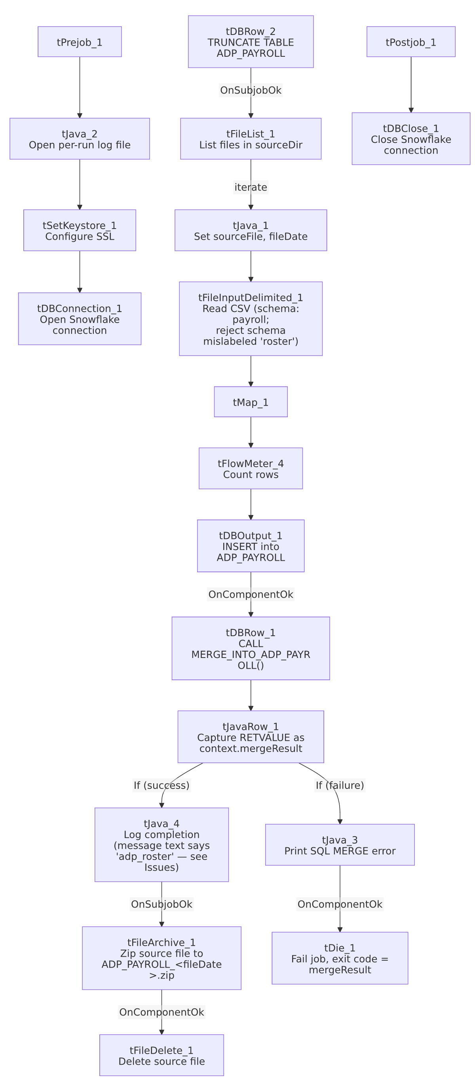

Settings tables

Source: `tFileInputDelimited_1`
Setting | Value | What it means
FILENAME | context.sourceFile | The current file from tFileList_1's iteration.
FIELDSEPARATOR / HEADER | , / 1 header row | Standard comma-delimited CSV with a header row skipped.
SCHEMA (main) | Repository schema "...- payroll" | The expected column layout for a well-formed payroll row (10 business columns, listed twice in this job's extracted schema — likely because both the main and reject schema branches were captured under one field — plus errorCode/errorMessage reject columns).
SCHEMA_REJECT | Repository schema "...- roster" | Mislabeled — this is a payroll job but its reject schema is named for a roster job. See Issues observed.
DIE_ON_ERROR | false | Malformed rows do not fail the job...
Reject flow | Not wired | ...but no connection routes rejected rows anywhere in this job. See Issues observed — rejected rows are silently dropped.

Target: `tDBOutput_1` (`tSnowflakeOutput`)
Setting | Value | What it means
Table | ADP_PAYROLL | Destination table for the raw loaded rows.
Output action | INSERT | Appends rows; relies on the earlier TRUNCATE to prevent duplicate accumulation across runs.
Table action | NONE | Table is not recreated/altered by this job.

Merge step: `tDBRow_1` (`tSnowflakeRow`)
Setting | Value | What it means
Query | CALL MERGE_INTO_ADP_PAYROLL(); | Calls a stored procedure (not shown in this metadata) that presumably merges the freshly loaded ADP_PAYROLL staging rows into a final warehouse table.
Result handling | RETVALUE → context.mergeResult → branch to success/failure logging | A non-zero (or otherwise "bad") return code routes to the failure branch and fails the job with that code.

Dependencies & configuration
- Triggers/depends on other jobs: none — no tRunJob links found.
- Context variables used: sourceDir, sourceFile, fileDate, fileName (referenced in tJava_4's log message but not set anywhere in this job's own components — see Issues observed), archiveDir, logDir, keystorePath, mergeResult (set internally from the merge procedure's return value).
- 4 hardcoded developer-workstation paths in tFileInputDelimited_1.TEMP_DIR, tFileArchive_1.SOURCE_FILE, and tFileDelete_1.DIRECTORY/PATH (all C:/Talend-Studio-20211109_1610-V8.0.1/workspace/...) — same portability risk documented project-wide in 05_operational_runbook.md.

Glossary
Component type | Plain-English meaning
tFileList | Lists files in a directory for the job to iterate over one at a time.
tFileInputDelimited | Reads a delimited (CSV-style) text file according to a schema.
tMap | Maps/transforms columns from one schema to another.
tFlowMeter | Counts rows passing through a point in the flow, for logging/monitoring.
tSnowflakeOutput / tSnowflakeRow / tSnowflakeConnection / tSnowflakeClose | Write rows to a Snowflake table / run an arbitrary SQL statement or stored-procedure call against Snowflake / open and close the Snowflake connection used throughout the job.
tJavaRow | Runs custom Java code once per input row (here, used just once to unpack a stored procedure's single return value).
tFileArchive / tFileDelete | Zip a processed file to an archive location, then delete the original from the source directory.
tDie / tWarn | Same as elsewhere in this project: tDie ends the job with a specific failure message and exit code.

Issues observed
- The reject schema on `tFileInputDelimited_1` is labeled `"...- roster"`, not `"...- payroll"`. This job is ADP_Payroll_Load; its main input schema is correctly labeled "payroll," but the reject schema appears to have been copied from an ADP_Roster_Load job and never repointed. Whether this causes an actual column-mismatch failure on a rejected row depends on how similar the two repository schemas are — unable to determine from this metadata; verify directly in the Talend repository.
- No reject flow is wired from `tFileInputDelimited_1`. DIE_ON_ERROR is false, so malformed rows don't fail the job, but there is also no connection carrying rejected rows anywhere (no file, no log, no table) — they are silently dropped with no record of how many rows, or which ones, failed to parse.
- The success-branch logging in `tJava_4` refers to the wrong job. Its System.out messages read "%d rows merged into dw.adp_roster" and "Archiving ... to file " + context.archiveDir + "ADP_ROSTER_" + context.fileDate + ".zip" — both say "roster," not "payroll." This appears to be copy-paste leftover from an ADP_Roster_Load job. It is a cosmetic/log-message bug only: the actual archive step (tFileArchive_1.TARGET) is correctly configured as context.archiveDir + "ADP_PAYROLL_" + context.fileDate + ".zip", so the real archived file is named correctly — only the printed log line is misleading, which could confuse anyone reading the run log to diagnose an issue.
- `context.fileName` is referenced in `tJava_4`'s log message but is never set anywhere in this job. Only context.sourceFile and context.fileDate are assigned (in tJava_1). Unable to determine from this job's own metadata whether fileName is set globally elsewhere (e.g., a shared context default) or is simply an unset/blank value at that point in the log line; verify with the team.
- The merge stored procedure is named `MERGE_INTO_ADP_PAYROLL()`, following a MERGE_INTO_<table> convention. Not a functional issue on its own, but worth knowing that EDW2SF does not use a single consistent merge-procedure naming convention project-wide (see job_Mail_Merge_Load.md and others for different conventions) — verify per job rather than assuming.
- `TRUNCATE TABLE ADP_PAYROLL;` has no staging-schema prefix. If ADP_PAYROLL in this connection's default schema is also the table downstream reports query directly (rather than a dedicated staging table), there could be a brief window where the table is empty mid-run — unable to confirm from metadata alone whether ADP_PAYROLL is a staging table or the final warehouse table; verify with the team before assuming it's safe to query during a run.

