Talend Job: ADP_Roster_Load

Overview
Loads ADP employee-roster export files (department, job title, position status, seniority, termination reason, etc.) from a source directory into the Snowflake ADP_ROSTER table, then runs a merge procedure and a follow-up update that end-dates a debtor's — rather, an employee's — prior department/title record whenever a newer file shows it changed (a simple slowly-changing-dimension pattern). Sibling in shape to ADP_Payroll_Load (same author, same overall truncate→load→merge→archive design) but for roster/position data instead of payroll timecards, and with one structurally significant difference — see Issues observed.

Detail table
Field | Value
Job name | ADP_Roster_Load
Version | 0.1
Project | EDW2SF
Author | jmach@harriscollect.com
Created | 2023-02-09T10:42:34.769-0800
Last Modified | 2026-03-24T10:08:27.094-0700

Step-by-step data flow
Setup subjob: tPrejob_1 → tJava_2 opens a per-run log file → tSetKeystore_1 configures SSL (both SSL_TRUSTSERVER_TRUSTSTORE and SSL_KEYSTORE use context.keystorePath here — correctly parameterized, unlike several sibling jobs in this batch that hardcode the truststore path) → tDBConnection_1 opens the Snowflake connection.
Main subjob — a separate top-level chain with no visible wiring back to the setup subjob:
- tFileList_1 lists files in context.sourceDir, ordered by modified date ascending (ORDER_BY_MODIFIEDDATE=true, ORDER_ACTION_ASC=true — oldest-modified file processed first if more than one is present). EXCLUDEFILEMASK="*.txt" is set but IFEXCLUDE=false, so it's not actually applied.
- For each file (ITERATE), tJava_1 sets context.sourceFile and derives context.fileDate from the filename (the parsing code is truncated in this metadata beyond .substrin... — see Issues observed).
- tFileInputDelimited_1 reads the CSV (comma-delimited, header row, TRIMALL=true, DIE_ON_ERROR=false) using a repository schema correctly labeled "...- roster" for both main and reject rows.
- tMap_1 → tFlowMeter_4 (row count) → tDBOutput_1 inserts into Snowflake ADP_ROSTER (INSERT, `tableAction=TRUNCATE` — see Issues observed, this sits inside the per-file loop).
- On COMPONENT_OK, tDBRow_1 calls CALL MERGE_INTO_ADP_ROSTER(); → tJavaRow_1 captures RETVALUE into context.mergeResult, which then branches on two ordered RUN_IF conditions (branch logic not captured in this metadata, but component wiring and message content make the intent clear):
- Order 1 (failure path): tJava_3 prints "SQL MERGE error: %d" → tDie_1 fails the job with message "Job " + jobName + " failed." and exit code = context.mergeResult.
- Order 2 (success path): tJava_4 prints "%d rows merged into dw.adp_roster" → on SUBJOB_OK, tDBRow_2 runs an UPDATE against DW.ADP_ROSTER that end-dates a prior department/title record whenever a later file shows the employee's department or title changed (a lightweight SCD-2-style tracking update using LAG/LEAD window functions over FILE_DATE) → on SUBJOB_OK, tFileArchive_1 zips the source file to context.archiveDir + "ADP_ROSTER_" + context.fileDate + ".zip" → on COMPONENT_OK, tFileDelete_1 deletes context.sourceFile.
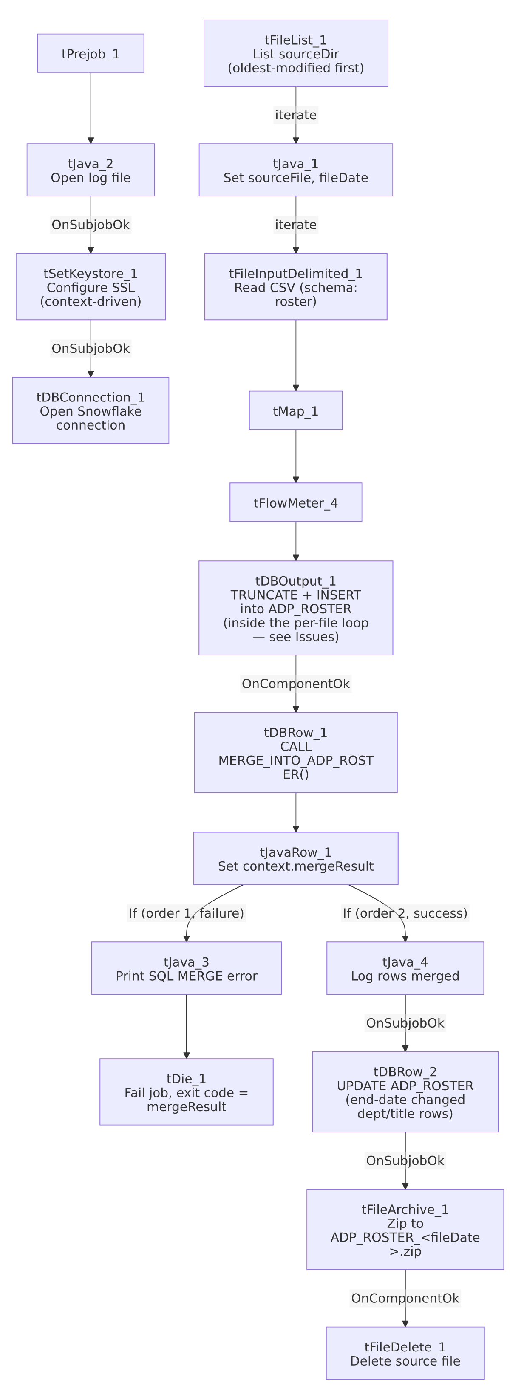

Settings tables

Source: `tFileInputDelimited_1`
Setting | Value | What it means
FIELDSEPARATOR / TRIMALL | , / true | Comma-delimited, all fields trimmed of whitespace.
SCHEMA (main + reject) | Repository schema "...- roster" | Correctly labeled for both branches, unlike ADP_Payroll_Load's mismatched reject schema.
DIE_ON_ERROR | false | Malformed rows don't fail the job...
Reject flow | Not wired | ...but no connection routes rejected rows anywhere — silently dropped.

Target: `tDBOutput_1` (`tSnowflakeOutput`)
Setting | Value | What it means
Table | ADP_ROSTER | Destination table.
Output action / Table action | INSERT / `TRUNCATE` | Table is cleared immediately before each insert — and because this component sits inside the per-file ITERATE loop, that TRUNCATE fires on every file processed, not once before the loop starts. See Issues observed.

Merge & SCD update: `tDBRow_1` / `tDBRow_2`
Setting | Value | What it means
Query 1 (tDBRow_1) | CALL MERGE_INTO_ADP_ROSTER(); | Merges freshly loaded ADP_ROSTER rows into whatever final table the procedure targets (not shown in this metadata).
Query 2 (tDBRow_2) | UPDATE DW.ADP_ROSTER ar SET ar.END_DATE = DATEADD('D',-1,z.END_DATE) FROM (...LAG/LEAD over FILE_DATE partitioned by FILE_NUMBER_PAY_STATEMENTS...) WHERE ar.IS_CURRENT = 0 AND ar.TERMINATION_DATE IS NULL AND ... | Closes out ("end-dates") a prior roster record the day before a later file shows the employee's department or title changed — a simple type-2 history-tracking pattern.

Dependencies & configuration
- Triggers/depends on other jobs: none — no tRunJob links found.
- Context variables used: archiveDir, fileDate, fileName, keystorePath, logDir, mergeResult, sourceDir, sourceFile.
- 4 hardcoded developer-workstation paths in tFileInputDelimited_1.TEMP_DIR, tFileArchive_1.SOURCE_FILE, and tFileDelete_1.DIRECTORY/PATH — same risk documented project-wide in 05_operational_runbook.md.

Glossary
Component type | Plain-English meaning
tFileList / tFileInputDelimited / tMap / tFlowMeter | Same as elsewhere in this project: list files, read a delimited file, transform columns, count rows.
tSnowflakeOutput / tSnowflakeRow / tSnowflakeConnection | Write rows to Snowflake / run an arbitrary SQL statement or procedure call / open the Snowflake connection.
tJavaRow | Runs custom Java code once per input row — here, unpacking a stored procedure's single return value.
tFileArchive / tFileDelete | Zip a processed file to an archive location, then delete the original.
tDie | Ends the job with a specific failure message and exit code.

Issues observed
- `tDBOutput_1`'s `tableAction` is `TRUNCATE`, and this component sits inside the per-file `ITERATE` loop from `tFileList_1` — unlike ADP_Payroll_Load and ADP_Employee_Raw_Load, which run one explicit TRUNCATE TABLE via a separate tDBRow component *before* their file loops start. If more than one file is ever present in context.sourceDir at once, each iteration's TRUNCATE wipes out the previous iteration's just-inserted rows — only the last file processed (per tFileList_1's oldest-modified-first ordering, meaning the file with the *newest* modified timestamp survives, processed last) would actually remain in ADP_ROSTER after the job finishes. This is a concrete correctness risk if sourceDir is ever allowed to hold more than one roster file between runs — verify with the team whether that's guaranteed never to happen, or whether this table has in fact only ever been loaded from single-file directories.
- Because the merge, SCD update, archive, and delete steps are all wired downstream of `tDBOutput_1` (which is itself inside the per-file loop), they too appear to run once per file rather than once after all files are loaded — compounding the risk above if multiple files are ever present at once.
- Same non-functioning `EXCLUDEFILEMASK` pattern as other jobs in this project (IFEXCLUDE=false).
- No reject flow wired from `tFileInputDelimited_1`; DIE_ON_ERROR=false, so malformed rows are silently dropped with no record.
- `tJava_1`'s file-date-parsing code is truncated in this metadata (ends at .substrin...) — the full logic deriving context.fileDate from the filename isn't visible. Unable to determine from metadata whether it correctly extracts the date in all cases; verify directly in Talend Studio if fileDate-based filenames (e.g., the archive name) ever look wrong.

