Talend Job: Activity_Load_Daily

Overview
Reads all rows from a Snowflake table named ACTIVITY (collector-activity records: logon, debtor, activity type/date/description/amount) and writes them back into a Snowflake table also named ACTIVITY, renaming one column (DEBTOR → DEBTOR_NUMBER) along the way. Two separate Snowflake connections are opened in this job, which strongly suggests source and target are actually in different schemas (e.g., a staging schema and the legacy warehouse schema both using the name ACTIVITY) — but this job's own metadata does not show which connection either the input or output component actually uses, so that can't be confirmed here (see Issues observed).

Detail table
Field | Value
Job name | Activity_Load_Daily
Version | 0.1
Project | EDW2SF
Author | jmach@harriscollect.com
Created | 2022-07-28T10:46:11.236-0700
Last Modified | 2022-07-28T11:20:52.239-0700

Step-by-step data flow
Setup subjob: tPrejob_1 → tDBConnection_1 opens a Snowflake connection → on COMPONENT_OK, tDBConnection_2 opens a second, separate Snowflake connection.
Teardown subjob: tPostjob_1 → tDBClose_1 → tDBClose_2.
Main subjob — a separate top-level chain, with no visible wiring connecting it to either connection above:
- tDBInput_1 reads the Snowflake table ACTIVITY in full (no filter query — a plain table read of all 14 source columns, including FILEDATE, LOGON, DIMLOGON, DEBTOR, DEBTOR_IDX, ACTIVITY, ACTIVITY_DATE, ACTIVITY_TYPE, ACTIVITY_DESC, ACTIVITY_AMT, MATCH_FLG, NTC_FLG, CUSTOM_DATE, UPDATE_KEY).
- tMap_1 renames DEBTOR → DEBTOR_NUMBER and drops FILEDATE from the output (13 columns).
- tDBOutput_1 inserts the rows into a Snowflake table also named ACTIVITY (INSERT, tableAction=NONE — a pure append, no truncate anywhere in this job).
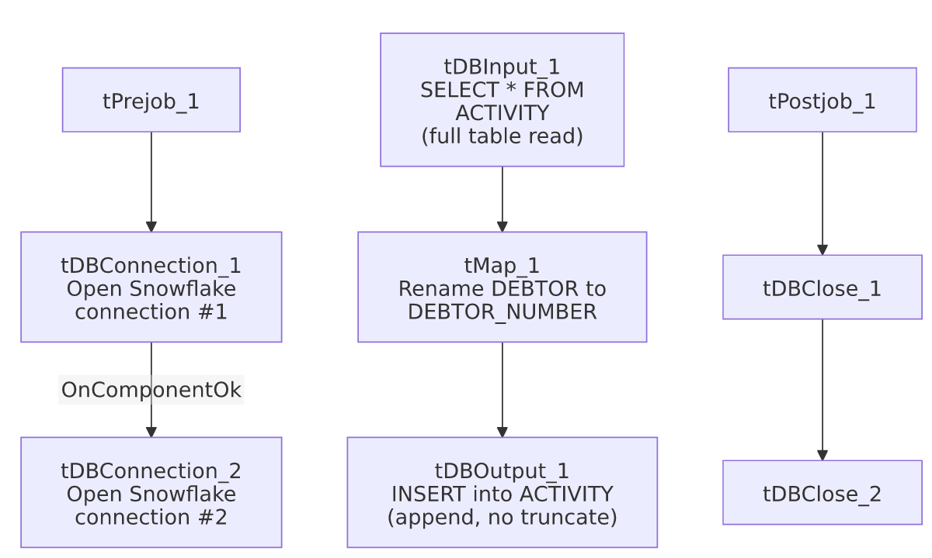

Settings tables

Source: `tDBInput_1` (`tSnowflakeInput`)
Setting | Value | What it means
Table | ACTIVITY | Read with no query filter — every row in the table is pulled on every run.
Connection binding | Not captured in this job's metadata | Which of the two open Snowflake connections this component actually uses is unable to determine from metadata — see Issues observed.

Target: `tDBOutput_1` (`tSnowflakeOutput`)
Setting | Value | What it means
Table | ACTIVITY | Same table name as the source.
Output action / Table action | INSERT / NONE | Pure append — no truncate step exists anywhere in this job.

Dependencies & configuration
- Triggers/depends on other jobs: none — no tRunJob links found.
- Context variables used: none (context_vars_referenced is empty).
- No hardcoded developer-workstation paths found in this job.

Glossary
Component type | Plain-English meaning
tSnowflakeConnection / tSnowflakeClose | Open/close a Snowflake database connection used by other components in the job.
tSnowflakeInput / tSnowflakeOutput | Run a query (or full-table read) against Snowflake / write rows into a Snowflake table.
tMap | Maps/transforms columns from one schema to another.

Issues observed
- Two Snowflake connections (`tDBConnection_1`, `tDBConnection_2`) are opened, but neither `tDBInput_1` nor `tDBOutput_1` shows an explicit connection binding in its captured parameters, and both source and target reference a table literally named `ACTIVITY`. This could be a legitimate staging-schema-to-warehouse-schema copy (reading ACTIVITY from one schema, writing ACTIVITY into another — a common pattern elsewhere in this project), or it could be a same-schema round-trip. Unable to determine from this metadata which connection each component actually uses — verify directly in Talend Studio before assuming this is a cross-schema copy.
- `tDBInput_1`'s query has no filter (`query: ""`, a full-table read), and `tDBOutput_1` has no truncate (`tableAction=NONE`, a pure append). With no incremental key check (unlike i3_CallDetail_40_Load's MAX(InsertKey) pattern) and no truncate step anywhere in this job, rerunning it would re-read the entire source ACTIVITY table and duplicate every row already present in the target.
- No wiring connects the main data-flow subjob (`tDBInput_1` → `tMap_1` → `tDBOutput_1`) to the `tPrejob_1` setup chain in this job's diagram — the same disconnected-diagram pattern seen in several other jobs in this batch.
- No error handling of any kind (no tDie/tWarn/tSendMail) — a failure here would only surface as a generic Talend execution error.
- This job's "modified" date (2022-07-28) is the same day as its "created" date and has never been touched again, unlike its apparent counterpart Activity_Load_Legacy (last modified 2025-09-24). Combined with the full-table-read/no-truncate risk above, it's worth confirming with the team whether Activity_Load_Daily is actually still scheduled to run daily, or has been superseded.

