Talend Job: Activity_Load_Legacy

Overview
Loads collector-activity records from the legacy EDWProdHH MSSQL database into a Snowflake ACTIVITY_BACKFILL table, parsing a LOGON value out of the leading portion of DEBTOR_IDX and pulling activity type/date/amount fields. The target table's _BACKFILL suffix and CREATE_IF_NOT_EXISTS table action (rather than TRUNCATE) suggest this is a one-time or occasional backfill mechanism, distinct from the ongoing Activity_Load_Daily job that loads a plain ACTIVITY table in this same project.

Detail table
Field | Value
Job name | Activity_Load_Legacy
Version | 0.1
Project | EDW2SF
Author | jmach@harriscollect.com
Created | 2022-07-27T12:42:31.732-0700
Last Modified | 2025-09-24T10:59:56.211-0700

Step-by-step data flow
Setup subjob: tPrejob_1 → tDBConnection_1 opens a Snowflake connection → on COMPONENT_OK, tDBConnection_2 opens an MSSQL connection using context.EDWProdHH_Server/Port/Schema/Database/Login (password ***REDACTED***).
Teardown subjob: tPostjob_1 → tDBClose_1 (Snowflake) → tDBClose_2 (MSSQL).
Main subjob — a separate top-level chain, with no visible wiring back to the setup subjob's connections:
- tDBInput_1 (tMSSqlInput, reusing the shared tDBConnection_2) runs a fixed SELECT against the legacy source. The visible portion of the query derives LOGON via SUBSTRING(DEBTOR_IDX,1,CHARINDEX('-',DEBTOR_IDX)-1), casts DimLogOn to DIMLOGON, aliases DEBTOR as DEBTOR_NUMBER, converts CUSTOM_DATE to ACTIVITY_DATE, and derives ACTIVITY_TYPE via COALESCE([TYPE],'') — the query text is truncated in this metadata beyond that point, so the full column list and any WHERE clause are not visible (see Issues observed).
- tMap_1 passes the 13 columns through unchanged.
- tDBOutput_1 inserts the rows into Snowflake ACTIVITY_BACKFILL (INSERT, tableAction=CREATE_IF_NOT_EXISTS — creates the table only if it doesn't already exist; does not clear existing rows).
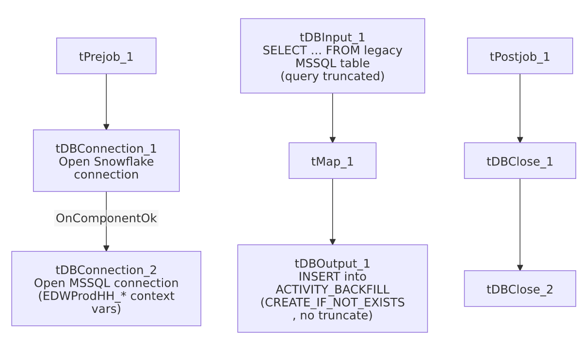

Settings tables

Source: `tDBInput_1` (`tMSSqlInput`)
Setting | Value | What it means
Connection | Shared tDBConnection_2 | Reuses the job's single MSSQL connection.
Query | Fixed SELECT deriving LOGON/DIMLOGON/DEBTOR_NUMBER/ACTIVITY_DATE/ACTIVITY_TYPE from a legacy activity table (full text truncated in metadata) | The visible portion shows the transformation logic but not the full column list or any filtering WHERE clause.

Target: `tDBOutput_1` (`tSnowflakeOutput`)
Setting | Value | What it means
Table | ACTIVITY_BACKFILL | A separately named table from Activity_Load_Daily's plain ACTIVITY target.
Output action / Table action | INSERT / CREATE_IF_NOT_EXISTS | Creates the table only if missing — does not clear existing data on each run, unlike the TRUNCATE pattern used by most load jobs in this project.

Dependencies & configuration
- Triggers/depends on other jobs: none — no tRunJob links found.
- Context variables used: EDWProdHH_Database, EDWProdHH_Login, EDWProdHH_Port, EDWProdHH_Schema, EDWProdHH_Server.
- No hardcoded developer-workstation paths found in this job.

Glossary
Component type | Plain-English meaning
tSnowflakeConnection / tSnowflakeClose | Open/close a Snowflake database connection.
tMSSqlConnection / tMSSqlInput / tMSSqlClose | Open a Microsoft SQL Server connection, run a query against it, and close it.
tSnowflakeOutput | Writes rows into a Snowflake table, with configurable table-creation behavior.
tMap | Maps/transforms columns from one schema to another.

Issues observed
- The captured `tDBInput_1.QUERY` text is truncated (visible portion ends at ...ACTIVITY_TYP...) — the full column list, and critically any WHERE clause bounding the extract to a specific backfill window or date range, is not visible in this metadata. Unable to determine whether this job is scoped to a specific backfill period or would re-pull the entire legacy activity history on every run; verify directly in Talend Studio.
- `tDBOutput_1`'s table action is `CREATE_IF_NOT_EXISTS`, not `TRUNCATE`. Combined with the unknown query scope above, rerunning this job could duplicate rows in ACTIVITY_BACKFILL if the source query isn't itself filtered to new/unprocessed data — there is no incremental key check (e.g., a max-date/max-key pattern like i3_CallDetail_40_Load or CHI_E_Media_Load) visible in this job's own metadata.
- No wiring connects the main data flow to the `tPrejob_1`/`tDBConnection` setup chain in this job's diagram — the same disconnected-diagram pattern seen in Activity_Load_Daily and several other jobs in this batch.
- No error handling (no tDie/tWarn/tSendMail) — a failure here surfaces only as a generic Talend execution error.
- This job's name ("_Legacy") and its "_BACKFILL"-suffixed target table, alongside Activity_Load_Daily's separate, differently-shaped pipeline into the plain ACTIVITY table, suggest these are two distinct activity-loading mechanisms (an ongoing daily job and an occasional legacy backfill) rather than interchangeable variants of one template. Unlike this project's site-code job families (CHI/CO/DC/etc.), these two are not simple copies of each other.

