Talend Job: AgentKPI_Daily_Load

Overview
Loads call-center agent KPI/scorecard metrics (talk time, idle/DND/wrap time, inbound/outbound call and contact counts across dialer/manual/IMC channels) from the EDWProdHH MSSQL AgentKPI_DailyV3 table into the Snowflake AGENTKPI_DAILYV3 table. Uses an incremental-load pattern keyed on AGENTDATE: it first checks the maximum date already loaded into Snowflake, though — as with i3_CallDetail_40_Load in this same project — the metadata does not show that value actually being used to filter the source query (see Issues observed).

Detail table
Field | Value
Job name | AgentKPI_Daily_Load
Version | 0.1
Project | EDW2SF
Author | jmach@harriscollect.com
Created | 2022-03-22T10:03:44.607-0700
Last Modified | 2025-11-12T06:46:30.930-0800

Step-by-step data flow
Setup subjob: tPrejob_1 → tSetKeystore_1 configures SSL (SSL_TRUSTSERVER_TRUSTSTORE hardcoded to "C:/clientTrustStore.trustStore", SSL_KEYSTORE via context.keystorePath) → tDBConnection_1 opens the Snowflake connection → on SUBJOB_OK, tDBConnection_2 opens the MSSQL connection using context.EDWProdHH_* variables (password ***REDACTED***).
Teardown subjob: tPostjob_1 → tDBClose_1 (Snowflake) → tDBClose_2 (MSSQL).
Main subjob:
- tDBInput_1 runs SELECT CAST(COALESCE(MAX(AGENTDATE),'2010-01-01') AS VARCHAR(10)) AS MAX_DATE FROM AGENTKPI_DAILYV3; against Snowflake.
- tJavaRow_1 captures that value into context.maxDate.
- On SUBJOB_OK, tDBInput_2 (tMSSqlInput, shared tDBConnection_2) runs a fixed SELECT of 42 named columns from AgentKPI_DailyV3 (UserName, AgentDate, PayrollID, Supervisor, Manager, Department, call-time and contact/success metrics across dialer/manual/inbound/IMC channels, AuditInsertKey, etc.). The captured query text is truncated in this metadata (ends at ...CAST(NonDia...) and does not visibly reference context.maxDate in the portion available — see Issues observed.
- tMap_1 renames the 42 source columns to uppercase target columns and drops `AuditInsertKey` (41 output columns).
- tFlowMeter_1 counts rows passing through.
- tDBOutput_1 inserts the rows into Snowflake AGENTKPI_DAILYV3 (INSERT, no table-recreate action).
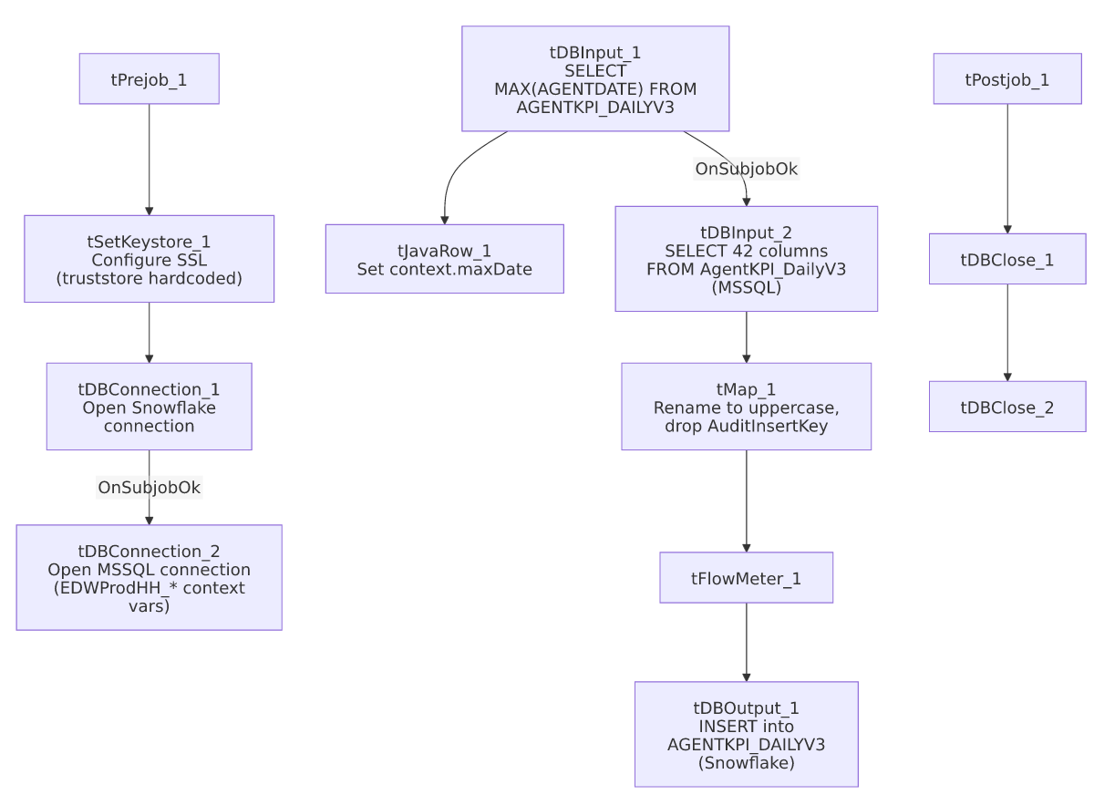

Settings tables

Incremental check: `tDBInput_1` / `tJavaRow_1`
Setting | Value | What it means
Query | SELECT CAST(COALESCE(MAX(AGENTDATE),'2010-01-01') AS VARCHAR(10)) AS MAX_DATE FROM AGENTKPI_DAILYV3; | Finds the latest date already loaded (defaulting to 2010-01-01 if the table is empty).
Result handling | MAX_DATE → context.maxDate | Intended to bound the MSSQL extract to newer rows only.

Source: `tDBInput_2` (`tMSSqlInput`)
Setting | Value | What it means
Connection | Shared tDBConnection_2 | Reuses the job's single MSSQL connection.
Table | AgentKPI_DailyV3 | Source agent-KPI table.
Query | Fixed SELECT of 42 named columns (truncated in metadata) | The visible portion does not show a WHERE clause referencing context.maxDate — see Issues observed.

Target: `tDBOutput_1` (`tSnowflakeOutput`)
Setting | Value | What it means
Table | AGENTKPI_DAILYV3 | Destination table in Snowflake.
Output action | INSERT | Appends — there is no TRUNCATE step in this job, consistent with an incremental-append design, assuming the max-date check is actually applied upstream.

Dependencies & configuration
- Triggers/depends on other jobs: none — no tRunJob links found.
- Context variables used: EDWProdHH_Database, EDWProdHH_Login, EDWProdHH_Port, EDWProdHH_Schema, EDWProdHH_Server, keystorePath, maxDate (computed internally).
- 1 hardcoded developer-workstation path in tSetKeystore_1.SSL_TRUSTSERVER_TRUSTSTORE ("C:/clientTrustStore.trustStore").

Glossary
Component type | Plain-English meaning
tSetKeystore | Configures SSL keystore/truststore settings used by the job's database connections.
tSnowflakeConnection / tSnowflakeClose / tSnowflakeInput / tSnowflakeOutput | Open/close a Snowflake connection, run a query and return results, write rows to a table.
tMSSqlConnection / tMSSqlInput / tMSSqlClose | Open a Microsoft SQL Server connection, run a query against it, and close it.
tJavaRow | Runs custom Java code once per input row — here, unpacking a single query result into a context variable.
tMap / tFlowMeter | Map/transform columns; count rows passing a point in the flow.

Issues observed
- The incremental-load logic may not actually be applied, the same uncertainty documented in i3_CallDetail_40_Load. The job computes context.maxDate from Snowflake before reading MSSQL, strongly suggesting the intent is to pull only rows dated after the last load — but the captured tDBInput_2.QUERY text is truncated after the column list (...CAST(NonDia...) and does not show a WHERE clause referencing context.maxDate in the visible portion. Unable to determine from this metadata whether the query is actually filtered — if it isn't, every run re-reads and re-inserts the entire source table, duplicating all previously loaded rows in Snowflake (there is no TRUNCATE before the INSERT). Verify directly in Talend Studio.
- `tSetKeystore_1.SSL_TRUSTSERVER_TRUSTSTORE` is hardcoded to "C:/clientTrustStore.trustStore" rather than a context variable, unlike ADP_Roster_Load's equivalent component (which uses context.keystorePath for both keystore and truststore) — an inconsistent pattern that also appears in Avita_Monthly_Report_Extract and CFDAILY_Load in this same batch.
- No error/row-count logging specific to this job's business outcome (no tWarn/tDie/tSendMail) — a load failure would only surface as a generic Talend execution error.

