Talend Job: Avita_Monthly_Report_Extract

Overview
Extracts a monthly patient/debtor report for the "Avita Health System" client from a Snowflake publish-schema view (EDWPRODHH.PUB_LWASHINGTON.AVITA_HEALTH_REPORT), decrypts an encrypted SSN column, filters out rows with a blank SSN, writes the result to a dated CSV, and emails it (or a "no records" notice) to configured recipients before deleting the local CSV copy. This is one of the 12 jobs in this project that sends email on completion (see 05_operational_runbook.md).

Detail table
Field | Value
Job name | Avita_Monthly_Report_Extract
Version | 0.1
Project | EDW2SF
Author | jmach@harriscollect.com
Created | 2025-05-22T09:47:59.054-0700
Last Modified | 2025-10-20T09:17:38.054-0700

Step-by-step data flow
Setup subjob: tPrejob_1 → tJava_2 opens a per-run log file → on SUBJOB_OK, tSetKeystore_1 configures SSL (truststore path hardcoded, keystore via context.keystorePath) → on SUBJOB_OK, tDBConnection_1 opens the Snowflake connection.
Main subjob — a separate top-level chain, gated on today's output file not already existing:
- tFileExist_1 checks whether today's dated output file (context.outputDir + "Avita_Monthly_Report_" + <today's date> + ".csv") already exists.
- If it does (RUN_IF), tFileDelete_1 removes the stale copy first. Either way, on SUBJOB_OK, tJava_1 builds the target fileName/filePath/headerRecord strings (code truncated in this metadata after building headerRecord — see Issues observed).
- On SUBJOB_OK, tDBInput_1 runs a fixed SELECT of 23 named columns (CLIENT, NAME1, ADD1, CITY, ST, ZIP, DEBTORNUMBER, PACKET, DOB, "C.D.#", SSN, STATUS, ASGN_AMT, ASGN_COLL, TOTAL_BAL, "QUALIFYING MEMBER PACKET TOTAL", employer info, admit/discharge dates, an "AVITA HEALTH SYSTEM" flag column, DT_ASSIGNED) from EDWPRODHH.PUB_LWASHINGTON.AVITA_HEALTH_REPORT.
- tDataDecrypt_1 decrypts the SSN column (AES; SECRET_KEY/PASSWORD_M1/SECRET_TYPE all ***REDACTED***, key file at context.cryptoPath + "dimdbtr.crypt", DIE_ON_ERROR=false).
- tFilterRow_4 keeps only rows where input_row.SSN.trim().compareTo("") > 0 (excludes blank-SSN rows).
- tFlowMeter_2 counts rows, then tFileOutputDelimited_1 writes the CSV to context.outputDir + "Avita_Monthly_Report_" + <today's date> + ".csv" (comma-delimited, INCLUDEHEADER=false, APPEND=true — see Issues observed).
Separately, tDBInput_1 → SUBJOB_OK → tFileRowCount_2 counts rows in the just-written CSV, then branches: RUN_IF rows_le_1 → tSendMail_2 ("No valid records for this month's Avita Health report."); RUN_IF rows_gt_1 → tSendMail_1 (attaches and sends the file, "The Avita Health monthly report is attached.").
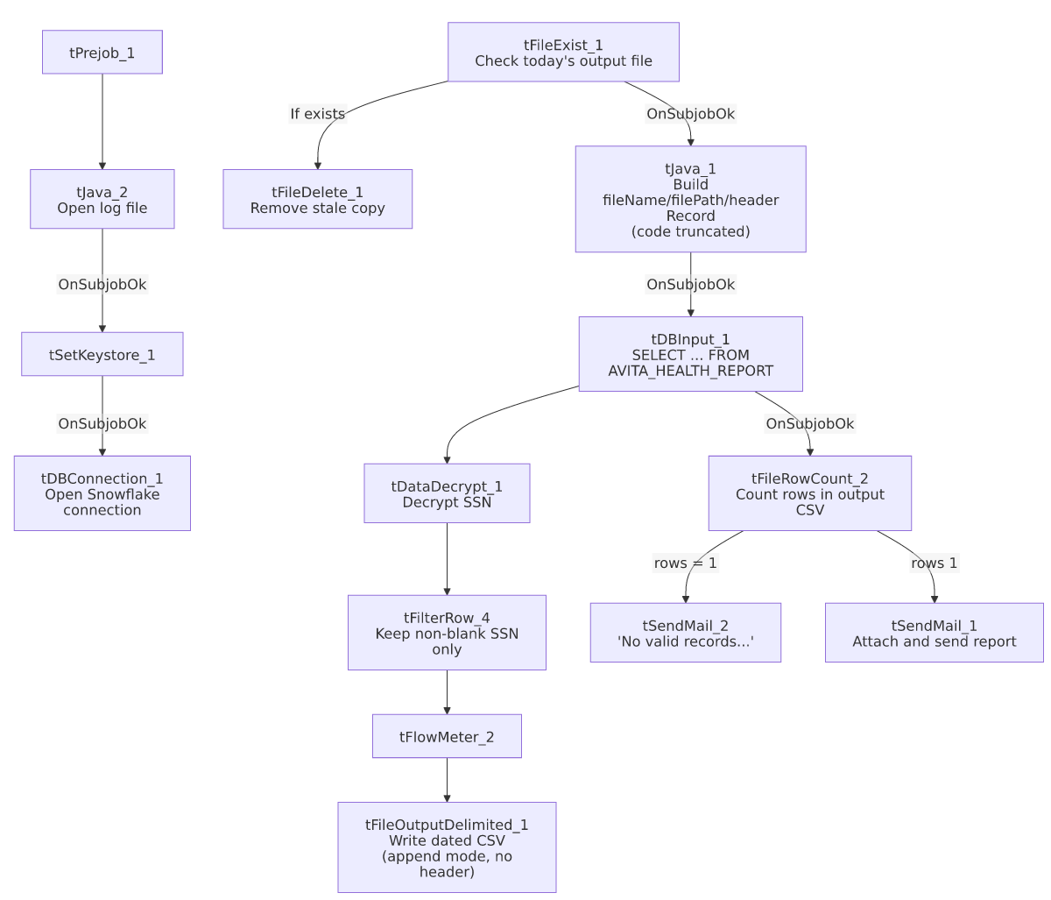

Settings tables

Source: `tDBInput_1` (`tSnowflakeInput`)
Setting | Value | What it means
Query | SELECT CLIENT, NAME1, ADD1, CITY, ST, ZIP, DEBTORNUMBER, PACKET, DOB, "C.D.#", SSN, STATUS, ASGN_AMT, ASGN_COLL, TOTAL_BAL, "QUALIFYING MEMBER PACKET TOTAL", EMP1_NAME, EMP1_ADDR, EMP1_CSZ, EMP1_PHN, ADMIT_DATE, DISCHARGE_DATE, "AVITA HEALTH SYSTEM", DT_ASSIGNED FROM EDWPRODHH.PUB_LWASHINGTON.AVITA_HEALTH_REPORT; | Pulls the full monthly Avita report dataset from a dedicated publish-schema view.

Decrypt & filter: `tDataDecrypt_1` / `tFilterRow_4`
Setting | Value | What it means
CRYPTO_METHOD | AES | SSN column is stored encrypted and decrypted at extract time.
SECRET_KEY / PASSWORD_M1 / SECRET_TYPE | ***REDACTED*** | Preserved as redacted — never guessed.
CRYPTO_FILE_PATH | context.cryptoPath + "dimdbtr.crypt" | Key file name suggests it was originally built for a "DimDebtor" job/table — likely a shared, reused decryption asset rather than a mistake.
Filter condition | input_row.SSN.trim().compareTo("") > 0 | Drops rows with a blank/missing SSN after decryption.

Output & mail: `tFileOutputDelimited_1` / `tSendMail_1` / `tSendMail_2` / `tFileRowCount_2`
Setting | Value | What it means
FILENAME | context.outputDir + "Avita_Monthly_Report_" + <today's date> + ".csv" | Dated output filename.
APPEND / INCLUDEHEADER | true / false | The component itself never writes a header row and appends rather than overwrites — see Issues observed.
Row-count gate | tFileRowCount_2 on the same output file, <=1 vs >1 rows | Determines whether the "no records" or "report attached" email is sent — see Issues observed for the off-by-one implication.
TO / FROM (both mails) | context.mailRecipients / svc_analytics@harriscollect.com | DIE_ON_ERROR=true on both — a failed send fails the job.

Dependencies & configuration
- Triggers/depends on other jobs: none — no tRunJob links found.
- Context variables used: cryptoPath, keystorePath, logDir, mailRecipients, outputDir.
- 3 hardcoded developer-workstation paths in tFileDelete_1.DIRECTORY/PATH and tSetKeystore_1.SSL_TRUSTSERVER_TRUSTSTORE.

Glossary
Component type | Plain-English meaning
tDataDecrypt | Decrypts an encrypted column's values using a configured key/algorithm.
tFilterRow | Keeps or drops rows based on a condition.
tFileOutputDelimited | Writes rows to a delimited (CSV-style) text file.
tFileRowCount | Counts the rows in a file, for logging or branching decisions.
tSendMail | Sends an email — used here to deliver the report or notify that no records qualified.
tFileExist / tFileDelete | Check whether a file exists / delete a file.

Issues observed
- `tFileOutputDelimited_1` has `APPEND=true` and `INCLUDEHEADER=false`, while a separate `tJava_1` component independently builds a `headerRecord` string (truncated in this metadata) that is never shown being written to the output file by any captured connection. This strongly suggests the intended design is for tJava_1 to manually write a header line before the component appends data rows — but unable to determine from this metadata whether the header row is actually written to the CSV, or whether headerRecord is dead code. If the header is never written, the emailed monthly report would ship as a headerless CSV. Verify directly in Talend Studio.
- The row-count gate branches on "≤1 row" vs. ">1 row" rather than "0 rows" vs. ">0 rows". If tFileOutputDelimited_1 does write a header line as a literal data row (consistent with APPEND=true and the header-string logic above), a file with exactly one real data row would be misclassified as "no valid records" and never emailed to the client. This is a plausible off-by-one directly tied to the header-writing ambiguity above; verify with the team.
- `tSetKeystore_1.SSL_TRUSTSERVER_TRUSTSTORE` is hardcoded, the same pattern flagged in AgentKPI_Daily_Load and CFDAILY_Load elsewhere in this batch.
- The crypto key file is named `"dimdbtr.crypt"`, suggesting the SSN decryption key material was originally built for a "DimDebtor" job/table rather than this Avita-specific extract — likely an intentionally shared decryption asset, but worth confirming with the team that reusing it here is expected rather than accidental.

