Talend Job: Backfill_Debtor_Cell_Phone_f83

Overview
One-time backfill load of debtor cell-phone numbers (logon, debtor number/index, phone) from a single hardcoded, dated source file — X:/CO_DEBTOR_CELL_PHONE_F83_SPECIAL_20250821.txt (CO site, dated August 21, 2025) — into the Snowflake DEBTOR_CELL_PHONE_F83 table. This is an extremely minimal, two-component job with no connection management, logging, or error handling: a manual/ad hoc backfill utility, not a recurring scheduled load.

Detail table
Field | Value
Job name | Backfill_Debtor_Cell_Phone_f83
Version | 0.1
Project | EDW2SF
Author | jmach@harriscollect.com
Created | 2025-08-22T15:00:45.696-0700
Last Modified | 2025-09-24T11:08:42.424-0700

Step-by-step data flow
This job has no tPrejob/tPostjob, no tDBConnection/tDBClose, and no logging — just a two-component flow:
- tFileInputDelimited_1 reads the fixed file X:/CO_DEBTOR_CELL_PHONE_F83_SPECIAL_20250821.txt (tab-delimited, header row, DIE_ON_ERROR=false) with schema LOGON/DEBTOR/DEBTOR_IDX/PHONE.
- tDBOutput_2 inserts the rows into Snowflake DEBTOR_CELL_PHONE_F83 (INSERT, tableAction=NONE — appends to whatever is already there, no truncate).
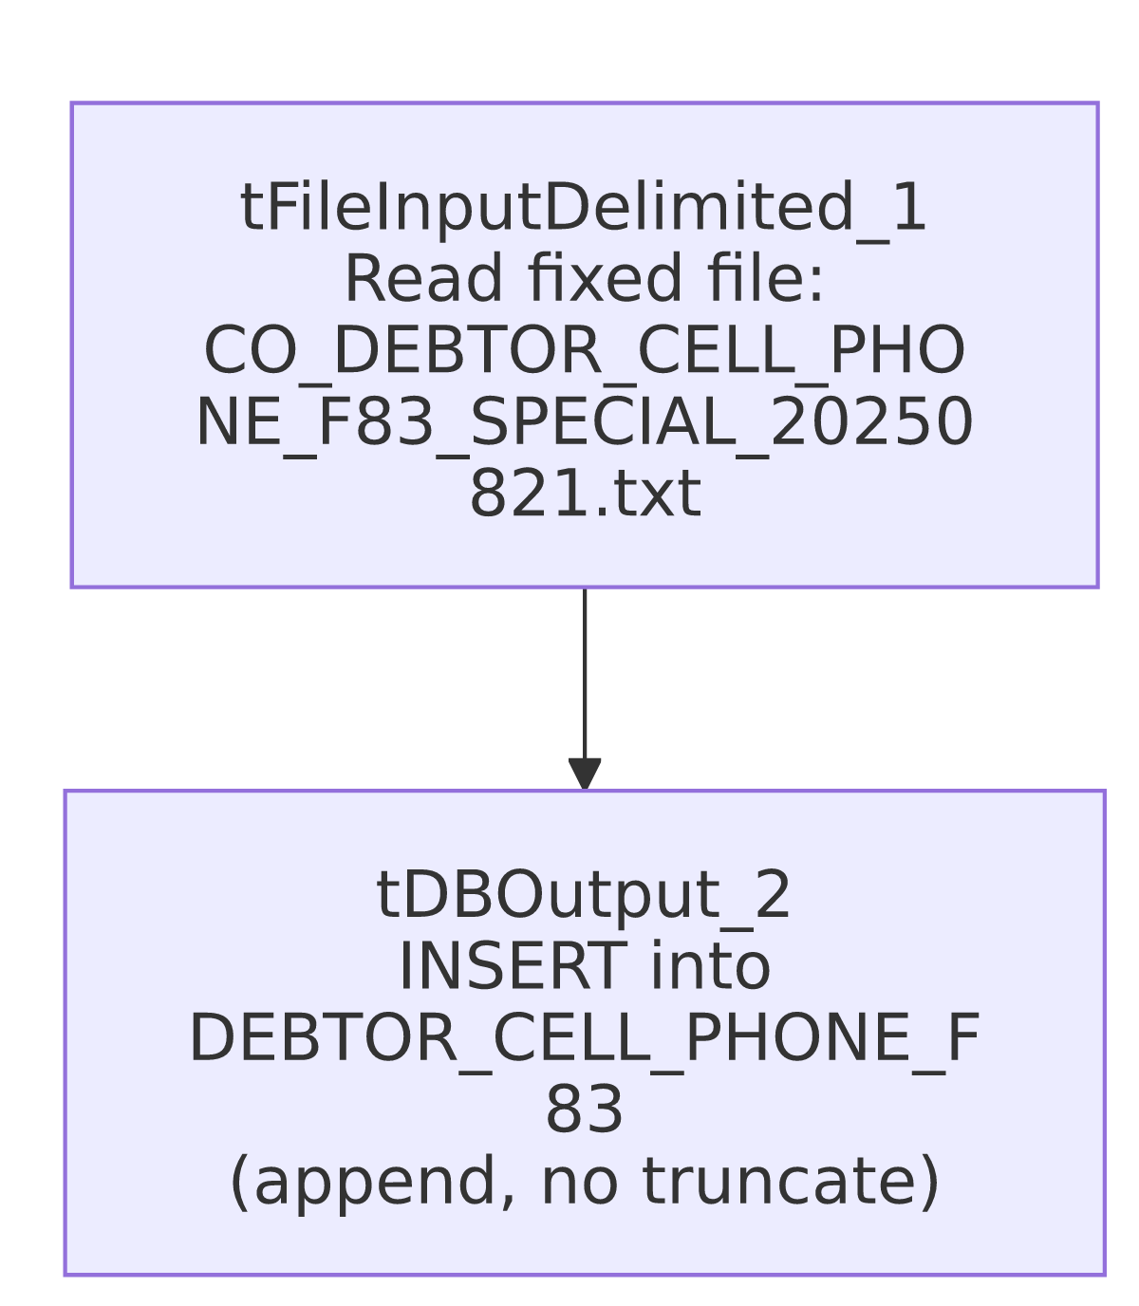

Settings tables

Source: `tFileInputDelimited_1`
Setting | Value | What it means
FILENAME | "X:/CO_DEBTOR_CELL_PHONE_F83_SPECIAL_20250821.txt" | A fully hardcoded, dated, site-specific file path.
FIELDSEPARATOR / HEADER | \t / 1 header row | Tab-delimited, header skipped.
DIE_ON_ERROR | false | Malformed rows don't fail the job; no reject flow is wired either, so they're silently dropped.

Target: `tDBOutput_2` (`tSnowflakeOutput`)
Setting | Value | What it means
Table | DEBTOR_CELL_PHONE_F83 | Destination table.
Output action / Table action | INSERT / NONE | Pure append — no truncate or dedup of any kind.

Dependencies & configuration
- Triggers/depends on other jobs: none — no tRunJob links found.
- Context variables used: none — everything is hardcoded.
- 1 hardcoded developer-workstation path in tFileInputDelimited_1.TEMP_DIR.

Glossary
Component type | Plain-English meaning
tFileInputDelimited | Reads a delimited (CSV/TSV-style) text file according to a schema.
tSnowflakeOutput | Writes rows into a Snowflake table.

Issues observed
- `FILENAME` is a fully hardcoded, dated, site-specific path (X:/CO_DEBTOR_CELL_PHONE_F83_SPECIAL_20250821.txt) rather than a context variable — this is unambiguously a one-time backfill utility built to load one specific extract file, not a job intended to be rerun on a schedule. If it were accidentally re-triggered, it would either fail (the file no longer present) or, if the file still exists, insert the exact same rows again — see next point.
- `tDBOutput_2`'s table action is `NONE` (append) with no truncate and no dedup/merge step — rerunning this job against the same source file would duplicate every row already loaded into DEBTOR_CELL_PHONE_F83.
- No `tDBConnection`/`tDBClose` components are present in this job's metadata at all (the same absence pattern as ADP_Employee_Load elsewhere in this batch) — unable to determine from metadata how this job obtains its Snowflake connection.
- No archiving, deletion, or logging of any kind — once run, there is no record inside the job itself of when or by whom it was executed, beyond whatever the scheduler/execution log captures externally.
- "f83" in the job name and filename appears to be a specific extract/batch identifier — not otherwise defined in the metadata. Likely a client- or ticket-specific reference number; verify with the team if this ever needs to be cross-referenced.

