Talend Job: Backfill_Debtor_Phones

Overview
A backfill utility very similar to Backfill_Debtor_Cell_Phone_f83 in this same batch, but generalized to loop over every file in a fixed directory (/mnt/cubs) rather than pointing at a single hardcoded file, loading debtor phone numbers into the Snowflake DEBTOR_PHONE_SP table. Same minimal, connection-less, no-error-handling shape as its sibling.

Detail table
Field | Value
Job name | Backfill_Debtor_Phones
Version | 0.1
Project | EDW2SF
Author | jmach@harriscollect.com
Created | 2025-08-21T11:38:51.440-0700
Last Modified | 2025-09-24T11:07:57.239-0700

Step-by-step data flow
This job has no tPrejob/tPostjob, no tDBConnection/tDBClose, and no logging — just:
- tFileList_1 lists files in "/mnt/cubs" (a hardcoded directory, not a context variable — see Issues observed). EXCLUDEFILEMASK="*.txt" is set but IFEXCLUDE=false, so it's not actually applied.
- For each file (ITERATE), tFileInputDelimited_1 reads it (tab-delimited, header row, same LOGON/DEBTOR/DEBTOR_IDX/PHONE schema as Backfill_Debtor_Cell_Phone_f83).
- tDBOutput_2 inserts the rows into Snowflake DEBTOR_PHONE_SP (INSERT, tableAction=NONE — appends, no truncate).
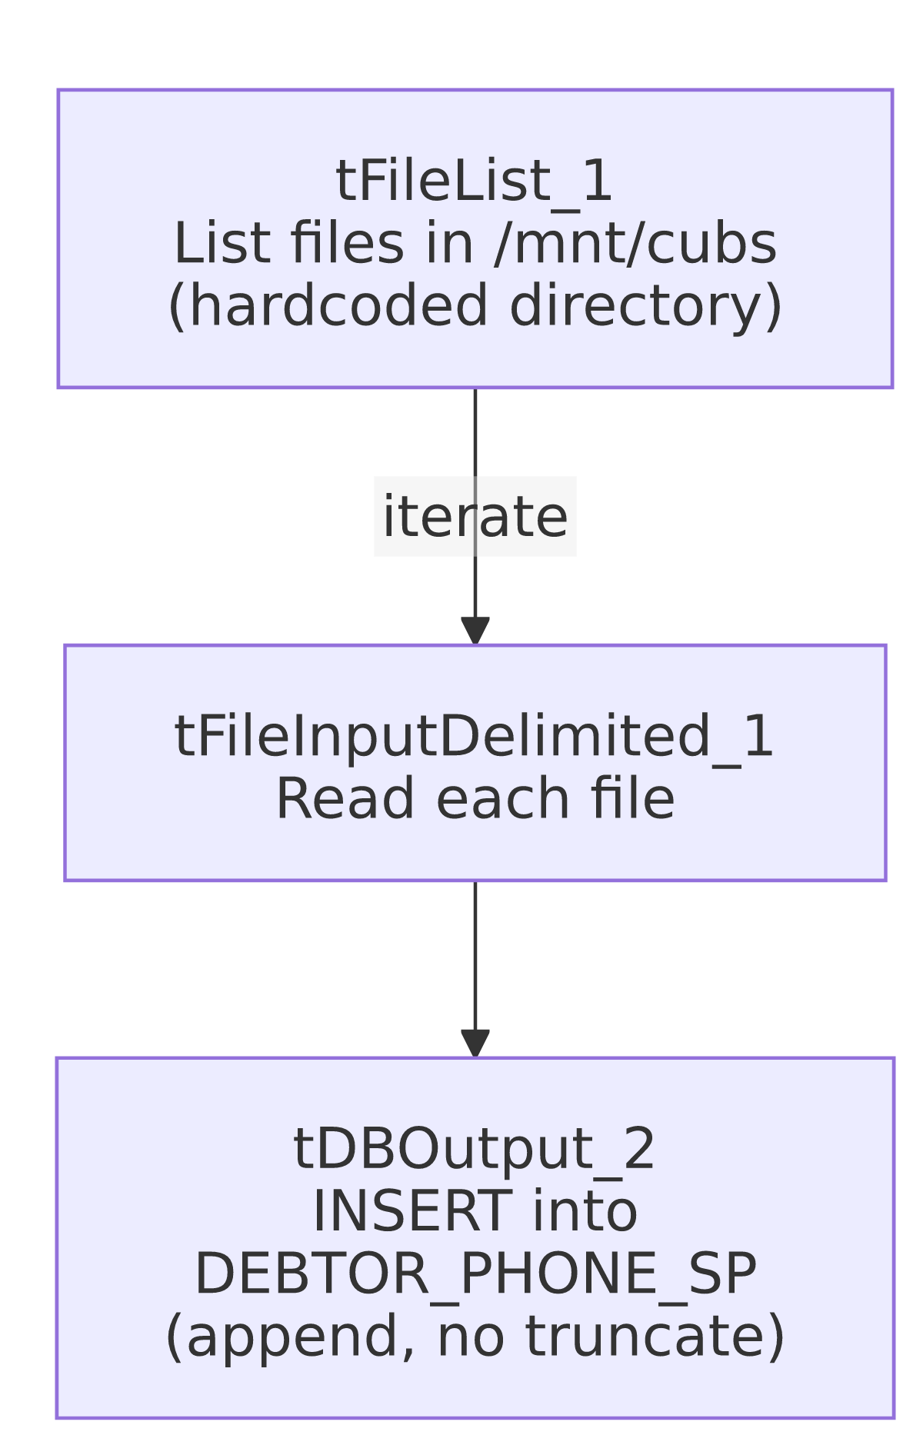

Settings tables

Source: `tFileList_1` / `tFileInputDelimited_1`
Setting | Value | What it means
DIRECTORY | "/mnt/cubs" | Hardcoded Linux-style path — not a context variable.
FIELDSEPARATOR / HEADER | \t / 1 header row | Tab-delimited, header skipped.
Schema | LOGON, DEBTOR, DEBTOR_IDX, PHONE | Same shape as Backfill_Debtor_Cell_Phone_f83's source.

Target: `tDBOutput_2` (`tSnowflakeOutput`)
Setting | Value | What it means
Table | DEBTOR_PHONE_SP | Destination table — a different target than Backfill_Debtor_Cell_Phone_f83's DEBTOR_CELL_PHONE_F83.
Output action / Table action | INSERT / NONE | Pure append — no truncate or dedup.

Dependencies & configuration
- Triggers/depends on other jobs: none — no tRunJob links found.
- Context variables used: none.
- 1 hardcoded developer-workstation path flagged in tFileInputDelimited_1.TEMP_DIR; the DIRECTORY="/mnt/cubs" hardcoding is not flagged by this extraction's hardcoded_path_findings (which appears tuned to the Windows workstation path pattern) but is functionally the same kind of environment-specific hardcoding — see Issues observed.

Glossary
Component type | Plain-English meaning
tFileList | Lists files in a directory for the job to iterate over one at a time.
tFileInputDelimited | Reads a delimited (CSV/TSV-style) text file according to a schema.
tSnowflakeOutput | Writes rows into a Snowflake table.

Issues observed
- `DIRECTORY` on `tFileList_1` is hardcoded to `"/mnt/cubs"` rather than a context variable — the same portability risk as the project-wide C:/Talend-Studio hardcoded paths, just not flagged by this extraction's hardcoded_path_findings (tuned to the Windows workstation path pattern specifically). Any move of this job to a different runner/host would break it.
- This job and `Backfill_Debtor_Cell_Phone_f83` load structurally identical schemas (LOGON, DEBTOR, DEBTOR_IDX, PHONE) into two differently-named target tables (DEBTOR_PHONE_SP vs. DEBTOR_CELL_PHONE_F83) via two different sourcing strategies (directory loop vs. single hardcoded dated file) — they read as two separate one-off backfills rather than a reusable template, despite the near-identical shape. Confirm with the team whether DEBTOR_PHONE_SP and DEBTOR_CELL_PHONE_F83 are genuinely different target tables (e.g., landline vs. cell numbers) or whether one of these jobs is now redundant.
- Same appended-no-truncate risk as the sibling job: tDBOutput_2's table action is NONE, so rerunning against files already loaded (or leaving already-processed files in /mnt/cubs) would duplicate rows, with no dedup/merge step visible.
- No `tDBConnection`/`tDBClose`, no logging, no error handling — the same absence pattern as its sibling.

