Talend Job: Bad_Phone_Load

Overview
Loads "bad phone" / Do-Not-Call source files from a shared directory into a Snowflake staging table (BADPHN_DONOTCALL_STAGING), stamping each row with the source file's own OS-level last-modified timestamp, then merges the staged rows into a downstream Do-Not-Call table via a stored procedure. Version 0.2 — one of the few jobs in this batch that has been revised past its initial 0.1.

Detail table
Field | Value
Job name | Bad_Phone_Load
Version | 0.2
Project | EDW2SF
Author | jmach@harriscollect.com
Created | 2025-01-14T11:24:17.452-0800
Last Modified | 2025-09-24T11:06:36.459-0700

Step-by-step data flow
Setup subjob: tPrejob_1 → tDBConnection_1 opens the Snowflake connection.
Main subjob — a separate top-level chain, with no visible wiring back to tDBConnection_1:
- tDBRow_1 runs TRUNCATE TABLE BADPHN_DONOTCALL_STAGING;.
- On SUBJOB_OK, tFileList_1 lists files in context.dncSourceDir (EXCLUDEFILEMASK="*.txt" set but IFEXCLUDE=false, not actually applied).
- For each file (ITERATE), tJava_1 sets context.dncFilePath/context.dncFileName, then tFileInputDelimited_1 reads it (tab-delimited, header row, REMOVE_EMPTY_ROW=false, main schema labeled "...- bad_phone" but reject schema labeled generically "...- metadata" — see Issues observed).
- tJavaRow_1 derives FILE_DATE/JAVA_TIMESTAMP from the source file's OS last-modified attribute (via Java NIO Files.readAttributes), alongside PHONE/CONTENT (the code is truncated in this metadata beyond that point).
- tMap_1 adds SOURCE, FILE_NAME, UPLOAD_DATE columns.
- tDBOutput_1 inserts the rows into Snowflake BADPHN_DONOTCALL_STAGING (INSERT, tableAction=NONE — the truncate already ran once, upstream of the loop).
Separately, tFileList_1 → SUBJOB_OK → tDBRow_2 runs CALL MERGE_BADPHONE_INTO_DONOTCALL(); after the entire file loop completes — correctly wired at the tFileList_1 level (once, after all files), not per-iteration.
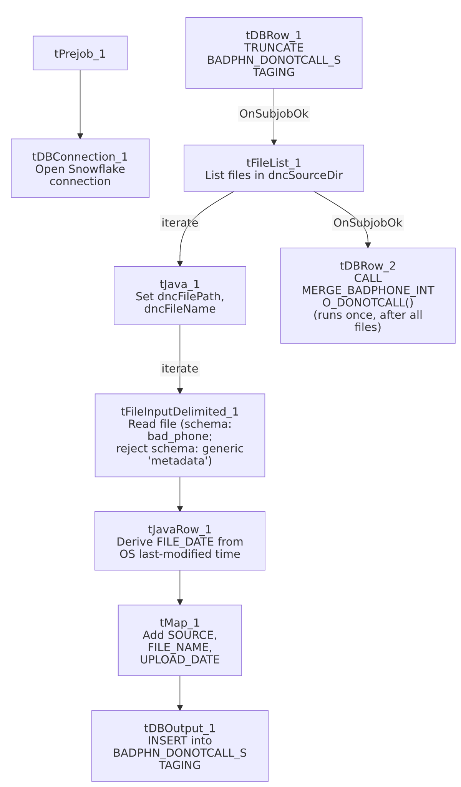

Settings tables

Truncate: `tDBRow_1`
Setting | Value | What it means
Query | TRUNCATE TABLE BADPHN_DONOTCALL_STAGING; | Runs once, before the file loop starts — the correct upfront-truncate pattern.

Source: `tFileInputDelimited_1`
Setting | Value | What it means
SCHEMA (main) | Repository schema "...- bad_phone" | Correctly labeled for this job.
SCHEMA_REJECT | Repository schema "...- metadata" | Generically labeled, not bad-phone-specific — similar mismatched/generic-reject-schema pattern seen elsewhere in this project (e.g. ADP_Payroll_Load, ADP_Employee_Load).
DIE_ON_ERROR | false | Malformed rows don't fail the job...
Reject flow | Not wired | ...but no connection routes rejected rows anywhere — silently dropped.

Derived timestamp: `tJavaRow_1`
Setting | Value | What it means
Code (partial) | Reads the source file's OS lastModifiedTime via Files.readAttributes into FILE_DATE/JAVA_TIMESTAMP | FILE_DATE reflects when the file was last touched on disk, not necessarily a date embedded in its content or filename — see Issues observed.

Target & merge: `tDBOutput_1` / `tDBRow_2`
Setting | Value | What it means
Table (tDBOutput_1) | BADPHN_DONOTCALL_STAGING | Staging table; INSERT, tableAction=NONE.
Query (tDBRow_2) | CALL MERGE_BADPHONE_INTO_DONOTCALL(); | Merges staged rows into the downstream Do-Not-Call table, run once after the whole file loop finishes.

Dependencies & configuration
- Triggers/depends on other jobs: none — no tRunJob links found.
- Context variables used: dncFileName, dncFilePath, dncSourceDir.
- 1 hardcoded developer-workstation path in tFileInputDelimited_1.TEMP_DIR.

Glossary
Component type | Plain-English meaning
tFileList / tFileInputDelimited / tMap | List files in a directory, read a delimited file, transform columns.
tJavaRow | Runs custom Java code once per input row — here, deriving a timestamp from the source file's own OS metadata.
tSnowflakeConnection / tSnowflakeRow / tSnowflakeOutput | Open a Snowflake connection, run an arbitrary SQL/procedure call, write rows to a table.

Issues observed
- `tFileInputDelimited_1`'s reject schema is labeled generically `"metadata"` rather than something bad-phone-specific — a similar mismatched/generic-reject-schema pattern flagged in ADP_Payroll_Load (mislabeled "roster") and ADP_Employee_Load (generic "metadata" main schema) elsewhere in this project. Whether this causes a real column-mismatch on a rejected row can't be determined from metadata alone.
- No reject flow is wired from `tFileInputDelimited_1` despite DIE_ON_ERROR=false — malformed rows are silently dropped with no record, the same pattern flagged project-wide in 05_operational_runbook.md.
- `tJavaRow_1`'s code is truncated in this metadata right after establishing FILE_DATE/JAVA_TIMESTAMP from the file's OS last-modified attribute — the full logic for how PHONE/CONTENT are derived from the row isn't visible. Verify directly in Talend Studio if phone-number parsing ever looks wrong.
- Using the file's OS last-modified timestamp (rather than a value from the file's own content or filename) as `FILE_DATE` means the recorded date reflects whenever the file was last touched on disk — if source files are ever re-transferred or re-saved without preserving their original timestamp, FILE_DATE would silently reflect the transfer/save time instead of the true source date. Worth confirming this is the intended behavior with the team.

