Talend Job: CFDAILY_Load

Overview
Loads two parallel branches of "call file" daily records (CFDAILY — collector call/callback file tracking: logon, call-file ID, debtor, start/end/total time, activity code, collector initials, port/date/time/sequence) into a shared Snowflake CFDAILY table — one branch from a general source directory, one from a DC-site-specific directory — then archives and deletes the source files from both branches and merges the staged rows via a stored procedure once both branches finish. This is the clearest tParallelize-based dual-branch loader in this batch.

Detail table
Field | Value
Job name | CFDAILY_Load
Version | 0.1
Project | EDW2SF
Author | jmach@harriscollect.com
Created | 2025-09-08T12:30:37.554-0700
Last Modified | 2025-11-04T11:08:08.921-0800

Step-by-step data flow
Setup subjob: tPrejob_1 → tJava_1 opens a per-run log file → on SUBJOB_OK, tSetKeystore_1 (truststore path hardcoded) → on SUBJOB_OK, tDBConnection_1 opens the Snowflake connection.
Main subjob — a separate top-level chain:
- tDBRow_1 runs TRUNCATE TABLE STAGING.CFDAILY; (runs once, before the parallel branches start).
- On SUBJOB_OK, tParallelize_1 fans out to two branches:
- Branch 1 (general, order 1): tFileList_1 lists context.sourceDir → ITERATE → tFileInputDelimited_1 reads each file (tab-delimited, 15 named columns: LOGON, CFID, CFID_IDX, DEBTOR, ST_TIME, ET_TIME, TOT_TIME, ACT_CODE, COL_INITIALS, ACT_DATE, UNIT_NO, CF_PORT, CF_DATE, CF_TIME, CF_SEQ) → tMap_1 adds LOAD_DT → tFlowMeter_1 → tDBOutput_1 inserts into Snowflake CFDAILY (INSERT, tableAction=NONE). Separately, tFileList_1 → SUBJOB_OK → tFileList_3 re-lists context.sourceDir from scratch → ITERATE → tFileArchive_2 zips each file to context.archiveDir + <today's date> + "/" + <filename> + ".zip"; tFileList_3 → SUBJOB_OK → tFileDelete_3 deletes each listed file (FAILON=true).
- Branch 2 (DC, order 2): tFileList_2 lists context.sourceDCDir → ITERATE → tFileInputDelimited_2 reads each file (same 15-column schema) → tMap_2 adds LOAD_DT → tFlowMeter_7 → tDBOutput_2 inserts into the same Snowflake CFDAILY table. Separately, tFileList_2 → SUBJOB_OK → tFileArchive_1 zips a single fixed filename (SOURCE=context.sourceDCDir, ALL_FILES=false, TARGET=context.archiveDir + <date> + "/DC-EDW-EXPORT-CFDAILY.txt.zip") → SUBJOB_OK → tFileDelete_2 deletes context.sourceDCDir + "DC-EDW-EXPORT-CFDAILY.txt" (FAILON=true).
- Both branches converge on tParallelize_2, which SYNCHRONIZEs (waits for both tFileDelete_2 and tFileDelete_3 via SUBJOB_OK) before firing tDBRow_2: CALL STAGING.MERGE_INTO_CFDAILY();.
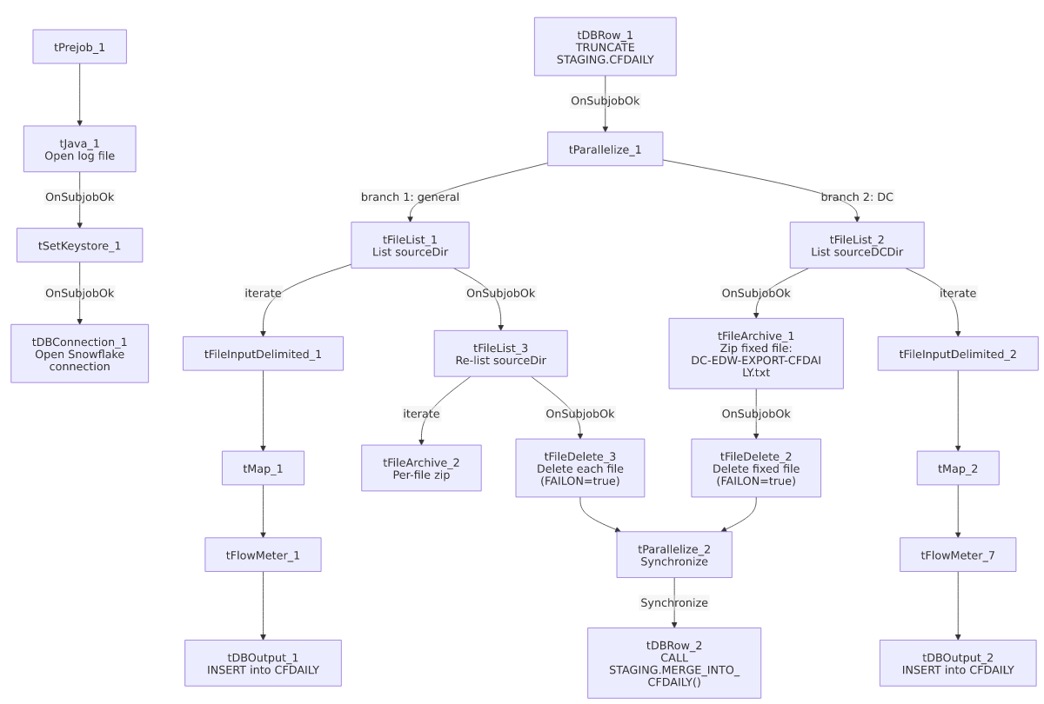

Settings tables

Truncate & merge: `tDBRow_1` / `tDBRow_2`
Setting | Value | What it means
Query 1 | TRUNCATE TABLE STAGING.CFDAILY; | Runs once, before tParallelize_1 fans out — the correct upfront-truncate pattern shared by both branches.
Query 2 | CALL STAGING.MERGE_INTO_CFDAILY(); | Runs once, after tParallelize_2 confirms both branches' archive/delete steps have finished.

Sources: `tFileInputDelimited_1` / `_2`
Setting | Value | What it means
DIRECTORY | context.sourceDir (branch 1) / context.sourceDCDir (branch 2) | Two separate source directories feeding the same target table.
Reject flow | Not wired (either branch) | DIE_ON_ERROR=false, malformed rows silently dropped.

Targets: `tDBOutput_1` / `_2`
Setting | Value | What it means
Table (both) | CFDAILY | Both branches insert into the same table.
Output action / Table action | INSERT / NONE | Relies entirely on the single upfront tDBRow_1 truncate (before both branches start) to prevent duplicate accumulation — correctly ordered, unlike ADP_Roster_Load's per-iteration truncate issue elsewhere in this batch.

Archive/Delete asymmetry
Setting | Value | What it means
Branch 1 (tFileArchive_2/tFileDelete_3) | Per-file, driven by a fresh tFileList_3 directory listing | Archives and deletes every file actually found.
Branch 2 (tFileArchive_1/tFileDelete_2) | Single fixed filename "DC-EDW-EXPORT-CFDAILY.txt" | Archives/deletes only that exact name — see Issues observed.

Dependencies & configuration
- Triggers/depends on other jobs: none — no tRunJob links found.
- Context variables used: archiveDir, keystorePath, logDir, sourceDCDir, sourceDir.
- 10 hardcoded developer-workstation paths: tFileInputDelimited_1/_2.TEMP_DIR, tFileArchive_1/_2.SOURCE_FILE (unused placeholders), tFileDelete_2/_3.DIRECTORY/PATH (unused placeholders), and tSetKeystore_1.SSL_TRUSTSERVER_TRUSTSTORE.

Glossary
Component type | Plain-English meaning
tParallelize | Runs its downstream branches at the same time rather than one after another; a second tParallelize with SYNCHRONIZE waits for all its incoming branches to finish before continuing.
tFileList / tFileInputDelimited / tMap / tFlowMeter | List files in a directory, read a delimited file, transform columns, count rows.
tFileArchive / tFileDelete | Zip a processed file to an archive location, then delete files from the source directory.
tSnowflakeRow | Runs an arbitrary SQL statement or stored-procedure call against Snowflake.

Issues observed
- The DC-specific branch (`tFileArchive_1`/`tFileDelete_2`) archives and deletes a single hardcoded filename ("DC-EDW-EXPORT-CFDAILY.txt") rather than iterating the directory listing like the general branch does. If the DC extract ever produces more than one file in context.sourceDCDir, only that exact filename would be archived/deleted; any other file would be left behind (and, since IFEXCLUDE=false on tFileList_2, would likely be reloaded again on the next run).
- `tFileDelete_2` has `FAILON=true` (the job fails if the file to delete doesn't exist), while tFileDelete_3 and nearly every other tFileDelete component across this batch use FAILON=false. An inconsistent error-handling choice; if the DC extract's tFileInputDelimited_2 step ever processes a file that's already been renamed or moved by the time the delete step runs, this would hard-fail the job rather than continuing quietly.
- Same non-functioning `EXCLUDEFILEMASK` pattern (IFEXCLUDE=false) on both tFileList_1 and tFileList_2.
- No reject flow wired from either `tFileInputDelimited` component; DIE_ON_ERROR=false, rows silently dropped.
- The truncate-before-parallelize / synchronize-before-merge design is correctly ordered here (unlike ADP_Roster_Load's per-iteration truncate bug documented elsewhere in this batch) — worth noting as the *correct* version of this pattern for comparison.

