Talend Job: CHI_E_Media_Load

Overview
Loads "electronic media" records (letter/notice waterfall and status tracking: status date/time/text/type, content series, source) for the CHI site from an EDWProdHH MSSQL table into the Snowflake CHI_ELECTRONICSMEDIA table, upserting on a max-UpdateKey incremental check. Notably, the MSSQL source table is literally named "DC-ElectronicsMedia" — a DC-site name — even though this is the CHI_E_Media_Load job writing into CHI_ELECTRONICSMEDIA (see Issues observed).

Detail table
Field | Value
Job name | CHI_E_Media_Load
Version | 0.1
Project | EDW2SF
Author | jmach@harriscollect.com
Created | 2022-05-17T09:34:47.680-0700
Last Modified | 2025-09-24T11:00:28.089-0700

Step-by-step data flow
Setup subjob: tPrejob_1 → tDBConnection_1 opens the MSSQL connection using context.EDWProdHH_* variables (password ***REDACTED***) → on COMPONENT_OK, tDBConnection_2 opens the Snowflake connection.
Teardown subjob: tPostjob_1 → tDBClose_2 (MSSQL) → tDBClose_1 (Snowflake).
Main subjob:
- tDBInput_2 (Snowflake) runs SELECT CAST(COALESCE(MAX(UPDATEKEY),0) AS VARCHAR(10)) AS MAXUPDATEKEY FROM DW.CHI_ELECTRONICSMEDIA;.
- tJavaRow_1 captures the result into context.maxUpdateKey.
- On SUBJOB_OK, tDBInput_1 (tMSSqlInput, shared tDBConnection_1) runs a fixed SELECT of 19 named columns (LOGON, EMID, EMID_IDX, LETTER_NAME, STATUS_DATE, STATUS_TIME, STATUS, STATUS_TEXT, STATUS_TYPE, WATERFALL, UPDATE_DT, UPDATE_TIME, CURR_SERIES, NEW_SERIES, CONTENT, ORIG_STATUS, SOURCE, SRC_NAME, UpdateKey) from MSSQL table `"DC-ElectronicsMedia"`. The captured query text is truncated in this metadata (ends at ...,[...) and does not show a visible WHERE clause referencing context.maxUpdateKey — see Issues observed.
- tMap_1 → tFlowMeter_2 (row count) → tDBOutput_1 upserts the rows into Snowflake CHI_ELECTRONICSMEDIA (outputAction=UPSERT, tableAction=NONE).
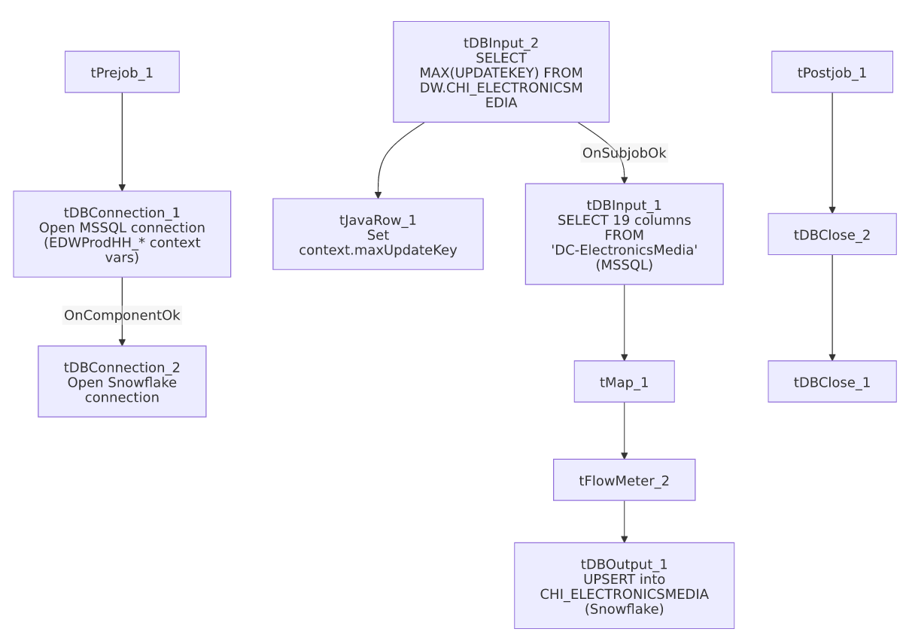

Settings tables

Source: `tDBInput_1` (`tMSSqlInput`)
Setting | Value | What it means
Connection | Shared tDBConnection_1 | Reuses the job's MSSQL connection.
Table | "DC-ElectronicsMedia" | The literal source table name — see Issues observed regarding the DC/CHI mismatch.
Query | Fixed SELECT of 19 columns (truncated in metadata) | No visible WHERE clause referencing context.maxUpdateKey.

Target: `tDBOutput_1` (`tSnowflakeOutput`)
Setting | Value | What it means
Table | CHI_ELECTRONICSMEDIA | Destination table.
Output action | UPSERT | Differs from most other jobs' plain INSERT — presumably keyed on UPDATEKEY or an equivalent natural key to avoid duplicating already-loaded rows on rerun, though the actual upsert key isn't visible in this metadata.

Dependencies & configuration
- Triggers/depends on other jobs: none — no tRunJob links found.
- Context variables used: EDWProdHH_Database, EDWProdHH_Login, EDWProdHH_Port, EDWProdHH_Schema, EDWProdHH_Server, maxUpdateKey (computed internally).
- No hardcoded developer-workstation paths found in this job.

Glossary
Component type | Plain-English meaning
tMSSqlConnection / tMSSqlInput / tMSSqlClose | Open a Microsoft SQL Server connection, run a query against it, and close it.
tSnowflakeInput / tSnowflakeOutput / tSnowflakeConnection / tSnowflakeClose | Run a query against Snowflake and return results / write (or upsert) rows into a table / open and close the connection.
tJavaRow | Runs custom Java code once per input row — here, unpacking a single query result into a context variable.
tMap / tFlowMeter | Map/transform columns; count rows passing a point in the flow.

Issues observed
- The MSSQL source table is named `"DC-ElectronicsMedia"`, a DC-site name, yet this job is `CHI_E_Media_Load` and writes into `CHI_ELECTRONICSMEDIA`. Either the source system genuinely stores CHI's electronic-media records in a table that was never renamed from a historical/legacy "DC" name, or this job was copied from an actual DC-site load job and the TABLE parameter was never repointed to a CHI-specific source table. Unable to determine which from metadata alone — this is a significant, concrete finding since it directly affects which site's data actually lands in CHI_ELECTRONICSMEDIA. Verify urgently with the team before trusting this table's site attribution.
- The incremental max-key check (`context.maxUpdateKey`) is computed, but the captured `tDBInput_1.QUERY` text is truncated after the column list, with no visible WHERE clause using it — the same uncertainty documented in i3_CallDetail_40_Load and AgentKPI_Daily_Load. However, unlike those two jobs, this one's outputAction is UPSERT rather than INSERT, which would at least prevent duplicate rows even if the full table were re-pulled every run (assuming the upsert key is correctly UpdateKey or an equivalent natural key) — so the practical risk here is more likely wasted read/compute cost on a full re-pull than duplicated data, though this can't be fully confirmed without the untruncated query.
- No error/row-count logging or reject-flow handling is visible for this job — a failure would only surface as a generic Talend execution error.

