Talend Job: CLT_XFR_DT_Load

Overview
Loads a single hardcoded client-transfer-date extract file (ME49630_P3-2.txt — a cryptic batch/ticket-style reference not otherwise explained in the metadata) into a Snowflake "catchup" table, CLT_XFR_DT_CATCHUP, dropping and recreating the table fresh on each run. Same one-off/manual-utility pattern as the Backfill_* jobs and ADP_Employee_Load elsewhere in this batch — a two-component job with no connection management, logging, or error handling.

Detail table
Field | Value
Job name | CLT_XFR_DT_Load
Version | 0.1
Project | EDW2SF
Author | jmach@harriscollect.com
Created | 2023-09-28T14:07:33.036-0700
Last Modified | 2025-09-24T11:09:04.544-0700

Step-by-step data flow
This job has no tPrejob/tPostjob, no tDBConnection/tDBClose, and no logging — just:
- tFileInputDelimited_1 reads the fixed file "C:/Data/ME49630_P3-2.txt" (tab-delimited, header row, DIE_ON_ERROR=false) with schema LOGON/DEBTORNUMBER/CLT_XFR_DT.
- tDBOutput_1 writes into Snowflake CLT_XFR_DT_CATCHUP (INSERT, tableAction=DROP_IF_EXISTS_AND_CREATE — the table is fully rebuilt each run, not just cleared).
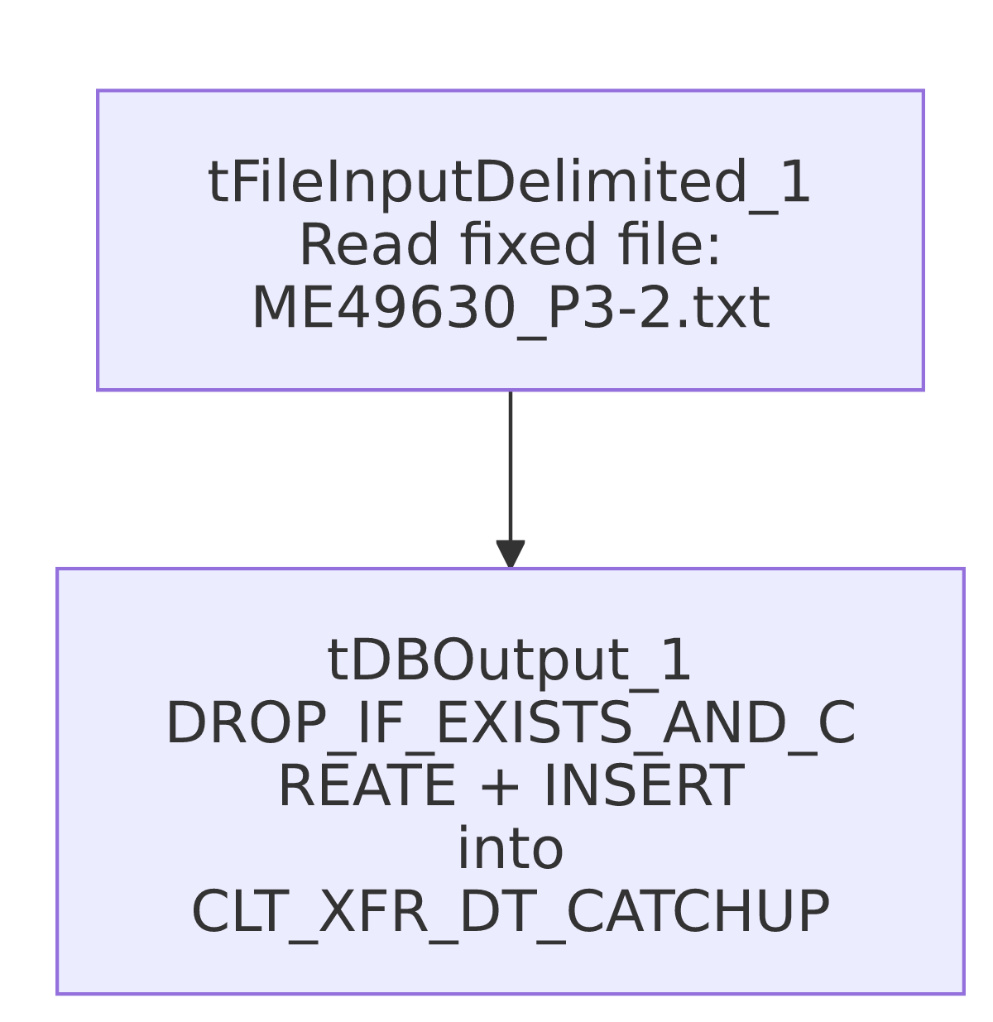

Settings tables

Source: `tFileInputDelimited_1`
Setting | Value | What it means
FILENAME | "C:/Data/ME49630_P3-2.txt" | A fully hardcoded path to a specific file; "ME49630" and "P3-2" are not otherwise explained in this metadata.
DIE_ON_ERROR | false | Malformed rows don't fail the job; no reject flow is wired either, so they're silently dropped.

Target: `tDBOutput_1` (`tSnowflakeOutput`)
Setting | Value | What it means
Table | CLT_XFR_DT_CATCHUP | Destination table.
Output action / Table action | INSERT / DROP_IF_EXISTS_AND_CREATE | Recreates the table's structure from the job's own schema on every run, rather than just clearing its rows (as TRUNCATE would).

Dependencies & configuration
- Triggers/depends on other jobs: none — no tRunJob links found.
- Context variables used: none — everything is hardcoded.
- 1 hardcoded developer-workstation path in tFileInputDelimited_1.TEMP_DIR.

Glossary
Component type | Plain-English meaning
tFileInputDelimited | Reads a delimited (CSV/TSV-style) text file according to a schema.
tSnowflakeOutput | Writes rows into a Snowflake table; here configured to drop and recreate the table each run.

Issues observed
- `FILENAME` is a fully hardcoded path to a specific file with a cryptic name ("C:/Data/ME49630_P3-2.txt") — the same one-time/manual-utility signature as the Backfill_* jobs and ADP_Employee_Load in this batch. Unable to determine from metadata what "ME49630" or "P3-2" refer to; verify with the team if this table's provenance is ever questioned.
- `tDBOutput_1`'s table action is `DROP_IF_EXISTS_AND_CREATE` rather than `TRUNCATE` — this recreates the table's structure from the job's own schema on every run rather than just clearing its rows. If any downstream object (view, grant, another job) depends on CLT_XFR_DT_CATCHUP's exact table definition or permissions, a drop-and-recreate could silently reset those on each run. It also means rerunning this job against the same 2023-dated source file would simply rebuild an identical table — nothing suggests this job is meant to run more than once.
- No `tDBConnection`/`tDBClose`, no logging, no error handling — the same absence pattern as other one-off utilities in this batch (e.g., ADP_Employee_Load, Backfill_Debtor_Cell_Phone_f83).

