Talend Job: CO_DEBTOR_SPECIAL_BACKFILL_LOAD

Overview
Loads "special" CO-site debtor attributes (retention period, statute-of-limitations, retention reason, lien flag) from a fixed file on a shared mount path into a freshly rebuilt Snowflake CO_DEBTOR_SPECIAL table. Similar in spirit to CLT_XFR_DT_Load and the Backfill_Debtor_* jobs elsewhere in this batch, but this one does include basic Snowflake connection lifecycle management (tDBConnection_1/tPostjob_1/tDBClose_1), unlike most of its fully bare-bones one-off siblings.

Detail table
Field | Value
Job name | CO_DEBTOR_SPECIAL_BACKFILL_LOAD
Version | 0.1
Project | EDW2SF
Author | jmach@harriscollect.com
Created | 2023-02-06T09:46:33.277-0800
Last Modified | 2025-09-24T11:08:21.910-0700

Step-by-step data flow
This job has no tPrejob_1 component — tDBConnection_1 is itself the job's starting point:
- tDBConnection_1 opens the Snowflake connection.
- On SUBJOB_OK, tFileInputDelimited_1 reads the fixed file "/mnt/cubs/CO_DEBTOR_SPECIAL.txt" (tab-delimited, header row, DIE_ON_ERROR=false) with schema LOGON/DEBTOR/DEBTOR_IDX/RET_PERIOD/ST_LIMIT/RET_REASON_EM/LIEN.
- tDBOutput_1 writes into Snowflake CO_DEBTOR_SPECIAL (INSERT, tableAction=DROP_IF_EXISTS_AND_CREATE).
Teardown: tPostjob_1 → tDBClose_1.
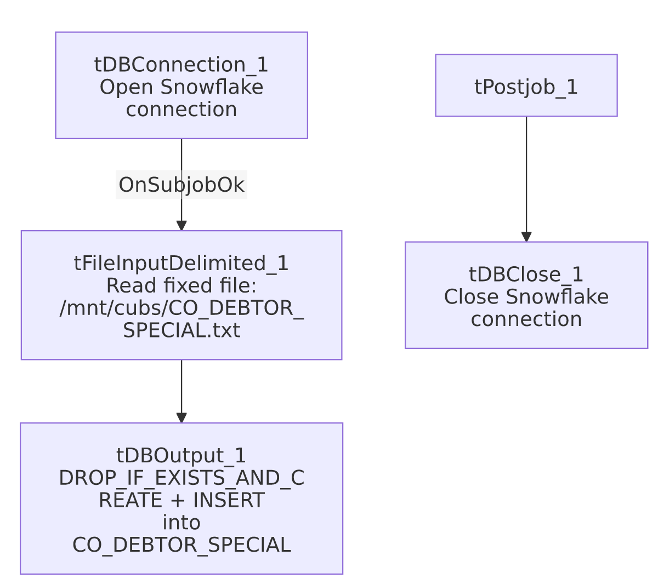

Settings tables

Source: `tFileInputDelimited_1`
Setting | Value | What it means
FILENAME | "/mnt/cubs/CO_DEBTOR_SPECIAL.txt" | Hardcoded Linux-style path, not a context variable.
DIE_ON_ERROR | false | Malformed rows don't fail the job; no reject flow is wired either, so they're silently dropped.

Target: `tDBOutput_1` (`tSnowflakeOutput`)
Setting | Value | What it means
Table | CO_DEBTOR_SPECIAL | Destination table.
Output action / Table action | INSERT / DROP_IF_EXISTS_AND_CREATE | Table is fully rebuilt from the job's own schema every run — the same rebuild-not-clear pattern flagged in CLT_XFR_DT_Load.

Dependencies & configuration
- Triggers/depends on other jobs: none — no tRunJob links found.
- Context variables used: none — everything is hardcoded.
- 1 hardcoded developer-workstation path flagged in tFileInputDelimited_1.TEMP_DIR; the FILENAME="/mnt/cubs/CO_DEBTOR_SPECIAL.txt" hardcoding is not caught by this extraction's hardcoded_path_findings (tuned to the Windows workstation path pattern), but carries the same one-off/portability risk — the same situation as Backfill_Debtor_Phones's hardcoded /mnt/cubs directory elsewhere in this batch.

Glossary
Component type | Plain-English meaning
tFileInputDelimited | Reads a delimited (CSV/TSV-style) text file according to a schema.
tSnowflakeOutput / tSnowflakeConnection / tSnowflakeClose | Write rows into a Snowflake table (here configured to drop and recreate it) / open and close the Snowflake connection.

Issues observed
- `FILENAME` is hardcoded to a fixed path ("/mnt/cubs/CO_DEBTOR_SPECIAL.txt") rather than a context variable — not caught by this extraction's hardcoded_path_findings (tuned to the Windows C:/Talend-Studio pattern), but the same portability/one-off risk as the flagged Windows paths elsewhere in this project.
- `tDBOutput_1`'s table action is `DROP_IF_EXISTS_AND_CREATE`, the same rebuild-the-table-every-run pattern flagged in CLT_XFR_DT_Load — any downstream dependency on CO_DEBTOR_SPECIAL's table definition or grants would be reset on each run.
- This job has no `tPrejob_1` (unlike CLT_XFR_DT_Load and ADP_Employee_Load, which have no connection/teardown components at all, and unlike the fuller jobs in this batch which have both tPrejob_1 and tPostjob_1) — it sits in between, with connection open/close but no logging setup. Not necessarily a defect, just an inconsistent shape relative to other jobs' conventions in this project.
- No reject-flow wiring, no error handling, no logging — the same one-off-utility profile as its siblings in this batch.
- The name "CO_DEBTOR_SPECIAL_BACKFILL_LOAD" and its target table's plain "CO_DEBTOR_SPECIAL" name (without a "_BACKFILL" suffix, unlike Activity_Load_Legacy's "_BACKFILL"-suffixed target) suggest this might be the primary/only load mechanism for this table rather than a genuine one-time backfill companion to some other ongoing job — but no other job in this batch's metadata references CO_DEBTOR_SPECIAL, so it's unable to determine from metadata alone whether an ongoing companion job exists elsewhere in the 289-job project. Verify with the team.

